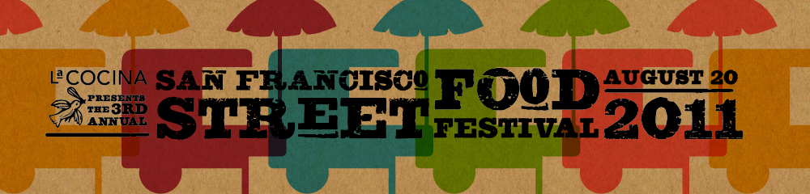

**FOR IMMEDIATE RELEASE**

**Contacts:** Caleb Zigas

415-824-2729 x. 304

[caleb@lacocinasf.org](mailto:caleb@lacocina.org)

**La Cocina’s Hosts 2011 SAN FRANCISCO STREET FOOD FESTIVAL**

**“All the best food in the Bay Area on one street”**

***Micro, Local and National Chefs Combine for Annual Event Benefiting Non-Profit La Cocina***

(SAN FRANCISCO, Calif. —June 16, 2011) San Francisco is easily the best food city in the country, and this year La Cocina’s 3rd San Francisco Street Food Festival, presented by Mission Tortilla proves it with all of the best food in the Bay Area on one single block. This year's festival features over 30 micro-vendors from La Cocina’s nationally-recognized incubator program, 25 of the Bay’s best owner-operated restaurants, over 5 formerly informal entrepreneurs formalized for the day, over 10 of the best food trucks from the growing mobile movement locally and, as special guests, 6 mobile vendors hand-picked from cities across the country. The festival, organized by La Cocina and functioning as a fundraiser for them as well, will be held August 20 from 11 a.m. until 7 p.m. in the Mission District on Folsom St. from 22nd to 26th Streets, and 23rd, 24th and 25th Streets Street between Shotwell and Treat Streets closed for communal seating. Admission is free and open to the public with all food priced below $8 and half of the food for less than $3.

La Cocina is a ground-breaking business incubator designed to reduce the obstacles that often prevent low-income food entrepreneurs from creating successful and sustainable small businesses. By providing affordable, shared, commercial kitchen space, an array of industry-specific technical assistance and services, and access to market opportunities, La Cocina works with entrepreneurs as they launch, grow, and formalize successful food businesses. The organization’s vision is that program participants become economically self-sufficient and contribute to a vibrant and diverse economy doing what they love to do.

“We fully believe that the tacos from Los Cilantros, Azalina’s curry or down-home Mexican food from El Buen Comer are as good or better than the foods made by this food town’s top chefs,” said Caleb Zigas, Executive Director of La Cocina. “The San Francisco Street Food Festival showcases our incredible entrepreneurs, empowering them to serve their dishes alongside some of the country’s best chefs. La Cocina is proud to support the incredible work of more than 30 of the most talented culinary professionals that San Francisco has to offer.”

San Francisco is an eater’s city, with the best of the best represented in everything from bacon-wrapped hot dogs cooked illegally on overturned sheet pans to Michelin starred and James Beard Award Winning Chefs. La Cocina’s San Francisco Street Food Festival celebrates this diversity in all of its deliciousness with a special focus on the people behind the food and the combination of the city’s low, middle and high all into one accessible price point.

**-more-**

*San Francisco Street Food Festival- Page 2*

Street food vendors like Lucero’s bacon-wrapped hot dogs share space with La Cocina vendors like Chaac Mool, El Buen Comer and Alicia’s Tamales and James Beard award-nominated restaurants like Flour+Water. This year, six mobile vendors from across the country will represent Portland (Big-Ass Sandwiches), Seattle (Skillet Street Food), Los Angeles (La Cocina grads Global Soul), New York (Schnitzel and Things), Madison (Ingrid’s Lunch Box) and Austin’s (Along Came a Slider) support for the work of La Cocina, cooking their specialties and donating all profits to La Cocina. Returning for their second year, Rye on the Road will pour beer from Amstel Light and spirits from San Francisco’s Skyy portfolio, not to mention beautiful Jello shots from La Cocina’s own Sweets Collection.

Zigas continues, “**This festival is a celebration of the taste, the heart and the commitment of our vendors , the small business owners in San Francisco who have supported a community of eaters that believe in this kind of food and the food trucks, carts, trailers and informal entrepreneurs that continue to make this city the best food city in the world.”**Guests will not only get to taste the food but also see vendors like Charles Phan, of the Slanted Door, try to keep up with Maria del Carmen Flores, of Estrellita’s Snacks in feeding 50,000 people in 8 hours. See who’s still smiling at the end of the day!

**The Street Food Festival will serve as the highlight at the end of a summer full of culinary activities. *In*** *June,* Wells Fargo willpresent *The Small Business Vote Your Vendor Contest.* The top-four San Francisco food vendors who are elected by the general public will receive a free space at the festival as well as technical assistance for their business from Wells Fargo and La Cocina. Vendors and home cooks can be nominated at [www.sfstreetfoodfest.com](http://www.sfstreetfoodfest.com) starting now. Beginning in July, La Cocina will present the *San Francisco Street Food Scavenger Hunt* in conjunction with The Go Game. This ten day race around the city will have food lovers looking for hidden-gems, chefs with secrets and street food where you least expect it. Teams will play for prizes, for fun and, of course, for pride.

Returning for their second year, Rye on the Road will pour beer from Amstel Light and spirits from San Francisco’s Skyy portfolio, not to mention beautiful jello shots from La Cocina’s own Sweets Collection.

For the second year, La Cocina will host the National Street Food Conference on August 21-22 at Fort Mason Center. The 2011 Conference will focus on the culture, economics and policy of street food with an extended look at small business incubation nationally. It is intended to be an open forum for ideas, an exchange between vendors, consumers, regulators and dreamers, and, hopefully, a place where changes can be set in motion to create more viable options for low-income vendors. Tickets can be purchased at [www.sfstreetfoodfest.com](http://www.sfstreetfoodfest.com).

Passports for La Cocina’s San Francisco Food Festival range from $50-$250 and can be purchased in advance, saving money and time the day of the event. Each passport comes with a souvenir Street Food journal and secret treats for passport holders. All vendors accept cash, but passports get you savings! For passports, Vote Your Vendor and Scavenger Hunt activities and more information on the San Francisco Street Food Festival, visit [www.sfstreetfoodfest.com](http://www.sfstreetfoodfest.com).

# # #

**About La Cocina**La Cocina is a non-profit food business incubator that provides affordable commercial kitchen space and technical assistance to low-income and immigrant entrepreneurs who are starting, launching or growing food businesses. La Cocina creates avenues for economic self-sufficiency through food businesses and places a priority on women-owned and immigrant-owned businesses.

For more information, visit [www.lacocinasf.org](http://www.lacocinasf.org).