LOCATING DARKER PIXELS IN AN IMAGE USING GROVER’s SEARCH ALGORITHM

Term project submission for the course

IT437 - Quantum Computing

By

Aditi Singh(211AI004)

Balla Pradeep(211AI10)

K.Ritvik(211AI022)

*Under the guidance of*

**Dr.Bhawana Rudra**



DEPARTMENT OF INFORMATION TECHNOLOGY

NATIONAL INSTITUTE OF TECHNOLOGY KARNATAKA

SURATHKAL, MANGALORE – 575025

MAY,2023

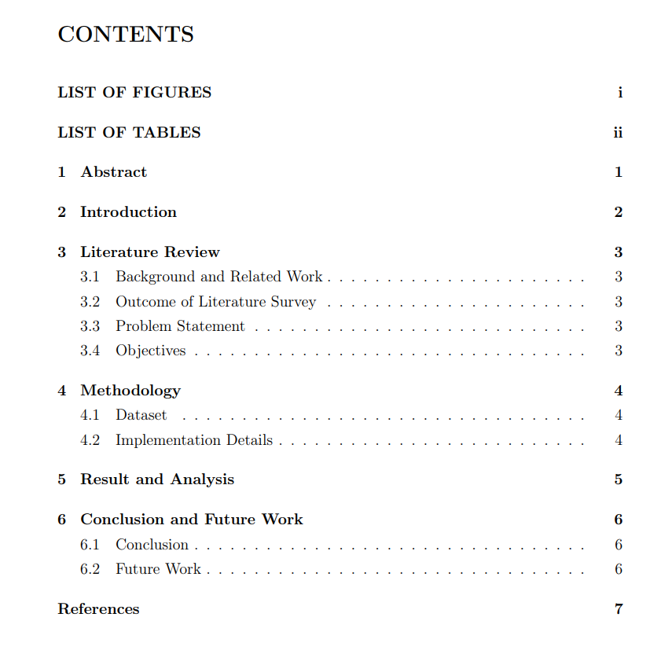

**1.Abstract**

Quantum Information Theory is a field that investigates the fundamental principles of Information Processing using Quantum Systems.It studies how quantum properties such as entanglement and superposition can be harnessed in the domains of Quantum Image processing, Error detection and Quantum Cryptography.

Quantum Information Processing combined with Quantum algorithms provides a very novel approach in the domain of Image Processing Tasks as they utilize the power of quantum properties such as entanglement and superposition which gives these tasks a Quadratic speedup as compared to the traditional classical methods. Our Research Interest for this paper is to locate the darker pixels in web-imported images and self-created images of different input sizes, using Grover’s Search Algorithm. As has been observed from the complexity analysis , Grover’s Search Algorithm takes O(2^n) time while classical Algorithm takes O(2^2n+2m), where n and m are dimensions of image.

KEYWORDS:- Grover’s algorithm, Quantum Computation, Darker Pixels, NEQR Quantum state, Image Processing

2.**INTRODUCTION**

Quantum Information Theory is revolutionising the field of Quantum Computations offering a Quantum Speed up to the classical approaches of Computation .In the domain of Image processing , it leverages the task by combining the properties of Quantum Computing like superposition and entanglement which enhances the efficiency of the tasks such as spotting of pixels with given Threshold in an image, although the practical implementations are limited but ongoing advancements in the field of Quantum Hardware and Algorithms hold a great promise in the future of Quantum Image Processing

In quantum image processing, classical images are transformed into quantum states using pixel locations. Different quantum representations of images have been extensively studied, but after thorough analysis, we found NEQR to be the best optimal state conversion techniques suitable for this Research paper.

The efficiency of quantum algorithms in achieving speed-up has been demonstrated in various studies . Grover's algorithm, for example, provides a quadratic speed-up in unsorted database searches, reducing the evaluations from O(N) to O(N^1/2), where N is the number of items in the list. The algorithm utilizes an oracle that flips the sign for the searched item and a diffuser operator that amplifies the probability amplitude of the search item and reduces the probability amplitudes of other items.

As the demand for the applications of Quantum Computations is increasing exponentially in almost all the domains, so is with its emergence in Steganography. In this paper, we worked on the methods for locating the darker pixels using Grover’s Algorithm to find its applications in classical and quantum steganography. In the first method, we created an image with 4 white dots in the corners with a black background of different sizes like 2x2, 8x8 dimensional inputs and defined certain threshold values for each one of them, and obtained a corresponding NEQR quantum state image for them and then we applied Grover’s Algorithm on them to locate the darker pixels below the defined threshold. In the second part of our implementation, we tried to import the images from the web with more complex color combinations and structural features(Eg:-Red Flower), and using Grover’s we tried to locate the darker pixels for such images as well based on given threshold.

3 .LITERATURE REVIEW

3.1 BACKGROUND AND RELATED WORK

Grover's algorithm, a quantum search algorithm, has garnered significant attention and research due to its potential for speeding up search operations. The following key papers have contributed to the understanding and application of Grover's algorithm in the fields of quantum computing and image processing:

Brassard, G., Hoyer, P., Mosca, M., & Tapp, A. (2002). "Quantum amplitude amplification and estimation." Contemporary Mathematics, 305, 53-74.

Brassard et al. introduced the concept of quantum amplitude amplification, a crucial technique employed in Grover's algorithm. The paper explores the fundamental principles behind amplitude amplification and estimation, demonstrating their significance in enhancing the efficiency of quantum search algorithms. It provides a theoretical foundation for Grover's algorithm, establishing its potential for efficient searching in quantum computing.

Zalka, C. (1999). "Grover's quantum searching algorithm is optimal." Physical Review A, 60(4), 2746-2751.

Zalka's work focuses on analyzing the optimality of Grover's quantum searching algorithm. Through rigorous mathematical analysis, Zalka proves that Grover's algorithm achieves the optimal performance for unstructured database search problems. The paper establishes the theoretical limits and advantages of Grover's algorithm, demonstrating its superiority over classical search algorithms. It provides crucial insights into the capabilities and limitations of Grover's algorithm in quantum computing.

Boyer, M., Brassard, G., Hoyer, P., & Tapp, A. (1998). "Tight bounds on quantum searching." Fortschritte der Physik: Progress of Physics, 46(4-5), 493-505.

Boyer et al. contribute to the understanding of quantum search algorithms, including Grover's algorithm, by providing tight bounds on their efficiency. The paper presents an analysis of the performance and limitations of quantum search algorithms, establishing important benchmarks for evaluating their efficiency and potential improvements. It provides valuable insights into the computational capabilities and limitations of Grover's algorithm and its application in quantum computing.

Building upon the knowledge and insights gained from these foundational papers, Basit Iqbal and Harkirat Singh from the National Institute of Technology Srinagar implemented Grover's algorithm on a 2x2 grayscale image as part of their project. This Paper has also served as the Base Paper for our Project . Their project showcases the application of Grover's search algorithm in image processing, highlighting the potential for efficient image processing tasks using quantum computing principles.

The literature review based on these papers emphasizes the advancements and potential applications of Grover's algorithm in quantum computing and image processing. It establishes the theoretical foundations, explores algorithmic efficiency, and demonstrates practical implementations. The project conducted by Basit Iqbal and Harkirat Singh further contributes to the growing body of knowledge by applying Grover's algorithm to image processing tasks, expanding the understanding and potential applications of Grover's algorithm in this domain.

Overall, the literature review provides a comprehensive overview of the contributions and advancements in Grover's algorithm, quantum searching, and its application in image processing. It combines theoretical insights with practical examples, showcasing the significance and potential of Grover's algorithm in quantum computing and its various applications.

3.2 OUTCOME OF THE LITERATURE SURVEY

|  |  |  |  |  |
| --- | --- | --- | --- | --- |
| RESEARCH  PAPERS | CONTRIBUTIONS | OUTCOME | MERITS | DEMERITS |
| Boyer et al. (1998) | Provided tight bounds on the efficiency of quantum search algorithms | Established benchmarks for evaluating the efficiency and potential improvements of quantum search algorithms, including Grover's algorithm | Defined efficiency limits for quantum search algorithms | Theoretical bounds may not translate directly into practical implementations |
| Zalka (1999) | Established the optimality of Grover's algorithm | Proved that Grover's algorithm achieves the optimal performance for unstructured database search problems, surpassing classical search algorithms | Validated the superiority of Grover's algorithm in unstructured database searches. | Limited applicability to specific search problems |
| Brassard et al. (2002) | Introduced quantum amplitude amplification | Demonstrated the significance of amplitude amplification in enhancing the efficiency of quantum search algorithms | Enhanced efficiency of quantum search algorithms | Theoretical framework may require further experimental validation. |
| Implementation of Grover's Algorithm on a 2x2 Grayscale Image | Introduced application of grover’s algorithm in image processing | Demonstrated the potential of Grover's algorithm in image processing | Efficiently processed a 2x2 grayscale image using Grover's algorithm. | Limited to a small image size (2x2) which may not generalize to larger images.  Challenges in scaling up the algorithm for larger images and complex  image processing tasks. |

The above research papers collectively contributed to the total understanding of the application of Grover’s Algorithm in Image processing Tasks and how they can be used to spot the darker pixels in an image

3.3 PROBLEM STATEMENT

To Design and Implement an Algorithm to spot the Darker/Coloured Pixels in an Image using Grover’s Search Algorithm.

3.4 OBJECTIVES

Based on the above Literature Review and Problem Statement we implemented the following Objectives as a part of the Research Paper

*Objective 1:* -Algorithm Development

* To Design and develop a quantum algorithm for different input image sizes and web imported images based on Grover's algorithm for efficiently spotting darker pixels in an image using the properties of Quantum Entanglement and superposition

*Objective 2*: Implementation

* To Implement the designed quantum algorithm for darker pixel detection using Quantum computing algorithm(Grover’s Algorithm).

*Objective 3:* Application and Potential Enhancements

* To Demonstrate the practical application of the developed quantum algorithm by applying it to real-world image datasets(For Eg. For our current Research paper we imported a Red flower with a White background as our Dataset for this paper)
* In the form of potential enhancements of the algorithm, we tried implementing our algorithm on different image sizes incorporating larger image sizes and different image formats such as JPEG and PNG

4. METHODOLOGY

4.1 Dataset

As a part of our Real Life dataset for the implementation of this Research Paper, we imported a Red Coloured Flower with a white Background(Fig.1) from the web. We chose this dataset because the Red color of the flower with a yellowish tint in the center creates a strong contrast with the white background. This contrast establishes consistency which is required for accurate analysis of spotting darker pixels using Grover’s algorithm.

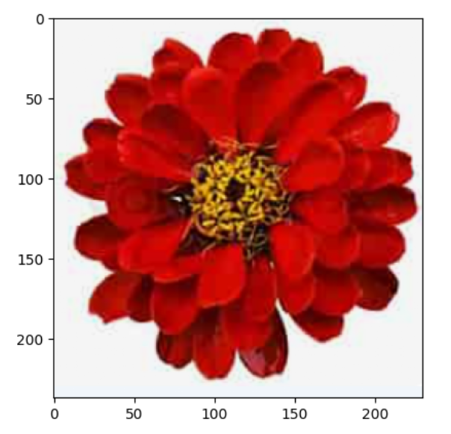

Fig 1.

1.Working on Dice Image

* + We created a 8x8 pixelated image with 4 Dots at corners representing a dice with 4 dots.
  + NumPy to create an 8x8 image with a white background, np.ones creates an array filled with ones, and multiplying it by 255 scales all values by 255, resulting in a white background (maximum intensity).
  + manually sets the pixels at the corners of the image to 0, representing black dots. The coordinates [row, column] are specified as [1, 1] for the top-left corner, [1, 6] for the top-right corner, [6, 1] for the bottom-left corner, and [6, 6] for the bottom-right corner.

2. Converting the Image to NEQR State

* + Iterating over each pixel in the input image using nested loops.
  + For each pixel at coordinates (i, j), it checks the intensity value.
    - If the intensity is less than 100, the corresponding pixel is set to 0 (black).
    - Otherwise, if the intensity is 100 or greater, the pixel is set to 255 (white).

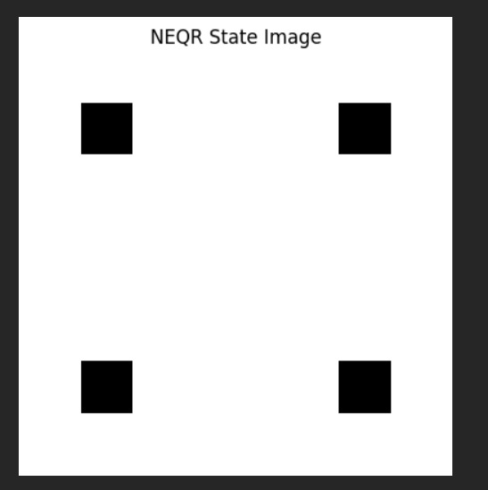

3.Applying Grover’s Algorithm

* Grover's algorithm amplifies the states of pixels with an intensity less than 100 in a NEQR image. (as user defined).
* First the grover algorithm function takes NEQR image as input.
* It calculates the number of qubits required based on the size of the NEQR image

num_qubits = int(np.log2(neqr_image.size))

* It also determines the number of iterations for Grover's algorithm based on the square root of the NEQR image size

num_iterations = int(np.sqrt(neqr_image.size))

* Then it creates a quantum circuit with the required number of qubits
* Initialize the qubits in a superposition of all states
* Creating an oracle to mark the target states. It iterates over each pixel in the NEQR image using nested loops. If a pixel has an intensity value of 0 (dark shade), the Z gate is applied to all qubits.
* Diffusion operator is applied to amplify the marked states. It first applies the Hadamard gate to all qubits, followed by the Pauli-Z gate
* Then, it applies the controlled-Z between the first and last qubits. Finally, it applies the Hadamard gate again.

4.2 Implementation Details

* Image Loading:-We imported the image from the web and displayed it using plt. imread () of matplotlib library of python and resized its pixels as 500x500 to ensure a consistent dataset for the flower image.
* Average Intensity Calculation:-To calculate the average intensity, the np.mean() function is applied along the third axis (axis=2) of the resized_image array. This calculates the mean value for each pixel by averaging the RGB channel values. The resulting average_intensity array is a 2-dimensional matrix of the same size as the resized image, where each element represents the average pixel intensity value for that pixel.This step is very crucial for forming the NEQR state as it gives a compact information regarding the brightness and darkness of the image.
* **NEQR State Generation**: Then NEQR state image was created based on a specified threshold value. The thresholding operation (np.where()) was applied to the average intensity image to generate the NEQR state image. It specifies the colormap as grayscale by putting values of vmin and vmax between 0 and 255.
* **Quantum Circuit Implementation**: Introduced the neqr_circuit() function that generates a quantum circuit for the NEQR state based on the flower image. The function applies quantum gates (circuit.x()) to specific qubits based on the NEQR state image.
* **Execution Time**: It describes the calculate_execution_time() function, which measures the execution time of the quantum circuit using Grover's algorithm.
* **3D Bar Plot of NEQR State:** A 3D plot visualisation was created to visualise the NEQR state which gives us the valuable insights on the spotted darker pixels.

5.RESULTS AND ANALYSIS:-

Following Images show how we generated the NEQR state for the Identification of darker coloured pixels with a set threshold value as 0.5(i.e. All the pixels below this value will be considered darker pixels)

 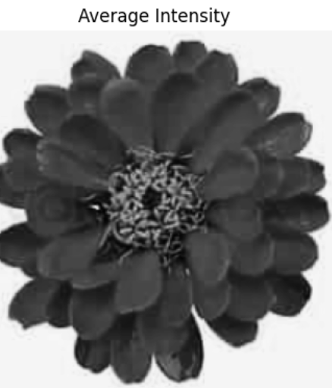 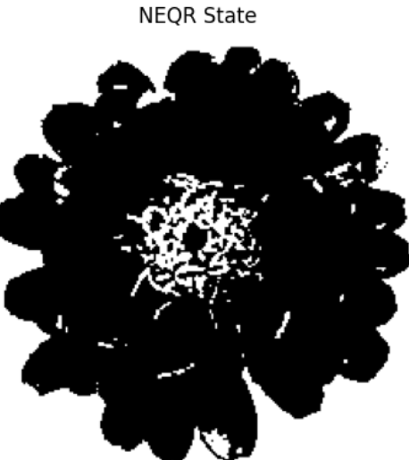

From our above image of NEQR state we gain valuable insights like how the superposition principle of Quantum Computing helps in representation of multiple states , in the above context we can see the representation of both darker pixels and lighter pixels in our NEQR generated image.

Below is the 3-D plot Histogram representing the darker pixels formed during NEQR state.

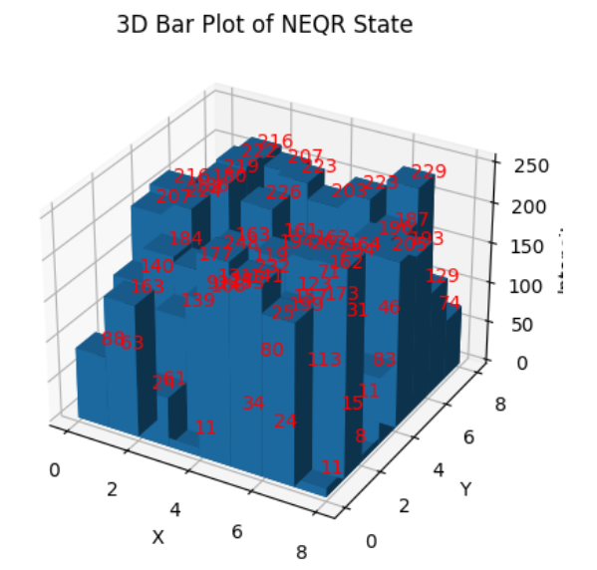

In case of Dice image representing four we generated a 3-D Histogram which shows the pixels with intensities less than 100 as histogram bars and the pixels with intensites more than 100 as Zero.

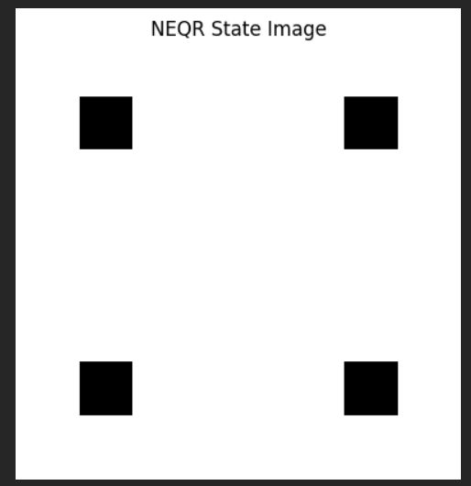 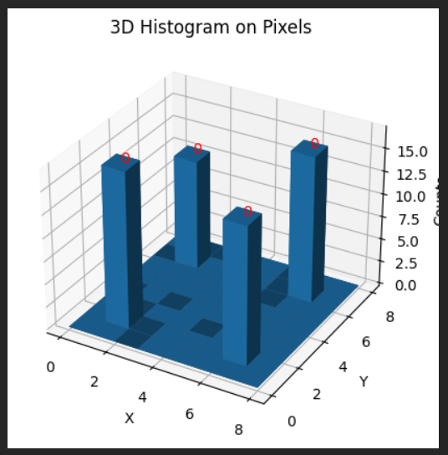

Similarly We woked on finding darker pixels with 8x8 random generated image.

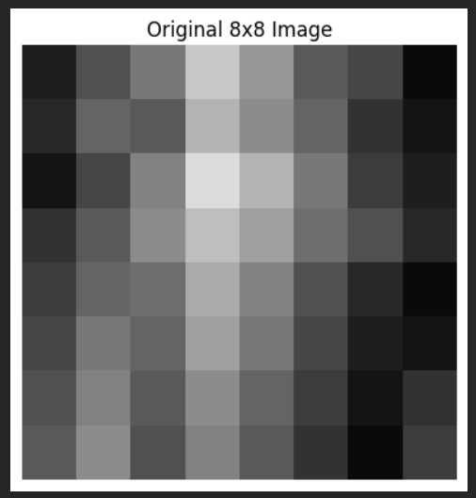 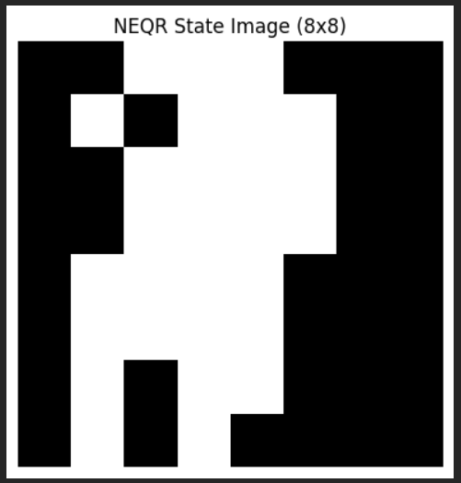 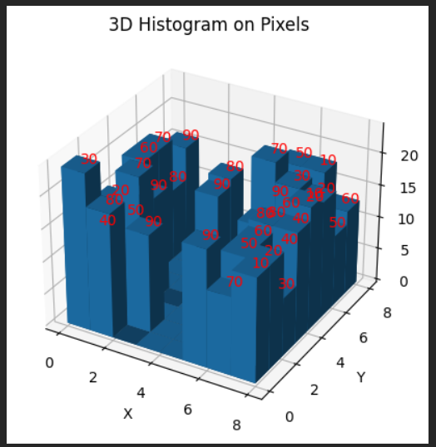

In the 3-D histogram the bars represent the found darker pixels with intensities ranging from 0-99 and rest pixels are kept zero as intensity in the NEQR image. The NEQR image shows the intensities of pixels ranging from 0-99 as 0 and intensities of pixels greater than 100 as 255 intensity resulting, the selected pixels as dark and rest as white. The intensities on the bars in 3-D Histogram represent the initial intensities of the pixels which were taken when generating images.

6. CONCLUSION AND FUTURE WORKS

6.1 CONCLUSION

In conclusion this Research Paper on spotting of Darker Pixels in an image proves to be very useful as it helps us to draw comparisons between classical Quantum Computing techniques like Grover’s algorithm and Traditional Image processing techniques on an image of different input sizes and real life complex images. Through this research paper we saw how Quantum algorithms combined with quantum computing techniques of entanglement and superposition leverage so many image processing tasks including that of spotting darker pixels in an image.

6.2 FUTURE WORKS

Also the development of an algorithm for locating darker pixels in an image proves to be a starting point for many more upcoming Quantum image processing techniques like Quantum Edge Detection , investigating new Quantum State Conversion techniques like NEQR and how these new techniques make new advances in Image processing .Some of the future works that we brainstormed are listed below.

* Advanced Image Processing Tasks: To explore the application of Grover’s Algorithm in the domain of Image processing to make even more sophisticated advances in image processing tasks like pattern recognition , image segmentation and Quantum Edge Detection.
* Quantum-Inspired Image Encoding: Developing Novel Quantum state conversion Techniques Like NEQR to further explore the possibility of coming up of even more complicated tasks on an image using Grover’s Algorithm which will extend beyond spotting the darker pixels
* Hybrid Quantum-Classical Approaches: Also we brainstormed about an Hybrid Quantum Approach which will combine the Classical and Quantum computing techniques to achieve better scalability , accuracy and efficiency.