# Python installation

The python version 3.11.x is required to be installed on the computer to run CoMOLA. There are different approaches to install python and there is very likely already a version of python installed on the computer on which CoMOLA should run. To ensure however, that the setup is the same for all case studies a clean new installation will be done using miniconda. miniconda is a python package manager that allows to easily install different versions of python and required python packages.

**Installation of miniconda**

Below two approaches to install miniconda are shown, one which automatically runs the installation from the Windows powershell and the second which uses the Windows installer. If it is OK to install the software in the default programs folder of the computer you can just use the command line approach.

Installation from the command line

To run the installation from the command line you have to open the Windows power shell. Click on the Windows start button and type “cmd” and press enter.

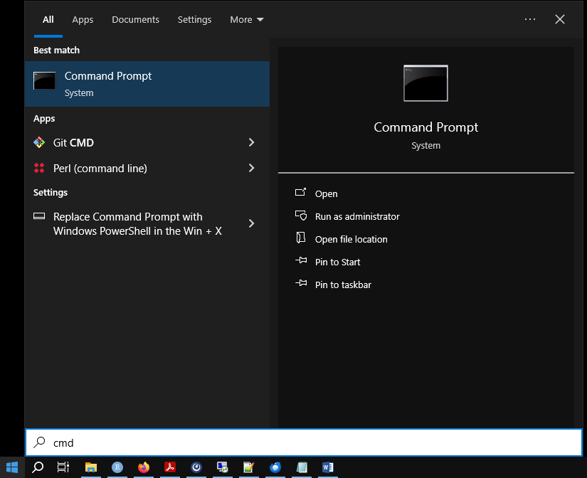

A command prompt will open. To run the installation just copy the few lines of code below into the command line. The commands will get you set up quickly with the latest miniconda installer. It downloads, installs and at the end deletes the installer.

curl https://repo.anaconda.com/miniconda/Miniconda3-latest-Windows-x86_64.exe -o miniconda.exe

start /wait "" miniconda.exe /S

del miniconda.exe

Installation with the installer

For an installation with the installer go to <https://docs.anaconda.com/free/miniconda/> and download the most recent Windows installer. Run the installation and install miniconda in the desired location.

**miniconda setup**

miniconda comes with an own prompt (which is different to the Windows CMD). If you do not want to register the paths of conda and python in the Windows PATHs (which may cause troubles with other software) it is safer to just work in the base environment of miniconda. To use the miniconda prompt just again click on the Windows start button and search for the “Anaconda Prompt (miniconda3)”

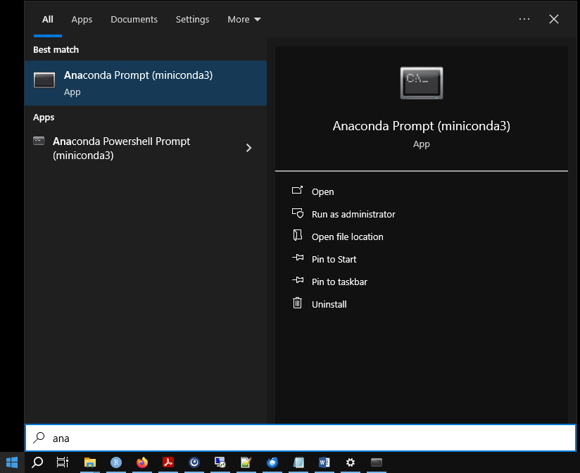

python and package installation

By starting the Anaconda prompt a new command window opens which should look similar as below:

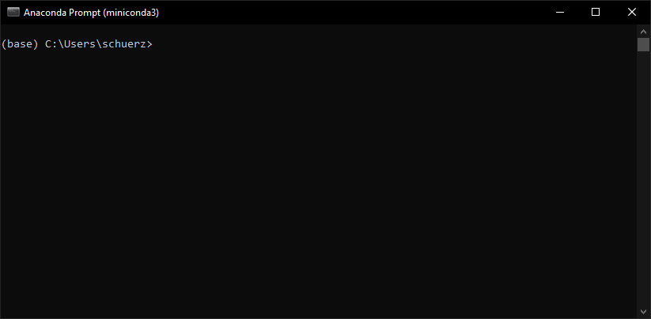

For running CoMOLA the python version 3.11.x is required. Therefore, in a first step we will install the newest version of python 3.11.x which is version 3.11.9 at the time this document was compiled.

To install this python version run the command below in the Anaconda prompt:

conda install python=3.11.9

This should start the installation process:

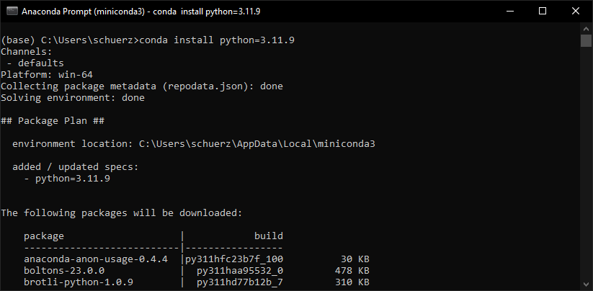

When asked to proceed, just press enter to downgrade all packages to the version 3.11 (which is not the most recent python version).

CoMOLA requires numpy as an additional package which is not by default installed with the miniconda installation. To install numpy run this line in the Anaconda prompt and again press enter when asked to proceed:

conda install numpy

**First CoMOLA test run**

Before running CoMOLA please make sure that the file config.ini has been updated correctly. In the config.ini file you need to specify the paths to both the R and the python executable you want to use. The path to your newly installed python can be seen by running:

where python

The config.ini file allows you also to modify parameters of the optimization algorithm. The most important parameters are population size (pop_size) and maximum number of generations (max_generations). For testing, small values should be chosen (e.g. pop_size = 5, max_generations = 2).

If the installation process was successful, a first CoMOLA test run can be performed. Therefore, we have to change to the directory where the CoMOLA project is located. Switch to the directory with the command cd in the Anaconda prompt:

cd Path:\to\the\CoMOLA_directory

The CoMOLA project is executed with the following command:

python __init__.py

If the setup was done correctly CoMOLA should start without showing any errors.

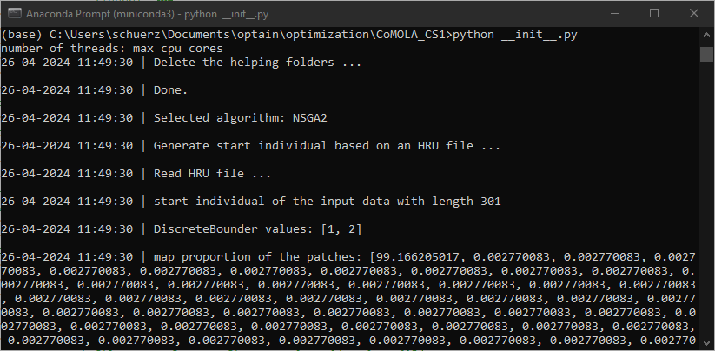

With the same command, you can run CoMOLA from the Windows CMD (this can be a solution when R cannot be executed successfully within the Anaconda prompt due to issues with spaces in the R executable path). However, if your newly installed python (version 3.11.9) has not been registered as Windows PATH variable, the command for running CoMOLA must contain the full path and name of the python executable, e.g.:

C:/ProgramData/miniconda3/python.exe __init__.py