Data Structures and Algorithms Lab
Assignment 5
Experiment 5 (Tree): To demonstrate the creation of a binary tree using arrays/linked lists and working with tree traversal.

Instruction: Make a pdf file of the program code in C and its output.
Name:Aditi Srivastava
SAP ID: 590026127
Batch: 39
Course: B.Tech. CSE (Sem II)
Subject: DSA Lab
Date: 07 April 2026
Note: Do all the implementations in C programming.
- Write a C program to create a binary tree using an array. The program should support the following operations:
- Insert elements into the tree.
- Display the tree elements.
- Display the parent, left child, and right child of a given node.

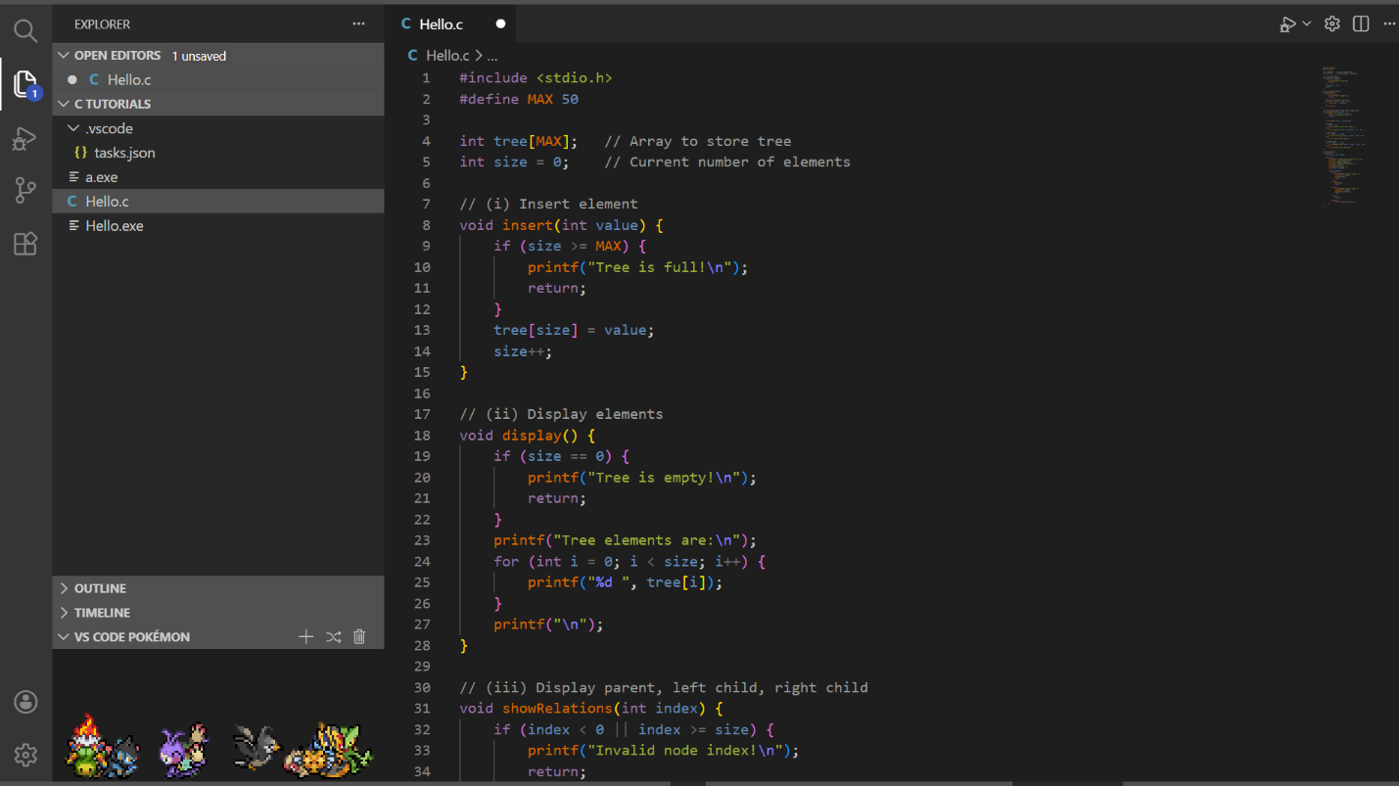
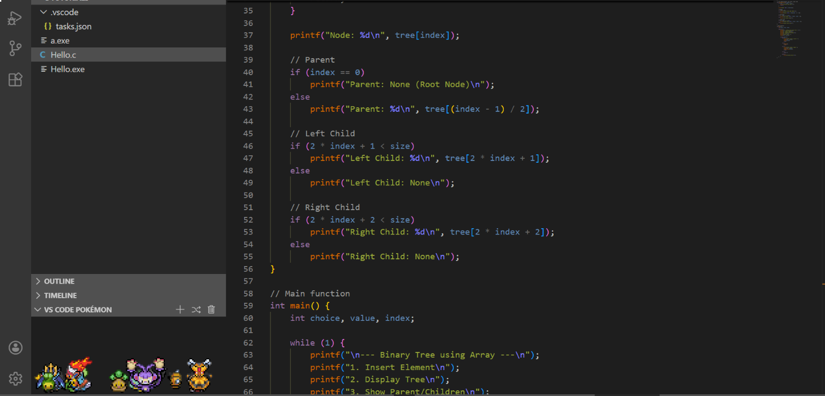

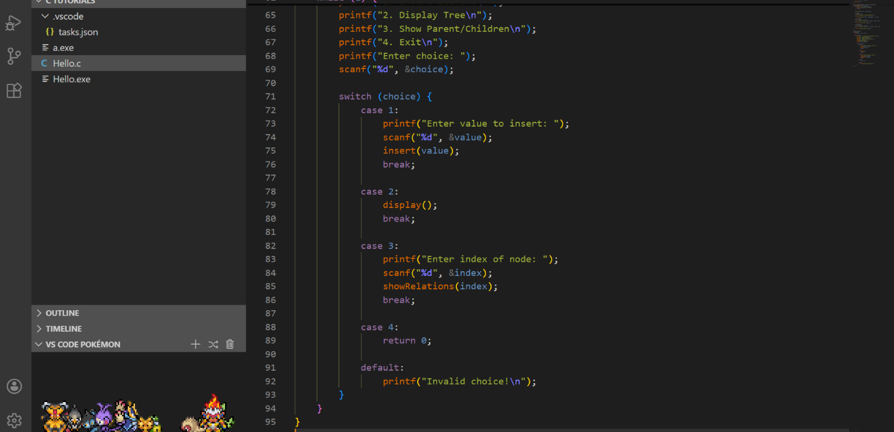

- Write a C program to create a binary tree using linked list representation and perform various operations on it.
- Insert nodes into the tree (use user input).
- Create separate functions to count.
- Total number of nodes.
- Number of leaf nodes (nodes with no children).
- Height of the binary tree.

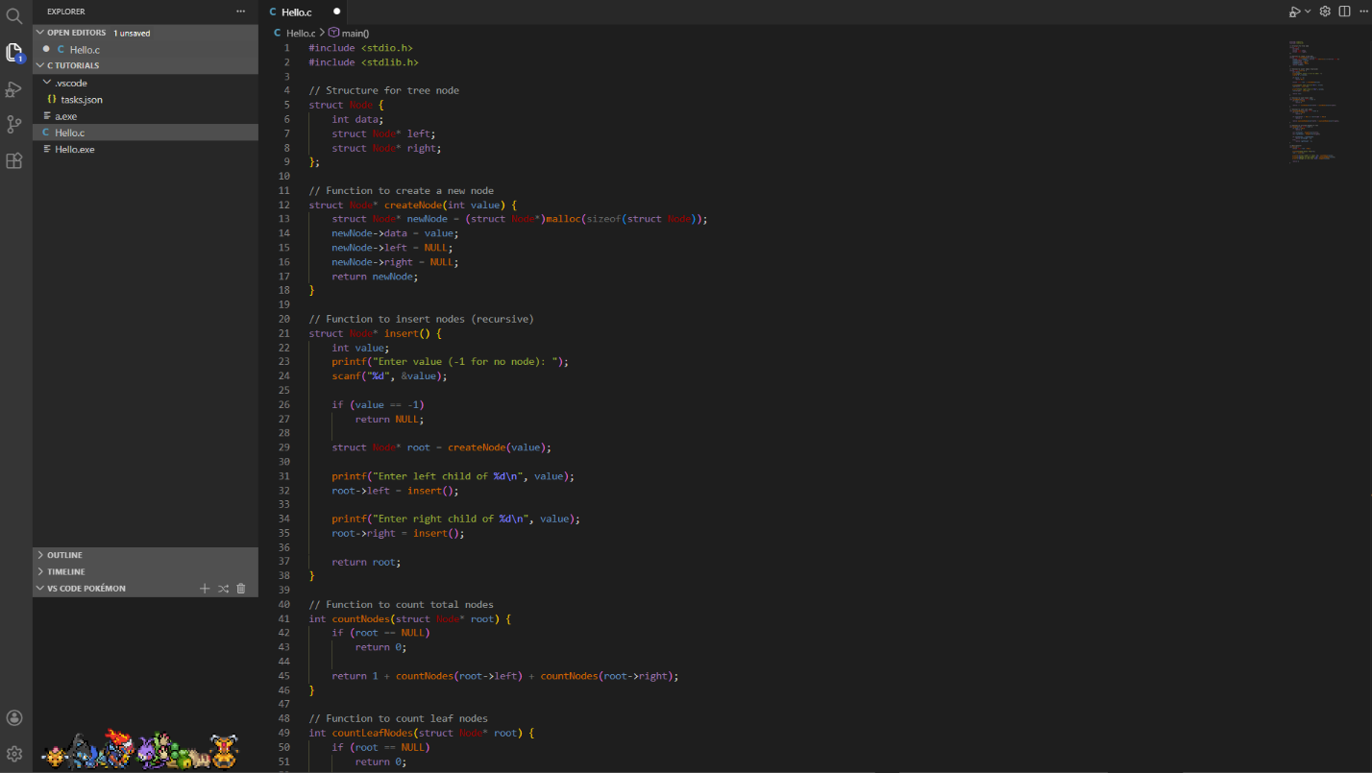

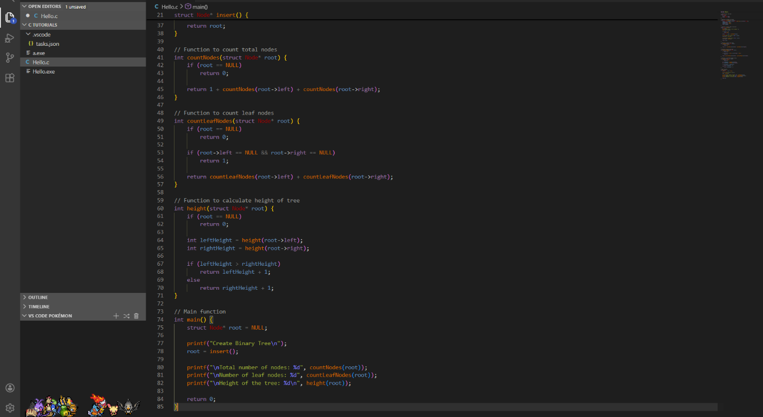

- Write a C program to implement recursive tree traversals on a binary tree. Your program should perform the following traversal functions:
- Inorder traversal (Left → Root → Right).
- Preorder traversal (Root → Left → Right).
- Postorder traversal (Left → Right → Root).

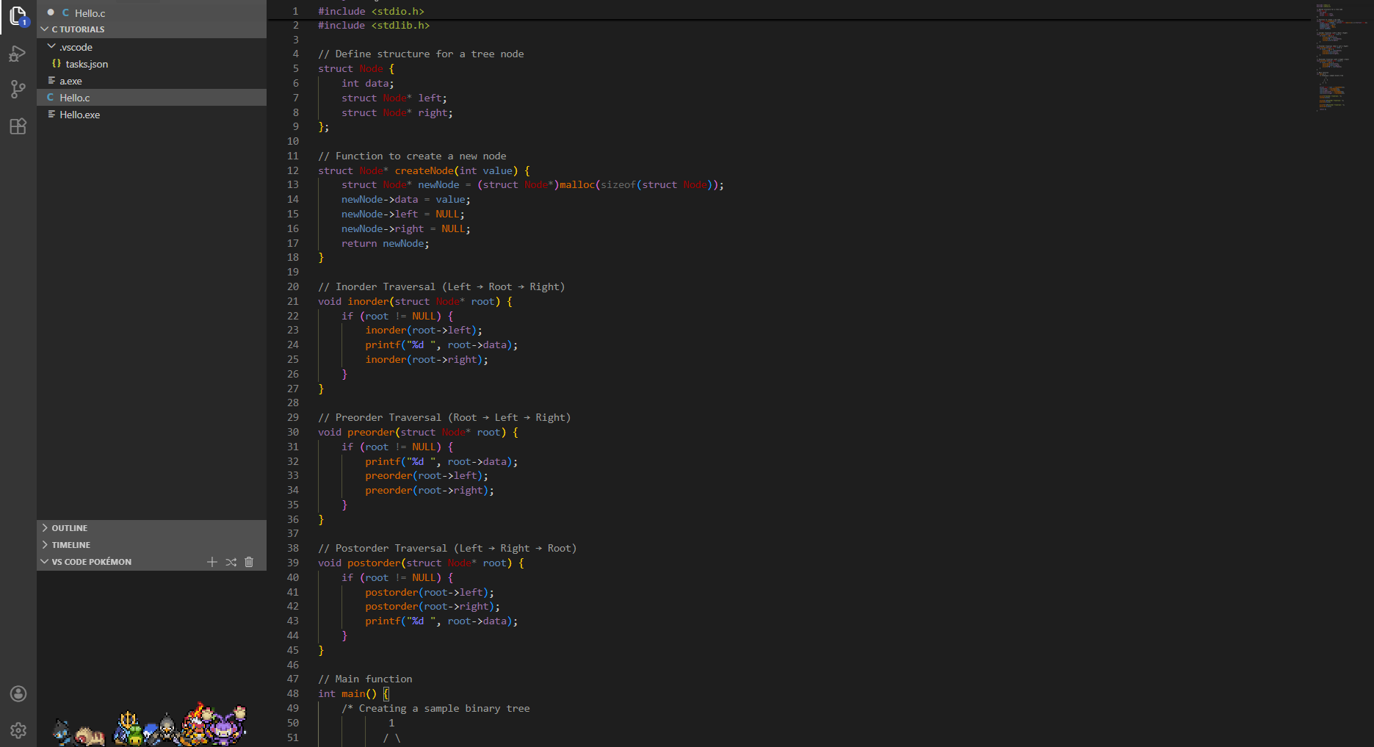

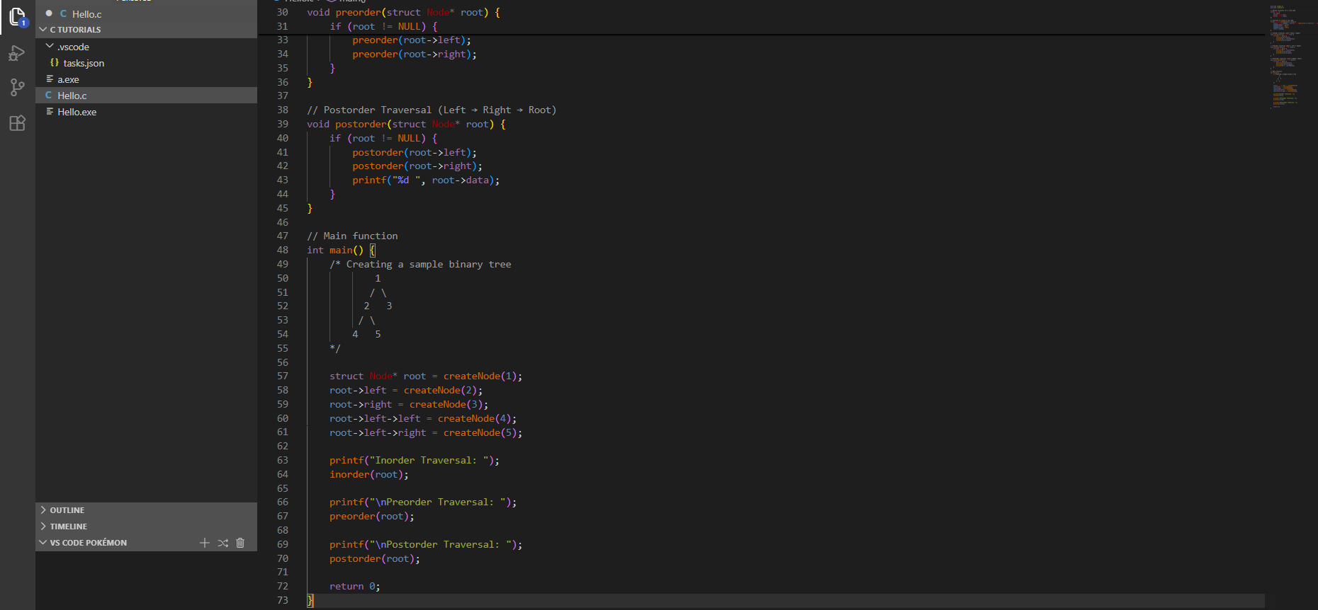

- Write a C program to perform Level Order Traversal on a binary tree using a queue.

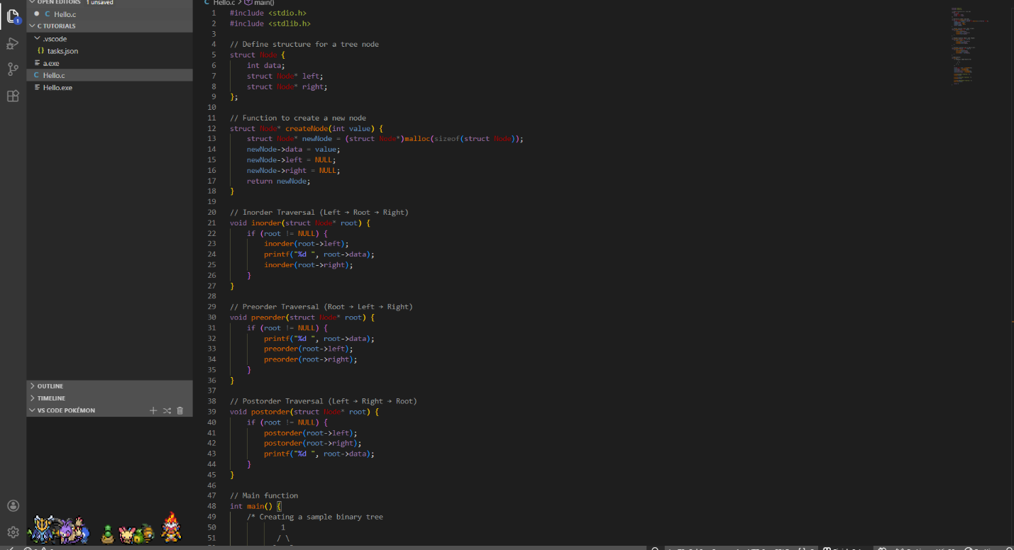

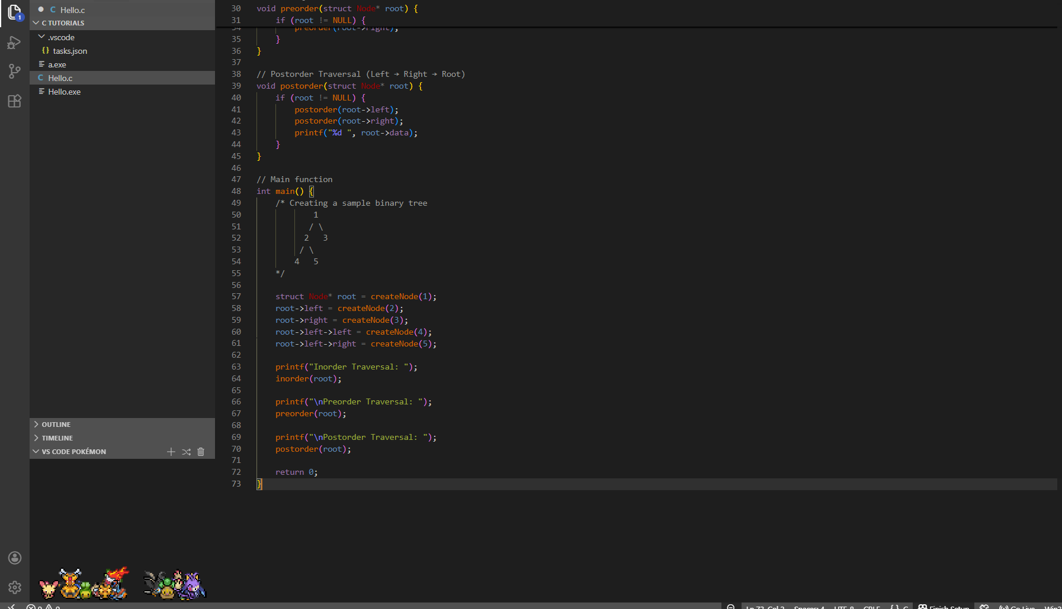

- Write a C program to implement non-recursive tree traversals of a binary tree using a stack. Your program should implement the following traversals using the stack:
- Inorder traversal (Left → Root → Right).
- Preorder traversal (Root → Left → Right).

