**MICROCONTROLLER AND MICROPROCESSOR LAB**

**EXPERIMENT 10 - B**

**AIM**: Write an embedded C program to display a digital clock showing “HH:MM: SS” on the first line and the actual time on the second line of a 16×2 LCD interface to an 8051-microcontroller hardware kit.

**SOFTWARE USED**: Keil uVision5

**CODE**:

#include<reg51.h>

#define lsb 0xFD

#define msb 0x4B

sbit RS=P2^7;

sbit RWB=P2^6;

sbit EN=P2^5;

sbit BUSY=P0^7;

unsigned char msg1[16]={"HH:MM:SS"};

unsigned char disp_data[8]=0;

void lcd_cmd(unsigned char);

void lcd_data(unsigned char);

void lcd_busy(void);

void lcd_initialize(void);

void t0isr(void);

void display_clock(void);

bit bdata secflg=0;

unsigned char i,j,cnt=0,sec=0,min=0,hr=0;

void main(void)

{ int i;

TMOD=0X01;

TL0=lsb;

TH0=msb;

EA=1;

ET0=1;

EN=0;

lcd_initialize();

lcd_cmd(0x80);

for(i=0;i<8;i++)

{

lcd_data(msg1[i]);

}

lcd_cmd(0xc0);

for(i=0;i<8;i++)

{

if(i==2|i==5)

lcd_data(':');

else

lcd_data(disp_data[i]+'0');

}

TR0=1;

while(1)

{

if(secflg==1)

{

secflg=0;

sec++;

if(sec==60)

{

sec=0;

min++;

if(min==60)

{

min=0;

hr++;

if(hr==24)

hr=0;

disp_data[0]=hr/10;

disp_data[1]=hr%10;

}

disp_data[3]=min/10;

disp_data[4]=min%10;

}

disp_data[6]=sec/10;

disp_data[7]=sec%10;

display_clock();

}

}

}

void lcd_cmd(unsigned char temp)

{

lcd_busy();

RS=0;

RWB=0;

P0=temp;

EN=1;

EN=0;

return;

}

void lcd_data(unsigned char temp)

{

lcd_busy();

RS=1;

RWB=0;

P0=temp;

EN=1;

EN=0;

return;

}

void lcd_busy(void)

{

BUSY=1;

RS=0;

RWB=1;

EN=1;

EN=0;

while(BUSY==1)

{

EN=0;

EN=1;

}

EN=0;

return;

}

void lcd_initialize(void)

{

lcd_cmd(0X3C);

lcd_cmd(0X06);

lcd_cmd(0X0E);

lcd_cmd(0X01);

return;

}

void t0isr(void) interrupt 1

{

TL0=lsb;

TH0=msb;

cnt++;

if(cnt==20)

{

cnt=0;

secflg=1;

}

return;

}

void display_clock(void)

{ int i;

lcd_cmd(0xc0);

for(i=0;i<8;i++)

{

if(i==2|i==5)

lcd_data(':');

else

lcd_data(disp_data[i]+'0');

}

return;

}

**RESULT**:

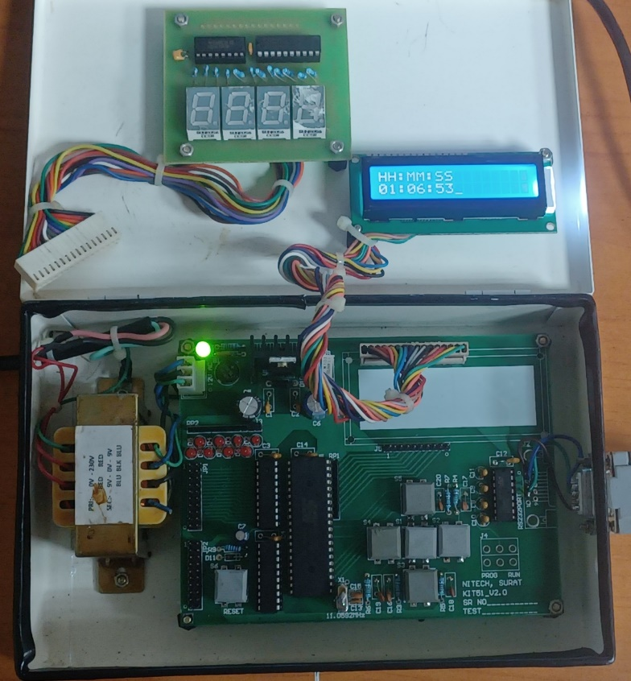

**CONCLUSION:**

This embedded C program for an 8051 microcontroller displays a digital clock on a 16x2 LCD interface. The clock format "HH:MM:SS" is updated in real-time using interrupts and displays the current time accurately. Ensure hardware setup and LCD connections for proper functionality. Additional features or optimizations can be implemented within hardware constraints.