**MICROCONTROLLER AND MICROPROCESSOR LAB**

**EXPERIMENT 10 - C**

**AIM**: Write an embedded C program to blind all the LEDs connected to Port1 on 8051 microcontrollers with the following pattern. The delay between the two patterns should be 1ms.

 

Pattern 1 Pattern 2

**SOFTWARE USED**: Keil uVision5

**CODE**:

#include<reg51.h>

void timer_isr();

void timer_isr(void) interrupt 1

{

static unsigned int sec_cnt;

static unsigned pattern=0xaa;

TH0=0XE8;

TL0=0x2F;

sec_cnt++;

if (sec_cnt==500)

{

sec_cnt=0;

pattern=~pattern;

P1=pattern;

}

}

void main()

{

P1=0;

TMOD=0x01;

TH0=0XE8;

TL0=0x2F;

ET0=1;

EA=1;

TR0=1;

while(1);

}

**RESULT**:

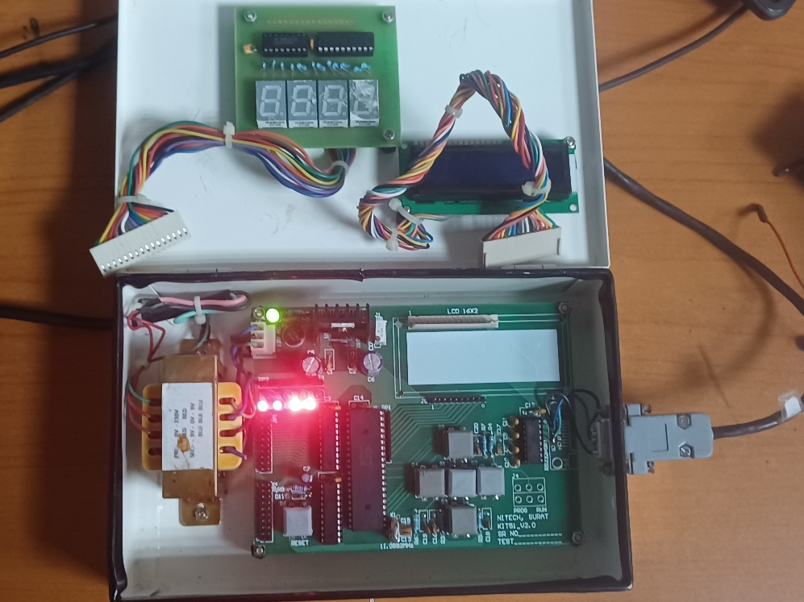

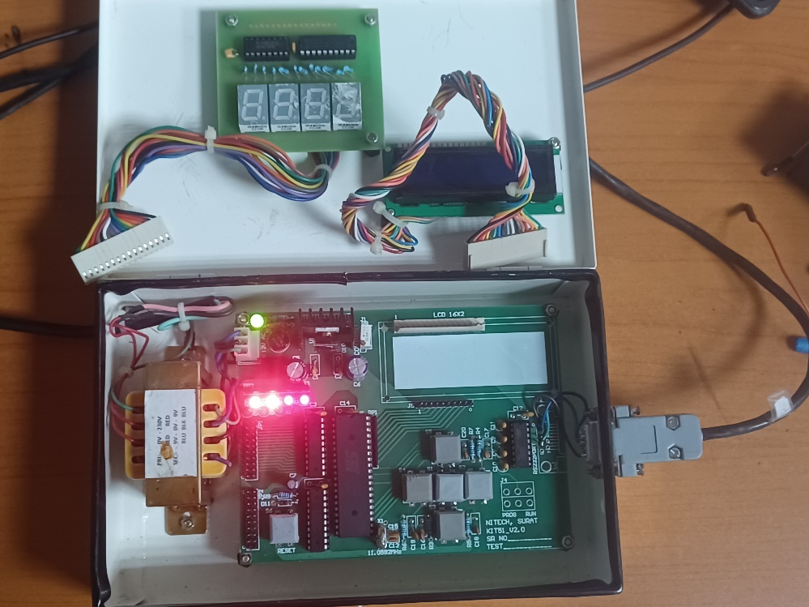

**CONCLUSION:**

This embedded C program toggles all LEDs connected to Port1 on an 8051 microcontroller with alternating patterns, synchronized by a timer interrupt running at 1 ms intervals. The pattern switches every 500 ms.