**MICROCONTROLLER AND MICROPROCESSOR LAB**

**EXPERIMENT 11**

**AIM**: Write an embedded C program to generate different waves using DAC.

**SOFTWARE USED**: Keil uVision5

**Question-1:** Write an embedded C program for the generation of a sine wave of frequency 60 Hz using DAC.

**Code**:

#include<reg51.h>

#include<math.h>

#include<intrins.h>

sbit DAC_WR=P3^0;

unsigned int i=0,x=0,count;

unsigned int dac_cntr;

unsigned int xdata arr[360];

void main()

{

TMOD=0x01;

IE=0x82;

TH0=0xFF;

TL0=0xCC;

TR0=1;

for(i=0;i<360;i++)

{

count=(sin(i*3.14/180)*127)+128;

arr[i]=count;

}

while(1)

{

if(x==1)

{

x=0;

DAC_WR=1;

dac_cntr++;

P1=arr[dac_cntr];

DAC_WR=0;

if(dac_cntr==359)

{

dac_cntr=0;

}

}

}

}

void timer0_int() interrupt 1

{

x=1;

TH0=0xFF;

TL0=0xCC;

return;

}

**Result**:

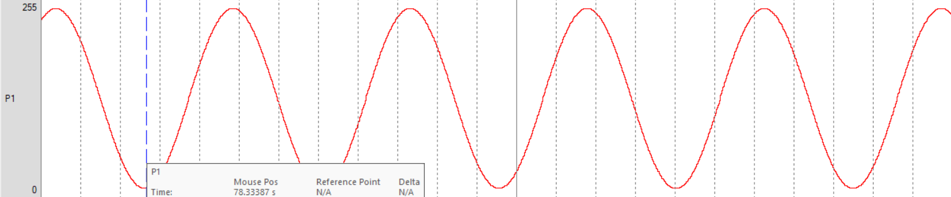

**Question-2:** Write an embedded C program for the generation of a unipolar triangular wave of frequency 50 Hz using DAC.

**Code**:

#include <reg51.h>

#include <math.h>

sbit DAC_WR=P3^0;

unsigned int i=0,x=0,z=0;

unsigned int dac_cntr = 0;

void main()

{

TMOD=0X01;

IE=0X82;

TH0=0XFF; // Timer value for 39*10^(-6) sec = [10*10^(-3)/256]

TL0=0X88;

TR0=1;

while(1)

{

if(x==1)

{

x=0;

if(z==0)

{

DAC_WR=1;

P1=dac_cntr;

dac_cntr++;

DAC_WR=0;

if(dac_cntr==255)

{

z=1;

}

}

if(z==1)

{

DAC_WR=1;

P1=dac_cntr;

dac_cntr--;

DAC_WR=0;

if(dac_cntr==0)

{

z=0;

}

}

}

}

}

void timer0_int() interrupt 1

{

x=1;

TH0=0xFF;

TL0=0x88;

return;

}

**Result**:

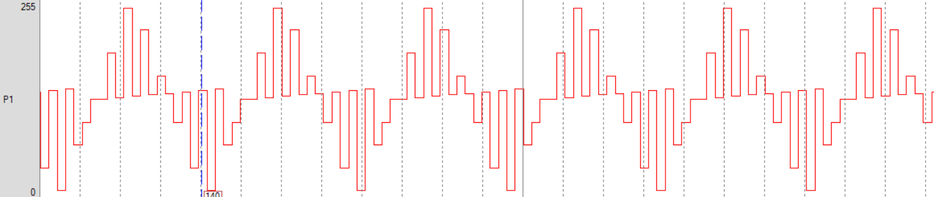

**Question-3:** Write an embedded C program for the generation of a bipolar triangular wave of frequency 50 Hz using DAC.

**Code**:

#include <reg51.h>

#include <math.h>

sbit DAC_WR=P3^0;

unsigned int i=0,x=0,z=0;

unsigned int dac_cntr;

void main()

{

TMOD=0X01;

IE=0X82;

TH0=0XFF; // Timer value for 39*10^(-6) second [10*10^(-3)/256]

TL0=0X88;

TR0=1;

dac_cntr=127;

while(1)

{

if(x==1)

{

x=0;

if(z==0)

{

DAC_WR=1;

P1=dac_cntr;

dac_cntr++;

DAC_WR=0;

if(dac_cntr==255)

{

z=1;

}

}

if(z==1)

{

DAC_WR=1;

P1=dac_cntr;

dac_cntr--;

P1=dac_cntr;

if(dac_cntr==0)

{

z=2;

}

}

if(z==2)

{

DAC_WR=1;

P1=dac_cntr;

dac_cntr++;

DAC_WR=0;

if(dac_cntr==127)

{

z=0;

}

}

}

}

}

void timer0_int() interrupt 1

{

x=1;

TH0=0xFF;

TL0=0x88;

return;

}

**Result**:

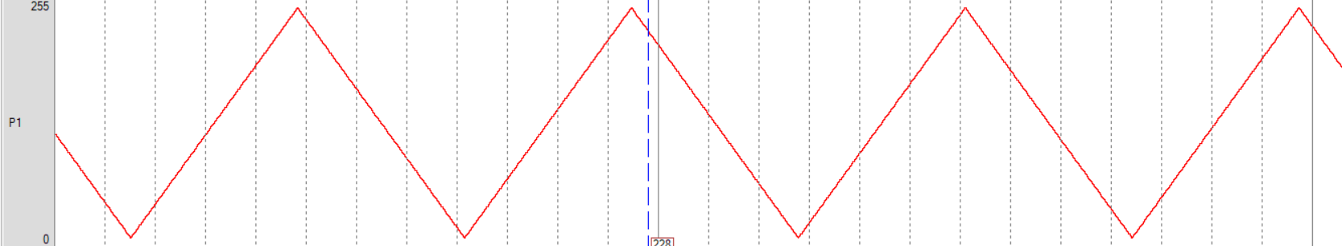

**Question-4:** Write an embedded C program for the generation of a staircase wave of frequency 50 Hz using DAC.

**Code**:

#include<reg51.h>

#include<math.h>

#include<intrins.h>

sbit DAC_WR=P3^0;

unsigned int i=0,x=0,count;

unsigned int dac_cntr;

unsigned int xdata arr[18]={128,160,192,224,255,255,224,192,160,128,96,64,32,1,1,32,64,96};

void main()

{

TMOD=0x01;

IE=0x82;

TH0=0xFC;

TL0=0x00;

TR0=1;

for(i=0;i<15;i++)

{

count=((i+)+128;

arr[i]=count;

}

while(1)

{

if(x==1)

{

x=0;

DAC_WR=1;

dac_cntr++;

P1=arr[dac_cntr];

DAC_WR=0;

if(dac_cntr==17)

{

dac_cntr=-1;

}

}

}

}

void timer0_int() interrupt 1

{

x=1;

TH0=0xFC;

TL0=0x00;

return;

}

**Result**:

