**MICROCONTROLLER AND MICROPROCESSOR LAB**

**EXPERIMENT 3**

**AIM**: To understand the operation of the overflow flag during addition, and subtraction operations in 8051.

**SOFTWARE USED**: Keil uVision5

**Question-1**: Write an assembly language program to add two signed 8-bit numbers and observe the overflow flag.

**Code**:

ORG 0000H

MOV A,30H

MOV B,31H

ADD A, B

MOV 40H, A

END

**Algorithm**:

1. Set the memory location ORG 0000H.

2. Load the hexadecimal value 30H into register A.

3. Load the hexadecimal value 31H into register B.

4. Add the content of register B to register A.

5. Store the result of the addition into memory location 40H.

6. End the program.

**Result**:

Case 1: Both numbers are positive.

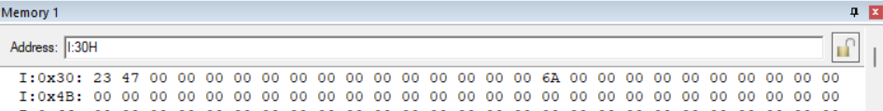

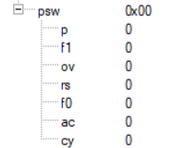

Case 2: One number is positive and the other is negative. (Overflow Flag is 0)

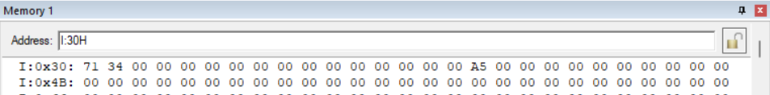

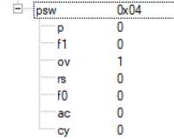

Case 3: One number is positive and the other is negative. (Overflow Flag is 1)

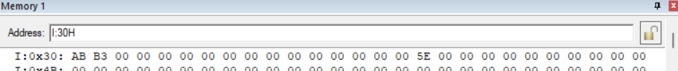

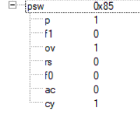

Case 4: Both numbers are negative.

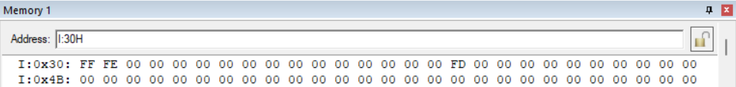

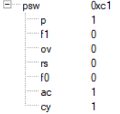

**Conclusion:**

The assembly language program adds two signed 8-bit numbers, observing the overflow flag in different scenarios. Cases include adding positive numbers (no overflow expected), positive and negative numbers (overflow flag may remain 0 or set to 1), and negative numbers (similar to positive numbers case).