**Experiment no xx**

Aim: Write an embedded C program to blind all the LEDs connected to Port1 on 8051 microcontroller with the following pattern. The delay between the two patterns should be 1ms.

 

Pattern 1 Pattern 2

Code:

#include<reg51.h>

void timer_isr();

void timer_isr(void) interrupt 1

{

static unsigned int sec_cnt;

static unsigned pattern=0xaa;

TH0=0XE8;

TL0=0x2F;

sec_cnt++;

if (sec_cnt==500)

{

sec_cnt=0;

pattern=~pattern;

P1=pattern;

}

}

void main()

{

P1=0;

TMOD=0x01;

TH0=0XE8;

TL0=0x2F;

ET0=1;

EA=1;

TR0=1;

while(1);

}

Result:

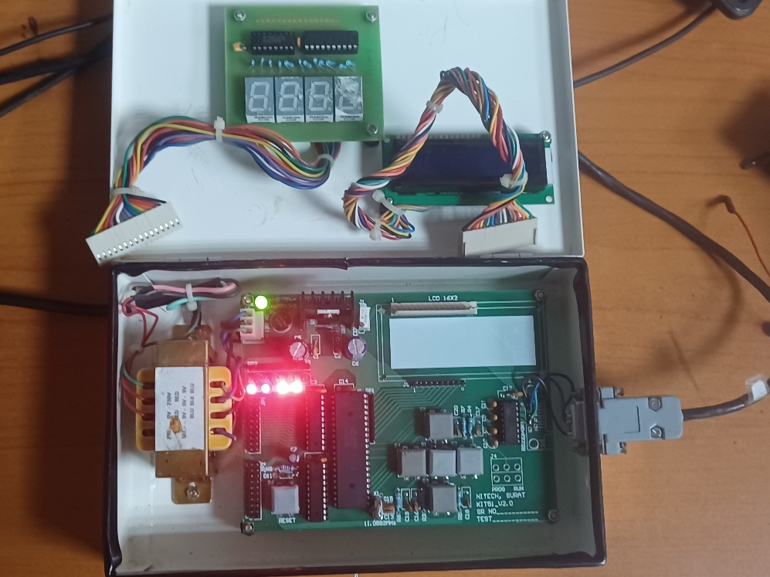 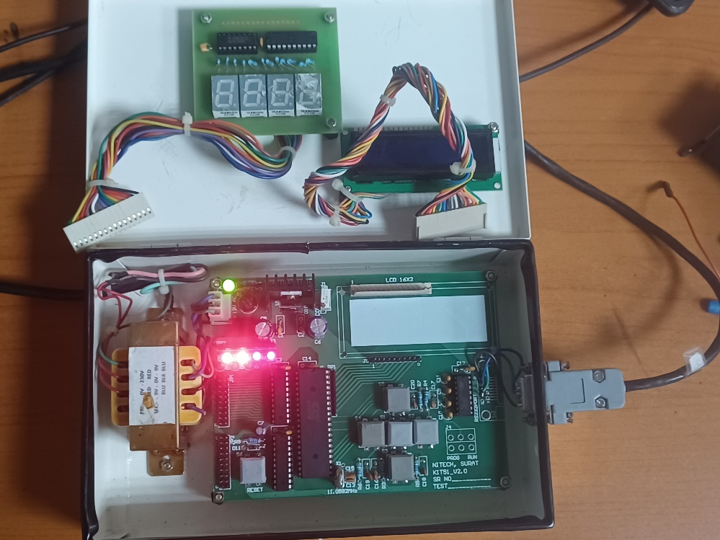

Conclusion: