Title Sponsor



<https://www.schaeffler.co.in/>

<https://www.facebook.com/SchaefflerIndia/>

<https://www.twitter.com/schaefflergroup>

<https://www.instagram.com/schaefflergroup/>

<https://www.linkedin.com/company/schaeffler>

Associate Sponsor



<https://www.linkedin.com/company/oxfam-india/>

<https://www.youtube.com/channel/UCv8JJT5rA0mt7f76FZaxIuw>

<https://twitter.com/OxfamIndia>

<https://www.instagram.com/oxfam_india/?hl=en>

<https://www.facebook.com/oxfamindia/>

<https://www.oxfamindia.org/>

Powered By

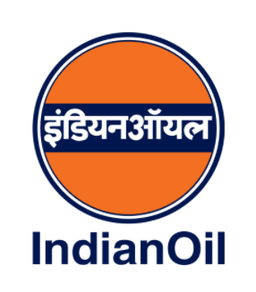

<https://iocl.com/>

<https://www.facebook.com/IndianOilCorpLimited>

<https://www.twitter.com/indianOilcl>

<https://www.instagram.com/indianoilcorp>

<https://www.linkedin.com/company/indian-oil-corp-limited>