Financial Analysis - Approach

* + Performing Exploratory data analysis using NumPy.
  + Normalize the data and calculate daily returns of the stocks.
  + Perform data visualizations using Matplotlib and Plotly.
  + Analyse daily returns using histogram & distplot.
  + Obtain correlation between the price change of each stock using heatmaps from Seaborn.

Output Images

Data Exploratory Analysis

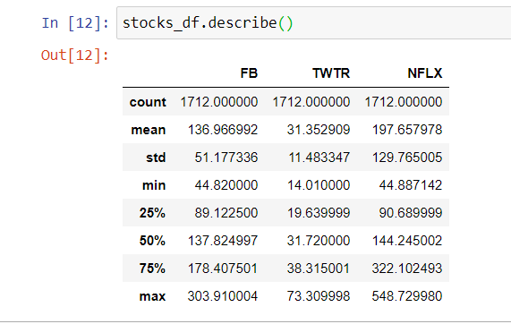

Data Visualization

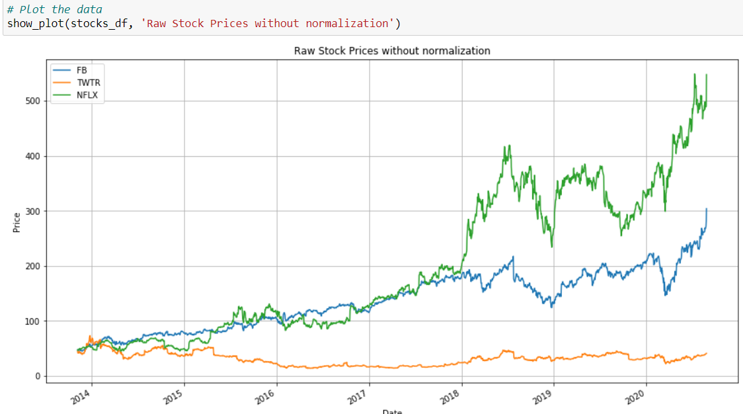

Distplot (Std dev of daily price return)

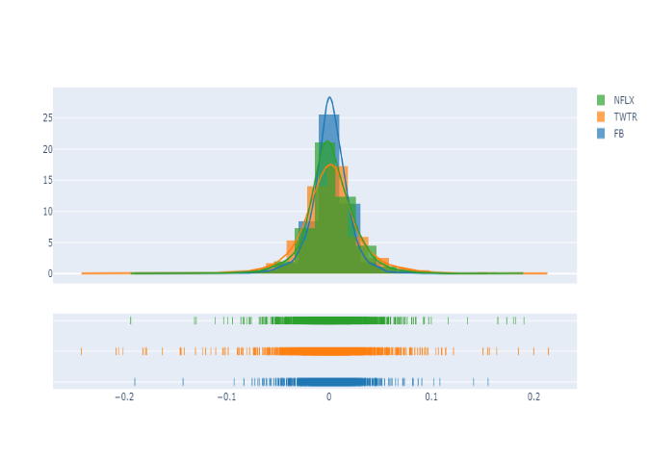

Interactive Plots

|  |  |
| --- | --- |
|  |  |

Heatmaps (Correlation b/w price change of NFLX, FB & TWTR)

