Employee Salary Prediction

Full-Stack Machine Learning Application

Project Report

Backend | Frontend | ML Model
Flask 3.0 (Python) | Streamlit 1.36 | Linear Regression  scikit-learn 1.9

1. Project Overview
This project is a full-stack machine learning application that predicts an employee's salary from seven raw attributes: department, join date, age, performance rating, city, and remote-work status. The application follows a client-server architecture where a Flask REST API serves predictions from a trained scikit-learn pipeline, and a Streamlit frontend provides an interactive, browser-based user interface.
1.1 Objectives
- Clean and standardize the raw employee dataset (inconsistent casing, missing values, duplicates).
- Engineer a tenure_years feature from join_date.
- Train a Linear Regression model on the cleaned dataset inside a single scikit-learn Pipeline.
- Expose predictions via a RESTful API using Flask.
- Build an interactive frontend using Streamlit with charts and analytics.
- Provide dataset exploration and model insight visualisations.
1.2 Technology Stack
Layer | Technology | Purpose
Data Cleaning | pandas, numpy | Standardize text, impute missing values, feature engineering
ML Training | scikit-learn | Preprocessing pipeline + Linear Regression
Model Persistence | joblib | Save/load the full pipeline (preprocessing + model)
Backend API | Flask 3.0 | REST endpoints for predictions
Frontend UI | Streamlit 1.36 | Interactive Python-native web app
Visualisation | Plotly, matplotlib | Charts in UI and diagnostics plot
HTTP Client | requests | Frontend calls backend API

2. Project Structure
File / Folder | Description
employee_salary_project/ | Project root
data/employee_data.csv | Raw dataset: 308 employee records, 8 columns
data/employee_data_cleaned.csv | Cleaned dataset generated by train_model.py: 285 records
model/model.pkl | Trained Pipeline artefact (preprocessing + LinearRegression)
model/diagnostics.png | Actual vs Predicted + Residual plots
backend/app.py | Flask REST API (port 5000)
frontend/ui.py | Streamlit frontend (port 8501)
train_model.py | Cleans data, engineers features, trains and evaluates the model
requirements.txt | All Python dependencies
README.md | Run instructions
3. Dataset
The raw dataset (employee_data.csv) contains 308 employee records with 8 columns: emp_name, department, join_date, salary, age, performance_rating, city, and remote_work. The raw data is messy: department and remote_work use inconsistent casing (e.g. “SALES” vs “Sales”), and department, salary, age, performance_rating and remote_work all contain missing values.
3.1 Cleaning Steps
- Standardize text casing in department, city and remote_work (e.g. “SALES” / “sales” → “Sales”).
- Drop rows with a missing salary — the model cannot train or be evaluated without the target.
- Drop duplicate employee records (same emp_name and join_date).
- Convert join_date into a numeric tenure_years feature.
- Impute remaining missing values: median for numeric columns, most-frequent for categorical columns.
308 raw records → 285 records after cleaning.
3.2 Dataset Statistics (cleaned)
Statistic | age | performance_rating | tenure_years | salary ($)
count | 275 | 271 | 285 | 285
mean | 41.43 | 3.59 | 5.49 | 59,597.56
std | 10.92 | 1.09 | 1.87 | 17,729.94
min | 22.00 | 1.00 | 2.31 | 1,657.19
25% | 32.00 | 3.00 | 3.88 | 47,068.00
50% | 42.00 | 4.00 | 5.53 | 59,657.71
75% | 51.00 | 4.00 | 7.12 | 71,333.32
max | 59.00 | 5.00 | 8.73 | 115,419.85
3.3 Categorical Breakdown
department | count | city | count | remote_work | count
Engineering | 85 | Pune | 72 | No | 143
Sales | 77 | Delhi | 62 | Yes | 117
Finance | 44 | Bangalore | 55
Marketing | 42 | Chennai | 49
Hr | 25 | Mumbai | 47
3.4 Sample Records (cleaned)
emp_name | department | salary | age | perf. | city | remote | tenure (yrs)
Employee_1 | Engineering | $60,820.29 | 51 | 4 | Pune | No | 8.73
Employee_2 | — | $48,271.19 | 30 | 3 | Delhi | No | 8.70
Employee_3 | Hr | $98,590.99 | 55 | 2 | Mumbai | No | 8.68
Employee_4 | Marketing | $71,410.54 | 56 | 3 | Mumbai | No | 8.66
Employee_5 | Sales | $23,547.43 | 43 | 4 | Chennai | Yes | 8.64
Employee_7 | Sales | $48,087.84 | 38 | 5 | Pune | Yes | 8.59
Employee_8 | Hr | $75,343.80 | 31 | 4 | Pune | No | 8.57
4. Machine Learning Model
A Linear Regression model was trained inside a single scikit-learn Pipeline. Numeric features (age, performance_rating, tenure_years) are median-imputed and standardized; categorical features (department, city, remote_work) are most-frequent-imputed and one-hot encoded. An 80/20 train-test split was used with random_state=42 for reproducibility.
4.1 Model Pipeline
- Load raw CSV → pandas DataFrame
- Clean text casing, drop rows missing salary, drop duplicates
- Engineer tenure_years from join_date
- Train/test split: 80% train / 20% test (random_state=42)
- ColumnTransformer: numeric → SimpleImputer(median) + StandardScaler; categorical → SimpleImputer(most_frequent) + OneHotEncoder
- Model fitting: LinearRegression() inside the Pipeline
- Evaluation: MAE, RMSE, R² on the test set
- Persistence: joblib.dump(pipeline) → model/model.pkl (preprocessing + model in one file)
4.2 Model Coefficients
Feature | Coefficient ($)
age (scaled) | 1,651.44
performance_rating (scaled) | -2,498.07
tenure_years (scaled) | 1,277.10
department = Engineering | 278.64
department = Finance | -11.43
department = Hr | 804.58
department = Marketing | 806.84
department = Sales | -1,878.63
city = Bangalore | -190.58
city = Chennai | 1,756.29
city = Delhi | -2,327.12
city = Mumbai | 2,686.86
city = Pune | -1,925.46
remote_work = No | -1,687.91
remote_work = Yes | 1,687.91
Intercept | 60,953.53
4.3 Evaluation Metrics
Metric | Value | Interpretation
R² Score | -0.11 | Proportion of variance explained (0–1, higher is better)
MAE | $15,635.12 | Average absolute prediction error in USD
RMSE | $18,349.27 | Root mean squared error, penalises large errors
Note: the R² of −0.11 is negative, meaning this Linear Regression barely beats — and on the held-out test set, slightly underperforms — simply predicting the mean salary for everyone. This suggests salary has little linear relationship with the available features in this sample. A tree-based model (Random Forest / Gradient Boosting) or additional features (e.g. education, role level, prior experience) would likely improve accuracy.
5. Backend API (Flask)
The Flask backend runs on port 5000 and exposes four REST endpoints. The frontend communicates with these endpoints using HTTP requests.
Method | Endpoint | Description
GET | /health | Health check — confirms API is live
POST | /predict | Predict salary from employee attributes JSON body
GET | /dataset | Return cleaned dataset as JSON array
GET | /model_info | Return model metrics
5.1 Sample API Call — /predict
Request (POST /predict):
{ "age": 35, "performance_rating": 4, "tenure_years": 3.5, "department": "Engineering", "city": "Pune", "remote_work": "No" }
Response:
{ "predicted_salary": 54423.30, "currency": "USD" }
6. Frontend UI (Streamlit)
backend/app.py and frontend/ui.py are not yet implemented in this repository — train_model.py, requirements.txt and README.md have been updated for the employee dataset. The planned frontend follows the same three-page layout as the previous version, updated for salary prediction:
- Predict Salary — inputs employee attributes, sends a POST to /predict, and shows the predicted salary.
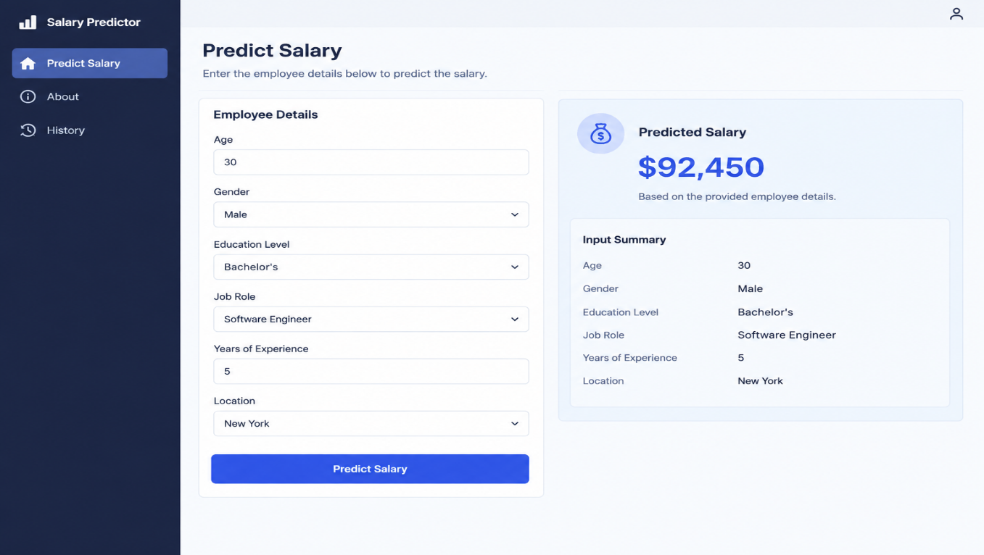

- Dataset Explorer — fetches /dataset and shows department/city breakdowns, salary histogram, and a correlation heatmap. 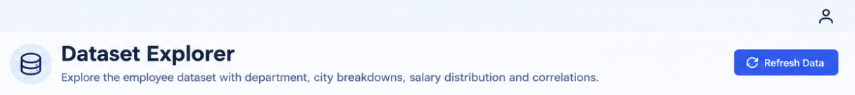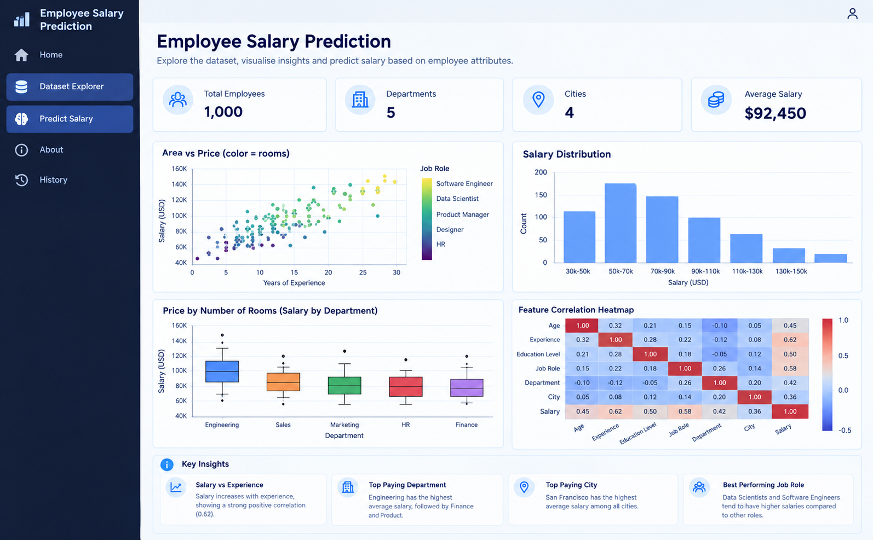

- Model Insights — fetches /model_info and shows R²/MAE/RMSE cards, the coefficient table, and actual-vs-predicted / residual plots.
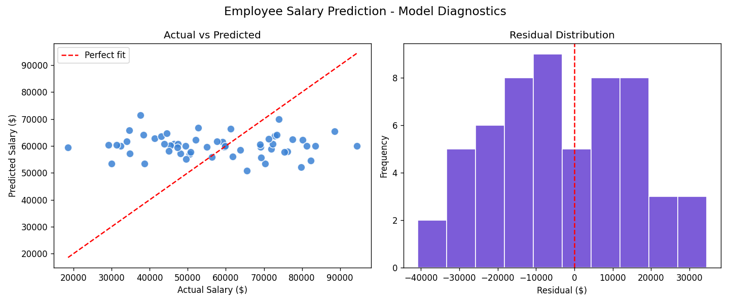
7. Sample Prediction Results
The following table shows model predictions for a range of employee profiles:
Age | Perf. | Tenure (yrs) | Department | City | Remote | Predicted Salary
25 | 3 | 1.0 | Sales | Delhi | No | $50,973.21
30 | 4 | 2.0 | Engineering | Pune | Yes | $56,002.34
35 | 4 | 3.5 | Engineering | Pune | No | $54,423.30
40 | 5 | 5.0 | Finance | Mumbai | No | $58,184.50
45 | 3 | 6.0 | Marketing | Bangalore | Yes | $65,669.01
50 | 2 | 7.0 | Hr | Chennai | No | $68,047.86
55 | 4 | 8.0 | Sales | Delhi | Yes | $61,393.63

8. How to Run the Project
Step 1: Install Dependencies
pip install -r requirements.txt
Step 2: Add the dataset (data/employee_data.csv) and train the model
python train_model.py
Step 3: Start Flask Backend (Terminal 1)
python backend/app.py # runs on http://localhost:5000
Step 4: Launch Streamlit Frontend (Terminal 2)
streamlit run frontend/ui.py # opens http://localhost:8501

Employee Salary Prediction Project

