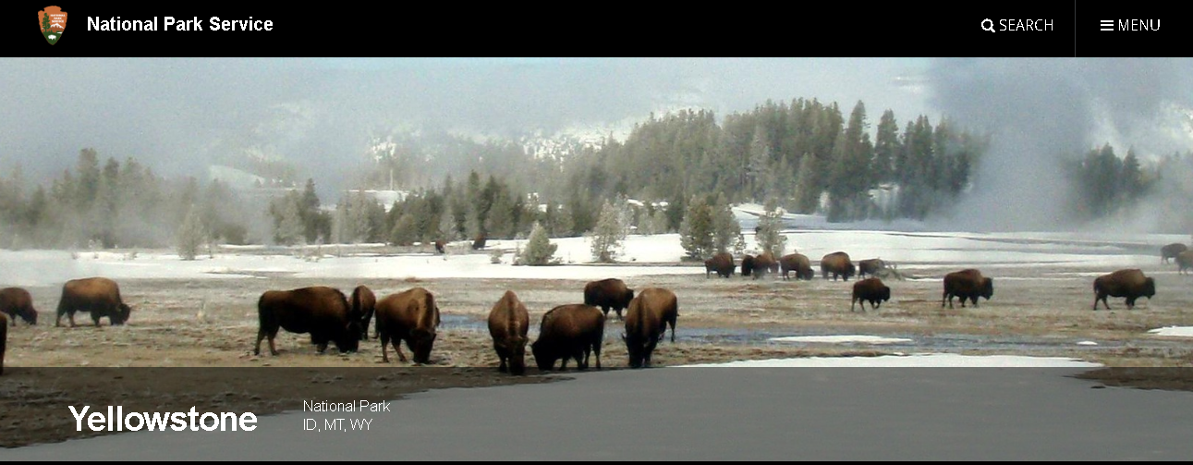

**Plan What You’d Like to See and Do**

The park is a true wonderland of thermal features, abundant wildlife, and endless recreation opportunities. With so many options to choose from, you’ll have some tough decisions to make. But where to begin?

Visitor: Steve and Jaime Halverson

Address: 234 Reston Street, Valkrie, NM

Reservation code: 543e245

The[**Yellowstone National Park Service website**](https://www.nps.gov/yell/planyourvisit/index.htm) offers an array of information on the many activities and natural attractions that await you, including park maps and a complete “Things to Do” section from camping, to wildlife watching, to kid-friendly activities.

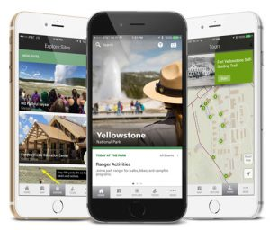For the tech-savvy, Yellowstone is proud to offer two [**free apps**](https://www.nps.gov/yell/planyourvisit/app.htm) to help you make the most of your trip. These include an interactive map, self-guided tours, event updates, and more.

Yellowstone Forever Park Stores have a wide variety of[**trip planning materials**](https://shop.yellowstone.org/trip-planning) available. For the avid hiker, there’s our comprehensive [***Yellowstone Trails: A Hiking Guide***](https://shop.yellowstone.org/trip-planning/yellowstone-trails-a-hiking-guide-1)—featuring descriptions and mileage for over 100 trails. For those who on a limited timeframe, we’ve got plenty of ideas in [***Yellowstone in a Day***](https://shop.yellowstone.org/trip-planning/yellowstone-in-a-day). Or, if you’re seeking a collection of maps, guidebooks, and other handy resources all in one—including our [***Official Guide***](https://shop.yellowstone.org/trip-planning/official-guide)—we offer this [**Premium Trip Planner**](https://shop.yellowstone.org/trip-planning/premium-trip-planner). Yellowstone Forever [**supporters**](https://www.yellowstone.org/donate/) receive 15% off their purchases.

**Lodging**

Even if you plan to see the park in one day, Yellowstone is remote. Chances are you’re going to need to plan where you’ll stay the night.

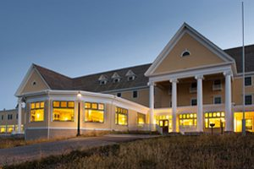Lodging in Yellowstone can be broken up into two distinct seasons: [**summer**](http://www.yellowstonenationalparklodges.com/lodging/summer-lodges/) and [**winter**](http://www.yellowstonenationalparklodges.com/lodging/winter-lodges/). Remember you’ll have different options available to you in winter versus summer, as many of the park’s interior roads are only accessed by [**oversnow vehicles**](http://www.yellowstonenationalparklodges.com/things-to-do/winter-things-to-do/snowcoach-transportation/) when the snow flies.

The summer lodging season begins in late April, and facilities open on a staggered [**schedule**](https://www.nps.gov/yell/planyourvisit/parkroads.htm) as the roads are cleared of snow. Room availability fills up extremely fast in the summer; be sure to book your hotel well in advance. Learn all about the [**nine lodging facilities**](https://www.yellowstone.org/yellowstone-lodging-101/)operated by our partners at Yellowstone National Park Lodges, including some of our favorite classic lodges like the Old Faithful Inn and Lake Hotel.

Staying inside the park is an unforgettable experience, but rooms fill quickly. Gateway communities offer a variety of lodging options from charming rustic cabins to large hotels. Explore your options in [**Gardiner, Montana**](http://www.visitgardinermt.com/) (North Entrance), [**West Yellowstone, Montana**](http://www.destinationyellowstone.com/) (West Entrance), [**Cody, Wyoming**](http://codychamber.org/) (East Entrance), [**Jackson, Wyoming**](https://www.jacksonholechamber.com/) (South Entrance) and [**Cooke City, Montana**](http://www.cookecitychamber.org/) (Northeast Entrance).

**Guided Programs and Tours**

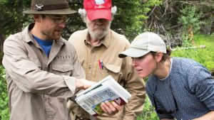You can always let an experienced guide or instructor do the planning for you. A variety of guided programs and tours are available in the park that appeal to all sorts of interests and age levels.

[**The Yellowstone Forever Institute**](https://www.yellowstone.org/experience/yellowstone-forever-institute/) introduces thousands of students to the park’s natural wonders. Programs range from one day to three weeks in length, and highlight the park’s wildlife, geothermal areas, history, and wilderness. For those with a specific park interest or passion, check out one of our in-depth [**Field Seminars**](https://shop.yellowstone.org/courses/field-seminars). You can also tailor a customized tour with your group with an Institute [**Private Tour**](https://shop.yellowstone.org/courses/private-tours).

Yellowstone National Park Lodges also offers[**daily tours**](http://www.yellowstonenationalparklodges.com/things-to-do/) (including a special outing in an iconic historic Yellow bus!), while the National Park Service provides a wide variety of engaging [**ranger-led programs**](https://www.nps.gov/yell/planyourvisit/rangerprog.htm) on topics from geology to the night sky.

**Roads, Operating Hours, and Weather**

There’s nothing worse than arriving to the park only to realize the interior roads are closed for the season. Before you arrive, be sure to check out [**road conditions**](https://www.nps.gov/yell/planyourvisit/parkroads.htm) and a schedule of [**operating hours and seasons.**](https://www.nps.gov/yell/planyourvisit/hours.htm)

If we’ve said it once, we’ll say it again – [**Yellowstone’s weather**](https://www.nps.gov/yell/planyourvisit/weather.htm) is unpredictable. At an elevation of 7,349 feet at Old Faithful, visitors should be prepared with a wide range of clothing options. Be sure to bring a warm jacket and rain gear, even in summer.

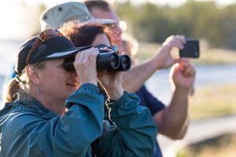**Safety**

Yellowstone is filled with natural wonders that are also potential hazards. Special safety rules do apply. Learn how to [**protect yourself and the park**](https://www.nps.gov/yell/planyourvisit/yellowstonepledge.htm) while you enjoy all that Yellowstone has to offer.

**One last word of advice?**

Relax and enjoy, because the anticipation that comes with the planning process is half the fun. And as any experienced traveler will tell you: a little extra planning can be the difference between needing a vacation from your vacation….or an effortless getaway your family will be talking about for years to come.

**Other Resources**  
[**Basic Information from the National Park Service**](https://www.nps.gov/yell/planyourvisit/basicinfo.htm)  
[**Directions and Transportation**](https://www.nps.gov/yell/planyourvisit/directions.htm)  
[**Safety Information**](https://www.nps.gov/yell/planyourvisit/safety.htm)  
[**Pets in Yellowstone**](https://www.nps.gov/yell/planyourvisit/pets.htm)  
[**Park Maps**](https://www.nps.gov/yell/planyourvisit/maps.htm)  
[**Yellowstone National Park FAQ**](https://www.nps.gov/yell/faqs.htm)

***Photos, top to bottom: Norris Geyser Basin Boardwalk – Matt Ludin/Yellowstone Forever; Old Faithful Crowd – NPS; Yellowstone Apps – NPS; Lake Hotel – Yellowstone National Park Lodges; Yellowstone Forever Institute Instructor – Maria Bisso/Yellowstone Forever; People Wildlife Watching – Matt Ludin/Yellowstone Forever***