 | 

SHARDA SCHOOL OF COMPUTING SCIENCE AND ENGINEERING (SSCSE)
COMPUTER SCIENCE & ENGINEERING
Hybrid Quantum-Classical Machine Learning for Breast Cancer Diagnosis: A Comparative Study of Quantum Kernel SVM and Variational Quantum Classifier
Quantum Computing with Artificial Intelligence (Course Code: NV62010)

Final Assignment Technical Report
Semester- 7th
Submission date: [fill in]
Submitted By:  Student Name: Aditi Yadav  System ID: 2023215091  Roll No.: 2301010045  Section/Group: BTech CSB (G1) | Submitted To:  Dr. Dharam Raj  Sharda University, Greater Noida

Declaration
I declare that this report is my own submission for course NV62010, that the experiments were run on the configuration stated in Section 4, and that every source used is listed in Section 7.
Use of AI assistance [confirm against the course policy; edit or remove as required]: an AI assistant (Claude, by Anthropic) was used to help write and run the code, find and check literature records, and draft and format this report. All result numbers come from code that was actually executed. The literature reviews are based on abstracts as stated in Section 3.
Signature: [fill in] Date: [fill in]

Abstract
Breast cancer is a leading cause of cancer death in women, and missing a malignant tumour is the most serious diagnostic error. This work tests whether small quantum circuits can classify tumours from fine-needle aspirate measurements. Two hybrid quantum-classical models were built in Qiskit on the Breast Cancer Wisconsin (Diagnostic) dataset of 569 samples: a quantum kernel support vector classifier (QSVC) and a variational quantum classifier (VQC). The 30 features were reduced to four by principal component analysis and encoded into four qubits. Both models were compared with five classical models on identical features, and with a support vector machine (SVM) on all 30 features. In 5-fold cross-validation, QSVC reached 0.805 accuracy and 0.646 malignant recall, and VQC reached 0.647 and 0.471. The radial basis function SVM on the same features reached 0.961 and 0.934. The quantum models missed 75 and 112 of 212 malignant cases, against 14 for that SVM. Experiments on qubit count, circuit depth, entanglement, training size, optimiser and noise showed that a feature map without entanglement performed best (0.901 accuracy), and that kernel values were very small for entangling maps, which is consistent with kernel concentration. All results came from simulators, and VQC training had not converged after 100 iterations. No quantum advantage was found on this task. Classical models remain the better choice for this dataset, while the pipeline provides a fair, reproducible basis for further study.

Table of Contents
Declaration ii
Abstract iii
Table of Contents iv
List of Figures vi
List of Tables vii
List of Abbreviations viii
1. Introduction and Synopsis 1
2. Fundamentals of Quantum Computing and Quantum Algorithms 2
2.1 Introduction and Principles 2
2.2 Classical Bits versus Qubits 2
2.3 Quantum Superposition 3
2.4 Quantum Entanglement 3
2.5 Quantum Gates and Circuits 4
2.6 Quantum Measurement 5
2.7 Quantum Noise 5
2.8 Classical versus Quantum Computing Architectures 6
2.9 Deutsch-Jozsa Algorithm 7
2.10 Grover's Search Algorithm 8
2.11 Shor's Algorithm (Overview) 9
2.12 Computational Complexity and Quantum Advantage 11
3. Critical Review of Advanced Machine Learning and Quantum Machine Learning Research 12
3.1 Review Method 12
3.2 QML Surveys and Foundations 12
3.3 Quantum Kernel Methods and QSVM 14
3.4 Variational Quantum Algorithms and VQC 16
3.5 Quantum Neural Networks and Trainability 17
3.6 Hybrid Quantum-Classical Models 18
3.7 QML in Healthcare and Medical Diagnosis 19
3.8 Quantum-Enhanced Image Recognition 21
3.9 Quantum Optimization 22
3.10 AI and ML for Quantum Computing 23
3.11 Applications in Finance, Logistics and Cybersecurity 24
3.12 Consolidated Comparative Research Matrix 25
3.13 Identified Research Gaps 28
4. Proposed Mini Project: Design and Development of a Hybrid Quantum Machine Learning Model 29
4.1 Problem Statement 29
4.2 Background and Motivation 29
4.3 Objectives 29
4.4 Research Gaps Addressed 29
4.5 Proposed Solution and Contributions 30
4.6 Techniques and Justification 30
4.7 Mathematical Formulation 30
4.8 Dataset and Preprocessing 31
4.9 System Architecture 34
4.10 Hybrid Model Architecture 35
4.11 Algorithms and Pseudocode 35
4.12 Workflow Flowchart 36
4.13 Use Case Diagram 37
4.14 Quantum Circuit Design 37
4.15 Implementation in Qiskit 38
4.16 Implementation Environment 39
5. Results, Performance Evaluation and Discussion 40
5.1 Implementation Outcomes 40
5.2 Main Comparison (E1) 40
5.3 Experiments E2 to E9 42
5.3.1 E2: Number of Qubits 42
5.3.2 E3: Feature Map Depth 42
5.3.3 E4: Entanglement 43
5.3.4 E5: Ansatz Depth 43
5.3.5 E6: Optimiser 44
5.3.6 E7: Training Size 44
5.3.7 E8: Noise 45
5.3.8 E9: Iris Multiclass 46
5.4 Computational Cost Analysis 46
5.5 Clinical View: Missed Cancers 47
5.6 Discussion 47
6. Conclusion and Future Scope 49
6.1 Conclusion 49
6.2 Future Scope 49
7. References and Bibliography 50

List of Figures
Fig. 2.1. Bloch sphere positions of the states $|0⟩$, $|1⟩$, $|+⟩$ and $|+i⟩$ (Qiskit output). 2
Fig. 2.2. Three-qubit uniform superposition: circuit (left) and measured histogram (right). 3
Fig. 2.3. Bell state $|Φ^{+}⟩$: circuit (left) and histogram showing only 00 and 11 (right). 4
Fig. 2.4. Estimated $P(1)$ of $H|0⟩$ against the number of shots. 5
Fig. 2.5. Bell state on ideal and noisy simulators (left) and success against circuit depth under noise (right). 6
Fig. 2.6. Block diagram of the classical and quantum computing stacks. 6
Fig. 2.7. Deutsch-Jozsa circuit for $n=3$ with a balanced oracle. 7
Fig. 2.8. Deutsch-Jozsa flowchart (left) and measured results for both oracles (right). 8
Fig. 2.9. Geometric picture of Grover's algorithm (left) and success probability against iterations (right). 9
Fig. 2.10. Grover circuit for three qubits, marked state $|101⟩$, two iterations. 9
Fig. 2.11. Grover flowchart (left) and oracle queries against search space size (right). 9
Fig. 2.12. Four-qubit QFT circuit (left) and measured phases for $N=15$, $a=7$ (right). 10
Fig. 2.13. Flowchart of Shor's algorithm. 11
Fig. 2.14. Believed relationship between the classes P, NP, BQP and PSPACE. 11
Fig. 4.1. Class distribution (left) and PCA explained variance (right). 32
Fig. 4.2. Correlation heatmap of the 30 features. 33
Fig. 4.3. Standardised box plots of the six features most correlated with the label. 33
Fig. 4.4. Training samples in the first two principal components. 34
Fig. 4.5. Overall architecture of the proposed system. 34
Fig. 4.6. Architecture of the hybrid QSVC path (a) and VQC loop (b). 35
Fig. 4.7. Complete workflow of the project. 36
Fig. 4.8. Use case diagram of the system. 37
Fig. 4.9. ZZFeatureMap with reps = 2 and linear entanglement (top); RealAmplitudes ansatz with reps = 3 (bottom). 37
Fig. 4.10. Full VQC circuit, decomposed (top); compute-uncompute kernel circuit for one pair of samples (bottom). 38
Fig. 5.1. Accuracy, precision, recall and F1-score of all models on the hold-out split. 41
Fig. 5.2. Confusion matrices of all models on the hold-out split. 41
Fig. 5.3. ROC curves (left) and VQC training loss with COBYLA (right), hold-out split. 41
Fig. 5.4. Training kernel matrices: quantum (left) and RBF (right), with samples sorted by class. 42
Fig. 5.5. Accuracy and training time against the number of qubits (E2). 42
Fig. 5.6. Accuracy and training time against feature map repetitions (E3). 43
Fig. 5.7. QSVC accuracy and mean kernel value for each feature map (E4). 43
Fig. 5.8. VQC accuracy and time against ansatz depth (E5). 44
Fig. 5.9. VQC loss curves for each ansatz depth (E5). 44
Fig. 5.10. VQC loss for COBYLA and SPSA (E6). 44
Fig. 5.11. Accuracy and training time against training size (E7). 45
Fig. 5.12. Time to build the training kernel against training size (E7). 45
Fig. 5.13. Accuracy under exact simulation, shots and device noise (E8). 46
Fig. 5.14. Training time of all models on the hold-out split (log scale). 47

List of Tables
TABLE 2.1. Comparison of a classical bit and a qubit. 2
TABLE 2.2. Common quantum gates. 4
TABLE 2.3. Calibration ranges of the fake IBM Manila noise model. 5
TABLE 2.4. Classical and quantum architectures compared. 6
TABLE 2.5. Measured phases and the period guess from each outcome (1024 shots). 10
TABLE 2.6. Classical and quantum complexity of selected problems. 11
TABLE 3.1. Comparative research matrix of the reviewed papers. 25
TABLE 4.1. Selected techniques and why they were chosen. 30
TABLE 4.2. Dataset summary. 32
TABLE 4.3. Circuit size for four qubits after decomposition. 38
TABLE 4.4. Implementation environment. 39
TABLE 5.1. Performance of all models on the hold-out split (455 training and 114 test samples, four qubits). 40
TABLE 5.2. Five-fold cross-validation results: mean over folds, with standard deviation for accuracy and recall. 40
TABLE 5.3. Effect of shots and device noise (one seed). 45
TABLE 5.4. Circuit counts and measured time on the main task (455 training and 114 test samples). 46
TABLE 5.5. Missed cancers and false alarms over 5-fold cross-validation (212 malignant and 357 benign samples). 47

List of Abbreviations
Abbreviation | Meaning
AI | Artificial Intelligence
AUC | Area Under the Curve
BQP | Bounded-error Quantum Polynomial time
CNN | Convolutional Neural Network
CNOT / CX | Controlled-NOT gate
COBYLA | Constrained Optimization BY Linear Approximation
CV | Cross-Validation
EDA | Exploratory Data Analysis
FN / FP | False Negative / False Positive
FNA | Fine-Needle Aspirate
KNN | K-Nearest Neighbours
MLP | Multilayer Perceptron
ML | Machine Learning
NISQ | Noisy Intermediate-Scale Quantum
PCA | Principal Component Analysis
QAOA | Quantum Approximate Optimization Algorithm
QCNN | Quantum Convolutional Neural Network
QFT | Quantum Fourier Transform
QML | Quantum Machine Learning
QNN | Quantum Neural Network
QSVC | Quantum Support Vector Classifier
QSVM | Quantum Support Vector Machine
RBF | Radial Basis Function
ROC | Receiver Operating Characteristic
SPSA | Simultaneous Perturbation Stochastic Approximation
SVM | Support Vector Machine
VQA | Variational Quantum Algorithm
VQC | Variational Quantum Classifier
WDBC | Wisconsin Diagnostic Breast Cancer dataset
WHO | World Health Organization

1. Introduction and Synopsis
Quantum Machine Learning (QML) studies how quantum computers can support learning from data [1]. Most current work is hybrid: a parametrised quantum circuit processes data, while a classical computer stores the data and trains the model. Within Artificial Intelligence (AI) [2], QML is therefore best seen as an experimental extension of machine learning (ML) rather than a replacement for it. Today's hardware belongs to the noisy intermediate-scale quantum (NISQ) era, so most studies use small circuits or simulators [3], [4].
Major applications. In image recognition, hybrid networks with parallel quantum circuits have been tested on benchmark image sets [5]. In healthcare, quantum classifiers and kernels have been applied to clinical tables and electronic health records [6], [7]. In financial modelling, quantum methods target Monte Carlo estimation, optimisation and learning [8]. In logistics, vehicle routing has been reformulated for variational solvers [9]. In optimisation, the Quantum Approximate Optimization Algorithm (QAOA) and analogue devices are studied on hard combinatorial problems [10], [11].
Potential advantages. A quantum feature map places data in a Hilbert space that grows exponentially with qubit number [12], and speed-ups have been proven for specially constructed learning problems [13]. Some bounds also suggest good generalisation from few training points [14]. These remain potential benefits: with enough data, classical models can compete even on problems designed for quantum models [15].
Current trends. Active topics include variational algorithms [16], quantum kernels [12], [17], barren plateaus (vanishing training gradients) [18], error mitigation [19], and dequantization, in which classical surrogates reproduce some quantum models [20]. Hardware roadmaps are also moving towards error correction: surface-code memories have operated below threshold [21], and IBM has published a plan for a fault-tolerant machine by 2029 [22]. Industry reports describe surging investment [23], which is a sign of interest and not evidence of practical advantage.
Challenges and limitations. Noise, small qubit counts, the cost of encoding classical data, poor trainability and exponential concentration of kernel values all limit current models [17], [24]. Large benchmarks have also found that standard classical models usually beat quantum classifiers on small tasks [25], and it has been argued that beating classical ML may not be the most useful research goal at this stage [26].
Future scope. Useful directions include better encodings, trainable kernels, error mitigation and larger hardware. In healthcare, QML could one day support decision making, but it must first show reliable performance, strong recall of disease, and privacy-safe handling of data.
This report. The mini project in this report classifies breast tumours as malignant or benign using two hybrid models, a quantum kernel support vector classifier and a variational quantum classifier, and compares them honestly with classical models. Section 2 covers quantum computing fundamentals and algorithms. Section 3 reviews 45 research papers. Section 4 describes the proposed project, Section 5 presents the results, Section 6 concludes, and Section 7 lists the references.

2. Fundamentals of Quantum Computing and Quantum Algorithms
This section explains the concepts used later in the mini project. Wherever possible, the working of a concept is shown with a circuit that was run in Qiskit [27], [28]. The same circuits could also be written in Cirq [29]. All demonstrations use a fixed random seed of 42 and the scripts in the folder section2_demos.

2.1 Introduction and Principles
Feynman argued that simulating quantum physics efficiently calls for a computer that itself follows quantum rules [30]. Deutsch then described a universal quantum computer [31]. Later results by Deutsch and Jozsa [32], Shor [33] and Grover [34] showed that quantum algorithms can beat known classical methods on particular problems. The standard textbook treatment is given in [35], and an applied introduction in [36]. In simple terms, four postulates describe the model: a system's state is a unit vector in a complex vector space; it evolves by unitary operations; measurement gives random outcomes with fixed probabilities; and joint systems are described by the tensor product of their parts.

2.2 Classical Bits versus Qubits
A classical bit is either 0 or 1. A qubit can be in a superposition of both basis states, as written in Eq. (1).
 | $$|ψ⟩=α|0⟩+β|1⟩,|α|^{2}+|β|^{2}=1$$ | (1)

Here $α$ and $β$ are complex amplitudes, and $|α|^{2}$ and $|β|^{2}$ are the probabilities of measuring 0 and 1. Up to a global phase, any single-qubit state is a point on the Bloch sphere, as in Fig. 2.1. Table 2.1 compares the two units of information.
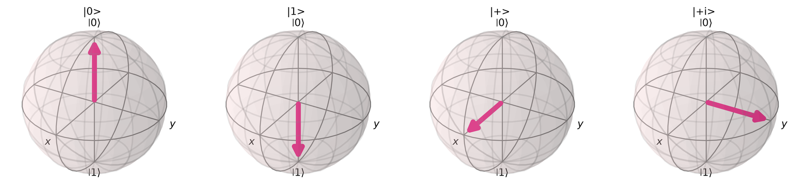
Fig. 2.1. Bloch sphere positions of the states $|0⟩$, $|1⟩$, $|+⟩$ and $|+i⟩$ (Qiskit output).
TABLE 2.1. Comparison of a classical bit and a qubit.
Property | Classical bit | Qubit
State | 0 or 1 | $$α|0⟩+β|1⟩$$
State of $n$ units | One of $2^{n}$ values | $2^{n}$ complex amplitudes
Reading | Does not change the value | Gives a random outcome and collapses the state
Copying | Free | Forbidden for unknown states (no-cloning)
Errors | Rare in practice | Common: decoherence and gate errors

2.3 Quantum Superposition
The Hadamard gate $H$ in Eq. (2) creates an equal superposition. For example, $H|0⟩=(|0⟩+|1⟩)/\sqrt{2}=|+⟩$.
 | $$H=\frac{1}{\sqrt{2}}\left(\begin{matrix}1 & 1 \\ 1 & −1\end{matrix}\right)$$ | (2)

Measuring $H|0⟩$ over 1024 shots gave 0 with frequency 0.514 and 1 with frequency 0.486. Applying $H$ to three qubits gave all eight outcomes, as shown in Fig. 2.2, with frequencies between 0.106 and 0.139 around the ideal value 0.125. A superposition is not the same as trying every answer: a measurement returns only one outcome, so a useful algorithm must use interference to raise the probability of the right one.
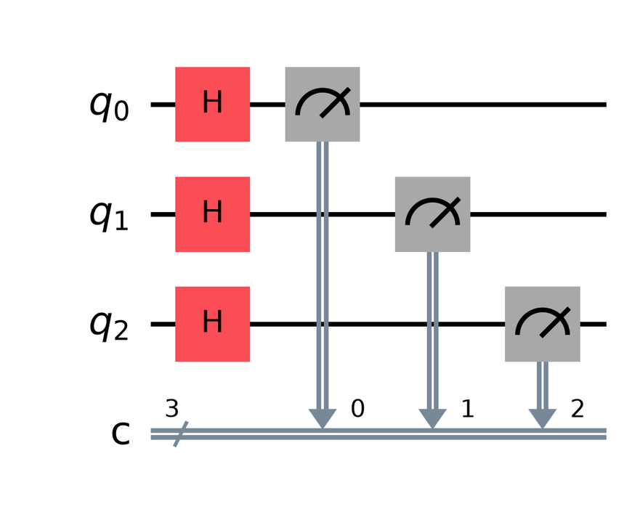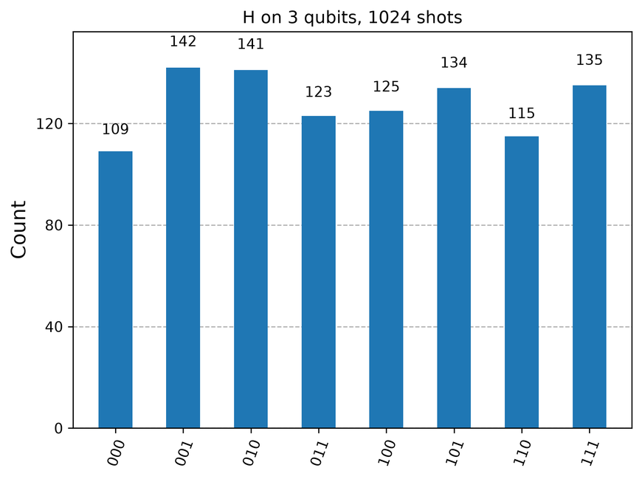
Fig. 2.2. Three-qubit uniform superposition: circuit (left) and measured histogram (right).

2.4 Quantum Entanglement
An entangled state of two qubits cannot be written as a product of two separate states. The Bell state in Eq. (3) is made by a Hadamard gate followed by a controlled-NOT (CNOT) gate.
 | $$|Φ^{+}⟩=\frac{|00⟩+|11⟩}{\sqrt{2}}$$ | (3)

Each qubit alone looks random, yet the two results always agree. In the run shown in Fig. 2.3, the outcomes were 00 (521 counts) and 11 (503 counts), and never 01 or 10. Entanglement is a key resource for many algorithms. It does not allow faster-than-light communication, and, as Section 5 shows, more of it does not always improve a model.
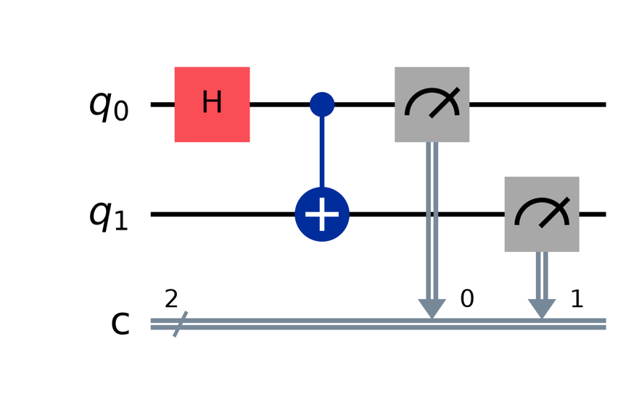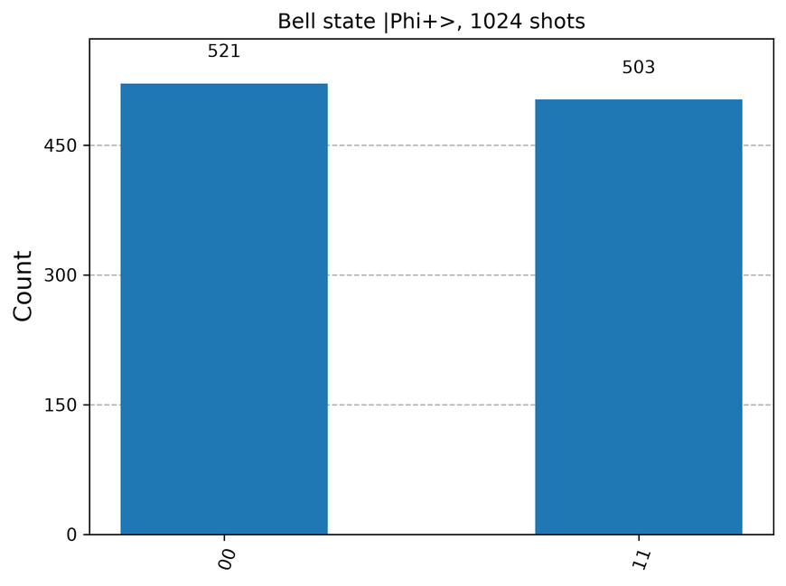
Fig. 2.3. Bell state $|Φ^{+}⟩$: circuit (left) and histogram showing only 00 and 11 (right).

2.5 Quantum Gates and Circuits
Quantum gates are unitary matrices, so they are reversible. A circuit is a sequence of gates applied to qubits, read from left to right and usually ending in measurement. Table 2.2 lists the common gates. A small set, such as $H$, $T$ and CNOT, is universal: it can approximate any unitary operation.
TABLE 2.2. Common quantum gates.
Gate | Matrix or action | Effect
X | $$\left(\begin{matrix}0 & 1 \\ 1 & 0\end{matrix}\right)$$ | Bit flip
Y | $$\left(\begin{matrix}0 & −i \\ i & 0\end{matrix}\right)$$ | Bit and phase flip
Z | $$\left(\begin{matrix}1 & 0 \\ 0 & −1\end{matrix}\right)$$ | Phase flip
H | $$\frac{1}{\sqrt{2}}\left(\begin{matrix}1 & 1 \\ 1 & −1\end{matrix}\right)$$ | Creates superposition
S | $$\left(\begin{matrix}1 & 0 \\ 0 & i\end{matrix}\right)$$ | Phase of $π/2$
T | $$\left(\begin{matrix}1 & 0 \\ 0 & e^{iπ/4}\end{matrix}\right)$$ | Phase of $π/4$
RX($θ$) | $$\left(\begin{matrix}cos\frac{θ}{2} & −isin\frac{θ}{2} \\ −isin\frac{θ}{2} & cos\frac{θ}{2}\end{matrix}\right)$$ | Rotation about x
RY($θ$) | $$\left(\begin{matrix}cos\frac{θ}{2} & −sin\frac{θ}{2} \\ sin\frac{θ}{2} & cos\frac{θ}{2}\end{matrix}\right)$$ | Rotation about y
RZ($θ$) | $$\left(\begin{matrix}e^{−iθ/2} & 0 \\ 0 & e^{iθ/2}\end{matrix}\right)$$ | Rotation about z
CNOT | $$|c,t⟩→|c,t⊕c⟩$$ | Flips target if control is 1
CZ | $$|c,t⟩→(−1)^{ct}|c,t⟩$$ | Phase flip if both are 1
SWAP | $$|a,b⟩→|b,a⟩$$ | Exchanges two qubits
Toffoli | $$|a,b,t⟩→|a,b,t⊕ab⟩$$ | Flips target if both controls are 1

2.6 Quantum Measurement
Measurement follows the Born rule: for a state $|ψ⟩$, the probability of basis outcome $x$ is $P(x)=|⟨x|ψ⟩|^{2}$, and the state then collapses to $|x⟩$. Probabilities are estimated by repeating the circuit many times, and each repeat is called a shot. The estimate has a standard error of $\sqrt{p(1−p)/s}$ for $s$ shots, which is the shot noise. Fig. 2.4 shows the estimated probability approaching 0.5 as shots increase.
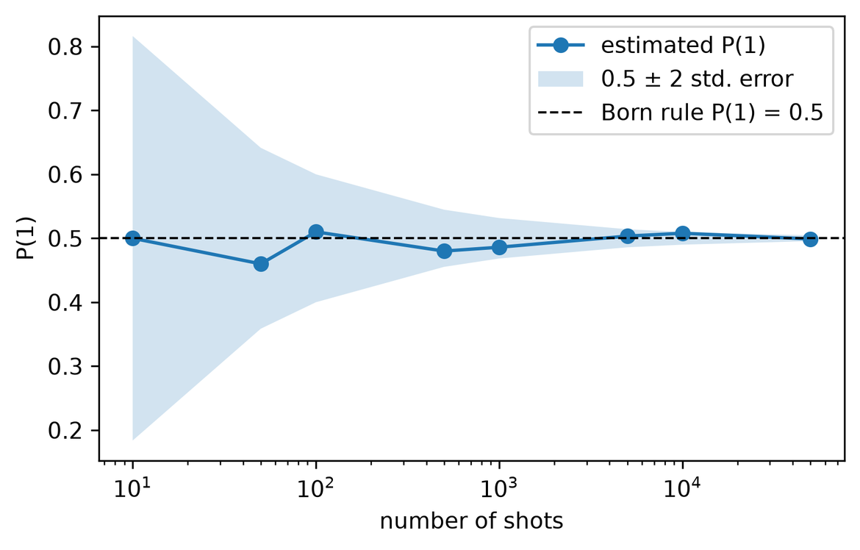
Fig. 2.4. Estimated $P(1)$ of $H|0⟩$ against the number of shots.

2.7 Quantum Noise
Real qubits lose information to their surroundings. Energy relaxation has a time constant $T_{1}$, and loss of phase has a time constant $T_{2}$. Gates and readout also introduce errors. A simple model is the depolarizing channel in Eq. (4).
 | $$ℰ(ρ)=(1−p)ρ+p\frac{I}{2^{n}}$$ | (4)

Here $ρ$ is the density matrix of the state, $p$ is the error probability, $I$ is the identity matrix and $n$ is the number of qubits. Devices of this kind are the NISQ machines described by Preskill [37]. Table 2.3 gives the properties of the noise model used in this work, which copies the 5-qubit IBM Manila device through a fake backend.
TABLE 2.3. Calibration ranges of the fake IBM Manila noise model.
Property | Range across the device
$$T_{1}$$ | 124.5 to 179.1 $μ$s
$$T_{2}$$ | 25.1 to 102.2 $μ$s
Single-qubit (SX) gate error | 0.02% to 0.07%
Two-qubit (CX) gate error | 0.57% to 1.39%
Readout error | 1.4% to 9.6%

As Fig. 2.5 shows, the Bell state on this noise model gave wrong outcomes (120 counts of 01 and 138 of 10 in 4096 shots), and the correct-outcome probability $P(00)+P(11)$ fell from 1.000 to 0.937. Adding pairs of CNOT gates, which cancel in theory, lowered it further to 0.739 at 65 CNOTs. Deep circuits therefore suffer more.
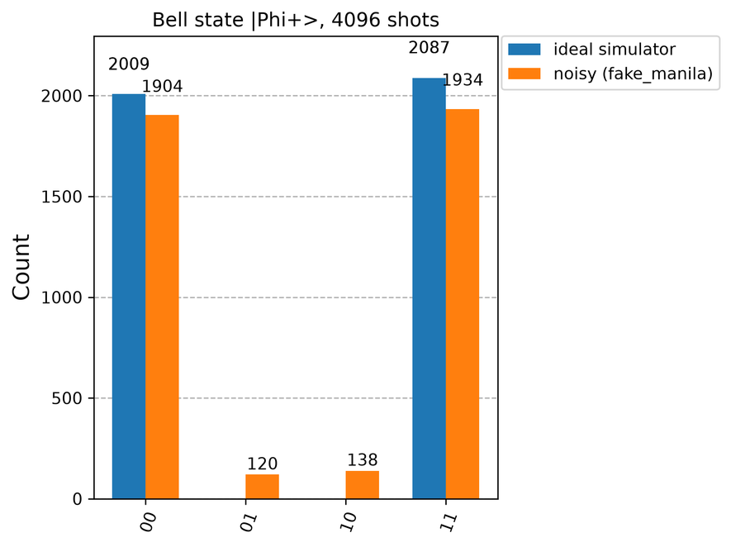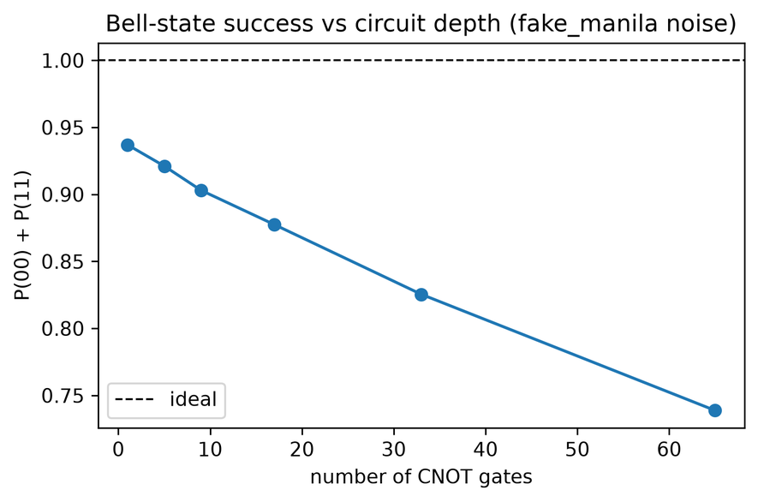
Fig. 2.5. Bell state on ideal and noisy simulators (left) and success against circuit depth under noise (right).

2.8 Classical versus Quantum Computing Architectures
Both kinds of machine use layered designs, as Fig. 2.6 shows, but the lowest layers differ greatly. A quantum processor is not a stand-alone computer, since classical electronics control it and a classical computer processes its results. Table 2.4 summarises the differences.
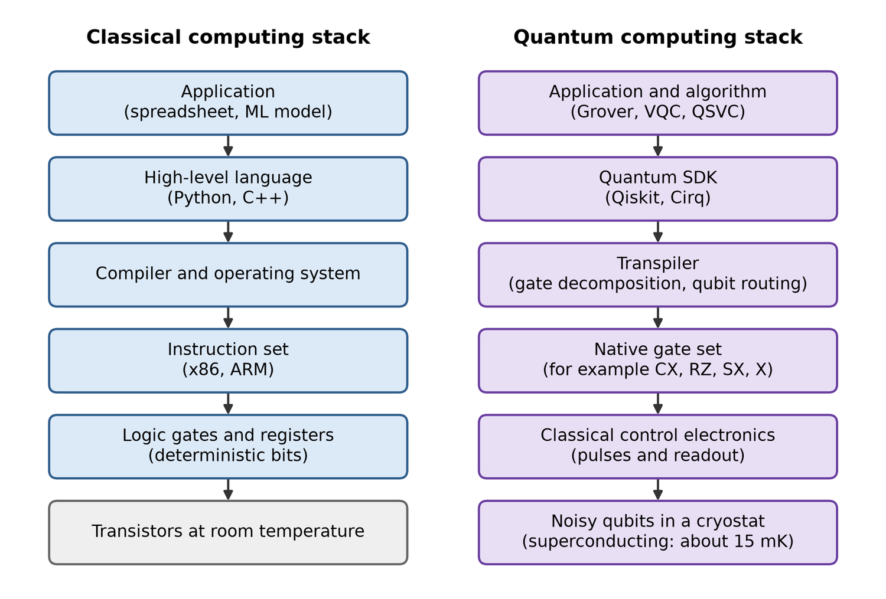
Fig. 2.6. Block diagram of the classical and quantum computing stacks.
TABLE 2.4. Classical and quantum architectures compared.
Feature | Classical | Quantum
Data unit | Bit | Qubit
Operations | Logic gates, mostly irreversible | Unitary gates, reversible until measured
Parallelism | Many cores and threads | Superposition with interference; not simple parallel search
Errors | Very low, handled in hardware | High today; error correction is still emerging
Hardware | Silicon transistors | Superconducting circuits, trapped ions, neutral atoms and others
Temperature | Room temperature | About 15 mK for superconducting qubits

2.9 Deutsch-Jozsa Algorithm
Problem. A function $f:\{0,1\}^{n}→\{0,1\}$ is promised to be either constant or balanced (0 on exactly half of the inputs). A deterministic classical algorithm may need $2^{n−1}+1$ queries in the worst case, while Deutsch-Jozsa needs one [32]. Method. With the output qubit in $|−⟩$, the oracle adds a phase through phase kickback, as in Eq. (5).
 | $$\frac{1}{\sqrt{2^{n}}}\sum_{x}{}|x⟩\overset{U_{f}}{→}\frac{1}{\sqrt{2^{n}}}\sum_{x}{}(−1)^{f(x)}|x⟩$$ | (5)

Applying $H^{⊗n}$ again gives the amplitude of $|0^{n}⟩$ in Eq. (6).
 | $$a_{0}=\frac{1}{2^{n}}\sum_{x}{}(−1)^{f(x)}$$ | (6)

If $f$ is constant, $|a_{0}|=1$, so the result is always $0^{n}$. If $f$ is balanced, the terms cancel and $a_{0}=0$, so the result is never $0^{n}$. Fig. 2.7 shows the 3-qubit circuit with a balanced oracle, and Fig. 2.8 shows the flowchart and results. The constant oracle gave 000 in all 1024 shots and the balanced oracle gave 111 in all 1024 shots. Although it solves an artificial problem, this algorithm clearly shows the value of interference.
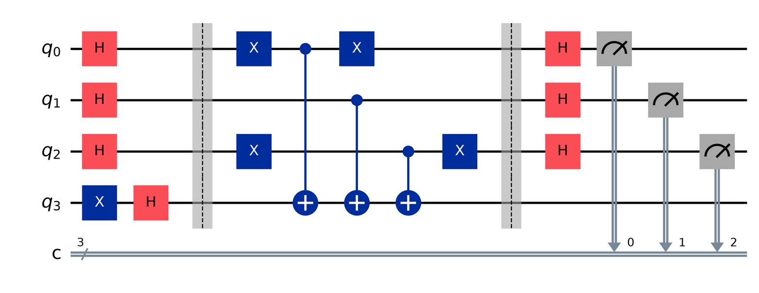
Fig. 2.7. Deutsch-Jozsa circuit for $n=3$ with a balanced oracle.
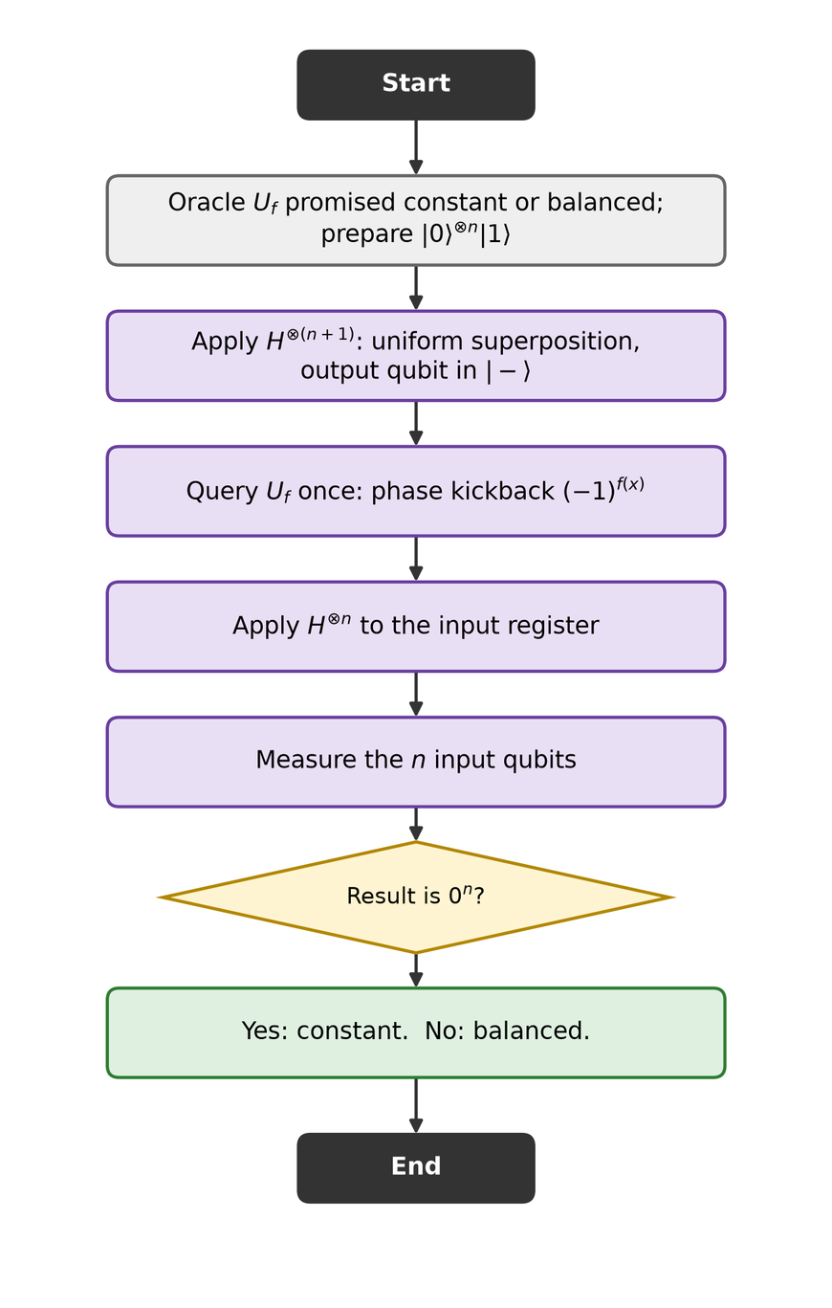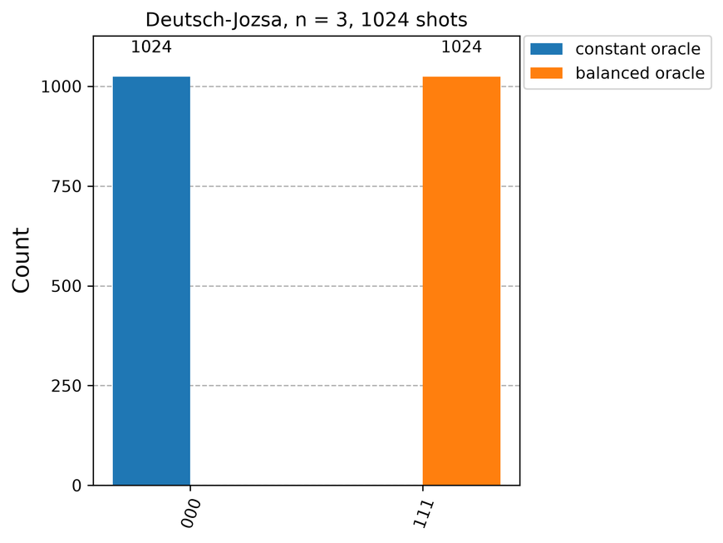
Fig. 2.8. Deutsch-Jozsa flowchart (left) and measured results for both oracles (right).

2.10 Grover's Search Algorithm
Problem. Find one marked item among $N=2^{n}$ unsorted items. A classical search needs about $N/2$ checks on average, whereas Grover's algorithm needs about $\sqrt{N}$ [34]. Method. Each iteration applies an oracle, which flips the sign of the marked state, followed by a diffusion operator $2|s⟩⟨s|−I$ that reflects about the uniform state $|s⟩$. Geometrically, as in Fig. 2.9, the two reflections rotate the state towards the marked state by $2θ$, with $sinθ=1/\sqrt{N}$. After $k$ iterations the success probability and optimum are given in Eq. (7).
 | $$P_{k}=\sin^{2}((2k+1)θ),k_{opt}≈\frac{π}{4}\sqrt{N}$$ | (7)

Going beyond the optimum lowers the success probability, as the curves in Fig. 2.9 show. Fig. 2.10 shows the 3-qubit circuit. In the runs, the 2-qubit search found the marked state in every shot (success 1.000), and the 3-qubit search with two iterations reached 0.963 over 1024 shots, against a theoretical 0.945; the exact statevector value matches theory, so the difference is shot noise. Fig. 2.11 gives the flowchart and the query scaling.
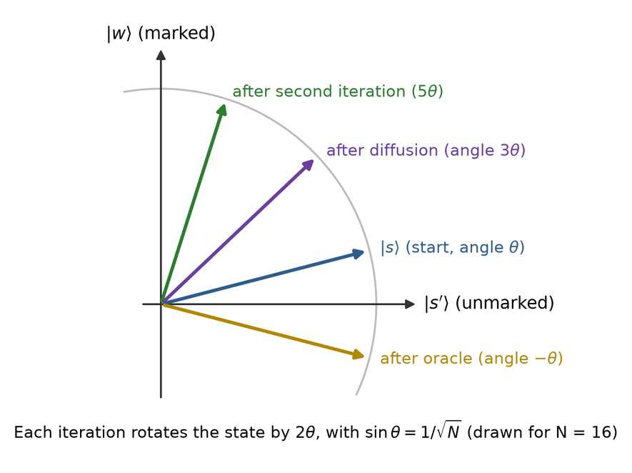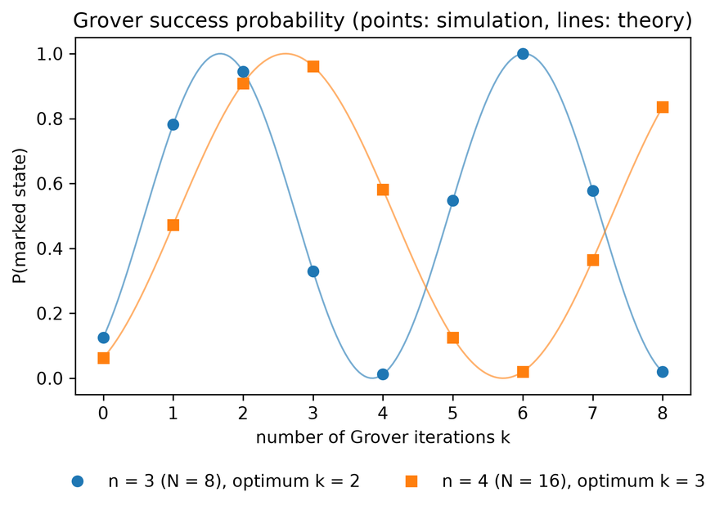
Fig. 2.9. Geometric picture of Grover's algorithm (left) and success probability against iterations (right).
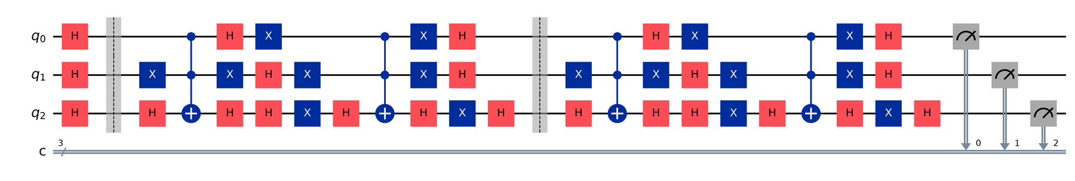
Fig. 2.10. Grover circuit for three qubits, marked state $|101⟩$, two iterations.
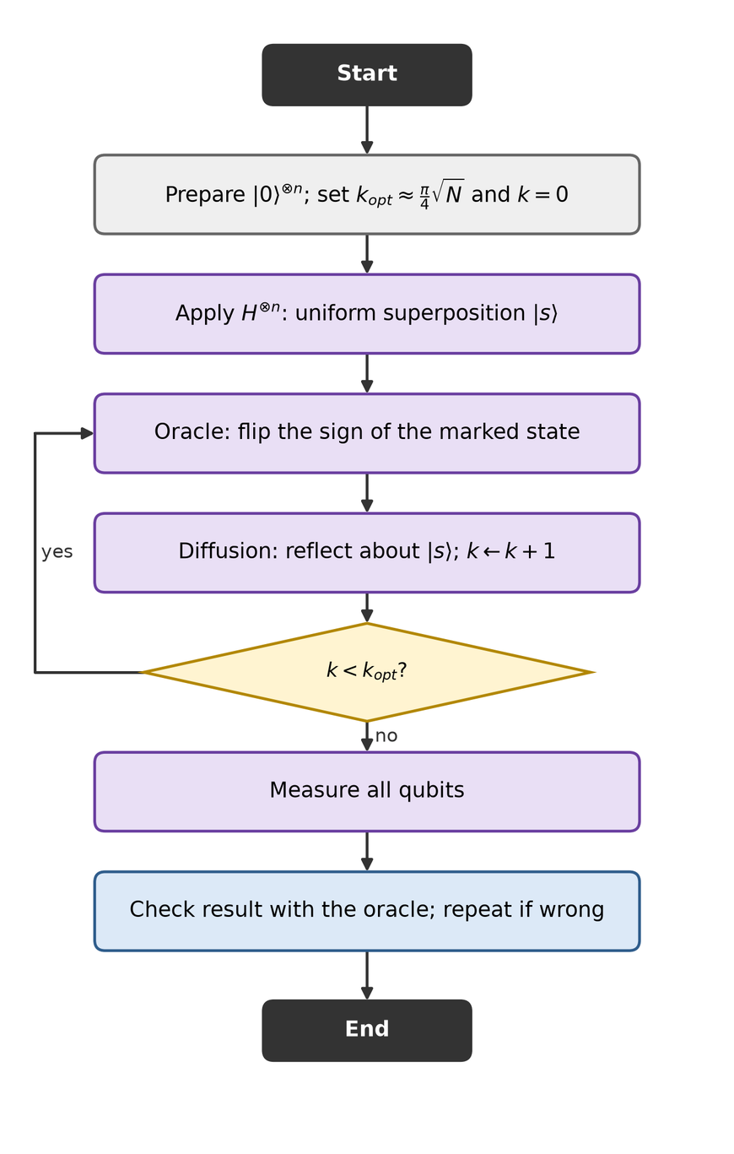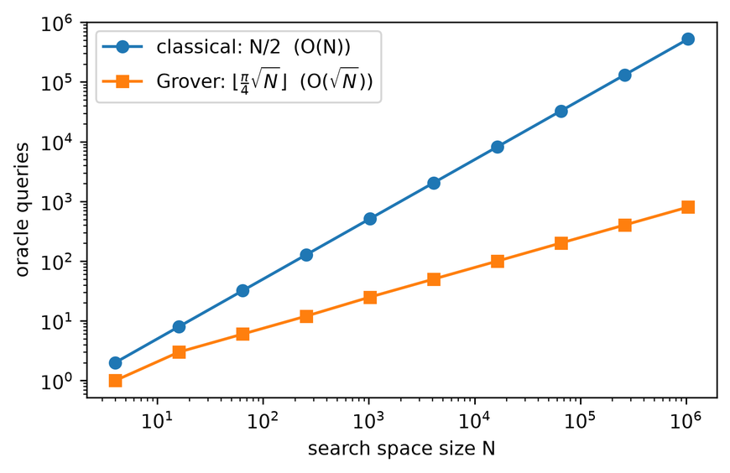
Fig. 2.11. Grover flowchart (left) and oracle queries against search space size (right).

2.11 Shor's Algorithm (Overview)
Shor's algorithm factors an integer $N$ in polynomial time [33]. Factoring reduces to finding the period $r$ of $f(x)=a^{x}modN$, for a random $a$ that shares no factor with $N$. When $r$ is even and $a^{r/2}≠−1(modN)$, the values $gcd(a^{r/2}±1,N)$ give factors. The quantum step is phase estimation, which uses the inverse of the Quantum Fourier Transform (QFT) in Eq. (8).
 | $$\text{QFT}|x⟩=\frac{1}{\sqrt{N}}\sum_{k=0}^{N−1}{}e^{2πixk/N}|k⟩$$ | (8)

Worked example, $N=15$, $a=7$. The powers of 7 modulo 15 repeat as 1, 7, 4, 13, so $r=4$. Then $7^{2}=49$, $gcd(48,15)=3$ and $gcd(50,15)=5$, which gives $15=3×5$. A textbook circuit with eight counting qubits and four work qubits was simulated. As Fig. 2.12 and Table 2.5 show, the four measured phases were 0, 1/4, 1/2 and 3/4, as expected for $r=4$. Only 1/4 and 3/4 reveal $r$ directly. The result 1/2 suggests $r=2$, but $7^{2}mod15≠1$, so a classical check rejects it and the run is repeated. Impact. A large fault-tolerant machine could break RSA encryption, whose security rests on the difficulty of factoring. This is far beyond current devices, which is why this simulation of $N=15$ is only an illustration.
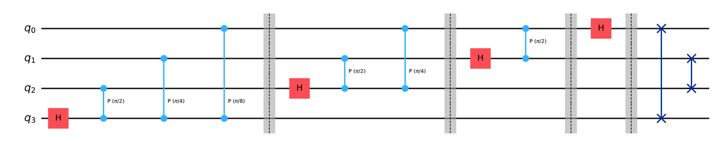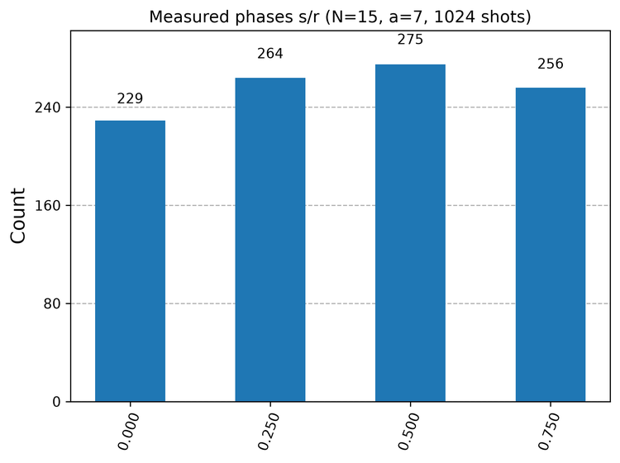
Fig. 2.12. Four-qubit QFT circuit (left) and measured phases for $N=15$, $a=7$ (right).
TABLE 2.5. Measured phases and the period guess from each outcome (1024 shots).
Register | Phase | Fraction | Guess $r$ | $7^{r}$ mod 15 = 1? | Factors | Counts
00000000 | 0.000 | 0/1 | 1 | no | none (retry) | 229
01000000 | 0.250 | 1/4 | 4 | yes | 3 x 5 | 264
10000000 | 0.500 | 1/2 | 2 | no | none (retry) | 275
11000000 | 0.750 | 3/4 | 4 | yes | 3 x 5 | 256

Fig. 2.13 shows how the classical and quantum steps fit together.
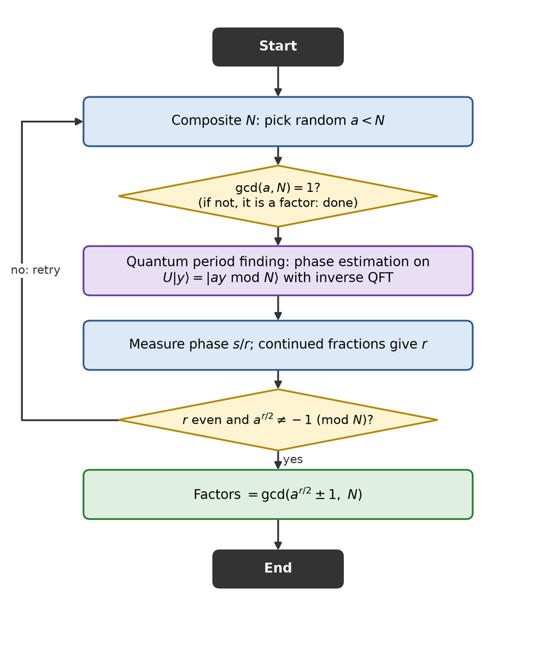
Fig. 2.13. Flowchart of Shor's algorithm.

2.12 Computational Complexity and Quantum Advantage
P contains problems that a classical computer solves efficiently, NP contains problems whose solutions can be checked efficiently, and BQP contains problems that a quantum computer solves efficiently with bounded error. Fig. 2.14 shows the widely believed relationships. Factoring is in BQP but is not known to be in P, while NP-complete problems are not expected to be in BQP. So quantum computers are not expected to solve every hard problem quickly. Table 2.6 compares the algorithms discussed. A proven gain on a particular problem also does not imply a gain for practical ML, which is the question tested in Section 5.
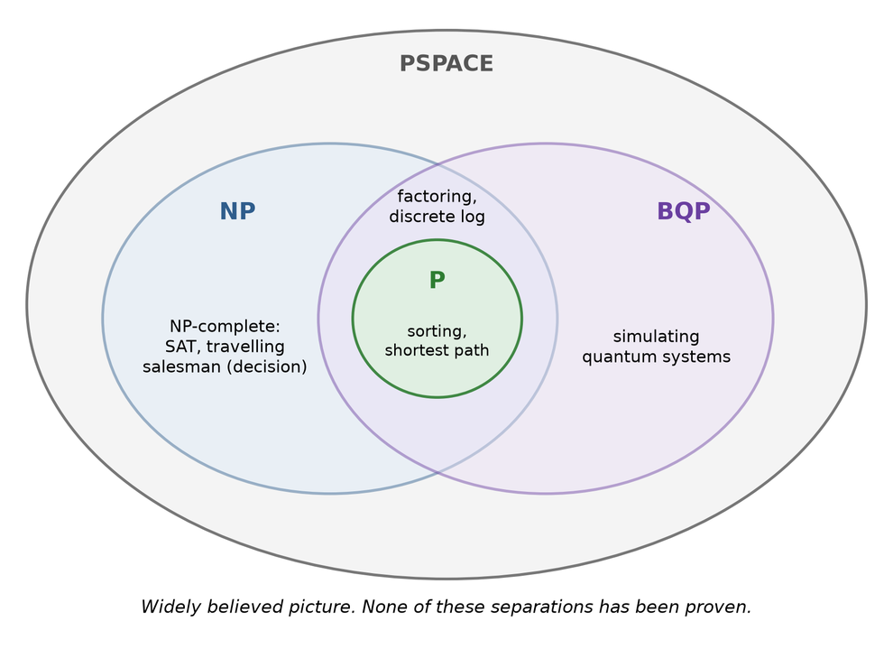
Fig. 2.14. Believed relationship between the classes P, NP, BQP and PSPACE.
TABLE 2.6. Classical and quantum complexity of selected problems.
Problem | Best classical | Quantum | Gain
Deutsch-Jozsa | $2^{n−1}+1$ queries (deterministic) | 1 query | Exponential, but only against deterministic algorithms
Unstructured search | $O(N)$ queries | $O(\sqrt{N})$ queries | Quadratic
Factoring an $n$-bit number | Sub-exponential (number field sieve) | Polynomial in $n$ | Super-polynomial

3. Critical Review of Advanced Machine Learning and Quantum Machine Learning Research

3.1 Review Method
Candidate papers came from the assignment's seed list, from well-known work in each theme, and from web searches using keywords such as "quantum support vector machine breast cancer", "variational quantum classifier healthcare" and "quantum machine learning intrusion detection". Each candidate was then checked against its registered record: Crossref for journal papers, with a check that the DOI is registered, and the arXiv service for preprints. OpenAlex supplied retraction flags. Abstracts came from Crossref or OpenAlex, Semantic Scholar, an arXiv version with the same title and first author, or, in one case, the publisher's page. Google Scholar and IEEE Xplore were not searched directly. From 68 verified candidates, 45 papers were selected to meet the theme targets: 41 from 2021 onwards and 4 foundational papers from 2019 and 2020. Two are labelled preprints. Papers were included when they addressed a listed theme and an abstract could be read, and relevance to breast cancer or tabular medical data was favoured. No selected journal paper carries a retraction flag in OpenAlex; preprints were not checked for this. All reviews are based on abstracts rather than full texts, so their claims are kept general. The bracketed number at the start of each review is its IEEE reference number.

3.2 QML Surveys and Foundations
[3] Cerezo et al. (2022), "Challenges and opportunities in quantum machine learning." Problem and objective: This review asks where quantum machine learning (QML) could realistically help data analysis, with emphasis on quantum data from materials science, biochemistry and high-energy physics. Research gap: Early enthusiasm paid less attention to whether these models can actually be trained and how they truly differ from classical learning. Methodology: The authors survey current methods and applications, giving most attention to quantum neural and deep learning models, and contrast them with classical machine learning. Results: As a review it reports no new experiments. Its main message is that trainability remains an open obstacle, while quantum data is named as an especially promising setting. Limitations / scope: The focus on quantum data leaves classical tabular problems, such as medical diagnosis, less directly addressed, so its conclusions need testing on those datasets.
[26] Schuld and Killoran (2022), "Is Quantum Advantage the Right Goal for Quantum Machine Learning?." Problem and objective: This perspective questions whether proving quantum advantage should be the main goal of QML research. Research gap: Classical machine learning works well in practice but is hard to analyse, whereas quantum computing cannot yet be tested at realistic scale. Judging practical quantum power is therefore unusually difficult, yet the literature often assumes a race against classical models. Methodology: The authors reason through why the available tools struggle to answer this question, and they point to existing work that takes other viewpoints. Results: They call for a critical debate on the narrative of beating classical models and argue that other research perspectives are an important alternative. No numerical results are presented. Limitations / scope: Being an opinion-based perspective, it gives direction rather than evidence. Its advice still has to be applied through careful, honest studies on real data.
[15] Huang et al. (2021), "Power of data in quantum machine learning." Problem and objective: This paper asks when a quantum model can really outperform classical learners once training data is available. Research gap: Most complexity arguments consider computation without data, yet data can make a classically hard function easy to predict. Methodology: The authors derive prediction-error bounds and use them as a test for potential advantage. They also propose a projected quantum kernel model and run numerical tests with up to 30 qubits. Results: With data, classical models were often competitive even on problems tailored to quantum models. The projected model gave a rigorous speed-up in the fault-tolerant setting and a clear near-term advantage on engineered datasets. Limitations / scope: The near-term advantage was shown on datasets deliberately built to favour quantum models, so it does not automatically carry over to real-world data such as clinical records.
[13] Liu et al. (2021), "A rigorous and robust quantum speed-up in supervised machine learning." Problem and objective: This work seeks a provable quantum speed-up for supervised classification that needs only classical access to the data. Research gap: Earlier algorithms either assumed quantum access to data or were heuristics with no proof of advantage. Methodology: A conventional support vector machine (SVM) is combined with a fault-tolerant quantum computer that estimates the kernel as a circuit transition amplitude. The authors construct a family of datasets linked to the discrete logarithm problem. Results: Assuming that problem is hard, no classical learner beats random guessing by more than an inverse polynomial, while the quantum classifier reaches high accuracy and tolerates additive kernel errors from finite sampling. Limitations / scope: The proof depends on fault-tolerant hardware and artificially constructed data. It therefore says little about near-term devices or about natural datasets.
[14] Caro et al. (2022), "Generalization in quantum machine learning from few training data." Problem and objective: This study examines how well variational QML models generalise after training on only a limited number of examples. Research gap: It was not clearly known how much training data such models need, a key point for applications where data is scarce. Methodology: The authors prove generalisation bounds in terms of the number of trainable gates T, the number of substantially changed gates K, and the number of training points N. Results: The error grows at worst as the square root of T/N and improves to the square root of K/N when few gates change greatly. Unitary compiling and classifying quantum phases with a quantum convolutional network need little data. Limitations / scope: A small generalisation gap does not ensure a low training error or a useful model, and the highlighted applications involve quantum rather than classical data.
[25] Bowles et al. (2024), "Better than classical? The subtle art of benchmarking quantum machine learning models." Problem and objective: This preprint tests how far published claims about QML models hold when they are compared systematically with classical baselines. Research gap: Experimental design choices, small scales and commercial narratives make simulated benchmarks hard to interpret reliably. Methodology: The authors built an open-source PennyLane package and tested 12 popular models on 6 binary classification tasks, forming 160 datasets. Results: Out-of-the-box classical models generally beat the quantum classifiers. Removing entanglement often gave equal or better performance, which hints that quantum effects may not be what matters most at these small scales. Five questions for model design are also identified. Limitations / scope: The findings apply to the small tasks that can be simulated today and cannot rule out benefits at larger scale. It was also consulted as a preprint.

3.3 Quantum Kernel Methods and QSVM
[12] Havlíček et al. (2019), "Supervised learning with quantum-enhanced feature spaces." Problem and objective: This foundational paper explores using a quantum state space as the feature space for supervised classification. Research gap: Kernel methods become limited when feature spaces grow large and kernels become expensive to compute classically. Methodology: Two approaches were proposed and run on a superconducting processor: a quantum variational classifier, and a quantum kernel estimator whose output trains a classical SVM. Results: Both algorithms were demonstrated experimentally and solved the construction of a classifier. The work presents feature spaces reachable efficiently only on a quantum computer as a possible route to advantage, and it supplies tools for near-term devices. Limitations / scope: The advantage is described only as a possible path, not a proven gain. Real-world performance was left open, which motivates tests on data such as breast cancer records.
[17] Thanasilp et al. (2024), "Exponential concentration in quantum kernel methods." Problem and objective: This paper studies the measurement resources needed to estimate quantum kernel values accurately enough for learning. Research gap: The convex training of kernel models is attractive, but it assumes that kernel values can be obtained efficiently from hardware. Methodology: The authors derive analytical concentration bounds for four sources and check them with numerical simulations on several QML tasks. Results: Kernel values for different inputs can concentrate exponentially around a fixed value as qubits increase. With polynomially many measurements, predictions then become independent of the input. Embedding expressivity, global measurements, entanglement and noise are all causes, and kernel alignment can suffer too. Limitations / scope: The bounds hold under certain conditions, and they warn about what to avoid rather than offering a complete design recipe for useful kernels.
[38] Jerbi et al. (2023), "Quantum machine learning beyond kernel methods." Problem and objective: This paper seeks a common framework for comparing QML models built from parametrised circuits. Research gap: Understanding of how these model families relate to each other and to classical models was still limited. Methodology: Using quantum information tools, the authors show that all standard models, including data re-uploading circuits, can be mapped to linear models in Hilbert space. They then analyse the qubit and data requirements. Results: For certain learning tasks, linear models need exponentially more qubits than re-uploading models, and kernel methods additionally need exponentially more data points. This separates the models by their resource demands under near-term constraints. Limitations / scope: The separations are proven for particular tasks, so they do not indicate which model will work best on a given practical dataset. Empirical comparison remains necessary.
[39] Hubregtsen et al. (2022), "Training quantum embedding kernels on near-term quantum computers." Problem and objective: This work addresses how to choose a suitable quantum kernel and how noise affects it on near-term hardware. Research gap: Kernel methods face three issues: quadratic cost in training samples, difficult kernel selection, and unknown noise effects. The authors tackle the last two. Methodology: They introduce trainable quantum embedding kernels tuned through kernel-target alignment. Device and finite-sampling noise are studied, and mitigation methods are compared numerically and on data from a real processor. Results: Training reduced the training error significantly in the tested setup, and the best mitigation strategy raised the quality of the kernel matrix. Limitations / scope: The quadratic cost of building the kernel matrix was explicitly left unsolved, and the abstract reports its gains for one experimental setup, without numerical values.
[40] Shaydulin and Wild (2022), "Importance of kernel bandwidth in quantum machine learning." Problem and objective: This paper investigates how one hyperparameter, kernel bandwidth, shapes the performance of quantum kernels. Research gap: Earlier studies largely overlooked hyperparameters and reported that quantum kernel performance falls as qubits increase. Methodology: The authors identify the parameter that controls bandwidth and test several quantum kernels on classical datasets through large numerical studies, relating the behaviour to classical kernels. Results: Models moved from underfitting at large bandwidth to overfitting at small bandwidth, with the best generalisation in between. Optimising bandwidth reduced the exponential decay of kernel values, so performance improved with qubit count and became competitive with leading classical methods. Limitations / scope: The results come from numerical simulation, so finite sampling and device noise on hardware may reduce the benefit. Bandwidth also adds another setting that must be tuned.
[41] Peters et al. (2021), "Machine learning of high dimensional data on a noisy quantum processor." Problem and objective: This experiment tests whether a quantum kernel classifier can handle real high-dimensional data on noisy hardware. Research gap: Earlier demonstrations were small and used synthetic datasets, leaving the practical difficulties of scaling on noisy devices largely unaddressed. Methodology: On Google's Sycamore processor, 17 qubits were used to label 67-dimensional cosmology data without compressing it. They designed a circuit that keeps kernel magnitudes from vanishing and applied error mitigation tailored to kernels. Results: Test-set classification accuracy was comparable to noiseless simulation, showing that careful circuit design and mitigation can preserve useful kernels on real hardware. Limitations / scope: The demonstration concerns a single cosmology dataset and depends on a tailored circuit. Accuracy comparable to simulation does not by itself show an advantage over classical methods.
[42] Wang et al. (2021), "Towards understanding the power of quantum kernels in the NISQ era." Problem and objective: This paper asks whether the advantage of quantum kernels survives the noise and limited measurements of near-term machines. Research gap: Earlier results showing lower generalisation error for quantum kernels were mostly established in an ideal setting that ignored these hardware issues. Methodology: The authors analyse kernels theoretically while including system noise and sampling error, propose a remedy based on indefinite kernel learning, and check their results with numerical simulations. Results: The advantage vanishes for large datasets, few measurements and large system noise. The indefinite kernel learning method is offered as a way of preserving the benefit, and the simulations agree with the theory. Limitations / scope: The evidence is theoretical and simulated rather than taken from hardware, and the remedy has not been shown here on practical datasets such as medical records.

3.4 Variational Quantum Algorithms and VQC
[16] Cerezo et al. (2021), "Variational quantum algorithms." Problem and objective: This review covers variational quantum algorithms (VQAs), which train a parametrised circuit with a classical optimiser. Research gap: Fault-tolerant machines are unlikely to arrive soon, and current devices are limited in qubit number and in circuit depth because of noise. A broad account of how to work within these limits was needed. Methodology: The authors give an overview of the field, its applications and the strategies proposed for overcoming its main difficulties. Results: VQAs have been proposed for nearly every envisioned quantum application and are presented as the leading near-term strategy. Trainability, accuracy and efficiency remain the main challenges. Limitations / scope: As a review it offers no new empirical test, and its optimism about advantage is a prospect that has still to be demonstrated in practical applications.
[4] Bharti et al. (2022), "Noisy intermediate-scale quantum algorithms." Problem and objective: This review summarises what can be attempted on noisy intermediate-scale quantum (NISQ) computers before error correction becomes available. Research gap: Fully fault-tolerant machines need millions of good qubits and may take decades, whereas noisy devices with limited coherence already exist. A thorough account of their algorithms was therefore useful. Methodology: The authors summarise NISQ paradigms and algorithms across physics, machine learning, chemistry and combinatorial optimisation, along with benchmarking and software tools. Results: The review explains the shared structure of these algorithms along with their limitations and advantages. It gives readers a common map of the field rather than a single new performance result. Limitations / scope: Because the review covers many fields, machine learning receives only part of its attention, and individual claims still require independent benchmarking on specific problems.
[43] Schuld et al. (2021), "Effect of data encoding on the expressive power of variational quantum-machine-learning models." Problem and objective: This paper studies how the way data is encoded determines what functions a parametrised quantum circuit can represent. Research gap: Although such circuits had been widely applied, many of their basic theoretical properties as function approximators remained unknown. Methodology: The authors analyse quantum models mathematically by expressing their outputs through a partial Fourier series over the inputs. Results: The available frequencies are set by the data-encoding gates, and repeating simple encoding gates gives access to a richer spectrum. With a sufficiently rich spectrum, some of these models are universal function approximators. Limitations / scope: Being able to represent a function does not guarantee that a model can be trained or that it generalises well. The analysis also concerns expressive power rather than performance on real datasets.
[44] Pérez-Salinas et al. (2020), "Data re-uploading for a universal quantum classifier." Problem and objective: This foundational paper asks how much classification power a very small quantum circuit can provide. Research gap: One qubit seems too limited for classifying complex data, because it holds only a simple superposition and its gates are single rotations. Methodology: The authors load the data repeatedly, alternating re-uploading steps with single-qubit processing units and using a classical subroutine for optimisation. They also extend the design to several qubits and benchmark it on varied examples. Results: A single qubit assisted in this way forms a universal quantum classifier. Multi-dimensional inputs and several output classes can be handled, and adding entanglement across qubits improves efficiency. Limitations / scope: The benchmarks are described as examples of complex data rather than a clinical task, and the abstract does not assess hardware noise. Practical medical value therefore remains open.
[45] Skolik et al. (2021), "Layerwise learning for quantum neural networks." Problem and objective: This paper looks for a training strategy that makes parametrised quantum circuits easier to optimise on near-term devices. Research gap: The difficult cost landscapes of these circuits, including barren plateaus, make standard full-circuit training unreliable. Methodology: In layerwise learning the circuit depth is increased gradually during optimisation, and only a subset of parameters is updated in each step. The method was tested on a handwritten digit classification task with sampling noise considered. Results: It reached an 8% lower generalisation error on average than standard schemes for circuits of the same size. The share of runs reaching lower test errors was up to 40% larger. Limitations / scope: The evidence comes from one image task, and the approach reduces the risk of plateaus rather than removing it for all circuits and datasets.

3.5 Quantum Neural Networks and Trainability
[46] Abbas et al. (2021), "The power of quantum neural networks." Problem and objective: This paper compares the expressibility and trainability of quantum neural networks (QNNs) with those of classical networks. Research gap: The near-term benefits of QML were unclear, and expressibility and trainability of quantum models both needed further study. Methodology: Using information geometry, the authors define an effective dimension based on the Fisher information, prove a generalisation bound, and connect the Fisher spectrum to barren plateaus. Results were also verified on real quantum hardware. Results: Well-designed QNNs reached a significantly higher effective dimension than comparable classical networks. Certain QNNs also resisted barren plateaus and trained faster, owing to a more evenly spread Fisher spectrum. Limitations / scope: The benefit is stated for well-designed networks, not QNNs in general, and higher effective dimension does not automatically produce better accuracy on practical data.
[18] Cerezo et al. (2021), "Cost function dependent barren plateaus in shallow parametrized quantum circuits." Problem and objective: This paper asks how the choice of cost function affects gradient size in shallow variational circuits. Research gap: VQAs are heuristic methods whose scaling was unproven, and it was unclear whether shallow circuits would avoid vanishing gradients. Methodology: The authors prove two results for alternating layered ansatz circuits built from blocks forming local 2-designs, then illustrate them with quantum autoencoder simulations of up to 100 qubits. Results: Global observables produce exponentially vanishing gradients even at shallow depth. Local observables give at worst polynomially vanishing gradients when depth is logarithmic in the number of qubits, which links locality to trainability. Limitations / scope: The proofs hold for a specific class of ansatz, and they address trainability alone. A trainable cost function may still fail to give good accuracy on a real task.
[24] Wang et al. (2021), "Noise-induced barren plateaus in variational quantum algorithms." Problem and objective: This paper examines whether hardware noise places a fundamental limit on variational quantum algorithms. Research gap: Earlier barren plateau work linked vanishing gradients to random parameter initialisation in noise-free circuits, leaving the effect of noise itself unsettled. Methodology: The authors give a rigorous proof for local Pauli noise, covering a generic ansatz that includes alternating operator and unitary coupled cluster circuits. Numerical work with a realistic hardware noise model supports it. Results: When circuit depth grows linearly with qubit number, gradients shrink exponentially with qubit count. These noise-induced plateaus differ in concept from the noise-free kind. Limitations / scope: The proof assumes a particular noise model and depth scaling. It warns against deep circuits but does not by itself show how much shallow, small circuits are affected.
[47] Holmes et al. (2022), "Connecting Ansatz Expressibility to Gradient Magnitudes and Barren Plateaus." Problem and objective: This paper explores the relationship between how expressive an ansatz is and how large its gradients are. Research gap: Barren plateau results were known for ansatze forming exact 2-designs, but not for arbitrary circuits used in practice. Methodology: The authors extend the analysis to general ansatze, calculating gradient variance in terms of the distance of the ansatz from a 2-design, and they provide numerical illustrations. Results: The bounds indicate that highly expressive ansatze have flatter cost landscapes and are harder to train. Expressibility therefore comes at a cost, and this must be considered when designing circuits that avoid plateaus. Limitations / scope: The analysis concerns gradient behaviour and does not identify the best ansatz for a particular dataset. Less expressive circuits may also be unable to represent the required solution.

3.6 Hybrid Quantum-Classical Models
[48] Mari et al. (2020), "Transfer learning in hybrid classical-quantum neural networks." Problem and objective: This foundational paper applies transfer learning to networks that combine classical and quantum parts. Research gap: Intermediate-scale quantum devices cannot process high-dimensional data such as images directly. Methodology: Several hybrid schemes are proposed, mainly a pre-trained classical network followed by a final variational quantum circuit. Proof-of-concept examples cover image recognition and quantum state classification, with PennyLane experiments on IBM and Rigetti computers. Results: The classical part can pre-process large inputs and pass a small set of informative features to the quantum processor, and a high-resolution image classifier was tested on two real quantum computers. Limitations / scope: These are proofs of concept, and the classical network carries much of the feature extraction, so the specific contribution of the quantum layer needs separate evaluation.
[49] Liu et al. (2021), "Hybrid quantum-classical convolutional neural networks." Problem and objective: This paper designs a quantum-classical analogue of a convolutional neural network that suits current noisy devices. Research gap: Deep learning recognises patterns well, and quantum circuits can produce distributions that are hard to generate classically, yet the two needed a practical bridge that respects limited qubits and depth. Methodology: The authors propose a hybrid network that uses quantum circuits to enhance feature mapping, with a framework that computes gradients of hybrid loss functions automatically. It was tested on a Tetris dataset. Results: The hybrid network exceeded the learning accuracy of a classical CNN with the same structure while keeping nonlinearity and scalability. Limitations / scope: The Tetris dataset is simple and the classical comparison used the same structure only, so a stronger tuned baseline might narrow the reported gap.
[50] Hur et al. (2022), "Quantum convolutional neural network for classical data classification." Problem and objective: This study benchmarks fully parameterised quantum convolutional neural networks on classical data. Research gap: Many quantum analogues of the CNN had been proposed, but how design choices affect classical data classification needed systematic comparison. Methodology: Using only two-qubit interactions, the authors varied circuit structures, data encoding, classical pre-processing, cost functions and optimisers on MNIST and Fashion-MNIST. Results: Accuracy was excellent in most cases despite few free parameters, and the quantum networks performed noticeably better than CNNs under similar training conditions. Their shallow circuits suit near-term devices. Limitations / scope: The result compares models trained under similar conditions, which may favour small models, and the datasets are image benchmarks. Results may differ for tabular medical features or under real device noise.
[51] Jäger and Krems (2023), "Universal expressiveness of variational quantum classifiers and quantum kernels for support vector machines." Problem and objective: This paper asks how far variational classifiers and quantum kernel SVMs can, in principle, extend quantum advantage. Research gap: The search for advantage in QML models needed a precise theoretical statement of what these model types can solve. Methodology: The authors construct a classification problem from the k-Forrelation problem, which is PromiseBQP-complete, and show that both model types can solve it. Results: A suitable feature map and quantum kernel exist that make these models efficient solvers for any BQP problem. They can therefore be designed for an advantage on classification problems that are quantum-tractable but classically intractable. Limitations / scope: This is an existence result about designed feature maps. It gives no route to finding one for natural data, and it reports no performance on practical datasets.
[52] Ren et al. (2022), "Experimental quantum adversarial learning with programmable superconducting qubits." Problem and objective: This experiment tests whether quantum classifiers are vulnerable to small, deliberately crafted changes in their input. Research gap: Theory predicted this weakness, which matters in safety-critical settings, but it had not been demonstrated experimentally. Methodology: The authors trained variational classifiers on ten transmon qubits, with average two-qubit gate fidelity above 99.4%, using real images including medical MRI scans as well as quantum data. Results: Classifiers reaching test accuracy up to 99% were deceived by small adversarial perturbations, and adversarial training substantially improved their robustness. Limitations / scope: The work addresses security, not whether quantum classifiers outperform classical ones. Protection was shown against the perturbations studied, and wider clinical robustness remains open.

3.7 QML in Healthcare and Medical Diagnosis
[6] Moradi et al. (2022), "Clinical data classification with noisy intermediate scale quantum computers." Problem and objective: This study assesses whether QML is feasible on real clinical datasets using actual hardware. Research gap: Progress in QML had not been matched by broad testing on open clinical data with near-term devices. Methodology: The authors propose a quantum distance classifier and a simplified quantum-kernel SVM. Data was embedded with logarithmic encoding and run on the 15-qubit IBMQ Melbourne computer, then compared with earlier QML and classical methods on three open clinical datasets. Results: The distance classifier did better on datasets with few samples and features, and kernel methods did better on larger ones. The encoding raised the area under the ROC curve by up to 2%. Limitations / scope: The abstract reports relative comparisons rather than a clear win over classical models, and the 2% gain is small and specific to the tested datasets.
[53] Azevedo et al. (2022), "Quantum transfer learning for breast cancer detection." Problem and objective: This work classifies full-image mammograms from the BCDR collection as malignant or benign with a hybrid quantum model. Research gap: The authors wanted to learn whether the transfer learning idea of Mari et al. could benefit a hard medical imaging task. Methodology: They trained a set of hybrid classical-quantum networks with transfer learning, used heatmaps to inspect the image regions targeted, evaluated several metrics, and also ran experiments on a real quantum device. Results: Accuracy reached 84%, against 76.9% for the state-of-the-art work they compared with. Some architectures suited particular tasks better, and the method may help generalisation on complex data. Limitations / scope: The authors themselves state that further tests are needed. Much of the feature extraction is classical, so the gain cannot be credited to the quantum part alone.
[54] Jose P et al. (2024), "Enhanced QSVM with elitist non-dominated sorting genetic optimisation algorithm for breast cancer diagnosis." Problem and objective: This paper applies a quantum SVM to the binary diagnosis of malignant breast cancer. Research gap: The authors aim to improve on using a quantum SVM alone by also optimising its parameters against several objectives. Methodology: The quantum SVM is combined with an elitist non-dominated sorting genetic algorithm that tunes its parameters, and quantum kernel estimation is run in an IBM QSVM simulator. Results: The authors report remarkably accurate results compared with a classical SVM and an execution time of 0.14, although the abstract states neither a specific accuracy figure nor a unit for that time. Limitations / scope: Without those figures in the abstract, the size of the claimed gain cannot be judged from it. Execution on a simulator also leaves real hardware noise unexamined.
[55] Akpinar et al. (2024), "Evaluating the Impact of Different Quantum Kernels on the Classification Performance of Support Vector Machine Algorithm: A Medical Dataset Application." Problem and objective: This preprint measures how the choice of quantum feature map changes the classification results of a quantum kernel SVM on medical data. Research gap: Encoding classical data is essential, but its specific effect on classification outcomes had been little explored. Methodology: The authors computed kernel matrices from nine feature maps and applied them to the original Wisconsin Breast Cancer dataset and the TCGA Glioma dataset, comparing classifier performance and execution time. Results: Feature maps built on Rx gates worked best for the Wisconsin data, and Ry gates worked best for Glioma, on both performance and time. The choice of map clearly affected outcomes. Limitations / scope: It uses the original Wisconsin dataset rather than the Diagnostic version studied here, compares no wider classical model set in its abstract, and is a preprint.
[56] Zorlu and Colak (2026), "A Robustness-Oriented Quantum–Classical Hybrid Machine Learning Pipeline for Breast Cancer Diagnosis: External Validation, Explainability, and Rigorous Benchmarking in the NISQ Era." Problem and objective: This study evaluates quantum models for breast cancer diagnosis under a deliberately strict protocol, without expecting them to win. Research gap: Many comparisons use one internal hold-out result and omit calibration, decision value and explainability. Methodology: Using WDBC for development and an independent Wisconsin cohort for external validation, it compared five classical learners, an eight-qubit VQC, a ZZ-feature-map QSVM and a hybrid ensemble. Results: Internally the RBF SVM reached AUC 0.998, while the QSVM reached only 0.727. Externally the VQC scored 0.983, with intervals overlapping the best models. Z-rotation embeddings collapsed the VQC to chance. Limitations / scope: The authors stress that curated benchmark data does not establish clinical readiness, and the classical models are already close to the performance ceiling on this dataset.
[7] Krunic et al. (2022), "Quantum Kernels for Real-World Predictions Based on Electronic Health Records." Problem and objective: This work investigates whether empirical quantum advantage can be found on real healthcare data. Research gap: Provable advantages existed for synthetic data, but it had not been studied empirically whether advantage is attainable, or on which data. Methodology: The authors built an end-to-end framework over electronic health record subsets with 5 to 20 features and 200 to 300 training samples. RBF SVMs were compared with quantum kernel models run on an IBM quantum computer. Results: Regimes where quantum kernels might help were identified, and a new terrain ruggedness index was proposed for estimating how a model will perform on a dataset. Limitations / scope: The framework identifies where advantage could occur for selected subsets, not across clinical data generally. Further validation on independent cohorts is therefore still required.
[57] Landman et al. (2022), "Quantum Methods for Neural Networks and Application to Medical Image Classification." Problem and objective: This paper introduces new quantum neural network methods and tests them on medical image classification. Research gap: Quantum methods needed efficient training procedures and direct comparison with classical networks on real hardware. Methodology: The authors present an orthogonal network based on a pyramidal circuit, and quantum-assisted networks that use a quantum computer for inner product estimation. They compared quantum and classical methods on hardware and simulators. Results: Quantum and classical neural networks gave a similar level of accuracy, and the new training algorithms were proven to scale asymptotically better than earlier ones. Limitations / scope: Similar accuracy is not an advantage, and the authors tie the promise of these methods to the arrival of better quantum hardware. Practical benefit in imaging thus remains prospective.

3.8 Quantum-Enhanced Image Recognition
[58] Henderson et al. (2020), "Quanvolutional neural networks: powering image recognition with quantum circuits." Problem and objective: This foundational paper introduces a quantum layer for extracting image features within a convolutional architecture. Research gap: CNNs depend on hierarchical feature extraction, and it was unknown whether small quantum transformations could usefully contribute to this on near-term devices. Methodology: Quanvolutional layers transform local patches of input with random quantum circuits. Three model types were compared on MNIST: CNNs, quanvolutional networks, and CNNs with added non-linearities. Results: The quanvolutional models gave higher test accuracy and faster training than the purely classical CNNs. The small circuits need little or no error correction. Limitations / scope: MNIST is an easy benchmark and the abstract's accuracy claim is limited to those models. Whether the benefit is uniquely quantum, and whether it survives on harder images, is not settled.
[5] Senokosov et al. (2024), "Quantum machine learning for image classification." Problem and objective: This study develops two hybrid quantum models for image classification that can operate within near-term limits. Research gap: Circuits with many qubits are not yet feasible, so image classification needs designs built from smaller quantum parts. Methodology: The first model uses parallel quantum circuits and was tested on MNIST, Medical MNIST and CIFAR-10. The second uses a quanvolutional layer to reduce image resolution. Results: The first model reached 99.21% on full MNIST using one-eighth of the parameters of the matching classical model, above 99% on Medical MNIST and above 82% on CIFAR-10. The second equalled the classical version with a quarter of the parameters. Limitations / scope: The models are heavily hybrid, so results cannot be attributed to the quantum layers alone, and their performance on noisy hardware is not reported in the abstract.
[59] Wei et al. (2022), "A quantum convolutional neural network on NISQ devices." Problem and objective: This paper proposes a quantum convolutional network that lowers computational complexity on NISQ devices. Research gap: Near-term models must be practical in size and noise tolerance, and they need implementable circuits that correspond to specific classical kernels. Methodology: The design uses a number of basic gates polylogarithmic in input size. Numerical simulations cover spatial filtering, namely smoothing, sharpening and edge detection, as well as handwritten number recognition. Results: Complexity is greatly reduced compared with classical counterparts, the model tolerates certain noise in image recognition, and its parameters do not depend on input size. It maps classical filters directly to quantum circuits. Limitations / scope: Results come from numerical simulation on simple image tasks, the noise robustness applies only to certain noise, and costs of loading data are not discussed in the abstract.

3.9 Quantum Optimization
[10] Blekos et al. (2024), "A review on Quantum Approximate Optimization Algorithm and its variants." Problem and objective: This review assesses the Quantum Approximate Optimization Algorithm (QAOA) and its variants for combinatorial optimisation. Research gap: Researchers needed clear guidance on whether QAOA can beat classical algorithms and in which circumstances it should be used. Methodology: The authors overview QAOA performance across problem types and scenarios, examine hardware concerns, including how errors and noise affect it, and carry out a comparative study of selected extensions. Results: The review presents the current state of the algorithm and its variants, along with future directions and a short practical guide for applying it. Limitations / scope: The abstract treats classical competitiveness as a question to examine rather than a settled result. The review format also means that claims depend on the varied studies that it collects.
[11] Ebadi et al. (2022), "Quantum optimization of maximum independent set using Rydberg atom arrays." Problem and objective: This experiment searches for a quantum speed-up on a hard practical problem, maximum independent set. Research gap: Realising a speed-up on relevant, computationally hard problems remains a central open challenge. Methodology: Two-dimensional arrays of Rydberg atoms, reaching 289 qubits, were programmed with an encoding based on the blockade effect, and variational algorithms were optimised in a closed loop on graphs of chosen connectivity. Results were benchmarked against simulated annealing. Results: Problem hardness was governed by solution degeneracy and the number of local minima. On the hardest graphs, the team saw a superlinear speed-up for exact solutions when circuits were deep. Limitations / scope: The comparison is with simulated annealing specifically, on one class of graphs, so it does not establish an advantage over every classical solver.
[60] Abbas et al. (2024), "Challenges and opportunities in quantum optimization." Problem and objective: This perspective reviews where quantum algorithms may help optimisation and how such claims should be tested. Research gap: Interest in quantum optimisation is widespread, but approaches differ across fields and comparisons with classical methods need clear standards. Methodology: The authors use complexity theory to separate provably exact from heuristic settings, outline algorithmic building blocks and problem classes, and analyse the effects of scaling on noisy devices. Results: They identify key open questions, propose metrics for fair classical comparison, and suggest finance and sustainability as sources of benchmark problems. Limitations / scope: It sets out an agenda rather than demonstrating a new advantage, and its metrics and benchmarks must still be adopted and tested by future experimental work.

3.10 AI and ML for Quantum Computing
[61] Bausch et al. (2024), "Learning high-accuracy error decoding for quantum processors." Problem and objective: This paper applies machine learning to decoding errors in the surface code, a leading scheme for quantum error correction. Research gap: Decoding noisy syndrome information accurately is a key obstacle to large-scale fault-tolerant machines, and human-designed decoders may not capture complex real errors. Methodology: The authors developed a recurrent, transformer-based neural decoder. It was trained first on approximate synthetic data and then refined on a small number of experimental samples. Results: It outperformed other leading decoders on real data from Google's Sycamore processor for distances 3 and 5, and kept its advantage on simulated data up to distance 11 with realistic cross-talk and leakage. Limitations / scope: Beyond distance 5 the evidence is from simulation, and the abstract does not settle whether decoding is fast enough at larger scale for practical machines.
[62] Alexeev et al. (2025), "Artificial intelligence for quantum computing." Problem and objective: This review examines how artificial intelligence can help build and operate useful quantum computers. Research gap: Applying leading AI methods to quantum computing requires expertise from two demanding fields that rarely meet, so a shared account was needed. Methodology: The authors review state-of-the-art AI techniques across the hardware and software stack, from device design through to applications, then assess future opportunities and obstacles. Results: The review argues that many of the largest scaling challenges in quantum computing may depend on progress in AI, and it shows that AI methods are already advancing several parts of the stack. Limitations / scope: As a review it does not provide a new quantitative test, and it addresses AI serving quantum computing rather than quantum models improving classical prediction tasks.

3.11 Applications in Finance, Logistics and Cybersecurity
[8] Herman et al. (2023), "Quantum computing for finance." Problem and objective: This review summarises the state of quantum computing for financial applications, written for physicists. Research gap: Physicists need an account of the classical techniques used in finance and of where quantum methods could genuinely help. Methodology: The authors cover quantum algorithms for stochastic modelling, optimisation and machine learning, and they discuss potential advantages, limitations and open challenges. Results: Monte Carlo integration and gradient estimation on quantum machines may run quadratically faster than classical versions, while financial optimisation can take continuous, discrete or mixed forms. The benefits and difficulties of QML for classical problems also apply in finance. Limitations / scope: The quadratic speed-up still requires reduced quantum resources before it could become feasible even on early fault-tolerant machines, so practical gains in finance remain in the future.
[9] Harwood et al. (2021), "Formulating and Solving Routing Problems on Quantum Computers." Problem and objective: This paper studies how logistics routing problems should be formulated for quantum computers. Research gap: Vehicle routing is NP-hard and well served by classical methods, while the suitability of quantum algorithms and formulations required exploration. Methodology: The authors propose several formulations that treat inventory routing as vehicle routing under time-window constraints. They compare the resulting quadratic unconstrained binary problems using difficulty metrics, then solve them on simulated devices with quantum algorithms including VQE and QAOA. Results: Each formulation has strengths and weaknesses, and the simulated runs showed the relative benefits and robustness of the different algorithms. Limitations / scope: The solutions come from simulated rather than physical devices, and the abstract does not claim superiority over classical routing methods, so practical logistics value remains unproven.
[63] Kalinin and Krundyshev (2023), "Security intrusion detection using quantum machine learning techniques." Problem and objective: This paper evaluates QML for detecting security intrusions when network data becomes very large. Research gap: Conventional machine learning on ordinary hardware can become slow or lose accuracy on inputs of a million samples or more. Methodology: Quantum SVM and quantum convolutional networks were compared with conventional detectors, using the authors' own dataset. Their software groups network packets into streams and encodes them for quantum computing. Results: The authors report 98% accuracy and processing twice as fast as the conventional algorithms applied to the same task. Limitations / scope: Results rest on a dataset created by the authors, which makes independent comparison harder, and the abstract does not explain how the speed comparison treats simulation or hardware.

3.12 Consolidated Comparative Research Matrix
Table 3.1 summarises all reviewed papers, in the same theme order as the reviews above.
TABLE 3.1. Comparative research matrix of the reviewed papers.
S. No. | Authors (Year) | Technique | Methodology / Dataset | Key findings | Limitations
[3] | Cerezo et al. (2022) | QML review | Survey of QNNs and quantum deep learning | Trainability is the central open challenge; quantum data looks most promising | No new experiments; little on classical tabular data
[26] | Schuld and Killoran (2022) | Perspective on quantum advantage | Critical argument; no dataset | Questions the focus on beating classical ML; proposes other research goals | No experiments; gives direction, not evidence
[15] | Huang et al. (2021) | Projected quantum kernels; prediction-error bounds | Theory plus simulations up to 30 qubits on engineered data | Data lets classical models compete; projected kernel gives advantage on engineered data | Advantage shown on data built to favour quantum models
[13] | Liu et al. (2021) | Quantum kernel SVM; complexity proof | Theoretical construction from discrete logarithm | Rigorous speed-up with classical data access; robust to sampling error | Needs fault tolerance; constructed data only
[14] | Caro et al. (2022) | Generalisation bounds for QML | Theoretical proofs with QCNN and compiling examples | Error scales at worst as sqrt(T/N), improving to sqrt(K/N) | Does not ensure low training error; applications use quantum data
[25] | Bowles et al. (2024) | Large-scale QML benchmarking | 12 models, 6 tasks, 160 datasets, PennyLane simulation | Classical models outperform; removing entanglement often does not hurt | Small simulated scale; preprint
[12] | Havlíček et al. (2019) | Quantum kernel estimator; variational classifier | Experiments on a superconducting processor | Quantum feature spaces demonstrated in both methods | Advantage remains only a possible path; real data untested
[17] | Thanasilp et al. (2024) | Quantum kernel concentration analysis | Analytical bounds and numerical simulation | Expressivity, global measurement, entanglement and noise cause concentration | Holds under conditions; no full design recipe
[38] | Jerbi et al. (2023) | Linear quantum models framework | Theoretical mapping and resource separation | Kernels may need exponentially more data than re-uploading models on some tasks | Proven for particular tasks; empirical tests still needed
[39] | Hubregtsen et al. (2022) | Trainable quantum embedding kernels | Kernel-target alignment; simulation and real QPU data | Training lowers training error; mitigation improves kernel matrix | Quadratic cost unsolved; results tied to one setup
[40] | Shaydulin and Wild (2022) | Quantum kernel bandwidth tuning | Numerical experiments, multiple kernels and classical datasets | Tuned bandwidth counters kernel decay; performance competitive with classical | Simulation-based; adds a hyperparameter
[41] | Peters et al. (2021) | Quantum kernel on hardware | Sycamore, 17 qubits, 67-dimensional cosmology data | Test accuracy comparable to noiseless simulation | One dataset; no classical advantage shown
[42] | Wang et al. (2021) | Noisy quantum kernel theory; indefinite kernel learning | Theory plus numerical simulation | Advantage vanishes with large data, few shots and large noise | No hardware; not tested on practical data
[16] | Cerezo et al. (2021) | Variational quantum algorithms review | Survey of design, training and applications | VQAs are a leading near-term strategy; trainability and accuracy remain challenges | No new tests; advantage still a prospect
[4] | Bharti et al. (2022) | NISQ algorithms review | Survey of paradigms, benchmarks and software tools | Common structure, limits and advantages of NISQ algorithms mapped | Broad coverage; ML is only one part
[43] | Schuld et al. (2021) | Fourier analysis of data encoding | Mathematical analysis of parametrised circuits | Encoding gates set accessible frequencies; repetition enriches spectrum | Says nothing about trainability or real data
[44] | Pérez-Salinas et al. (2020) | Data re-uploading classifier | Single- and multi-qubit circuits on benchmark examples | One qubit with re-uploading forms a universal classifier | Hardware noise and clinical data not assessed
[45] | Skolik et al. (2021) | Layerwise QNN training | Handwritten digit classification with sampling noise | 8% lower generalisation error; up to 40% more runs reach lower error | One image task; plateau risk reduced, not removed
[46] | Abbas et al. (2021) | Effective dimension of QNNs | Information geometry; verification on real hardware | Well-designed QNNs show higher effective dimension and faster training | Only for well-designed QNNs; accuracy on real data not ensured
[18] | Cerezo et al. (2021) | Barren plateau theory; local vs global cost | Proofs for layered ansatz; 100-qubit autoencoder simulation | Global costs give barren plateaus; local costs stay trainable at log depth | Specific ansatz; trainability only
[24] | Wang et al. (2021) | Noise-induced barren plateaus | Proof under local Pauli noise; numerics with hardware noise model | Gradients vanish exponentially when depth grows linearly with qubits | Assumes specific noise and depth scaling
[47] | Holmes et al. (2022) | Expressibility and trainability bounds | Gradient variance analysis with numerics | Highly expressive ansatze give flatter landscapes, harder to train | Does not select an ansatz for a given dataset
[48] | Mari et al. (2020) | Hybrid classical-quantum transfer learning | Pre-trained network plus VQC; IBM and Rigetti tests | Classical pre-processing makes large inputs feasible on small devices | Proof of concept; quantum contribution unclear
[49] | Liu et al. (2021) | Hybrid quantum-classical CNN | Quantum feature mapping; automatic gradients; Tetris data | Higher learning accuracy than same-structure CNN | Simple dataset; only same-structure baseline
[50] | Hur et al. (2022) | Quantum convolutional neural network | Design comparison on MNIST and Fashion-MNIST | High accuracy with few parameters; better than CNNs under similar conditions | Image benchmarks; comparison depends on training conditions
[51] | Jäger and Krems (2023) | Complexity theory of VQC and QSVM | Reduction from k-Forrelation (PromiseBQP-complete) | Suitable feature maps can solve any BQP problem | Existence result; no practical feature map or data
[52] | Ren et al. (2022) | Quantum adversarial learning | Ten superconducting qubits; images, MRI and quantum data | Up to 99% accuracy, yet small perturbations deceive; adversarial training helps | Security focus; wider clinical robustness open
[6] | Moradi et al. (2022) | Quantum distance classifier; simplified quantum-kernel SVM | IBMQ Melbourne, 15 qubits, three open clinical datasets | Best method depends on data size; encoding adds up to 2% AUC | No clear win over classical; small gain
[53] | Azevedo et al. (2022) | Hybrid quantum transfer learning | Mammograms from BCDR; simulator and real device | 84% accuracy against 76.9% for prior work | Further tests needed; quantum share of the gain unclear
[54] | Jose P et al. (2024) | QSVM with genetic optimisation | Breast cancer diagnosis; IBM QSVM simulator | Authors report high accuracy against classical SVM | Abstract gives no accuracy figure; simulator only
[55] | Akpinar et al. (2024) | QSVM with nine feature maps | Wisconsin Breast Cancer (original) and TCGA Glioma | Rx maps best for Wisconsin; Ry maps best for Glioma | Original Wisconsin data; preprint
[56] | Zorlu and Colak (2026) | VQC, ZZ QSVM and classical benchmark | WDBC (n=569) and external WBC (n=683); ablation and noise tests | RBF SVM AUC 0.998; ZZ QSVM 0.727; external VQC 0.983 | Benchmark data only; not clinical readiness
[7] | Krunic et al. (2022) | Quantum kernels on health records | EHR subsets; 5-20 features; 200-300 samples; IBM hardware | Regimes of possible advantage found; ruggedness index proposed | Selected subsets; needs independent validation
[57] | Landman et al. (2022) | Quantum orthogonal and quantum-assisted networks | Medical image tasks on hardware and simulators | Quantum and classical accuracy similar; training scales better | No accuracy advantage; depends on better hardware
[58] | Henderson et al. (2020) | Quanvolutional neural network | Random quantum circuit filters; MNIST | Higher test accuracy and faster training than purely classical CNNs | Easy benchmark; quantum origin of benefit unsettled
[5] | Senokosov et al. (2024) | Hybrid parallel and quanvolutional networks | MNIST, Medical MNIST, CIFAR-10 | 99.21% on MNIST with eight times fewer parameters | Heavily hybrid; noisy hardware not reported
[59] | Wei et al. (2022) | QCNN mapped from classical filters | Simulated filtering and handwritten number recognition | Reduced complexity; parameters independent of input size | Simulation on simple tasks; only certain noise tolerated
[10] | Blekos et al. (2024) | QAOA review | Survey and comparison of QAOA variants | Current status of QAOA and a practical guide provided | Advantage over classical not settled in abstract
[11] | Ebadi et al. (2022) | Rydberg atom variational optimisation | Up to 289 qubits; maximum independent set; programmable graphs | Superlinear speed-up over simulated annealing on hardest graphs | One classical comparator and graph class
[60] | Abbas et al. (2024) | Quantum optimisation perspective | Complexity analysis, building blocks, benchmarking metrics | Open questions and fair comparison metrics proposed | Agenda only; no new advantage demonstrated
[61] | Bausch et al. (2024) | Transformer-based neural decoder | Sycamore data at distance 3 and 5; simulation up to 11 | Outperforms leading decoders on real and simulated data | Simulation beyond distance 5; speed at scale unsettled
[62] | Alexeev et al. (2025) | AI for quantum computing review | Survey across hardware and software stack | Scaling challenges in quantum computing may depend on AI progress | No new test; opposite direction to this project
[8] | Herman et al. (2023) | Quantum finance review | Survey of stochastic modelling, optimisation and ML | Monte Carlo methods offer quadratic speed-up in principle | Resources must fall before practical gains
[9] | Harwood et al. (2021) | VQE and QAOA for vehicle routing | Inventory routing formulations; simulated quantum devices | Formulations differ in difficulty; relative algorithm benefits shown | Simulation only; no classical superiority claimed
[63] | Kalinin and Krundyshev (2023) | QSVM and QCNN intrusion detection | Authors' own network traffic dataset | Reported 98% accuracy and twice the speed | Own dataset; basis of speed claim unclear in abstract

3.13 Identified Research Gaps
The following gaps describe the 45 reviewed papers as seen through their abstracts. They are not a claim about the whole field. Each gap links to an objective of the mini project in Section 4.3.
- G1. Few direct comparisons of quantum kernels and variational classifiers on the same medical dataset. Medical studies mostly evaluate one quantum family: kernels in [6], [7], [54], [55], and quantum or hybrid networks in [53], [57]. Only [56] compares a VQC and a ZZ quantum kernel on WDBC. This project adds an independent comparison (objective O1).
- G2. Limited fair comparison on identical reduced features. Some positive reports use a same-structure baseline [49], train under similar conditions [50], use the authors' own data [63], or give no accuracy figure in the abstract [54], while a large benchmark found that classical models generally win [25]. Here every reduced-feature model receives the same PCA features (O2).
- G3. Little joint analysis of how circuit design changes medical results. Theory explains the effects of expressibility, entanglement and depth [17], [24], [47], and [40] tunes kernel bandwidth. Medical studies examine parts of the design, such as feature maps [55] or embeddings, depth and noise [56]. No reviewed abstract varies qubit count, feature-map depth, entanglement, ansatz depth and training size together on one medical dataset (O3).
- G4. Little study of noise effects on diagnostic recall. Noise is studied for kernels [39], [42], gradients [24] and hardware [41], and [56] tests depolarising noise on a VQC. No reviewed abstract reports malignant-class recall under a device noise model (O4).
- G5. Diagnostic errors are rarely the headline result. Medical abstracts mostly report accuracy or AUC [7], [53], [56], and the reviewed abstracts do not report false-negative counts. This project reports missed cancers for every model (O2).
- G6. Costs are rarely reported next to accuracy. The quadratic kernel cost is noted but left open in [39], and speed claims can be hard to interpret [54], [63]. This project records time, circuit counts and depth (O5).

4. Proposed Mini Project: Design and Development of a Hybrid Quantum Machine Learning Model

4.1 Problem Statement
The World Health Organization (WHO) estimates that 2.4 million women were diagnosed with breast cancer in 2024 and that the disease caused 694,000 deaths; it was the most common cancer in women in 164 of 186 countries [64]. GLOBOCAN estimates for 2022 place female breast cancer at 11.6% of all new cancers worldwide [65]. Accurate and early diagnosis supports timely treatment, and in a diagnostic test a false negative, which is a missed malignant tumour, is far more harmful than a false alarm. This project classifies tumours as malignant or benign from fine-needle aspirate (FNA) measurements, with malignant-class recall as the main clinical measure, and asks whether small quantum circuits can do this as well as classical models.

4.2 Background and Motivation
FNA features are a well-studied benchmark on which classical ML is already strong, so any quantum result can be judged fairly. QML papers report mixed results on this and similar data. Some report strong quantum performance [54], while others find that classical models remain ahead [56], [66]. Quantum kernels and VQCs are the two leading near-term approaches [12], but each has known problems: kernel concentration [17] and barren plateaus [18], [24]. Testing them together, on identical features, shows how these issues appear on a real diagnostic task. QML is included here as the subject of a fair experiment, not because it is expected to win. A careful negative result is still useful, as argued in [25], [26].

4.3 Objectives
1. O1. Build QSVC and VQC pipelines in Qiskit and evaluate both on the Wisconsin Diagnostic Breast Cancer (WDBC) data with the same preprocessing.
2. O2. Compare them with classical models on identical reduced features using accuracy, precision, recall, specificity, F1-score, ROC-AUC and missed malignant cases, with 5-fold cross-validation.
3. O3. Measure how qubit count (2 to 8), feature-map depth, entanglement, ansatz depth, optimiser and training size affect accuracy and cost.
4. O4. Measure the effect of shot noise and a fake IBM device noise model on accuracy and recall.
5. O5. Report the computational cost of each model and explain where quantum models stand today.

4.4 Research Gaps Addressed
- A direct VQC and quantum kernel comparison on WDBC, which only [56] offers among the reviewed papers.
- A fair baseline on identical features, in contrast to weaker or unclear comparisons in [49], [50], [54].
- A joint sweep of circuit settings on one medical dataset, extending the partial studies in [55], [56] and connecting them to theory [17], [47].
- Malignant recall under device noise, which goes beyond kernel-level and gradient-level noise studies [24], [39].
- Missed-cancer counts and cost figures for every model, which the reviewed abstracts rarely report [7], [53].

4.5 Proposed Solution and Contributions
The solution is a single pipeline in which the data is scaled, reduced by Principal Component Analysis (PCA) and scaled again into rotation angles. The same features then go to a QSVC, a VQC and classical baselines, and every model is scored in the same way. The expected contributions are: (1) a working hybrid QML pipeline for medical diagnosis in Qiskit; (2) a fair comparison on identical reduced features with a focus on malignant recall; (3) an analysis of how qubit count, depth, entanglement, training size and noise affect accuracy and cost; and (4) an honest discussion of where quantum models stand in the NISQ era.

4.6 Techniques and Justification
Table 4.1 gives the reason for each choice. The default settings follow common practice in the reviewed work and keep the circuits small enough for a laptop simulator.
TABLE 4.1. Selected techniques and why they were chosen.
Technique | Role | Justification
PCA [67] | Reduces 30 features to $n$ | One qubit per feature limits the input size; PCA keeps the most variance with no use of labels
Angle encoding | Maps features to rotation angles | Simple, uses few qubits, and repeated encoding enriches the model [43]
ZZFeatureMap [12] | Encodes data with entanglement | Standard map, believed hard to simulate at large scale
Fidelity quantum kernel | Computes sample similarity | Lets a classical SVM use the quantum feature space, with convex training
SVM [68] | Finds the decision boundary | Same algorithm as the RBF baseline, so only the kernel differs
RealAmplitudes | Trainable circuit $W(θ)$ | Compact: only RY rotations and CNOT gates; gives a real-valued ansatz
COBYLA [69] | Trains the VQC | Gradient-free, so it avoids extra circuit runs for gradients
SPSA [70] | Alternative optimiser | Estimates gradients with two circuits and is designed to tolerate noise
Classical baselines [71] | Comparison models | RBF SVM, logistic regression, random forest, KNN and MLP cover the main model families

4.7 Mathematical Formulation
Preprocessing. PCA and scaling are given in Eq. (9), where $x$ is a standardised sample, $μ$ the training mean, $W_{k}$ the first $k$ principal directions, and $\min_{j}$ and $\max_{j}$ the training extremes of component $j$.
 | $$z=W_{k}^{⊤}(x−μ),{\overset{\sim }{z}}_{j}=π·\frac{z_{j}−\min_{j}}{\max_{j}−\min_{j}}$$ | (9)

Feature map. One layer of the ZZFeatureMap applies Eq. (10), where $Z_{j}$ is the Pauli-Z operator on qubit $j$ and $H$ is the Hadamard gate. In this work $x_{j}$ denotes the scaled feature ${\overset{\sim }{z}}_{j}$. The layer is repeated reps times.
 | $$U_{Φ}(x)=exp(i\sum_{j}{}x_{j}Z_{j}+i\sum_{j<k}{}(π−x_{j})(π−x_{k})Z_{j}Z_{k})H^{⊗n}$$ | (10)

Quantum kernel. The kernel in Eq. (11) measures the overlap of two encoded states. On a device it is estimated as the probability of measuring all zeros.
 | $$k(x,x^{′})=|⟨ϕ(x)|ϕ(x^{′})⟩|^{2}=|⟨0^{n}|U_{Φ}^{†}(x^{′})U_{Φ}(x)|0^{n}⟩|^{2}$$ | (11)

SVM. Training solves the dual problem in Eq. (12) with labels $y_{i}∈\{−1,+1\}$ and regularisation $C$, subject to $0≤α_{i}≤C$ and $\sum_{i}{}α_{i}y_{i}=0$. Prediction uses Eq. (13), where $b$ is the bias.
 | $$\max_{α}\sum_{i}{}α_{i}−\frac{1}{2}\sum_{i,j}{}α_{i}α_{j}y_{i}y_{j}k(x_{i},x_{j})$$ | (12)

 | $$f(x)=\text{sign}(\sum_{i}{}α_{i}y_{i}k(x_{i},x)+b)$$ | (13)

VQC. The circuit output gives class probabilities, and training minimises the cross-entropy in Eq. (14), where $M$ is the number of samples and $y_{i,c}$ is 1 for the true class and 0 otherwise. In the Qiskit version used, the default mapping assigns the class as the measured bitstring value modulo 2, as in Eq. (15). Although that function is named parity, it depends only on qubit 0.
 | $$L(θ)=−\frac{1}{M}\sum_{i=1}^{M}{}\sum_{c}{}y_{i,c}logp_{c}(x_{i};θ),θ^{∗}={argmin}_{θ}L(θ)$$ | (14)

 | $$p_{c}(x;θ)=\sum_{b:b\text{mod}2=c}{}|⟨b|W(θ)U_{Φ}(x)|0^{n}⟩|^{2}$$ | (15)

4.8 Dataset and Preprocessing
The Breast Cancer Wisconsin (Diagnostic) dataset [72] was loaded from scikit-learn [71]. Table 4.2 summarises it. Labels were re-mapped so that malignant is the positive class. There were 0 missing values.
TABLE 4.2. Dataset summary.
Item | Detail
Samples | 569: 212 malignant (37.3%) and 357 benign
Features | 30 real values: mean, standard error and worst value of 10 measurements
Measurements | Radius, texture, perimeter, area, smoothness, compactness, concavity, concave points, symmetry, fractal dimension
Split | Stratified 80/20: 455 training and 114 test samples (42 malignant, 72 benign in the test set)
Labels | Malignant = 1 (re-mapped from scikit-learn, where 0 = malignant)

Fig. 4.1 shows the class balance and the variance kept by PCA. Four components keep 79.3% of the variance, and two, six and eight keep 63.1%, 88.9% and 92.8%. Always predicting benign would score 0.627, which is the minimum that a useful model must beat. Fig. 4.2 shows that the features are strongly correlated, which is why PCA compresses them well. Fig. 4.3 shows that the six features most correlated with the label separate the classes clearly, and Fig. 4.4 shows the same separation in the first two components.
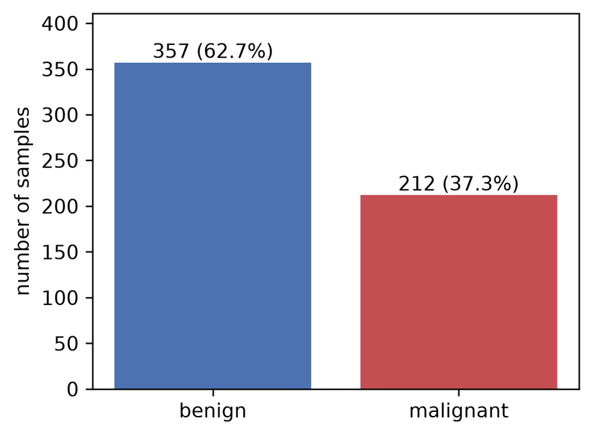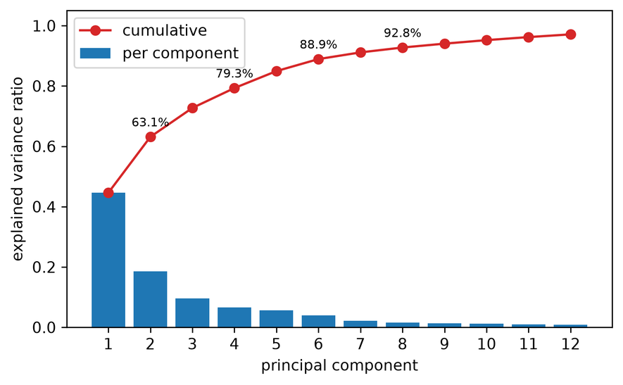
Fig. 4.1. Class distribution (left) and PCA explained variance (right).
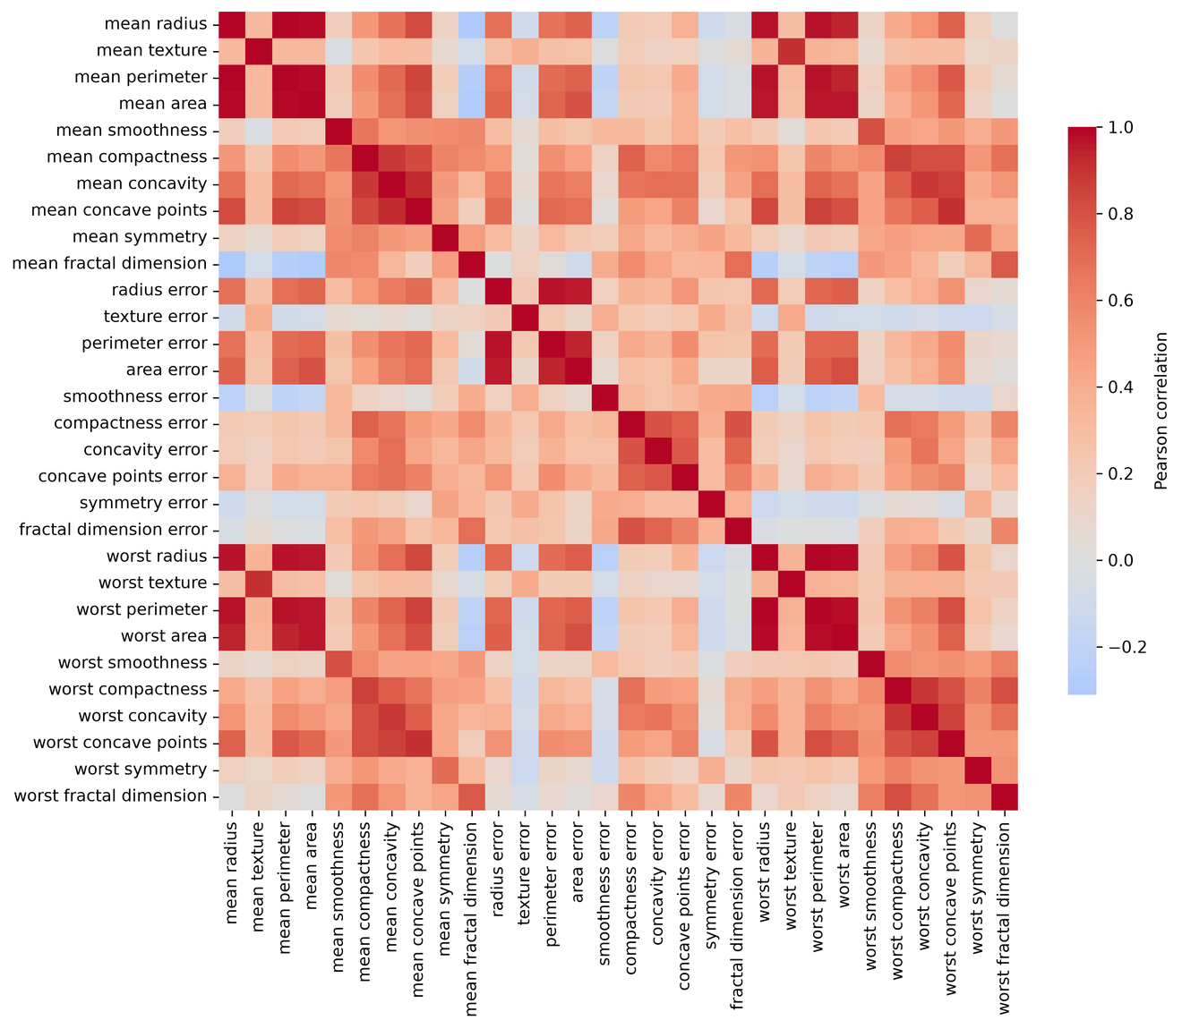
Fig. 4.2. Correlation heatmap of the 30 features.
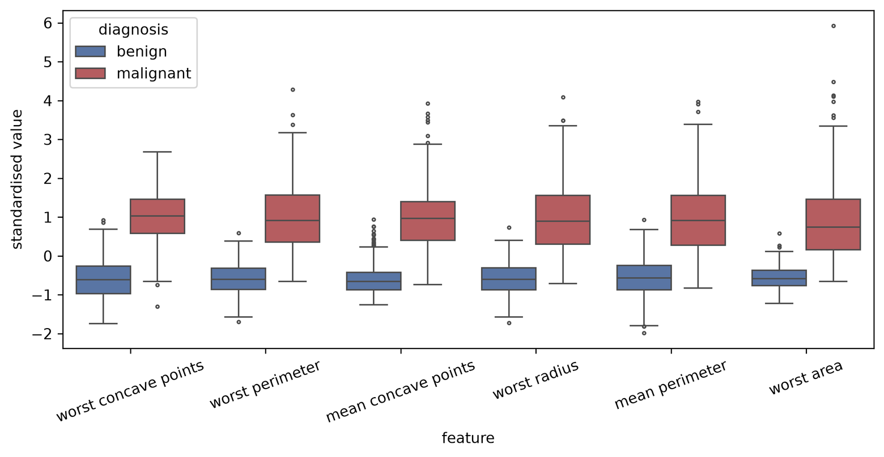
Fig. 4.3. Standardised box plots of the six features most correlated with the label.
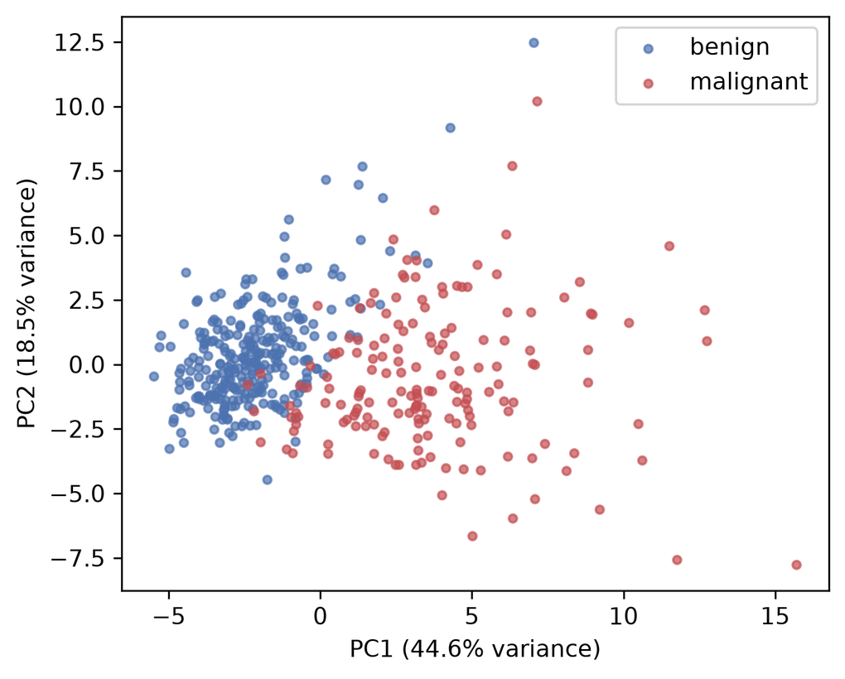
Fig. 4.4. Training samples in the first two principal components.
The preprocessing steps were: stratified split; StandardScaler; PCA to $n=4$ components (2 to 8 in E2); and MinMaxScaler to $[0,π]$. Every scaler and the PCA were fitted on training data only, which prevents information from the test set leaking into the models. Test values can fall slightly outside $[0,π]$, and they were not clipped because they remain valid angles.

4.9 System Architecture
Fig. 4.5 shows the complete system. Data flows through preprocessing to the quantum and classical paths, and all models are scored in the same evaluation step.
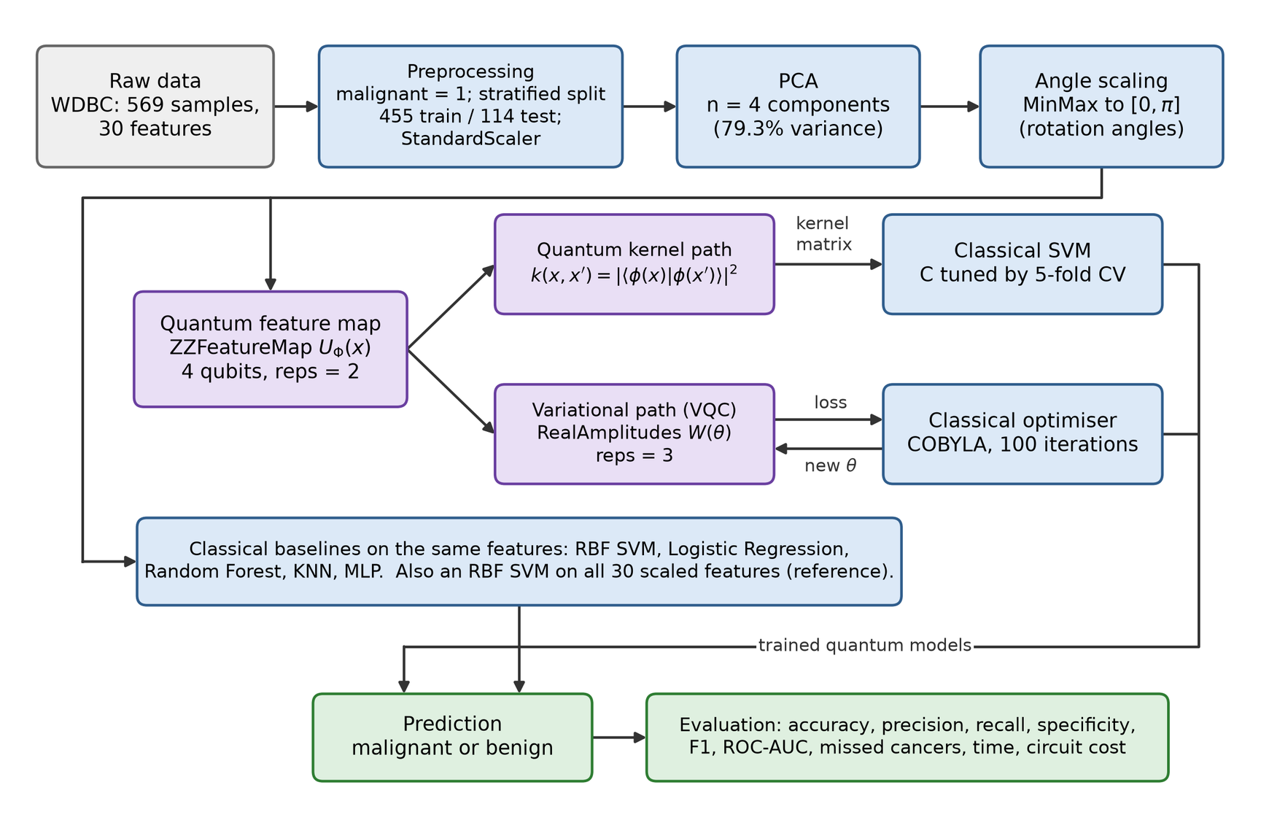
Fig. 4.5. Overall architecture of the proposed system.

4.10 Hybrid Model Architecture
Fig. 4.6 separates the work done on the simulator from the work done on the CPU. In the QSVC, circuits only produce the kernel matrix, and all training is classical. In the VQC, the circuit makes the prediction, and a classical optimiser repeatedly updates its angles.
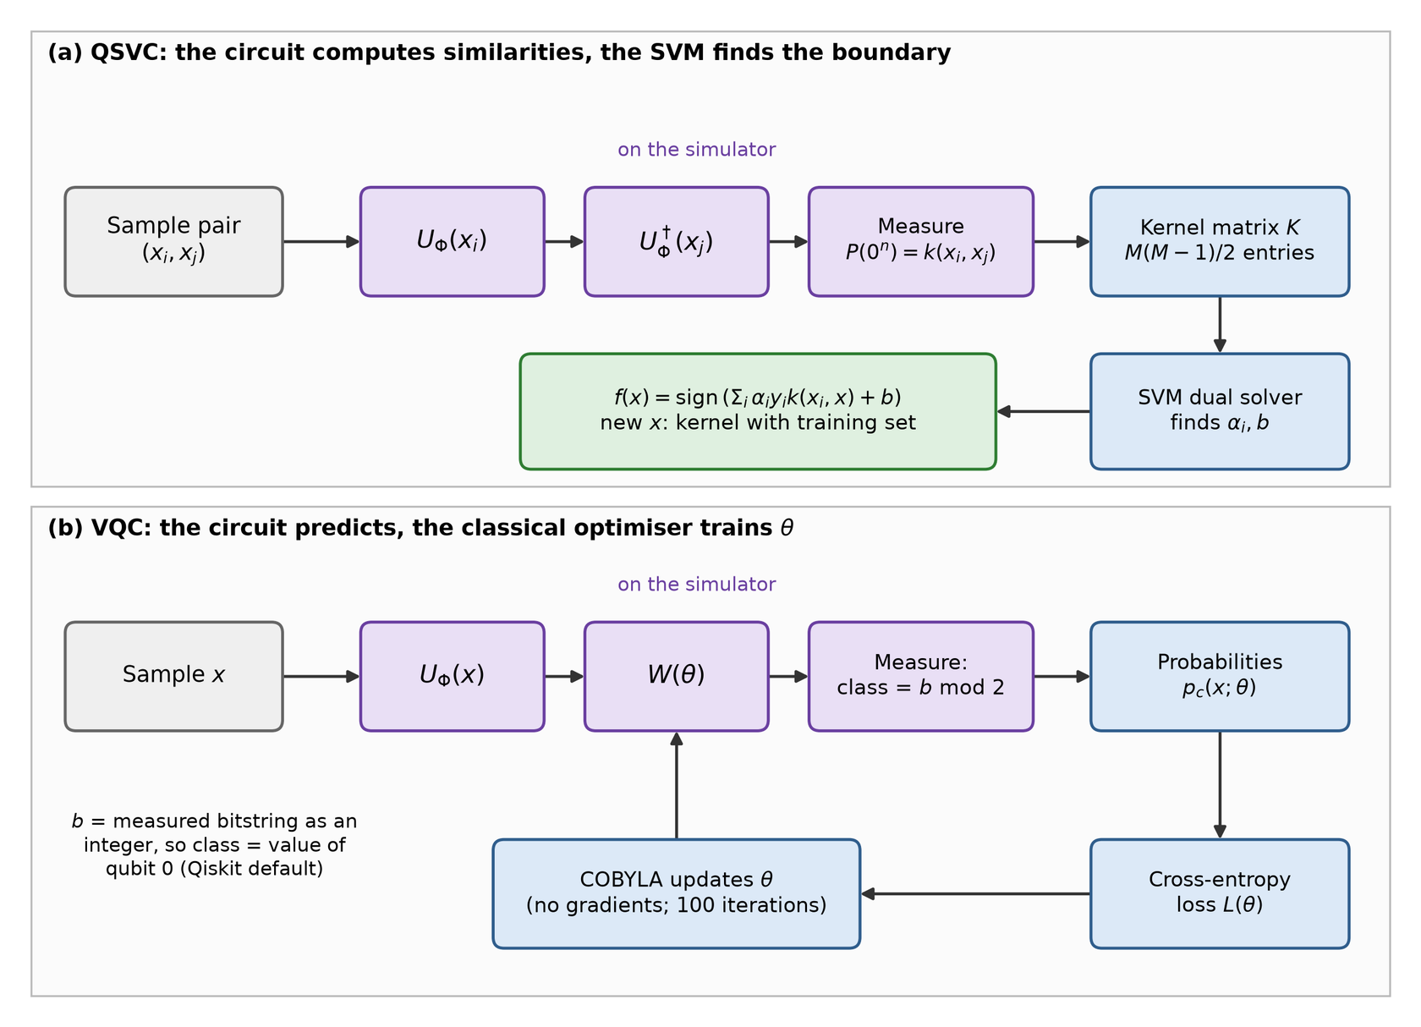
Fig. 4.6. Architecture of the hybrid QSVC path (a) and VQC loop (b).

4.11 Algorithms and Pseudocode
Algorithms 1 and 2 give the two quantum models in pseudocode.
Algorithm 1: QSVC training and prediction
Input: training set (X, y), test set T, feature map U, grid C = {0.1, 1, 10}
1 for each pair (x_i, x_j) with i < j do
2 K[i][j] <- |<0| U†(x_j) U(x_i) |0>|^2 # one kernel value
3 K[i][i] <- 1; K[j][i] <- K[i][j]
4 for each C value do
5 score[C] <- 5-fold CV accuracy of SVM(C) on K
6 C* <- value with the highest score
7 train SVM(C*) on K to obtain alpha and b
8 for each t in T do
9 K_t[i] <- k(t, x_i) for all training samples
10 predict sign(sum_i alpha_i y_i K_t[i] + b)

Algorithm 2: VQC training
Input: training set (X, y), feature map U, ansatz W, maxiter = 100
1 theta <- random values in [-pi, pi] (fixed seed)
2 repeat
3 for each sample x_i do
4 run W(theta) U(x_i) |0> and obtain p_c(x_i; theta)
5 L <- mean cross-entropy over the samples
6 record L; COBYLA proposes a new theta
7 until maxiter evaluations are used
8 return theta
Prediction: class with the larger p_c(x; theta)

4.12 Workflow Flowchart
Fig. 4.7 gives the full workflow from raw data to the final comparison, including the loop that repeats it for each seed, fold and experiment setting.
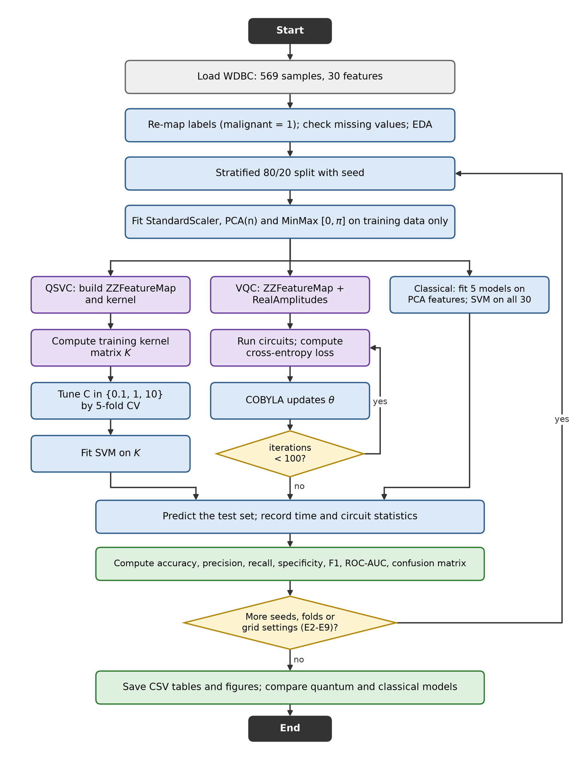
Fig. 4.7. Complete workflow of the project.

4.13 Use Case Diagram
Fig. 4.8 shows the two actors. A researcher preprocesses data, trains the quantum models, and evaluates and compares them. A clinician or other user would enter tumour features and view a prediction. That clinical use is only a concept here: no clinical tool was built or validated.
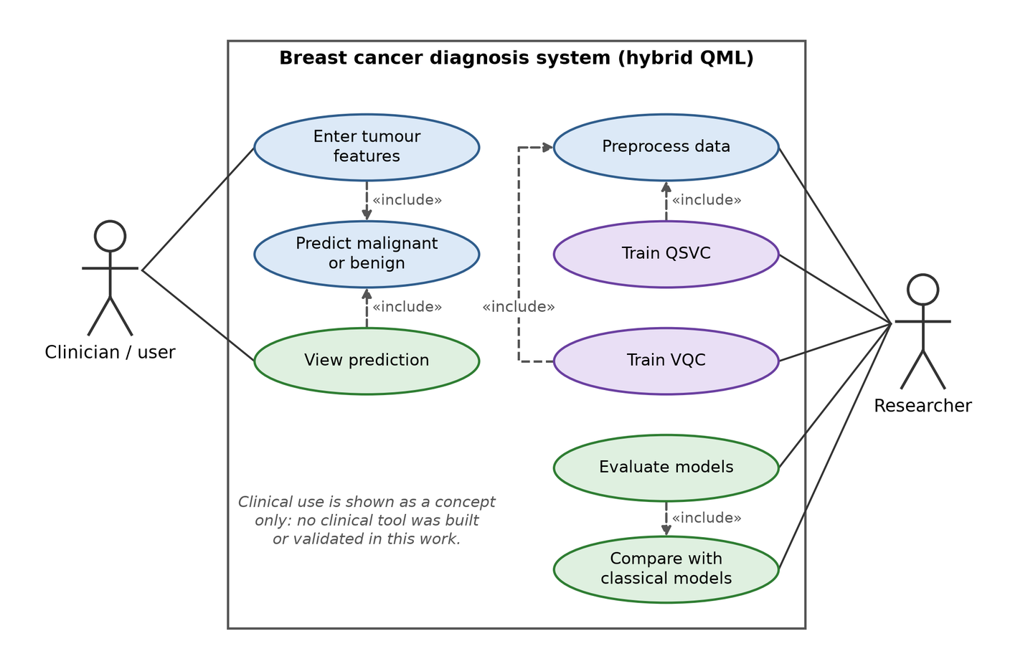
Fig. 4.8. Use case diagram of the system.

4.14 Quantum Circuit Design
Fig. 4.9 and Fig. 4.10 show the circuits for four qubits, and Table 4.3 gives their size after decomposition into the basis gates CX, RZ, SX and X. The kernel circuit is the feature map followed by its inverse with the second sample, so its depth is about twice that of the map.
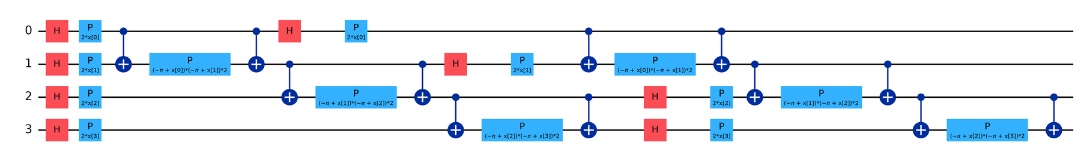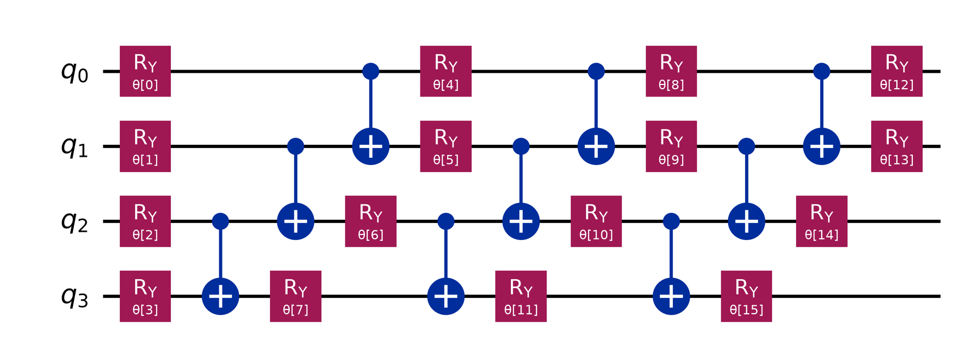
Fig. 4.9. ZZFeatureMap with reps = 2 and linear entanglement (top); RealAmplitudes ansatz with reps = 3 (bottom).
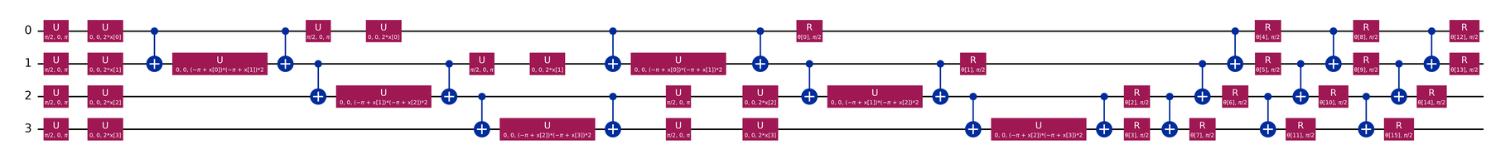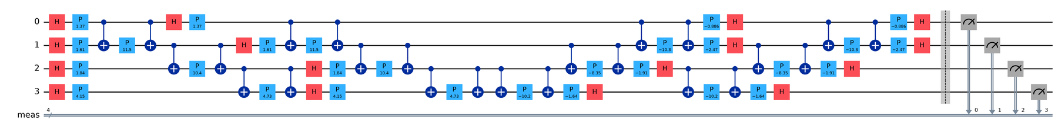
Fig. 4.10. Full VQC circuit, decomposed (top); compute-uncompute kernel circuit for one pair of samples (bottom).
TABLE 4.3. Circuit size for four qubits after decomposition.
Circuit | Qubits | Depth | CX gates | Total gates | Parameters
ZZFeatureMap (reps = 2, linear) | 4 | 23 | 12 | 50 | 4 (data)
RealAmplitudes (reps = 3) | 4 | 27 | 9 | 89 | 16 (trainable)
Full VQC | 4 | 50 | 21 | 139 | 20 (4 data + 16 trainable)
Kernel circuit | 4 | 46 | 24 | 100 | None once samples are bound

4.15 Implementation in Qiskit
The code uses Qiskit [27], [28] and Qiskit Machine Learning [73]. The excerpts below come from src/quantum_models.py and src/grid.py. The kernel is first built on the feature map:
feature_map = zz_feature_map(n_qubits, reps=reps, entanglement=entanglement)
kernel = FidelityStatevectorKernel(feature_map=feature_map) # exact and fast
# kernel = FidelityQuantumKernel(feature_map=feature_map) # one circuit per pair
K = kernel.evaluate(X_train)
search = GridSearchCV(SVC(kernel="precomputed"), {"C": [0.1, 1, 10]}, cv=cv)
search.fit(K, y_train)

The VQC uses the same feature map with an ansatz, an optimiser and a callback that records the loss:
ansatz = real_amplitudes(n_qubits, reps=3)
init = np.random.default_rng(seed).uniform(-np.pi, np.pi, ansatz.num_parameters)
vqc = VQC(feature_map=feature_map, ansatz=ansatz, optimizer=COBYLA(maxiter=100),
callback=callback, initial_point=init)
vqc.fit(X_train, y_train)

Noisy execution uses an Aer sampler with a noise model copied from the fake backend, with circuits transpiled for that device:
fake = FakeManilaV2()
pm = generate_preset_pass_manager(backend=fake, optimization_level=1,
seed_transpiler=seed)
noise = NoiseModel.from_backend(fake)
sampler = AerSampler(default_shots=1024, seed=seed,
options={"backend_options": {"noise_model": noise}})
fidelity = ComputeUncompute(sampler=sampler, pass_manager=pm)
kernel = FidelityQuantumKernel(feature_map=feature_map, fidelity=fidelity)

Simulation and execution. Three modes were used. (1) The exact statevector kernel computes one state per sample and takes inner products. (2) The compute-uncompute circuit kernel simulates one circuit for each pair. A check on 60 samples (1,770 kernel entries) showed that the two agree to within 7.3e-12, while the circuit form took 16.2 s against 0.18 s, about 92 times longer. The same check showed that Qiskit's QSVC class gives the same test predictions as an SVM on the precomputed kernel. Mode 1 was therefore used for the main runs and sweeps. (3) Sampled simulation, with or without the device noise model, was used in E8. The VQC used Qiskit's default exact sampler. No real quantum hardware was used.

4.16 Implementation Environment
Table 4.4 lists the configuration. All randomness uses seed 42, or seeds 42, 43 and 44 in repeated experiments. The exact package versions are in requirements.txt.
TABLE 4.4. Implementation environment.
Item | Detail
Operating system | Windows 11 Pro
CPU and RAM | Intel Core i3-1115G4 at 3.00 GHz; 7.7 GB RAM; no GPU
Language | Python 3.12.10
Quantum libraries | Qiskit 2.6.1; Qiskit Machine Learning 0.9.1; Qiskit Aer 0.18.2; Qiskit IBM Runtime 0.51.0
Classical libraries | scikit-learn 1.9.1; NumPy 2.5.4; SciPy 1.18.1; pandas 3.1.0; Matplotlib 3.11.2; seaborn 0.13.2
Simulators | Statevector simulation; Aer SamplerV2; FakeManilaV2 noise model (5 qubits)
Dataset | Breast Cancer Wisconsin (Diagnostic) from scikit-learn; Iris for E9
Development tools | Python scripts run from a terminal; report built with python-docx and WPS Office

5. Results, Performance Evaluation and Discussion

5.1 Implementation Outcomes
All planned code ran on the laptop in Table 4.4. Eight models were trained on the same data: QSVC, VQC, five classical models on the same four PCA features, and an RBF SVM on all 30 features as an upper reference. Experiments E1 to E9 were completed. Optional experiment E10, on real hardware, was not run. Reduced training sets were used where run time required it, and these are stated with each result. Malignant is the positive class throughout. Timing caveat: the laptop's speed changed with its power state, and it slept during some runs. Runs affected by sleep were repeated, classical times are medians of five fits, and times should still be read as rough sizes rather than precise values. The cross-validation run was interrupted and resumed from its saved folds.

5.2 Main Comparison (E1)
Table 5.1 gives the results on the single 80/20 split, and Table 5.2 gives the 5-fold cross-validation results. Cross-validation is the more reliable of the two because every sample is tested once. On the hold-out split, a single test sample changes accuracy by nearly 0.009, so small differences between the classical models should not be over-read.
TABLE 5.1. Performance of all models on the hold-out split (455 training and 114 test samples, four qubits).
Model | Accuracy | Precision | Recall | Specificity | F1 | ROC-AUC | Train (s) | Infer (s)
QSVC | 0.8509 | 0.8205 | 0.7619 | 0.9028 | 0.7901 | 0.9157 | 3.25 | 1.41
VQC | 0.6053 | 0.4667 | 0.5000 | 0.6667 | 0.4828 | 0.6392 | 262 | 0.54
SVM (RBF) | 0.9561 | 0.9744 | 0.9048 | 0.9861 | 0.9383 | 0.9960 | 0.50 | <0.01
Logistic Regression | 0.9649 | 1.0000 | 0.9048 | 1.0000 | 0.9500 | 0.9970 | <0.01 | <0.01
Random Forest | 0.9561 | 0.9744 | 0.9048 | 0.9861 | 0.9383 | 0.9949 | 0.32 | 0.02
KNN | 0.9386 | 0.9730 | 0.8571 | 0.9861 | 0.9114 | 0.9517 | <0.01 | <0.01
MLP | 0.9649 | 1.0000 | 0.9048 | 1.0000 | 0.9500 | 0.9983 | 0.58 | <0.01
SVM (RBF, 30 features) | 0.9825 | 1.0000 | 0.9524 | 1.0000 | 0.9756 | 0.9960 | 0.75 | <0.01

TABLE 5.2. Five-fold cross-validation results: mean over folds, with standard deviation for accuracy and recall.
Model | Accuracy | Precision | Recall | Specificity | F1 | ROC-AUC | Train (s)
QSVC | 0.805 ± 0.014 | 0.797 | 0.646 ± 0.088 | 0.899 | 0.709 | 0.876 | 2.20
VQC | 0.647 ± 0.067 | 0.533 | 0.471 ± 0.134 | 0.751 | 0.494 | 0.667 | 161
SVM (RBF) | 0.961 ± 0.024 | 0.964 | 0.934 ± 0.072 | 0.978 | 0.947 | 0.994 | 0.33
Logistic Regression | 0.961 ± 0.025 | 0.981 | 0.916 ± 0.071 | 0.989 | 0.946 | 0.994 | <0.01
Random Forest | 0.944 ± 0.027 | 0.936 | 0.920 ± 0.071 | 0.958 | 0.924 | 0.985 | 0.24
KNN | 0.940 ± 0.014 | 0.947 | 0.892 ± 0.051 | 0.969 | 0.917 | 0.984 | <0.01
MLP | 0.963 ± 0.024 | 0.964 | 0.939 ± 0.063 | 0.978 | 0.950 | 0.994 | 0.38
SVM (RBF, 30 features) | 0.979 ± 0.013 | 0.982 | 0.962 ± 0.040 | 0.989 | 0.971 | 0.995 | 0.53

The classical models clearly outperformed both quantum models. In cross-validation, the RBF SVM reached 0.961 on the same features, against 0.805 for QSVC and 0.647 for VQC. VQC was only slightly above the 0.627 achieved by always predicting benign. The all-feature SVM reached 0.979, so reducing the data to four components cost about 0.018 in accuracy for the SVM. That loss is much smaller than the gap between the classical and quantum models, so PCA alone does not explain their weaker results. Fig. 5.1 compares the metrics, Fig. 5.2 the confusion matrices, and Fig. 5.3 the ROC curves and VQC training.
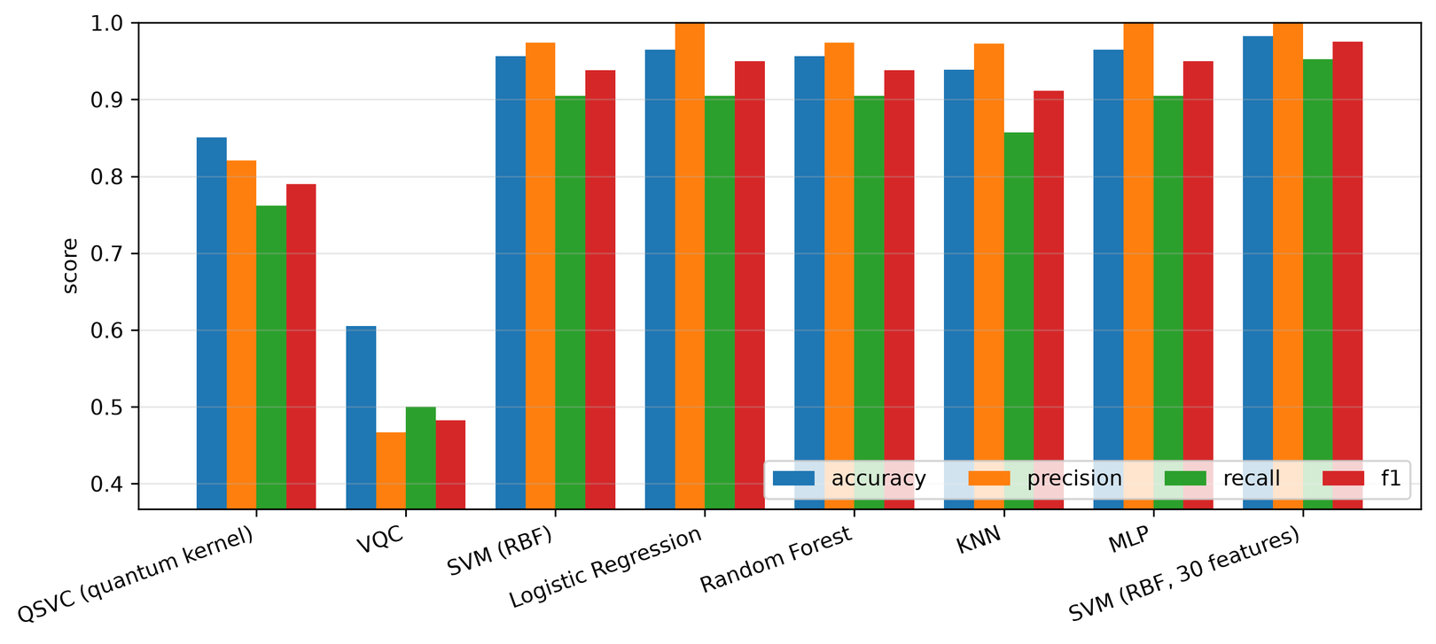
Fig. 5.1. Accuracy, precision, recall and F1-score of all models on the hold-out split.
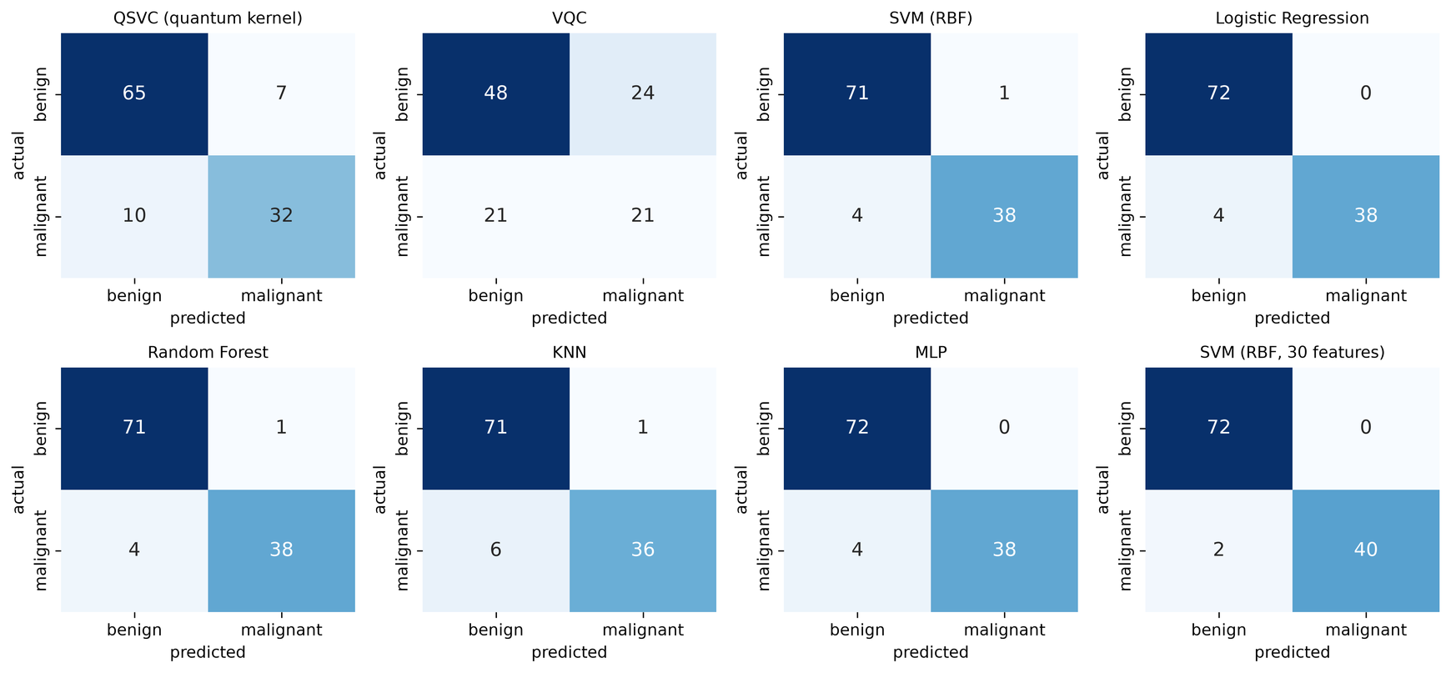
Fig. 5.2. Confusion matrices of all models on the hold-out split.
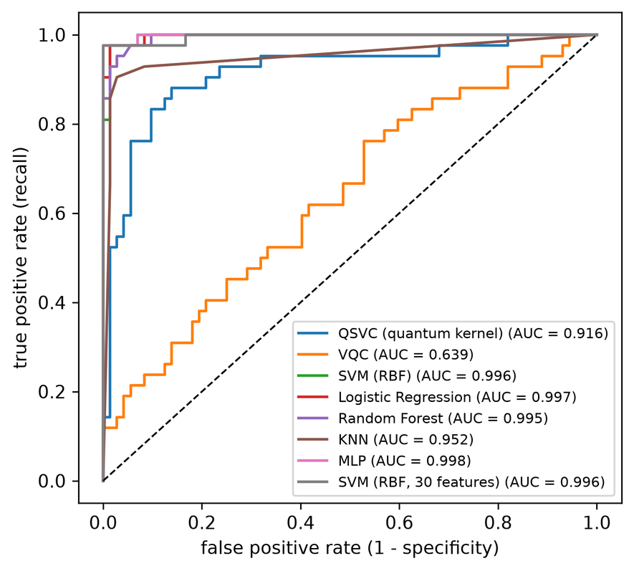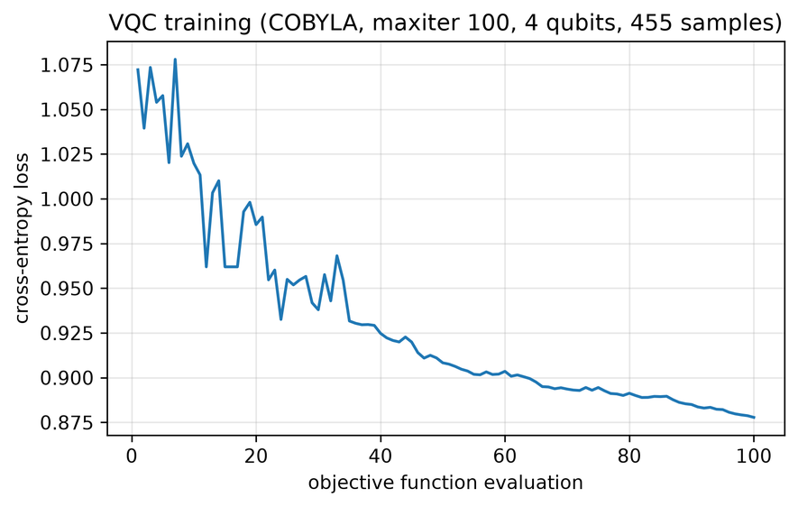
Fig. 5.3. ROC curves (left) and VQC training loss with COBYLA (right), hold-out split.
The VQC loss fell only from 1.072 to 0.878. That is still above $ln2≈0.693$, the loss of a model that always outputs equal probabilities, so training had clearly not converged within the 100 iterations set for this project. Fig. 5.4 compares the two kernels. The RBF kernel shows clear benign and malignant blocks, while most off-diagonal values of the quantum kernel are close to zero, with a mean of about 0.084 across seeds. Most pairs of samples therefore look almost unrelated, giving the SVM little to use.
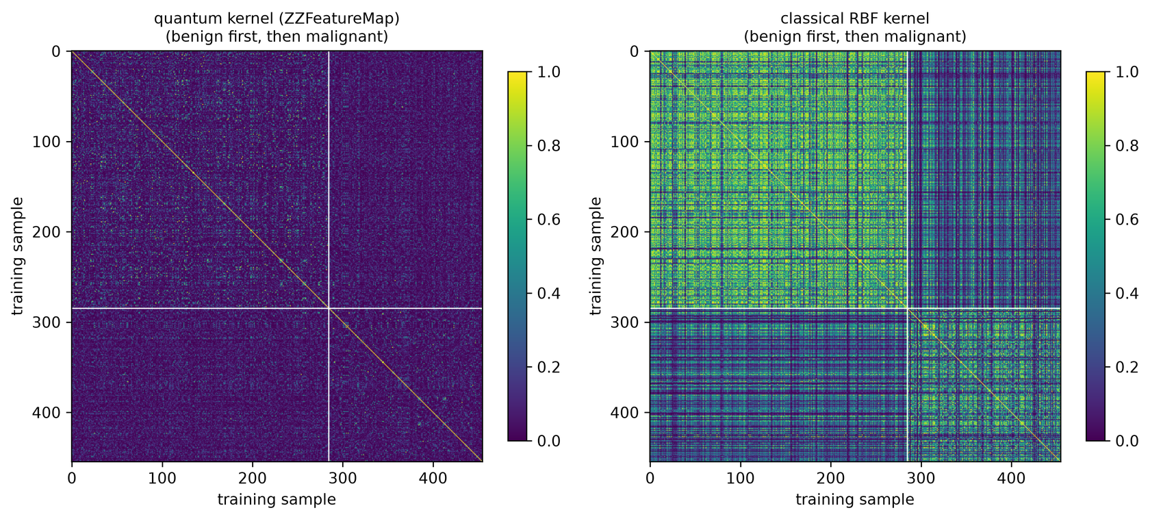
Fig. 5.4. Training kernel matrices: quantum (left) and RBF (right), with samples sorted by class.

5.3 Experiments E2 to E9
Unless stated otherwise, these runs use three seeds (a different split and starting point for each), and values are means over seeds.

5.3.1 E2: Number of Qubits
Fig. 5.5 varies the qubit count and PCA components together. QSVC fell from 0.865 at 2 qubits to 0.769 at 8, even though more qubits carried more variance (63.1% to 92.8%). The RBF SVM rose from 0.921 to 0.956. The mean kernel value fell from 0.469 to 0.010, which matches the trend expected from concentration [17]. VQC, run with one seed and 200 training samples, scored 0.816, 0.763, 0.570 and 0.632, and its time rose from 33.29 s to 628 s.
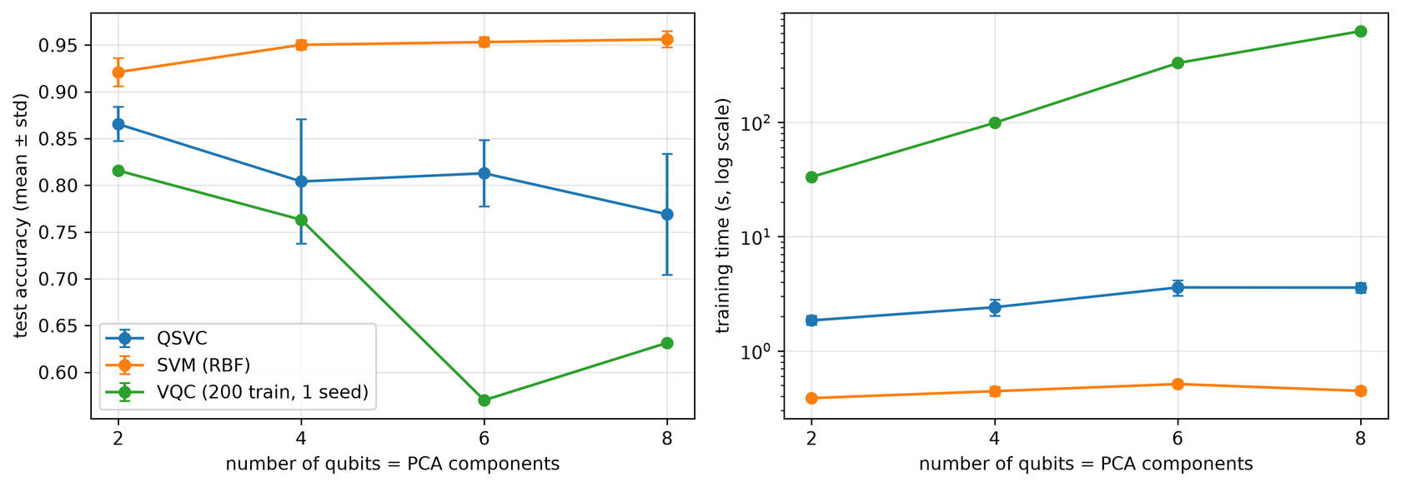
Fig. 5.5. Accuracy and training time against the number of qubits (E2).

5.3.2 E3: Feature Map Depth
In Fig. 5.6, deeper feature maps were worse. QSVC accuracy for reps = 1, 2, 3 and 4 was 0.860, 0.804, 0.804 and 0.708. The mean kernel value stayed near 0.09 throughout (0.085, 0.084, 0.098, 0.089), so a low mean alone does not explain this decline. Extra depth also makes the map vary more quickly with its input, which may reduce useful structure.
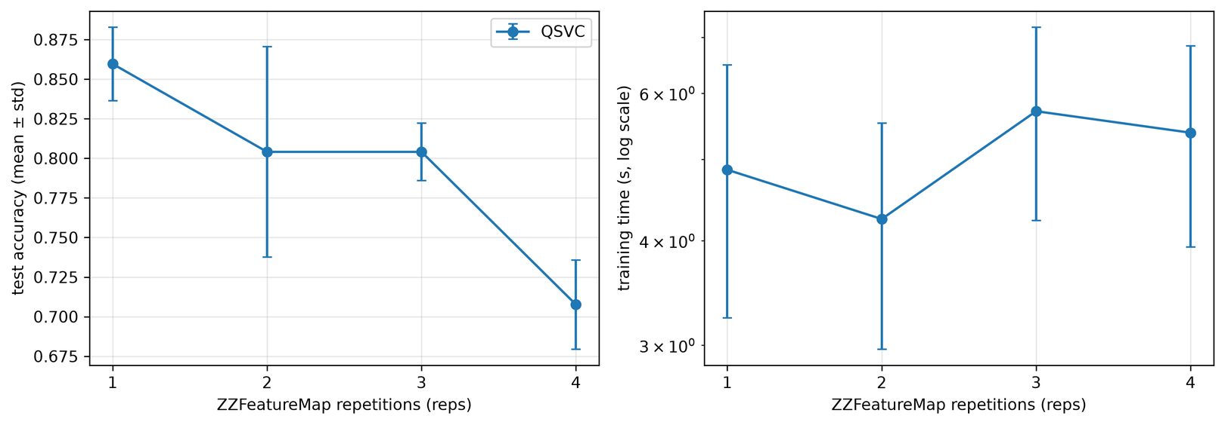
Fig. 5.6. Accuracy and training time against feature map repetitions (E3).

5.3.3 E4: Entanglement
Fig. 5.7 gives the clearest result of the study. The Z feature map, which has no entanglement, reached 0.901 with recall 0.849, and its mean kernel value was 0.355. The ZZ maps with linear, circular and full entanglement reached 0.804, 0.810 and 0.775, and the Pauli map reached 0.830, all with mean kernel values near 0.08. On this task more entanglement did not help, which agrees with the large benchmark in [25]. The Z map is simple to simulate classically, so its better result is not evidence of a quantum benefit.
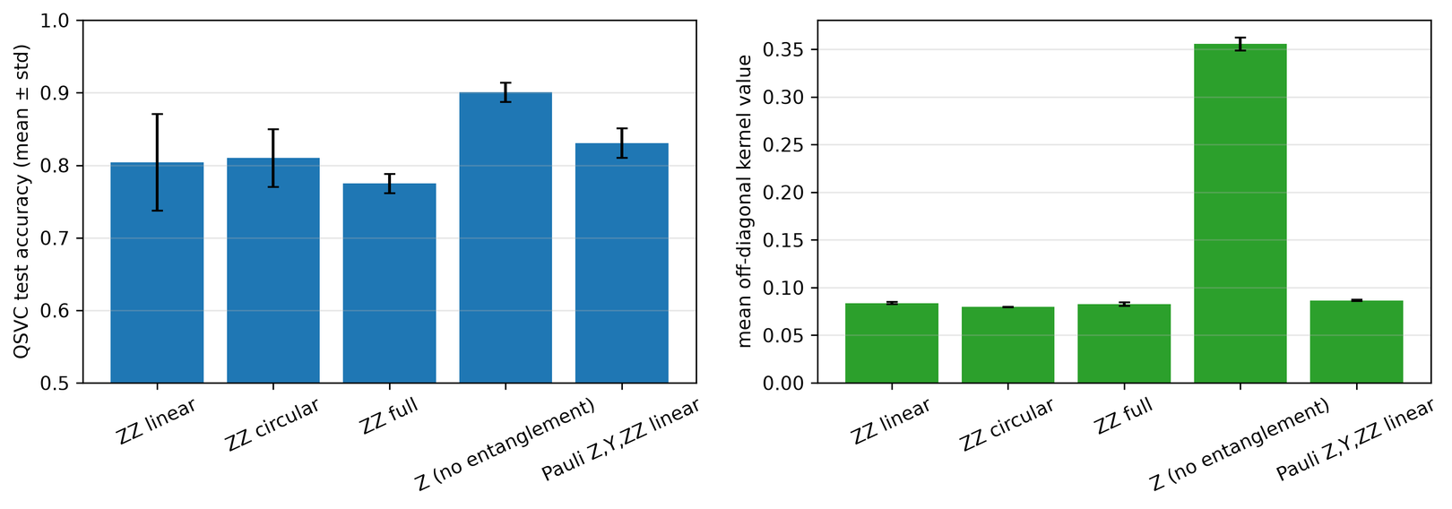
Fig. 5.7. QSVC accuracy and mean kernel value for each feature map (E4).

5.3.4 E5: Ansatz Depth
With 200 training samples, VQC accuracy for reps = 1, 2, 3 and 4 was 0.719, 0.705, 0.687 and 0.696, with standard deviations of 0.023 to 0.071. As Fig. 5.8 shows, the differences are within the spread between seeds, so there is no clear trend. Final loss improved only slightly with depth (0.864 to 0.815), and Fig. 5.9 shows that all runs stayed above 0.693.
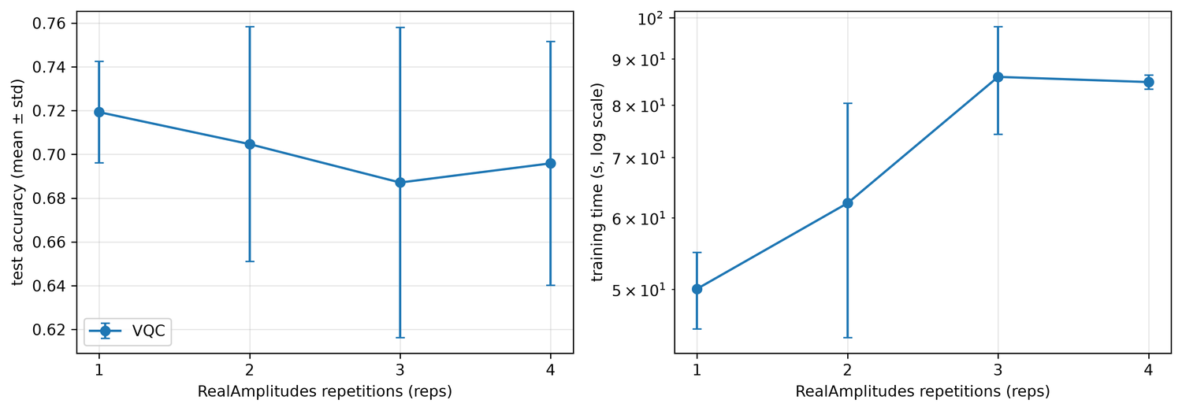
Fig. 5.8. VQC accuracy and time against ansatz depth (E5).
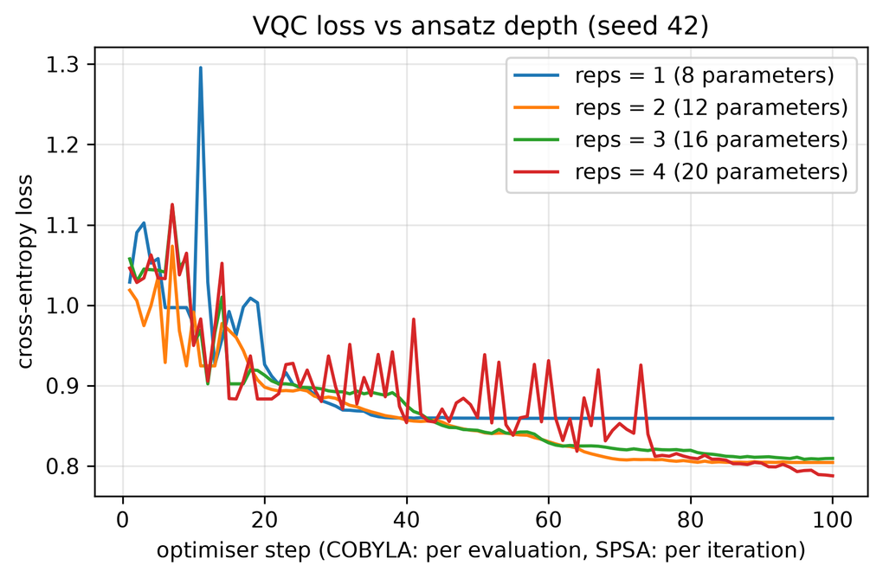
Fig. 5.9. VQC loss curves for each ansatz depth (E5).

5.3.5 E6: Optimiser
COBYLA reached 0.687 ± 0.071 using 100 evaluations and about 114 s. SPSA reached 0.637 ± 0.045 using 300 evaluations and about 456 s. As Fig. 5.10 shows, SPSA's loss curve was smoother but ended higher (0.865 against 0.814 on average). With these settings, COBYLA was both cheaper and better. These two sets of runs were completed before the laptop's power problem was fixed, so their times are less reliable than those in E5.
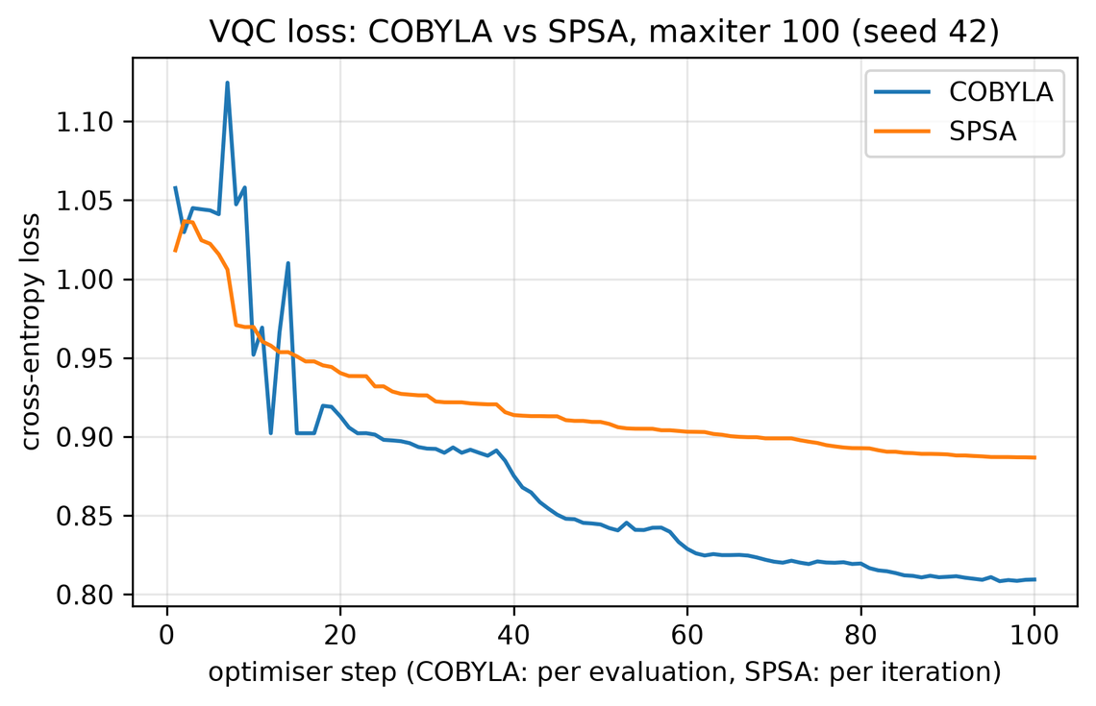
Fig. 5.10. VQC loss for COBYLA and SPSA (E6).

5.3.6 E7: Training Size
As Fig. 5.11 shows, QSVC needed much more data than the RBF SVM. With 50, 100, 200 and 455 samples, QSVC reached 0.632, 0.702, 0.787 and 0.804. At 50 samples its recall was 0.000, meaning it predicted every test sample as benign. The RBF SVM already reached 0.933 at 50 samples. Fig. 5.12 shows the cost of the circuit kernel: 10.3 s, 46.6 s and 163.7 s for 50, 100 and 200 samples, following the expected $M^{2}$ growth.
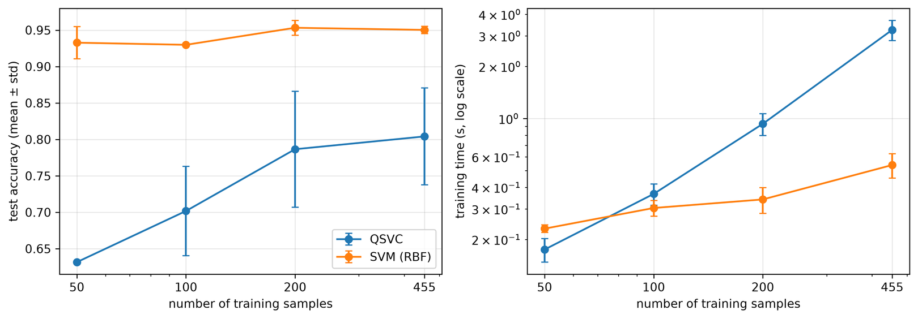
Fig. 5.11. Accuracy and training time against training size (E7).
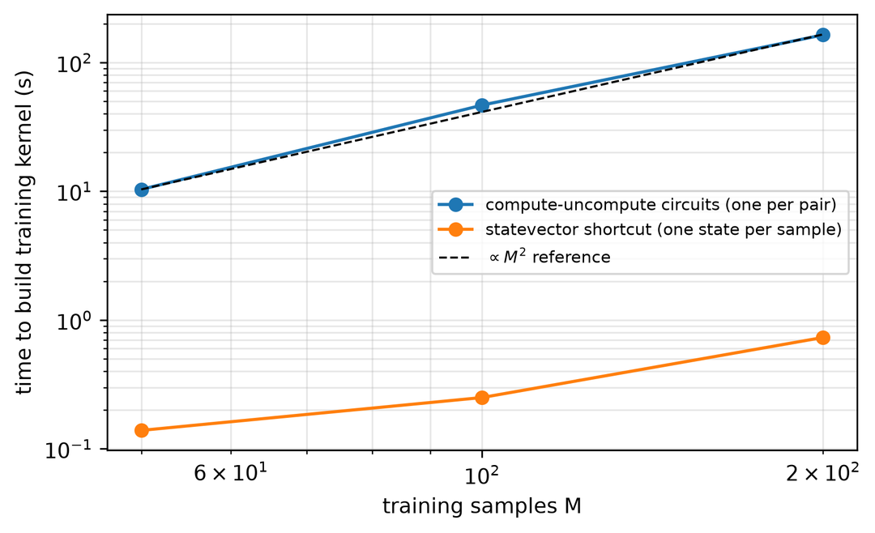
Fig. 5.12. Time to build the training kernel against training size (E7).

5.3.7 E8: Noise
Table 5.3 and Fig. 5.13 compare exact simulation, an ideal sampler with 1024 shots, and the fake Manila noise model, using one seed. QSVC used 100 training samples because every kernel entry is a separate noisy circuit. The VQC was trained on the exact simulator with 200 samples, then evaluated on each setting.
TABLE 5.3. Effect of shots and device noise (one seed).
Model | Setting | Accuracy | Recall | Missed | ROC-AUC
QSVC | Exact statevector | 0.772 | 0.524 | 20 | 0.852
QSVC | Ideal sampler, 1024 shots | 0.816 | 0.690 | 13 | 0.823
QSVC | Noisy fake Manila, 1024 shots | 0.772 | 0.524 | 20 | 0.852
VQC | Exact statevector | 0.763 | 0.476 | 22 | 0.787
VQC | Ideal sampler, 1024 shots | 0.746 | 0.452 | 23 | 0.776
VQC | Noisy fake Manila, 1024 shots | 0.763 | 0.452 | 23 | 0.777

At this small scale, noise changed the summary scores very little. This does not mean that noise has no effect. QSVC's exact and noisy rows are identical in their totals, yet a direct check at the same C showed that 8 of 114 individual predictions differed and that 136 of 3,024 ranked pairs changed order. These changes happened to cancel exactly. The noise also changed the kernel values, with a mean absolute error of 0.028 against the exact kernel, compared with 0.006 for shots alone. The higher score with shots should not be read as shot noise helping, because cross-validation picked C = 10 there and C = 1 in the other two cases, and this is only one split.
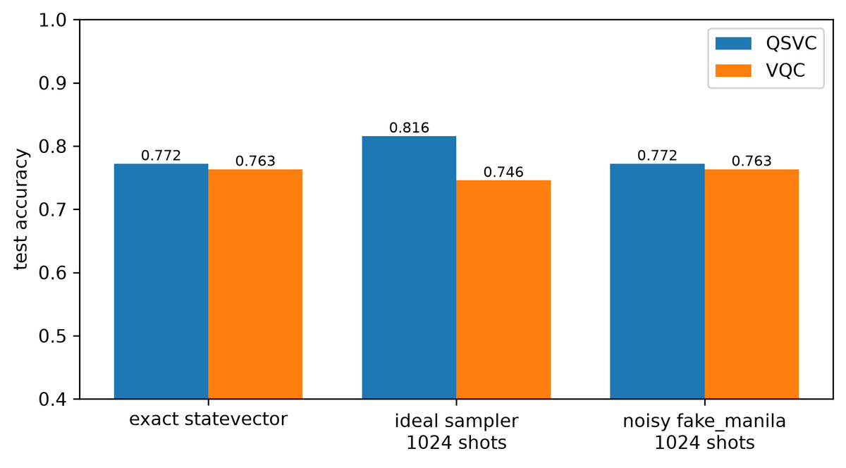
Fig. 5.13. Accuracy under exact simulation, shots and device noise (E8).

5.3.8 E9: Iris Multiclass
To check multiclass support, QSVC and an RBF SVM were run on the Iris data (150 samples, 3 classes) with four qubits and no PCA. QSVC reached 0.881 ± 0.068 and the RBF SVM reached 0.956 ± 0.038. The quantum model handled three classes without changes, and the classical model again scored higher.

5.4 Computational Cost Analysis
Table 5.4 compares the costs. QSVC needs about ${M^{2}}/2$ circuits for $M$ training samples, plus $M×T$ for $T$ test samples. VQC needs about one circuit per sample for every optimiser evaluation. Simulating $n$ qubits requires storing $2^{n}$ amplitudes. On real hardware each circuit must also be repeated for many shots, and that would multiply these counts. Fig. 5.14 shows measured training times on a log scale.
TABLE 5.4. Circuit counts and measured time on the main task (455 training and 114 test samples).
Model | Training circuits | Test circuits | Mean train time in CV
QSVC | $M(M−1)/2$ = 103,285 | $M×T$ = 51,870 | 2.20 s (exact statevector kernel)
VQC | Iterations $×M$ = 45,500 | $T$ = 114 | 161 s
RBF SVM | None | None | 0.33 s (includes tuning)
Logistic regression | None | None | <0.01 s

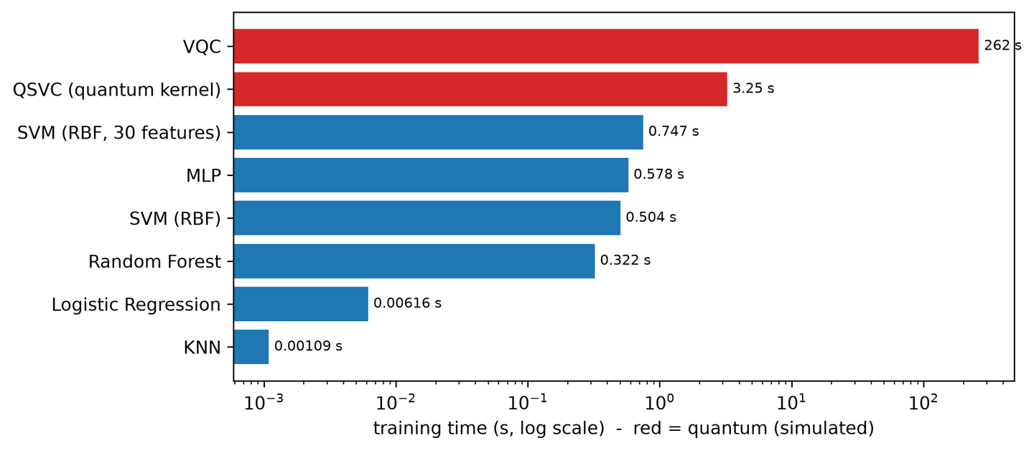
Fig. 5.14. Training time of all models on the hold-out split (log scale).
The short QSVC time depends on the exact statevector shortcut, which a real quantum computer cannot use. With real circuits, simulated cost grows quickly: the 200-sample kernel alone took 163.7 s. So no computational advantage was observed; every quantum model cost more than the classical models it was compared with. This is a result of classical simulation and small problem size, and it does not rule out advantages for other problems on future hardware [13], [15].

5.5 Clinical View: Missed Cancers
Table 5.5 totals errors across the five folds, so each of the 212 malignant samples was tested exactly once. All models used their default decision threshold. QSVC missed about 5.4 times as many cancers as the RBF SVM, and VQC about 8.0 times as many. Missing 112 of 212 cancers would be unacceptable in a diagnostic setting. It should also be noted that even the classical models missed some cancers, so they too would need clinical validation. Changing the threshold could trade false alarms for fewer misses, as a VQC study with high recall on the same dataset suggests [66], but this was not tested here.
TABLE 5.5. Missed cancers and false alarms over 5-fold cross-validation (212 malignant and 357 benign samples).
Model | Missed cancers (FN) | False alarms (FP) | Mean recall
QSVC | 75 | 36 | 0.646
VQC | 112 | 89 | 0.471
SVM (RBF) | 14 | 8 | 0.934
Logistic Regression | 18 | 4 | 0.916
Random Forest | 17 | 15 | 0.920
KNN | 23 | 11 | 0.892
MLP | 13 | 8 | 0.939
SVM (RBF, 30 features) | 8 | 4 | 0.962

5.6 Discussion
Effectiveness. Both quantum pipelines worked correctly from end to end, but neither matched the classical models. QSVC's best setting (Z feature map, 0.901) was still below the RBF SVM (0.950, with the same three seeds at four qubits). These findings align with [25], which reported that classical models generally win on small tasks, and with [56], which reported that a ZZ quantum kernel under-performed on WDBC.
Why the quantum models fell short. The following are likely causes. Each is supported by the results above or by the literature, but this study does not separate them with controlled tests.
- Unsuitable kernel scale. Angles in $[0,π]$ give large ZZ phases, and off-diagonal kernel values were small. Tuning kernel bandwidth has been shown to help [40], but it was not tested here.
- Kernel concentration. Mean kernel values fell as qubits were added, as predicted in [17], although at this size the values are not yet exponentially small.
- Too little VQC training. The loss stayed above 0.693 after 100 iterations with 16 parameters. A well-tuned eight-qubit VQC reached an external AUC of 0.983 in [56], so the VQC result here should not be read as typical of the model family.
- Single-qubit readout. The default class mapping uses only qubit 0, which may limit the VQC. Its effect was not tested.
- Information lost in PCA. Four components keep 79.3% of the variance. This has a real but smaller effect, as the SVM comparison shows.
- Uneven tuning. The RBF SVM tuned both C and gamma over 16 combinations, QSVC tuned only C over three values, and the VQC had no tuning. Classical models therefore had an advantage in this design.
Benefits. The work gives a reproducible pipeline, a fair baseline, and direct evidence on how design choices affect results. QSVC training is convex, so it did not show the training failures seen in the VQC. Implementation challenges. Qiskit's APIs change quickly, simulation time limited the experiment grid, noisy kernels were slow, and long runs were affected by the laptop's power state. Limitations. All runs used simulators; E2's VQC and all of E8 used one seed; VQC sweeps and noisy QSVC used reduced training sets; seeds and folds are few, so small differences are not significant; WDBC is a curated benchmark, so nothing here shows clinical readiness; and the literature review rests on abstracts. Claims about advantage. No claim of quantum advantage is made. The observed results support the opposite conclusion for this task on these simulated small circuits.

6. Conclusion and Future Scope

6.1 Conclusion
This work developed an understanding of quantum computing from qubits, gates, measurement and noise through to the Deutsch-Jozsa, Grover and Shor algorithms, each demonstrated in Qiskit. It showed that quantum algorithms offer proven gains on particular problems, and that these gains do not automatically carry over to machine learning. The review of 45 papers showed a field with strong theory and real hardware progress, but also serious issues: barren plateaus, kernel concentration, noise and a lack of proven practical advantage on classical data.
The mini project built and compared two hybrid models on breast cancer data. In 5-fold cross-validation, QSVC reached 0.805 accuracy with 0.646 recall, and VQC reached 0.647 with 0.471. On identical features, the RBF SVM reached 0.961 with 0.934, and the all-feature SVM reached 0.979. The quantum models missed 75 and 112 of 212 cancers, compared with 14 for the RBF SVM. Removing entanglement improved QSVC to 0.901, deeper feature maps reduced its accuracy, and kernel values shrank as qubits were added. Small-scale noise changed summary scores little in one seed, although individual predictions changed.
The contributions are a working Qiskit pipeline, a fair comparison focused on missed cancers, a joint analysis of circuit settings and cost, and an honest statement of where these models stand. The main limitations are that all results are simulated, the VQC did not converge in its fixed training budget, and tuning was uneven. On this dataset, classical models remain the better choice, and that is a valid finding.

6.2 Future Scope
- Advanced Quantum Neural Networks. Test deeper or problem-specific QNNs, and use a readout based on more than one qubit.
- Improved Variational Quantum Circuits. Train for longer, tune hyperparameters, try better ansatz designs and data re-uploading [44], and use layerwise training [45].
- Better kernels. Tune kernel bandwidth [40], use trainable kernels with alignment [39], and test projected kernels [15].
- Quantum optimisation. Use QAOA [10] for feature selection before encoding.
- Noise and hardware. Apply error mitigation [19], and repeat the tests on real IBM devices and on larger, error-corrected machines as they appear [21], [22].
- Scalable hybrid models. Build hybrid quantum CNNs for mammograms and histopathology images [48], [53], and draw on the hybrid-model background in [74].
- Real-world use. Test on real clinical cohorts with external validation, calibration and threshold tuning, and consider clinical decision support only with attention to privacy, regulation and adversarial robustness [52], [56].

7. References and Bibliography
References are numbered in order of first citation and follow the IEEE style. They include the 45 reviewed papers, books, organisational reports, official framework documentation and the dataset citation. Records of journal papers were checked against Crossref or arXiv, and web pages were opened on the access date shown.
[1] J. Biamonte, P. Wittek, N. Pancotti, P. Rebentrost, N. Wiebe, and S. Lloyd, "Quantum machine learning," Nature, vol. 549, no. 7671, pp. 195–202, 2017, doi: 10.1038/nature23474.
[2] S. Russell and P. Norvig, Artificial Intelligence: A Modern Approach, 4th ed. Hoboken, NJ, USA: Pearson, 2020.
[3] M. Cerezo, G. Verdon, H.-Y. Huang, L. Cincio, and P. J. Coles, "Challenges and opportunities in quantum machine learning," Nat. Comput. Sci., vol. 2, no. 9, pp. 567–576, 2022, doi: 10.1038/s43588-022-00311-3.
[4] K. Bharti et al., "Noisy intermediate-scale quantum algorithms," Rev. Mod. Phys., vol. 94, no. 1, Art. no. 015004, 2022, doi: 10.1103/RevModPhys.94.015004.
[5] A. Senokosov, A. Sedykh, A. Sagingalieva, B. Kyriacou, and A. Melnikov, "Quantum machine learning for image classification," Mach. Learn.: Sci. Technol., vol. 5, no. 1, Art. no. 015040, 2024, doi: 10.1088/2632-2153/ad2aef.
[6] S. Moradi et al., "Clinical data classification with noisy intermediate scale quantum computers," Sci. Rep., vol. 12, no. 1, Art. no. 1851, 2022, doi: 10.1038/s41598-022-05971-9.
[7] Z. Krunic, F. F. Flöther, G. Seegan, N. Earnest-Noble, and O. Shehab, "Quantum Kernels for Real-World Predictions Based on Electronic Health Records," IEEE Trans. Quantum Eng., vol. 3, pp. 1–11, 2022, doi: 10.1109/TQE.2022.3176806.
[8] D. Herman et al., "Quantum computing for finance," Nat. Rev. Phys., vol. 5, no. 8, pp. 450–465, 2023, doi: 10.1038/s42254-023-00603-1.
[9] S. Harwood, C. Gambella, D. Trenev, A. Simonetto, D. B. Neira, and D. Greenberg, "Formulating and Solving Routing Problems on Quantum Computers," IEEE Trans. Quantum Eng., vol. 2, pp. 1–17, 2021, doi: 10.1109/TQE.2021.3049230.
[10] K. Blekos et al., "A review on Quantum Approximate Optimization Algorithm and its variants," Phys. Rep., vol. 1068, pp. 1–66, 2024, doi: 10.1016/j.physrep.2024.03.002.
[11] S. Ebadi et al., "Quantum optimization of maximum independent set using Rydberg atom arrays," Science, vol. 376, no. 6598, pp. 1209–1215, 2022, doi: 10.1126/science.abo6587.
[12] V. Havlíček et al., "Supervised learning with quantum-enhanced feature spaces," Nature, vol. 567, no. 7747, pp. 209–212, 2019, doi: 10.1038/s41586-019-0980-2.
[13] Y. Liu, S. Arunachalam, and K. Temme, "A rigorous and robust quantum speed-up in supervised machine learning," Nat. Phys., vol. 17, no. 9, pp. 1013–1017, 2021, doi: 10.1038/s41567-021-01287-z.
[14] M. C. Caro et al., "Generalization in quantum machine learning from few training data," Nat. Commun., vol. 13, no. 1, Art. no. 4919, 2022, doi: 10.1038/s41467-022-32550-3.
[15] H.-Y. Huang et al., "Power of data in quantum machine learning," Nat. Commun., vol. 12, no. 1, Art. no. 2631, 2021, doi: 10.1038/s41467-021-22539-9.
[16] M. Cerezo et al., "Variational quantum algorithms," Nat. Rev. Phys., vol. 3, no. 9, pp. 625–644, 2021, doi: 10.1038/s42254-021-00348-9.
[17] S. Thanasilp, S. Wang, M. Cerezo, and Z. Holmes, "Exponential concentration in quantum kernel methods," Nat. Commun., vol. 15, no. 1, Art. no. 5200, 2024, doi: 10.1038/s41467-024-49287-w.
[18] M. Cerezo, A. Sone, T. Volkoff, L. Cincio, and P. J. Coles, "Cost function dependent barren plateaus in shallow parametrized quantum circuits," Nat. Commun., vol. 12, no. 1, Art. no. 1791, 2021, doi: 10.1038/s41467-021-21728-w.
[19] Y. Kim et al., "Evidence for the utility of quantum computing before fault tolerance," Nature, vol. 618, no. 7965, pp. 500–505, 2023, doi: 10.1038/s41586-023-06096-3.
[20] F. J. Schreiber, J. Eisert, and J. J. Meyer, "Classical Surrogates for Quantum Learning Models," Phys. Rev. Lett., vol. 131, no. 10, Art. no. 100803, 2023, doi: 10.1103/PhysRevLett.131.100803.
[21] Google Quantum AI and Collaborators, "Quantum error correction below the surface code threshold," Nature, vol. 638, no. 8052, pp. 920–926, 2025, doi: 10.1038/s41586-024-08449-y.
[22] R. Mandelbaum et al., "How IBM will build the world's first large-scale, fault-tolerant quantum computer," IBM Quantum Computing Blog, Jun. 10, 2025. [Online]. Available: https://www.ibm.com/quantum/blog/large-scale-ftqc (accessed Nov. 6, 2026).
[23] H. Soller, M. Gschwendtner, S. Shabani, and W. Svejstrup, "The year of quantum: From concept to reality in 2025," McKinsey & Company, Rep., Jun. 23, 2025. [Online]. Available: https://www.mckinsey.com/capabilities/tech-and-ai/our-insights/the-year-of-quantum-from-concept-to-reality-in-2025 (accessed Nov. 6, 2026).
[24] S. Wang et al., "Noise-induced barren plateaus in variational quantum algorithms," Nat. Commun., vol. 12, no. 1, Art. no. 6961, 2021, doi: 10.1038/s41467-021-27045-6.
[25] J. Bowles, S. Ahmed, and M. Schuld, "Better than classical? The subtle art of benchmarking quantum machine learning models," arXiv:2403.07059, 2024.
[26] M. Schuld and N. Killoran, "Is Quantum Advantage the Right Goal for Quantum Machine Learning?," PRX Quantum, vol. 3, no. 3, Art. no. 030101, 2022, doi: 10.1103/PRXQuantum.3.030101.
[27] A. Javadi-Abhari et al., "Quantum computing with Qiskit," arXiv:2405.08810, 2024.
[28] IBM Quantum, "Introduction to Qiskit and IBM Quantum," Qiskit documentation. [Online]. Available: https://quantum.cloud.ibm.com/docs/en/guides (accessed Nov. 6, 2026).
[29] Google Quantum AI, "Cirq," documentation. [Online]. Available: https://quantumai.google/cirq (accessed Nov. 6, 2026).
[30] R. P. Feynman, "Simulating physics with computers," Int. J. Theor. Phys., vol. 21, no. 6-7, pp. 467–488, 1982, doi: 10.1007/BF02650179.
[31] D. Deutsch, "Quantum theory, the Church–Turing principle and the universal quantum computer," Proc. R. Soc. Lond. A, vol. 400, no. 1818, pp. 97–117, 1985, doi: 10.1098/rspa.1985.0070.
[32] D. Deutsch and R. Jozsa, "Rapid solution of problems by quantum computation," Proc. R. Soc. Lond. A, vol. 439, no. 1907, pp. 553–558, 1992, doi: 10.1098/rspa.1992.0167.
[33] P. W. Shor, "Polynomial-Time Algorithms for Prime Factorization and Discrete Logarithms on a Quantum Computer," SIAM J. Comput., vol. 26, no. 5, pp. 1484–1509, 1997, doi: 10.1137/S0097539795293172.
[34] L. K. Grover, "A fast quantum mechanical algorithm for database search," in Proc. 28th Annu. ACM Symp. Theory Comput., Philadelphia, PA, USA, 1996, pp. 212–219, doi: 10.1145/237814.237866.
[35] M. A. Nielsen and I. L. Chuang, Quantum Computation and Quantum Information, 10th Anniversary ed. Cambridge, U.K.: Cambridge Univ. Press, 2010, doi: 10.1017/CBO9780511976667.
[36] J. D. Hidary, Quantum Computing: An Applied Approach, 2nd ed. Cham, Switzerland: Springer, 2021, doi: 10.1007/978-3-030-83274-2.
[37] J. Preskill, "Quantum Computing in the NISQ era and beyond," Quantum, vol. 2, Art. no. 79, 2018, doi: 10.22331/q-2018-08-06-79.
[38] S. Jerbi, L. J. Fiderer, H. P. Nautrup, J. M. Kübler, H. J. Briegel, and V. Dunjko, "Quantum machine learning beyond kernel methods," Nat. Commun., vol. 14, no. 1, Art. no. 517, 2023, doi: 10.1038/s41467-023-36159-y.
[39] T. Hubregtsen, D. Wierichs, E. Gil-Fuster, P.-J. H. S. Derks, P. K. Faehrmann, and J. J. Meyer, "Training quantum embedding kernels on near-term quantum computers," Phys. Rev. A, vol. 106, no. 4, Art. no. 042431, 2022, doi: 10.1103/PhysRevA.106.042431.
[40] R. Shaydulin and S. M. Wild, "Importance of kernel bandwidth in quantum machine learning," Phys. Rev. A, vol. 106, no. 4, Art. no. 042407, 2022, doi: 10.1103/PhysRevA.106.042407.
[41] E. Peters et al., "Machine learning of high dimensional data on a noisy quantum processor," npj Quantum Inf., vol. 7, no. 1, Art. no. 161, 2021, doi: 10.1038/s41534-021-00498-9.
[42] X. Wang, Y. Du, Y. Luo, and D. Tao, "Towards understanding the power of quantum kernels in the NISQ era," Quantum, vol. 5, Art. no. 531, 2021, doi: 10.22331/q-2021-08-30-531.
[43] M. Schuld, R. Sweke, and J. J. Meyer, "Effect of data encoding on the expressive power of variational quantum-machine-learning models," Phys. Rev. A, vol. 103, no. 3, Art. no. 032430, 2021, doi: 10.1103/PhysRevA.103.032430.
[44] A. Pérez-Salinas, A. Cervera-Lierta, E. Gil-Fuster, and J. I. Latorre, "Data re-uploading for a universal quantum classifier," Quantum, vol. 4, Art. no. 226, 2020, doi: 10.22331/q-2020-02-06-226.
[45] A. Skolik, J. R. McClean, M. Mohseni, P. V. D. Smagt, and M. Leib, "Layerwise learning for quantum neural networks," Quantum Mach. Intell., vol. 3, no. 1, Art. no. 5, 2021, doi: 10.1007/s42484-020-00036-4.
[46] A. Abbas, D. Sutter, C. Zoufal, A. Lucchi, A. Figalli, and S. Woerner, "The power of quantum neural networks," Nat. Comput. Sci., vol. 1, no. 6, pp. 403–409, 2021, doi: 10.1038/s43588-021-00084-1.
[47] Z. Holmes, K. Sharma, M. Cerezo, and P. J. Coles, "Connecting Ansatz Expressibility to Gradient Magnitudes and Barren Plateaus," PRX Quantum, vol. 3, no. 1, Art. no. 010313, 2022, doi: 10.1103/PRXQuantum.3.010313.
[48] A. Mari, T. R. Bromley, J. Izaac, M. Schuld, and N. Killoran, "Transfer learning in hybrid classical-quantum neural networks," Quantum, vol. 4, Art. no. 340, 2020, doi: 10.22331/q-2020-10-09-340.
[49] J. Liu, K. H. Lim, K. L. Wood, W. Huang, C. Guo, and H.-L. Huang, "Hybrid quantum-classical convolutional neural networks," Sci. China Phys. Mech. Astron., vol. 64, no. 9, Art. no. 290311, 2021, doi: 10.1007/s11433-021-1734-3.
[50] T. Hur, L. Kim, and D. K. Park, "Quantum convolutional neural network for classical data classification," Quantum Mach. Intell., vol. 4, no. 1, Art. no. 3, 2022, doi: 10.1007/s42484-021-00061-x.
[51] J. Jäger and R. V. Krems, "Universal expressiveness of variational quantum classifiers and quantum kernels for support vector machines," Nat. Commun., vol. 14, no. 1, Art. no. 576, 2023, doi: 10.1038/s41467-023-36144-5.
[52] W. Ren et al., "Experimental quantum adversarial learning with programmable superconducting qubits," Nat. Comput. Sci., vol. 2, no. 11, pp. 711–717, 2022, doi: 10.1038/s43588-022-00351-9.
[53] V. Azevedo, C. Silva, and I. Dutra, "Quantum transfer learning for breast cancer detection," Quantum Mach. Intell., vol. 4, no. 1, Art. no. 5, 2022, doi: 10.1007/s42484-022-00062-4.
[54] Jose P, S. Hariharan, V. Madhivanan, Sujaudeen N, M. Krisnamoorthy, and A. K. Cherukuri, "Enhanced QSVM with elitist non-dominated sorting genetic optimisation algorithm for breast cancer diagnosis," IET Quantum Commun., vol. 5, no. 4, pp. 384–398, 2024, doi: 10.1049/qtc2.12113.
[55] E. Akpinar, S. M. N. Islam, and M. Oduncuoglu, "Evaluating the Impact of Different Quantum Kernels on the Classification Performance of Support Vector Machine Algorithm: A Medical Dataset Application," arXiv:2407.09930, 2024.
[56] G. Zorlu and C. Colak, "A Robustness-Oriented Quantum–Classical Hybrid Machine Learning Pipeline for Breast Cancer Diagnosis: External Validation, Explainability, and Rigorous Benchmarking in the NISQ Era," Diagnostics, vol. 16, no. 13, Art. no. 1996, 2026, doi: 10.3390/diagnostics16131996.
[57] J. Landman et al., "Quantum Methods for Neural Networks and Application to Medical Image Classification," Quantum, vol. 6, Art. no. 881, 2022, doi: 10.22331/q-2022-12-22-881.
[58] M. Henderson, S. Shakya, S. Pradhan, and T. Cook, "Quanvolutional neural networks: powering image recognition with quantum circuits," Quantum Mach. Intell., vol. 2, no. 1, Art. no. 2, 2020, doi: 10.1007/s42484-020-00012-y.
[59] S. Wei, Y. Chen, Z. Zhou, and G. Long, "A quantum convolutional neural network on NISQ devices," AAPPS Bull., vol. 32, no. 1, Art. no. 2, 2022, doi: 10.1007/s43673-021-00030-3.
[60] A. Abbas et al., "Challenges and opportunities in quantum optimization," Nat. Rev. Phys., vol. 6, no. 12, pp. 718–735, 2024, doi: 10.1038/s42254-024-00770-9.
[61] J. Bausch et al., "Learning high-accuracy error decoding for quantum processors," Nature, vol. 635, no. 8040, pp. 834–840, 2024, doi: 10.1038/s41586-024-08148-8.
[62] Y. Alexeev et al., "Artificial intelligence for quantum computing," Nat. Commun., vol. 16, no. 1, Art. no. 10829, 2025, doi: 10.1038/s41467-025-65836-3.
[63] M. Kalinin and V. Krundyshev, "Security intrusion detection using quantum machine learning techniques," J. Comput. Virol. Hacking Techn., vol. 19, no. 1, pp. 125–136, 2023, doi: 10.1007/s11416-022-00435-0.
[64] World Health Organization, "Breast cancer," Fact Sheet, Jul. 3, 2026. [Online]. Available: https://www.who.int/news-room/fact-sheets/detail/breast-cancer (accessed Nov. 6, 2026).
[65] F. Bray et al., "Global cancer statistics 2022: GLOBOCAN estimates of incidence and mortality worldwide for 36 cancers in 185 countries," CA Cancer J. Clin., vol. 74, no. 3, pp. 229–263, 2024, doi: 10.3322/caac.21834.
[66] K. Mpofu and P. Mthunzi-Kufa, "Comparing artificial neural networks with variational quantum circuits for biomedical data classification," MATEC Web Conf., vol. 417, Art. no. 02001, 2025, doi: 10.1051/matecconf/202541702001.
[67] C. M. Bishop, Pattern Recognition and Machine Learning. New York, NY, USA: Springer, 2006.
[68] C. Cortes and V. Vapnik, "Support-vector networks," Mach. Learn., vol. 20, no. 3, pp. 273–297, 1995, doi: 10.1007/BF00994018.
[69] M. J. D. Powell, "A direct search optimization method that models the objective and constraint functions by linear interpolation," in Advances in Optimization and Numerical Analysis, S. Gomez and J.-P. Hennart, Eds. Dordrecht, Netherlands: Springer, 1994, pp. 51–67, doi: 10.1007/978-94-015-8330-5_4.
[70] J. Spall, "Multivariate stochastic approximation using a simultaneous perturbation gradient approximation," IEEE Trans. Autom. Control, vol. 37, no. 3, pp. 332–341, 1992, doi: 10.1109/9.119632.
[71] F. Pedregosa et al., "Scikit-learn: Machine learning in Python," J. Mach. Learn. Res., vol. 12, pp. 2825–2830, 2011. [Online]. Available: https://jmlr.org/papers/v12/pedregosa11a.html
[72] W. Wolberg, O. Mangasarian, N. Street, and W. Street, "Breast Cancer Wisconsin (Diagnostic)," UCI Machine Learning Repository, 1995, doi: 10.24432/C5DW2B.
[73] Qiskit Machine Learning contributors, "Qiskit Machine Learning," software repository and documentation links. [Online]. Available: https://github.com/stfc/qiskit-machine-learning (accessed Nov. 6, 2026).
[74] M. Schuld and F. Petruccione, Machine Learning with Quantum Computers, 2nd ed. Cham, Switzerland: Springer, 2021, doi: 10.1007/978-3-030-83098-4.

