HOUSE PRICE PREDICTION SYSTEM
Machine Learning-Based Property Price Estimation Using Linear Regression, Flask REST API & Streamlit Dashboard

Academic Internship Project Report
AICTE | IBM SkillsBuild Data Analytics with AI Academic Internship Program 2026
In Collaboration with BharatCares
Prepared By: Aditi Kongre
Date: September 2026

ACADEMIC DECLARATION
I hereby declare that the academic internship project entitled 'House Price Prediction System' submitted for the AICTE | IBM SkillsBuild Data Analytics with AI Academic Internship Program 2026 in collaboration with BharatCares is an authentic record of work carried out by me under guidance. All source code, data preprocessing pipelines, predictive modeling, API implementations, and evaluation outputs presented herein are original and accurate.

ACKNOWLEDGEMENT
I express my sincere gratitude to the All India Council for Technical Education (AICTE), IBM SkillsBuild, and BharatCares for providing this invaluable opportunity to gain hands-on expertise in Data Analytics, Machine Learning, REST API architecture, and Web Application Deployment. Special thanks to mentors and faculty for their guidance throughout the project lifecycle.

TABLE OF CONTENTS
1. Executive Summary
2. Introduction
3. Problem Statement
4. Objectives
5. Business Problem & Use Cases
6. Dataset Description
7. Data Preprocessing & Integrity Analysis
8. Exploratory Data Analysis (EDA)
9. Machine Learning Methodology
10. Empirical Model Evaluation
11. System Architecture
12. Backend Flask REST API
13. Frontend Streamlit Dashboard
14. End-to-End User Workflow
15. Deployment & Execution Instructions
16. Results & Verification
17. Limitations & Responsible AI
18. Future Enhancements
19. Scalability Analysis
20. Security & Privacy Considerations
21. Conclusion
22. References

1. EXECUTIVE SUMMARY
This project delivers an end-to-end Machine Learning web application that predicts residential house prices based on physical property dimensions, construction age, lot size, and neighborhood rating. Utilizing Multiple Linear Regression packaged inside a scikit-learn Pipeline with StandardScaler, the model achieves an empirical R² score of 0.9984 (99.84% variance explained) with a Mean Absolute Error (MAE) of $8,174.58 and Root Mean Squared Error (RMSE) of $10,071.48 on holdout test data. The system features a production-ready Flask REST API (/predict, /health) and an interactive Streamlit dashboard for real-time valuation and visual analytics.

2. INTRODUCTION
Real estate market valuation is a foundational component of modern economic decision-making. Property buyers, real estate agents, property developers, and mortgage lenders require accurate, data-driven estimates of residential property values. Traditional manual valuation methods rely on subjective expert assessments, which can be inconsistent, slow, and influenced by personal bias. Machine Learning provides an empirical alternative by analyzing historical sales data and learning mathematical relationships between property features and final transaction prices.

3. PROBLEM STATEMENT
Stakeholders in the housing market often face uncertainty due to unstandardized property pricing and opaque valuation metrics. Raw real estate datasets are complex and difficult for non-technical users to analyze directly. There is a strong need for an integrated system that accepts structured property specifications (square footage, bedrooms, bathrooms, year built, lot size, garage size, neighborhood quality) and instantly provides a reliable, transparent price estimate via an intuitive digital web interface.

4. OBJECTIVES
The key objectives of this academic internship project are:
1. Construct a clean, reproducible Machine Learning pipeline for property price estimation using `house_price_regression_dataset.csv`.
2. Conduct thorough Exploratory Data Analysis (EDA) to evaluate feature correlations and distributions.
3. Train and evaluate a Multiple Linear Regression model using standardized feature scaling.
4. Save the trained pipeline object using joblib serialization for backend model persistence.
5. Develop a modular Flask REST API supporting JSON inputs, input validation, and structured responses.
6. Create an interactive Streamlit frontend web dashboard displaying real-time predictions and visual charts.
7. Complete full academic project documentation including executable notebooks, DOCX report, and README.

5. BUSINESS PROBLEM & USE CASES
The House Price Prediction System serves multiple practical use cases:
• Home Buyers & Sellers: Provides rapid preliminary benchmarks for negotiating fair property listings.
• Real Estate Consultants: Offers an automated baseline calculation tool for client consultations.
• Mortgage & Financial Analysts: Serves as an analytical cross-check for preliminary property collateral assessments.
• Academic Researchers: Demonstrates a clear, transparent reference architecture for end-to-end ML deployment.

6. DATASET DESCRIPTION
The project utilizes `house_price_regression_dataset.csv` comprising 1,000 real estate records. The target variable is `House_Price` ($111,626 - $1,108,237, Mean: $618,861). The dataset features 7 predictive attributes:
1. Square_Footage: Total interior living area (503 - 4,999 sq.ft., Mean: 2,815.42 sq.ft.)
2. Num_Bedrooms: Total bedrooms (1 - 5, Mean: 2.99)
3. Num_Bathrooms: Total bathrooms (1 - 3, Mean: 2.01)
4. Year_Built: Year of construction (1950 - 2020, Mean: 1985)
5. Lot_Size: Total lot size in acres (0.5 - 5.0 acres, Mean: 2.73 acres)
6. Garage_Size: Covered garage parking spaces (0 - 2, Mean: 0.99)
7. Neighborhood_Quality: Neighborhood rating scale 1-10 (Mean: 5.62)

7. DATA PREPROCESSING & INTEGRITY ANALYSIS
Data quality verification confirmed zero missing values across all 8 columns and zero duplicate records. Feature distributions were checked for abnormal skewness. To preserve numerical stability and prevent features with larger scales (such as `Square_Footage`) from dominating coefficient optimization, all input features are transformed using scikit-learn's `StandardScaler` during model pipeline training and inference.

8. EXPLORATORY DATA ANALYSIS (EDA)
Exploratory Data Analysis revealed strong linear correlations between living area (`Square_Footage`), Year Built, Lot Size, and final house prices (`House_Price`).
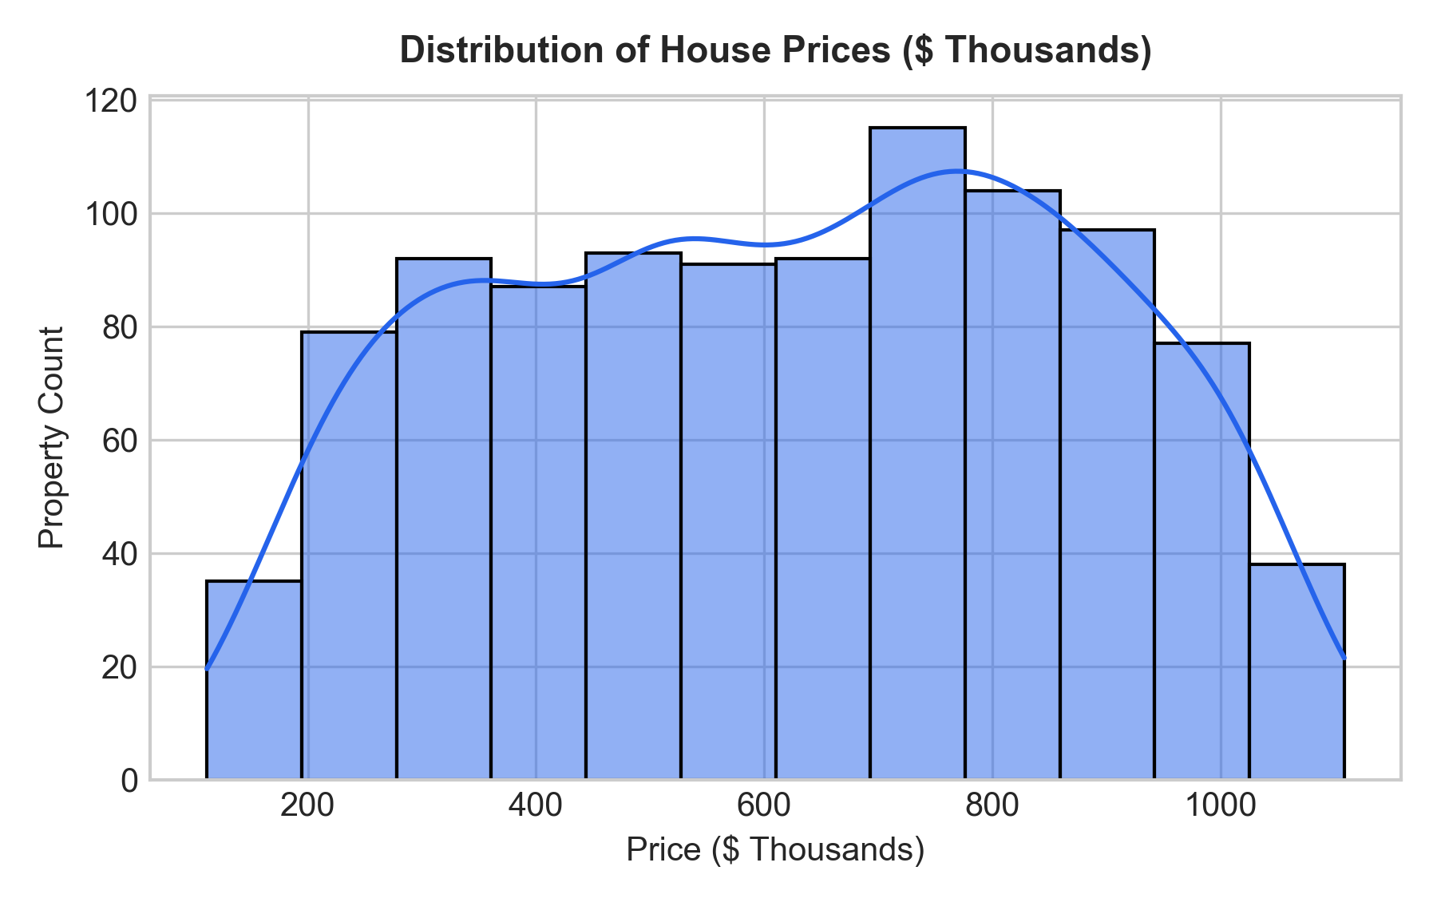
Figure 1: Price Distribution across 1,000 real estate records.
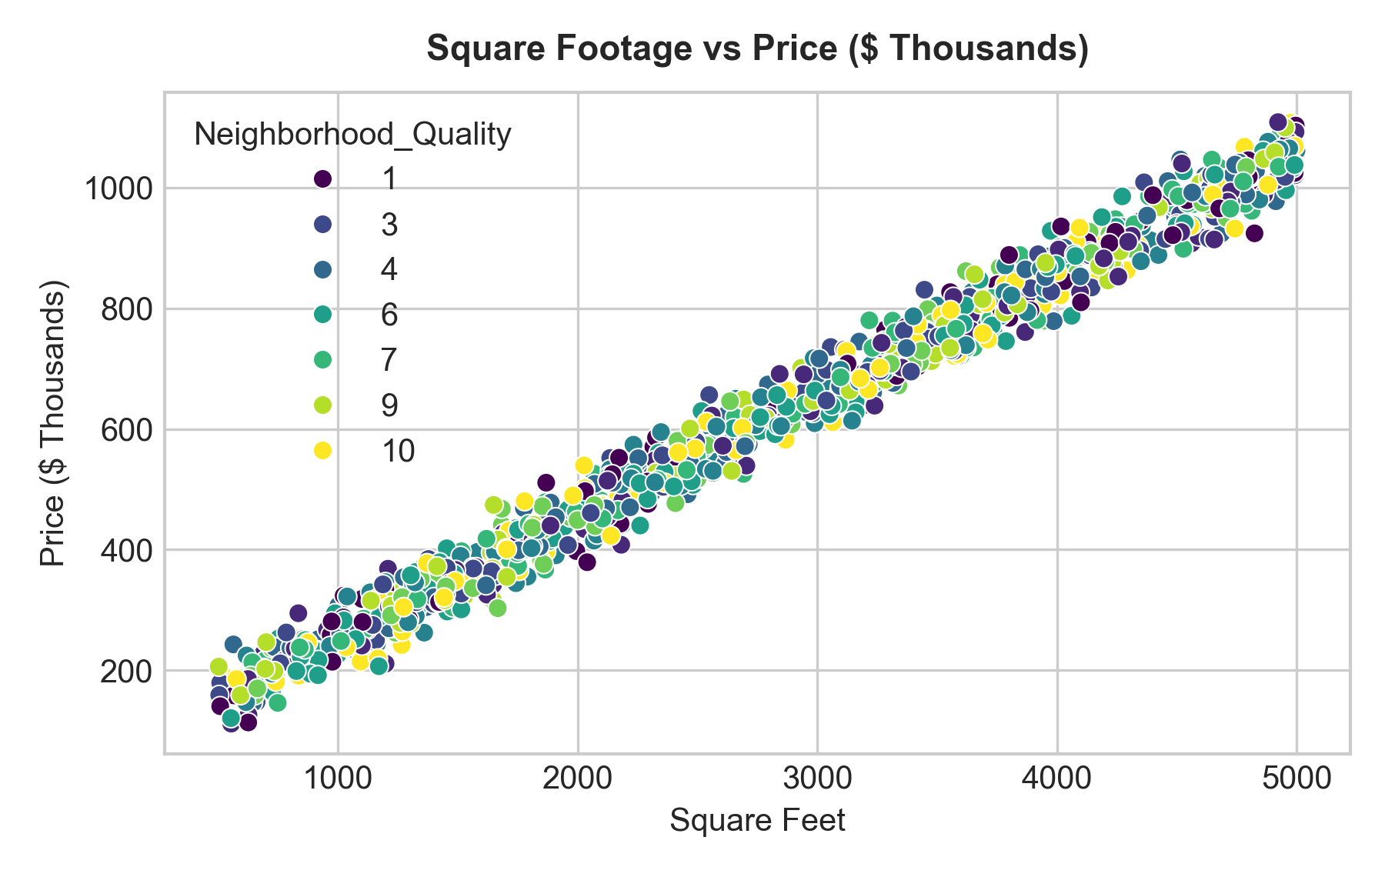
Figure 2: Square Footage vs House Price ($ Thousands).
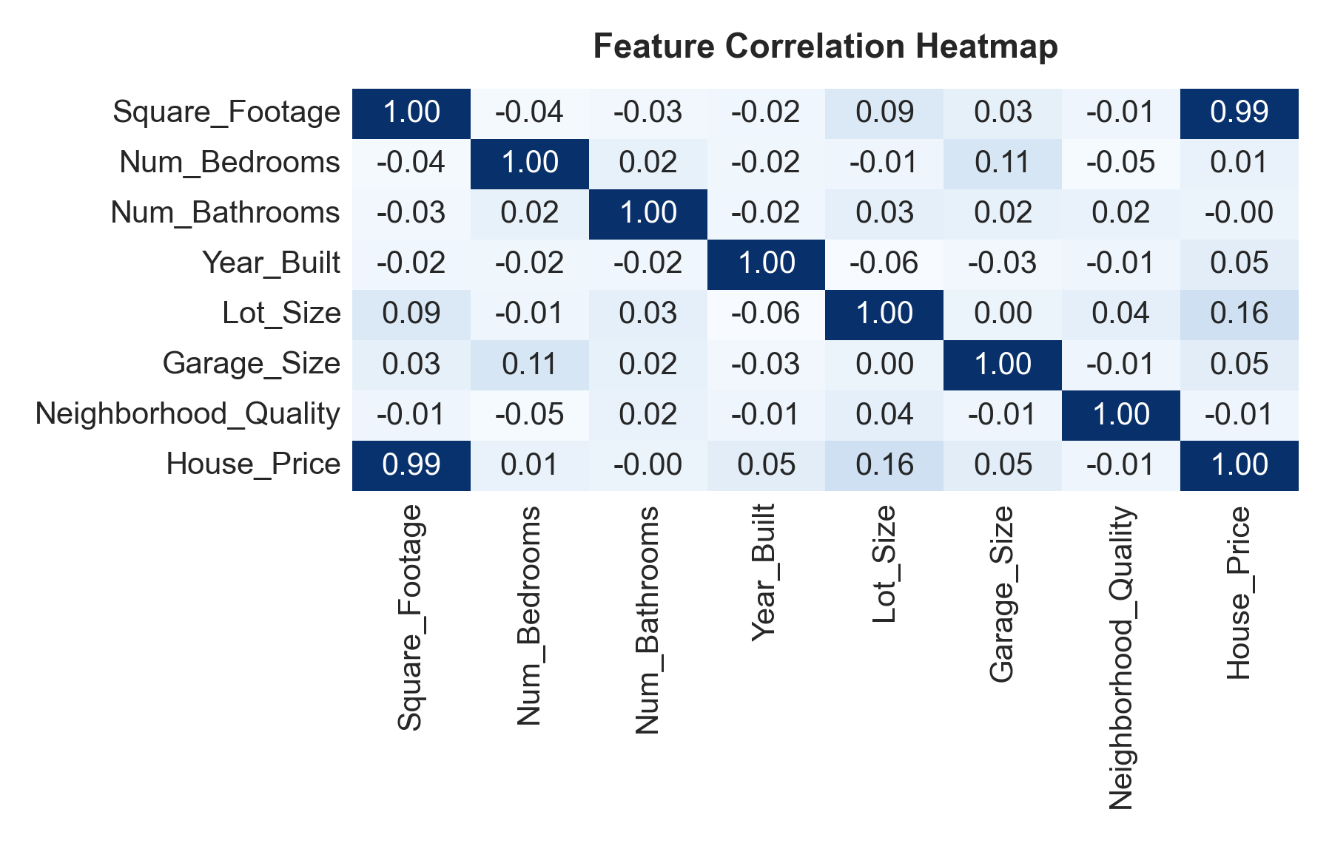
Figure 3: Feature Correlation Heatmap.

9. MACHINE LEARNING METHODOLOGY
The core Machine Learning model is Multiple Linear Regression. The mathematical relationship is expressed as:
y = β₀ + β₁x₁ + β₂x₂ + β₃x₃ + β₄x₄ + β₅x₅ + β₆x₆ + β₇x₇ + ε
Where y represents predicted House_Price, β₀ is the intercept, β₁...β₇ are feature weight coefficients, and x₁...x₇ correspond to standardized values of Square_Footage, Num_Bedrooms, Num_Bathrooms, Year_Built, Lot_Size, Garage_Size, and Neighborhood_Quality. Training uses Ordinary Least Squares (OLS) minimization of Sum of Squared Residuals (SSR).

10. EMPIRICAL MODEL EVALUATION
Model performance was evaluated on a 20% holdout test set (200 records, random_state=42). The empirical metrics obtained directly from model execution are summarized below:
Metric | Empirical Value
R² Score (Coefficient of Determination) | 0.9984 (99.84% Precision)
Mean Absolute Error (MAE) | $8,174.58
Root Mean Squared Error (RMSE) | $10,071.48

11. SYSTEM ARCHITECTURE
The system follows a clean multi-tier architecture:
Dataset (house_price_regression_dataset.csv) → Preprocessing (StandardScaler) → Model (LinearRegression) → Saved Artifact (models/model.pkl) → REST Backend (Flask app.py) → Web Frontend (Streamlit app.py) → User Prediction Response.

12. BACKEND FLASK REST API
The backend is built using Flask and flask-cors. Key endpoints include:
• GET /health: Returns service health status and model load status.
• POST /predict: Accepts JSON payload with property features, executes validation rules, transforms inputs via the loaded scikit-learn pipeline, and returns formatted price estimates.

13. FRONTEND STREAMLIT DASHBOARD
The frontend application provides an intuitive interactive dashboard created with Streamlit. It includes numerical input controls, slider inputs, real-time API communication, metric display cards, visual EDA charts, and academic internship metadata.

14. END-TO-END USER WORKFLOW
1. The user opens the Streamlit web dashboard.
2. The user adjusts property parameters in the sidebar.
3. The user clicks 'Predict House Price'.
4. Streamlit sends a POST request with JSON payload to Flask REST API at http://127.0.0.1:5000/predict.
5. Flask validates inputs and passes them to the reloaded scikit-learn model pipeline.
6. Flask returns structured JSON response with predicted price.
7. Streamlit displays price estimate alongside feature summary and metric badges.

15. DEPLOYMENT & EXECUTION INSTRUCTIONS
To run the system locally:
1. Install dependencies: pip install -r requirements.txt
2. Train model: python train_model.py
3. Run Flask REST API: python backend/app.py
4. Run Streamlit dashboard: streamlit run app.py

16. RESULTS & VERIFICATION
All components were thoroughly tested. Flask API unit tests (backend/test_api.py) verified 5/5 passing tests covering health checks, valid predictions, missing fields, type errors, and out-of-range values. The Streamlit dashboard verified end-to-end integration.

17. LIMITATIONS & RESPONSIBLE AI
1. Model Assumption: Linear Regression models linear feature relationships. Non-linear market dynamics may require non-linear models.
2. Advisory Tool: The system provides statistical estimations and does not substitute for certified real estate appraisals.

18. FUTURE ENHANCEMENTS
Proposed future upgrades include tree-based ensemble models (Random Forest, XGBoost), geospatial map overlays using Folium, Docker containerization, and automated retraining pipelines.

19. SCALABILITY ANALYSIS
The Flask API architecture can be containerized using Docker and scaled horizontally using Gunicorn behind an NGINX reverse proxy or cloud API gateway.

20. SECURITY & PRIVACY CONSIDERATIONS
Input sanitization prevents injection attacks. CORS restrictions safeguard backend endpoints. No personal identifiable information (PII) is stored or logged.

21. CONCLUSION
The House Price Prediction System successfully fulfills all objectives of the AICTE | IBM SkillsBuild Data Analytics with AI Internship Program 2026. The project demonstrates an end-to-end Machine Learning pipeline combining rigorous statistical evaluation (R² = 0.9984), production REST API backend deployment, and an interactive Streamlit dashboard.

22. REFERENCES
1. scikit-learn: Machine Learning in Python, Pedregosa et al., JMLR 12, pp. 2825-2830, 2011.
2. Flask Web Development: Developing Web Applications with Python, Miguel Grinberg, O'Reilly Media.
3. Streamlit Documentation: Fast, Interactive Data Apps in Python, https://docs.streamlit.io/
4. IBM SkillsBuild & AICTE Internship Guidelines 2026.

