**Report on Errors and Bugs**

**Note:** All the code, input and output files are available under “Python Modeling” in my GitHub.

**Part 1: OSM2GMNS**

* The network type ‘railway’ cannot produce default lanes, default speed and default capacity using the code below.

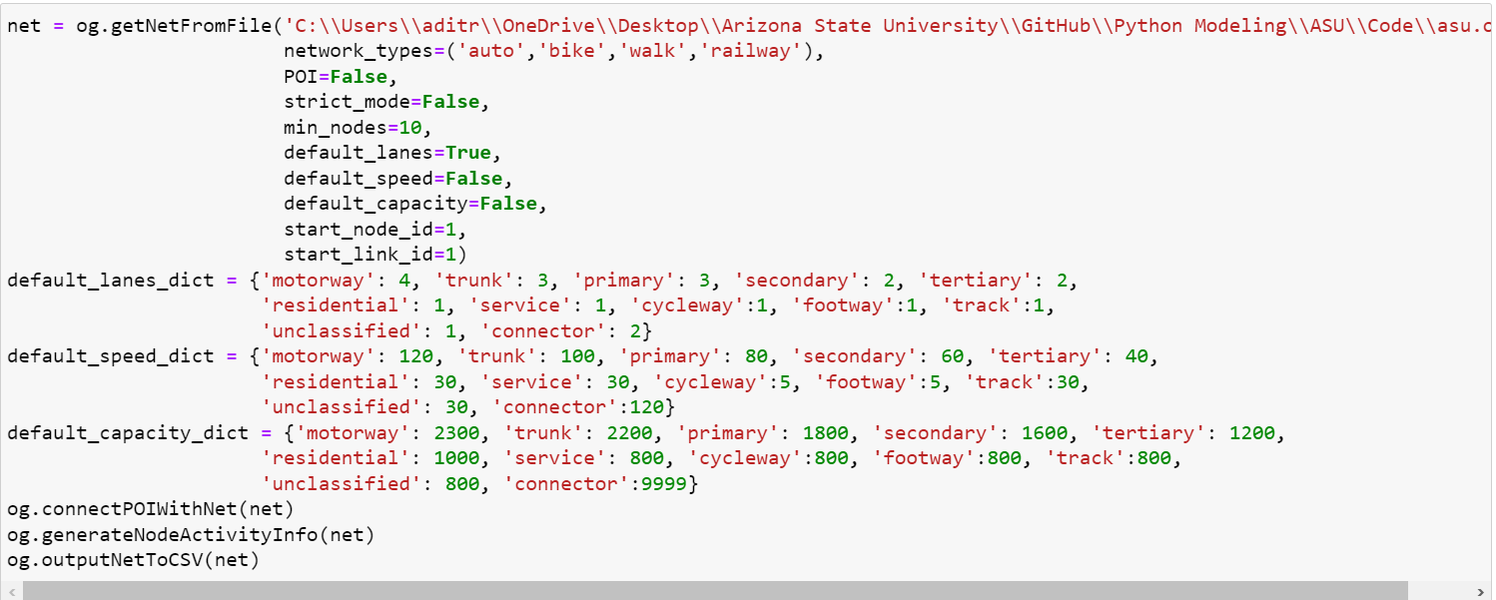

* The following error occurs when the code is run. Moreover, the error is similar for default lanes, default speed and default capacity.

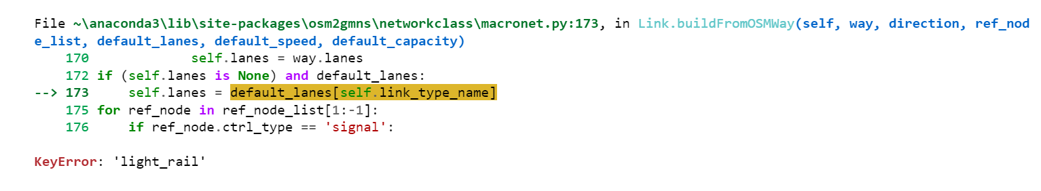

* The “allowed_users” column in the link.csv file does not contain a valid type for public transit (excluding walk and bike).
* OSM2GMNS does not have an option to produce routes with bus mode.

**Part 2: GRID2DEMAND**

* The code throws an error: UnicodeDecodeError: 'utf-8' codec can't decode byte 0xea in position 154614: invalid continuation byte.

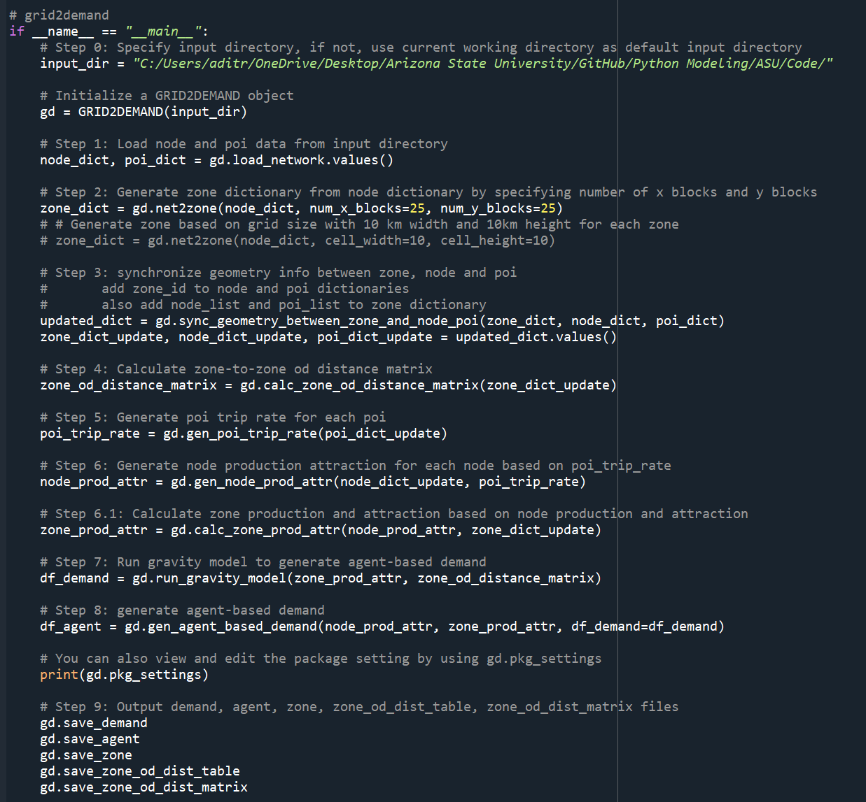

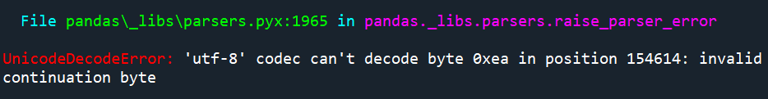

**Part 3: PATH4GMNS**

* There is no clarity on the column generation concept.
* The agent.csv file is empty.
* The equity_60min.csv file contain only zeros for all accessibility columns.
* The columns ‘volume’ and ‘voc’ in the link_performance.csv file contain only zeros.
* The od_accessibility.csv file has major problems. As shown below, the values for all columns (except o_zone_id) are completely out of place.

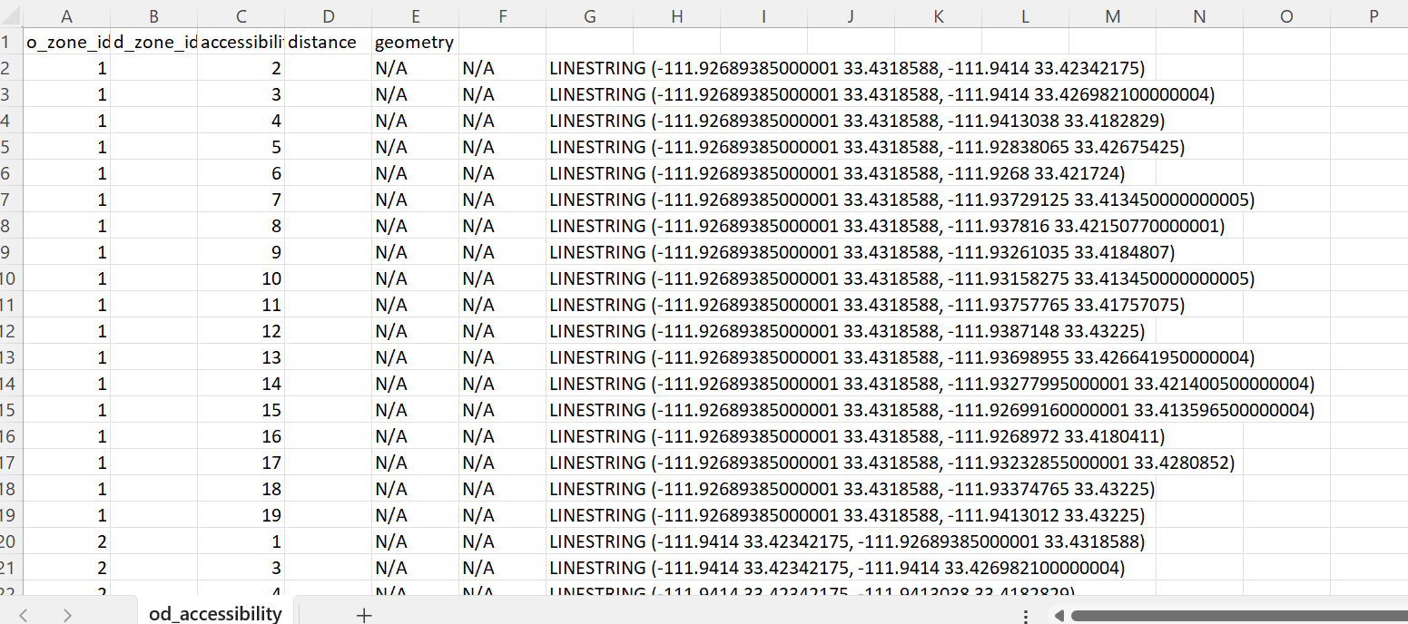

* The trajectory.csv file is empty.
* The column ‘TT_10’ in the zone_accessibility.csv file contains only zeros.