EquiPPP Product

Software Architecture Document

Version 1.0

Revision History

Date | Version | Description | Author
25-Feb-2016 | 1.0 | Initial Version | Lakshmana Rao

Table of Contents
1. Introduction 4
1.1 Purpose 4
1.2 Scope 4
1.3 Overview 4
2. Architectural Representation 4
3. Logical View 4
3.1 Overview 4
3.2 Architecturally Significant Design Packages 5
3.2.1 Application Layer 5
1.1.2 Data Layer 5
3.2.2 Presentation Layer 5
4. Deployment View 6
5. Implementation View 6
5.1 Overview 6
5.2 Layers 7
1.1.3 Presentation Layer 7
1.1.4 Web Server Layer 7
1.1.5 Data Layer 7
6. Size and Performance 7

Software Architecture Document

Introduction

Purpose
This document provides a comprehensive architectural overview of the EquiPPP product, using a number of different architectural views to depict different aspects of the system. It is intended to capture and convey the significant architectural decisions which have been made on the EquiPPP product.

Scope
This document applies to the overall design of the EquiPPP product. It contains information relating to the architectural design of the product, the technologies used, and of the physical servers hosting the site.

Overview
This Document provides the reader with an understanding of the design of the EquiPPP. It is organized into several views of the system, the Logical view, which will give an overview of the components the system is comprised of, and the Technologies view, which will give go into how the system will develop and what are the technologies we would be using.

Architectural Representation
This system was designed using a standard three tiered architecture, with a Presentation Tier, Application Tier and Data tier. The Presentation Tier contains all of the visible web pages and handles all input from and output to the user. The Application Tier handles all of the Business logic and provides an abstraction to the database, the Data tier consists of the Database and stored procedures contained within, and this provides the persistence required for the system. The Logical View shows a quick overview of all of the basic subsystems in the System and gives a basic overview of the System as a whole. The Deployment view tells how the system is physically configured. The Implementation View gives a more in-depth view into how the system has been implemented. The Data view shows how the Database is setup and structured.

Logical View

Overview

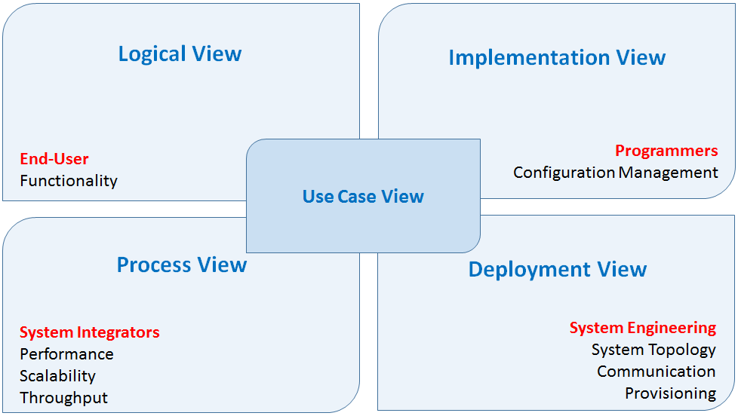

Use Case View
The conceptual view consists of a small subset of important scenarios—instances of use cases—to show that the elements of the four views work together seamlessly. This view overlaps, and is somewhat redundant with, the other four views, but it plays two critical roles: it acts as a driver to help designers discover architectural elements and patterns during the architecture design, and it also validates and illustrates the architecture design, both on paper and as the starting point for the tests of an architectural prototype.
Audience: End Users, Business Analysts, Integrators, Programmers, Software Managers, System Engineers, and Infrastructure Personnel

Logical View
The logical view primarily supports the functional requirements and the functionality the system should provide to its end users. Designers decompose the system into a set of key abstractions, taken mainly from the problem domain. These abstractions are objects or object classes that exploit the principles of abstraction, encapsulation, and inheritance. In addition to aiding functional analysis, decomposition identifies mechanisms and design elements that are common across the system.
Audience: End Users, Business Analysts

Process View
The process view mainly focuses on the business processes that the target application is to support. Interestingly enough, it clearly serves as the “service bridge” between the Logical View (Functionality) and the Physical View (Implementation Technology). At its core, the basic principle of this architecture phase is the technological agnosticism. In other words, business processes are clearly identified without much deliberation of what technological solutions may be implemented. Then, business process analyses are used to ascertain business contexts and patterns, which serve as the roadmap for abstraction and decomposition thereof into business services.
In addition, the process view takes into account some nonfunctional requirements, such as performance and system availability. It addresses concurrency and distribution, system integrity, and fault-tolerance. The process view may also specify which thread of control executes each operation of each class identified in the logical view.
Audience: Business Analysts, Technical Leads

Implementation View
This implementation view is the most interesting section of the techies to include the implementation options and provide a list of pros and cons for each of them. Again, technical pros and cons don’t make much sense to business people. They are mostly interested in Cost of Ownership and availability of the resources and so on. If technologies suggested or if it has already been selected, list the products and services that are needed on a production environment.

This Diagram shows the various high level packages that the system is broken down into. The packages can be seen here separated into the various layers by color, the Presentation layer is the blue and yellow packages, and the Application layer is the green and red packages while the Data layer is the grey packages.
EquiPPP intends in creating a Public Private Partnership platform, where Users/Individuals and entities like Government, Banks, and High Profile Individuals can showcase and participate in various social and business activities.
The platform collects only expression of interest to share, participate and post projects on the website and intends to builds strong collaboration between different Users and entities. The engagements does not involve in any kind of financial transactions on the platform.

Architecturally Significant Design Packages

Application Layer
The Application Layer provides the business logic and connects the Presentation Layer to the Database. The Application Layer is contained within the EquiPPP product. All communication with the Presentation layer is done through Business Objects.

Business Objects
This product contains all of the objects which provide the Business logic for the system.

Data Access Objects (DAO)
This product contains all of the objects which are used to communicate with the database. Each object contained in this product has a table or tables representing it in the database.

Data Layer
The Data Layer consists of the MySQL database. The Data Layer provides persistence for the product and all communication is done through SQL queries, stored procedures, functions and views.

Presentation Layer
The Presentation Layer is composed of four basic packages, Registration, Dashboard, Submit project and Project investors. All front end components used Active Server Pages as the primary interface.

Registration

This subsystem contains the components for the registration of new accounts and organizations.

Submit Project
This package contains to submit the project and the logic to do basic parsing and validation of data related to the pages directly. An example of some of the Subsystems contained within Submit Project are:

Create New Project
This subsystem is responsible for creating the new project.

Searching
This subsystem is responsible for search project by its location or category.

List of Projects and details
This subsystem is responsible for displaying list of projects and the user can Rate, Comment, Share, and Recommend the project in the system.

Project Investors
This package contains to project investors and the logic to do basic parsing and validation of data related to the pages directly.

Registration
This subsystem contains the components for the registration of new accounts and organizations.

Deployment View
This system is deployed on a single server hosting the database, and webserver. Clients connect using web browsers through the internet.

Implementation View

Overview

The system is implemented using a three tiered architecture. The first layer is the Presentation Layer consisting of Active Server Pages, This layer contains all of the pages that the user sees, and some of the basic logic to present them and validate input. The second layer is the Web Server layer, this layer provides all Business Logic functions and connects the Presentation Layer and the Data Layer. The third Layer is the Data Layer, this layer consists of the Database, and utilizes stored procedures to keep the logic of maintaining the database closer to the data.

Layers

Presentation Layer
The presentation Layer Consists of the Registration, Submit Project, Project Invertors and Dashboard products. These products contain all of the visible web pages, as well as some of the logic to deal with parsing and verifying user input. The Registration project deals only with the registration of a new user and duplicates a lot of the functionality of the Submit Project, Project Invertors and Dashboard package. All of these products communicate with the Web Server layer, and gain access to persistent data through that layer.

Web Server Layer
The Web Server Layer consists of the EquiPPP product and provides all of the Business Logic of the system. This layer also acts as an intermediary between the Data layer and the Presentation layer. This layer provides Web server which the Presentation layer consumes, and uses SQL queries to communicate with the data layer

Data Layer
The Data Layer consists of the MySQL database and provides persistence for the system as well as the logic directly related to the manipulation of that data through the means of stored procedures, functions. This layer communicates with the Web Server Layer by responding to SQL queries.

Size and Performance
This system currently has mostly listings for the finger lakes region, but the editors are attempting to grow it first to the state level and then eventually to the national level, as such the system had to be designed to allow it to scale up to significantly larger numbers of users and registered organizations.

