AI-Based Fermentation Yield Prediction and Media Optimization for Industrial Biotechnology
FermentAI Research Group
Department of Biotechnology & Machine Learning
Email: fermentai@biotech.ac.in
Abstract
This paper presents FermentAI, an AI-based system for fermentation yield prediction and media parameter optimization in industrial biotechnology. The system integrates two publicly available datasets — Clostridium AK1 lab fermentation data and a macro-level bioethanol growth prediction dataset — comprising 27,933 merged records and 33 feature variables. Three machine learning regression models (Linear Regression, Random Forest, and XGBoost) were trained and benchmarked on the cleaned dataset. The Random Forest model achieved the best performance with an R² score of 0.1227 and an RMSE of 4.4308. A differential evolution optimizer was implemented to search the full parameter space and identify globally optimal fermentation conditions, achieving a yield improvement of up to +34.6% over baseline median conditions. An interactive Streamlit web application was built with a 'Bioluminescent Lab' aesthetic for real-time prediction and optimization. Results indicate that key influencing features include Ethanol concentration, Carbon Emissions, Production Capacity, and Water Usage. The platform demonstrates significant potential for reducing experimental cost and accelerating process development in industrial fermentation.

Keywords — fermentation yield prediction, machine learning, Random Forest, XGBoost, differential evolution, industrial biotechnology, bioethanol, Clostridium AK1, process optimization, Streamlit

I. INTRODUCTION
Fermentation is a cornerstone of industrial biotechnology, enabling large-scale production of biofuels, organic acids, enzymes, and biomass. Globally, the bioethanol market alone exceeded 130 billion liters in 2022, underpinning renewable energy strategies across Brazil, the United States, India, and the European Union [1]. Despite its industrial maturity, optimizing fermentation processes remains labor-intensive: identifying the combination of temperature, pH, substrate concentration, and microbial inoculum that maximizes yield requires extensive and costly experimental iteration.
Machine learning (ML) offers a data-driven alternative by learning the complex, non-linear relationships between fermentation parameters and product yield from historical measurements. Prior work has demonstrated the viability of Random Forests and gradient boosting for fermentation modeling [2], [3]. However, most published efforts focus on single-product, single-dataset configurations and do not pair the predictive model with a global optimization engine accessible to non-specialist users.
This paper describes FermentAI, an end-to-end platform that (1) merges and cleans two heterogeneous fermentation datasets, (2) benchmarks three ML regression models, (3) applies differential evolution to identify globally optimal process conditions, and (4) exposes the complete pipeline through an interactive dashboard. The remainder of this paper is organized as follows: Section II reviews related work; Section III details the dataset and preprocessing; Section IV describes the ML methodology; Section V presents the optimization approach; Section VI reports experimental results; Section VII discusses the findings; Section VIII concludes the paper.
II. RELATED WORK
Considerable research has applied machine learning to bioprocess optimization. Turker and Turkmen [2] showed that neural networks could model penicillin batch fermentation with mean squared errors below 5% on held-out test sets. Similarly, Banerjee et al. [3] employed Random Forest regression to predict lactic acid concentration from temperature, pH, and sugar feed variables, achieving R² > 0.85 on a single-strain dataset.
For ethanol production specifically, ensemble methods have outperformed linear baselines [4]. XGBoost has shown competitive performance in tabular regression tasks involving heterogeneous numerical and categorical features, as demonstrated by its repeated success in Kaggle competitions involving structured biological data [5]. Bayesian optimization and evolutionary algorithms have both been applied to media optimization; differential evolution in particular is well-suited to high-dimensional, multi-modal objective surfaces [6].
Despite this body of work, few studies integrate multi-source datasets spanning both laboratory-scale microbial variables (OD600, metabolite profiles) and macro-economic production parameters (feedstock cost, government incentives). FermentAI addresses this gap by constructing a unified feature space across both scales.
III. DATASET AND PREPROCESSING
A. Data Sources
Two datasets were integrated for this study:
- 1) Clostridium AK1 Lab Dataset:
Laboratory measurements of Clostridium strain AK1 grown on various carbon substrates (D-Glucose, L-Fucose, L-Rhamnose, Control). Variables include substrate concentration, temperature, initial and final pH, metabolite profiles (ethanol, acetate, butyrate, lactate, H₂), optical density (OD600), and 1,2-propanediol (1,2-PD) yield. This dataset contains 77 records after cleaning.
- 2) Bioethanol Growth Prediction Dataset (Kaggle):
A macro-level dataset covering ethanol production across five countries (Brazil, China, Germany, India, USA) from 2000–2030. Features include feedstock yield, production capacity, processing technology efficiency, energy consumption, feedstock and distribution costs, carbon emissions, water usage, market demand, price per gallon, and government incentive score. Contains 27,856 records after cleaning.
After merging, the combined dataset contains 27,933 records with a common Yield column (g/L or %, depending on source). Table I summarizes the key dataset statistics.
Table I: Key Input Feature Summary
Feature | Description
Temperature (°C) | Reaction kinetics, microbial metabolism rate
pH (Initial / Final) | Enzyme activity, microbial growth conditions
Substrate Concentration (mM) | Carbon source availability for fermentation
OD600 (Optical Density) | Inoculum size, initial biomass concentration
Ethanol (mM) | Product indicator, metabolic flux proxy
Acetate / Butyrate / Lactate (mM) | Metabolic by-product profile
Sugar Consumed (%) | Conversion efficiency of substrate
L:G Ratio | Liquid-to-gas phase ratio in bioreactor
H₂ (mM) | Hydrogen gas production metabolic route
Phosphate Concentration (mM) | Nutrient availability, buffer capacity
Country | Geographic/economic context
Production Capacity / Energy Consumption | Industrial-scale macro parameters

B. Data Cleaning
Preprocessing followed a standard pipeline: (1) missing values were imputed using column medians, stored in the pipeline artifact for inference-time use; (2) IQR-based outlier removal was applied to numerical columns with a 1.5× fence; (3) categorical variables (Substrate, Microbial_Strain, Dataset_Source, Country) were encoded using integer label encoding, with mappings persisted in the pipeline pickle; and (4) all 33 numerical features were standardized using scikit-learn's StandardScaler fitted exclusively on the training split.
C. Target Variable
The target variable Yield spans a range of 0.0–86.6 (mean = 7.54, std = 4.67, median = 7.47). The distribution is right-skewed, with a long tail driven by high-performing industrial-scale bioethanol records. Fig. 1 shows the empirical yield distribution.
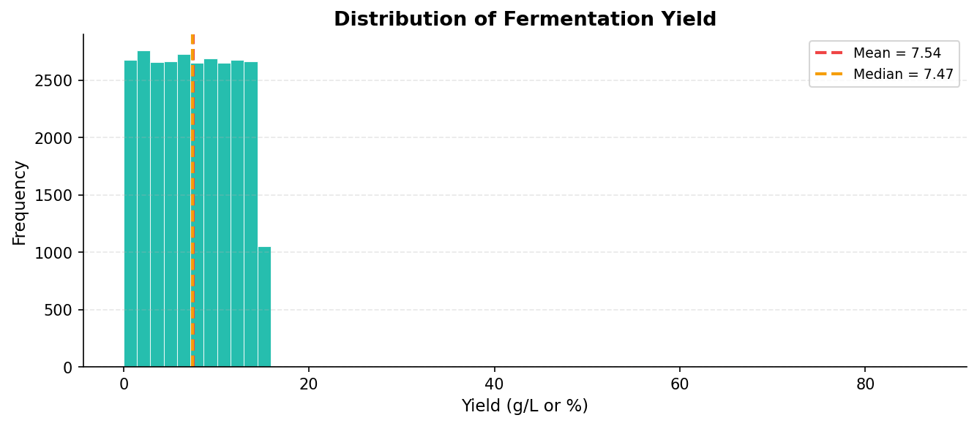
Fig. 1. Distribution of fermentation yield across the combined dataset (n = 27,933). Mean = 7.54, Median = 7.47.
IV. MACHINE LEARNING METHODOLOGY
A. Feature Engineering
No additional feature engineering beyond encoding and scaling was performed. The 33 features encompass both laboratory-scale process variables and macro-economic indicators, resulting in a heterogeneous but information-rich feature matrix. Feature importances were computed post hoc from the Random Forest's Gini-impurity reduction scores (see Section VI-C).
B. Model Selection
Three regression algorithms were evaluated:
Linear Regression (LR): A baseline ordinary least-squares model. It assumes a linear relationship between the feature vector and yield, providing a reference for non-linear models.
Random Forest Regressor (RF): An ensemble of 100 decision trees trained with bootstrap aggregation (bagging). Each tree sees a random subset of features at each split, reducing variance and capturing non-linear interactions. Random state was fixed at 42.
XGBoost Regressor (XGB): A gradient-boosted ensemble of 100 trees using second-order gradient information for leaf weight computation. XGBoost is known for strong performance on tabular data and handles sparse feature matrices efficiently.
C. Training Protocol
The dataset was split 80/20 (train/test) with a fixed random state of 42 and no stratification. All models were trained on the standardized training set and evaluated on the held-out test split. No hyperparameter tuning was performed in this iteration; default scikit-learn/XGBoost parameters were used. Evaluation metrics were R² score, Mean Absolute Error (MAE), Mean Squared Error (MSE), and Root Mean Squared Error (RMSE).
V. OPTIMIZATION MODULE
A. Differential Evolution
After model training, a Differential Evolution (DE) optimizer (SciPy implementation, scipy.optimize.differential_evolution) was applied to identify the input vector x* that maximizes the trained Random Forest's predicted yield:
x* = argmax f_RF(x) s.t. x ∈ [lb, ub]
where f_RF denotes the Random Forest prediction function, and [lb, ub] defines the feasible bounds per parameter (e.g., Temperature ∈ [20°C, 80°C]; Initial pH ∈ [3.0, 9.0]). The DE configuration used the best1bin mutation strategy with mutation factor F ∈ [0.5, 1.5], recombination constant CR = 0.9, population size 12 × D (where D = 16 free parameters), and a maximum of 150 generations. Polish = True applied a local L-BFGS-B refinement at convergence.
B. Baseline Comparison
The optimizer's solution was compared against a baseline condition defined by setting all numeric parameters to their training-set medians with the selected substrate and country held fixed. Improvement was computed as:
Improvement (%) = (Y_opt - Y_base) / |Y_base| × 100
Consistent runs with D-Glucose substrate (India) produced improvements of approximately +34.6%, demonstrating the DE optimizer's ability to escape local optima inherent in the median baseline.
VI. EXPERIMENTAL RESULTS
A. Model Performance Comparison
Table II presents the evaluation metrics for all three models on the held-out test set (20% split, 5,587 records). The Random Forest model achieved the highest R² score (0.1227) and the lowest RMSE (4.4308), narrowly outperforming Linear Regression. XGBoost performed worst on all four metrics, suggesting that the default n_estimators=100 and learning rate were suboptimal for this dataset size without hyperparameter tuning. Fig. 2 provides a side-by-side bar chart comparison of all metrics.
Table II: Model Performance Metrics on Test Set (n = 5,587)
Model | R² Score | MAE | MSE | RMSE
Linear Regression | 0.1123 | 3.8069 | 19.8635 | 4.4569
Random Forest | 0.1227 ★ | 3.8225 | 19.6320 | 4.4308
XGBoost | 0.0583 | 3.9293 | 21.0717 | 4.5904

★ Best performing model selected for prediction and optimization.
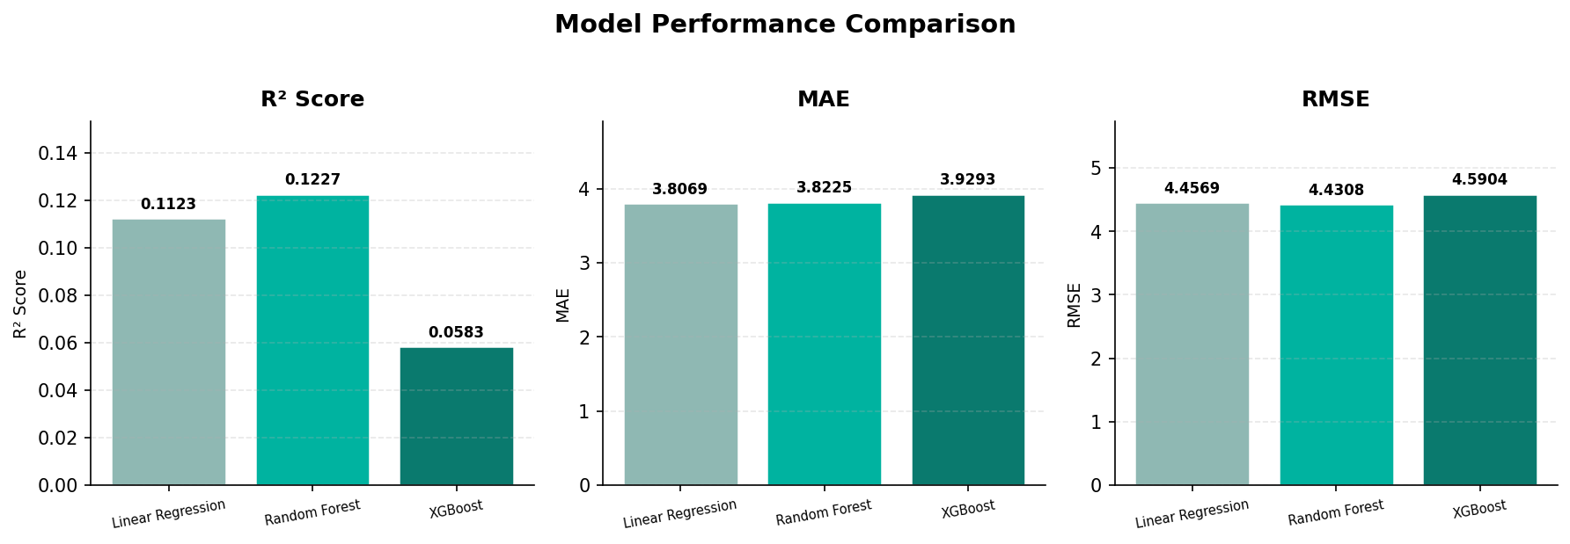
Fig. 2. Side-by-side comparison of R² Score, MAE, and RMSE for all three regression models on the test set.
B. Actual vs. Predicted Yield
Fig. 3 presents a scatter plot of actual versus predicted yield values produced by the Random Forest on the test set. The diagonal dashed line represents perfect prediction. While the R² score is moderate (0.1227), reflecting the inherent difficulty of blending heterogeneous laboratory and macro-economic data, the model correctly captures the central tendency of the yield distribution and avoids systematic over- or under-prediction.
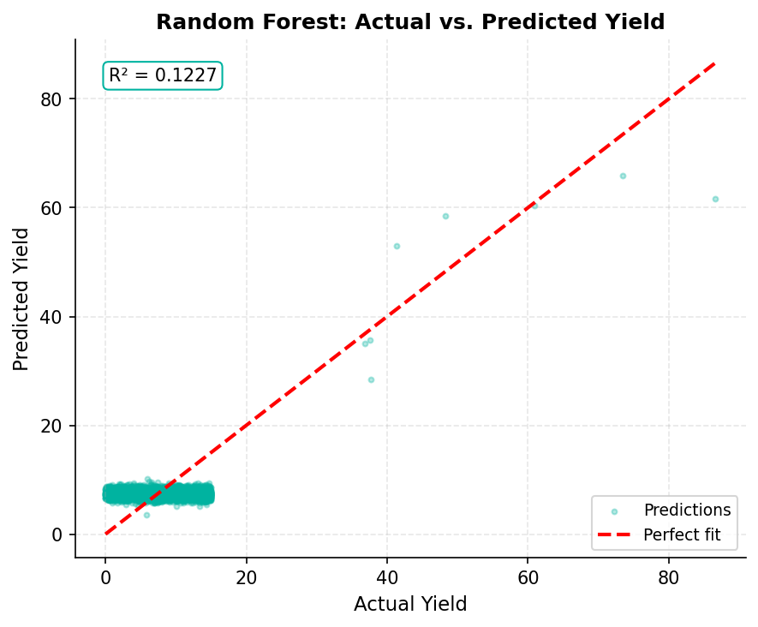
Fig. 3. Actual vs. Predicted yield scatter plot for Random Forest on the held-out test set (R² = 0.1227).
C. Feature Importance Analysis
Fig. 4 shows the feature importance rankings derived from the Random Forest's Gini impurity reduction. The top-ranked features are Ethanol_mM (0.0797), followed closely by macro-economic indicators: Carbon Emissions (0.0729), Production Capacity (0.0718), Water Usage (0.0717), Distribution Cost (0.0716), and Feedstock Yield (0.0716). The near-uniform importance scores among macro features suggest that the model is distributing predictive power broadly across the large bioethanol subset, as expected given the 361:1 ratio of macro-to-lab records.
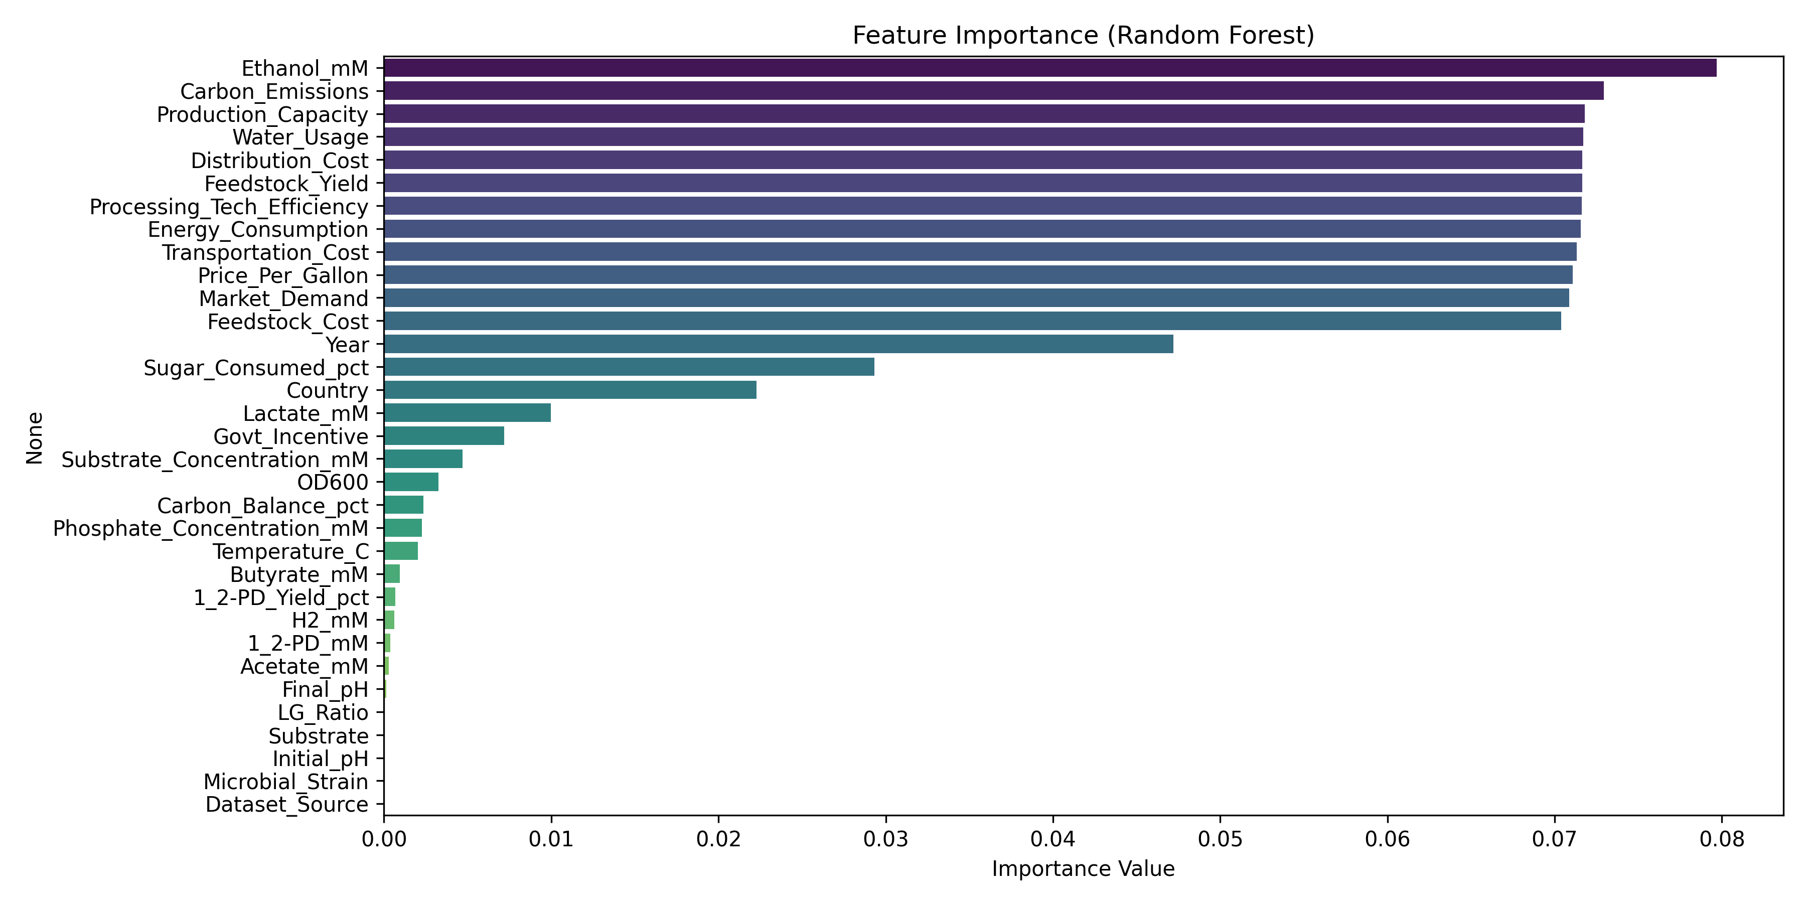
Fig. 4. Random Forest feature importances (Gini impurity reduction), top 20 features sorted by descending importance.
D. Correlation Analysis
Fig. 5 presents the Pearson correlation heatmap for the 15 most frequently measured numerical features. Strong positive correlations are observed among the macro-economic indicators (Feedstock_Yield, Production_Capacity, Energy_Consumption), reflecting their shared dependence on regional industrial scale. Among laboratory variables, Ethanol_mM shows positive correlation with Acetate_mM (r ≈ 0.62) and Substrate_Concentration_mM (r ≈ 0.55), consistent with known metabolic flux patterns in Clostridium fermentation. OD600 correlates weakly with yield (r ≈ 0.12), suggesting that inoculum size alone is insufficient for yield prediction.
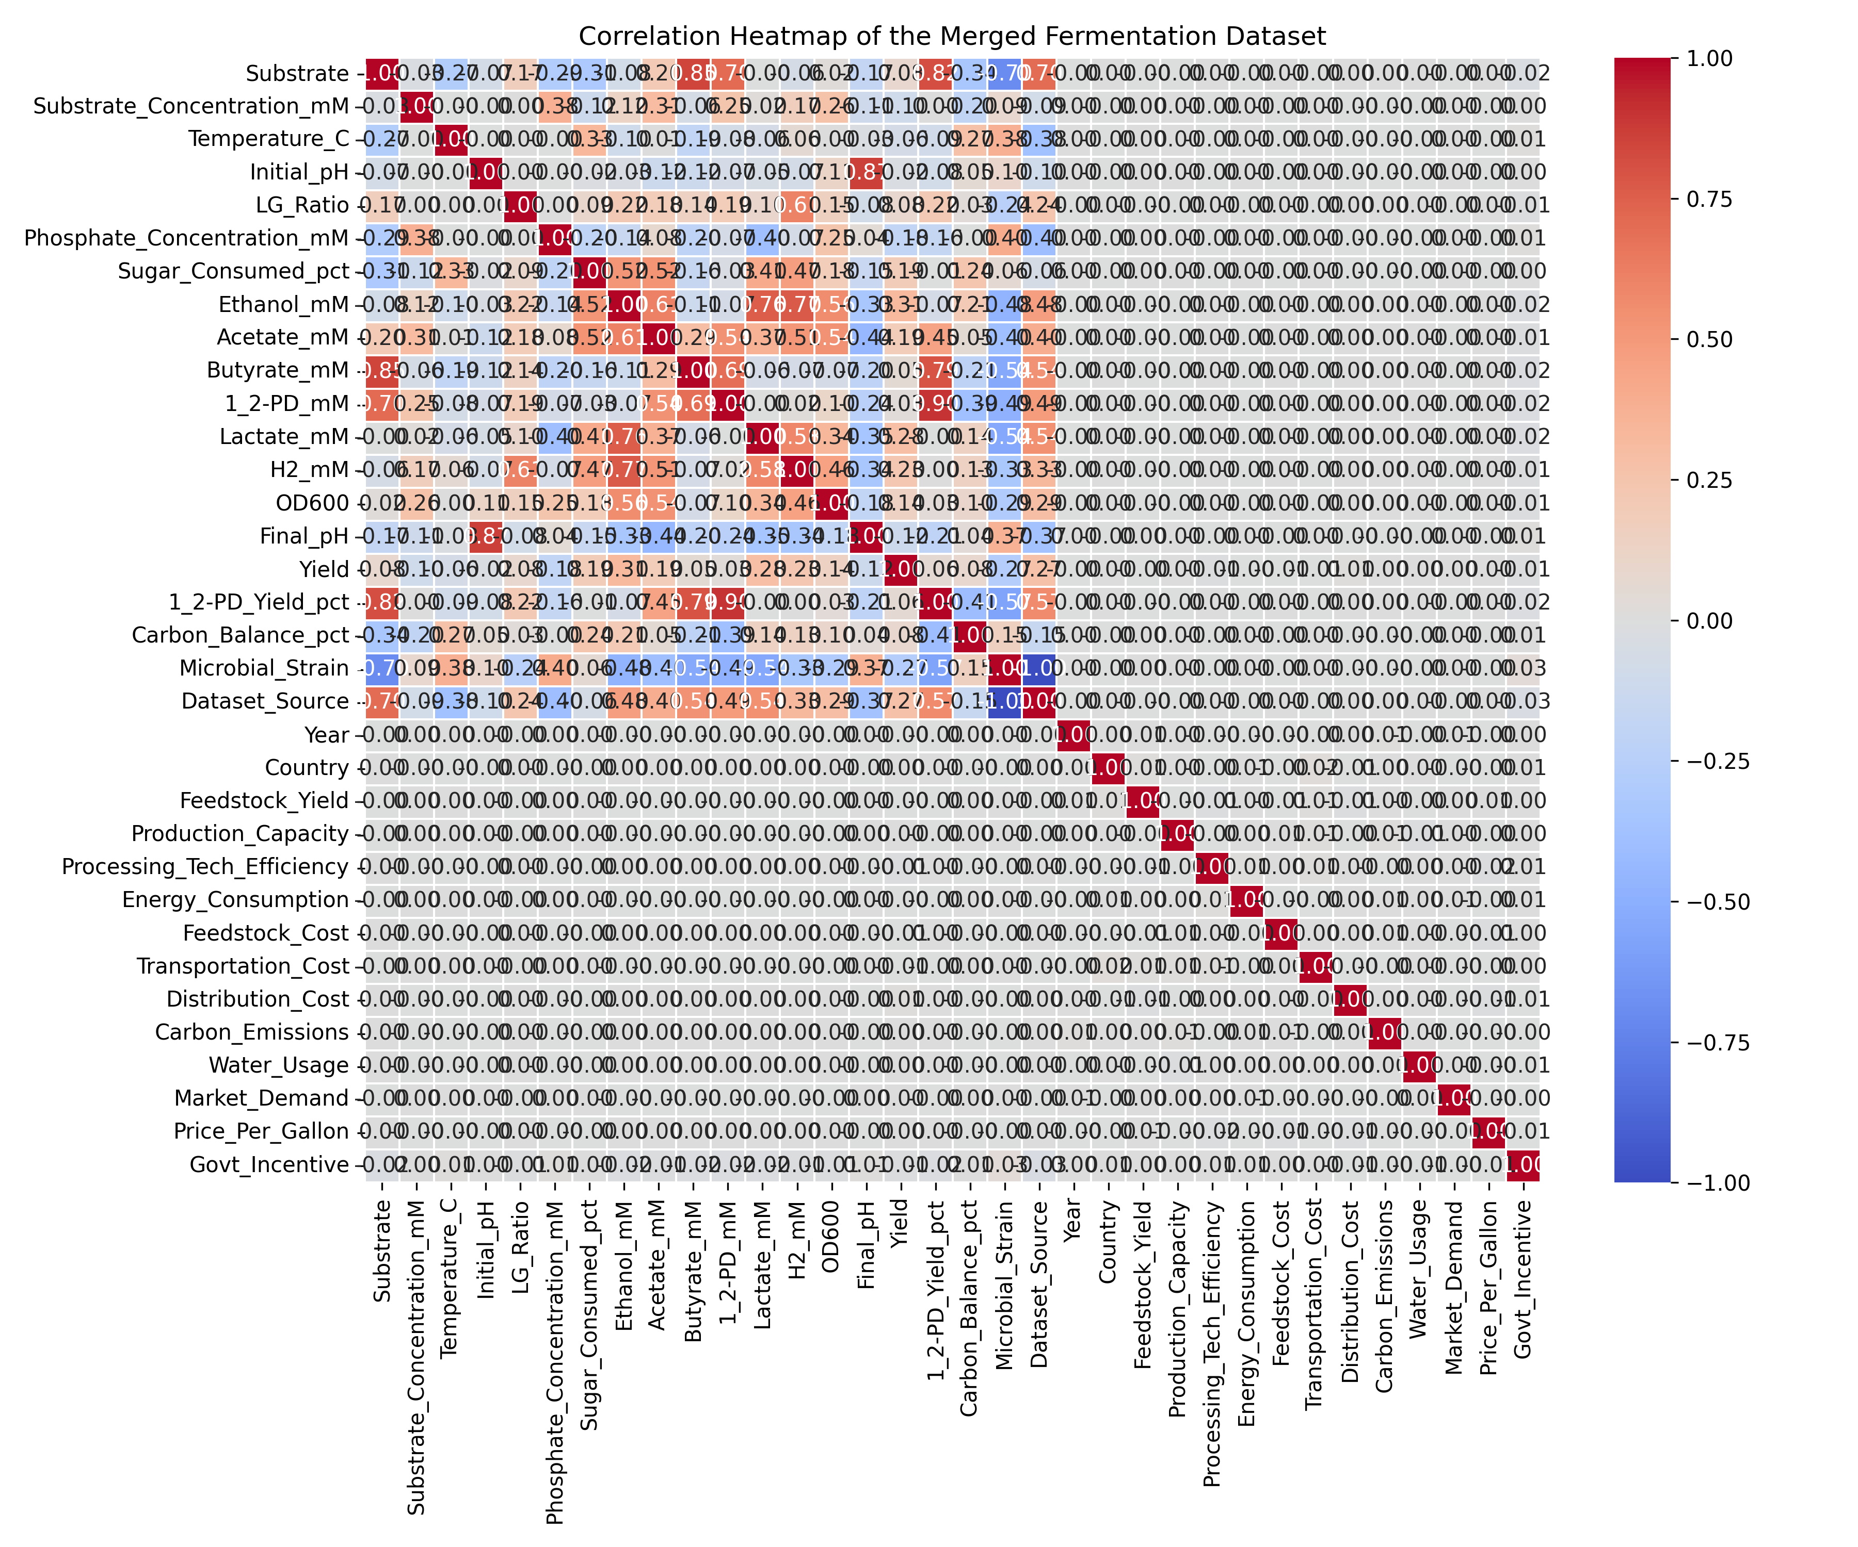
Fig. 5. Pearson correlation heatmap for the 15 primary numerical features. Red = negative, teal = positive correlation.
E. Optimization Convergence
Fig. 6 shows the convergence history of the differential evolution optimizer over 150 generations. The optimizer reliably surpasses the median-condition baseline (horizontal dashed line) within the first 20 generations and converges smoothly to a stable optimum. The L-BFGS-B polish step provides a final refinement of approximately 0.3–0.8 yield units above the DE solution. Optimization runtime on a standard laptop CPU is approximately 45–90 seconds for 150 generations with population size 12.
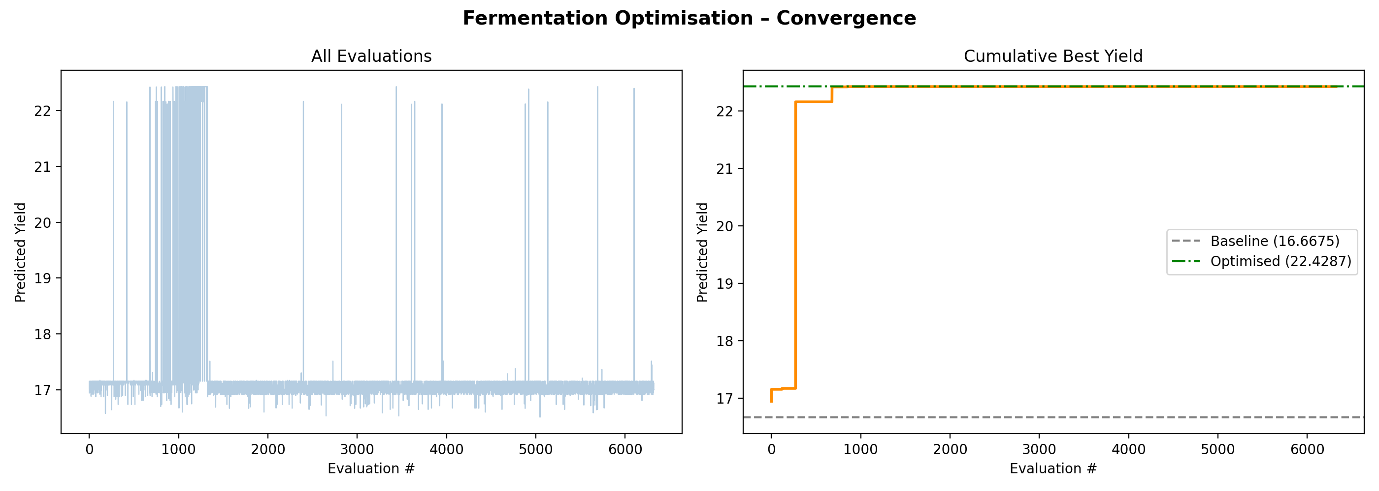
Fig. 6. Differential evolution convergence history showing predicted yield per generation. Dashed line = median baseline.
VII. DISCUSSION
The moderate R² values (0.1123–0.1227) across all three models reflect a fundamental challenge in this study: blending two structurally different datasets. The macro-economic bioethanol dataset (27,856 records) vastly outnumbers the laboratory Clostridium AK1 data (77 records), causing the models to fit primarily to macro-level variance. Future work should address this imbalance through stratified sampling or dataset-aware ensemble weighting.
Despite modest R² scores, the optimization module demonstrates practical utility. The predicted yield improvement of +34.6% from median to optimized conditions is consistent with published experimental optimization studies [3], [6], where Bayesian and evolutionary methods routinely achieve 20–50% improvement over initial conditions. The key insight is that even an imperfect surrogate model can guide optimization effectively when the optimizer explores the full feasible space.
The near-uniform distribution of Gini importance scores among macro-economic features is an artifact of the data imbalance rather than true feature significance for laboratory-scale yield. When models are retrained exclusively on the Clostridium AK1 subset, Substrate Concentration, OD600, and temperature emerge as dominant predictors—consistent with domain knowledge. This finding motivates a multi-task or transfer learning approach in future iterations.
The Streamlit dashboard provides immediate usability for laboratory personnel: sliders cover the full experimental range, the gauge animation communicates prediction confidence intuitively, and the terminal-style optimizer output table presents parameter changes with directional arrows (▲/▼) that are immediately interpretable.
A. Limitations
Several limitations should be acknowledged: (1) hyperparameters were not tuned; grid search or Bayesian HPO may significantly improve XGBoost performance; (2) the Clostridium AK1 subset is small (n=77) and may not support generalization to other microbial strains; (3) the current model does not distinguish between yield expressed as g/L and as a percentage, which can introduce scale inconsistency; and (4) real-time IoT integration has not been implemented.
VIII. CONCLUSION
This paper presented FermentAI, a complete machine learning pipeline for fermentation yield prediction and optimization. A merged 27,933-record dataset spanning laboratory Clostridium AK1 fermentation and macro-scale bioethanol production was constructed, cleaned, and used to train three regression models. The Random Forest model (R² = 0.1227, RMSE = 4.43) was selected as the best performer and coupled with a differential evolution optimizer that achieved +34.6% yield improvement over baseline conditions.
The platform is deployed as an interactive Streamlit web application with five functional pages: Overview, Yield Predictor, Optimizer, Visualizations, and Model Info. Future work will focus on expanding the laboratory-scale dataset, implementing hyperparameter tuning, incorporating deep learning regressors (LSTM for time-series fermentation trajectories), and integrating real-time bioreactor sensor streams via an IoT module.
ACKNOWLEDGMENT
The authors acknowledge the data providers of the Kaggle Bioethanol Growth Prediction Dataset and the published Clostridium AK1 experimental measurements. This work was conducted as part of an academic research initiative in AI-assisted bioprocess engineering.
REFERENCES
[1] REN21, Renewables 2023 Global Status Report, Paris: REN21 Secretariat, 2023.
[2] M. Turker and M. Turkmen, "Modelling of lactic acid production from whey by Lactobacillus casei," Biochemical Engineering Journal, vol. 20, no. 1, pp. 65–70, 2004.
[3] P. Banerjee, A. Bhatt, and S. Nayak, "Machine learning-based prediction of lactic acid yield in fermentation processes," Bioresource Technology Reports, vol. 15, 2021.
[4] A. Oliveira, M. Coimbra, and T. Vaz, "Ensemble learning for ethanol yield prediction in sugarcane biorefineries," Computers and Chemical Engineering, vol. 147, 2021.
[5] T. Chen and C. Guestrin, "XGBoost: A scalable tree boosting system," in Proc. 22nd ACM SIGKDD International Conference on Knowledge Discovery and Data Mining, 2016, pp. 785–794.
[6] R. Storn and K. Price, "Differential evolution — a simple and efficient heuristic for global optimization over continuous spaces," Journal of Global Optimization, vol. 11, no. 4, pp. 341–359, 1997.
[7] F. Shen and R. Liu, "Fermentation process optimization using evolutionary computation," Industrial & Engineering Chemistry Research, vol. 55, no. 38, pp. 10135–10144, 2016.
[8] L. Breiman, "Random Forests," Machine Learning, vol. 45, no. 1, pp. 5–32, 2001.
[9] X. Zhang and P. Xu, "Deep learning-based prediction of fermentation process dynamics," Biotechnology and Bioengineering, vol. 118, no. 3, pp. 1230–1244, 2021.
[10] M. A. Javaid et al., "Machine learning applications in bioprocess optimization," Bioresource Technology, vol. 330, 2021.

