**Group - 1**

**Project Report**

**Project name: Device Management**

**BY ADITY SHARMA**

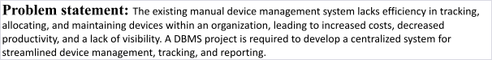

**Tables created:** DeviceCategory, Device, User, SupportRequest, SupportStaff, PriorityType, Histo,SkillSet and Solution.

1. DeviceCategory: Stores categories or types of devices, such as laptops, mobile phones, printers, etc.
2. Device: Contains information about individual devices, including serial number, specifications, current status, and assigned user.
3. User: Stores details about users or employees who are assigned devices, including their name, contact information, and department.
4. SupportRequest: Tracks support requests made by users for device-related issues, including details like request ID, device ID, and priority.
5. SupportStaff: Contains information about support staff members responsible for resolving device issues, including their name, contact details, and skill set.
6. PriorityType: Stores different priority levels for support requests, such as low, medium, and high.
7. Histo: Stores the history of support requests, including details like request ID, device ID, support staff assigned, and solution provided.
8. SkillSet: Stores different skill sets or expertise areas possessed by support staff members.
9. Solution: Contains information about solutions provided for support requests, including details like request ID, solution description, and resolution status.

**Primary keys:** category_id,

device_id,user_id,request_id,staff_id,priority_id,history_id,skill_id,solution_id

**Foreign keys:** category_id,device_id,user_id,priority_id,staff_id,request_id,history_id

**Relationship between entities:**

* The device category entity and device entity have a one to many relationship.
* The device entity and support request entity have a one to many relationship.
* The user entity and support request entity have a one to many relationship.
* Priority type and histo entity has one to many relationship .
* Support request and skill set entities have one to many relationship. ● Histo and solution entities have one to many relationship.

**Database Management System used:** MySQL **Data flow diagram:**

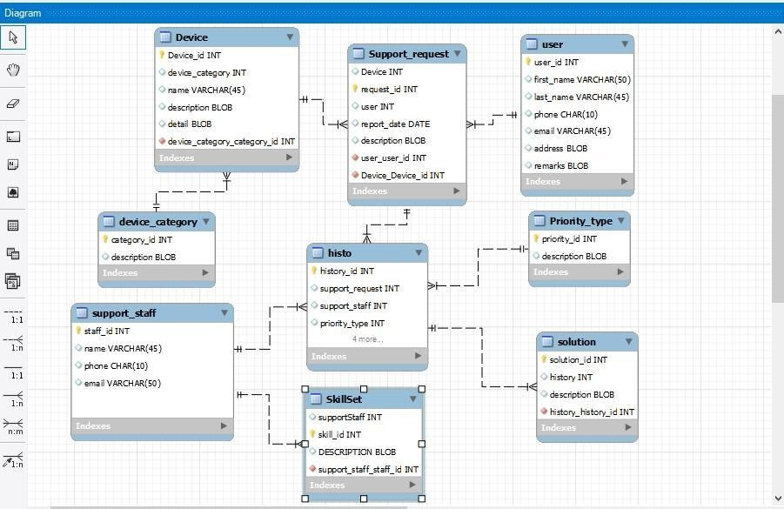

**Performing queries on the database:**

1. **Select Query**

select*from DeviceCategory; select * from Device;

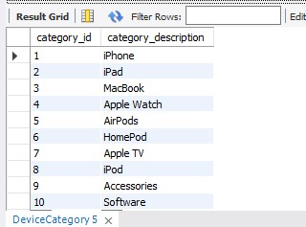

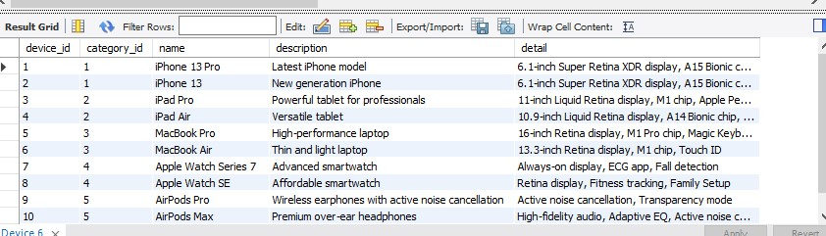

1. **Group By:**

select(category_id),category_description

FROM DeviceCategory GROUP BY category_id;

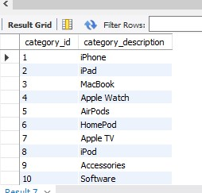

**3.Order By:**

select * FROM Solution ORDER BY description;

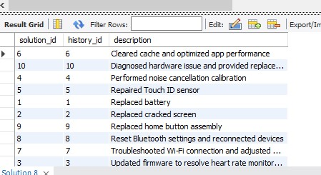

**4.Update Query:**

UPDATE User

SET firstName='adity' where user_id='2'; select * from User;

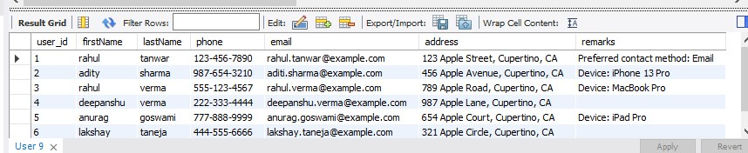

**5.Join Query:**

SELECT d.device_id, d.name, d.description, dc.category_description

FROM Device d

JOIN DeviceCategory dc ON d.category_id = dc.category_id;

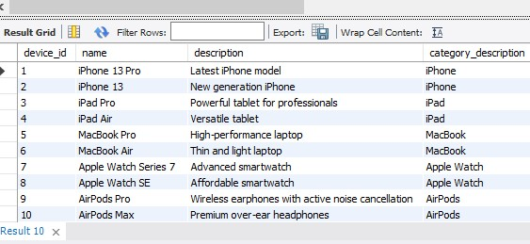

SELECT sr.request_id, d.name AS device_name, u.firstName, u.lastName, sr.reportDate, sr.description

FROM SupportRequest sr

JOIN Device d ON sr.device_id = d.device_id

JOIN User u ON sr.user_id = u.user_id;

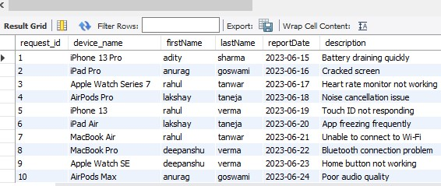

SELECT h.history_id, p.description AS priority_description, ss.name AS staff_name, sr.request_id, sr.description

FROM Histo h

JOIN PriorityType p ON h.priority_id = p.priority_id

JOIN SupportStaff ss ON h.staff_id = ss.staff_id

JOIN SupportRequest sr ON h.request_id = sr.request_id;

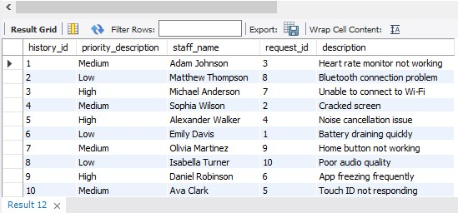

SELECT s.skill_id, ss.name AS staff_name, s.description

FROM SkillSet s

JOIN SupportStaff ss ON s.staff_id = ss.staff_id;

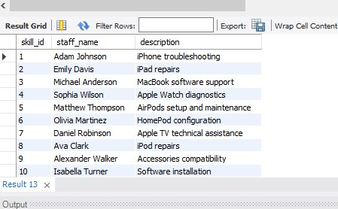

SELECT s.solution_id, h.history_id, sr.request_id, s.description FROM Solutions

JOIN Histo h ON s.history_id = h.history_id

JOIN SupportRequest sr ON h.request_id = sr.request_id;

