LOGISTICS DATA SCIENCE INTERNSHIP - WEEK 2
Data Collection, Cleaning and Preprocessing
A reproducible pandas pipeline for a pan-India shipment feed
Prepared by | Kaju
Report date | October 2026
Reference datasets | DataCo Smart Supply Chain, Olist Brazilian E-Commerce (field-aligned simulation used here)
Tools | Python 3 (pandas, NumPy, SciPy, scikit-learn, Matplotlib)
Script | src/02_cleaning_pipeline.py

1. Executive summary
The raw shipment feed contains 12,160 rows and 19 columns, and it is deliberately messy in the ways real logistics extracts are: 160 repeated shipment IDs, 2,682 missing cells, 9 spellings of 3 shipping modes, three date layouts, negative costs, zero distances and extreme weights and costs. A ten-step pipeline cleans it into 11,880 analysis-ready rows (280 removed, 2.3%). Data completeness rises from 98.84% to 99.82%, invalid values fall from 207 to 0, and duplicates from 160 to 0.
Key decisions. (1) Outliers are detected with a robust z-score on the log scale within product category or shipping mode, because global IQR and z-score rules flag 1,296 and 57 weights respectively while the robust rule flags 118. (2) Missing weights are imputed from volume and category density after a masked-value benchmark of five methods. (3) The target variable (actual_days) is never imputed. (4) Scaling is applied after a log transform for skewed fields and is always fitted inside cross-validation folds in Week 4 to avoid leakage.

2. Data collection simulation

2.1 Reference datasets
The workflow mirrors two public logistics datasets. DataCo Smart Supply Chain (Constante et al., 2019) has about 180,000 orders with scheduled and real shipping days, shipping mode, region and a late-delivery flag. Olist's Brazilian E-Commerce data (Olist, 2018) has about 100,000 orders with estimated and actual delivery dates, freight value and product weight. Because those files are large and licensed, this project simulates a feed with matching fields and realistic defects, so the full pipeline can be run offline and reproduced exactly (seed 42).

2.2 Characteristics of the raw feed
Table 1. Raw dataset profile.
Property | Value
Rows / columns | 12,160 / 19
Period | 2025-01-01 to 2025-12-31
Grain | One row per shipment (shipment_id), 5 warehouses, 8 destination hubs, 6 zones, 4 carriers
Numeric fields | distance_km, weight_kg, volume_m3, order_value_inr, weather_index, traffic_index, planned_days, actual_days, delivery_cost_inr, customer_rating
Categorical fields | origin_warehouse, destination_hub, destination_zone, product_category, shipping_mode, priority, carrier
Delivery target | actual_days (continuous) and delayed = actual_days > planned_days (binary, derived)
Missing cells | 2,682 (1.16% of all cells)

2.3 Data quality issues found
Table 2. Missing values by column.
Column with missing values | Share missing
weight_kg | 5.05%
distance_km | 3.96%
customer_rating | 3.52%
traffic_index | 3.02%
carrier | 2.98%
weather_index | 2.52%
volume_m3 | 1.01%

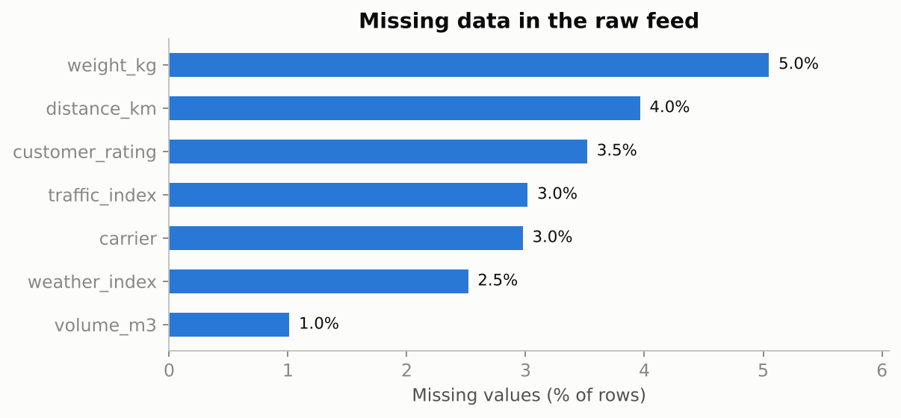
Figure 1. Missingness profile of the raw feed.
Table 3. Other quality problems detected during profiling.
Issue | Count
Duplicate shipment IDs (system retries) | 160
Negative delivery cost | 49
Zero distance between different cities | 36
Negative actual delivery days | 49
Actual days above 30 | 74
Spellings of 3 shipping modes | 9
Spellings of 4 carriers | 8
Date layouts | 3 (ISO, DD/MM/YYYY, 'Mon DD, YYYY')

3. Cleaning methodology and rationale
Each step below states what was done, why that technique was chosen, and how it affects later analysis. The pipeline is ordered deliberately: structural fixes first (duplicates, labels, dates), then impossible values, then statistical outliers, then imputation, then transformation.

3.1 Duplicates, labels and dates
Duplicate IDs come from system retries; keeping the first occurrence avoids double counting volume and cost. Labels such as 'express', 'EXPRESS ' and 'Express' are one category; left alone they would split into nine groups and bias every group-by KPI. Dates are parsed with explicit formats rather than guessing, because 03/04/2025 is ambiguous between 3 April and 4 March and a silent wrong guess would corrupt the seasonality analysis.
Code 1. Duplicates and label standardisation
dups = int(df["shipment_id"].duplicated().sum())
df = df.drop_duplicates(subset="shipment_id", keep="first")
note("Duplicates", "Repeated shipment_id (system retries)", dups, "Dropped, keeping first occurrence")
df["shipping_mode"] = df["shipping_mode"].astype("string").str.strip().str.title()
df["origin_warehouse"] = df["origin_warehouse"].astype("string").str.strip().str.title()

3.2 Impossible values
Values that break physical or business rules are treated differently from statistical outliers. A negative cost is a sign-entry error with a plausible magnitude, so the absolute value is kept. A zero distance between two different cities is missing information and is re-derived from the lane median. Non-positive or over-30-day actual_days is removed: the target variable must not be imputed, because any imputed target would simply teach a model the imputation rule.

3.3 Outlier detection: comparing three methods
Table 4. Number of rows flagged by each outlier rule.
Method | Weight flags | Cost flags
IQR rule (1.5 x IQR), global, raw scale | 1,296 | 458
Z-score |z| > 3, global, raw scale | 57 | 96
Robust z > 4 (median/MAD), log scale, within group | 118 | 121

The global IQR rule flags over a thousand weights because parcel weight is strongly right-skewed (skewness 4.4): heavy furniture is normal, not an error. The z-score rule is distorted because the mean and standard deviation are themselves pulled by the extremes (Leys et al., 2013). The chosen rule works on the log scale, uses the median and MAD, and compares each parcel with others of the same category (or each cost per km with others of the same shipping mode). It flags only values that are extreme relative to a sensible peer group. A 200 kg carrier limit is added as a business rule.
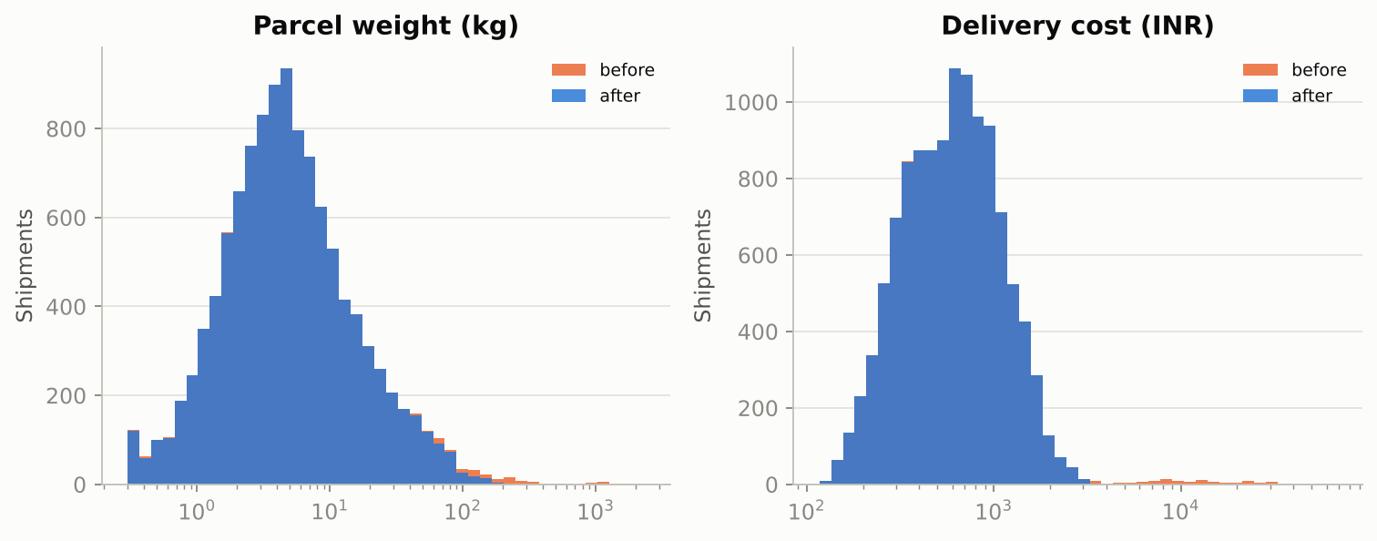
Figure 2. Weight and cost distributions before and after outlier treatment (log x-axis).
Code 2. Outlier rules
def robust_z(x: pd.Series) -> pd.Series:
med = x.median(); mad = (x - med).abs().median()
return 0.6745 * (x - med) / (mad if mad else np.nan)

def iqr_flags(x: pd.Series, k: float = 1.5) -> pd.Series:
q1, q3 = x.quantile([0.25, 0.75]); i = q3 - q1
return (x < q1 - k * i) | (x > q3 + k * i)

# weight: compared on log scale inside each product category (furniture is heavier by nature)
lw = np.log(df["weight_kg"])
z_w = lw.groupby(df["product_category"]).transform(robust_z)
method_counts = {
"weight_kg": {
"IQR (raw, global)": int(iqr_flags(df["weight_kg"].dropna()).sum()),
"z-score |z|>3 (raw, global)": int((np.abs(stats.zscore(df["weight_kg"].dropna())) > 3).sum()),
"Robust z>4 (log, per category)": int((z_w.abs() > 4).sum()),
}
}
flag_w = (z_w.abs() > 4) | (df["weight_kg"] > 200) # 200 kg = carrier parcel limit (business rule)
df["weight_flag"] = flag_w.fillna(False)

# cost: per-km cost within each shipping mode, log scale
cpk = df["delivery_cost_inr"] / df["distance_km"]
z_c = np.log(cpk).groupby(df["shipping_mode"]).transform(robust_z)
method_counts["delivery_cost_inr"] = {
"IQR (raw, global)": int(iqr_flags(df["delivery_cost_inr"].dropna()).sum()),
"z-score |z|>3 (raw, global)": int((np.abs(stats.zscore(df["delivery_cost_inr"].dropna())) > 3).sum()),
"Robust z>4 (log cost/km, per mode)": int((z_c.abs() > 4).sum()),
}
flag_c = (z_c.abs() > 4).fillna(False)
df["cost_flag"] = flag_c

The effect on analysis is large. In Week 1 a regression of cost on distance had R-squared 0.07 before trimming the extreme costs and 0.67 after: a handful of billing errors was hiding a strong relationship.

3.4 Missing values
Before choosing a method, the missingness mechanism was checked. A chi-square test of 'weight is missing' against product category gives p = 0.136, so there is no evidence that missingness depends on category; it is plausibly missing completely at random (Little & Rubin, 2019), which means simple imputation will not introduce systematic bias. Dropping every row with any missing cell would have discarded about 20% of the data (2,445 of 12,160 rows), so imputation is preferable.
To pick a method for weight objectively, 10% of known weights were masked and five imputers were scored by mean absolute error:
Table 5. Imputation benchmark for weight_kg (lower is better).
Method | MAE (kg) | Note
KNN (k=7, log scale) | 2.52 | lowest error
Volume x category density | 2.80 | chosen
Category median | 4.86
Global median | 7.15
Global mean | 8.86

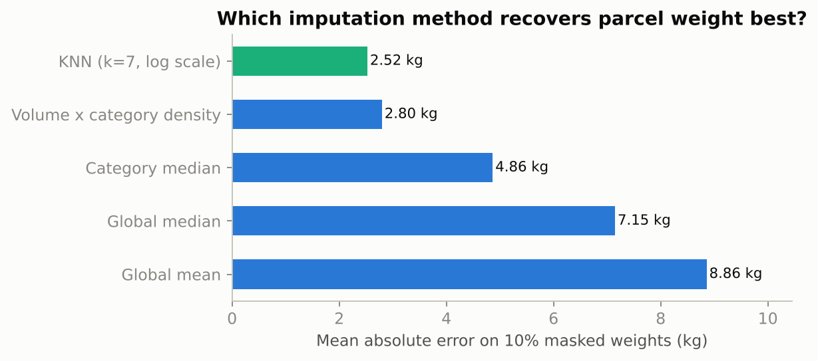
Figure 3. Imputation error on masked weights.
KNN is slightly more accurate (MAE 2.52 kg) but the volume x category density rule (2.80 kg) is nearly as good, needs no tuning and can be explained to an operations manager in one sentence (weight = volume x typical density of that product type). It was therefore chosen. Mean and median imputation are clearly worse and also shrink the variance of the variable. Other fields: distance from the lane median, weather and traffic from the same calendar month median, carrier as an explicit 'Unknown' category (it cannot be inferred honestly), customer rating left missing and excluded only from rating statistics.
Code 3. Benchmarking imputation methods on masked values
# 7b. Benchmark imputation methods for weight by masking known values
ok = df.dropna(subset=["weight_kg", "volume_m3"]).copy()
mask_idx = ok.sample(frac=0.10, random_state=SEED).index
truth = ok.loc[mask_idx, "weight_kg"]
train = ok.drop(index=mask_idx)
dens = (train["weight_kg"] / train["volume_m3"]).groupby(train["product_category"]).median()
preds = {
"Global mean": pd.Series(train["weight_kg"].mean(), index=mask_idx),
"Global median": pd.Series(train["weight_kg"].median(), index=mask_idx),
"Category median": ok.loc[mask_idx, "product_category"].map(train["weight_kg"].groupby(train["product_category"]).median()),
"Volume x category density": ok.loc[mask_idx, "volume_m3"] * ok.loc[mask_idx, "product_category"].map(dens),
}
knn_df = pd.get_dummies(ok[["product_category"]], dtype=float)
knn_df["lw"] = np.log(ok["weight_kg"]); knn_df["lv"] = np.log(ok["volume_m3"]); knn_df["lo"] = np.log(ok["order_value_inr"])
knn_in = knn_df.copy(); knn_in.loc[mask_idx, "lw"] = np.nan
knn_out = KNNImputer(n_neighbors=7).fit_transform((knn_in - knn_in.mean()) / knn_in.std())
lw_hat = pd.Series(knn_out[:, knn_df.columns.get_loc("lw")], index=ok.index) * knn_in["lw"].std() + knn_in["lw"].mean()
preds["KNN (k=7, log scale)"] = np.exp(lw_hat.loc[mask_idx])
bench = {k: float((v - truth).abs().mean()) for k, v in preds.items()}

3.5 Skewness and normalisation
Table 6. Skewness before and after a log transform.
Variable | Skewness (raw) | Skewness (log1p)
weight_kg | 4.44 | 0.75
volume_m3 | 4.96 | 3.72
order_value_inr | 2.80 | 0.32
delivery_cost_inr | 1.45 | -0.01
distance_km | 0.71 | -0.25

Right-skewed money and weight variables are log-transformed first (skewness of order value falls from 2.80 to 0.32, of weight from 4.44 to 0.75). Scaling alone does not change the shape of a distribution, as the table below shows: min-max, z-score and robust scaling all keep the skewness of 4.44. Min-max scaling is also very sensitive to the single largest value.
Table 7. Effect of each normalisation on weight_kg.
Transformation | Mean | Std | Min | Max | Skew
Raw | 9.47 | 15.15 | 0.29 | 195.11 | 4.44
log1p | 1.85 | 0.90 | 0.25 | 5.28 | 0.75
Min-max [0,1] | 0.05 | 0.08 | 0.00 | 1.00 | 4.44
Z-score | 0.00 | 1.00 | -0.61 | 12.26 | 4.44
Robust (median/IQR) | 0.69 | 2.10 | -0.59 | 26.43 | 4.44
log1p + Z-score | 0.00 | 1.00 | -1.76 | 3.79 | 0.75

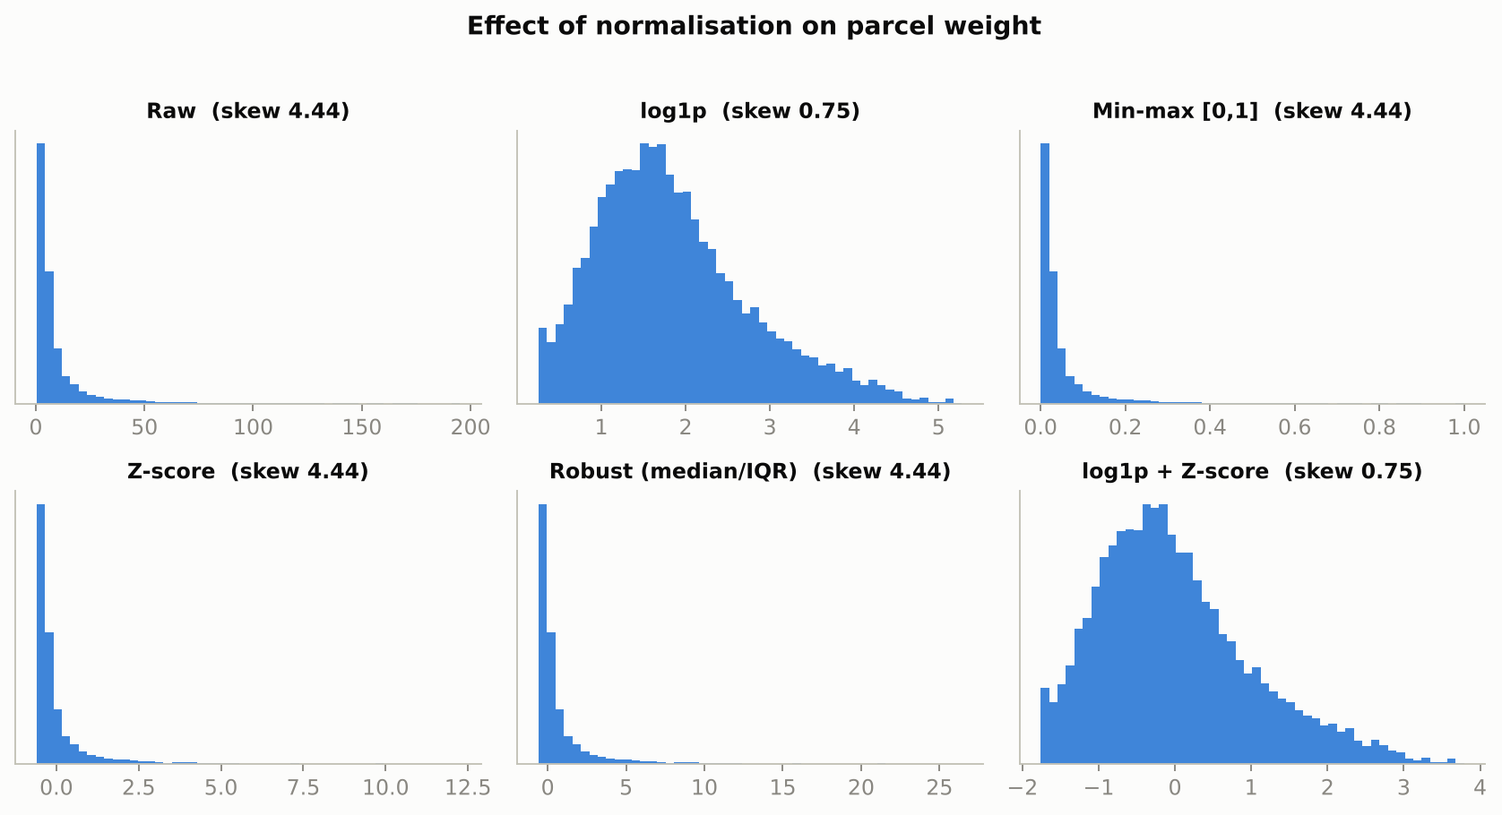
Figure 4. Histograms of parcel weight under six transformations.
Guidance used: log1p + z-score for linear and distance-based methods (regression, K-Means, KNN); no scaling for tree ensembles, which are invariant to monotone transformations; and always fit the scaler on training folds only. The scaled file in data/processed is for demonstration; Week 4 refits scaling inside a scikit-learn Pipeline.
Code 4. Normalisation variants compared
scaled_variants = {
"Raw": df[demo_col].values,
"log1p": np.log1p(df[demo_col].values),
"Min-max [0,1]": MinMaxScaler().fit_transform(x).ravel(),
"Z-score": StandardScaler().fit_transform(x).ravel(),
"Robust (median/IQR)": RobustScaler().fit_transform(x).ravel(),
"log1p + Z-score": StandardScaler().fit_transform(np.log1p(x)).ravel(),
}

4. Cleaning log and before/after scorecard
Table 8. Complete cleaning log (also saved to results/week2_results.json).
Step | Issue | Rows | Action
Duplicates | Repeated shipment_id (system retries) | 160 | Dropped, keeping first occurrence
Categorical labels | 9 spellings of 3 shipping modes (case/whitespace); carrier and warehouse case drift | 2,553 | strip() + title-case; carrier mapped through a canonical dictionary
Dates | Three date layouts (ISO 86%, DD/MM/YYYY, 'Mon DD, YYYY') | 1,632 | Parsed with explicit formats (never guessing day/month order); unparseable -> NaT
Invalid values | Negative delivery cost (sign-entry error) | 48 | Absolute value taken (magnitude plausible)
Invalid values | Zero distance between different cities | 36 | Set to missing, re-derived from lane median
Invalid values | actual_days <= 0 or > 30 (target variable) | 120 | Rows removed - the target cannot be imputed without leaking assumptions
Missing values | distance_km missing / invalid | 509 | Imputed with median of the same origin-destination lane
Outliers | Implausible parcel weights (robust z>4 in log space per category, or >200 kg limit) | 119 | Treated as entry errors -> set to missing and imputed
Outliers | Implausible delivery costs (robust z>4 on log cost/km per shipping mode) | 121 | Treated as billing errors -> set to missing and imputed
Missing values | weight_kg missing (incl. removed outliers) | 716 | Volume x category median density (MAE 2.80 kg vs 2.52 kg for KNN, chosen for transparency and zero tuning); category median as fallback
Missing values | volume_m3 missing | 120 | Weight / category median density
Missing values | weather_index missing | 300 | Median of same calendar month
Missing values | traffic_index missing | 355 | Median of same calendar month
Missing values | carrier missing | 355 | Kept as explicit category 'Unknown' (no honest way to infer it)
Missing values | delivery_cost_inr removed as outlier | 121 | Median cost-per-km of the shipping mode x distance
Missing values | customer_rating missing | 414 | Left missing; excluded only from rating-specific statistics

Table 9. Data-quality scorecard.
Metric | Before | After
Rows | 12,160 | 11,880
Completeness of core columns | 98.84% | 99.82%
Duplicate IDs | 160 | 0
Invalid values | 207 | 0
Shipping-mode spellings | 9 | 3

Completeness after cleaning is below 100% only because customer ratings were intentionally left missing.

5. Reflection: why data quality matters for logistics decisions
- KPIs. Duplicate IDs inflate volume; mixed labels split carriers and modes; negative costs and zero distances corrupt cost per km. Every KPI in the Week 1 scorecard depends on these fixes.
- Models. A few extreme costs reduced a cost-distance R-squared from 0.67 to 0.07. A model trained on such data would mis-price lanes and mis-allocate volume.
- Decisions. Misread carrier performance leads to wrong contract decisions; a mis-dated peak season leads to wrong staffing and inventory buffers.
- Trust. A documented cleaning log lets managers audit every change; the pipeline is reproducible, so the same data gives the same result on any machine.
- Limits. Simulated defects are cleaner than real ones. In production the pipeline should add schema checks, range alerts and drift monitoring at ingestion.

References
Constante, F., Silva, F., & Pereira, A. (2019). DataCo Smart Supply Chain for Big Data Analysis [Data set]. Mendeley Data (also mirrored on Kaggle).
Olist (2018). Brazilian E-Commerce Public Dataset by Olist [Data set]. Kaggle. https://www.kaggle.com/datasets/olistbr/brazilian-ecommerce
McKinney, W. (2010). Data structures for statistical computing in Python. Proceedings of the 9th Python in Science Conference, 56-61.
Pedregosa, F., et al. (2011). Scikit-learn: Machine learning in Python. Journal of Machine Learning Research, 12, 2825-2830.
Virtanen, P., et al. (2020). SciPy 1.0: Fundamental algorithms for scientific computing in Python. Nature Methods, 17, 261-272.
Tukey, J. W. (1977). Exploratory Data Analysis. Addison-Wesley.
Little, R. J. A., & Rubin, D. B. (2019). Statistical Analysis with Missing Data (3rd ed.). Wiley.
Leys, C., Ley, C., Klein, O., Bernard, P., & Licata, L. (2013). Detecting outliers: Do not use standard deviation around the mean, use absolute deviation around the median. Journal of Experimental Social Psychology, 49(4), 764-766.
Christopher, M. (2016). Logistics & Supply Chain Management (5th ed.). Pearson.

