LOGISTICS DATA SCIENCE INTERNSHIP - WEEK 4
Predictive Modeling and Optimization
Forecasting delivery time and late risk, then optimising warehouse allocation, carrier mix and delivery promises
Prepared by | Kaju
Report date | October 2026
Dataset | Cleaned shipments (n = 11,880); 80/20 split: 9,504 train, 2,376 test
Tools | Python 3 (scikit-learn, SciPy HiGHS linear programming, pandas, Matplotlib)
Script | src/04_modeling_optimisation.py

1. Executive summary
This report builds a predictive model for delivery time (days from order to delivery), a classifier for late-delivery risk, and three optimisation models that use them. The tuned gradient-boosting model reaches a hold-out RMSE of 0.55 days (MAE 0.38, R-squared 0.90), against RMSE 0.67 for simply trusting the promised days and 0.58 for linear regression. Because most variation in delivery time is already explained by distance and the promised days, the gain over simple baselines is real but modest, and the report says so plainly.
Table 1. Headline results.
Result | Value
Delivery-time model (hold-out) | RMSE 0.552 d, MAE 0.384 d, R-squared 0.896; 75% of predictions within 0.5 day, 95% within 1 day
Late-risk classifier (hold-out) | ROC-AUC 0.76; reviewing the riskiest 20% of shipments catches 40% of late deliveries (precision 60% vs 30% base rate)
Warehouse-to-hub LP (practical) | 19.1% lower delivery cost, late rate unchanged at 29.3%, 32% of volume re-routed
Carrier-mix LP | 2.3% lower cost overall; late rate 29.4% to 29.3%
Model-based delivery promise | 90% on-time needs an average promise of 4.41 days vs 4.65 days with a flat buffer

2. Problem definition and data
Prediction target. actual_days, the delivery time in days, is a continuous regression target. A second target, delayed (actual_days greater than planned_days), supports a classification model for proactive intervention. Business use. Better delivery-time predictions allow realistic promise dates; late-risk scores allow the operations team to review a small share of shipments instead of all of them.
Features. Only information available at dispatch time is used, so there is no target leakage: distance, weight, volume, order value, weather and traffic indices (as forecast), planned days, peak-season flag, order month and weekday (numeric); shipping mode, priority, carrier, origin warehouse, destination zone and product category (categorical, one-hot encoded). Customer rating, delay_days and delayed are excluded because they are only known after delivery.
Split. An 80/20 random split (9,504 / 2,376) with seed 42. All tuning uses 5-fold cross-validation on the training part only; the test set is touched once for final scoring. A forward-chaining time-series CV is added as a robustness check because deployed models predict the future from the past.
Code 1. Features, split and preprocessing pipeline
NUM = ["distance_km", "weight_kg", "volume_m3", "order_value_inr", "weather_index", "traffic_index", "planned_days",
"is_peak_season", "order_month", "order_dow"]
CAT = ["shipping_mode", "priority", "carrier", "origin_warehouse", "destination_zone", "product_category"]
FEATURES = NUM + CAT # everything here is known (or forecast) at dispatch time - no leakage
TARGET = "actual_days"

X, y = df[FEATURES], df[TARGET]
X_tr, X_te, y_tr, y_te = train_test_split(X, y, test_size=0.20, random_state=SEED)
idx_tr, idx_te = X_tr.index, X_te.index

def prep() -> ColumnTransformer:
return ColumnTransformer([("num", StandardScaler(), NUM),
("cat", OneHotEncoder(handle_unknown="ignore", sparse_output=False), CAT)])

def pipe(model) -> Pipeline:
return Pipeline([("prep", prep()), ("model", model)])

3. Model selection and implementation

3.1 Candidate models and rationale
Table 2. Candidate models.
Model | Why it was included
Mean predictor | Floor: any useful model must beat predicting the average
Promised days (current rule) | Business baseline: how good is today's promise as a predictor?
Linear / Ridge regression | Interpretable, fast; delivery time is strongly linear in distance and promised days
Decision tree (depth 8) | Captures interactions and non-linearities; easy to explain, but high variance
Random forest (Breiman, 2001) | Averages many trees; reduces variance, robust to scaling and outliers
Gradient boosting (Friedman, 2001) | Builds trees sequentially on residuals; usually the strongest tabular learner

Code 2. Training and cross-validating every candidate inside one Pipeline
models = {
"Mean predictor": DummyRegressor(strategy="mean"),
"Linear regression": LinearRegression(),
"Ridge (alpha=1)": Ridge(alpha=1.0),
"Decision tree (depth 8)": DecisionTreeRegressor(max_depth=8, min_samples_leaf=20, random_state=SEED),
"Random forest": RandomForestRegressor(n_estimators=300, min_samples_leaf=3, n_jobs=-1, random_state=SEED),
"Gradient boosting (default)": HistGradientBoostingRegressor(random_state=SEED),
}
cv = KFold(n_splits=5, shuffle=True, random_state=SEED)
scoring = {"rmse": "neg_root_mean_squared_error", "mae": "neg_mean_absolute_error", "r2": "r2"}
rows = []
fitted = {}
for name, m in models.items():
p = pipe(m)
cvr = cross_validate(p, X_tr, y_tr, cv=cv, scoring=scoring, n_jobs=1)
p.fit(X_tr, y_tr); pred = p.predict(X_te); fitted[name] = p
rows.append({"model": name, "cv_rmse": -cvr["test_rmse"].mean(), "cv_rmse_sd": cvr["test_rmse"].std(),
"cv_mae": -cvr["test_mae"].mean(), "cv_r2": cvr["test_r2"].mean(),
"test_rmse": root_mean_squared_error(y_te, pred), "test_mae": mean_absolute_error(y_te, pred),
"test_r2": r2_score(y_te, pred)})

Scaling and encoding live inside a scikit-learn Pipeline, so they are re-fitted on each training fold. This prevents information from the validation fold leaking into preprocessing.

3.2 Evaluation metrics
- RMSE (days): square root of mean squared error; penalises large misses, so it is the main metric because very late parcels are the costly ones.
- MAE (days): average absolute miss; easy to explain to operations ('wrong by about 0.4 day').
- R-squared: share of variance explained, for comparing with the mean predictor. For classification: ROC-AUC, average precision and a gain curve, because the late class is a 30% minority and accuracy would be misleading.

3.3 Results
Table 3. Delivery-time models: 5-fold CV on training data and hold-out test scores.
Model | CV RMSE | Test RMSE | Test MAE | Test R-squared
Mean predictor | 1.733 | 1.713 | 1.332 | -0.000
Linear regression | 0.572 | 0.578 | 0.409 | 0.886
Ridge (alpha=1) | 0.572 | 0.578 | 0.409 | 0.886
Decision tree (depth 8) | 0.580 | 0.583 | 0.410 | 0.884
Random forest | 0.554 | 0.566 | 0.395 | 0.891
Gradient boosting (default) | 0.548 | 0.560 | 0.390 | 0.893
Tuned gradient boosting | 0.545 | 0.552 | 0.384 | 0.896
Promised days (current rule) | - | 0.665 | 0.508 | 0.849

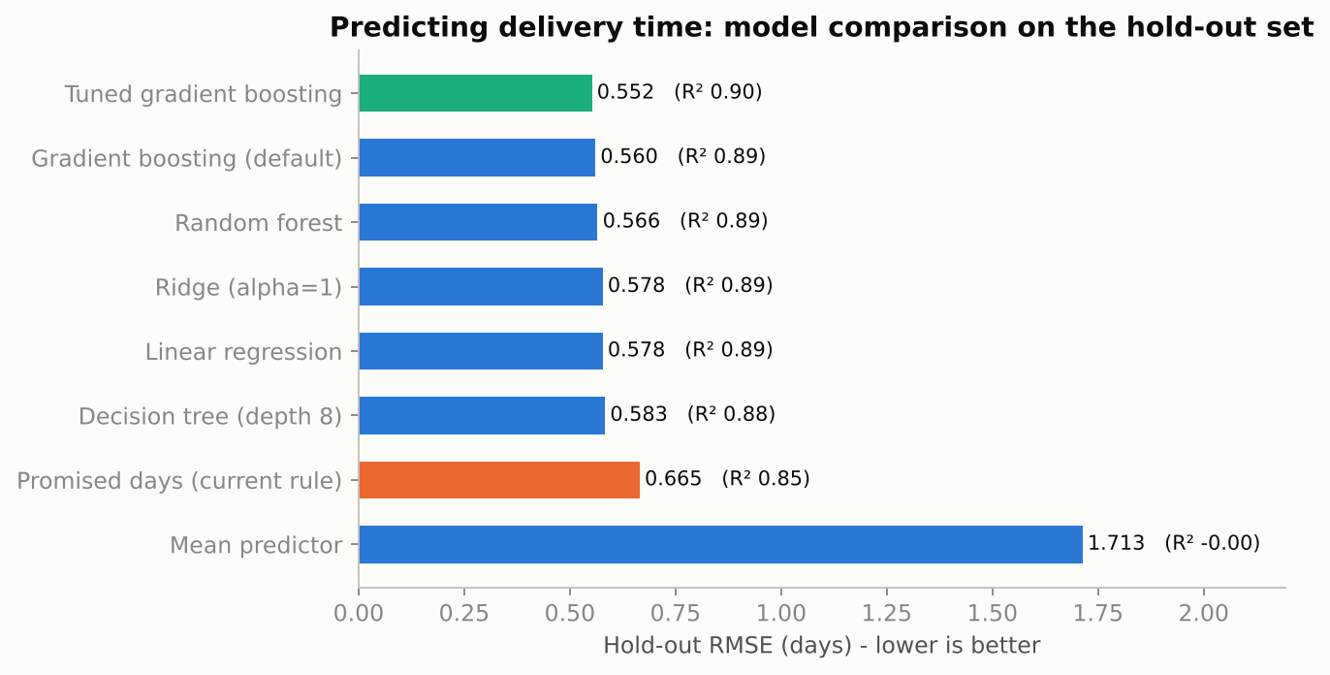
Figure 1. Hold-out RMSE by model (lower is better).
Every learned model is far better than the mean predictor (R-squared about 0.89 vs 0.00). Linear regression (RMSE 0.578) is already strong because distance and promised days carry most of the signal. Tree ensembles add a small, consistent gain (random forest 0.566, boosting 0.560). Tuning brings RMSE to 0.552. Compared with today's promised days (RMSE 0.665) the final model reduces error by 17%. The differences among the ensemble models are small relative to the cross-validation spread (about 0.011), so the choice among them should also weigh simplicity: linear regression is a defensible production fallback.

3.4 Cross-validation and hyper-parameter tuning
The best ensemble family in CV was tuned with randomised search (20 candidate settings x 5-fold CV, scored on RMSE). Selected parameters: min_samples_leaf = 40, max_leaf_nodes = 8, max_iter = 400, learning_rate = 0.08, l2_regularization = 5.0. The chosen settings are conservative (shallow trees, strong regularisation), which suits a dataset where the signal is mostly smooth.
Code 3. Randomised hyper-parameter search
if best_family == "Random forest":
est = RandomForestRegressor(n_estimators=250, n_jobs=-1, random_state=SEED)
space = {"model__max_depth": [8, 12, 16, None], "model__min_samples_leaf": [1, 3, 5, 10, 20],
"model__max_features": [0.3, 0.5, 0.8, 1.0]}
else:
est = HistGradientBoostingRegressor(random_state=SEED)
space = {"model__learning_rate": [0.03, 0.05, 0.08, 0.12], "model__max_leaf_nodes": [8, 15, 31, 63],
"model__min_samples_leaf": [10, 20, 40, 80], "model__l2_regularization": [0.0, 0.1, 1.0, 5.0],
"model__max_iter": [200, 400, 600]}
search = RandomizedSearchCV(pipe(est), space, n_iter=20, cv=cv, scoring="neg_root_mean_squared_error",
random_state=SEED, n_jobs=1, refit=True)
search.fit(X_tr, y_tr)

Forward-chaining CV (train on earlier months, validate on the next block) gives RMSE of 0.50, 0.50, 0.55, 0.63, 0.65 over five folds (mean 0.567). Error rises in the later folds, which cover the festive peak: the model has seen fewer festive-season examples when it predicts them, which is a warning that it should be retrained before each peak and monitored for drift.
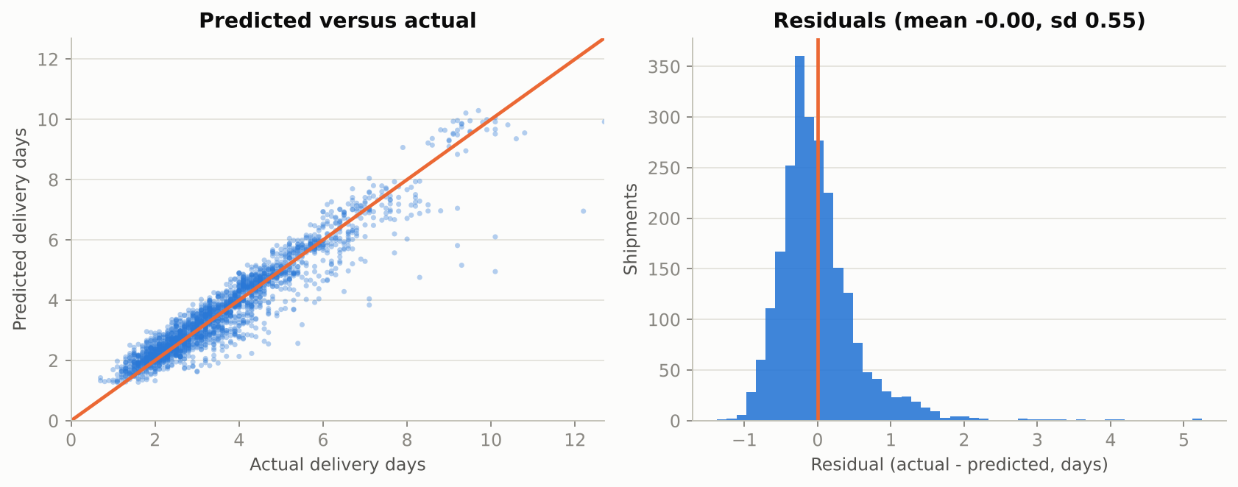
Figure 2. Predicted vs actual delivery days (left) and residual distribution (right) on the hold-out set.
Residuals are centred near zero (mean -0.002 day, standard deviation 0.55); 75% of predictions are within half a day and 95% within one day.

3.5 What drives delivery time?
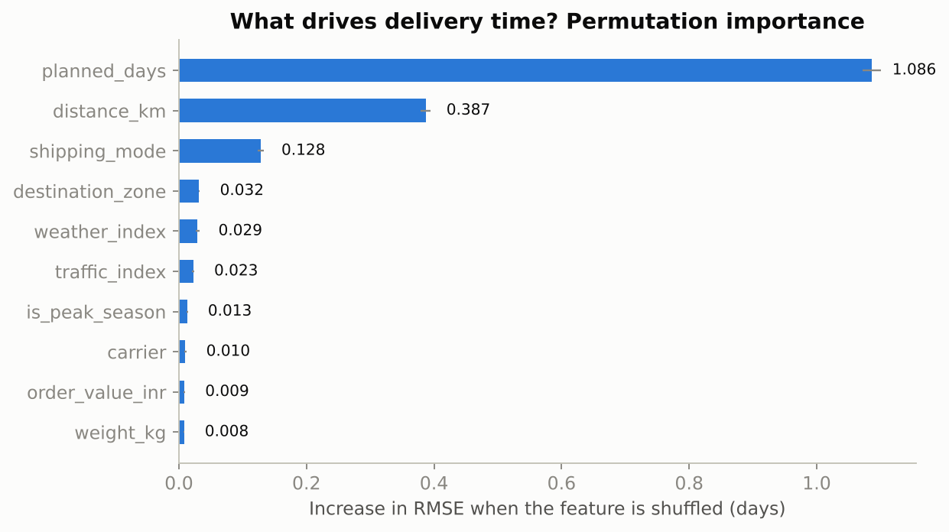
Figure 3. Permutation importance (increase in RMSE when a feature is shuffled).
Permutation importance on the test set shows planned_days (1.09), distance_km (0.39), shipping_mode (0.13), destination_zone (0.03), weather_index (0.03). Planned days and distance dominate; service level and destination zone come next. Weather and traffic add small but positive information. Carrier, weight and order value matter little for transit time, although carrier matters for lateness and cost.

4. Late-delivery risk model
Table 4. Late-risk classifiers (base rate 30%).
Model | CV AUC | Test AUC | Test avg. precision | F1 at 0.5
Logistic regression | 0.719 | 0.739 | 0.511 | 0.327
Gradient boosting classifier | 0.748 | 0.758 | 0.571 | 0.442

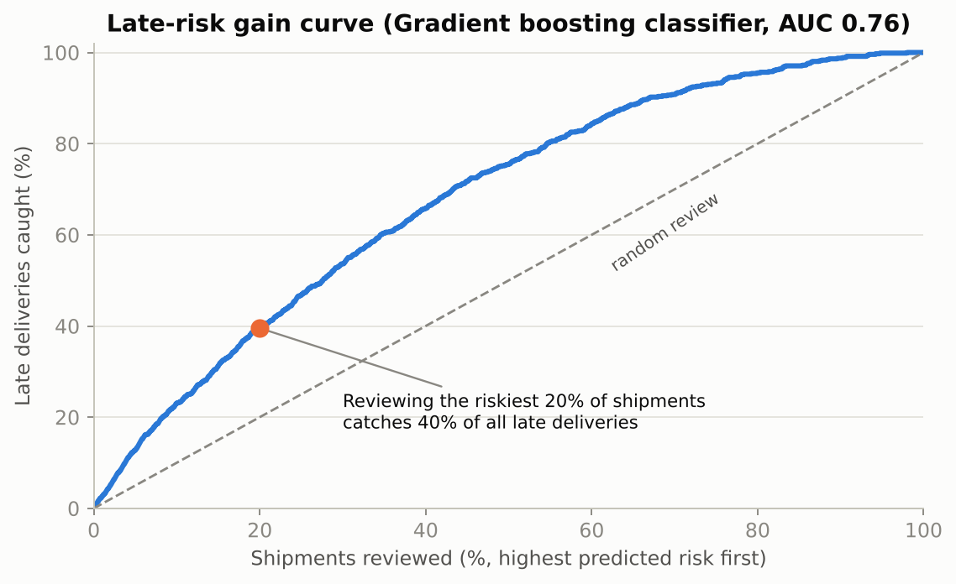
Figure 4. Gain curve: share of late deliveries caught versus share of shipments reviewed.
An AUC of 0.76 is moderate: lateness depends on many small and partly random causes, so no model can be near-perfect. It is nevertheless operationally useful. Reviewing the riskiest 20% of shipments catches 40% of the late ones, with 60% of reviewed shipments actually late against 30% at random, about twice as efficient. Reviewing the top 30% catches 54%. The default 0.5 threshold gives a low F1 because late shipments are a minority; in practice the review threshold should be set from the capacity of the control tower rather than at 0.5.

5. Optimisation strategies

5.1 Warehouse-to-hub allocation (transportation linear programme)
Decision: what share of each hub's demand should each warehouse serve? Variables x[w,h] are shipments sent from warehouse w to hub h. Objective: minimise the sum of x[w,h] x (mean delivery cost + penalty x late rate) with an assumed late-delivery penalty of INR 150. Constraints: every hub's demand is met exactly; each warehouse can absorb at most 20% more than its current volume; optionally, total expected late deliveries may not exceed today's, and each lane must keep a minimum share of today's volume (so the network does not change overnight). The model is solved with SciPy's HiGHS solver (Huangfu & Hall, 2018).
Code 4. Transportation LP with service-protection and lane-stickiness constraints
def solve_alloc(penalty=PENALTY, cap_factor=CAP_FACTOR, floor=0.0, protect_service=False):
"""Transportation LP. floor = minimum share of today's volume each lane must keep (lane stickiness);
protect_service = network late-delivery count may not exceed today's."""
C = (cost_m + penalty * late_m).values
nW, nH = C.shape
demand = cur.sum(axis=0).values
cap = cur.sum(axis=1).values * cap_factor
A_eq = np.zeros((nH, nW * nH)); A_ub = np.zeros((nW, nW * nH))
for h in range(nH):
for w in range(nW):
A_eq[h, w * nH + h] = 1
for w in range(nW):
A_ub[w, w * nH:(w + 1) * nH] = 1
b_ub = list(cap)
if protect_service:
A_ub = np.vstack([A_ub, late_m.values.ravel()]); b_ub.append(base_late_total)
lb = floor * cur.values.ravel()
r = linprog(C.ravel(), A_ub=A_ub, b_ub=b_ub, A_eq=A_eq, b_eq=demand, bounds=[(l, None) for l in lb], method="highs")
assert r.success, r.message
x = r.x.reshape(nW, nH)
return x, {"delivery_cost_per_shipment": float((x * cost_m.values).sum() / N_TOT),
"late_pct": float(100 * (x * late_m.values).sum() / N_TOT),
"reassigned_pct": float(100 * np.abs(x - cur.values).sum() / 2 / N_TOT)}

Table 5. Warehouse-allocation scenarios (baseline: INR 705 per shipment, 29.3% late).
Scenario | Cost / shipment (INR) | Late rate | Volume moved | Cost saving
Cost-optimal, free reassignment | 430 | 32.9% | 63% | 38.9%
Service-protected, free reassignment | 453 | 29.3% | 62% | 35.7%
Practical: <=50% of a lane moves | 570 | 29.3% | 32% | 19.1%
Conservative: <=25% of a lane moves | 630 | 29.3% | 16% | 10.7%

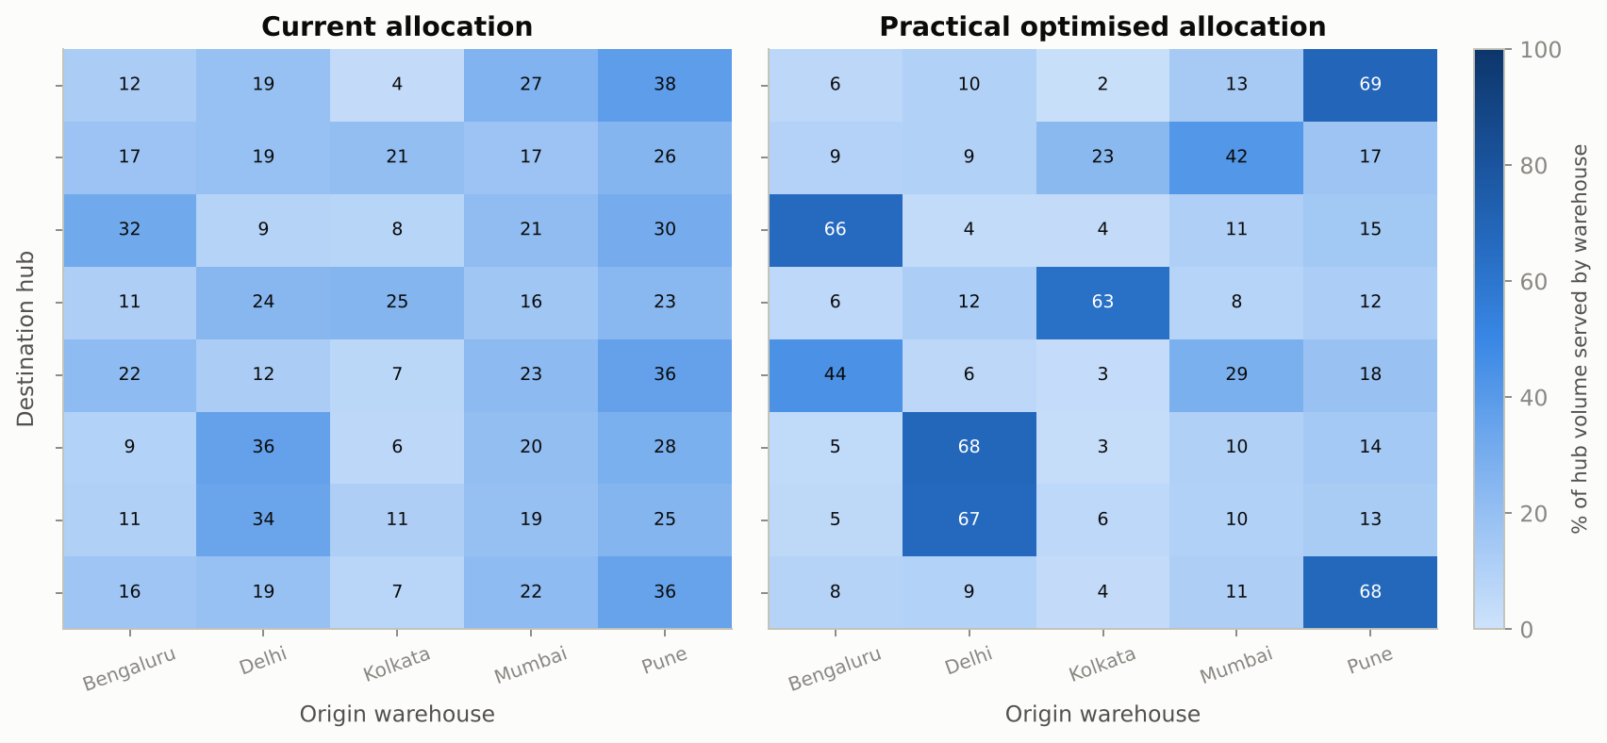
Figure 5. Share of each hub's volume served by each warehouse: today versus the practical optimised plan.
The cost-only solution saves 39% but raises the late rate to 32.9%, which shows why a service constraint is essential. The practical plan, which protects the late rate and moves at most half of any lane, saves 19.1% while re-routing 32% of volume; the conservative plan saves 10.7% with 16% moved. Biggest moves: Guwahati from Kolkata (+37 pp, taken from Delhi); Chennai from Bengaluru (+34 pp, taken from Pune); Lucknow from Delhi (+33 pp, taken from Pune). The late penalty did not change the practical result for penalties of INR 0, 150 and 400, because the service-protection constraint, not the penalty, is what binds.
Caveat. Lane costs and late rates are historical averages and are assumed to stay constant when volume moves. Real tariffs, congestion and warehouse stock may react to a 30% shift in flows, so these savings are an upper-bound planning estimate to be validated in a pilot on a few hubs.

5.2 Carrier mix per destination zone
For each zone, a small LP chooses carrier shares to minimise mean delivery cost, subject to the zone's expected late count not exceeding today's and each carrier keeping between 10% and 45% of the zone's volume (to avoid dependence on one carrier).
Table 6. Carrier-mix optimisation by zone.
Zone | Shipments | Cost now (INR) | Cost optimised (INR) | Saving | Late rate
Central | 1,150 | 597 | 580 | 2.8% | 23.4% to 23.4%
East | 1,560 | 838 | 828 | 1.2% | 26.2% to 26.2%
North | 2,629 | 662 | 642 | 3.0% | 26.6% to 26.6%
North-East | 1,380 | 1170 | 1122 | 4.1% | 46.6% to 46.3%
South | 3,324 | 592 | 588 | 0.8% | 25.8% to 25.8%
West | 1,482 | 539 | 527 | 2.3% | 34.1% to 34.1%

Savings are modest (about 1% to 4%) because carriers are already fairly balanced and the bounds limit change; the North-East gains most because its cost is highest. Carrier mix is therefore a secondary lever; the allocation of warehouses to hubs is the primary one.

5.3 Data-driven delivery promises
Today the promised date is a distance-and-mode rule. Instead, quantile gradient-boosting models predict the q-th percentile of delivery time for each shipment and the promise is that value rounded up. Raising q buys reliability with longer promises; the question is how efficiently.
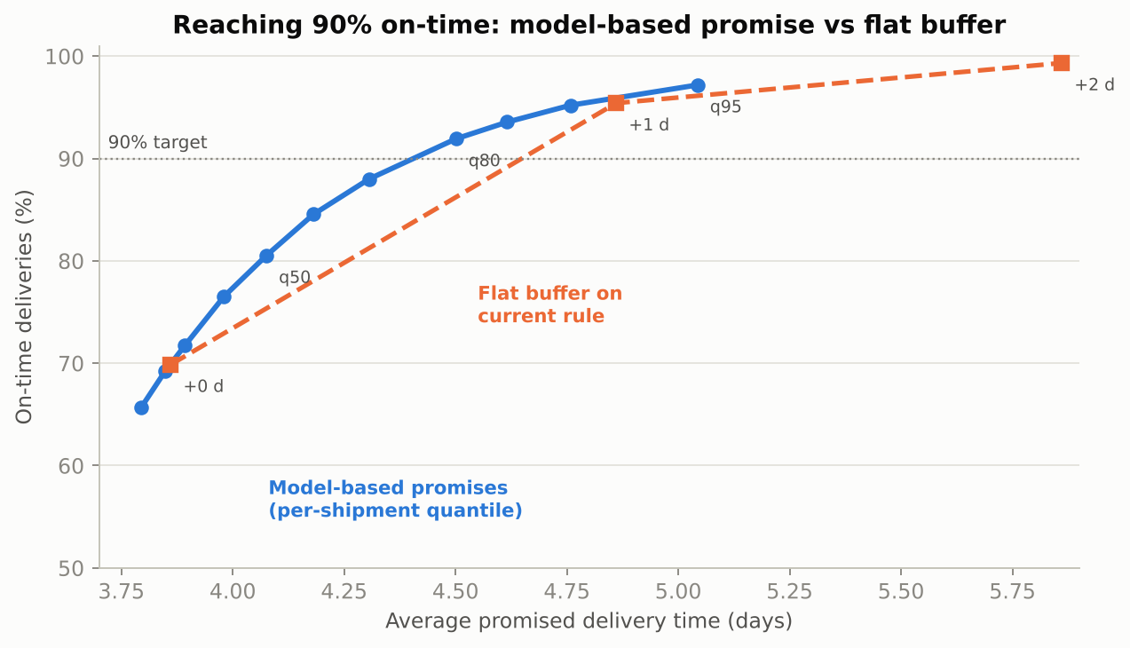
Figure 6. On-time rate versus average promised days: per-shipment quantile promise versus a flat buffer on the current rule.
Table 7. Promise policies on the hold-out set.
Policy | Avg promise (days) | On-time
Current rule | 3.86 | 69.9%
Flat +1 day | 4.86 | 95.4%
Flat +2 day | 5.86 | 99.3%
Quantile q50 | 4.08 | 80.5%
Quantile q70 | 4.31 | 88.0%
Quantile q80 | 4.50 | 91.9%
Quantile q90 | 4.76 | 95.2%

At the same average promise length as today (3.86 days) the model gives 69.9% on time, essentially the same as the current rule (69.9%): better predictions do not create reliability for free. The gain appears when targeting a service level. To reach 90% on time, the per-shipment promise needs 4.41 days on average, whereas a flat buffer on the current rule needs 4.65 days, about 0.24 day shorter for the same reliability, because the model gives long, risky lanes more time and short, safe lanes less.

6. Final recommendations
Table 8. Prioritised actions.
# | Recommendation | Evidence | Expected effect
1 | Replace the rule-based promise with a quantile model targeting 85-90% on-time | Frontier in Section 5.3 | 90% on-time with about 0.2 day shorter average promise than a flat buffer
2 | Pilot the practical warehouse-allocation plan on 2-3 hubs (Guwahati, Chennai, Lucknow first) | Section 5.1 | Up to 19% lower delivery cost with no rise in late rate (to be validated)
3 | Score every shipment for late risk at dispatch and review the top 20% | Section 4 | Catch 40% of late shipments with 20% of the effort
4 | Re-balance carrier mix by zone within 10-45% bounds | Section 5.2 | 1-4% cost saving at constant service
5 | Retrain monthly and before each peak; monitor RMSE and AUC | Time-series CV, Section 3.4 | Prevents drift-related degradation

Limitations
- Simulated data: effect sizes illustrate the method; they are not forecasts for a real company.
- Delivery time is dominated by distance and promised days, so absolute R-squared is high and the improvement over simple baselines is small.
- LP savings assume stable lane costs and late rates; the late penalty is an assumption.
- A random split was used for the main test; the forward-chaining CV shows error rises in peak months.

References
Breiman, L. (2001). Random forests. Machine Learning, 45(1), 5-32.
Friedman, J. H. (2001). Greedy function approximation: A gradient boosting machine. Annals of Statistics, 29(5), 1189-1232.
Pedregosa, F., et al. (2011). Scikit-learn: Machine learning in Python. Journal of Machine Learning Research, 12, 2825-2830.
Koenker, R., & Bassett, G. (1978). Regression quantiles. Econometrica, 46(1), 33-50.
Toth, P., & Vigo, D. (Eds.) (2014). Vehicle Routing: Problems, Methods, and Applications (2nd ed.). SIAM.
Dantzig, G. B., & Ramser, J. H. (1959). The truck dispatching problem. Management Science, 6(1), 80-91.
Huangfu, Q., & Hall, J. A. J. (2018). Parallelizing the dual revised simplex method. Mathematical Programming Computation, 10, 119-142.
Virtanen, P., et al. (2020). SciPy 1.0: Fundamental algorithms for scientific computing in Python. Nature Methods, 17, 261-272.
Christopher, M. (2016). Logistics & Supply Chain Management (5th ed.). Pearson.
Chopra, S., & Meindl, P. (2016). Supply Chain Management: Strategy, Planning, and Operation (6th ed.). Pearson.
Hunter, J. D. (2007). Matplotlib: A 2D graphics environment. Computing in Science & Engineering, 9(3), 90-95.

