Automated Pre-Match Opponent Analysis Platform
Project Summary — Architecture, Plan & Resume Points
Aditya Chilla | 2025 | github.com/aditya-018

1. What Is It
An end-to-end AI-powered football intelligence system that ingests raw StatsBomb event data, applies ML models to extract tactical insights, and auto-generates executive pre-match coaching reports using a locally hosted LLM — all free, open-source, and privacy-safe.

2. System Architecture

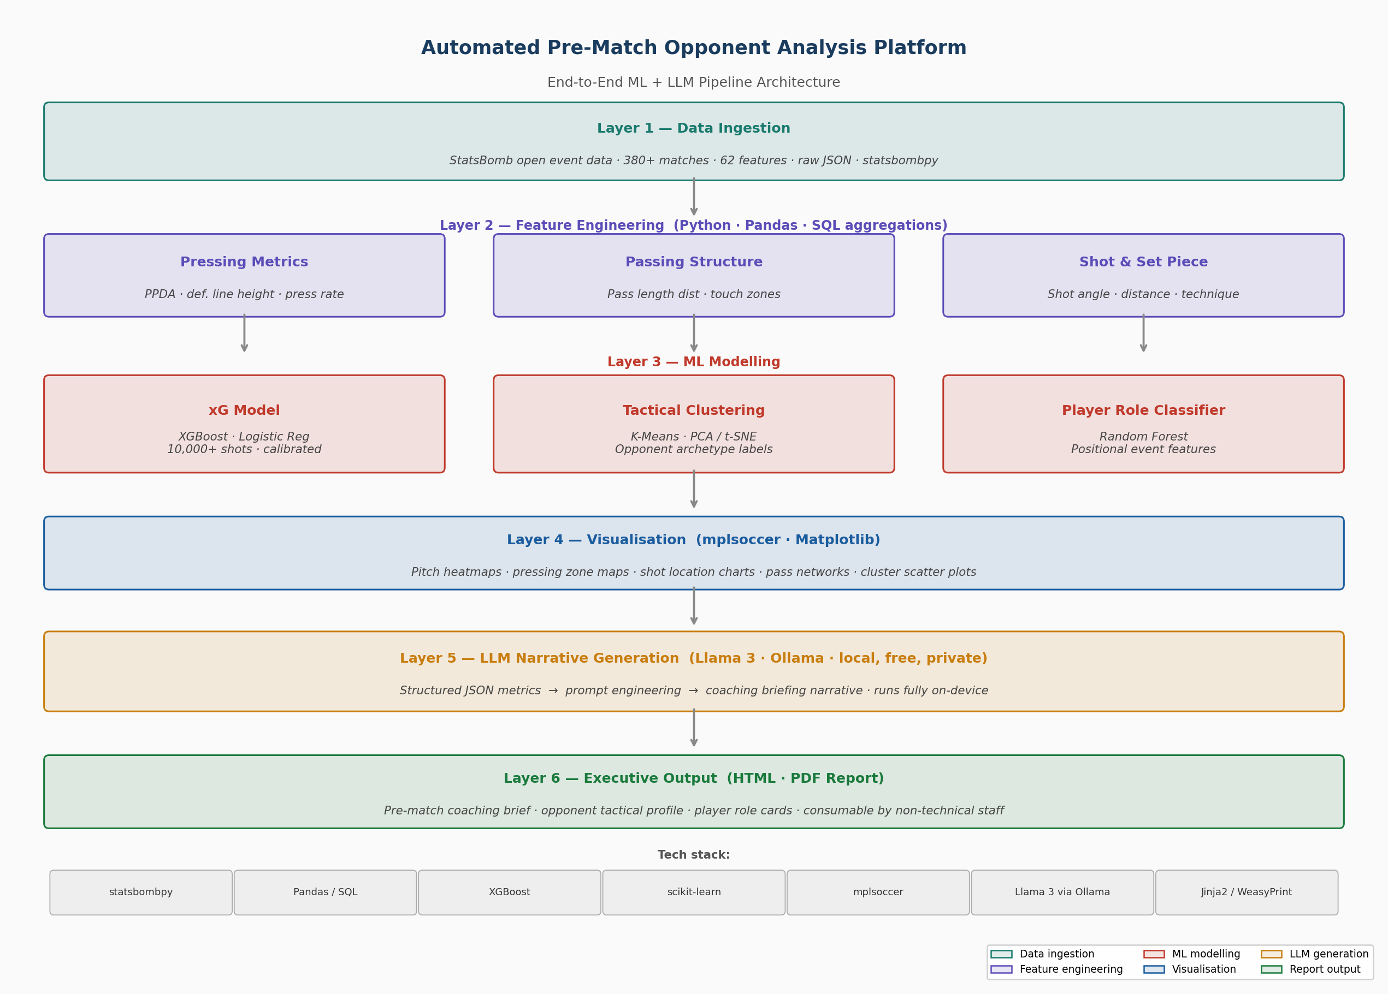

3. Pipeline — Six Layers

Layer | Name | What it does | Key tools
1 | Data Ingestion | Load raw StatsBomb JSON event files, normalise to DataFrames | statsbombpy, Pandas
2 | Feature Engineering | Compute PPDA, pass distributions, touch zones, shot features from raw events | Pandas, NumPy, SQL-style aggregations
3 | ML Modelling | xG model (XGBoost), tactical clustering (K-Means/PCA), player role classifier (Random Forest) | XGBoost, scikit-learn
4 | Visualisation | Pitch heatmaps, shot maps, pass networks, cluster scatter plots | mplsoccer, Matplotlib
5 | LLM Generation | Converts structured metrics to written coaching briefing — runs locally, no data leaves device | Llama 3 (8B) via Ollama
6 | Report Output | Packages visuals and narrative into executive HTML/PDF coaching report | Jinja2, WeasyPrint

4. Two-Week Build Plan

Phase | Days | Deliverables
1 — Data & Visuals | Days 1–5 | Environment setup · StatsBomb data loaded · PPDA & passing features computed · first pitch heatmap and shot map produced
2 — ML Models | Days 6–10 | xG model trained and evaluated · K-Means clustering with PCA visualisation · Random Forest player role classifier · all model outputs validated
3 — LLM & Report | Days 11–14 | Ollama + Llama 3 installed · prompt engineered · JSON metrics pipeline connected · HTML/PDF report generated · GitHub README + Loom video recorded

5. Resume Bullet Point

Built an end-to-end opponent profiling system using raw StatsBomb open data, applying XGBoost xG modelling, K-Means tactical clustering, and LLM-powered (Llama 3 via Ollama) narrative generation to automate executive pre-match coaching reports with mplsoccer pitch visualisations.

6. Manchester United JD Alignment

JD Requirement | Covered by
Work with raw football event data independently | Layer 1 & 2 — raw JSON ingested and engineered, no dashboards
Proficiency in SQL and Python for open-ended questions | Layer 2 — SQL-style Pandas group operations for all metrics
Pre- and post-match opponent profiling reports | Layer 6 — automated HTML/PDF opponent profile per fixture
Executive-level reporting for senior leadership | Layer 5 & 6 — LLM narrative in coaching language, report format
Data visualisation and football tactics understanding | Layer 4 — pitch heatmaps, shot maps, pass networks, clusters
Curious, self-motivated, explores beyond the ask | ML clustering + role classification + LLM go beyond standard stats

7. Key Interview Talking Points

On the data:
- Loaded raw StatsBomb JSON and normalised nested structures to flat DataFrames — no pre-built dashboards used
- All metrics computed from raw event logs using Pandas group operations, mirroring how a professional club analyst works
On the xG model:
- Chose XGBoost for non-linear feature interactions; handled class imbalance via scale_pos_weight
- Evaluated with log-loss, AUC-ROC, and calibration curve — not just accuracy
On the LLM choice:
- Chose Llama 3 via Ollama over GPT-4 for data privacy — tactical data never leaves the local environment
- Used few-shot prompting to produce concise, action-oriented coaching language rather than generic analytical prose

Aditya Chilla | adityacv2000@gmail.com | github.com/aditya-018 | aditya-018.github.io/portfolio

