Cloud Computing Exercise #7

Given the Class C network of 192.168.5.0/24, subnet the network to create the network in the figure below with the host requirements shown.

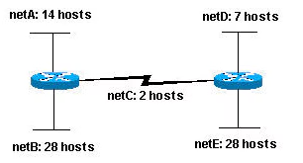

Figure: Computer network

Hint:

It’s nice to know:

-how many usable addresses are there in class C networks?

-find out how many subnets are required(See the figure) and what’s the largest no.of hosts a subnet requires

Step1: Calculate the number of subnet (Determine how many bits you will have to “borrow” from the host portion of IP address and use them for subnetting)

Step2: Calculate the Number of hosts per subnet, (formula for calculating the number of hosts in a subnet is **2^number of host bits - 2** (the subtraction of 2 is because 1 address is reserved for the network, and 1 is reserved for the broadcast). (Remember what is our max requirement for largest no.of hosts, Does it meet the requirements?

Step3: Assign Subnets. (Remember that when you borrow “X” bits from host portion of the IP, the subnet mask is increased by “X”)