HF-SELAP: A Hierarchical Federated Lightweight Authentication Framework for Secure UAV-Assisted VANET Communication in Disaster Rescue
Vansh Garg (24BCI0132) | Aditya Bhatt (24BCI0143)
BCSE308L – Computer Networks • Project Report

Abstract
When an earthquake, flood or wildfire destroys roadside units and cellular towers, unmanned aerial vehicles (UAVs) can restore connectivity for stranded vehicles. Their radio links are open, though, and the devices on both ends have little processing power, so the authentication scheme must be both strong and cheap. SELAP, a recent lightweight protocol built from ASCON authenticated encryption, hash functions and physical unclonable functions (PUFs), meets those two goals. However, it depends on a single trusted authority (TA), it ties UAV identity to PUF hardware whose noisy responses need a fuzzy extractor and helper data, and it does not handle overload, authority failure, compromised devices or the move to quantum-resistant parameters. This work proposes and implements HF-SELAP, a hierarchical federated extension. HF-SELAP keeps SELAP's four-message ASCON exchange but replaces the PUF and fuzzy extractor with pairing-free certificateless public-key authentication: every vehicle and UAV combines a secret value of its own with a partial private key from a key generation centre and signs its protocol message, so no certificates are needed and the key generation centre never learns a complete private key. Authentication is spread over several Regional TAs coordinated by a Root/Federation TA, with score-based TA selection and load balancing, heartbeat-based fail-over, federated trust management, a revocation registry, identity refresh, recovery by re-enrolment and an Ascon-80pq post-quantum mode. The complete system was implemented in Python. That includes a from-scratch ASCON verified against the reference implementation, the certificateless scheme on the NIST P-256 curve, and a discrete-event network simulator. Measured results show 0.928 ms of computation on the vehicle and 0.924 ms on the UAV per authentication, with 3584 bits on the air interface. Under a 70 % hot-spot load of 2100 requests/s, three load-balanced Regional TAs authenticated 99.9 % of requests, against 33.7 % for a single TA. While a Regional TA was down, 91.4 % of requests were still served within one second, against 0.0 % without federation. All 26 implemented attack scenarios were blocked, including public-key replacement and malicious key-generation-centre attacks, and the post-quantum mode changed the total computation by 3.1 %.
Keywords: UAV-assisted VANET, Lightweight authentication, Certificateless cryptography, ASCON, Federated trust management, Disaster communication

1. Introduction
Large disasters cut off exactly the communication services that rescue teams depend on. Fallen towers, flooded cabinets and power outages leave roadside units, base stations and Wi-Fi access points unusable for hours or days, while people in vehicles still need route guidance, hazard warnings and a way to report casualties. Vehicular ad hoc networks (VANETs) let vehicles exchange this information, but in a damaged area they need a temporary backbone. UAVs suit this role well. They can be launched within minutes, placed over the affected road segments, and moved as the situation changes [9], [16], [17].
Putting UAVs into the communication path creates its own security problems. Every frame between a vehicle, a UAV and the coordinating trusted authority crosses an open wireless channel, so it can be eavesdropped, replayed, altered or blocked. A UAV can be shot down or captured, and an attacker who reads its memory could then forge rescue instructions. On-board units and UAV flight computers have limited computation and energy, so schemes that need many elliptic-curve or pairing operations per session are poorly matched to the task [6], [14]. Finally, people expect their identity and movements to stay private, even during an emergency.
SELAP, the base protocol of this project [21], answers these concerns with a careful combination of symmetric primitives. All protocol messages are protected by the lightweight AEAD scheme ASCON [22]. UAV identities are tied to PUF responses that are stabilised by a fuzzy extractor. A pair of old and current temporary identities kept at the TA prevents desynchronisation. The result is a four-message exchange of only 2432 bits. The SELAP authors themselves point out the limits of the design: everything depends on one trusted authority, robustness under heavy load and high mobility has not been examined, the PUF and fuzzy extractor add hardware dependence and management complexity, compromised entities cannot be revoked and rehabilitated, and migration to post-quantum primitives is left open.
This project turns those open points into a working system. Its contributions are:
- A hierarchical federated architecture (HF-SELAP). Regional TAs run the authentication exchange for their regions. A Root/Federation TA keeps inter-TA trust, a sealed credential escrow and a federated identity directory, so any trusted Regional TA can serve a foreign vehicle or UAV without new radio messages.
- Certificateless authentication instead of PUFs. Each entity's private key SK_{E} = x_{E} + D_{E} combines a secret value chosen by the entity with a partial private key issued by a key generation centre (KGC) hosted by the Root TA [23]. The Regional TA verifies signatures with the registered public key. No certificates, special hardware or helper data are needed, and the KGC never knows a complete private key.
- Availability mechanisms. Regional TAs are chosen by a score that combines load, availability, reliability and communication delay. Inter-TA trust evolves with observed service, a heartbeat monitor detects failed TAs and fails over to healthy ones, and recovered TAs are resynchronised automatically.
- Life-cycle security. A versioned, federation-wide revocation registry is pushed to every Regional TA. Pseudonyms are refreshed after every session. Recovery by re-enrolment issues fresh credentials and a fresh key pair to one entity without a network reset. An optional post-quantum mode switches the symmetric layer to Ascon-80pq with 160-bit keys.
- A complete, tested implementation and evaluation. The evaluation covers computation, communication, storage, energy, scalability, delay decomposition, load imbalance, fault tolerance, mobility, certificateless key management and 26 executable attack scenarios, all reproducible from the published scripts.
The rest of the report is organised as follows. Section 2 surveys related work, Section 3 presents the architecture, Section 4 details the methodology and implementation, Section 5 reports and discusses the results, and Section 6 concludes.

2. Literature Survey
The surveyed work falls into five groups: reliable vehicular messaging, lightweight and privacy-preserving VANET authentication, hardware-rooted security, UAV-assisted emergency networking, and survey studies. For each group we note what carries over to a UAV-supported disaster setting and what is still missing.

2.1 Reliable dissemination of safety messages
Nwizege et al. [1] studied DSRC vehicle-to-infrastructure safety messaging and proposed ACARS, a rate-selection algorithm that uses vehicle speed and context to adapt the transmission rate. Their simulations show higher throughput and shorter delay in fast-moving traffic, but security is not part of the design and the results are not validated in the field. Fogue et al. [12] secured warning dissemination through cooperative neighbour position verification. Before relaying an alert, vehicles check where their neighbours claim to be, which raised dissemination performance by up to 50 % under false-position attacks. The method depends on honest cooperation and does not authenticate the senders themselves. Jing et al. [15] proposed EABA, which assigns priorities to messages and lets vehicles and roadside units share batch verification, lowering delay and loss in dense traffic. Chim et al. [7] proposed MLAS, which separates routine messages verified with HMACs from urgent messages that receive stronger verification and reports large reductions in verification delay. Both of the last two schemes still rely on roadside units, exactly the infrastructure a disaster removes.

2.2 Lightweight and privacy-preserving VANET authentication
Hsieh et al. [2] built ECC-based group key agreement for V2V and V2I groups and added a delay-based flooding rule that reduces broadcast collisions. Frequent membership changes, however, force costly re-keying. Theodore et al. [8] combined an improved TESLA broadcast authentication with a cuckoo filter, achieving mutual authentication, anonymity and revocation support with small memory. Gao et al. [11] integrated pseudonyms, group signatures and identity-based cryptography into PMIPv6 so that handovers stay anonymous and cheap, but they leave inter-domain trust to future work. Thorncharoensri et al. [10] replaced attribute-based access control with level-based signcryption, which gives constant-size ciphertexts but no efficient credential revocation. Wang et al. [19] proposed HDMA for 5G-enabled VANETs, using group signatures, pseudonyms and pre-computed tables to avoid pairings. Shawky et al. [13] extracted keys with Chebyshev chaotic maps and added physical-layer checks, keeping authentication reliable down to 0 dB SNR at 45 m/s. Tan and Chung [20] used a consortium blockchain, edge computing and the Chinese Remainder Theorem for certificateless authentication and dynamic group keys, at the cost of consensus and storage overhead. All of these schemes target conventional VANETs. None considers UAV relays or the loss of the trusted infrastructure itself.

2.3 Hardware-rooted and certificateless authentication
Alfadhli et al. [4] proposed MFSPV, a multi-factor scheme in which PUFs and one-time dynamic pseudonyms protect V2V and V2I exchanges against cloning, impersonation and replay. The design assumes dependable PUF hardware and trusted regional certificate authorities. Aghabagherloo et al. [5] combined the advantages of RSU-aided and tamper-resistant-device-aided conditional privacy-preserving authentication. Their scheme keeps working, and even detects tampering, when an on-board unit is physically compromised. These works show the value of binding identity to hardware, which SELAP adopts for UAVs. Hardware binding has a price, however: noisy PUF responses need a fuzzy extractor and stored helper data, enrolment needs the physical device, and a damaged module cannot be re-provisioned remotely.
Certificateless public-key cryptography, introduced by Al-Riyami and Paterson [23], offers a software alternative. A key generation centre issues only a partial private key, and each user completes it with a secret value of its own. This removes the certificate management of a conventional public-key infrastructure and the key escrow of identity-based cryptography, because no single party knows a user's full key. The original constructions use bilinear pairings; pairing-free variants built from ordinary elliptic-curve operations keep the same structure at a much lower cost, which is the approach HF-SELAP follows. Tan and Chung [20] show that certificateless authentication fits vehicular networks, although their design adds blockchain consensus.

2.4 UAV-assisted emergency communication
On the networking side, Sona et al. [9] placed UAV relays according to population density, terrain, altitude and battery level and routed traffic energy-efficiently, reporting lower path and packet loss and more than 93 % communication efficiency. Sharvari et al. [16] designed MO3DR, an opportunistic 3D routing algorithm that picks forwarding UAVs under coverage and collision constraints. Matracia et al. [17] surveyed terrestrial, aerial and space-borne post-disaster networks, and identified backhauling, UAV placement, mobility and energy management as open problems. None of these three works includes authentication. On the security side, Aissaoui et al. [6] reviewed cryptography for UAV traffic management and concluded that mainstream Internet security standards are often too heavy for small UAVs. Lei et al. [18] proposed ODIAP for the Internet of Drones, offloading Chinese-Remainder-Theorem computations to servers and verifying the protocol with ProVerif. Cui et al. [3] designed a provably secure authentication and key agreement scheme for UAV-assisted VANETs in emergency rescue, based on chaotic maps, fuzzy verifiers and honeywords. It meets fourteen security requirements, but the honeyword store adds storage and the design keeps a single authority.

2.5 Survey studies
Jan et al. [14] classified privacy-preserving VANET authentication into pseudonym-, identity-, hash-, group-signature- and blockchain-based families. They compared the families' attack resistance and overhead, and concluded that secure, scalable and efficient mechanisms are still needed.
Table 1. Summary of the surveyed literature
Ref. | Core technique | Main strength | Gap relevant to this work
[1] | Context-aware rate selection (DSRC) | Throughput and delay under mobility | No security; simulation only
[2] | ECDH group keys, delayed flooding | Secure group messaging, fewer collisions | Costly re-keying; no UAVs
[3] | Chaotic maps, fuzzy verifier, honeywords | Provable UAV-VANET AKA | Single authority; honeyword storage
[4] | PUF + one-time pseudonyms | Clone and impersonation resistance | Needs trusted regional CAs; no UAVs
[5] | RSU- and TRD-aided CPPA | Survives OBU compromise | Random-oracle model; trusted TA
[6] | Survey of UTM cryptography | Gap analysis for small UAVs | No protocol proposed
[7] | HMAC for regular, strong auth for urgent | Very low verification delay | Depends on RSUs
[8] | Improved TESLA + cuckoo filter | Cheap broadcast auth, revocation | No UAV support
[9] | Optimised UAV relay placement | Coverage and energy efficiency | No authentication
[10] | Level-based signcryption | Constant-size, simple access control | No efficient revocation
[11] | PMIPv6 + pseudonyms + group signatures | Anonymous handover | No inter-domain trust
[12] | Cooperative position verification | Robust warning dissemination | Needs cooperative honest nodes
[13] | Chaotic keys + PHY-layer checks | Low-cost re-authentication | Channel-dependent; no UAVs
[14] | Survey of privacy-preserving auth | Taxonomy and open issues | No protocol proposed
[15] | Priority-based batch verification | Lower delay in dense traffic | Relies on RSU cooperation
[16] | Opportunistic 3D UAV routing | Reliable multi-hop delivery | No security; no energy model
[17] | Survey of post-disaster networks | Architectures and challenges | No protocol proposed
[18] | CRT-based IoD authentication | Low UAV computation, ProVerif | Server dependence; IoD only
[19] | Group signatures + lookup tables | Pairing-free 5G VANET auth | Trusted infrastructure; no UAVs
[20] | Consortium blockchain + edge + CRT | Certificateless auth, group keys | Consensus/storage overhead

2.6 Research gap
Taken together, the literature offers efficient cryptographic building blocks and capable UAV networking schemes, but they are rarely combined. SELAP [21] closes much of this gap. It brings ASCON, PUFs, a fuzzy extractor and desynchronisation-resistant identity updates into one protocol for UAV-assisted VANETs and outperforms elliptic-curve designs in cost. What remains open is the system around the protocol: a single trusted authority is both a capacity limit and a single point of failure, UAV identity depends on PUF hardware and helper data, compromised entities cannot be removed and re-admitted, behaviour under overload and high mobility is unknown, and there is no post-quantum path. HF-SELAP is designed to fill exactly these gaps. It keeps SELAP's lightweight ASCON message structure and replaces hardware-bound identity with certificateless keys.

3. Proposed System Architecture
The architecture (Fig. 1) arranges the system in layers. Vehicles and UAVs form the access layer. Regional TAs form the authentication layer. A Root/Federation TA, which also hosts the key generation centre, forms the trust-coordination layer. A set of cross-cutting security modules and an evaluation layer complete the design.
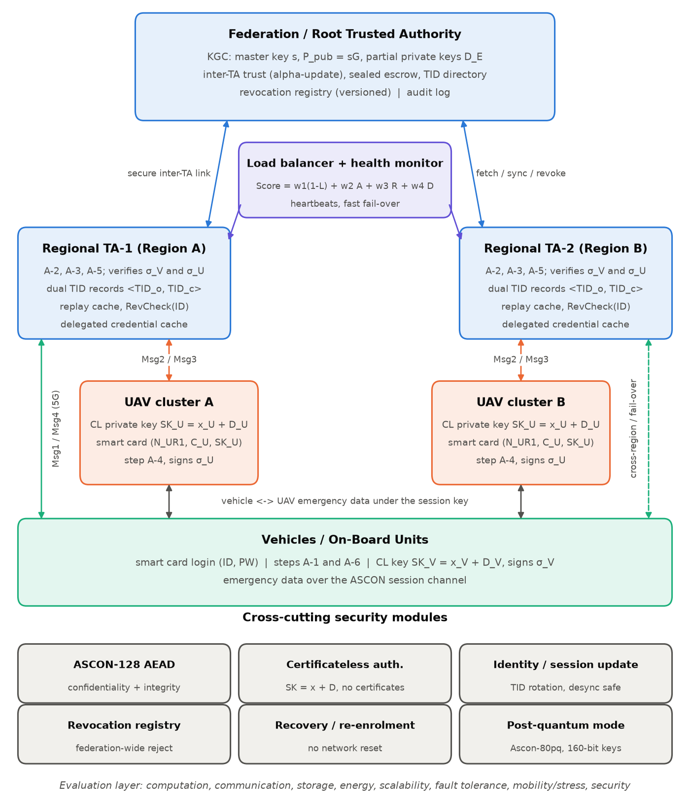
Fig. 1. HF-SELAP architecture: certificateless authentication at Regional TAs under a Root/Federation TA, with load balancing, fail-over and cross-cutting security modules.

3.1 Components and their roles
- Vehicles / on-board units. A vehicle requests emergency service, unlocks its smart card with its identity and password, and runs steps A-1 and A-6. The card holds the vehicle's symmetric credentials and its certificateless private key SK_{V}, so the OBU performs only hashing, two ASCON operations and one signature per session.
- UAV clusters. UAVs give coverage where ground infrastructure has failed. Each UAV holds a certificateless key pair; its smart card seals the credentials N_{UR1}, C_{U} and the private key SK_{U} under the operator's password. No special hardware is required. UAVs are grouped by region so the fleet can grow.
- Regional TAs (RTAs). Each RTA manages the vehicles and UAVs enrolled in its region and runs the TA side of the protocol (A-2, A-3, A-5). It verifies both signatures with the registered public keys and keeps SELAP's dual temporary-identity records, a replay cache, the local copy of the revocation list, and a cache of credentials delegated by the federation.
- Federation / Root TA and KGC. The Root TA authorises the RTAs and hosts the key generation centre, which holds the master secret s and issues partial private keys. It maintains the inter-TA trust matrix and per-RTA reliability scores, stores a sealed escrow copy of every entity's public credentials, and keeps a federated directory of temporary identities. It mediates every cross-region, load-sharing or fail-over request.
- Load balancer. For every request the load balancer scores the operational, trusted RTAs by load, availability, reliability and communication delay, and picks the best. An RTA whose load exceeds a limit is bypassed, so a disaster hot-spot does not overload a single RTA.
- Fault-tolerance procedure. RTAs send heartbeats. A missing heartbeat, or a timeout together with a missing heartbeat, marks an RTA as down, and its traffic moves to another trusted RTA. A recovered RTA is resynchronised by the Root TA.
- ASCON AEAD security layer. Every protocol message, every inter-TA message and the post-authentication data channel are protected by ASCON, which gives confidentiality and integrity at low cost. The signatures travel inside the ciphertexts.
- Certificateless authentication module. Partial private keys are validated before use, full keys never leave the entity, and every signature is bound to the session's nonces, the temporary identity, the serving RTA and a timestamp. Replacing a public key or abusing the KGC's knowledge of partial keys does not yield a valid signature.
- Identity and session update. Each successful run refreshes the vehicle's temporary identity with a hash of the old identity, a fresh nonce and the session time. The old and current values are both accepted, so lost messages cannot cause desynchronisation, and the update is pushed to the federation.
- Revocation registry. Compromised or retired vehicles and UAVs are recorded in a versioned registry at the Root TA. The registry is pushed to every RTA, and RTAs that were offline catch up when they rejoin.
- Recovery / re-enrolment. A revoked or damaged entity is re-admitted with new credentials and a new key pair while every other entity keeps working, so the network never needs a reset.
- Post-quantum lightweight layer. A configuration switch moves all AEAD operations to Ascon-80pq with 160-bit keys, raising resistance to quantum key search on the symmetric layer without changing message formats.
- Evaluation layer. The design is measured for authentication speed, traffic, computation, storage, energy and security, under high mobility, changing link conditions, overload and failures.

3.2 Operational workflow
- Step 1 – Secure enrolment. Each vehicle and UAV registers once with an RTA of its region over a secure provisioning channel. It generates a secret value, obtains a partial private key from the KGC through the RTA, validates it and forms its full private key. The RTA registers the public key and deposits a sealed copy of the credentials with the Root TA.
- Step 2 – Regional TA selection. The load balancer computes the load, availability, reliability and delay terms of every eligible RTA and directs the request to the RTA with the highest score. This is normally the local RTA, but another RTA when the local one is busy, failed or less reliable.
- Step 3 – Vehicle request. The vehicle builds Msg1 from a fresh nonce, a timestamp and its temporary identity, signs the request with its certificateless private key, and protects everything with an ASCON key derived from its SELAP credentials.
- Step 4 – Regional authentication. The RTA checks freshness, replays and revocation, decrypts Msg1 and verifies the vehicle's signature. If the vehicle or UAV belongs to another region, the RTA obtains its credentials from the Root TA over an authenticated inter-TA link. It then sends Msg2 to the UAV.
- Step 5 – UAV authentication and key agreement. The UAV authenticates the RTA through the ASCON tag, derives the session key, signs its answer and returns Msg3. The RTA verifies the UAV's signature, refreshes the vehicle's temporary identity and sends Msg4. The vehicle derives the same session key and confirms it with the verifier.
- Step 6 – Revocation. A compromised entity is entered in the federated revocation registry, and all RTAs then reject its requests.
- Step 7 – Recovery. A legitimate entity whose credentials were lost or revoked is re-enrolled with fresh credentials and a new key pair, without disturbing anyone else.
- Step 8 – Fail-over and load sharing. When an RTA fails or saturates, requests are handled by other trusted RTAs using delegated credentials. When it returns, it is resynchronised.
- Step 9 – Secure communication and evaluation. Emergency data flows under the session key, and the complete system is measured under high mobility, lossy links, overload and failures.

3.3 Mapping to the open issues of SELAP
Table 2. SELAP limitations and how HF-SELAP addresses them
Limitation stated for SELAP [21] | HF-SELAP mechanism | Evaluated in
Single TA limits scale in large or multi-domain deployments | Regional TAs + Root TA, delegated authentication, score-based load balancing | Sec. 5.6
Single TA is a single point of failure | Heartbeat monitoring, fail-over, resynchronisation | Sec. 5.7
Robustness under stress and high mobility not examined | Event simulation with loss, queues, retries and moving vehicles | Sec. 5.6–5.8
PUF / fuzzy extractor adds hardware dependence and management complexity | Certificateless keys: no special hardware, no helper data, remote re-enrolment | Sec. 5.9
No revocation or recovery of compromised entities | Federated revocation registry, re-enrolment protocol | Sec. 5.10
No post-quantum migration path | Ascon-80pq mode for the symmetric layer | Sec. 5.3, 5.11

4. Proposed Methodology

4.1 System and threat model
The system contains vehicles V_{t}, UAVs U_{k}, a set of Regional TAs and one Root TA that hosts the key generation centre (KGC). Vehicles and UAVs carry smart cards issued during enrolment, which hold their symmetric credentials and certificateless private keys. The attacker follows the Dolev–Yao model: it controls every public channel and can read, delete, delay, replay, modify and inject messages. Following the Canetti–Krawczyk extension used by SELAP, it may also learn ephemeral values, steal a smart card and read its contents, and try to guess passwords, but it cannot obtain a card's secrets and the matching password at the same time. For the certificateless layer we also consider the two standard adversaries: a Type-I adversary that can replace an entity's public key but does not know the master secret, and a Type-II adversary (a curious KGC) that knows the master secret and the partial keys it issued but not the entities' secret values. Regional TAs may crash, which is the failure case HF-SELAP adds, but they do not act maliciously. Inter-TA links run over a wired backhaul and are protected by per-RTA ASCON link keys issued by the Root TA. Clocks are loosely synchronised, and a message is accepted only if its timestamp is within ΔT of the receiver's clock.
Table 3. Notation
Symbol | Meaning
ID_{V}, PW_{V} / ID_{U}, PW_{U} | Identity and password of a vehicle / UAV
PID_{V}, PID_{U} | Pseudonymous identities (hash of identity and secret nonce)
TID_{V}, TIDº, TID^{c} | Temporary vehicle identity; old and current TA records
k_{TA}, ID_{TA} | Private master key and public identity of a Regional TA
N_{UR1}, C_{U} | UAV secret nonce and RTA-issued UAV credential
G, n, s, P_{pub} | P-256 base point and order; KGC master secret, P_{pub} = s·G
x_{E}, X_{E} | Secret value of entity E and its public value X_{E} = x_{E}·G
R_{E}, D_{E} | Public commitment and partial private key issued by the KGC
SK_{E}, Q_{E}, σ_{E} | Full private key, verification key and signature of E
N_{x}, T_{x} | 128-bit nonce, 32-bit timestamp
M_{x}, Mª, M^{b} | 256-bit credential and its two 128-bit halves
h(·), ⊕, ∥ | SHA-256, bitwise XOR, concatenation
Enc_{k}/Dec_{k} | ASCON authenticated encryption / decryption
SK_{HF}, SKV | Session key and its 128-bit verifier SK_{HF}ª ⊕ SK_{HF}^{b}

4.2 Cryptographic building blocks
ASCON. All authenticated encryption uses ASCON-128 [22] (or Ascon-80pq in post-quantum mode). Following SELAP, every ASCON instance is keyed from a 256-bit credential M that both parties can compute, so no key is ever transmitted:
IV = Mª, AD = M^{b}, k = Mª ⊕ M^{b}
In post-quantum mode the 160-bit key is k = Trunc₁₆₀(h("HF-SELAP-PQ" ∥ M)). IV and AD are unchanged. A tag mismatch makes the receiver abort, which gives integrity and implicit authentication in one step.
Certificateless key generation. HF-SELAP uses a pairing-free certificateless scheme on the NIST P-256 curve [25]. The KGC picks a master secret s and publishes P_{pub} = s·G. Entity E picks its secret value x_{E} and sends X_{E} = x_{E}·G. The KGC picks r_{E}, computes R_{E} = r_{E}·G and
h_{E} = H₁(ID_{E} ∥ X_{E} ∥ R_{E} ∥ P_{pub}), D_{E} = r_{E} + h_{E}·s mod n
The entity accepts D_{E} only if D_{E}·G = R_{E} + h_{E}·P_{pub}, and then forms its complete private key from both components:
SK_{E} = x_{E} + D_{E} mod n
The public key PK_{E} = (X_{E}, R_{E}) is registered with the Regional TA, which derives the verification key
Q_{E} = X_{E} + R_{E} + h_{E}·P_{pub} = SK_{E}·G
Certificateless authentication proof. For an authentication message M_{E}:
σ_{E} = Sign(SK_{E}, M_{E}), Verify(ID_{E}, Q_{E}, σ_{E}, M_{E}) = 1
Sign and Verify are ECDSA with SHA-256 [24]. Because X_{E} is an input of h_{E}, an adversary who replaces an entity's public key changes h_{E}, so the partial key no longer matches and the adversary does not know the discrete logarithm of the new Q_{E}. The KGC knows D_{E} but not x_{E}, so it cannot sign for the entity either.

4.3 Registration and login
Vehicle registration. The vehicle picks ID_{V}, N_{VR1} and its secret value x_{V}, and sends PID_{V} = h(ID_{V} ∥ N_{VR1}) and X_{V} to its RTA. The RTA issues TID_{V} and N_{VR2}, obtains (R_{V}, D_{V}) from the KGC for ID_{E} = PID_{V} over the inter-TA link, derives Q_{V}, and stores the record ⟨TIDº = ⊥, TID^{c} = TID_{V}, N_{VR2}, M_{VR1}, Q_{V}⟩, where:
M_{VR1} = PID_{V} ⊕ h(N_{VR2} ∥ k_{TA})
The vehicle validates D_{V} and computes SK_{V} = x_{V} + D_{V}. Its smart card picks N_{VR3}, stores M_{VR2} = N_{VR3} ⊕ h(ID_{V} ∥ PW_{V}), and seals N_{VR1} ∥ N_{VR2} ∥ SK_{V} under the key derived from M_{VR3} = h(ID_{V} ∥ PW_{V} ∥ N_{VR3}). The RTA deposits a sealed copy ⟨handle, TIDº, TID^{c}, N_{VR2}, PID_{V}, Q_{V}⟩ with the Root TA.
UAV registration. The RTA rejects identities already known to the federation. The UAV picks N_{UR1} and x_{U} and sends PID_{U} = h(ID_{U} ∥ N_{UR1}) and X_{U}. The RTA issues the credential C_{U}, obtains (R_{U}, D_{U}) for ID_{E} = ID_{U}, derives Q_{U} and stores:
M_{UR1} = PID_{U} ⊕ h(ID_{U} ∥ C_{U} ∥ k_{TA})
The UAV validates D_{U}, forms SK_{U} = x_{U} + D_{U}, and its smart card seals N_{UR1} ∥ C_{U} ∥ SK_{U} under the operator's password with the same construction as the vehicle card. The escrow copy deposited at the Root TA contains PID_{U}, C_{U} and Q_{U}.
Login. Entering ID and PW lets the card recover its nonce from M_{VR2} (or M_{UR2}), rebuild the ASCON key and open the sealed credentials and private key. A wrong password fails the tag check. After five consecutive failures the card locks, which stops online guessing on a stolen card.

4.4 Authentication and key agreement
Fig. 2 shows the exchange. It keeps SELAP's four messages and ASCON keys; the signatures and the serving-RTA identity travel inside the ciphertexts, which gives message sizes of 1056, 800, 928 and 800 bits.
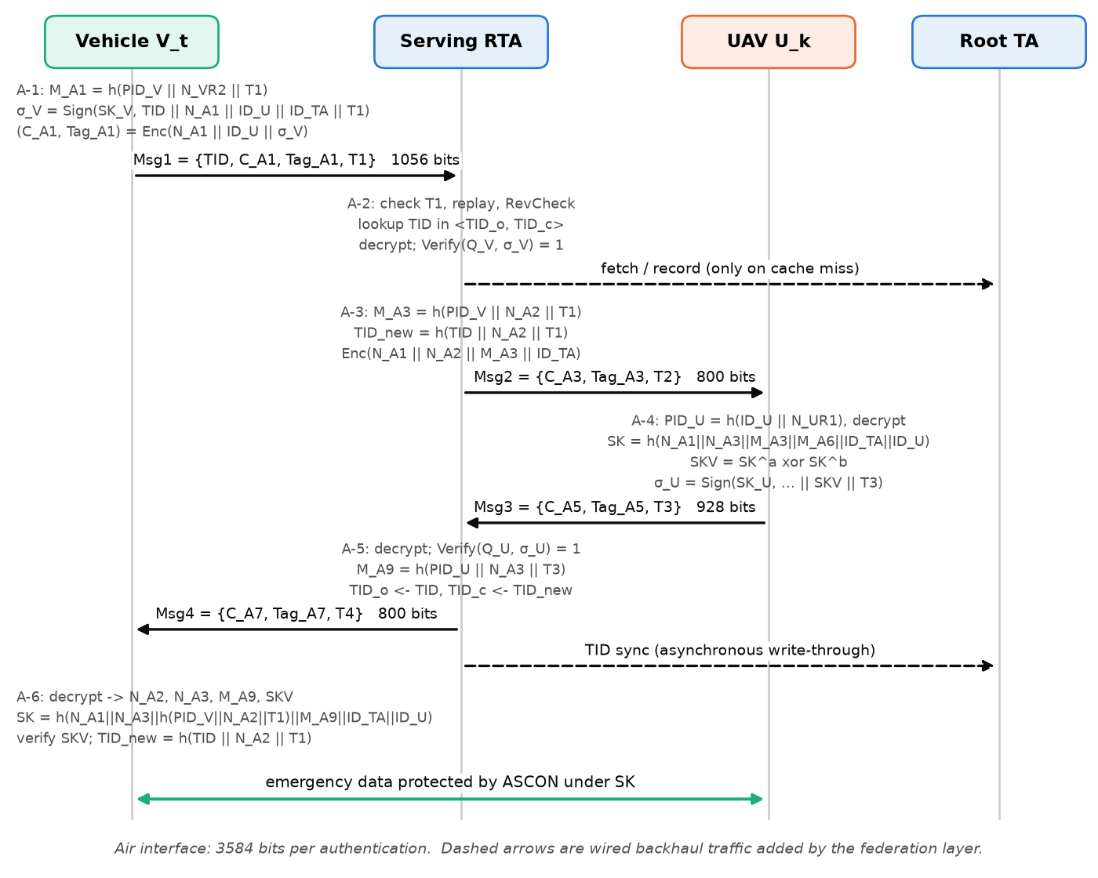
Fig. 2. Message flow of one HF-SELAP authentication. Solid arrows are radio messages and dashed arrows are backhaul traffic added by the federation.
- A-1 (vehicle). Computes PID_{V}, a nonce N_{A1}, a timestamp T₁ and M_{A1} = h(PID_{V} ∥ N_{VR2} ∥ T₁). Signs σ_{V} = Sign(SK_{V}, TID_{V} ∥ N_{A1} ∥ ID_{U} ∥ ID_{TA} ∥ T₁), encrypts N_{A1} ∥ ID_{U} ∥ σ_{V}, and sends Msg1 = {TID_{V}, C_{A1}, Tag_{A1}, T₁}.
- A-2 (RTA). Checks |T_{R} − T₁| ≤ ΔT and the replay cache. Finds TID_{V} in TIDº or TID^{c} (fetching the record from the Root TA if it belongs to another RTA) and applies RevCheck. Recovers PID_{V} = M_{VR1} ⊕ h(N_{VR2} ∥ k_{TA}), decrypts Msg1 with M_{A2} = h(PID_{V} ∥ N_{VR2} ∥ T₁), and requires Verify(PID_{V}, Q_{V}, σ_{V}, ·) = 1 before any foreign UAV record is fetched.
- A-3 (RTA). Looks up ID_{U} and applies RevCheck, recovers PID_{U}, picks N_{A2} and T₂, computes M_{A3} = h(PID_{V} ∥ N_{A2} ∥ T₁), the refreshed identity TID^{new} = h(TID_{V} ∥ N_{A2} ∥ T₁) and M_{A4} = h(PID_{U} ∥ C_{U} ∥ T₂), and sends Msg2 = {C_{A3}, Tag_{A3}, T₂} carrying N_{A1} ∥ N_{A2} ∥ M_{A3} ∥ ID_{TA}.
- A-4 (UAV). Computes PID_{U} = h(ID_{U} ∥ N_{UR1}) and decrypts Msg2 with M_{A5} = h(PID_{U} ∥ C_{U} ∥ T₂), which authenticates the RTA. Picks N_{A3} and T₃, computes M_{A6} = h(PID_{U} ∥ N_{A3} ∥ T₃), the session key SK_{HF} (below) and SKV, signs σ_{U} = Sign(SK_{U}, ID_{U} ∥ N_{A1} ∥ N_{A2} ∥ N_{A3} ∥ SKV ∥ ID_{TA} ∥ T₃), and returns Msg3 = {C_{A5}, Tag_{A5}, T₃} carrying N_{A3} ∥ SKV ∥ σ_{U}.
- A-5 (RTA). Decrypts Msg3, requires Verify(ID_{U}, Q_{U}, σ_{U}, ·) = 1, computes M_{A9} = h(PID_{U} ∥ N_{A3} ∥ T₃), sets TIDº ← TID_{V} and TID^{c} ← TID^{new}, and sends Msg4 = {C_{A7}, Tag_{A7}, T₄} carrying N_{A2} ∥ N_{A3} ∥ M_{A9} ∥ SKV. The identity update is then written through to the Root TA asynchronously.
- A-6 (vehicle). Decrypts Msg4, recomputes M_{A3} and SK_{HF}, accepts only if SK_{HF}ª ⊕ SK_{HF}^{b} = SKV, and adopts TID^{new} = h(TID_{V} ∥ N_{A2} ∥ T₁).
Session key. Both sides derive the key from the fresh nonces of vehicle and UAV, their session-bound pseudonyms, the serving RTA and the authenticated request:
SK_{HF} = h(N_{V} ∥ N_{U} ∥ PID*_{V} ∥ PID*_{U} ∥ ID_{TA} ∥ M)
with N_{V} = N_{A1}, N_{U} = N_{A3}, PID*_{V} = M_{A3}, PID*_{U} = M_{A6} = M_{A9} and M = ID_{U}. Communication starts only when SK_{VU} = SK_{UV}, which the vehicle checks through SKV.
Identity refresh. After every successful run the pseudonym is replaced by
PID_{new} = h(PID_{old} ∥ N_{new} ∥ T), here TID^{new} = h(TID_{V} ∥ N_{A2} ∥ T₁)
truncated to 128 bits. The vehicle and the RTA compute it independently, so Msg4 does not need to carry it.

4.5 Federation layer
Secure inter-TA link. Each RTA shares an ASCON-128 link key with the Root TA. Every inter-TA message carries a header (sender, receiver, type, sequence number, timestamp) that is authenticated as associated data. Sequence numbers must strictly increase, so inter-TA replays are rejected as well.
Revocation check and delegated authentication. Every RTA applies
RevCheck(ID) = 0 if ID ∈ RR, 1 if ID ∉ RR
against its copy of the revocation registry RR. An RTA that lacks a credential raises a fetch request. The Root TA serves a request from TA_{b} for an entity of TA_{a} only if
Trust(TA_{a}, TA_{b}) ≥ T_{min} ∧ Auth_{Ra}(V) = 1
that is, the home RTA trusts the requester at or above T_{min} = 0.6 and the entity holds a current, unrevoked registration at its home RTA. The serving RTA caches the record for 60 s and runs the unchanged steps, using PID_{V} and PID_{U} directly instead of unmasking them with the home RTA's k_{TA}, which never leaves the home RTA.
Federated trust update. After every service by TA_{j} for an entity of TA_{i}, the trust evolves with the latest observation S_{ij} (1 for a successful authentication, 0 for a failure):
Trust_{ij}^{new} = α·Trust_{ij}^{old} + (1 − α)·S_{ij}, 0 ≤ α ≤ 1, α = 0.9
The reliability R_{i} of each RTA used by the load balancer follows the same rule.
Consistent identity updates. After A-5 the serving RTA sends the new ⟨TIDº, TID^{c}⟩ pair to the Root TA, which updates the escrow and directory and forwards the change to the home RTA and to any RTA holding a cached copy. An update whose TIDº is no longer one of the identities the Root TA has on record is ignored. This prevents a delayed message from rolling a vehicle back to an old identity.
Dynamic Regional-TA selection and load balancing. The normalised load of TA_{i} is the ratio of its queued requests Q_{i} to its capacity C_{i}, and the delay term is normalised over the candidates:
L_{i} = Q_{i} / C_{i}, D_{i}^{score} = (D_{max} − D_{i}) / (D_{max} − D_{min})
Score(TA_{i}) = w₁(1 − L_{i}) + w₂A_{i} + w₃R_{i} + w₄D_{i}^{score}, w₁ + w₂ + w₃ + w₄ = 1
TA* = arg max_{i} Score(TA_{i})
The weights are (w₁, w₂, w₃, w₄) = (0.45, 0.15, 0.20, 0.20). A_{i} is the share of the last 10 s in which TA_{i}'s heartbeats arrived on time, R_{i} its reliability, and D_{i} the expected access delay (10 ms in-region, 25 ms cross-region). The maximisation runs only over eligible RTAs: operational, trusted by the entity's home RTA, and with L_{i} ≤ L_{max} = 0.9, so a request is redirected when L_{i} > L_{max} while another RTA is available.
Fault-tolerant fail-over. RTAs send a heartbeat every 500 ms. An RTA is treated as down after three missed heartbeats, or earlier if a request to it times out while at least one heartbeat is missing. The replacement is chosen by the same score:
TA_{fallback} = arg max_{j} Score(TA_{j}) s.t. Status(TA_{j}) = 1 ∧ Trust(TA_{j}, TA_{i}) ≥ T_{min}
A vehicle whose attempt times out (1.5 s) retries through another RTA, up to three attempts. A recovering RTA receives every revocation and identity update it missed before it serves again.
Revocation and recovery. Revoking an entity adds its handle to a versioned registry and pushes a REVOKE message to every operational RTA, which drops the entity from its indexes and caches. Recovery revokes the old handle (if it is not already revoked) and enrols the entity again: a vehicle receives a new temporary identity, N_{VR2} and key pair, and a UAV a new credential C_{U} and key pair.

4.6 Implementation
HF-SELAP is written in Python 3.12.6 and uses NumPy (simulation statistics), Matplotlib (figures) and the cryptography package. ASCON v1.2 was implemented from the specification and agrees byte-for-byte with the published reference implementation on the official test vector and on random inputs for both variants. SHA-256 comes from the Python standard library. ECDSA signing and verification and base-point multiplication on P-256 use OpenSSL through the cryptography package; the remaining curve arithmetic of the enrolment (point addition and h_{E}·P_{pub} with a precomputed window table) is written in Python and checked against OpenSSL by the tests. Table 4 lists the modules. 35 unit and security tests check functional correctness, operation counts, certificateless key handling, federation behaviour and every attack scenario.
Table 4. Implementation modules
Module | Responsibility
ascon.py | ASCON-128 and Ascon-80pq AEAD (pure Python)
primitives.py | h(·), key derivation, 32-bit timestamps, simulated clock, op meter
certificateless.py | KGC, partial keys, key validation, Q_{E}, ECDSA on P-256
messages.py | Wire formats of Msg1–Msg4, signed inputs, inter-TA messages
entities.py | Smart cards, vehicle (A-1, A-6), UAV (A-4), session key, TID refresh
ta.py | Regional TA: enrolment, A-2/A-3/A-5, signature checks, dual records
federation.py | Root TA: KGC, links, trust update, escrow, TID sync, revocation
loadbalancer.py | Health monitor, availability A_{i}, selection score, L_{max}
system.py | Facade: topology, enrolment, authentication, recovery
channel.py | ASCON data channel keyed by the session key
simulation.py | Discrete-event network simulator, T_{auth} decomposition, LI
attacks.py | Executable attack scenarios

4.7 Evaluation methodology
Two complementary methods are used. Direct measurement times every primitive and every protocol step on the real code, and counts operations with an instrumented meter. Discrete-event simulation executes the real protocol for every request inside a simulated network. Each link adds latency (10 ms in-region, 25 ms cross-region, 8 ms backhaul) plus Gaussian jitter (σ = 2 ms) and may drop messages. Each RTA and UAV is a first-in-first-out server whose service time is the CPU time actually measured for that step, so queueing grows out of real costs. An RTA queue holds at most C_{i} = 200 requests, and an overloaded RTA answers 'busy' so the vehicle can retry elsewhere. Timestamps are checked against simulated time, including queueing delay. Federation synchronisation runs asynchronously, and its CPU time is recorded separately. The 'single TA' baseline is the same code with one RTA, in which case no federation traffic is generated. Three metrics follow the formulation directly. The authentication delay of every successful request is split into its components,
T_{auth} = T_{req} + T_{TA} + T_{authz} + T_{UAV} + T_{resp}
namely Msg1 uplink with step A-1, RTA queueing and processing, delegated credential fetches from the Root TA, the RTA–UAV–RTA leg, and the Msg4 downlink with step A-6. Time lost in earlier, failed attempts is reported separately. The communication overhead is the size of all protocol messages, and the balance of the RTAs is measured by the load-imbalance metric over their utilisations L_{i}:
CO_{HF} = Σ_{i=1..n} |Msg_{i}|, LI = √( (1/n) Σ_{i=1..n} (L_{i} − L̄)² ), L̄ = (1/n) Σ_{i=1..n} L_{i}

5. Results and Discussion

5.1 Experimental platform
All experiments ran on 12th Gen Intel(R) Core(TM) i7-1255U under Windows-11-10.0.26300-SP0 with Python 3.12.6. Absolute times depend on this machine; message sizes, operation counts and security outcomes do not. Where energy is reported, it is estimated as E = P·t with the 7.029 W full-load power that the SELAP authors measured for a Raspberry Pi 5 [21]. These energy values are therefore an estimate, not a measurement on embedded hardware.

5.2 Cost of cryptographic primitives
Table 5. Execution time of primitives (2000 runs each)
Primitive | Mean (ms) | Std. dev. (ms) | Median (ms)
SHA-256 hash (Th) | 0.0005 | 0.0005 | 0.0005
Ascon-128 encryption, 64 B (Ta) | 0.1634 | 0.0287 | 0.1600
Ascon-128 decryption, 64 B (Ta) | 0.1714 | 0.0462 | 0.1656
Ascon-80pq encryption, 64 B | 0.1769 | 0.0445 | 0.1648
ECDSA P-256 signing (Ts) | 0.0246 | 0.0065 | 0.0236
ECDSA P-256 verification (Tv) | 0.0831 | 0.0344 | 0.0741

SHA-256 runs in native code and costs about 0.0005 ms, while the pure-Python ASCON needs about 0.163 ms to encrypt a 64-byte payload. ASCON therefore dominates protocol cost in this prototype. A native or hardware ASCON would be one to two orders of magnitude faster, so the absolute numbers below are conservative. Ascon-80pq costs essentially the same as Ascon-128 (0.177 ms): the two variants share the permutation and differ only in key loading. The certificateless operations run in native OpenSSL code: an ECDSA signature costs 0.025 ms and a verification 0.083 ms, each less than one pure-Python ASCON call.

5.3 Computation cost, post-quantum mode and energy
Table 6. Mean computation time per authentication (400 runs, ms)
Scenario | Vehicle | UAV | Serving TA | Total | Async. sync
Single TA (no federation) | 0.960 | 0.940 | 2.021 | 3.921 | –
HF-SELAP intra-region | 0.928 | 0.924 | 2.000 | 3.852 | 1.578
HF-SELAP cross-region | 0.948 | 0.935 | 1.989 | 3.872 | 1.568
HF-SELAP post-quantum | 0.978 | 0.943 | 2.050 | 3.971 | 1.608

Table 7. Primitive operations per authentication (counted by the instrumented meter)
Entity | SELAP cost model [21] | Measured (HF-SELAP)
Vehicle | 5T_{h} + 2T_{a} | 6T_{h} + 2T_{a} + T_{s}
UAV | 5T_{h} + 2T_{a} + T_{p} + T_{f} | 5T_{h} + 2T_{a} + T_{s}
Serving TA | 8T_{h} + 4T_{a} | 9T_{h} + 4T_{a} + 2T_{v}
Serving TA, cross-region | – | 8T_{h} + 4T_{a} + 2T_{v}
Federation sync (asynchronous) | – | T_{a} (RTA); 3T_{a} (Root TA)

In the table, T_{h}, T_{a}, T_{s} and T_{v} are one hash, ASCON operation, signature and verification; T_{p} and T_{f} are SELAP's PUF evaluation and fuzzy-extractor reproduction.
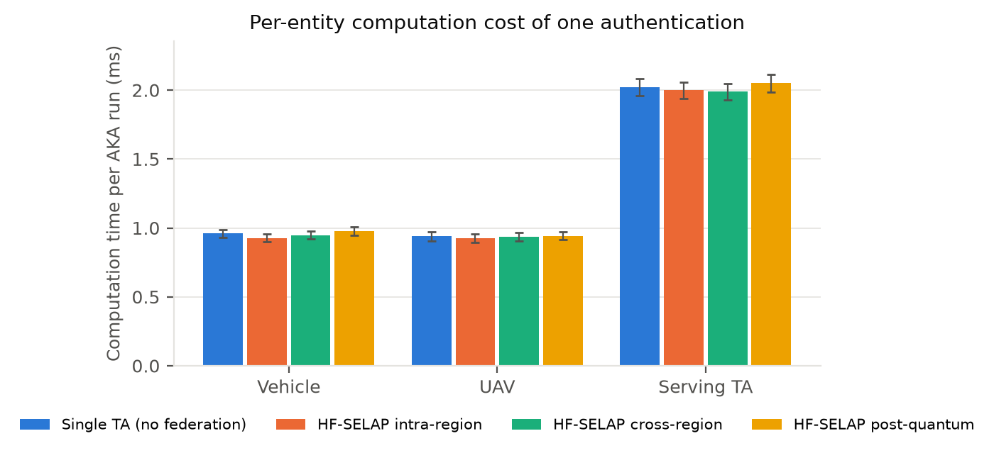
Fig. 3. Per-entity computation time of one authentication (error bars: 95 % confidence intervals).
The counts show exactly what the certificateless design changes with respect to SELAP's cost model. The UAV no longer evaluates a PUF or runs a fuzzy extractor; it signs once instead. The vehicle signs once and computes one extra hash for the identity refresh, and the serving TA computes that hash as well and verifies the two signatures. The federation itself adds nothing to the vehicle or the UAV. On the authentication path the serving TA costs 2.000 ms in HF-SELAP against 2.021 ms with a single TA. In a cross-region run the TA performs one hash fewer, because the delegated record already contains PID_{U}. The extra work the federation introduces is the asynchronous identity write-through, about 1.578 ms of combined RTA and Root TA time. It runs after Msg4 has been sent, so it does not delay the vehicle. The first cross-region request to a given UAV also pays a one-time credential fetch: 3.267 ms at the TA against 1.989 ms once cached. The post-quantum mode changed the total by 3.1 %, in line with the small difference between the two ASCON variants in Table 5.
With the 7.029 W power model, one authentication costs about 6.52 mJ on the vehicle and 6.50 mJ on the UAV (estimate). Even with an unoptimised Python ASCON, a UAV battery of a few tens of watt-hours could fund millions of authentications, so security does not limit flight time.

5.4 Communication overhead
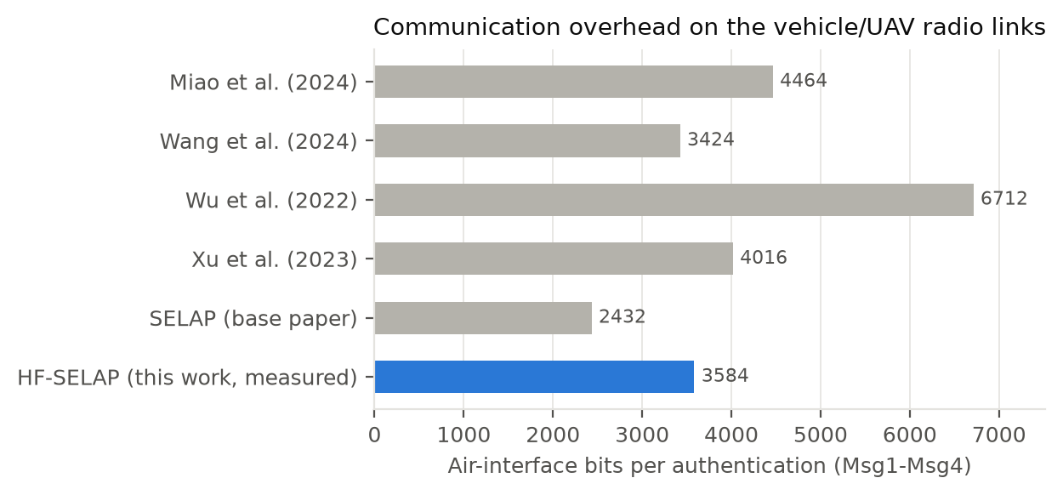
Fig. 4. Air-interface bits per authentication. Earlier schemes as reported in [21]; HF-SELAP measured from serialised messages.
Table 8. Measured traffic per authentication (bits)
Scenario | Air interface | Backhaul (wired) | Backhaul messages
Intra-region (home RTA serves) | 3584 | 776 | tid_sync ×1
Cross-region, first request (cold cache) | 3584 | 2544 | tid_sync ×1, fetch_uav ×1, record_uav ×1
Cross-region, cached credential | 3584 | 776 | tid_sync ×1
Fail-over / load-shared to foreign RTA (cold) | 3584 | 5248 | tid_sync ×2, fetch_uav ×1, record_uav ×1, fetch_vehicle ×1, record_vehicle ×1
Fail-over / load-shared to foreign RTA (cached) | 3584 | 1552 | tid_sync ×2

HF-SELAP sends 3584 bits over the radio links in every scenario, which matches CO_{HF} = Σ|Msg_{i}| over the four messages. That is 1152 bits more than SELAP's 2432: the two 512-bit signatures and the 128-bit RTA identity that the certificateless layer adds. That is still less than 3 of the 4 elliptic-curve schemes compared in [21]; Wang et al. (2024) needs 3424 bits (4.7 % fewer). The federation's traffic stays on the wired backhaul. A routine authentication adds one 776-bit identity-sync message. A cross-region or fail-over authentication additionally fetches the missing credential once, and later requests hit the cache. The remaining control-plane traffic is small: one heartbeat is 360 bits per RTA every 500 ms, a federation-wide revocation costs 1560 bits for three RTAs, and enrolment, including the partial-private-key request and answer, costs 3208 bits per vehicle and 2920 bits per UAV.

5.5 Storage cost
Table 9. Long-term storage (bits)
Item | HF-SELAP (measured) | SELAP (reported [21])
Vehicle smart card | 1024 | 768
UAV smart card | 896 | 656
Regional TA, per own vehicle | 904 | –
Regional TA, per own UAV | 776 | –
Regional TA, per cached foreign vehicle | 904 | –
Root TA escrow, per vehicle | 1336 | –
Root TA escrow, per UAV | 1176 | –

The vehicle card holds 1024 bits: SELAP's 768 plus the 256-bit private key SK_{V}. The UAV card holds N_{UR1}, C_{U} and SK_{U} in 896 bits. That is more than the 656 bits estimated in [21], which assumes 144 bits of fuzzy-extractor helper data, but less than a PUF-based card with a concrete repetition-code fuzzy extractor (896-bit helper data) would need: 1408 bits. Each RTA record grows by the 264-bit compressed verification key. Federation storage stays on servers: about one kilobit of escrow per entity at the Root TA, and a cached record only for foreign entities an RTA has actually served.

5.6 Scalability, load balancing and delay decomposition
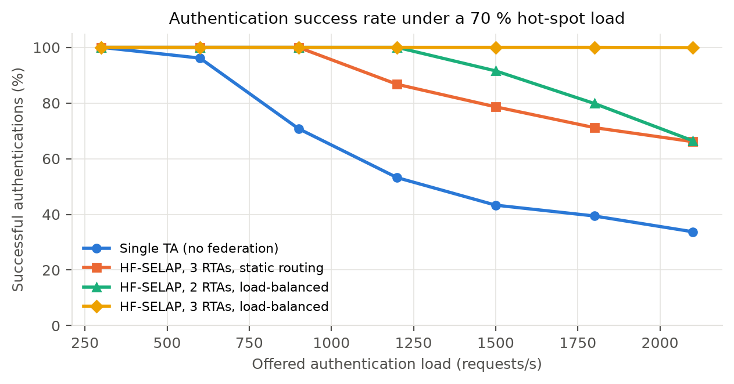
Fig. 5. Authentication success rate versus offered load when 70 % of requests come from Region A (mean of 2 independent runs per point).
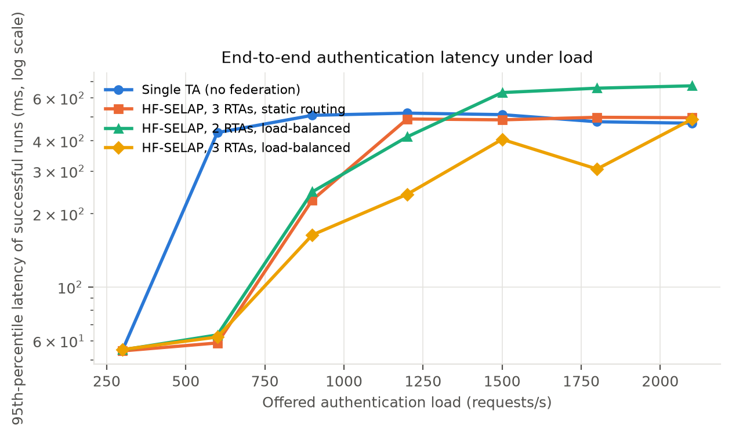
Fig. 6. 95th-percentile end-to-end latency of successful authentications versus offered load (log scale).
Table 10. Scalability summary (capacity = highest tested load with ≥ 99 % success; other columns at 2100 requests/s)
Deployment | Capacity (req/s) | Success (%) | Mean latency (ms) | p95 latency (ms) | Load imbalance LI
Single TA (no federation) | 300 | 33.7 | 398.0 | 472.2 | –
HF-SELAP, 3 RTAs, static routing | 900 | 66.1 | 231.3 | 497.5 | 0.216
HF-SELAP, 2 RTAs, load-balanced | 1200 | 66.4 | 423.2 | 673.1 | 0.003
HF-SELAP, 3 RTAs, load-balanced | ≥ 2100 | 99.9 | 278.5 | 490.1 | 0.014

Table 11. Decomposition of the mean authentication delay T_{auth} of successful requests (ms)
Deployment | Load (req/s) | T_{req} | T_{TA} | T_{authz} | T_{UAV} | T_{resp} | Earlier attempts | T_{auth}
Single TA (no federation) | 300 | 12.0 | 2.5 | 0.0 | 23.9 | 11.9 | 0.0 | 50.3
Single TA (no federation) | 2100 | 12.0 | 332.1 | 0.0 | 24.0 | 12.0 | 17.9 | 398.0
HF-SELAP, 3 RTAs, static routing | 300 | 12.0 | 2.1 | 0.0 | 23.9 | 11.9 | 0.0 | 50.0
HF-SELAP, 3 RTAs, static routing | 2100 | 12.1 | 175.7 | 0.0 | 24.1 | 12.0 | 7.4 | 231.3
HF-SELAP, 2 RTAs, load-balanced | 300 | 12.0 | 2.3 | 0.0 | 23.9 | 12.0 | 0.0 | 50.3
HF-SELAP, 2 RTAs, load-balanced | 2100 | 14.8 | 331.9 | 3.1 | 29.4 | 14.6 | 29.5 | 423.2
HF-SELAP, 3 RTAs, load-balanced | 300 | 12.1 | 2.4 | 0.0 | 24.1 | 11.9 | 0.0 | 50.5
HF-SELAP, 3 RTAs, load-balanced | 2100 | 16.8 | 204.3 | 5.7 | 33.5 | 16.7 | 1.4 | 278.5

A single TA becomes the bottleneck as soon as the offered load exceeds its service capacity. Its queue fills, requests wait past their timeouts or are refused, and success falls to 33.7 % at 2100 requests/s (it sustained ≥ 99 % up to 300 requests/s). Adding RTAs without load balancing helps, but only partly. The hot-spot RTA still receives 70 % of the traffic while the others sit partly idle: the load imbalance is LI = 0.216 and success 66.1 %. With the score-based load balancer, requests spill over to less loaded RTAs once the hot-spot queue grows, the imbalance drops to LI = 0.014, and three RTAs authenticated 99.9 % at 2100 requests/s (≥ 99 % up to 2100 requests/s); two balanced RTAs reached 66.4 %. The delay decomposition shows where the time goes. At light load T_{auth} is dominated by the radio and backhaul hops, and T_{TA} is a few milliseconds. At 2100 requests/s the single TA's successful requests spend 332 ms queueing and being processed at the TA, against 204 ms with three balanced RTAs, whose fetches of delegated credentials (T_{authz} = 5.7 ms on average) cost far less than the queueing they avoid.

5.7 Fault tolerance
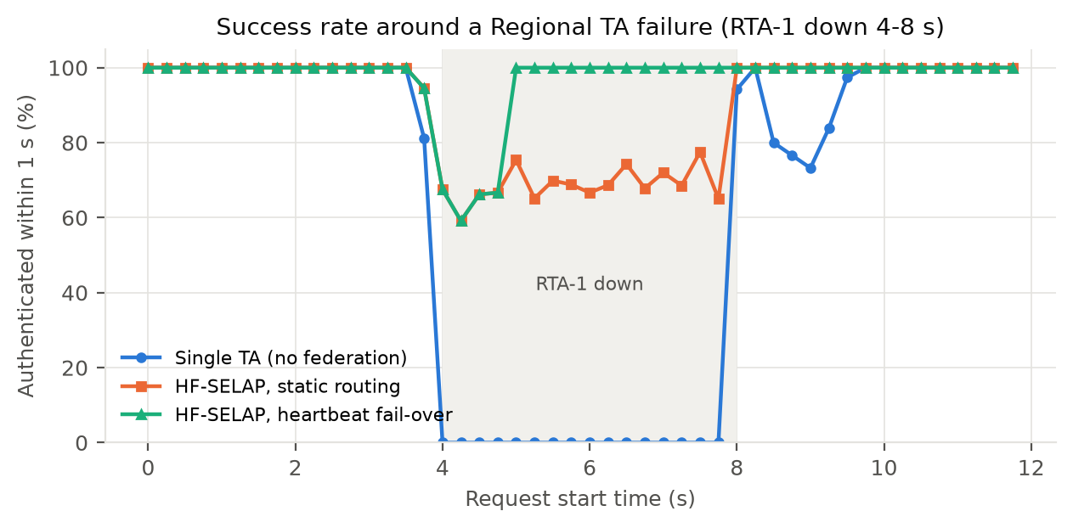
Fig. 7. Share of requests authenticated within 1000 ms, by request start time; RTA-1 fails at 4 s and recovers at 8 s (300 requests/s).
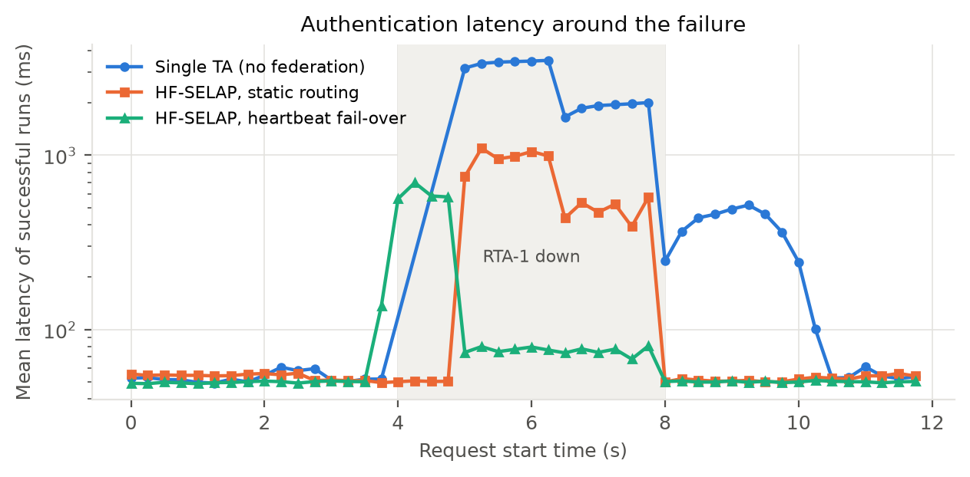
Fig. 8. Mean latency of successful authentications around the failure (log scale).
Table 12. Behaviour while RTA-1 is down (requests started between 4 s and 8 s)
Deployment | Within 1 s (%) | Eventually (%) | Mean latency (ms) | Max latency (ms)
Single TA (no federation) | 0.0 | 54.0 | 2,555 | 3,510
HF-SELAP, static routing | 68.7 | 91.3 | 607 | 3,062
HF-SELAP, heartbeat fail-over | 91.4 | 100.0 | 205 | 1,652

With a single TA, every request that starts during the outage misses the one-second deadline. Some succeed only after the TA returns, seconds later, which is too late for an emergency message. Static federation protects the regions whose own RTA is alive but abandons Region A. With heartbeat fail-over, the failed RTA was detected after 1.47 s. Requests already sent to it time out and are retried at the next-best RTA chosen by TA_{fallback}. Every request of the outage window was eventually served: 91.4 % within one second and 100.0 % overall. The latency spike is limited to the detection window. When RTA-1 returns, the Root TA replays the identity updates and revocations it missed, so its vehicles authenticate normally again; its availability term A_{i} then recovers over the following seconds.

5.8 High mobility and stress
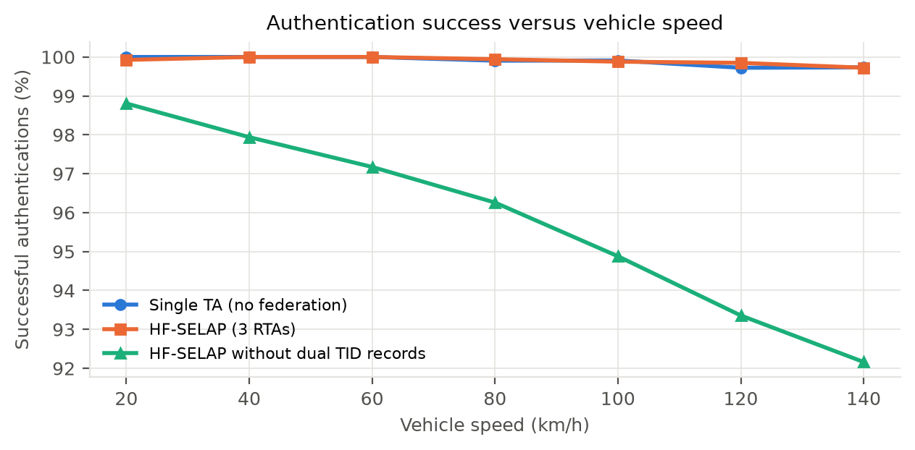
Fig. 9. Authentication success versus speed on a 30 km evacuation corridor (6000 vehicles, 1 km UAV cells, loss rising with speed).
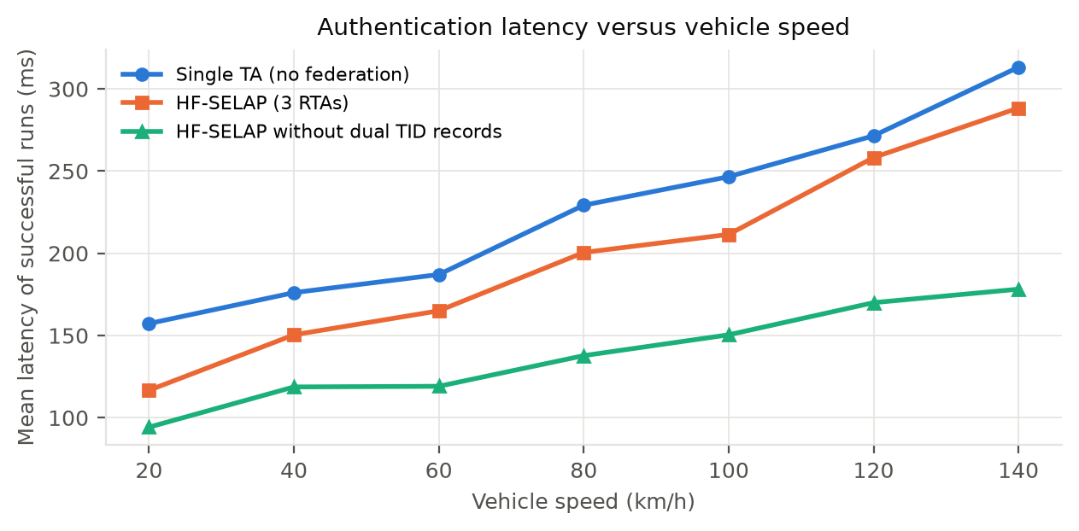
Fig. 10. Mean authentication latency versus vehicle speed.
Table 13. Mobility results at 140 km/h
Deployment | Offered load (req/s) | Success (%) | Within 1 s (%) | Mean latency (ms) | Cross-region (%) | Desync lock-outs
Single TA (no federation) | 235 | 99.73 | 86.86 | 313 | 0 | 0
HF-SELAP (3 RTAs) | 235 | 99.72 | 86.48 | 288 | 72 | 0
HF-SELAP without dual TID records | 235 | 92.16 | 85.55 | 178 | 70 | 725

Higher speed means more frequent cell changes (more authentications per second) and, in our stress model, more packet loss: 6.1 % per vehicle hop at 140 km/h. Retries keep the success rate of both the single-TA deployment and HF-SELAP at or above 99.7 %, and the extra latency comes from the 1.5 s timeouts after lost messages. Because evacuating vehicles come from everywhere, 72 % of HF-SELAP authentications were served through delegation, which shows the federation working in practice. The ablation is the most telling result. When the dual ⟨TIDº, TID^{c}⟩ record is removed, every lost Msg4 strands a vehicle on an identity the TA no longer accepts: 725 lock-outs occurred at 140 km/h, and success fell to 92.2 %. With the dual record there were none. The ablation's lower mean latency in Fig. 10 is a selection effect, not a benefit: its requests that hit a lost Msg4 end in failure instead of in a slow but successful retry, so they drop out of the latency average.

5.9 Certificateless key management
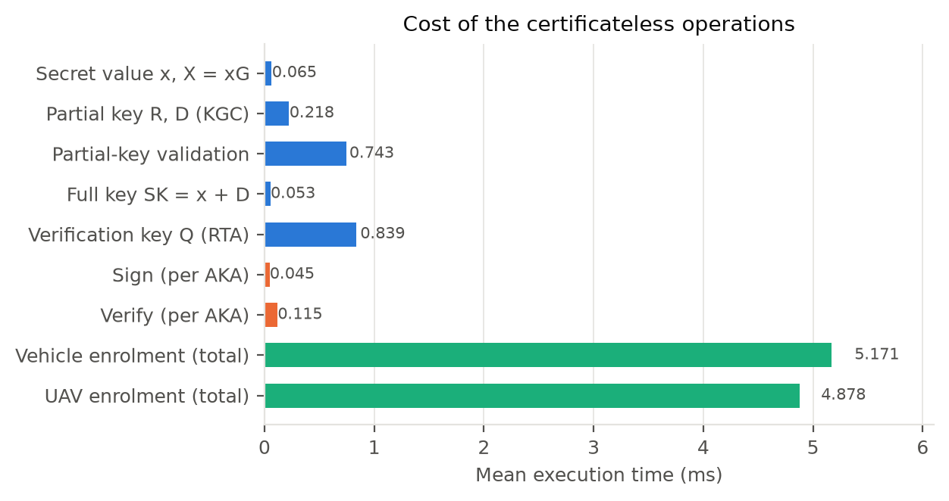
Fig. 11. Mean execution time of the certificateless operations (1000 runs each) and of complete enrolments (300 vehicles and UAVs).
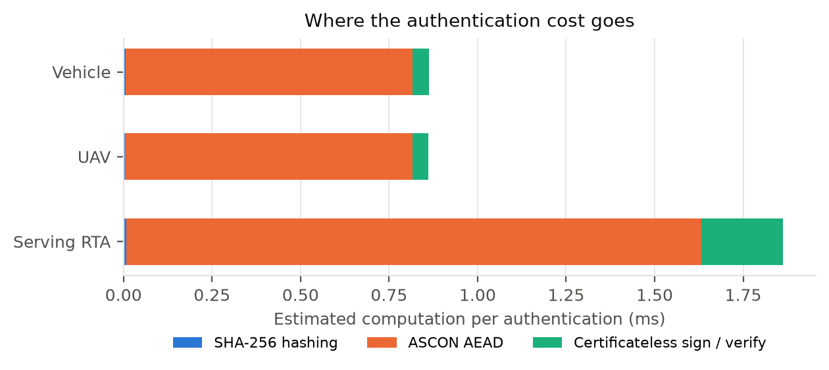
Fig. 12. Composition of the per-authentication computation, estimated from measured primitive costs and counted operations.
Table 14. Cost of certificateless key management
Operation | Mean (ms) | Std. dev. (ms)
Secret value x_E, X_E = x_E G (entity) | 0.0653 | 0.0252
Partial private key R_E, D_E (KGC) | 0.2184 | 0.0746
Partial-key validation (entity) | 0.7434 | 0.2347
Full private key SK_E = x_E + D_E (entity) | 0.0534 | 0.0232
Verification key Q_E (RTA) | 0.8392 | 0.2218
Sign sigma_E (entity, per AKA) | 0.0454 | 0.0290
Verify sigma_E (RTA, per AKA) | 0.1154 | 0.0635
Complete vehicle enrolment (VR-1 to VR-3) | 5.171 | 1.495
Complete UAV enrolment (UR-1 to UR-3) | 4.878 | 1.325

Key management is a one-time cost paid at enrolment. Generating the secret value (0.065 ms) and forming the full key (0.053 ms) use native code. Validating the partial key (0.743 ms) and deriving the verification key Q_{E} (0.839 ms) are the most expensive steps, because they compute h_{E}·P_{pub} in Python with a precomputed table. A complete enrolment, including the KGC round trip over the inter-TA link and the escrow deposit, took 5.17 ms for a vehicle and 4.88 ms for a UAV. Per authentication, the certificateless layer accounts for an estimated 5.3 % of the vehicle's computation, 5.3 % of the UAV's and 12.4 % of the serving RTA's; the pure-Python ASCON dominates everywhere. Unlike SELAP's PUF-based enrolment, no repeated measurements of the device are needed, there is no helper data to store, and a UAV can be re-enrolled remotely with a new key pair. Security of the keys themselves is exercised in Section 5.11: a forged partial key is rejected at enrolment, and neither a replaced public key nor the KGC's own partial key yields a valid signature.

5.10 Revocation and recovery
Table 15. Revocation and recovery cost versus re-registering the whole network
Enrolled vehicles N | Revoke one (ms / bits) | Re-enrol one (ms / bits) | Full reset (ms / bits) | Revoked rejected by all RTAs
100 | 1.20 / 1560 | 5.41 / 3208 | 741 / 320,800 | yes
500 | 1.79 / 1560 | 8.77 / 3208 | 3,506 / 1,604,000 | yes
1000 | 0.64 / 1560 | 5.55 / 3208 | 7,145 / 3,208,000 | yes
2000 | 1.89 / 1560 | 5.09 / 3208 | 11,307 / 6,416,000 | yes

Revocation and recovery costs do not depend on the network size. Revoking an entity is one message per RTA, and recovering it is one enrolment with a new key pair. Without a recovery protocol, replacing compromised credentials safely would mean re-enrolling all 2000 vehicles: 11,307 ms of computation and 6,416,000 bits at enrolment alone, before counting the physical re-issue of smart cards. In every run, the revoked entity was rejected by every RTA, including RTAs that had cached its credentials earlier, and the re-enrolled entity authenticated successfully.

5.11 Security evaluation
Table 16 lists the executable attack scenarios. Each scenario builds a fresh federation, mounts the attack through the message tap or by direct calls, and records the protocol's reaction.
Table 16. Attack scenarios (26/26 blocked)
Attack | Target | Defence that stopped it | Result
Passive eavesdropping / traceability | all messages | ASCON confidentiality, TID rotation, fresh nonces | Blocked
Replay of Msg1 inside Delta T | TA | replay cache (tag seen) | Blocked
Replay of Msg1 after Delta T | TA | timestamp freshness |T_R - T1| <= Delta T | Blocked
Timestamp forgery on a replayed Msg1 | TA | T1 is an input of the ASCON key (M_A2) | Blocked
Modification of Msg1 | TA | ASCON tag verification | Blocked
Modification of Msg2 | UAV | ASCON tag verification | Blocked
Modification of Msg3 | TA | ASCON tag verification | Blocked
Modification of Msg4 | vehicle | ASCON tag verification | Blocked
Vehicle impersonation (valid TID, forged ciphertext) | TA | key needs PID_V and N_VR2 | Blocked
TA impersonation towards the UAV | UAV | key needs PID_U and C_U | Blocked
Random / guessed TID | TA + Root | TID directory lookup | Blocked
Stolen smart card + password guessing | smart card | password-bound ASCON credential + lockout | Blocked
Vehicle impersonation with leaked symmetric credentials (no SK_V) | TA | certificateless signature sigma_V | Blocked
UAV impersonation with copied symmetric credentials (no SK_U) | TA | certificateless signature sigma_U | Blocked
Public-key replacement (Type-I certificateless adversary) | TA | X_U and R_U bound into h_U = H1(ID_U || X_U || R_U || P_pub) | Blocked
Malicious KGC signs with the partial key D_U (Type-II adversary) | TA | full key SK_U = x_U + D_U needs the UAV's secret value | Blocked
Forged partial private key at enrolment | vehicle | check D*G = R + h*P_pub before use | Blocked
Msg1 replayed to a different RTA inside Delta T | RTA-2 | ID_TA signed into sigma_V | Blocked
Man-in-the-middle: splice Msg3 from another session | TA | session-bound keys (N_A2, T3) | Blocked
Replay of Msg2 to the UAV | UAV | UAV replay cache | Blocked
Desynchronisation: Msg4 blocked, with dual TID records | TA/vehicle state | <TID_o, TID_c> dual record | Blocked
Revoked vehicle tries to authenticate (home and foreign RTA) | all RTAs | federated revocation registry | Blocked
Revoked UAV is requested by a vehicle | RTA | revocation registry | Blocked
Cross-region request through an untrusted RTA | Root TA | trust threshold on delegation | Blocked
Forged / replayed inter-TA control message | RTA | ASCON link key + sequence numbers | Blocked
Old credentials used after recovery / re-enrolment | RTA | revocation + fresh credentials | Blocked

All 26 attacks were blocked. The certificateless scenarios show defence in depth: an adversary that knows a vehicle's or UAV's symmetric credentials, for example from a leaked TA database, still fails the signature check, and a Msg1 redirected to another RTA fails because ID_{TA} is signed. The ablation confirms that the defences are necessary: with dual temporary-identity records disabled, the desynchronisation attack succeeds (vehicle locked out: federation refused delegation: unknown vehicle). Table 17 summarises the security and functional properties.
Table 17. Security and functional properties
Property | SELAP [21] | HF-SELAP
Mutual authentication and session-key agreement | ✓ | ✓
Anonymity and untraceability (rotating TID) | ✓ | ✓ (signatures encrypted)
Replay, MitM, impersonation, forgery resistance | ✓ | ✓
Smart-card loss resistance | ✓ | ✓ + lockout
Desynchronisation resistance | ✓ | ✓ (federation-consistent)
Hardware-bound UAV identity (PUF) | ✓ | – (replaced)
Certificateless public-key authentication | ✗ | ✓
Resistance to key replacement and malicious KGC | – | ✓
Multiple trusted authorities / cross-region service | ✗ | ✓
Load balancing | ✗ | ✓
TA fault tolerance | ✗ | ✓
Revocation of compromised entities | ✗ | ✓
Recovery / re-enrolment without reset | ✗ | ✓
Post-quantum key length option | ✗ | ✓ (Ascon-80pq)

Post-quantum considerations. SELAP uses only symmetric primitives. HF-SELAP adds elliptic-curve signatures, which Shor's algorithm would break on a large quantum computer. The design limits the consequences in two ways. First, the signatures only authenticate: the session key is derived from nonces carried under ASCON keys built from symmetric credentials, so breaking ECDSA later does not decrypt recorded sessions. Second, impersonating an entity needs both a valid signature and that entity's symmetric credentials, so against a quantum adversary the protocol falls back to the security of its symmetric layer. Grover's search roughly halves the effective length of symmetric keys: Ascon-128 offers about 64-bit security against quantum key search, the Ascon-80pq mode raises this to about 80 bits, and SHA-256 keeps roughly 128-bit preimage resistance. The mode changed neither message sizes nor storage and moved total computation by 3.1 %. A fully quantum-safe certificateless layer would need a lattice-based signature scheme, at the cost of much larger signatures.

5.12 Discussion and limitations
The results show that the federation layer adds availability, scalability and life-cycle security, and that certificateless keys can replace PUF hardware while keeping SELAP's lightweight ASCON structure. The certificateless layer costs one signature on each end device, two verifications at the RTA and 1152 extra bits on the radio links. The federation's own costs fall on the wired backhaul and on servers, which are the resources that can most easily be provisioned. Several limitations remain. Without a PUF, a UAV's private key is protected by its smart card and password, so an attacker who obtains both can clone the UAV until it is revoked; a tamper-resistant secure element would restore hardware binding. The KGC is needed only at enrolment, not for authentication. The prototype runs in one process with simulated links, so the absolute timings are those of a Python implementation on a desktop CPU. As in SELAP, TAs are fully trusted and can compute session keys, and escrowing pseudonymous credentials at the Root TA widens that trusted base. The speed-dependent loss model is an assumption, and real UAV-to-vehicle channels should be measured. Clock synchronisation within ΔT is assumed rather than enforced.

6. Conclusion
This project designed, implemented and evaluated HF-SELAP, which extends the lightweight SELAP authentication protocol for UAV-assisted VANETs from a single trusted authority to a hierarchical federation of Regional TAs under a Root TA, and replaces SELAP's PUF and fuzzy extractor with pairing-free certificateless authentication. Each vehicle and UAV holds a private key SK = x + D that no single party knows, and signs its request inside the ASCON-protected messages; the exchange stays at four messages and 3584 bits. Around it, HF-SELAP adds score-based Regional-TA selection and load balancing, federated trust management, delegated cross-region authentication, heartbeat fail-over with resynchronisation, a federated revocation registry, identity refresh, recovery by re-enrolment and an Ascon-80pq mode. In the measurements, the vehicle needed 0.928 ms and the UAV 0.924 ms of computation per authentication. Three balanced RTAs sustained 99.9 % success at 2100 requests/s where a single TA managed 33.7 %. During a TA outage, 91.4 % of requests were still served within one second. All 26 attack scenarios were blocked. Future work includes a native and hardware-accelerated implementation on embedded UAV platforms, field trials with real 5G/C-V2X radios, secure elements to protect the certificateless keys, a lattice-based certificateless signature for full post-quantum security, threshold techniques so that no single TA can derive session keys, and formal verification with tools such as ProVerif.

References
[1] K. S. Nwizege, M. Bottero, S. Mmeah, and E. D. Nwiwure, “Vehicles-to-infrastructure communication safety messaging in DSRC,” Procedia Computer Science, vol. 34, pp. 559–564, 2014.
[2] M.-Y. Hsieh, H.-Y. Lin, C.-F. Lai, and K.-C. Li, “Secure protocols for data propagation and group communication in vehicular networks,” EURASIP Journal on Wireless Communications and Networking, vol. 2011, Art. no. 167, 2011.
[3] J. Cui, X. Liu, H. Zhong, J. Zhang, L. Wei, I. Bolodurina, and D. He, “A practical and provably secure authentication and key agreement scheme for UAV-assisted VANETs for emergency rescue,” IEEE Transactions on Network Science and Engineering, vol. 11, no. 2, pp. 1454–1468, 2024.
[4] S. A. Alfadhli, S. Lu, K. Chen, and M. Sebai, “MFSPV: A multi-factor secured and lightweight privacy-preserving authentication scheme for VANETs,” IEEE Access, vol. 8, pp. 147602–147616, 2020.
[5] A. Aghabagherloo, M. Delavar, J. Mohajeri, M. Salmasizadeh, and B. Preneel, “An efficient and physically secure privacy-preserving authentication scheme for vehicular ad-hoc networks (VANETs),” IEEE Transactions on Intelligent Transportation Systems, vol. 23, no. 12, pp. 25298–25313, 2022.
[6] R. Aissaoui, J.-C. Deneuville, C. Guerber, and A. Pirovano, “A survey on cryptographic methods to secure communications for UAV traffic management,” Vehicular Communications, vol. 44, Art. no. 100661, 2023.
[7] T. W. Chim, S. M. Yiu, L. C. K. Hui, and V. O. K. Li, “MLAS: Multiple level authentication scheme for VANETs,” Ad Hoc Networks, vol. 10, no. 7, pp. 1445–1456, 2012.
[8] S. K. A. Theodore, K. R. Gandhi, and V. Palanisamy, “A novel lightweight authentication and privacy-preserving protocol for vehicular ad hoc networks,” Complex & Intelligent Systems, vol. 9, no. 3, pp. 2981–2991, 2023.
[9] D. R. Sona, K. Bagadi, V. Annepu, O. O. Oyerinde, M. Manikanta, K. A. Gangireddy, S. Dintakurthi, and K. S. K. Reddy, “Optimized UAV-based relay algorithm for enhanced emergency wireless coverage in disaster areas,” Engineering Reports, Art. no. e70295, 2025.
[10] P. Thorncharoensri, W. Susilo, and Y. Chow, “Secure and efficient communication in VANETs using level-based access control,” Security and Communication Networks, vol. 2022, Art. no. 8736531, 2022.
[11] T. Gao, X. Deng, N. Guo, and X. Wang, “An anonymous authentication scheme based on PMIPv6 for VANETs,” IEEE Access, vol. 6, pp. 14686–14698, 2018.
[12] M. Fogue, F. J. Martínez, P. Garrido, M. Fiore, C.-F. Chiasserini, C. Casetti, J.-C. Cano, C. T. Calafate, and P. Manzoni, “Securing warning message dissemination in VANETs using cooperative neighbor position verification,” IEEE Transactions on Vehicular Technology, vol. 64, no. 6, pp. 2538–2550, 2015.
[13] M. A. Shawky, M. Usman, M. A. Imran, Q. H. Abbasi, S. Ansari, and A. Taha, “Adaptive chaotic map-based key extraction for efficient cross-layer authentication in VANETs,” IET Intelligent Transport Systems, vol. 17, 2023.
[14] S. A. Jan, N. U. Amin, M. Othman, M. Ali, A. I. Umar, and A. Basir, “A survey on privacy-preserving authentication schemes in VANETs: Attacks, challenges and open issues,” Telecommunication Systems, vol. 84, pp. 99–136, 2023.
[15] T. Jing, Y. Pei, B. Zhang, C. Hu, Y. Huo, H. Li, and Y. Lu, “An efficient anonymous batch authentication scheme based on priority and cooperation for VANETs,” EURASIP Journal on Wireless Communications and Networking, vol. 2018, Art. no. 294, 2018.
[16] N. P. Sharvari, D. Das, J. Bapat, and D. Das, “Connectivity and collision constrained opportunistic routing for emergency communication using UAV,” Computer Networks, vol. 227, Art. no. 109714, 2023.
[17] M. Matracia, N. Saeed, M. A. Kishk, and M.-S. Alouini, “Post-disaster communications: Enabling technologies, architectures, and open challenges,” IEEE Open Journal of the Communications Society, vol. 3, pp. 1177–1205, 2022.
[18] Y. Lei, L. Zeng, Y.-X. Li, M.-X. Wang, and H. Qin, “A lightweight authentication protocol for UAV networks based on security and computational resource optimization,” IEEE Internet of Things Journal, vol. 8, no. 18, pp. 14096–14109, 2021.
[19] P. Wang, C.-M. Chen, S. Kumari, M. Shojafar, R. Tafazolli, and Y.-N. Liu, “HDMA: Hybrid D2D message authentication scheme for 5G-enabled VANETs,” IEEE Transactions on Intelligent Transportation Systems, vol. 22, no. 8, pp. 5071–5085, 2021.
[20] H. Tan and I. Chung, “Secure authentication and key management with blockchain in VANETs,” IEEE Access, vol. 8, pp. 171414–171428, 2020.
[21] M. Wu, X. Ai, A. Badshah, S. Tu, Z. Ning, H. Alfuhaid, M. Waqas, and Z. Halim, “SELAP: A security-enhanced lightweight authentication protocol for UAV-assisted VANETs in emergency scenarios,” Computer Networks, vol. 287, Art. no. 112523, 2026.
[22] C. Dobraunig, M. Eichlseder, F. Mendel, and M. Schläffer, “Ascon v1.2: Lightweight authenticated encryption and hashing,” Journal of Cryptology, vol. 34, no. 3, Art. no. 33, 2021.
[23] S. S. Al-Riyami and K. G. Paterson, “Certificateless public key cryptography,” in Advances in Cryptology – ASIACRYPT 2003, Lecture Notes in Computer Science, vol. 2894. Berlin, Germany: Springer, 2003, pp. 452–473.
[24] National Institute of Standards and Technology, “Digital Signature Standard (DSS),” Federal Information Processing Standards Publication FIPS 186-5, Feb. 2023.
[25] National Institute of Standards and Technology, “Recommendations for discrete logarithm-based cryptography: Elliptic curve domain parameters,” NIST Special Publication 800-186, Feb. 2023.

