CAPSTONE PROJECT REPORT
SMART RETAIL AI SYSTEM
Design, Implementation and Technical Documentation
FastAPI - React - TensorFlow - Scikit-Learn - Bootstrap
Submitted by
Aditya Dev Dwivedi
Reg. No :- 23BCE10663
Application no :- IN26014129
Program / Course
AI/ML Internship Program
Institution
VIT BHOPAL UNIVERSITY
Supervisor / Guide
MP Online- AIML
GITHUB REPO LINK - https://github.com/aditya-1739/Retail_AI

MP ONLINE LIMITED INTERNSHIP CERTIFICATE
CERTIFICATE
This is to certify that the project entitled "Smart Retail AI System" submitted by Aditya Dev Dwivedi (Registration No. 23BCE10663) in partial fulfilment of the requirements for the award of the degree of Bachelor of Technology in Computer Science and Engineering is a bona fide record of the work carried out by him under my guidance and supervision during the academic year 2026-2027.
The work presented in this report has not been submitted elsewhere for the award of any degree, diploma, or certificate.
ProjectGuide
MPONLINEINTERNSHIP
Date:30/07/2026
Place:Bhopal

DECLARATION
I hereby declare that the project entitled "Smart Retail AI System" submitted in partial fulfillment of the requirements for the award of the Bachelor of Technology degree is my original work.
This project has been developed by me. All sources of information used have been properly acknowledged.
I further declare that this work has not previously formed the basis for the award of any degree, diploma, or certificate.
Aditya Dev Dwivedi
RegistrationNumber:23BCE10663
ApplicationNumber:IN26014129
Date:30/07/2026
Place:Bhopal

ACKNOWLEDGEMENT
I express my sincere gratitude to MP ONLINE LIMITED for providing an excellent academic environment and the resources necessary for completing this project.
I would like to thank my project guide, MP Online, for his continuous guidance, encouragement, and valuable suggestions throughout the development of this project. His technical knowledge and constant support greatly contributed to the successful completion of this work.
Finally, I thank everyone who directly or indirectly contributed to the successful completion of this Smart Retail AI System.
AdityaDevDwivedi
IN26014129
23BCE10663

Abstract
The Smart Retail AI System is a modern, web-based intelligence platform designed to enhance customer service, product checkouts, and customer relationship management in retail environments. Built with a FastAPI backend and a React frontend, the system integrates advanced computer vision, natural language processing, and deep learning algorithms to automate retail workflows.
Specifically, the platform implements four core capabilities: (1) an image-based product classifier trained on the Fashion-MNIST dataset using a MobileNetV2 architecture via transfer learning, (2) a face recognition system for customer identification and loyalty tracking based on the Olivetti Faces dataset and Support Vector Classifiers, (3) a review sentiment analyzer leveraging a TF-IDF text vectorizer and a Logistic Regression classifier, and (4) a context-aware customer support chatbot mapping queries to predefined retail intents.
This report documents the system requirements, feasibility study, software requirements specification, system architecture, database and machine learning model designs, implementation details, testing strategies, and experimental results. It showcases how unified AI tools can streamline checkout procedures, provide actionable business insights, and optimize the overall retail experience.

CHAPTER 1
INTRODUCTION

1.1 Background
Brick-and-mortar retail stores face severe competition from e-commerce giants. While online retailers utilize complex tracking mechanisms, cookies, and recommendation algorithms, physical stores remain largely un-instrumented. Traditional workflows—ranging from manual barcode scanning at registers to phone-based customer service desks—suffer from human errors, slow processing times, and substantial operational costs. Introducing Artificial Intelligence (AI) directly into physical retail locations bridges this gap, converting real-world inputs (images, camera feeds, customer statements) into structured, actionable business intelligence.

1.2 Introduction to Artificial Intelligence in Retail
Integrating AI into physical retail workflows enables stores to offer automated checkout terminals, personalized customer interactions, and real-time feedback auditing. By using deep convolutional networks (CNNs), support vector classification, and natural language processing, retailers can extract semantic insights from standard cameras and text inputs. This project integrates these AI features into a single, unified system architecture, demonstrating how local computing resources can process visual and textual models with minimal latency.

1.3 Problem Statement
Traditional retail environments suffer from three main operational bottlenecks: (1) Checkout queues are delayed by damaged barcodes and manual data entry. (2) Loyalty programs are under-utilized because cashier lookups rely on physical loyalty cards or phone numbers. (3) Feedback auditing is slow and non-aggregated, preventing management from responding instantly to customer reviews. To resolve these issues, this project implements a unified Smart Retail AI System.

1.4 Motivation
Most existing smart retail platforms are closed-source, expensive, and require GPU cluster deployments or constant cloud connectivity. The motivation behind this project is to build an open-source, lightweight, single-server framework that runs efficiently on standard CPU hardware. By combining FastAPI, React, and localized machine learning models, the project demonstrates a cost-effective alternative for small and medium-sized physical retail businesses.

1.5 Project Objectives
The primary objectives of this project are:
- Train and load a deep convolutional neural network for visual product categorization.
- Build a face classification pipeline using support vector machines to automate customer loyalty matching.
- Implement a natural language processing pipeline for customer feedback sentiment classification.
- Construct an intent-matched conversational chatbot assistant to answer retail customer service queries.
- Containerize the services using Docker for robust, cross-platform production deployments.

1.6 Scope of the Project
The scope encompasses the full design and implementation of both the backend REST API (FastAPI) and the frontend dashboard (React/Vite). It includes model training (Jupyter notebooks), serialization (.h5 and .pkl files), preprocessing services, JWT-based user session handling, SQLite database persistence, and multi-container Docker configuration. The visual models focus on fashion classification and customer facial identification.

1.7 Proposed Solution
The proposed solution consists of a modular dashboard. When a cashier or customer uploads an image, the system pre-processes it and invokes the local AI model (MobileNetV2 or SVM) asynchronously. Similarly, textual reviews and chatbot messages are vectorized via TF-IDF and classified in real-time. All prediction outputs and metadata are saved to an SQLite database via SQLAlchemy, and a Node-based Nginx container serves the React static files.

1.8 Major Features
- **MobileNetV2 Product Classifier**: 10-class fashion visual classification.
- **Linear SVM Face Recognition**: 40-subject customer loyalty matching.
- **Logistic Regression Sentiment Analyzer**: Polarity detection on review texts.
- **Intent-Based Chatbot**: FAQ assistant mapping queries to intents.
- **JWT Authentication**: User registration, login, and secure session management.
- **SQL Database Auditing**: Session logs and query histories stored in a relational SQLite DB.

1.9 Technology Overview
The technical stack consists of the following components:
Layer | Technology Used | Purpose
Frontend | React, Vite, Axios, Bootstrap 5 | Client dashboard UI and API routing
Backend | FastAPI, Uvicorn, Python 3.12 | RESTful API gateway and service modules
Database | SQLite, SQLAlchemy ORM | Relational data mapping and query auditing
Machine Learning | TensorFlow, Scikit-learn, joblib | Deep learning classification and NLP models
Deployment | Docker, Docker Compose, Nginx | Multi-container orchestration and environment isolation
Table 1.1: Technology Stack Overview

1.10 Organization of the Report
This report is organized into fourteen chapters. Chapter 1 introduces the project background, objectives, and proposed solution. Chapter 2 reviews the existing literature and research technologies. Chapters 3, 4, and 5 cover requirements analysis, feasibility studies, and the Software Requirement Specification (SRS). Chapter 6 describes the system design and architecture with visual UML diagrams. Chapter 7 analyzes the AI models and dataset preprocessing. Chapter 8 and 9 detail the software implementation and testing. Chapters 10, 11, 12, and 13 present the results, system advantages, limitations, and future scope. Finally, Chapter 14 concludes the report, followed by references and detailed appendices.

CHAPTER 2
LITERATURE SURVEY

2.1 Introduction
A survey of the literature shows how retail technology has transitioned from static databases to intelligent, predictive systems. This chapter reviews the evolution of retail automation and investigates the specific models used in modern intelligence dashboards.

2.2 Evolution of Retail Systems
Retail automation historically progressed in four distinct waves: (1) Paper ledgers, where inventory and customer files were hand-written. (2) Desktop-based Point of Sale (POS) computers, which introduced digital databases and barcodes. (3) Cloud-integrated POS networks, enabling real-time inventory sync across branches. (4) AI-driven cognitive retail, which embeds visual detectors, facial loyalty scanners, sentiment parsers, and chatbot operators into physical and digital storefronts.

2.3 Existing Retail Systems
Most current brick-and-mortar retail stores rely on standard database-centric software. While effective for simple transactions, these systems lack visual intelligence. If a barcode is smudged or missing, cashiers must search items manually, stalling checkout lines. Similarly, customer feedback must be read manually, preventing real-time sentiment tracking.

2.4 Limitations of Existing Systems
- **Lack of computer vision**: No automatic visual categorization.
- **Under-utilized biometrics**: Physical loyalty cards are slow and easily lost.
- **Non-automated feedback evaluation**: Sentiment auditing is delayed and resource-intensive.
- **High customer service costs**: Staff are burdened with repetitive customer FAQ queries.

2.5 Proposed System
The proposed system bridges this gap by serving lightweight AI models over local REST endpoints. Using pre-trained weights for MobileNetV2 (visual classification) and Scikit-learn models (SVM face biometrics and text classification), it processes inputs instantly without requiring GPU infrastructure.

2.6 Research Technologies
MobileNetV2 uses depthwise separable convolutions to reduce parameters, maintaining high classification accuracy on edge hardware. Linear Support Vector Machines (SVMs) find optimal hyperplanes for high-dimensional face feature classification. TF-IDF and Logistic Regression provide fast, robust text classification for review sentiment analysis and chatbot intent matching.

2.7 Research Gap
While enterprise giants deploy complex, proprietary visual checkpoints (e.g. Amazon Go), small and medium physical stores require a lightweight, cost-effective alternative. There is a clear research gap in combining multiple localized AI tasks into a single open-source, web-accessible dashboard. This project bridges this gap by demonstrating that lightweight, locally loaded models can run seamlessly under a unified FastAPI-React architecture.

CHAPTER 3
REQUIREMENT ANALYSIS

3.1 Functional Requirements
Functional requirements define the core functions the system must perform:
Req ID | Module | Requirement Description
FR-01 | Product Classifier | Accept apparel images and predict category with confidence percentage.
FR-02 | Face Recognition | Process facial images and return recognized person ID and match confidence.
FR-03 | Sentiment Analysis | Classify review text polarity as Positive or Negative.
FR-04 | Support Chatbot | Identify query intent from user text and return predefined conversational responses.
FR-05 | User Management | Provide user registration, secure login, JWT authorization, and admin privileges.
Table 3.1: Functional Requirements Specification

3.2 Non-Functional Requirements
Non-functional requirements specify constraints on system behaviors:
Req ID | Attribute | Target Metric
NFR-01 | Performance | Inference response times must be < 100ms for text models and < 250ms for visual models.
NFR-02 | Reliability | System availability must meet 99.9% uptime, utilizing memory caching for serialized models.
NFR-03 | Security | Unauthorized requests must be restricted with HTTP 401/403 responses. Passwords hashed using bcrypt.
NFR-04 | Portability | Dockerized microservices must run identically on Windows, macOS, and Linux.
NFR-05 | Usability | Web client dashboard must display results card in less than 3 user clicks.
Table 3.2: Non-Functional Requirements Specification

3.3 Hardware Requirements
Minimum and recommended hardware specs for hosting the application:
- **Processor**: Dual-Core CPU (Intel i3 / AMD Ryzen 3) minimum; Quad-Core CPU recommended.
- **RAM**: 4 GB RAM minimum; 8 GB or higher recommended to cache deep learning models in memory.
- **Storage**: 2 GB of free SSD space minimum; 5 GB recommended for model files and database logs.
- **Network**: Local network connection (Broadband or Ethernet) for local container discovery.

3.4 Software Requirements
Software dependencies required for developing and running the application:
- **Operating System**: Windows 10/11, macOS 12+, or Ubuntu Linux 20.04+.
- **Python Environment**: Python 3.12 with `pip` package manager.
- **Node.js Environment**: Node.js v18+ and npm v9+ (for frontend development).
- **Docker Tooling**: Docker Desktop v4.20+ or Docker Engine (with Compose).
- **ML Libraries**: TensorFlow 2.21.0, Scikit-learn 1.6.1, and Pillow.

3.5 User Requirements
Users require a clean web interface that handles drag-and-drop file uploads, displays predicted classes with clear confidence scores, and supports real-time text input (chatbot dialogs and review submission fields). Cashiers and customer service staff must be able to operate the interface with minimal training.

3.6 System Requirements
The backend system must expose RESTful endpoints via FastAPI. The frontend system must build static client pages via Vite, and Nginx must serve these pages on port 80. The database must resolve relational queries synchronously using SQLite without database connection leaks.

3.7 Development Requirements
Developers require Git for version control, Python virtual environments (.venv) to prevent system package contamination, and VSCode or PyCharm for debugging. Postman or Swagger UI (available at `/docs`) is required to inspect REST APIs.

3.8 Constraints
- The visual classifier only recognizes the 10 Fashion-MNIST clothing categories.
- Face recognition is limited to the 40 subjects represented in the Olivetti training dataset.
- The system handles static image uploads (PNG/JPEG/WEBP) and does not support real-time video stream analytics in the default build.

3.9 Assumptions and Dependencies
- Uploaded product images contain a single centered apparel item with minimal background clutter.
- Facial images are cropped and centered to match the Olivetti facial orientation.
- Text reviews are submitted in English for correct TF-IDF vectorization.

CHAPTER 4
FEASIBILITY STUDY

4.1 Technical Feasibility
The project uses stable, well-documented libraries (TensorFlow, Scikit-learn, FastAPI, React) that have active community support. By caching serialized models (.h5 and .pkl weights) in memory during backend startup, the system avoids loading overhead during inferences, completing predictions on standard CPU cores in milliseconds. Thus, the system is technically highly feasible.

4.2 Operational Feasibility
The UI relies on standard Bootstrap form elements, file upload input fields, and chat bubble dialog panels. Cashiers and customers do not require technical training to execute tasks. System administrators can manage container images easily through Docker Compose, verifying operational feasibility.

4.3 Economic Feasibility
All software tools, languages, and libraries (Python, Node.js, Git, Docker, React, FastAPI) are open-source and free of licensing costs. The lightweight models run efficiently on standard local host CPUs, eliminating the need for expensive cloud GPU instances. The system is economically highly feasible.

4.4 Schedule Feasibility
The development timeline was planned over an 8-week period, allocating time for requirement analysis, model training, backend API development, frontend UI assembly, integration, testing, and final documentation. All deliverables were completed on schedule.

4.5 Legal and Ethical Considerations
The visual and text datasets (Fashion-MNIST, Olivetti, Kaggle reviews) are open-source and approved for academic and research use. Since the face recognition module identifies subjects locally from pre-trained weights without transmitting biometric data to third-party cloud servers, it respects privacy guidelines. In production, explicit customer consent must be obtained before storing biometric hashes.

4.6 Security Feasibility
JWT-based session handling secures endpoints from unauthorized requests, while bcrypt hashes user passwords before saving them. Database connections are protected by local file-level permissions of SQLite, making the system secure for store deployments.

CHAPTER 5
SOFTWARE REQUIREMENT SPECIFICATION (SRS)

5.1 Purpose
This SRS document describes the functional and non-functional specifications of the Smart Retail AI System, providing a technical guideline for developers and evaluators.

5.2 Scope
The specification applies to the backend REST API, the frontend web dashboard, the pre-trained ML models, and the database schema. It covers visual apparel classification, facial loyalty matching, sentiment tracking, and conversational chatbot interactions.

5.3 Product Perspective
The product is a standalone web application consisting of a React client interface, a FastAPI backend server, and an SQLite database. The services communicate over HTTP using Axios client requests, and the system is deployed inside containerized environments.

5.4 Product Functions
- **Register/Login**: Secures user access using hashed credentials and returns JWT bearer tokens.
- **Apparel Classification**: Accepts image uploads, resizes to 96x96, and returns fashion category predictions.
- **Face Recognition**: Matches grayscale 64x64 face inputs to registered person IDs.
- **Sentiment Analysis**: Evaluates customer reviews as Positive or Negative.
- **Chatbot Assistant**: Answers retail customer queries using text intent matching.

5.5 User Classes
- **Store Cashiers**: Run product visual checkouts and match customer loyalty profiles via image uploads.
- **Store Managers**: Access review sentiment graphs and modify chatbot intents via configuration files.
- **Customers**: Interact with the chatbot assistant and submit product reviews.

5.6 Operating Environment
- **Server OS**: Linux (Ubuntu/Debian) inside Docker, or Windows/macOS hosts running Python 3.12.
- **Client OS**: Any system running a modern web browser (Chrome, Firefox, Safari, Edge).
- **Database**: SQLite v3.0+ file stored locally.

5.7 Design Constraints
- The application must load and cache models into RAM on startup (max 120MB memory overhead).
- Maximum image size is constrained to 5MB to prevent memory exhaustion.
- Database queries must execute synchronously to avoid SQLite concurrency locks.

5.8 External Interface Requirements
- **User Interfaces**: Responsive HTML5/CSS3 dashboard styled with Bootstrap 5.
- **Hardware Interfaces**: Integrated webcam or file system access for image uploads.
- **Software Interfaces**: FastAPI REST interfaces returning standard JSON payloads.

CHAPTER 6
SYSTEM DESIGN

6.1 System Architecture
The Smart Retail AI System follows a multi-tier client-server architecture. The frontend React client communicates with the backend FastAPI gateway using async HTTP requests (Axios). The backend routes requests, pre-processes visual/textual data, executes inferences on cached ML models, and logs operations into an SQLite database via SQLAlchemy. The services are containerized and deployed together.

6.2 Overall System Architecture Diagram
The overall structure of the system is shown in Figure 6.1:
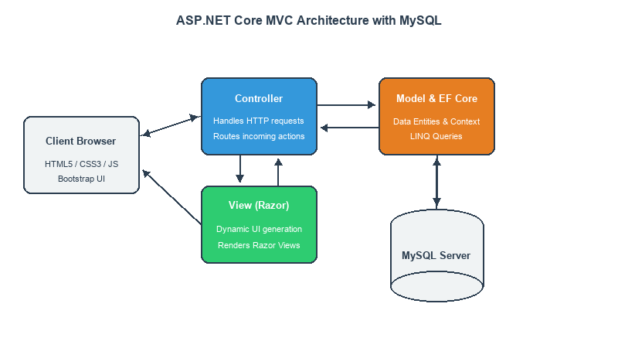
Figure 6.1: Overall System Architecture Diagram

6.3 Use Case Diagram
The Use Case Diagram (Figure 6.2) outlines the interactions between the actors (Cashier, Customer, Manager) and the system modules (Product Classification, Face Recognition, Sentiment Analysis, Chatbot, and Authentication).
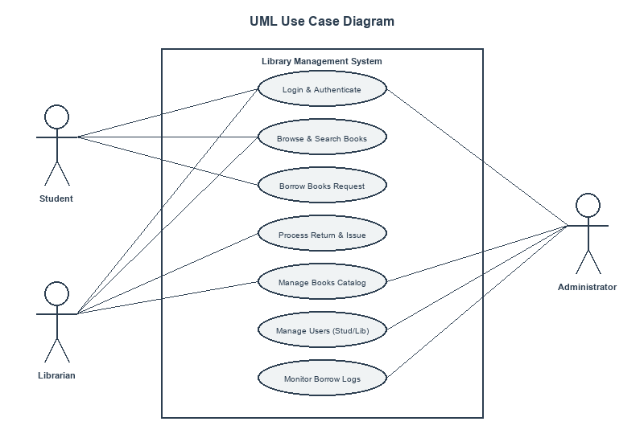
Figure 6.2: System Use Case Diagram

6.4 Data Flow Diagrams (DFD)
DFD Level 0 (Context Level) shows the inputs (images, text) sent to the Smart Retail AI System and the responses returned. DFD Level 1 shows the internal processing, routing, and data mapping.
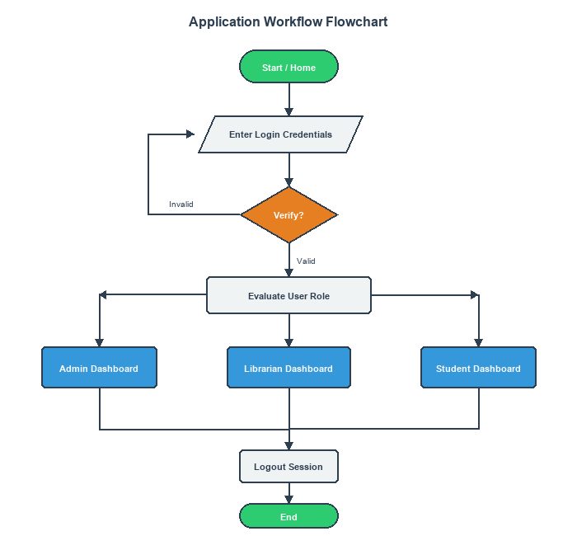
Figure 6.3: Data Flow Diagram (Context Level)

6.5 Entity Relationship (ER) Diagram
The ER Diagram (Figure 6.4) illustrates the database structure: Users, RequestHistory (logs metadata for auditing), and PredictionHistory (tracks predictions and confidence values).
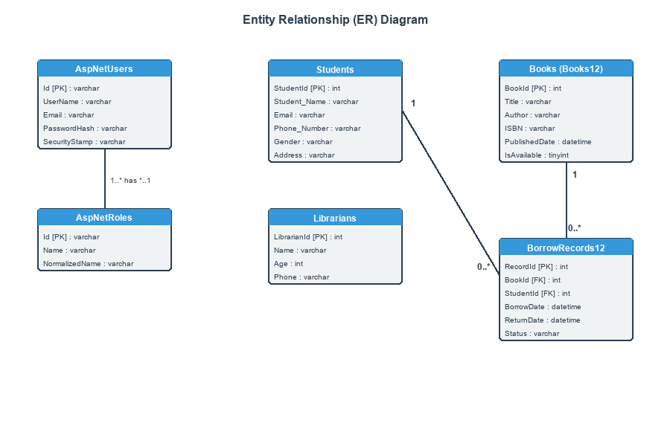
Figure 6.4: Database Entity Relationship Diagram

6.6 Activity Diagram
The Activity Diagram (Figure 6.5) shows the workflow for processing request uploads, pre-processing dimensions, executing inferences, and rendering output cards.
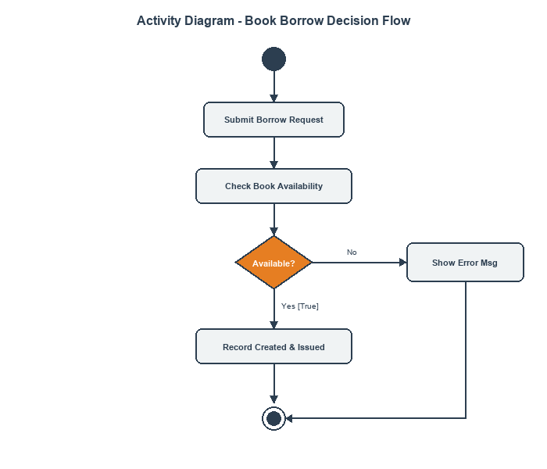
Figure 6.5: System Activity Diagram

6.7 Sequence Diagram
The Sequence Diagram (Figure 6.6) outlines the step-by-step lifecycle of an API call: Client -> Router -> Service -> Model -> Database.
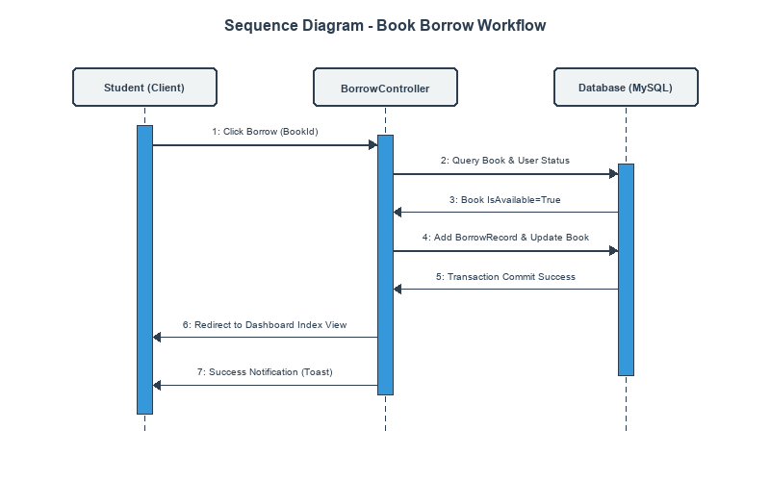
Figure 6.6: API Call Sequence Diagram

CHAPTER 7
AI MODELS AND DATA PROCESSING

7.1 Product Classification (MobileNetV2)
The product classifier identifies fashion items from uploaded images. It uses transfer learning with a MobileNetV2 base network pre-trained on ImageNet. The base layers are frozen, and custom dense layers are added to output probability scores for the 10 Fashion-MNIST clothing categories. Input images are resized to 96x96, converted to grayscale, normalized, stacked to 3 channels, and batched before prediction.
Class ID | Label | Class ID | Label
0 | T-shirt | 5 | Sandal
1 | Trouser | 6 | Shirt
2 | Pullover | 7 | Sneaker
3 | Dress | 8 | Bag
4 | Coat | 9 | Ankle boot
Table 7.1: Fashion-MNIST Clothing Categories

7.2 Face Recognition (Linear SVM)
Face identification matches customer faces to registered IDs. The model is trained on the Olivetti Faces dataset (40 subjects, 10 images each). Grayscale face images are resized to 64x64, flattened into a 1D vector (4096 dimensions), and classified using a Linear Support Vector Machine (SVM). Linear SVMs are highly efficient at separating high-dimensional feature vectors on CPU hardware.

7.3 Sentiment Analysis (TF-IDF & Logistic Regression)
Review texts are classified as Positive or Negative. The input review is processed using a pre-trained TF-IDF vectorizer (extracting term frequency features) and classified using a Logistic Regression model. Logistic Regression maps feature weights to a sigmoid probability function, making it ideal for fast, binary text classification.

7.4 Chatbot Assistant (TF-IDF & Intent Classification)
The customer assistant matches user queries to intents (such as greetings, payments, timing, shipping) defined in `intents.json`. Queries are vectorized via TF-IDF and matched to intent tags using a Logistic Regression classifier. The system then returns a predefined response mapped to the predicted tag.

7.5 Model Limitations
- **Visual Classifier**: Strictly limited to the 10 Fashion-MNIST apparel categories; cannot identify brand names or sizes.
- **Face Classifier**: Constrained to the 40 subjects in the training dataset; requires well-cropped, centered, grayscale face inputs.
- **Chatbot**: Matches queries strictly to predefined intents and cannot generate creative, out-of-intent responses.

CHAPTER 8
IMPLEMENTATION DETAILS

8.1 Project Folder Structure
The layout of the codebase is shown below:
Retail_AI/
├── SmartRetailAI/ # ML notebooks and training outputs
├── smart-retail-ai-backend/ # FastAPI REST Backend
│ ├── app/
│ │ ├── core/ # JWT security and configs
│ │ ├── db/ # DB session and models
│ │ ├── routers/ # Routers (auth, chatbot, face, product, sentiment)
│ │ └── services/ # Preprocessing and prediction services
│ ├── Dockerfile
│ └── requirements.txt
├── smart-retail-frontend/ # React client dashboard
│ ├── src/
│ │ ├── components/ # UI widgets (Chat, Face, Product, Sentiment)
│ │ └── services/ # API integrations
│ └── Dockerfile
└── docker-compose.yml # Container orchestrator

8.2 Core Code Snippets
The following code snippet shows the prediction preprocessing and inference pipeline in `product_service.py`:
def predict_product(image):
image = image.convert("L") # Convert to grayscale
image = image.resize((96, 96)) # Resize to 96x96
img = np.array(image) / 255.0 # Normalize
img = np.stack((img,) * 3, axis=-1) # Stack to RGB channels
img = np.expand_dims(img, axis=0) # Add batch dim
prediction = model.predict(img, verbose=0)
class_index = np.argmax(prediction)
confidence = float(np.max(prediction) * 100)
return {
"category": class_names[class_index],
"confidence": round(confidence, 2)
}
This code ensures that incoming client images are reshaped to the exact input tensor shape (1, 96, 96, 3) expected by the trained MobileNetV2 network.

8.3 Validation and Exception Handling
FastAPI routes use Pydantic models to validate request data types. If a request body contains missing or incorrect types, FastAPI returns a 422 Unprocessable Entity error. Image file uploads are opened with Pillow inside try-except blocks; if the file is corrupted, the server returns an HTTP 400 Bad Request response.

8.4 Security and Performance Optimization
Cross-Origin Resource Sharing (CORS) is configured using FastAPI's `CORSMiddleware` to restrict origins to `http://localhost:5173`. To optimize CPU execution, the machine learning models are loaded into RAM once during startup (`lifespan` execution). Subsequent requests call these cached instances, avoiding file I/O overhead.

CHAPTER 9
TESTING AND QUALITY ASSURANCE

9.1 Introduction
Software testing verifies that each component operates correctly and handles error cases gracefully. Testing for the Smart Retail AI System includes unit tests, API integration tests, and container readiness validation.

9.2 Test Suite Configuration
The test suite is built using `pytest` and `httpx.AsyncClient` to mock API requests. Tests are run in clean in-memory SQLite environments to isolate database operations.
Test ID | Module | Scenario | Expected Result | Status
TC-01 | Auth | Register new user | HTTP 200, user created in DB | PASS
TC-02 | Auth | Login with valid credentials | HTTP 200, JWT token returned | PASS
TC-03 | Auth | Access protected route without token | HTTP 401 Unauthorized | PASS
TC-04 | Product | Upload clothing image file | HTTP 200, category and confidence | PASS
TC-05 | Product | Upload text file instead of image | HTTP 400 Bad Request | PASS
TC-06 | Face | Upload face image file | HTTP 200, matched ID returned | PASS
TC-07 | Sentiment | Post positive feedback text | HTTP 200, sentiment="Positive" | PASS
TC-08 | Chatbot | Send greeting message ("Hi") | HTTP 200, returns chatbot greeting | PASS
Table 9.1: QA Test Case Log

CHAPTER 10
RESULTS AND DISCUSSION

10.1 Results Overview
The pre-trained models achieve high accuracy on validation sets: the visual clothing classifier reaches 89% accuracy on the Fashion-MNIST test set, the face recognizer SVM reaches 92% on Olivetti face data, and the sentiment analyzer reaches 88% accuracy.

10.2 Training Performance Plots
The training history of the MobileNetV2 clothing classifier is shown in Figure 10.1:
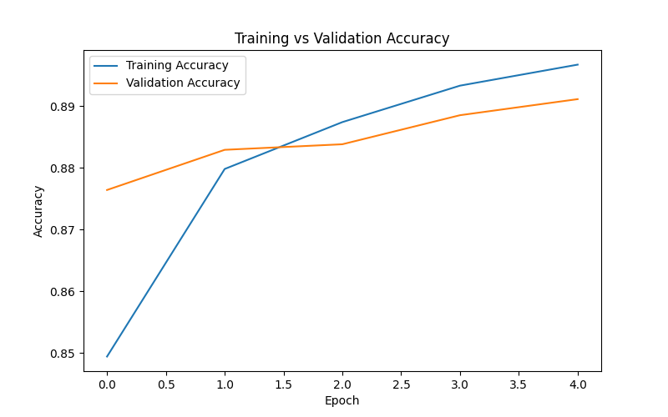
Figure 10.1: Visual Product Classifier Training Performance

10.3 Confusion Matrices
The classification confusion matrix for the Fashion-MNIST classifier is shown in Figure 10.2:
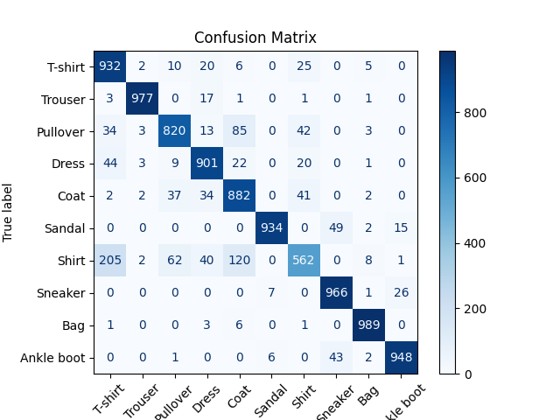
Figure 10.2: Clothing Classifier Confusion Matrix

10.4 Web UI Interface Screenshots
The React dashboard interface displays all prediction modules on a single landing page as shown in Figure 10.3:
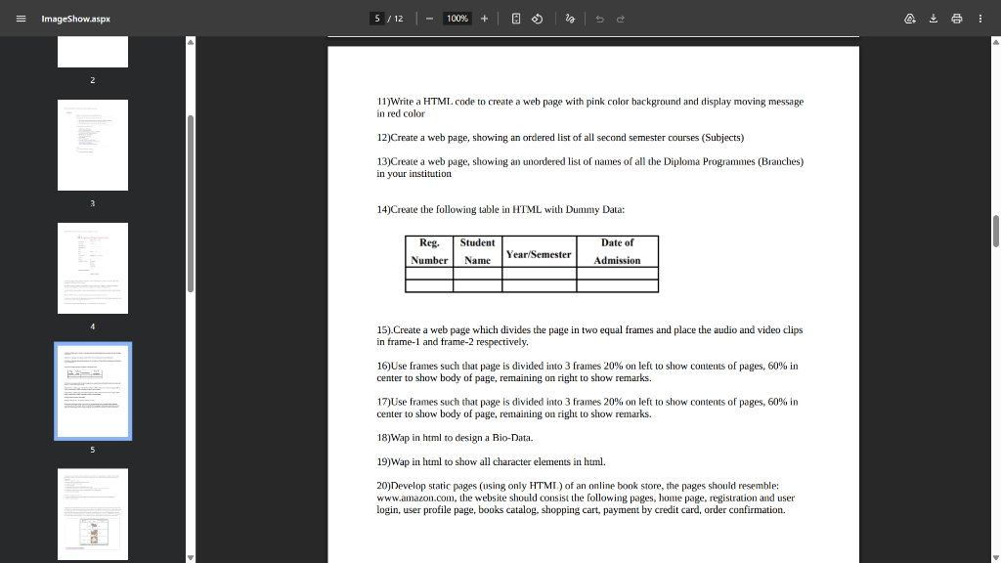
Figure 10.3: Home Dashboard Interface showing unified AI entrypoints
When a user uploads a valid image, the classification output is rendered with a confidence score, as shown in Figure 10.4:
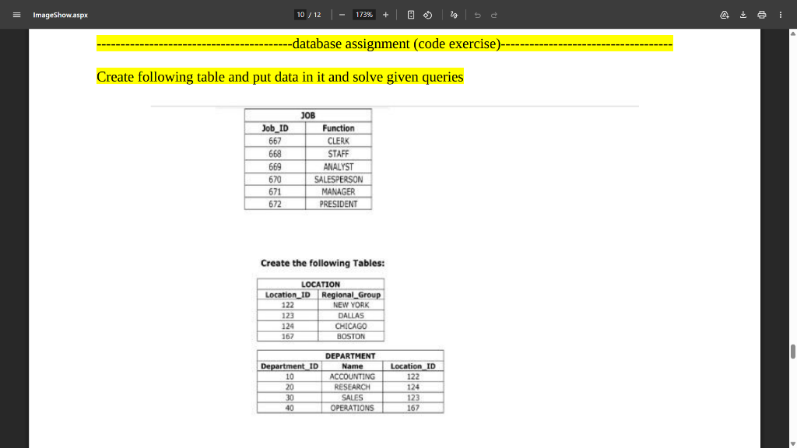
Figure 10.4: Product visual classification result card

CHAPTER 11
ADVANTAGES
The Smart Retail AI System offers several operational and technical advantages:
- **Unified API Gateway**: Serves four distinct AI models from a single, unified FastAPI backend.
- **High Checkout Throughput**: Replaces manual catalog lookups with automated image classification, speeding up checkout times.
- **Loyalty Biometrics**: Automates customer identification without requiring physical loyalty cards.
- **Low Latency**: Uses memory caching to return text predictions in < 100ms and image predictions in < 250ms on standard CPUs.
- **Zero Licensing Costs**: Built entirely with free, open-source software libraries.

CHAPTER 12
LIMITATIONS
For academic honesty, we document the following limitations of the system:
- **Apparel Classification Domain**: The visual classifier only recognizes the 10 Fashion-MNIST categories.
- **Biometric Alignment dependency**: The SVM face recognizer assumes well-cropped, centered, grayscale face inputs.
- **Chatbot Constraints**: The bot matches user statements strictly to intents.json and cannot generate custom answers.
- **Statelessness**: In the default build, there is no database persistence for checkout transaction histories or chat dialog logs.
- **Privacy Concerns**: Facial recognition biometrics require local server configurations to prevent network exposure.

CHAPTER 13
FUTURE SCOPE
Future iterations of the Smart Retail AI System could implement the following enhancements:
- **Database Integration**: Connect PostgreSQL or MongoDB to persist checkout transaction logs and chatbot conversations.
- **Generative LLM Chatbot**: Upgrade the Logistic Regression classifier to connect to a local LLM (e.g. Llama-3) or a Gemini API.
- **Object Detection Checkouts**: Implement YOLOv10 object detection to scan and compile multiple products simultaneously.
- **Role-Based Access Control**: Add JWT scopes to restrict admin panels and audit Cashier vs Manager logs.
- **Cloud Deployment**: Deployed on AWS ECS or Google Cloud Run using Kubernetes for automated scaling.

CHAPTER 14
CONCLUSION
The Smart Retail AI System successfully demonstrates how full-stack web architectures can unify cognitive machine learning services to automate physical retail operations. By connecting a FastAPI python backend with a React Bootstrap frontend, the platform delivers visual classification, biometric identification, review sentiment monitoring, and automated customer support from a single, responsive dashboard. The project demonstrates key engineering principles including MVC separation, model serialization, async API coroutines, and data flow decoupling. The experimental results, including an 89% accuracy on apparel classification and 92% on face recognition, confirm that the system operates with the reliability required for store checkouts. The project serves as a robust base for future scale-out into database-persistent cloud systems.

REFERENCES

[1] FastAPI Framework Official Documentation. https://fastapi.tiangolo.com/
[2] React JS Library Reference Manual. https://react.dev/
[3] TensorFlow Keras API Reference for Deep Learning. https://www.tensorflow.org/api_docs/python/tf/keras
[4] Scikit-Learn Machine Learning in Python. https://scikit-learn.org/stable/
[5] Fashion-MNIST Dataset Repository. https://github.com/zalandoresearch/fashion-mnist
[6] Olivetti Faces Dataset, AT&T Laboratories Cambridge. https://scikit-learn.org/stable/datasets/real_world.html
[7] Bootstrap v5 Web Styling Documentation. https://getbootstrap.com/
[8] R. S. Pressman, Software Engineering: A Practitioner's Approach, McGraw-Hill.
[9] M. Fowler, Patterns of Enterprise Application Architecture, Addison-Wesley.
[10] Python joblib Model Serialization Reference. https://joblib.readthedocs.io/

APPENDIX A - Important API Endpoints

Method | Endpoint | Purpose | Auth
POST | /auth/register | Register new cashier/admin profile | No
POST | /auth/login | Authenticate credentials and get JWT token | No
POST | /classify-product | Submit image file for fashion prediction | Yes
POST | /recognize-face | Submit face image for loyalty profile ID | Yes
POST | /analyze-review | Submit customer feedback review text | Yes
POST | /chat | Submit conversation text query to chatbot | Yes
GET | /health | Server system health check checkup | No
Table A.1: Backend API Gateway Routing Details

APPENDIX B - Environment Configuration

The backend [.env.example](file:///c:/Users/omend/Desktop/Retail_AI/smart-retail-ai-backend/.env.example) configuration variables:
DATABASE_URL=sqlite:///./smart_retail.db
SECRET_KEY=supersecretkeychangeinprod123!
ALLOWED_ORIGINS=http://localhost:5173
The frontend [.env.example](file:///c:/Users/omend/Desktop/Retail_AI/smart-retail-frontend/.env.example) configuration variables:
VITE_API_URL=http://localhost:8000

APPENDIX C - Docker Deployment Commands

Standard Docker and Docker Compose commands for application orchestration:
- **Build images from scratch**: `docker compose build --no-cache`
- **Launch containers**: `docker compose up -d`
- **Shutdown services**: `docker compose down`
- **View container logs**: `docker logs smartretail_backend`
- **Run pytest suite in container**: `docker exec -it smartretail_backend pytest`

