EXPERIMENT 6
ROLL NO: 240701020
NAME: ADITYA S

USER INTERFACE DESIGN

Aim
To simulate the lifecycle stages of UI design using the Rapid Application Development (RAD) model and develop a small interactive interface using Axure.

🛠 Tool Used
- Axure RP (for UI prototyping and interaction design)

📘 Introduction to RAD Model
Rapid Application Development (RAD) is a software development model that focuses on quick development and iteration through prototyping and user feedback. Unlike traditional models, RAD emphasizes working prototypes rather than extensive planning.
The RAD model consists of four main phases:
- Requirement Planning
- User Design
- Construction
- Cutover (Testing and Deployment)

🔄 RAD Lifecycle Applied to the Project
- Requirement Planning
The application developed is a Sneaker Shopping Mobile Interface (Shopzy).

Objective:
To create a simple and interactive UI that allows users to browse sneakers, view product details, and complete a purchase.

Target Users:
- Online shoppers
- Sneaker enthusiasts

Key Features:
- View product listings
- Search sneakers
- View product details
- Add to cart
- Checkout and payment confirmation

2. User Design (UI/UX Design)
In this phase, the user interface was designed based on the requirements. The design focuses on simplicity, usability, and smooth navigation.

Screens Designed:

🔹 Home Screen

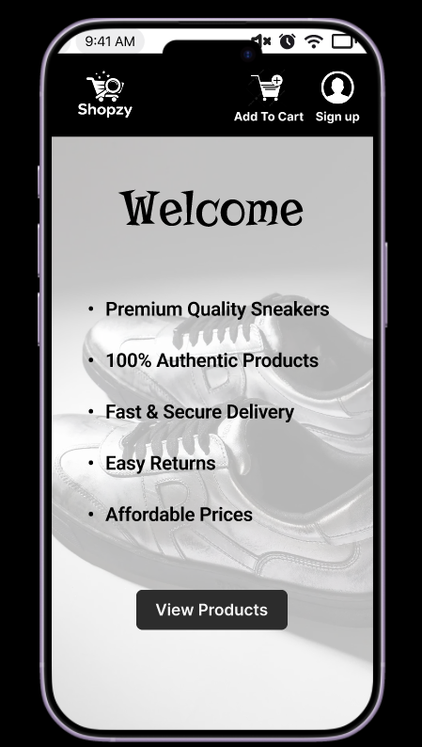
- Displays welcome message
- Highlights key features (quality, delivery, pricing)
- Includes “View Products” button

🔹 Product Listing Screen

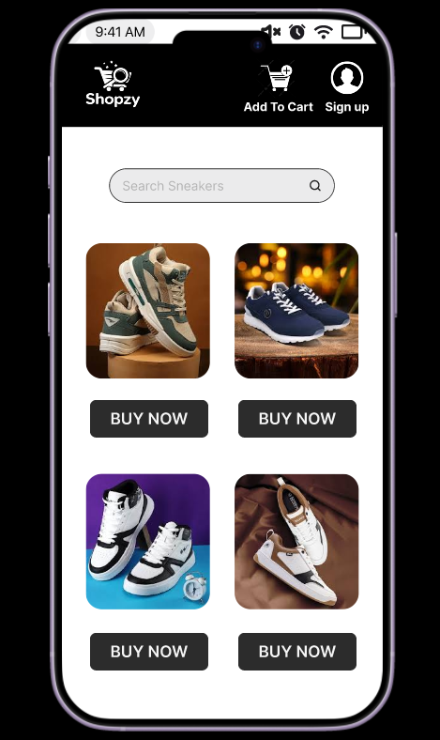
- Displays multiple sneaker options
- Includes search bar
- Each product has a “Buy Now” button

🔹 Product Details Screen

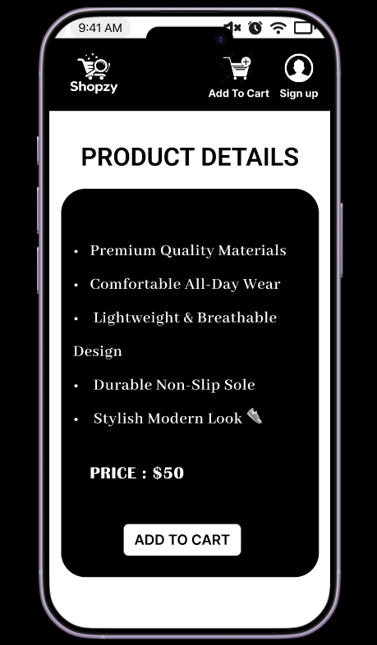
- Shows product features
- Displays price
- Includes “Add to Cart” option

🔹 Checkout Screen

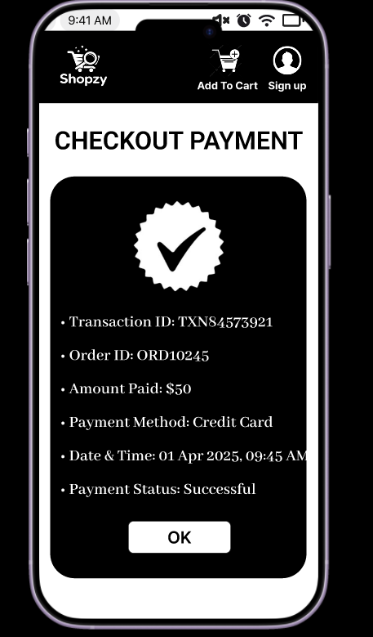
- Displays transaction details
- Shows payment status
- Includes confirmation button

🔹 Thank You Screen

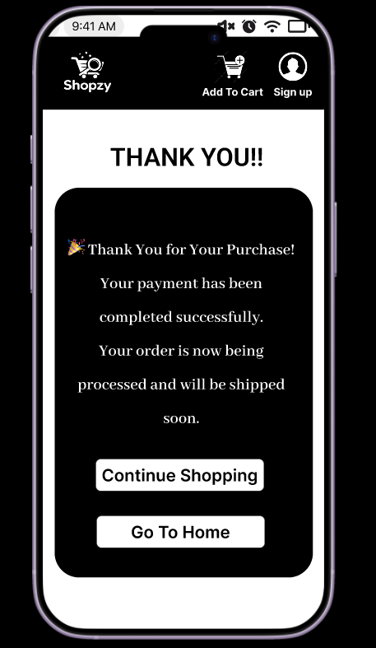
- Displays successful purchase message
- Options to continue shopping or return home

3. Construction (Prototype Development)
The prototype was developed using Axure RP.

Implementation Details:
- Each screen was created as a separate page
- Buttons were made interactive using OnClick events
- Navigation flow was implemented as follows:
  - View Products → Product Listing
  - Buy Now → Product Details
  - Add to Cart → Checkout
  - OK → Thank You Page
  - Continue Shopping → Product Listing

Key Features Implemented:
- Clickable buttons
- Page-to-page navigation
- Interactive user flow simulation
This phase demonstrates the RAD concept of rapid prototyping and functional UI development.

4. Cutover (Testing and Evaluation)
The prototype was tested using the preview feature in Axure.

Testing Results:
- All navigation flows worked correctly
- Buttons responded as expected
- User journey was smooth and logical

Limitations:
- No real backend integration
- Payment system is simulated
- Limited product filtering options

Future Improvements:
- Add cart management system
- Include multiple payment options
- Improve UI responsiveness
- Add user authentication

✅ Result
A functional and interactive UI prototype of a sneaker shopping application was successfully developed using the RAD model. The prototype demonstrates all stages of the RAD lifecycle and provides a smooth user experience.

Prototype Link:
https://www.figma.com/proto/4JePPCAPFzgMgdAiwywuYr/Untitled?page-id=0%3A1&node-id=1-2&p=f&viewport=158%2C71%2C0.49&t=q7Mk8Q88PqsWyM2n-1&scaling=scale-down&content-scaling=fixed&starting-point-node-id=1%3A2

