EXPERIMENT 7
ROLL NO: 240701020
NAME: ADITYA S

USER INTERFACE DESIGN

Aim
To make a prototype design and get feedback for the design to improve the look, color pattern, feature, etc..

Feedbacks Using Google Form:

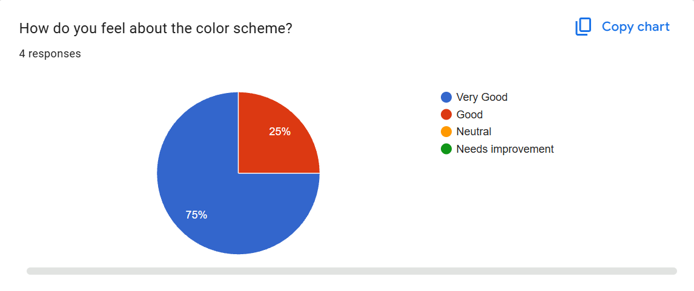
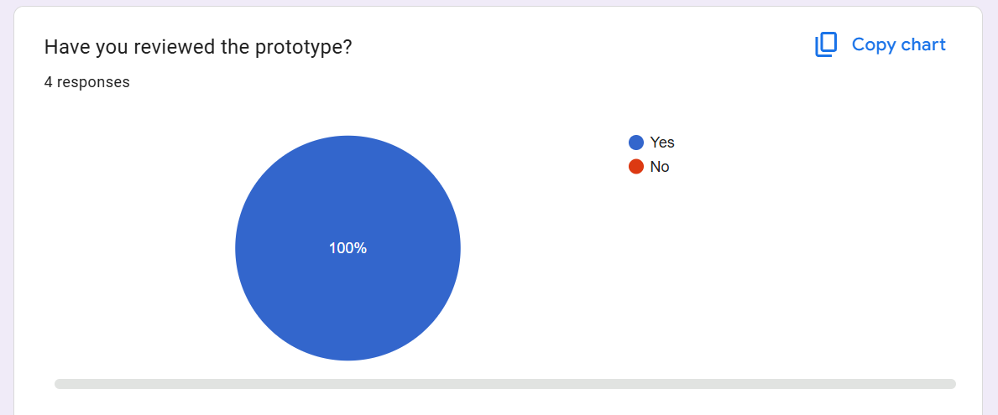
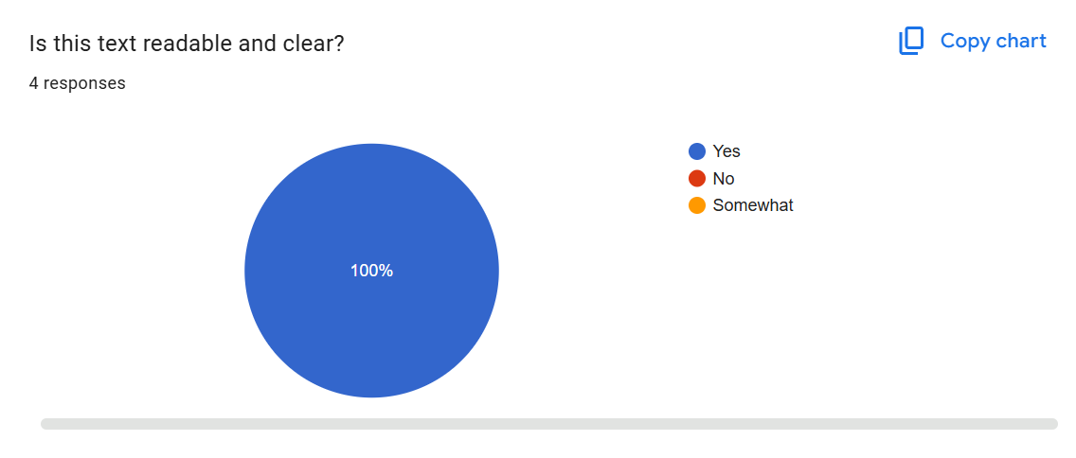
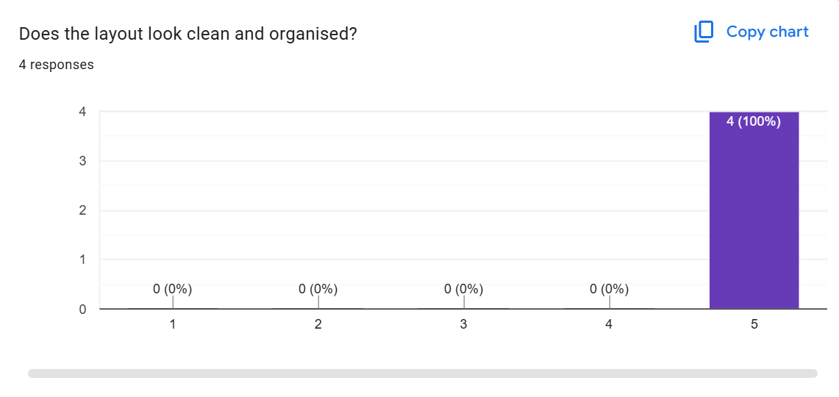
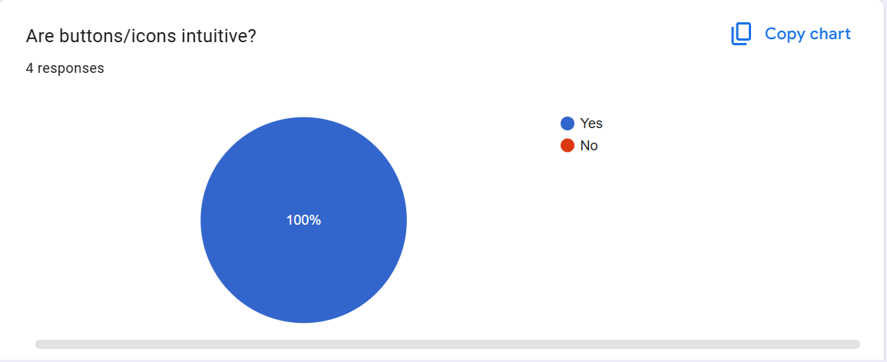

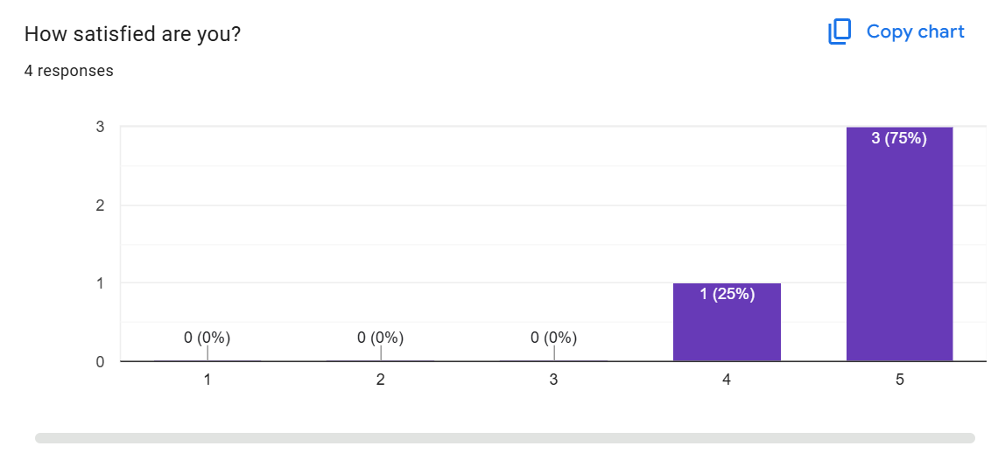

PROTOTYPE LINK AFTER IMPROVEMENT:
https://www.figma.com/proto/4JePPCAPFzgMgdAiwywuYr/Untitled?page-id=0%3A1&node-id=1-2&p=f&viewport=158%2C71%2C0.49&t=q7Mk8Q88PqsWyM2n-1&scaling=scale-down&content-scaling=fixed&starting-point-node-id=1%3A2

CONCLUSION:
Thus, the initial prototype design is attached with a Google Form and feedback are received through the Google Form. The improvements are made accordingly and the new Prototype link is given above.

