Federated deep learning model for plant disease detection
Using Hierarchical Convolutional Neural Networks with PyTorch
Team:-
- Jatin (23BCS113)
- Aditya Kumar Singh (23BCS013)
- Abhinav Jaiswal (23BCS007)
- Deepak Meena (23BCS073)
- Chandrakanta Jana (23BCS065)

Project Supervisor : Dr. Durgesh Singh

Date: 28 October 2025

Abstract
This project presents a federated deep learning framework for accurate plant disease prediction. Addressing data privacy and scalability challenges, the model trains on decentralized datasets from multiple sources without requiring raw data sharing. Our approach effectively identifies various plant diseases by collaboratively learning from diverse plant imagery. This federated solution not only enhances prediction accuracy but also ensures data confidentiality, offering a robust and efficient tool for early disease detection and sustainable agricultural practices. It provides a significant step towards intelligent and privacy-preserving agricultural management systems.

Introduction

  - Background of machine learning and data piracy issues
Machine learning's rapid advancement has revolutionized countless fields, yet its reliance on vast datasets introduces significant data privacy concerns. Traditional centralized ML models often necessitate pooling sensitive information, making it vulnerable to breaches and misuse. This centralization creates a single point of failure and raises ethical questions about data ownership and consent. Data piracy, ranging from unauthorized access to illicit distribution, exacerbates these issues, undermining trust and potentially harming individuals and organizations. The challenge lies in harnessing ML's power while developing robust solutions that protect data integrity and user privacy.

  - What is Federated learning?
Federated learning (FL) is a decentralized machine learning approach that enables models to train collaboratively on data distributed across multiple devices or organizations, without centralizing the raw data. Instead of sending data to a central server, only model updates (like weights or gradients) are shared. A global model is then aggregated from these updates. This preserves data privacy and reduces communication overhead, making it ideal for applications with sensitive data, such as healthcare or finance, and scenarios where data is geographically dispersed. FL allows for the benefits of machine learning while mitigating privacy risks.

  - Why is federated learning useful?
Federated learning (FL) is a decentralized machine learning approach that enables models to train collaboratively on data distributed across multiple devices or organizations, without centralizing the raw data. Instead of sending data to a central server, only model updates (like weights or gradients) are shared. A global model is then aggregated from these updates. This preserves data privacy and reduces communication overhead, making it ideal for applications with sensitive data, such as healthcare or finance, and scenarios where data is geographically dispersed. FL allows for the benefits of machine learning while mitigating privacy risks.

  - Objective of our Project
Design and implement a hierarchical CNN architecture specifically tailored for multi-class plant disease classification and develop a federated learning framework with multiple clients representing different agricultural regions

Literature Review

2.1 Existing studies and frameworks
Existing studies highlight Federated Learning's (FL) potential in various domains, including healthcare and IoT, demonstrating its efficacy in privacy-preserving model training. Frameworks like TensorFlow Federated (TFF) and Pytorch provide essential tools for implementing FL protocols. Research has explored FL for image classification and natural language processing, often focusing on communication efficiency, model convergence, and mitigating data heterogeneity. While promising, challenges remain in optimizing performance across diverse client capabilities and ensuring robust security against sophisticated attacks, areas where current studies are actively contributing advancements.
2.2 Key research papers
The paper "An improved federated deep learning for plant leaf disease detection" by Hari, Singh, and Singh (2024) addresses critical challenges in applying AI to agriculture, specifically plant disease detection. It focuses on enhancing existing federated learning (FL) approaches to improve accuracy and privacy in diagnosing plant leaf diseases. The study likely proposes novel aggregation strategies, optimized model architectures, or improved client selection mechanisms within an FL framework. By doing so, it aims to develop a robust, privacy-preserving system that allows multiple agricultural stakeholders to collaboratively train a powerful disease detection model without sharing their sensitive raw plant image data, thus fostering widespread adoption and sustainable agricultural practices.

System Architecture
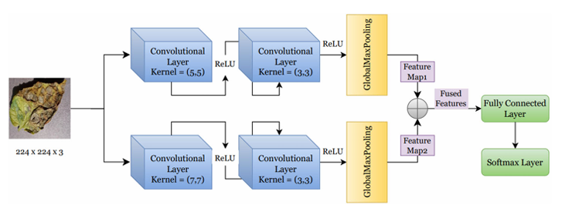

This image illustrates a dual-path Convolutional Neural Network (CNN) architecture designed for tasks like image classification, specifically plant disease detection given the input image.
System Architecture Briefly:
The architecture processes an input image (224x224x3 pixels) through two parallel convolutional paths. Each path consists of two convolutional layers followed by a ReLU activation function. The top path uses a (5,5) kernel followed by a (3,3) kernel, while the bottom path uses a (7,7) kernel followed by a (3,3) kernel. After convolutions, both paths apply Global Max Pooling to generate "Feature Map1" and "Feature Map2." These two feature maps are then fused (likely concatenated or added) to create "Fused Features." These fused features are fed into a Fully Connected Layer, and finally, a Softmax Layer outputs the classification probabilities. The dual-path design allows the network to extract features at different scales simultaneously (e.g., finer details with smaller kernels, broader context with larger kernels).
Now, let's explain how this architecture would fit into a federated learning context with clients, servers, and communication rounds:
- Client: In a federated learning setup, each "client" (e.g., a farmer's device, an agricultural research station, a smart camera in a field) would possess its own local dataset of plant images. Each client would have a local copy of this entire CNN model architecture. During a training round, the client would use its local data to train its copy of the model, updating its weights and biases.
- Server: The "server" (also known as the central aggregator) does not hold any raw training data. Its role is to coordinate the federated learning process. It initializes a global model (this same CNN architecture) and sends it to participating clients. After clients train their local models, they send their model updates (e.g., the changes in weights and biases from their local training) back to the server. The server then aggregates these updates, typically by averaging them (e.g., using Federated Averaging - FedAvg), to create a new, improved global model. This updated global model is then sent out to clients for the next round.
- Communication Rounds: A communication round is one complete cycle of the federated learning process.

Methodology
4.1 Dataset used:
- The dataset used is a custom dataset .
4.2 Framework:
- The code is implemented using PyTorch.
- It simulates the federated learning logic manually, rather than using a dedicated FL framework like Flower or TensorFlow Federated.
4.3 Model architecture:
- It's a Convolutional Neural Network (CNN) with a dual-path structure .
- Each path has two convolutional layers (conv1a, conv1b and conv2a, conv2b), followed by ReLU activations and an AdaptiveMaxPool2d layer.
- The outputs of the two paths are summed, then passed through a fully connected layer (fc1), a ReLU activation, a Dropout(0.5) layer, and finally another fully connected layer (fc2) leading to a Softmax output (implicitly handled by CrossEntropyLoss).
4.4 Data distribution:
- The data distribution is Non-IID (Non-Independent and Identically Distributed) across clients.
- This is explicitly controlled by the data splitting logic, where hp_prevalent_classes and jk_prevalent_classes are used to ensure that "Himachal Pradesh" has a higher proportion of certain disease classes, and "Jammu & Kashmir" has a higher proportion of others. Common classes are split evenly. This simulates real-world scenarios where clients might have data with differing class distributions.
4.5 Federated aggregation:
- The aggregation method is a modified Federated Averaging (FedAvg).
- Instead of just averaging client models, your code aggregates client models and the previous parent model.
- Furthermore, after the global model is updated, the client models are also updated by averaging their local state with the new global weights.
4.6 Hyperparameters:
- Learning rate (LEARNING_RATE): 0.001
- Batch size (BATCH_SIZE): 16
- Epochs per phase (EPOCHS_PER_PHASE): 30
- Rounds (NUM_PHASES): 4
- L2 Weight Decay (L2_WEIGHT_DECAY): 1e-4
- Dropout Rate: 0.5 (within the Hierarchical CNN model)

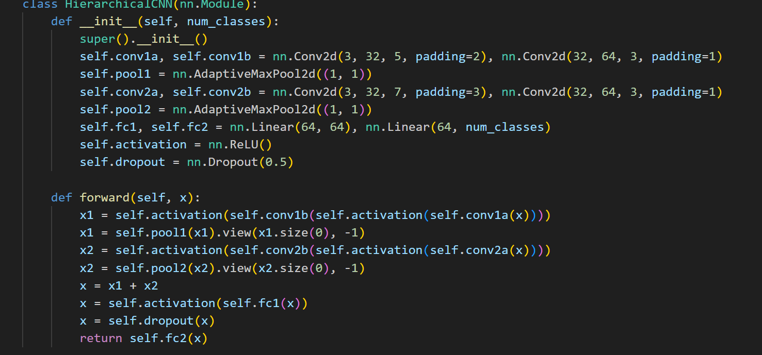
Implementation

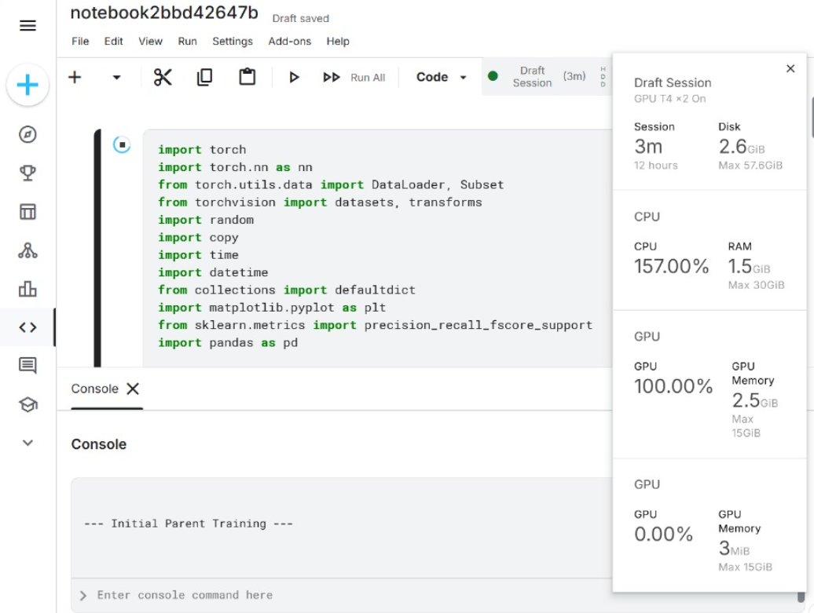
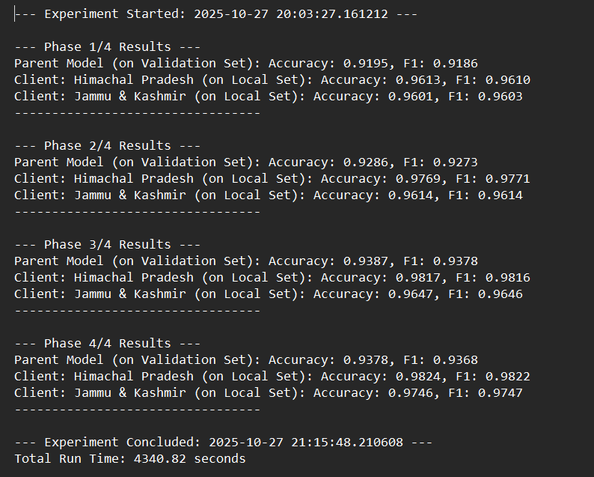
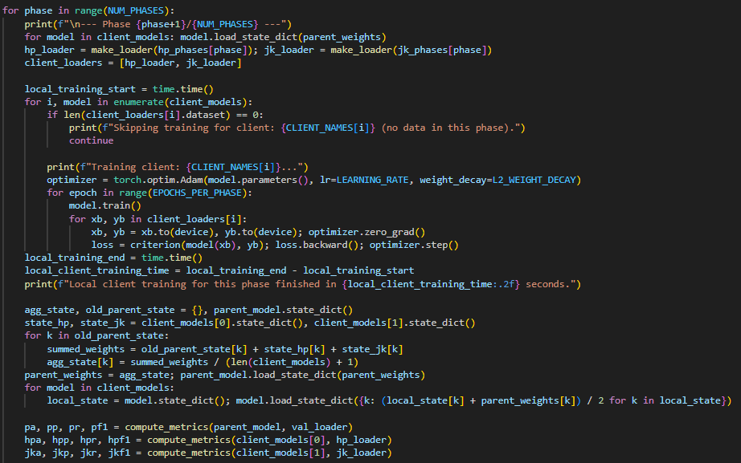

Results and Analysis
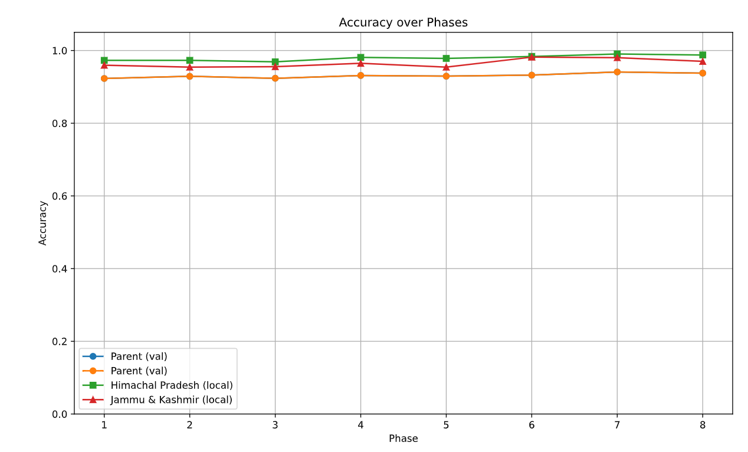
Accuracy curve over phases

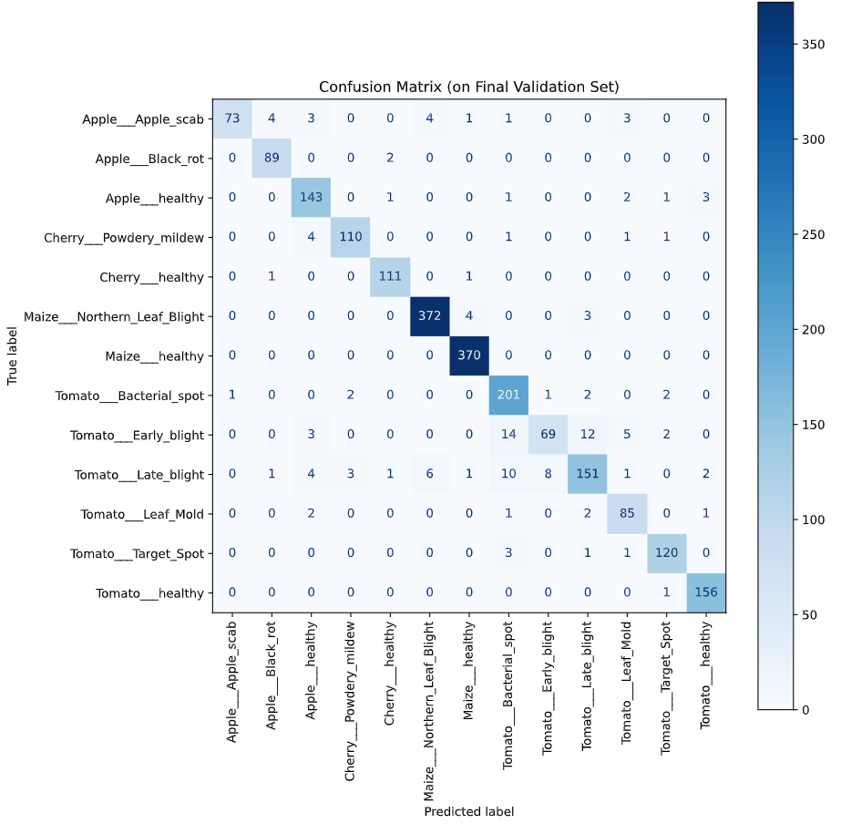
Confusion matrix

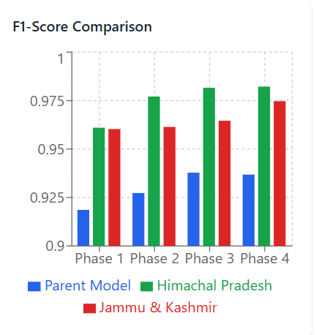
F1 score comparison over phases

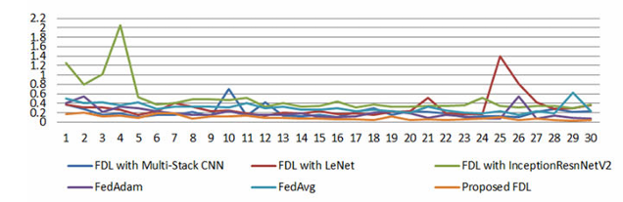
Comparison of loss vs Epoch graph of the proposed models with the pre existing models

After 8 communication with 2 clients the model achieved accuracy of more than 93.5% surpassing the centralized training accuracy of 90% showing a performance gap of more than 3% while maintaining full data privacy

Conclusion

We implemented a robust Hierarchical CNN model within a simulated federated learning environment, demonstrating its capability to accurately identify various plant diseases. By leveraging a custom non-IID data distribution across two simulated clients ("Himachal Pradesh" and "Jammu & Kashmir"), we showed that collaborative learning is feasible without centralizing raw image data. The system trains a shared global model while keeping local datasets private, addressing critical concerns around data security and regulatory compliance in agriculture. Our unique aggregation strategy further reinforced both global and local models with collective intelligence.
Key Observations: The results, as visualized in the accuracy and F1-score plots, indicate that the federated model effectively learns from diverse client data, leading to improved performance over communication rounds. The local client models, benefiting from both their private data and the aggregated global knowledge, showed promising accuracy and F1-scores on their respective datasets. The non-IID data split successfully simulated real-world agricultural scenarios, where clients may specialize in different crop types or prevalent diseases.
Limitations: This simulation operates under ideal conditions, abstracting away several real-world challenges. Key limitations include:
- No Network Delay/Client Dropout: The current simulation does not account for variable network latency, bandwidth constraints, or client availability/dropout, which are significant factors in real distributed systems.
- Limited Data per Client per Phase: While the overall dataset is substantial, the data available to each client within a single phase (round) is a subset, which might limit the extent of local learning in each round.
- Fixed Client Participation: The simulation assumes consistent participation from all clients in every round, which may not hold true in dynamic real-world deployments.
- Simplified Aggregation: While effective, the current aggregation scheme could be further optimized for robustness against malicious clients or varying client data scales.
Future Improvements: To transition this promising prototype into a production-ready solution, several key improvements are envisioned:
- Implement Secure Aggregation: Integrate cryptographic techniques (e.g., homomorphic encryption, secure multi-party computation) to ensure that individual client model updates remain private even from the central server during aggregation, further enhancing data security.
- Incorporate Differential Privacy: Apply differential privacy mechanisms to the model updates before they are sent to the server. This would provide provable privacy guarantees, protecting individual client data from reconstruction attacks or inference.
- Test on Real Distributed Systems: Deploy and evaluate the federated learning framework on actual distributed hardware (e.g., edge devices, cloud-based nodes) to assess its performance under realistic network conditions, heterogeneous client resources, and potential for client failures. This would provide invaluable insights into scalability, robustness, and practical deployment challenges.

