A Perceptron-based Approach for Diabetes Data Classification

Aditya D Pandey
The University of Adelaide
Adelaide, South Australia, Australia
aditya.pandey@student.adelaide.edu.au

Abstract

The ABSTRACT is to be in fully-justified italicized text, at the top of the left-hand column, below the author and affiliation information. Use the word “Abstract” as the title, in 12-point Times, boldface type, centered relative to the column, initially capitalized. The abstract is to be in 10-point, single-spaced type. The abstract may be up to 3 inches (7.62 cm) long. Leave two blank lines after the Abstract, then begin the main text.
Add here later

Introduction
Diabetes is a long-term condition that impacts individuals across the globe (Khan et. al 2020). Precise categorization of diabetes information plays a role, in identifying it making diagnoses and devising effective treatment strategies (WHO 2019). Over the years the application of machine learning methods has demonstrated encouraging outcomes in analyzing medical data particularly when it comes to classifying diabetes (Hama Saeed 2023), (Patra & khuntia 2021), (Darolia & Chhillar 2022), (Rajni & Amandeep 2019) 14-45 from Ismail. This study introduces an approach based on perceptron, for categorizing diabetes data by harnessing the capabilities of neural networks to enhance accuracy and efficiency.

Dataset
The dataset utilized in this research corresponds to the Pima Indian community situated near Phoenix, Arizona, a dataset that has been continuously examined since 1965 by the National Institute of Diabetes and Digestive and Kidney Diseases (Smith et. al 1988) [Ask if I should add this also]
PIMA Indian diabetes dataset (PIDD) consists of 9 attributes, 8 predictors and 1 class label. The dataset comprises of 768 women with age of more than 21 years. Below depicted are histogram plots and table with description and for each of attribute(s) of PIDD (Naz & Ahuja 2020 p. 395).

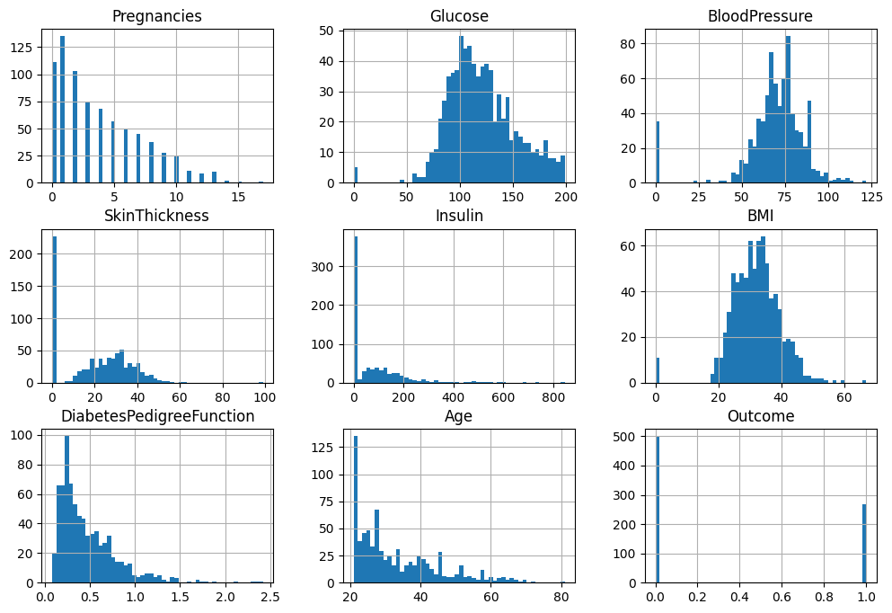
Figure 1: A histogram for each numerical attribute
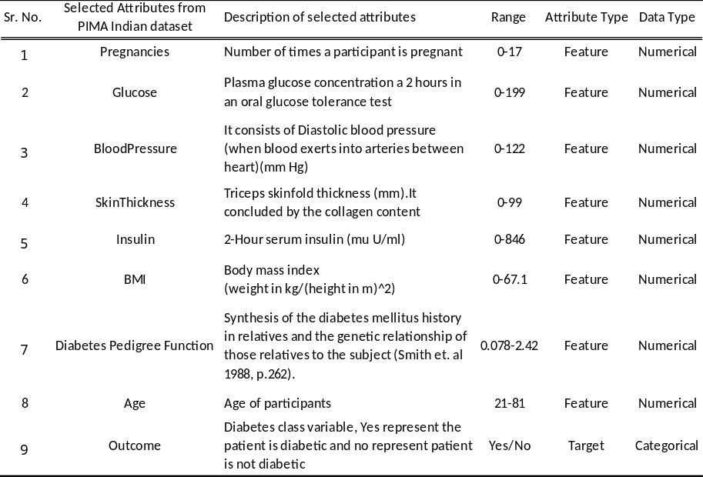
Table 1: Description of all the PIDD attributes

