Problem Statement
A private sector firm wants to develop an application for automating various operations. You need to help the firm by developing the application based on the class diagram and description given below.
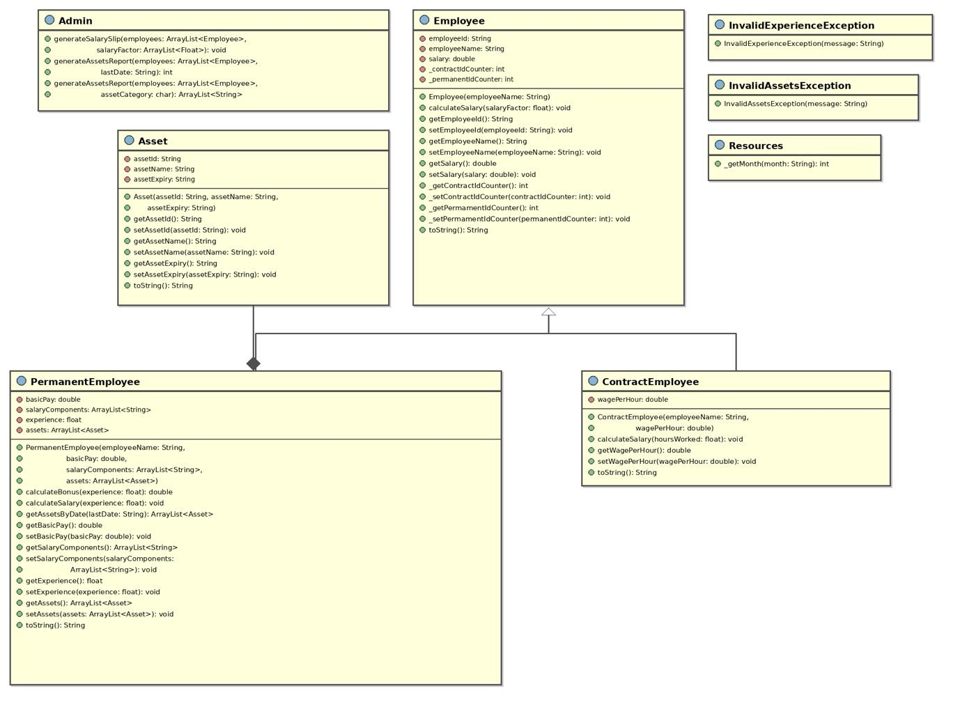
NOTE
- contractIdCounter and permenantIdCounter in Employee class are static variables.
- calculateSalary in Employee class is an abstract method.
- getContractIdCounter, setContractIdCounter, getPermenantIdCounter and setPermenantIdCounter in Employee class are static methods.
- getMonth in Resources class is a static method.
Implementation details
Asset class
- Asset(String assetId, String assetName, String assetExpiry)
  - The instance variables should be initialized with the values passed to the constructor appropriately.
- setAssetId(String assetId)
  - assetId instance variable should be set to the passed value if the passed valued is valid.
  - assetId passed is valid if it satisfies the following rules:
    - assetId should start with either "DSK" or "LTP" or "IPH" followed by a hyphen (-) and 6 digits and a character which should be either 'H' or 'L' (case-insensitive).
- Implement other setter and getter methods appropriately.

Resources class
- getMonth(String month)
  - The method should receive a short form of month in String format and return the corresponding month number.
  - For an invalid month, 0 should be returned.
  - month received will contain 3 characters starting with uppercase character.
  - E.g. -
    - If the month value received is Sep, 9 should be returned
    - If the month value received is sep, 0 should be returned

InvalidAssetsException class
- InvalidAssetsException(String message)
  - The instance variable should be initialized with the value passed to the constructor appropriately.

InvalidExperienceException class
- InvalidExperienceException(String message)
  - The instance variable should be initialized with the value passed to the constructor appropriately.

Employee class
- The static variables contractIdCounter and permenantIdCounter should be initialized to 10000 using a static block.
- Employee(String employeeName)
  - The instance variable employeeName should be initialized with the value passed to the constructor appropriately.
  - employeeId should be generated either using contractIdCounter static variable or permenantIdCounter static variable as follows:
    - The value of employeeId should start from 'C10001' and the numerical part should be incremented by 1 for the subsequent values, if the employee is a contract employee.
    - The value of employeeId should start from 'E10001' and the numerical part should be incremented by 1 for the subsequent values, if the employee is a permenant employee.
- setEmployeeName(String employeeName)
  - employeeName instance variable should be set to the passed value if the passed value is valid.
  - employeeName passed is valid if it satisfies the following rules:
    - Employee name can contain only alphabets and spaces. Space is allowed only between words.
    - Name should contain minimum 2 words.
    - Each word in the employee name should contain minimum 2 alphabets and it must start with an uppercase alphabet.
- setSalary(double salary)
  - salary instance variable should be set to the passed value if the passed value is greater than 0, else, salary instance variable should be set to 0.
- Implement other setter and getter methods appropriately.

ContractEmployee class
- ContractEmployee(String employeeName, double wagePerHour)
  - The inherited member variables should be initialized by invoking the base class constructor.
  - The member variable of ContractEmployee class should be initialized with the value passed to the constructor appropriately.
- calculateSalary(float hoursWorked)
  - The value of salary should be calculated using the formula given below:
    - salary = wagePerHour * hoursWorked
  - hoursWorked should be validated and checked whether it is greater than or equal to 190
  - If hoursWorked is less than 190, a portion of the salary should be deducted as per the following:
    - salary to be deducted will be the product of half of the wagePerHour and the number of hours less than the limit, i.e., 190.
  - The calculated salary should be rounded to the nearest integer and should be set to the instance variable salary.
- Implement the setter and getter methods appropriately.

PermanentEmployee class
- PermanentEmployee(String employeeName, double basicPay, ArrayList<String> salaryComponents, ArrayList<Asset> assets)
  - The inherited member variables should be initialized by invoking the base class constructor.
  - The member variables of PermanentEmployee class should be initialized with the values passed to the constructor appropriately.
- calculateBonus(float experience)
  - Bonus amount should be calculated and returned as per the table given below
  - If the value of experience is invalid, InvalidExperienceException should be thrown with the message "A minimum of 2.5 years is required for bonus!"
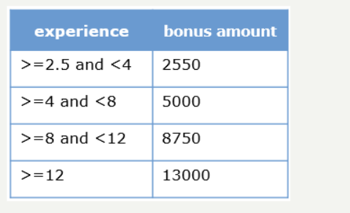

- calculateSalary(float experience)
  - The instance variable experience should be set using the value passed to the method.
  - The salary should be calculated using the formula given below:
    - salary = basicPay + DA component + HRA component + bonus amount
  - DA component and HRA component should be calculated based on the percentage value associated with each component given in the salaryComponents arrayList.
    - E.g. - If the salaryComponents is ["DA-50", "HRA-45"], DA is 50% of the basicPay and HRA is 45% of the basicPay.
  - The bonus amount should be calculated by invoking the calculateBonus() method
  - If InvalidExperienceException is thrown by the calculateBonus() method, the InvalidExperienceException exception should be handled and bonus amount should be set to 0
  - The calculated salary should be rounded to the nearest integer and should be set to the instance variable salary.
- getAssetsByDate(String lastDate)
  - An Asset arrayList (ArrayList<Asset>) containing all the allocated assets whose expiry is on or before the lastDate passed to the method should be returned.
  - The length of the arrayList being returned should be same as that of total number of assets allocated to the employee.
  - If there are no allocated assets whose expiry is on or before the lastDate passed to the method, InvalidAssetsException should be thrown with the message "No assets found for the given criteria!"
  - HINT:
    - The dates will be in the following String format: "YYYY-MON-DD". E.g. - "2023-Dec-05"
    - getMonth() method of the Resources class should be invoked for validating the month
- Implement the setter and getter methods appropriately.

Admin class
- generateSalarySlip(ArrayList<Employee> employees, ArrayList<Float> salaryFactor)
  - The calculateSalary() method of the appropriate Employee class should be invoked by passing the corresponding value from the salaryFactor arrayList.
  - The salaryFactor arrayList contains float values which are either hoursWorked or experience.
  - There is one to one mapping between the employees arrayList and the salaryFactor arrayList.
- generateAssetsReport(ArrayList<Employee> employees, String lastDate)
  - The total number of allocated assets whose expiry is on or before the lastDate passed to the method for all the employees present in the employees arrayList should be returned
  - For calculating the total number of allocated assets, getAssetsByDate() method of the PermanentEmployee class by should be invoked by passing the lastDate if the employee is a permanent employee.
  - If InvalidAssetsException is thrown by the getAssetsByDate() method, the InvalidAssetsException exception should be handled and -1 should be returned
  - Assumption: employees arrayList will contain contract employees and permanent employees who are allocated with assets.
- generateAssetsReport(ArrayList<Employee> employees, char assetCategory)
  - The assetIds of all the allocated assets whose assetId starts with the given character for all the employees present in the employees arrayList should be returned. Case-insensitive comparison should be performed.
  - The length of the arrayList being returned should be thrice the length of employees arrayList.
  - Assumption: employees arrayList will contain contract employees and permanent employees who are allocated with assets.

Test the functionalities using the provided Tester class.

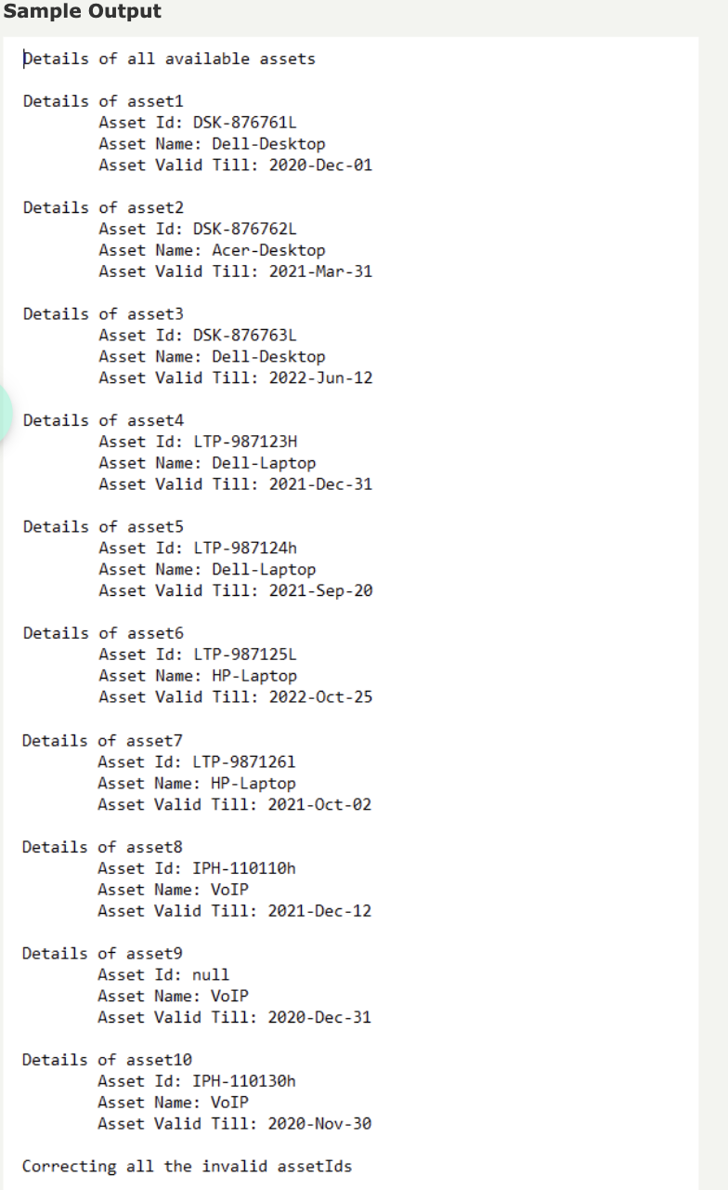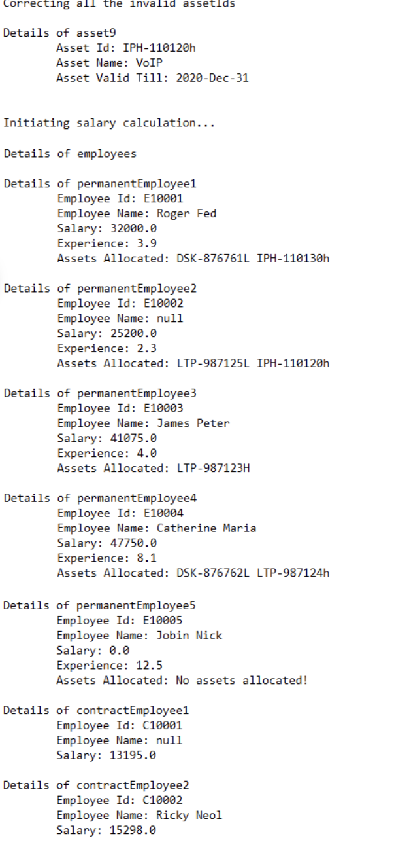

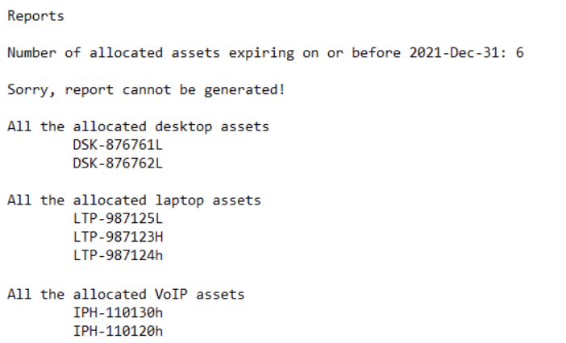

2)Problem Statement
Amazing Talent is a talent show that is introduced to launch talented citizens of the country. Based on their performance, they score marks that allow them to move to the next level. The Amazing Talent team has been keeping track of participant details like name and average scores of all the levels. You need to implement few functionalities for the team.
Implement the functionalities based on the description given below.
Method Description
- generateListOfFinalists(Participant[] finalists)
  - Store the details of finalists in an ArrayList and return the ArrayList.
- getFinalistsByTalent(List<Participant> finalists, String talent)
  - Return the details of all the finalists for the given 'talent' in an ArrayList.
Test the functionalities using the main() method of the Tester class

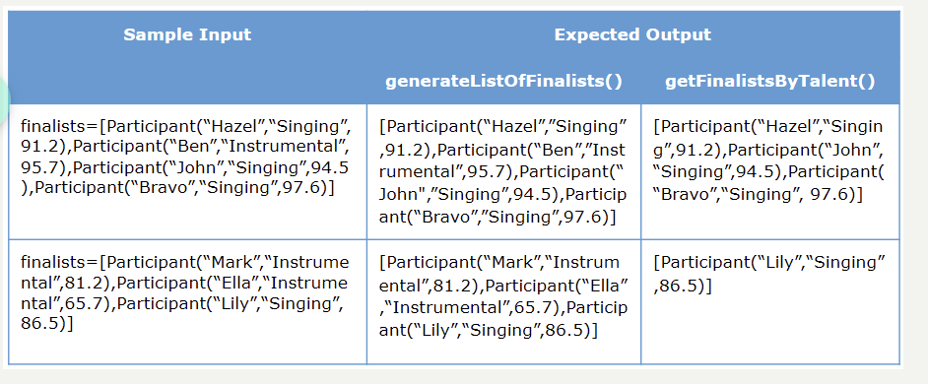

3)Problem Statement
A Sales company is conducting its month end reviews. The Sales department head decides to meet the employees based on the order of their sales. The person with maximum number of sales will have the meeting first followed by the person having second highest sales and so on. Implement the logic in sortSales() method to sort a HashMap containing the names of the employees and their corresponding sales and return a List<String> containing the names of the employees based on the decreasing order of their sales.
Test the functionalities using the main() method of the Tester class.

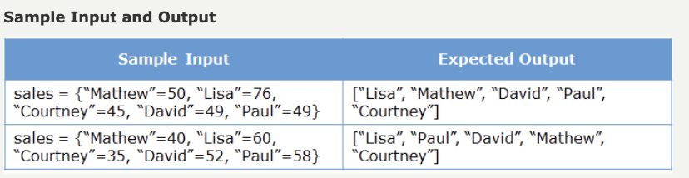

4)

Merge two hash maps in such a way that no data is lost. If the maps contain duplicate keys with different values, then while merging add the value of the duplicate key with a new key by concatenating "new" with the key. Implement the logic inside mergeMaps() method and return a HashMap containing the entries of both the HashMaps passed to the method.
Test the functionalities using the main() method of the Tester class.

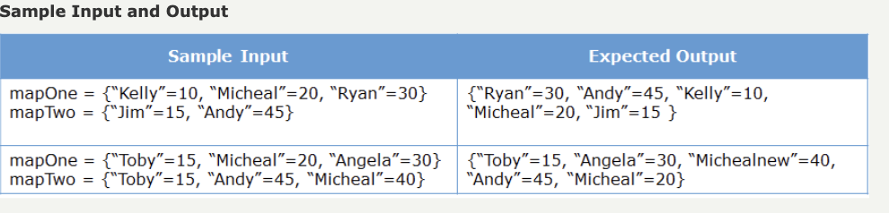

Problem Statement
Given a string, return a map containing the occurrences of the individual characters of the string. The map should be created in such a way that the keys are the individual characters and the values are the occurrences of each of the characters. Implement the logic inside findOccurrences() method.
Test the functionalities using the main() method of the Tester class.
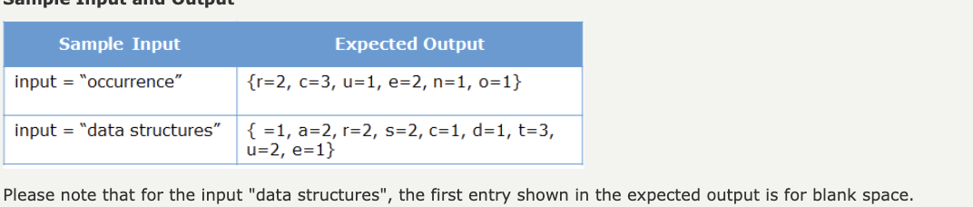

Problem Statement
Merge a given queue of integers and a queue of alphabets to form a single queue based on the below mentioned rules:
- Merge elements at the same position starting with the integer queue.
- If one of the queues has more elements than the other, add all the additional elements at the end of the output queue.
Implement the logic inside mergeQueue() method.
Test the functionalities using the main() method of the Tester class.
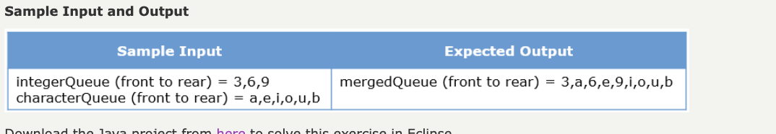

Problem Statement
Implement a program to update a given input stack such that all occurrences of the smallest value are at the bottom of the stack while the order of the other elements remain the same. Implement the logic inside changeSmallest() method.
Test the functionalities using the main() method of the Tester class.
