COMMUNICATION TRADEOFFS IN DECENTRALIZED LEARNING OVER LOSSY LINKS
Aditya Kumar Sahu, Rishav Kumar Manjhi, D. Yaswanth Reddy
Department of Computer Science and Engineering, Vellore Institute of Technology (VIT), Vellore,
632014, Tamil Nadu, India
Corresponding author: aditya.kumarsahu2024@vitstudent.ac.in

Abstract
Decentralized learning exchanges model parameters between neighboring clients without a central aggregation server. We evaluate when communication improves learning and what it costs under channel impairments. A PyTorch simulator compares local-only, standard gossip, and event-triggered learning using IID, exactly two-class, and Dirichlet label partitions. The core MNIST experiments use five independent seeds, ten gossip rounds, one local epoch per round, and a 206,922-parameter CNN. IID local-only accuracy is 98.03 ± 0.08%, while two-class local-only accuracy is 19.953 ± 0.003%; Ring gossip reaches 49.27 ± 3.13% on the same two-class setting. These controlled comparisons explain why high IID MNIST accuracy alone is insufficient evidence of channel robustness. Further experiments evaluate delay, independent and burst erasures, network size, and CIFAR-10. Traffic reduction is measured from actual directed messages and payload bytes. Spectral analysis verifies fixed-matrix averaging separately from local SGD. The conclusions characterize the tested configurations, rather than a universal topology ranking or a convergence theorem for impaired training.
Keywords: decentralized learning; gossip; non-IID data; event-triggered communication; packet loss; delay; spectral gap; reproducibility.

1 Introduction

1.1 Background
Federated learning enables clients to train on distributed datasets while exchanging model information instead of collecting all raw samples at a central location [1]. In a decentralized system, neighboring devices exchange updates directly. This architecture is relevant to edge and IoT deployments where a central aggregation service may be unavailable or costly to maintain. Keeping data local is a data-handling property; a formal privacy guarantee requires an additional mechanism.
Network structure determines which clients can exchange information, while unreliable delivery determines which of those exchanges actually influence a model. The resulting learning behavior must be evaluated together with the distribution of data and the amount of local computation. A high final test accuracy alone cannot isolate the contribution of communication.

1 Introduction continued

1.2 State of the Art
Decentralized SGD and decentralized federated averaging establish server-free training through local optimization and neighbor exchange [2], [3]. Consensus-based IoT learning and peer-to-peer graph learning further demonstrate that cooperation can be organized without a central model aggregator [4], [5]. These approaches motivate our implementation, while their update rules and convergence assumptions remain specific to each method.
Unreliable communication is already a substantial research topic. Soft-DSGD uses partially received information and reliability-aware mixing; D2D learning studies address unreliable wireless exchange; and Li et al. analyze aggregation bias and the number of local aggregations under imperfect channels [6], [7], [8]. Communication-efficient methods also include compression, sparse exchange, and adaptive communication rather than only whole-message suppression [9], [10].

1.3 The Research Gap
The practical question addressed here is how much a specified gossip implementation gains over matched local-only training when data heterogeneity, communication suppression, and channel impairments are varied within a common evaluation protocol. We investigate how that gain relates to actual payload traffic and model disagreement, and where ideal spectral predictions cease to describe the complete learning procedure. Section 2.4 develops this evaluation gap from the selected literature.

1.4 Objectives
1. Measure the accuracy gain of communication using matched local-only controls on IID and non-IID data.
2. Evaluate independent erasures, burst losses, and finite-round delayed delivery with explicit message accounting.
3. Quantify the accuracy-traffic tradeoff of fixed event thresholds using directed-message and payload-byte counts.
4. Compare Ring, Grid, and Random graph instances, and test whether small-network conclusions persist as client count grows.
5. Verify ideal spectral averaging calculations separately from empirical neural-network training.

1.5 Contributions
M1 provides a reproducible local-SGD and neighbor-averaging simulator with version-aware delayed delivery and measured aggregation-induced mean drift. M2 adds sender-side event triggering while sharing the M1 receiver path. M3 provides signed spectra, SLEM, and a squared-disagreement bound for ideal fixed averaging. The empirical contribution is a 155-run, five-seed evaluation with local-only controls, heterogeneous data, channel comparisons, larger networks, and a restricted CIFAR-10 extension. The study characterizes this implementation rather than introducing a new convergence theorem.

2 Literature Review

2.1 Decentralized Federated Learning and Gossip Based Optimization
Distributed averaging provides the mathematical basis for exchanging information over a graph. Xiao and Boyd study linear iterations for computing network averages, while Boyd et al. analyze randomized gossip and its relationship to matrix spectra [11], [12]. These foundations concern specified averaging operators. Applying them to a learning system requires attention to the local optimization steps and the communication mechanism used between those steps.
Lian et al. analyze decentralized parallel SGD, and Sun et al. study decentralized federated averaging with momentum and a quantized variant [2], [3]. Both connect local computation to neighbor communication, but an implementation using retained local optimizer momentum and receiver-wise normalization should not automatically inherit their theoretical guarantees. Our experimental protocol therefore records its exact update policy and assesses learning empirically.
Hegedűs et al. compare gossip learning with federated learning, including communication cost and differing data distributions. Savazzi et al. develop consensus-based cooperation for IoT devices, while Lalitha et al. propose graph-based peer-to-peer learning with a Bayesian-like belief update [13], [4], [5]. These studies establish several ways of organizing collaboration; their algorithms are not interchangeable implementations of one common averaging rule.
Gao et al. discuss the connection between decentralized optimization and federated learning, and Liu et al. examine how multiple local updates and communication steps balance computing cost and model consensus [14], [15]. This motivates specifying training and communication budgets separately. Our core comparison fixes ten rounds and one local epoch, and a separate IID control repeats the original twenty-round, two-local-epoch budget.

Implication for this study
A credible comparison needs a no-communication control, a precise local-update policy, and a clear definition of the quantity being mixed. We consequently compare individual client models under matched partitions and starting weights, retain optimizer momentum locally, and distinguish prediction accuracy from parameter agreement.

2.2 Communication Efficiency and Learning over Imperfect Channels
Communication can be reduced by sending smaller updates, selecting different peers, or suppressing an entire transmission opportunity. Koloskova et al. analyze compressed decentralized optimization. GossipFL combines model sparsification with adaptive communication and peer selection [9], [10]. Our M2 trigger instead suppresses a complete float32 model broadcast. Compression distortion and message erasure are distinct mechanisms, so results from one mechanism are not treated as direct evidence for the other.
Wireless learning additionally depends on how updates are transmitted. Xing et al. analyze digital and analog decentralized learning over D2D networks, including channel effects under stated assumptions. Chen et al. review distributed learning in wireless networks more broadly [16], [17]. The present simulator operates at the application-message level: it tests erasures and stale arrivals, and does not implement an analog waveform or a complete physical-layer channel.
The closest unreliable-link studies are Ye et al., Jiang et al., and Li et al. [6], [7], [8]. Ye et al. optimize mixing using link reliability information, while Li et al. relate imperfect aggregation to model bias and aggregation frequency. Our receiver-normalized baseline does not reproduce those algorithms. It provides a controlled reference whose average drift and finite-budget behavior can be measured explicitly.
Centralized and cellular FL studies provide complementary perspectives. Yang et al. study scheduling policies, Salehi and Hossain consider unreliable resource-constrained cellular networks, and Li et al. consider fairness with unreliable IoT links [18], [19], [20]. These topics motivate reporting actual communication and client-level performance, although centralized scheduling and fairness optimization are outside our implemented protocol.
Over-the-air and noisy-channel studies also require separate assumptions. Xu et al. examine learning-rate optimization for over-the-air computation; Amiri et al. analyze a noisy downlink; and Wei and Shen study learning over noisy channels [21], [22], [23]. Their continuous-valued channel errors are not equivalent to independently erasing complete model messages. We use them to delimit the wireless setting rather than to claim that our erasure model validates their analyses.

2.3 Network Topology Consensus and Convergence
Nedić et al. explain how graph structure and communication assumptions affect decentralized optimization [24]. The ideal mixing matrix is therefore a useful design descriptor, but its spectral gap is not a universal predictor of final neural-network accuracy. Local gradients, heterogeneous data, directed missing messages, and stale parameters can change the relation between an ideal graph property and observed model disagreement.
The surveys by Martínez Beltrán et al. and Yuan et al. organize DFL through architectures, communication mechanisms, topologies, system designs, and open challenges [25], [26]. Chung et al. specifically review non-IID DFL, covering architecture, topology, optimization, security, and evaluation practices [27]. Together these sources motivate an evaluation that states its data distribution and system assumptions instead of treating IID accuracy as a complete assessment.
Related studies also define important boundaries. Chen et al. develop a differentially private wireless DFL scheme; Imteaj et al. survey resource-constrained IoT learning; Nguyen et al. study self-organizing distributed learning; and Chen et al. investigate mobility-aware vehicular DFL [28], [29], [30], [31]. Our static-graph simulator does not implement privacy protection, autonomous network organization, or vehicle mobility. Those are extensions rather than capabilities inferred from keeping samples local.
Research strand | Representative references | Role in the present study
Optimization and averaging | [11], [12], [2], [24], [3] | Defines ideal mixing and local-update foundations; assumptions are stated explicitly.
Unreliable decentralized exchange | [16], [6], [7], [8] | Motivates loss, stale-arrival, and average-drift measurements.
Communication efficiency | [9], [10], [15] | Distinguishes whole-message suppression from compression and adaptive peer selection.
Heterogeneity and system evaluation | [25], [26], [27] | Motivates explicit non-IID settings and consistent evaluation metrics.
Privacy resources and mobility | [28], [20], [29], [30], [31] | Identifies capabilities that remain outside the implemented simulator.

Table 1. Literature synthesis. The table classifies the selected studies by their main relevance; it is not a claim that each paper studies only one issue.

2.4 Research Gap and Positioning of the Present Study
The selected literature already establishes decentralized optimization, wireless D2D learning, communication-efficient gossip, and learning over imperfect channels. Our research gap is therefore framed as a controlled evaluation question: for the specified receiver-normalized gossip procedure, how do the value and cost of communication change when data heterogeneity, graph structure, and message delivery are varied under matched training conditions?
First, a high accuracy on an easy IID task does not identify how much collaboration contributes. We address this measurement gap with paired local-only controls, exactly two-label client partitions, and Dirichlet α=0.1 partitions. Second, an implemented delay buffer does not establish tolerance to stale information. We evaluate finite delays and burst losses while distinguishing arrived, dropped, and pending messages. Third, suppressing a client broadcast is not the same as saving one neighbor message on an irregular graph. We therefore account for actual directed attempts and payload bytes.
A fourth question concerns the interpretation of topology. Ideal averaging theory characterizes a fixed operator, whereas learning repeatedly adds local updates. We test the ideal scalar bound separately and compare trained models at several client counts, without asserting that a larger ideal spectral gap guarantees better accuracy. This links a well-defined mathematical check to an empirical learning evaluation without treating the two as the same result.
Evaluation question | Literature basis | Evidence provided here
When does communication improve learning? | Peer-to-peer learning, decentralized averaging, and non-IID DFL [5], [3], [27] | Matched local-only controls; IID, two-class, and Dirichlet comparisons; paired five-seed gains.
How do losses and stale arrivals change outcomes? | Unreliable-link DFL and imperfect aggregation [6], [7], [8] | Bernoulli and Gilbert-Elliott erasures; maximum delay 0, 1, 2, 4; arrival accounting and mean drift.
What does an event trigger actually save? | Compressed, sparse, adaptive, and budget-aware communication [9], [10], [15] | Fixed-threshold accuracy-traffic curves; broadcasts, directed messages, and bytes counted separately.
Which spectral conclusions transfer to training? | Distributed averaging and topology-dependent optimization [11], [12], [24] | Signed spectra and ideal squared-error bounds; separate N=5/20/50 learning comparisons.

Table 2. Research questions derived from the literature and the corresponding experimental evidence. These are questions evaluated by this project, not assertions that all earlier work omitted them.
The contribution is the combined reproducible measurement protocol and its evidence for this implementation. Comparisons cover 31 conditions with five seeds each. The CIFAR-10 extension is limited to local-only versus Ring learning, and the scale study compares Ring and Grid with fixed total data. We do not benchmark against reimplementations of Soft-DSGD, GossipFL, or every method in the bibliography; the results consequently do not establish superiority over those algorithms.

3 Methodology

3.1 Problem Formulation
Client i holds a disjoint dataset Dᵢ with local mean cross-entropy loss Fᵢ. The intended objective weights clients uniformly. With unequal Dirichlet partition sizes, this differs from a sample-weighted pooled-data objective. Within each seed, all compared methods use identical partitions, reference weights, local hyperparameters, and per-client minibatch orders.
$min F(w) = N⁻¹ Σᵢ Fᵢ(w)$ (1)
Core experiments use one local SGD epoch per round; the separate original-budget control uses two. Learning rate is 0.01 and momentum is 0.9. Only model parameters are mixed; optimizer momentum remains local. This policy is shared by all methods. The core budget is ten local epochs per client in total, while the original-budget control uses forty.

Network Topologies
Ring is a cycle on N nodes. Grid keeps the first N row-major nodes of a rectangular grid whose row count is the nearest integer to √N, with enough columns to contain N nodes. Random uses connected Erdős-Rényi G(N,0.5) samples. Graphs are static and undirected; every raw run records its actual edges. Experimental seeds vary the Random realization, while the illustrative five-node spectral table uses seed 42.
$Wᵢⱼ = 1 / [1 + max(deg(i), deg(j))], (i,j) ∈ E$ (2)
$Wᵢᵢ = 1 − Σⱼ≠ᵢ Wᵢⱼ$ (3)
For an undirected graph, the original Metropolis-Hastings matrix is symmetric and doubly stochastic. Let Rᵢ(t) contain the neighbors whose newest acceptable messages arrive during round t. The receiver combines its own post-training model with those arrivals:
$wᵢ⁺ = [Wᵢᵢ wᵢ + Σⱼ∈Rᵢ(t) Wᵢⱼ wⱼ(received)] / [Wᵢᵢ + Σⱼ∈Rᵢ(t) Wᵢⱼ]$ (4)
With no acceptable arrival, the client retains its local model. Independently missing directed messages preserve row normalization but generally break column normalization. The arithmetic network mean can drift during aggregation. Consequently this policy is not described as unbiased global averaging under loss.
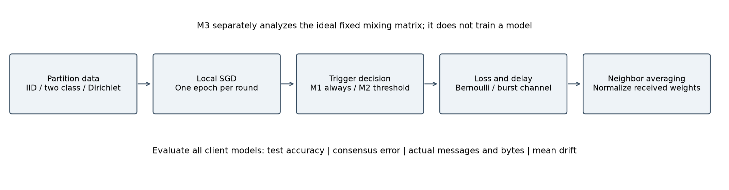
Figure 1. Common training workflow. M3 analyzes the ideal graph separately from neural-network learning.

3.1 Problem Formulation continued

Channel Model

Loss and burst model
The independent-loss channel erases each directed message with probability 0.2 in impaired comparisons. Randomness is keyed by seed, sender, receiver, round, and stream. Suppressing an unrelated transmission therefore cannot shift the channel outcome associated with a given link and round.
The Gilbert-Elliott model has good-to-bad transition probability 0.05 and bad-to-good probability 0.20 per round. Good-state erasure probability is zero; bad-state erasure probability is one. Stationary erasure probability is 0.05/(0.05+0.20)=0.20, matching the nominal independent-loss rate. Mean bad-state duration is five rounds. Each link starts in stationarity and evolves through silent rounds. Short-run realized losses remain variable and are retained in the raw counts.

Delay and receiver freshness
A surviving message receives an independent uniform integer delay between zero and dₘₐₓ inclusive. Maximum delays 1, 2, and 4 are compared with zero delay under 20% Bernoulli loss. Source-round metadata ensures that the newest arrival from a sender is selected, and an older version cannot replace one already accepted. Delivered messages discarded as stale still consume communication.
Packets scheduled after the final round remain pending. Attempted, dropped, arrived, and pending messages are separate counts. Delivered bytes refer to arrivals within the observation horizon, not future scheduled deliveries. No post-training buffer drain changes the final models.

M2 Event Triggered Gossip
$sendᵢ(t) ⇔ δ = 0 or ||wᵢ(t) − wᵢ(last sent)||₂ > δ$ (5)
A triggered client sends to every neighbor and updates its last-sent snapshot even if the channel later erases the update. Silent clients can still receive and average. Threshold zero explicitly means always transmit. Revised thresholds 0.5 and 2.0 are fixed comparison settings, not thresholds selected by optimizing test accuracy.
$message savings (\%) = 100 [1 − actual attempts / (2 |E| T)]$ (6)
Broadcast suppression uses N T opportunities. Message savings weight a silent client by its degree. The percentages coincide on a regular Ring but can differ on Grid or Random graphs. Payload bytes equal attempted messages times the float32 model size; network-protocol overhead is excluded.

3.2 Data and Materials

Datasets and Client Partitions
MNIST contains 60,000 training and 10,000 test images of handwritten digits. Grayscale 28×28 inputs are divided by 255 and normalized using mean 0.1307 and standard deviation 0.3081. IID allocation shuffles and divides indices. The two-class partition gives each client exactly two labels and splits each label among its assigned clients. Dirichlet allocation uses class-wise α=0.1 proportions and rejects a split with fewer than 100 samples at any client. Every split covers the full training set exactly once. Client sizes, class histograms, and partition hashes are saved.

CNN Architecture
Layer | MNIST configuration | Output
Convolution, ReLU, max pool | 1→16; 3×3; padding 1; pool 2 | 16×14×14
Convolution, ReLU, max pool | 16→32; 3×3; padding 1; pool 2 | 32×7×7
Flatten and FC, ReLU | 1568→128 | 128
Output logits | 128→10 | 10
Trainable parameters | 206,922 | 827,688 bytes/message

Table 3. Corrected MNIST CNN architecture and float32 communication payload.

CIFAR 10 Materials
CIFAR-10 adds 50,000 training and 10,000 test RGB images of size 32×32. The corresponding CNN uses three input channels and a 2048→128 first fully connected layer, giving 268,650 parameters. The extension applies the same Dirichlet α=0.1 allocation and compares local-only with Ring gossip. MNIST and CIFAR-10 are public benchmark datasets [32], [33].

Implementation Materials
The simulator uses Python and PyTorch for local learning, NumPy and NetworkX for numerical and graph operations, SciPy for Student-t intervals, and Matplotlib for figures. Data and model tensors are held on the training device to avoid repeated per-image preprocessing. Models are saved in a format that can be loaded onto a CPU for review.

3.3 Proposed Approach
Figure 1 summarizes the workflow. Local-only training is the control, M1 exchanges after each round of local training, and M2 adds a sender decision before the same receiver update. M3 runs separately on the ideal graph matrix. Every comparison uses the same partition and initialization within a seed.

M1 Standard Gossip Federated Learning
Every client trains locally, snapshots its parameters, sends the snapshot to each neighbor, and applies Equation (4) to the newest acceptable arrivals. All models are snapshotted before any receiver is updated, preventing an in-place update order from changing the meaning of a synchronous communication round. The no-communication control performs the same local training and evaluation while making no channel calls.

M2 Event Triggered Gossip
Each sender compares its post-training model with its last-transmitted snapshot using Equation (5). A triggered client attempts one directed model message per neighbor; a silent client may still receive messages. Threshold zero always sends. Standard and event-triggered methods share the receiver implementation, and reproducibility is checked by exact parameter hashes at zero threshold.

M3 Spectral Gap Analysis
The graph matrix is analyzed for signed eigenvalues, SLEM, spectral gap, and a sufficient ideal averaging time. A scalar simulation checks the squared-disagreement bound under the same fixed matrix [11], [12]. Neural-network training is evaluated empirically, with local SGD, missing messages, and stale arrivals outside that fixed-matrix proof.

Sequence of Operation
1. Initialize the seed, benchmark tensors, disjoint client partitions, graph, common model weights, and channel parameters.
2. Run the specified local SGD epochs independently at every client, preserving local optimizer state.
3. For M2, apply the change threshold; for M1, enable all sender broadcasts.
4. Sample directed-link erasures and surviving-message delays; release arrivals due in the current round.
5. Reject outdated versions and normalize the available neighbor weights before updating each receiver.
6. Evaluate individual client models and record mean accuracy, loss, disagreement, aggregation drift, and traffic.
7. Repeat for the specified budget, save the completed run, aggregate independent seeds, and analyze the ideal graph separately.

3.4 Experimental Setup
Setting | Revised value
Independent seeds | 42, 43, 44, 45, 46
Rounds / local epochs | 10 / 1
Batch / learning rate / momentum | 128 / 0.01 / 0.9
Core size and partitions | 5 clients; IID, two-class, Dirichlet α=0.1
Scale comparison | 20 and 50 clients; two-class; Ring and Grid
Loss comparison | 20% Bernoulli; 20% stationary Gilbert-Elliott
Delay comparison | Maximum delay 0, 1, 2, 4 rounds
Event comparison | Dirichlet; Ring and Grid; δ=0, 0.5, 2.0

Table 4. Revised experimental protocol. The core budget is ten rounds with one local epoch. A separate matched IID control uses twenty rounds and two local epochs.
All client models are evaluated on the full shared test set. Reported accuracy is their arithmetic mean, not an ensemble or centrally averaged predictor. Training uses the detected RTX 5070 Ti Laptop GPU and CUDA-enabled PyTorch with automatic mixed precision for computation. Exchanged parameters remain float32. Deterministic algorithms are enabled, and each run records software versions, device, graph edges, and complete configuration.

Experiment Families and Evaluation Scope
Experiment family | Conditions | Seeds each | Runs
Core MNIST: three partitions × local/Ring/Grid/Random | 12 | 5 | 60
Event thresholds: two topologies × two nonzero thresholds | 4 | 5 | 20
Independent/burst erasures and finite delays | 7 | 5 | 35
Scale: two client counts × Ring/Grid | 4 | 5 | 20
Original-budget IID: local-only/Ring | 2 | 5 | 10
CIFAR-10 Dirichlet: local-only/Ring | 2 | 5 | 10
Total reported experiments | 31 | 5 | 155

Table 5. Completed experimental design. Five additional ten-round GPU runs check M1/M2 zero-threshold equivalence and are not counted as independent comparison conditions.
The comparisons are controlled experiment families rather than a full cross-product of every setting. Delay and burst-loss learning use five-client Ring with Dirichlet MNIST; independent zero-delay loss additionally compares Grid and Random. Scale uses two-class MNIST on Ring and Grid. The original-budget IID control uses twenty rounds, two local epochs, and batch size 64. CIFAR-10 evaluates the restricted comparison described above.

3.5 Evaluation and Reproducibility
$E(t) = N⁻¹ Σᵢ ||wᵢ(t) − w̄(t)||₂²$ (7)
Consensus error measures squared parameter disagreement. It is not a substitute for test accuracy: neural-network symmetries and repeated local updates can change the relationship. Aggregation-only mean drift is the norm of the change in the network mean immediately across averaging, excluding the preceding local training step.
Every reported condition uses five independent seed-level results. The 95% interval is mean ± t₀.₉₇₅,ₙ₋₁ s/√n. It summarizes variation from initialization, data allocation, minibatches, graph sampling where applicable, and channel realization. It does not measure generalization across entirely different datasets or algorithm families. Five seeds provide limited precision; overlapping intervals are not used as a significance test.
Gossip-minus-local accuracy gains are also computed within each matched seed and then summarized with a Student-t interval. This paired estimate is preferable to subtracting independently aggregated interval endpoints. Conditions with different client counts are not pooled, and thresholds are not chosen retrospectively from the test results.

Validation checks
Full-budget GPU validation repeats ten-round Dirichlet training across all five seeds. Standard gossip and zero-threshold M2 match exact initial and final client-model hashes and per-round mean accuracy in the zero-loss Ring setting. Regression tests compare both training entry points on synthetic data under loss and delay. Additional checks cover pending arrival counts, randomness under suppressed sends, stale-version rejection, unequal-degree message savings, signed eigenvalues, parameter count, the squared-error averaging bound, partition coverage, and average drift under one-way reception.

Reproducible Artifacts and Data Availability
Revised raw runs are in results/review/runs. Aggregate statistics, plots, a validation record, and a legacy accounting audit accompany them. Filenames identify the condition, seed, and training budget. Completed results are saved atomically; the runner skips completed files when restarted. Partially trained runs restart from their initial state. Original reports and original result JSON files remain unchanged.
The portable CPU demonstration includes a trained MNIST model and twenty bundled test digits. It requires no retraining or dataset download. A separate standard-library command prints the saved experiment summary. Dependency specifications and handover commands allow review on a laptop without the training GPU. Source code, raw results, aggregate statistics, a dependency specification, and a portable checkpoint accompany the report.

4 Results

4.1 M1 Accuracy and Packet Loss Tolerance
Partition | Method | Accuracy % ± CI | Consensus error ± CI | Seeds
iid | Local only | 98.03 ± 0.08 | 3.63 ± 0.20 | 5
iid | Ring | 98.58 ± 0.08 | 0.047 ± 0.002 | 5
iid | Grid | 98.55 ± 0.08 | 0.13 ± 0.01 | 5
iid | Random | 98.56 ± 0.06 | 0.09 ± 0.15 | 5
two-class | Local only | 19.953 ± 0.003 | 6.83 ± 1.18 | 5
two-class | Ring | 49.27 ± 3.13 | 0.10 ± 0.03 | 5
two-class | Grid | 39.22 ± 6.62 | 0.38 ± 0.07 | 5
two-class | Random | 53.03 ± 16.90 | 0.20 ± 0.25 | 5
dirichlet | Local only | 53.03 ± 4.55 | 8.18 ± 0.38 | 5
dirichlet | Ring | 89.83 ± 1.05 | 0.08 ± 0.01 | 5
dirichlet | Grid | 85.11 ± 4.40 | 0.24 ± 0.14 | 5
dirichlet | Random | 88.25 ± 9.45 | 0.19 ± 0.37 | 5

Table 6. MNIST results at N=5, ten rounds, one local epoch, and no loss or delay. Intervals are 95% across five seeds.
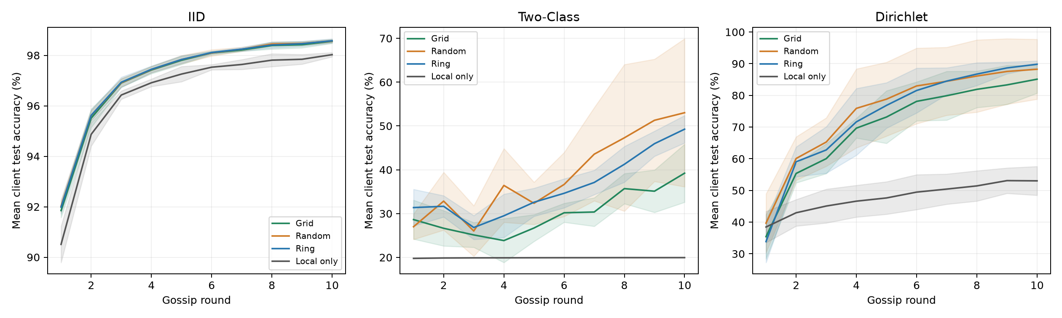
Figure 2. Mean client accuracy versus round, with 95% confidence bands. Conditions share data and initialization within each seed.
IID clients already see all classes, whereas two-class clients cannot learn the entire label space from their own samples alone. The appropriate evidence is the matched communication benefit under each partition. Learning curves reveal intermediate behavior that a final saturated accuracy value can obscure. These results do not establish robustness to impairments that are absent from this table.

4 Results continued

4.1.1 Paired Gains over Local Only
Partition | Topology | Accuracy gain over local only in points | Pairs
iid | Ring | 0.55 ± 0.03 | 5
iid | Grid | 0.53 ± 0.03 | 5
iid | Random | 0.54 ± 0.10 | 5
two-class | Ring | 29.31 ± 3.13 | 5
two-class | Grid | 19.27 ± 6.63 | 5
two-class | Random | 33.07 ± 16.89 | 5
dirichlet | Ring | 36.80 ± 4.63 | 5
dirichlet | Grid | 32.08 ± 4.25 | 5
dirichlet | Random | 35.22 ± 10.08 | 5

Table 7. Within-seed accuracy differences. Each condition has five matched pairs.

4.2 M2 Event Triggered Communication
Topology | δ | Accuracy % ± CI | Message savings % ± CI | Broadcast suppression % ± CI
Ring | 0.0 | 89.83 ± 1.05 | 0.00 ± 0.00 | 0.00 ± 0.00
Ring | 0.5 | 76.26 ± 5.94 | 25.20 ± 6.71 | 25.20 ± 6.71
Ring | 2.0 | 62.37 ± 3.51 | 79.60 ± 4.44 | 79.60 ± 4.44
Grid | 0.0 | 85.11 ± 4.40 | 0.00 ± 0.00 | 0.00 ± 0.00
Grid | 0.5 | 78.56 ± 6.86 | 25.00 ± 13.26 | 27.20 ± 11.46
Grid | 2.0 | 60.12 ± 4.37 | 82.20 ± 2.39 | 82.00 ± 1.76

Table 8. Event-triggered Dirichlet MNIST. Actual message savings measure payload reduction; broadcast suppression uses a different denominator.
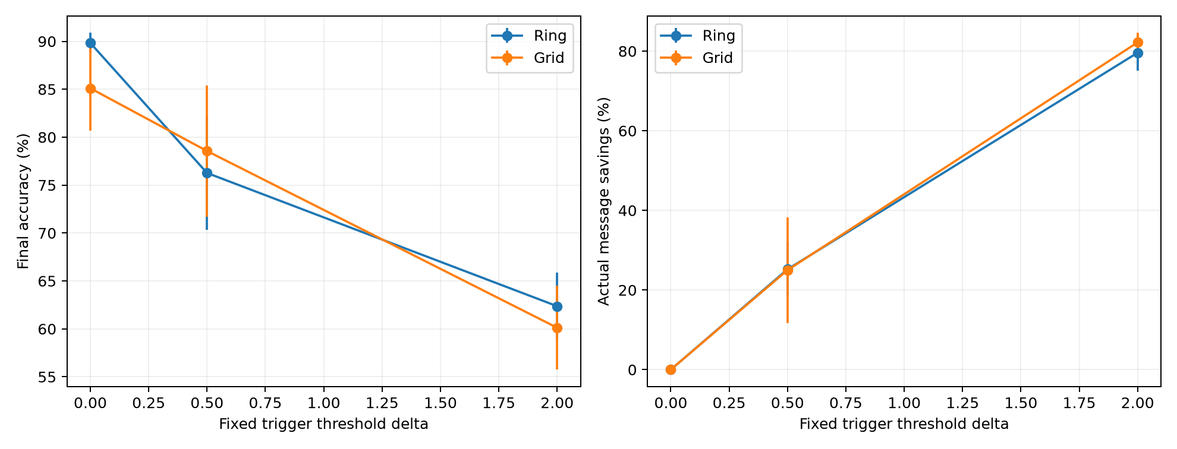
Figure 3. Accuracy and actual message savings versus fixed threshold, with 95% seed intervals.
At δ=2.0, Ring mean message savings are 79.6%, while mean accuracy changes from 89.83% to 62.37%. These are the observed means for the fixed threshold, not a claim of accuracy-preserving compression.
A silent broadcast can delay the spread of class information. Traffic savings therefore do not imply negligible accuracy loss. An absolute parameter-distance threshold is specific to the model, partition, and training budget; it should not be treated as transferable to another architecture without evaluation.

4.3 Packet Loss Delay and Burst Erasures
Topology | Channel | Max delay | Accuracy % ± CI | Consensus error ± CI | Mean drift
Grid | bernoulli | 0 | 82.10 ± 4.48 | 0.34 ± 0.17 | 0.0975
Random | bernoulli | 0 | 85.94 ± 10.11 | 0.28 ± 0.47 | 0.0960
Ring | bernoulli | 0 | 86.39 ± 1.63 | 0.15 ± 0.04 | 0.1338
Ring | gilbert-elliott | 0 | 85.46 ± 4.20 | 0.26 ± 0.20 | 0.1708
Ring | bernoulli | 1 | 78.34 ± 4.47 | 0.32 ± 0.14 | 0.2392
Ring | bernoulli | 2 | 71.35 ± 8.33 | 0.52 ± 0.20 | 0.2887
Ring | bernoulli | 4 | 69.22 ± 9.88 | 0.80 ± 0.45 | 0.3192

Table 9. Impaired-channel results on Dirichlet MNIST. The delay and burst comparisons use Ring; independent zero-delay loss also compares Grid and Random. Drift averages the aggregation-only norm across rounds and seeds. Bernoulli and burst channels match nominal long-run erasure probability, not realized losses.
The zero-delay Bernoulli runs erase 21.0% of attempted messages on average, compared with 22.6% for Gilbert-Elliott. Both models have nominal long-run loss 20%; the finite-run realizations need not coincide.
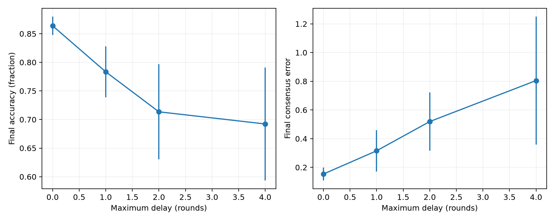
Figure 4. Delay sensitivity with independent erasure probability 0.2. Individual surviving messages can still have zero delay.
These runs exercise the delay model at fixed local-training and gossip-round budgets. An observed change can reflect missing arrivals, stale models, and altered mixing. The newest-version rule prevents an old packet from overwriting a newer accepted model. A favorable outcome at one delay is not evidence that arbitrary latency is harmless.
The burst model starts in stationarity, but ten rounds remain a short observation window relative to its five-round mean bad-state duration. Realized dropped and pending counts must be considered alongside accuracy. Neither this two-state model nor independent erasures constitute a full wireless physical-layer simulation.
Nonzero aggregation-only mean drift is consistent with receiver-wise renormalization under asymmetric reception. It distinguishes a measured limitation of the chosen method from an ideal doubly stochastic averaging property. Replacing this policy with an average-preserving algorithm would be a separate implementation and comparison, rather than a wording correction.

4.4 Scale and CIFAR 10 Extension
Clients | Topology | Accuracy % ± CI | Consensus error ± CI | Attempts
5 | Ring | 49.27 ± 3.13 | 0.10 ± 0.03 | 100
5 | Grid | 39.22 ± 6.62 | 0.38 ± 0.07 | 100
20 | Ring | 37.53 ± 4.80 | 0.51 ± 0.19 | 400
20 | Grid | 24.57 ± 1.20 | 0.61 ± 0.06 | 620
50 | Ring | 36.92 ± 3.11 | 0.43 ± 0.09 | 1000
50 | Grid | 55.17 ± 2.80 | 0.35 ± 0.07 | 1700

Table 10. Actual neural-network training at N=5, 20, and 50, using two-class MNIST. Total dataset size is fixed.
Ring mean accuracy is 49.27% at N=5 and 36.92% at N=50 under this fixed-round, fixed-total-data protocol. The corresponding uncertainty intervals and traffic counts appear in the scale comparison above.
This scale experiment trains client models; it is not merely a larger eigenvalue calculation. Each client sees two labels, but each label is distributed across more clients as N increases. Total data remain fixed, so per-client examples and minibatch counts decline. Within each N, Ring and Grid share partitions and training budgets. Fixed-density Random graphs are omitted from this training comparison because their growing communication cost would confound a sparse-graph comparison.
CIFAR-10 method | Accuracy % ± CI | Consensus error ± CI | Seeds
Local only | 28.29 ± 2.84 | 19.18 ± 1.52 | 5
Ring gossip | 38.36 ± 3.15 | 0.44 ± 0.04 | 5

Table 11. CIFAR-10 with five clients, Dirichlet α=0.1, and the same ten-round budget.
CIFAR-10 contains 50,000 training and 10,000 test RGB images, each 32×32. Channel means are (0.4914, 0.4822, 0.4465), and standard deviations are (0.2470, 0.2435, 0.2616). The two-convolution model has three input channels and a 2048→128 first fully connected layer, totaling 268,650 parameters. This extension compares local-only and Ring gossip; it does not claim a complete CIFAR-10 topology or channel sweep. No augmentation or architecture search is performed.
Under this protocol, Ring mean accuracy exceeds local-only by 10.06 percentage points. The table reports seed uncertainty for both means; the paired seed-level difference is also retained in the accompanying summary JSON.
The short-budget small-CNN result is a controlled comparison rather than a competitive CIFAR-10 benchmark. Absolute accuracy and any paired gain must be interpreted within this restricted protocol. Test outcomes are reported without retrospectively changing the budget to obtain a preferred conclusion.

4.5 M3 Spectral Gap and Convergence Analysis

Spectral Gap
The ideal spectral gap γ=1−ρ uses the second-largest eigenvalue modulus ρ. The signed spectrum and the magnitude used for SLEM are retained separately.
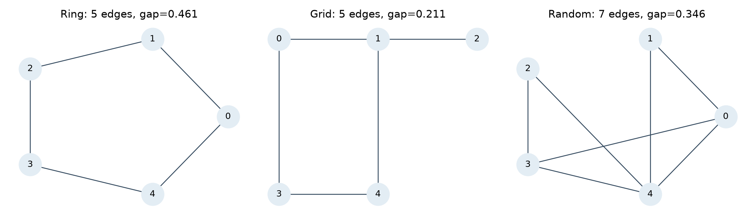
Figure 5. Actual five-node graphs at seed 42. The trimmed Grid has degree sequence 2, 3, 1, 2, 2, including a pendant node.
Topology | Edges | Gap γ | SLEM ρ | T(.01) | T(.001)
Ring | 5 | 0.460655 | 0.539345 | 4 | 6
Grid | 5 | 0.211325 | 0.788675 | 10 | 15
Random | 7 | 0.346447 | 0.653553 | 6 | 9

Table 12. Ideal five-node spectra. T is a sufficient integer number of rounds for a relative squared-disagreement target.

Eigenvalue Spectra
Topology | λ₁ | λ₂ | λ₃ | λ₄ | λ₅
Ring | 1.000000 | 0.539345 | 0.539345 | -0.206011 | -0.206011
Grid | 1.000000 | 0.788675 | 0.416667 | -0.250000 | 0.211325
Random | 1.000000 | 0.653553 | 0.300000 | -0.053553 | 0.000000

Table 13. Signed eigenvalues sorted by descending magnitude. SLEM uses magnitude; the full spectrum preserves signs.

Convergence Bound
For fixed symmetric doubly stochastic W, let J=11ᵀ/N and ρ=||W−J||₂. Disagreement under pure averaging is (W−J)ᵗX(0). Applying the spectral-norm bound to squared Frobenius disagreement gives [11], [12]:
$E(t) ≤ E(0) ρ²ᵗ, γ = 1 − ρ$ (8)

Mixing Time
$T(ε) = ceiling\{ log(1/ε) / [2 log(1/ρ)] \}$ (9)
Equation (9) targets E(t)/E(0)≤ε. An unsquared-norm target would remove the factor of two in the denominator. The table therefore states the relative squared-disagreement convention and reports sufficient integer round counts.

4.6 Spectral Validation and Comparison with M1
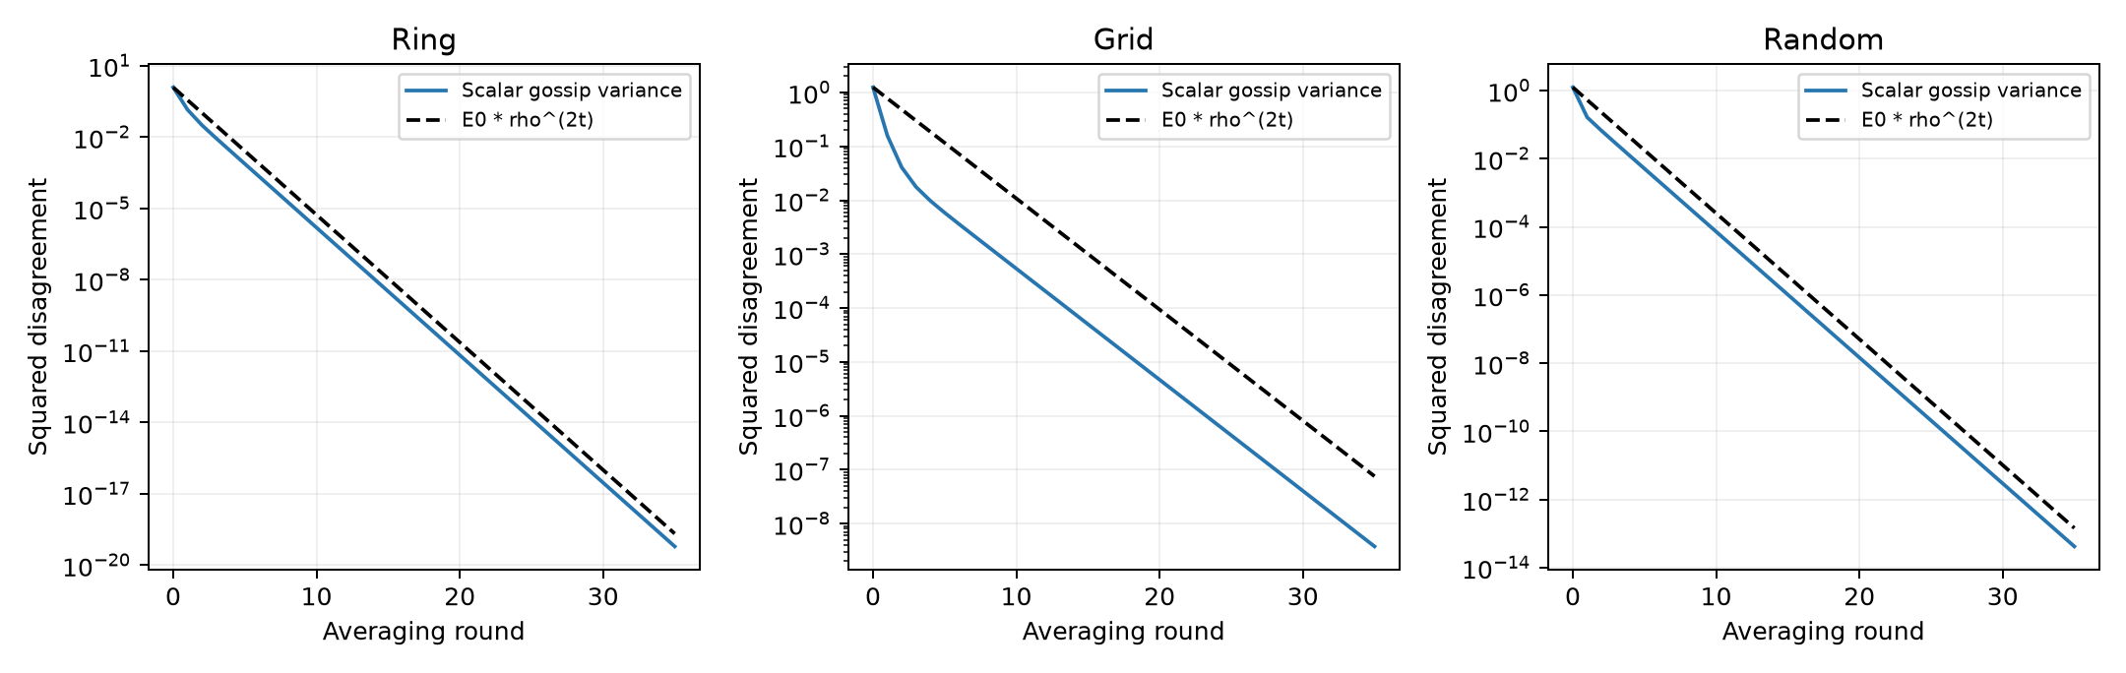
Figure 6. Scalar averaging variance and the squared-error bound on identical graph instances. This checks ideal averaging, not SGD convergence.
A scalar trajectory lies below the bound up to numerical effects. It need not equal the bound because the initial vector may have little projection onto the slowest eigenmode. Near floating-point precision, the apparent decay slope should not be interpreted as a physical convergence rate. The scalar trajectory is interpreted as a check of the stated upper bound rather than evidence of an exact rate match.

Cross Comparison with M1
Local SGD continually injects disagreement. Loss, event suppression, and stale arrivals also change the update operator with time. The fixed-matrix proof does not cover these effects. A larger ideal spectral gap consequently does not guarantee higher trained-model accuracy or smaller final learning disagreement.
The original saved results already contradict an unconditional ranking: under 20% loss, Random has consensus error about 0.161 and Ring about 0.301, although the ideal Ring gap is larger. The revised study treats these training outcomes as empirical comparisons rather than confirmations of an unconditional spectral prediction.
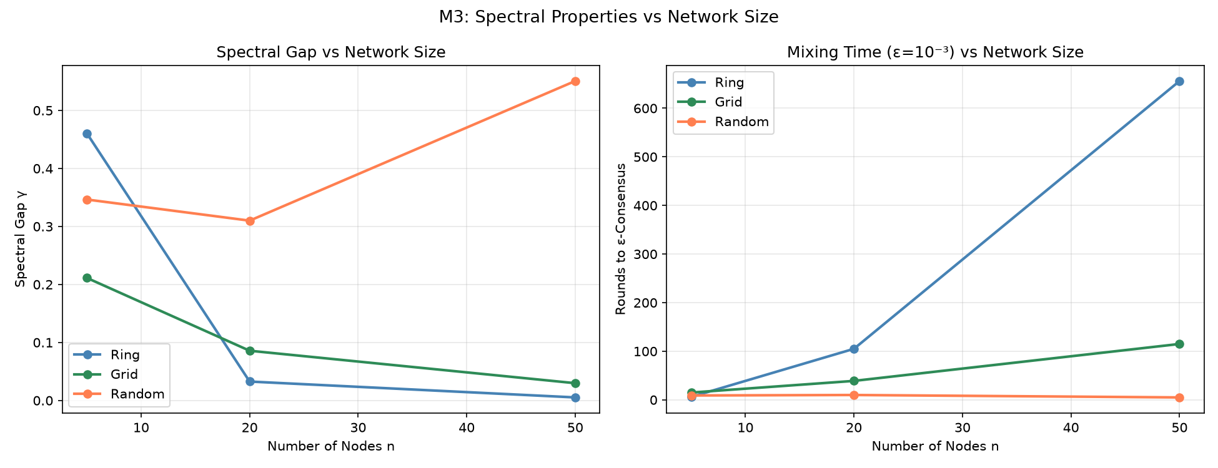
Figure 7. Ideal gap and squared-error mixing bound at N=5, 20, and 50. Fixed p=0.5 Random graphs become denser as N increases.

5 Discussion

5.1 Why Ring and Grid Performance Depends on Network Size
The five-node Ring is regular, while the trimmed five-node Grid includes a degree-one node. Their ideal gaps are approximately 0.461 and 0.211. This explains a difference in ideal mixing for those instances, not a general preference for Ring. The larger-network experiment also changes the amount of data held by each client because total data remain fixed.
On two-class MNIST, five-client mean accuracy is 49.27% for Ring and 39.22% for Grid. At fifty clients, the corresponding means are 36.92% and 55.17%. The observed ordering therefore depends on network size and the complete training protocol; within each size, the methods use matched data allocations.

5.2 Robustness to Packet Loss and Relation to Theory
Under Dirichlet MNIST, Ring mean accuracy decreases from 89.83% without loss to 86.39% under 20% Bernoulli erasure, and to 69.22% when maximum delay is four rounds at that erasure rate. These means characterize the tested budget and receiver policy. Confidence intervals and realized traffic are reported with the comparisons. Similar performance under one channel condition cannot establish arbitrary loss or delay tolerance.
Receiver-wise renormalization preserves row sums but can move the arithmetic network mean when receptions are asymmetric. Our measured aggregation-only drift exposes this property. Ideal spectral averaging predicts contraction for a fixed symmetric operator, whereas the learning system introduces gradients and time-dependent information. This distinction is consistent with the emphasis on communication assumptions and aggregation effects in the related literature [24], [6], [8].

5.3 Event Triggered Communication Analysis
At δ=2.0, Ring saves 79.6% of directed messages, but mean accuracy falls from 89.83% to 62.37%. The practical result is an accuracy-traffic tradeoff. A threshold based on an absolute parameter norm is model- and budget-dependent. Compression and adaptive peer selection provide different design options [9], [10], which are not implemented by simply raising this threshold.
On an irregular graph, a silent high-degree client removes more directed messages than a silent low-degree client. Broadcast suppression is consequently reported separately from traffic savings. For example, the original Grid counts contain eight suppressed broadcasts out of 100 opportunities, but 188 rather than 200 attempted neighbor messages: 8% broadcast suppression corresponds to 6% payload traffic reduction in that run.

5 Discussion continued

5.4 Limitations
Five seeds provide an initial uncertainty estimate. Reusing a benchmark test set does not replace evaluation on new populations, and no validation-driven hyperparameter search is performed. The client objective is uniformly weighted, unlike a pooled sample-weighted objective for unequal data sizes. Local momentum is retained after mixing. The core horizon is short, and larger-network comparisons fix total data rather than per-client examples.
The channel erases whole model messages and omits physical packetization, retries, measured bandwidth, energy, and real wall-clock latency. Integer-round delay is not a fully asynchronous execution model. Static, honest clients are assumed. Differential privacy, secure aggregation, Byzantine protection, dynamic vehicular topology, and average-preserving lossy aggregation remain outside the implementation [28], [30], [31]. The CIFAR-10 extension compares only local-only and Ring learning, and no claim of superiority over the referenced algorithms follows from these experiments.

5.5 Communication Benefit under the Original Training Budget
At twenty rounds, two local epochs, and batch size 64, local-only mean accuracy is 98.52 ± 0.07%, compared with 99.17 ± 0.09% for Ring gossip. The paired five-seed gain is 0.65 ± 0.02 percentage points. Thus communication makes a measurable contribution even in this IID setting, while the gain is much smaller than in the heterogeneous short-budget comparisons. These are newly matched control runs, not the historical single-seed records.

5.6 Findings in Relation to the Research Gap
The local-only controls answer whether communication contributes under a specified budget; non-IID runs make the role of shared class information visible; channel experiments exercise stale and missing information; and event-trigger results connect actual traffic to accuracy. The ideal scalar check establishes a separate mathematical property. Together these results address the evaluation questions in Section 2.4 without implying an improved algorithmic guarantee for all wireless settings.
The reviewed surveys and systems papers also identify the next boundaries to study: stronger heterogeneity, changing topology, resource constraints, privacy mechanisms, and alternative aggregation policies [29], [25], [26], [27]. A broader benchmark should reimplement selected methods under matched budgets before drawing comparative algorithm rankings.

6 Conclusion
On two-class MNIST, Ring gossip changes mean client accuracy from 19.95% under local-only training to 49.27%. On IID MNIST, the local-only control already reaches 98.03%. The contrast makes data heterogeneity central to interpreting the value of communication.
This study evaluates established decentralized learning mechanisms using matched local-only controls, heterogeneous data, five-seed uncertainty, and corrected traffic accounting. It separates trained-model outcomes from the ideal properties of a fixed mixing matrix. Conclusions apply to the tested partitions, budgets, graph instances, and channel models; they do not establish universal packet-loss immunity or a universal Ring-over-Grid preference.
Event triggering is an empirical accuracy-traffic tradeoff measured with actual directed-message and payload-byte counts. Delay is evaluated using version-aware receivers and a finite horizon. Saved runs, scripts, and dependency specifications make the numerical tables reproducible, while a CPU checkpoint demonstration supports review on another laptop.

6.1 Future Work
Future evaluation should compare selected unreliable-link and communication-efficient algorithms under the same data, training, and byte budgets. Useful extensions include average-preserving aggregation under directed loss, time-varying graphs, validation-driven threshold selection, longer harder-task training, and client fairness. Privacy protection and vehicular mobility require dedicated mechanisms rather than an inference from server-free execution [28], [20], [31].

7 Declarations
Funding: No specific grant is declared for this project. Conflicts of interest: None declared by the project authors. Data availability: MNIST and CIFAR-10 are public benchmark datasets [32], [33]. Code and results: The accompanying project includes source, dependency specifications, raw results, statistics, figures, validation tests, and a portable demonstration checkpoint. The accompanying artifacts provide the evaluated implementation and supporting evidence.

8 References
[1] McMahan, B., Moore, E., Ramage, D., Hampson, S., Aguera y Arcas, B. (2017). Communication-Efficient Learning of Deep Networks from Decentralized Data. AISTATS, PMLR 54, 1273-1282. https://proceedings.mlr.press/v54/mcmahan17a.html
[2] Lian, X., Zhang, C., Zhang, H., Hsieh, C.-J., Zhang, W., Liu, J. (2017). Can Decentralized Algorithms Outperform Centralized Algorithms? A Case Study for Decentralized Parallel Stochastic Gradient Descent. Advances in Neural Information Processing Systems 30. https://arxiv.org/abs/1705.09056
[3] Sun, T., Li, D., Wang, B. (2023). Decentralized Federated Averaging. IEEE Transactions on Pattern Analysis and Machine Intelligence, 45(4), 4289-4301. https://doi.org/10.1109/tpami.2022.3196503
[4] Savazzi, S., Nicoli, M., Rampa, V. (2020). Federated Learning With Cooperating Devices: A Consensus Approach for Massive IoT Networks. IEEE Internet of Things Journal, 7(5), 4641-4654. https://doi.org/10.1109/jiot.2020.2964162
[5] Lalitha, A., Kilinc, O.C., Javidi, T., Koushanfar, F. (2019). Peer-to-peer Federated Learning on Graphs. arXiv preprint arXiv:1901.11173. https://arxiv.org/abs/1901.11173
[6] Ye, H., Liang, L., Li, G.Y. (2022). Decentralized Federated Learning With Unreliable Communications. IEEE Journal of Selected Topics in Signal Processing, 16(3), 487-500. https://doi.org/10.1109/jstsp.2022.3152445
[7] Jiang, Z., Yu, G., Cai, Y., Jiang, Y. (2022). Decentralized Edge Learning via Unreliable Device-to-Device Communications. IEEE Transactions on Wireless Communications, 21(11), 9041-9055. https://doi.org/10.1109/twc.2022.3172147
[8] Li, W., Lv, T., Ni, W., Zhao, J., Hossain, E., Poor, H.V. (2024). Decentralized Federated Learning Over Imperfect Communication Channels. IEEE Transactions on Communications, 72(11), 6973-6991. https://doi.org/10.1109/tcomm.2024.3407208
[9] Koloskova, A., Stich, S.U., Jaggi, M. (2019). Decentralized Stochastic Optimization and Gossip Algorithms with Compressed Communication. Proceedings of the 36th International Conference on Machine Learning, PMLR 97, 3478-3487. https://proceedings.mlr.press/v97/koloskova19a.html
[10] Tang, Z., Shi, S., Li, B., Chu, X. (2023). GossipFL: A Decentralized Federated Learning Framework With Sparsified and Adaptive Communication. IEEE Transactions on Parallel and Distributed Systems, 34(3), 909-922. https://doi.org/10.1109/tpds.2022.3230938
[11] Xiao, L., Boyd, S. (2004). Fast linear iterations for distributed averaging. Systems & Control Letters, 53(1), 65-78. https://doi.org/10.1016/j.sysconle.2004.02.022
[12] Boyd, S., Ghosh, A., Prabhakar, B., Shah, D. (2006). Randomized gossip algorithms. IEEE Transactions on Information Theory, 52(6), 2508-2530. https://doi.org/10.1109/tit.2006.874516
[13] Hegedűs, I., Danner, G., Jelasity, M. (2019). Gossip Learning as a Decentralized Alternative to Federated Learning. Lecture Notes in Computer Science, 74-90. https://doi.org/10.1007/978-3-030-22496-7_5
[14] Gao, H., Thai, M.T., Wu, J. (2023). When Decentralized Optimization Meets Federated Learning. IEEE Network, 37(5), 233-239. https://doi.org/10.1109/mnet.132.2200530
[15] Liu, W., Chen, L., Zhang, W. (2022). Decentralized Federated Learning: Balancing Communication and Computing Costs. IEEE Transactions on Signal and Information Processing over Networks, 8, 131-143. https://doi.org/10.1109/tsipn.2022.3151242
[16] Xing, H., Simeone, O., Bi, S. (2021). Federated Learning Over Wireless Device-to-Device Networks: Algorithms and Convergence Analysis. IEEE Journal on Selected Areas in Communications, 39(12), 3723-3741. https://doi.org/10.1109/jsac.2021.3118400
[17] Chen, M., Gündüz, D., Huang, K., Saad, W., Bennis, M., Feljan, A.V., Poor, H.V. (2021). Distributed Learning in Wireless Networks: Recent Progress and Future Challenges. IEEE Journal on Selected Areas in Communications, 39(12), 3579-3605. https://doi.org/10.1109/jsac.2021.3118346
[18] Yang, H.H., Liu, Z., Quek, T.Q.S., Poor, H.V. (2020). Scheduling Policies for Federated Learning in Wireless Networks. IEEE Transactions on Communications, 68(1), 317-333. https://doi.org/10.1109/tcomm.2019.2944169
[19] Salehi, M., Hossain, E. (2021). Federated Learning in Unreliable and Resource-Constrained Cellular Wireless Networks. IEEE Transactions on Communications, 69(8), 5136-5151. https://doi.org/10.1109/tcomm.2021.3081746
[20] Li, Z., Zhou, Y., Wu, D., Tang, T., Wang, R. (2022). Fairness-Aware Federated Learning With Unreliable Links in Resource-Constrained Internet of Things. IEEE Internet of Things Journal, 9(18), 17359-17371. https://doi.org/10.1109/jiot.2022.3156046
[21] Xu, C., Liu, S., Yang, Z., Huang, Y., Wong, K.-K. (2021). Learning Rate Optimization for Federated Learning Exploiting Over-the-Air Computation. IEEE Journal on Selected Areas in Communications, 39(12), 3742-3756. https://doi.org/10.1109/jsac.2021.3118402
[22] Amiri, M.M., Gündüz, D., Kulkarni, S.R., Poor, H.V. (2022). Convergence of Federated Learning Over a Noisy Downlink. IEEE Transactions on Wireless Communications, 21(3), 1422-1437. https://doi.org/10.1109/twc.2021.3103874
[23] Wei, X., Shen, C. (2022). Federated Learning Over Noisy Channels: Convergence Analysis and Design Examples. IEEE Transactions on Cognitive Communications and Networking, 8(2), 1253-1268. https://doi.org/10.1109/tccn.2022.3140788
[24] Nedić, A., Olshevsky, A., Rabbat, M.G. (2018). Network Topology and Communication-Computation Tradeoffs in Decentralized Optimization. Proceedings of the IEEE, 106(5), 953-976. https://doi.org/10.1109/jproc.2018.2817461
[25] Martínez Beltrán, E.T., Quiles Pérez, M., Sánchez Sánchez, P.M., López Bernal, S., Bovet, G., Gil Pérez, M., Martínez Pérez, G., Huertas Celdrán, A. (2023). Decentralized Federated Learning: Fundamentals, State of the Art, Frameworks, Trends, and Challenges. IEEE Communications Surveys & Tutorials, 25(4), 2983-3013. https://doi.org/10.1109/comst.2023.3315746
[26] Yuan, L., Wang, Z., Sun, L., Yu, P.S., Brinton, C.G. (2024). Decentralized Federated Learning: A Survey and Perspective. IEEE Internet of Things Journal, 11(21), 34617-34638. https://doi.org/10.1109/jiot.2024.3407584
[27] Chung, W.-C., Lo, C.-A., Lin, Y.-H., Chen, Z.-H., Hung, C.-L. (2026). Decentralized Federated Learning with Non-IID Data: Challenges, Trends, and Future Opportunities. ACM Computing Surveys, 58(8), 1-41. https://doi.org/10.1145/3785657
[28] Chen, S., Yu, D., Zou, Y., Yu, J., Cheng, X. (2022). Decentralized Wireless Federated Learning With Differential Privacy. IEEE Transactions on Industrial Informatics, 18(9), 6273-6282. https://doi.org/10.1109/tii.2022.3145010
[29] Imteaj, A., Thakker, U., Wang, S., Li, J., Amini, M.H. (2022). A Survey on Federated Learning for Resource-Constrained IoT Devices. IEEE Internet of Things Journal, 9(1), 1-24. https://doi.org/10.1109/jiot.2021.3095077
[30] Nguyen, M.N.H., Pandey, S.R., Dang, T.N., Huh, E.-N., Tran, N.H., Saad, W., Hong, C.S. (2023). Self-Organizing Democratized Learning: Toward Large-Scale Distributed Learning Systems. IEEE Transactions on Neural Networks and Learning Systems, 34(12), 10698-10710. https://doi.org/10.1109/tnnls.2022.3170872
[31] Chen, D., Deng, T., Jia, J., Feng, S., Yuan, D. (2025). Mobility-aware decentralized federated learning with joint optimization of local iteration and leader selection for vehicular networks. Computer Networks, 263, 111232. https://doi.org/10.1016/j.comnet.2025.111232
[32] LeCun, Y., Cortes, C., Burges, C. J. C. (n.d.). The MNIST database of handwritten digits. Dataset: 60,000 training and 10,000 test images. https://www.tensorflow.org/datasets/catalog/mnist
[33] Krizhevsky, A. (2009). Learning Multiple Layers of Features from Tiny Images. University of Toronto technical report; CIFAR-10 dataset. https://www.cs.toronto.edu/~kriz/cifar.html

