**Contents**

What is NumPy?

NumPy Array Object

NumPy Dimensions

NumPy Array Indexing

NumPy Array slicing

NumPy Array shape and Reshape

NumPy Array Joining and splitting

NumPy Array Searching and Sorting

**Python NumPy**

NumPy stands for Numerical Python.

NumPy is a Python library used for working with arrays.

It also has functions for working in domain of linear algebra, Fourier transform, and matrices.

**Why NumPy?**

In Python we have lists that serve the purpose of arrays, but they are slow to process.

NumPy aims to provide an array object that is up to 50x faster than traditional Python lists.

Arrays are very frequently used in data science, where speed and resources are very important.

**Create a NumPy ndarray Object**

NumPy is used to work with arrays. The array object in NumPy is called ndarray.

We can create a NumPy ndarray object by using the array() function.

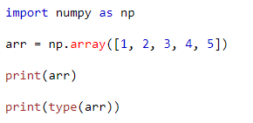

Output:

[1 2 3 4 5]  
<class 'numpy.ndarray'>

**Dimensions in arrays**

**0-D Arrays:**

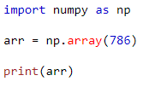

Output:

786

**1-D Arrays:**

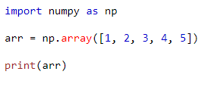

Output:

[1 2 3 4 5]

**2-D Arrays:**

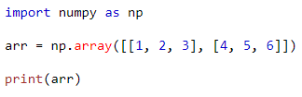

Output:

[[1 2 3]  
 [4 5 6]]

**3-D Arrays:**

An array containing more than one 2-D matrices is known as 3-D Arrays.

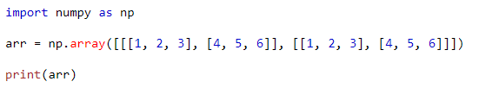

**Output:**

**[[[1 2 3]**  
 **[4 5 6]]**  
  
 **[[1 2 3]**  
 **[4 5 6]]]**

**Check Number of Dimensions?**

NumPy Arrays provides the ndim attribute that returns an integer that tells us how many dimensions the array has.

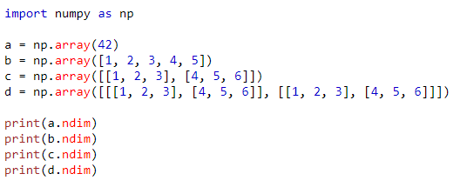

Output:

0

1

2

3

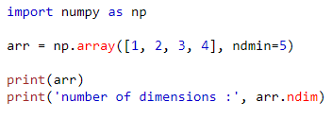

Output:

[[[[[1 2 3 4]]]]]  
number of dimensions: 5

**NumPy array indexing**

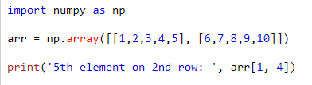

Output:

5th element on 2nd dim: 10

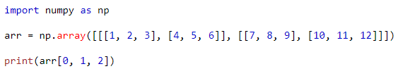

Output:

6

**NumPy Array Slicing**

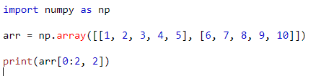

Output:

[3 8]

**NumPy Array shape**

Returns (rows, columns)

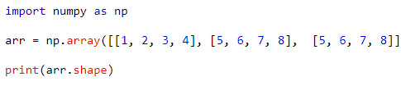

Output:

(3,4)

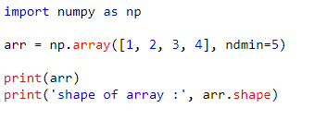

Output:

[[[[[1 2 3 4]]]]]  
shape of array: (1, 1, 1, 1, 4)

**NumPy Array Reshape**

Reshaping means changing the shape of an array.

By reshaping we can add or remove dimensions or change number of elements in each dimension.

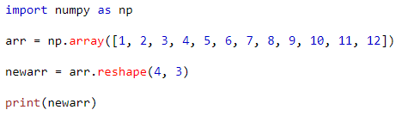

Output:

[[ 1 2 3]  
 [ 4 5 6]  
 [ 7 8 9]  
 [10 11 12]]

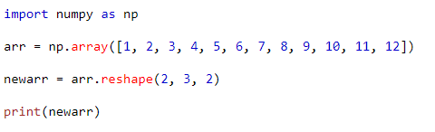

Output:

[[[ 1 2]  
 [ 3 4]  
 [ 5 6]]  
  
 [[ 7 8]  
 [ 9 10]  
 [11 12]]]

**NumPy Joining Arrays**

Joining means putting contents of two or more arrays in a single array.

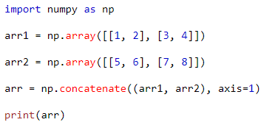

Output:

[[1 2 5 6]  
 [3 4 7 8]]

**NumPy Splitting Array**

Splitting is reverse operation of Joining.

We use array_split() for splitting arrays, we pass it the array we want to split and the number of splits.

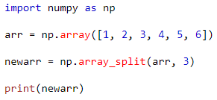

Output:

[array([1, 2]), array([3, 4]), array([5, 6])]

**NumPy Searching Arrays**

You can search an array for a certain value, and return the indexes that get a match.

To search an array, use the where() method.

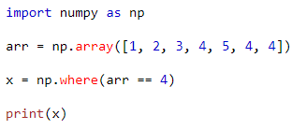

Output:

(array([3, 5, 6]),)

**NumPy Sorting Arrays**

The NumPy ndarray object has a function called sort(), that will sort a specified array.

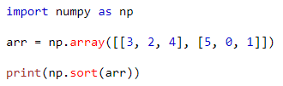

Output:

[[2 3 4]  
 [0 1 5]]

**Note:** This method returns a copy of the array, leaving the original array unchanged.