OpenMANIPULATOR-X Quick Setup
OpenCR board + Mac + Arduino IDE

You need
OpenMANIPULATOR-X arm on its base plate, OpenCR 1.0 board, 12V power adapter (5A), micro USB data cable, Mac.

1. Hardware
- Keep the board's power switch OFF while connecting cables.
- Plug the arm's white 3-pin cable into a 3-pin port on the bottom-left edge of the board (next to the red connector). Do not use the 4-pin ports.
- Plug the 12V adapter into the round power jack.
- Connect the micro USB port (right edge of the board) to your Mac.
- Make sure the arm is upright and secured, then switch the power ON.

2. Arduino IDE
- Install Arduino IDE from arduino.cc.
- Arduino IDE > Settings > Additional boards manager URLs, paste:
https://raw.githubusercontent.com/ROBOTIS-GIT/OpenCR/master/arduino/opencr_release/package_opencr_index.json
- Boards Manager: search OpenCR, install.
- Library Manager: search Dynamixel2Arduino, install.
- Tools > Board > OpenCR > OpenCR Board, and Tools > Port > the usbmodem port.

3. Test
- Paste the code below into a new sketch and click Upload.
- Open Tools > Serial Monitor at 115200 baud.
- You should see Found ID 11 to Found ID 15, then live joint angles. Move a joint by hand to see it change.
If upload fails: hold PUSH SW2, press RESET, release SW2, upload again. If an ID is missing: check 12V power and that the servo cable is fully seated.
#include <Dynamixel2Arduino.h>
Dynamixel2Arduino dxl(Serial3, 84); // OpenCR TTL port
const uint8_t IDS[] = {11, 12, 13, 14, 15};
void setup() {
#ifdef BDPIN_DXL_PWR_EN
pinMode(BDPIN_DXL_PWR_EN, OUTPUT);
digitalWrite(BDPIN_DXL_PWR_EN, HIGH);
#endif
Serial.begin(115200);
while (!Serial);
dxl.begin(1000000);
dxl.setPortProtocolVersion(2.0);
for (uint8_t id : IDS) {
Serial.print(dxl.ping(id) ? "Found ID " : "MISSING ID ");
Serial.println(id);
dxl.torqueOff(id);
}
}
void loop() {
for (uint8_t id : IDS) {
Serial.print(id); Serial.print(": ");
Serial.print(dxl.getPresentPosition(id, UNIT_DEGREE), 1);
Serial.print(" ");
}
Serial.println(); delay(500);
}

4. Understanding the output
Each servo has an ID. They go in order from the bottom of the arm to the gripper:
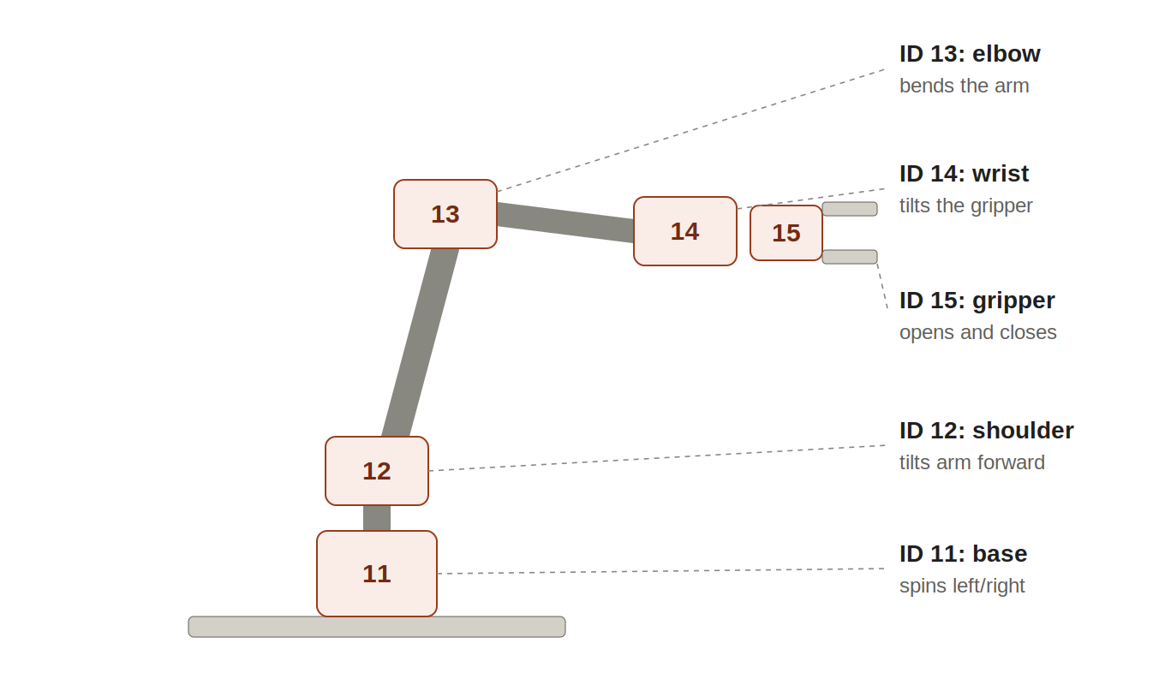
Each line in the Serial Monitor shows ID: angle. For example, 13: 270.1 means the elbow servo is at 270.1 degrees. To check which joint is which, move one by hand and watch which number changes.
- Range is 0 to 360 degrees. Inside, the servo splits one full turn into 4096 steps (about 0.088 degrees each). The code converts steps into degrees.
- 180 is the center (zero) position. Subtract 180 to see how far a joint is bent: 270 means 90 degrees one way, 90 means 90 degrees the other way.
- The gripper (15) shows the motor angle, not the gap between the fingers. A gear turns that rotation into opening and closing.
- Why IDs start at 11: new servos come with ID 1 from the factory, and TurtleBot3 wheels use IDs 1 and 2 on the same board. Starting at 11 avoids clashes. Every servo on the cable must have a different ID.

5. Baud rate
Baud rate is how fast data travels over a wire, in bits per second. This setup has two separate connections:
- Board to Mac: 115200. Set by Serial.begin(115200) and the Serial Monitor dropdown. It only affects the text on your screen. Keep both numbers the same. The OpenCR uses a virtual USB connection, so a mismatch may not show any problem, but on most other Arduino boards it gives random symbols or nothing.
- Board to servos: 1,000,000 (1 Mbps). Set by dxl.begin(1000000). This must match the speed saved inside the servos. If it does not match, every servo shows MISSING ID.
- Baud rate does not change how fast the arm moves. It only changes how fast messages are sent. Arm speed is set by separate servo settings.

