***Business Analytics, 2e, GE* (Evans)**

**Chapter 3 Visualizing and Exploring Data**

1) To select a chart type in Excel from the Charts group, which tab has to be accessed?

A) Design tab

B) Layout tab

C) Insert tab

D) Format tab

Answer: C

Diff: 1

Blooms: Remember

Topic: Data Visualization

LO1: Create Microsoft Excel charts.

LO2: Compare and contrast tools for presenting and organizing data

2) Roger wants to compare values across categories using vertical rectangles. Which of the following charts must Roger use?

A) Line chart

B) Clustered column chart

C) Pie chart

D) Stacked column chart

Answer: B

Diff: 2

Blooms: Apply

AACSB: Analytic Skills

Topic: Data Visualization

LO1: Determine the appropriate chart to visualize different types of data.

LO2: Compare and contrast tools for presenting and organizing data

3) Which of the following charts provides a useful means for displaying data over time?

A) Scatter chart

B) A doughnut chart

C) Pie chart

D) Line chart

Answer: D

Diff: 1

Blooms: Remember

Topic: Data Visualization

LO1: Determine the appropriate chart to visualize different types of data.

LO2: Compare and contrast tools for presenting and organizing data

4) Philip wishes to understand the relative proportion of each data source to the total. Which of the following charts must Philip use?

A) Pie chart

B) Bar chart

C) Scatter chart

D) Column chart

Answer: A

Diff: 1

Blooms: Remember

Topic: Data Visualization

LO1: Determine the appropriate chart to visualize different types of data.

LO2: Compare and contrast tools for presenting and organizing data

5) Observations consisting of pairs of variable data are required to construct a ________ chart.

A) doughnut

B) scatter

C) radar

D) line

Answer: B

Diff: 1

Blooms: Remember

Topic: Data Visualization

LO1: Determine the appropriate chart to visualize different types of data.

LO2: Compare and contrast tools for presenting and organizing data

6) Which of the following charts shows three-dimensional data?

A) Surface chart

B) Column chart

C) Stock chart

D) Doughnut chart

Answer: A

Diff: 1

Blooms: Remember

Topic: Data Visualization

LO1: Determine the appropriate chart to visualize different types of data.

LO2: Compare and contrast tools for presenting and organizing data

7) Peige, a stock broker, has data consisting of price, price/earnings ratio, and market capitalization for seven different stocks on one particular day. She wishes to plot these three variables in two dimensions. Which of the following charts must Peige use?

A) Stock chart

B) Surface chart

C) Bubble chart

D) Line chart

Answer: C

Diff: 2

Blooms: Apply

AACSB: Analytic Skills

Topic: Data Visualization

LO1: Determine the appropriate chart to visualize different types of data.

LO2: Compare and contrast tools for presenting and organizing data

8) Which of the following charts allows plotting of multiple dimensions of several data series?

A) Doughnut chart

B) Bubble chart

C) Radar chart

D) Area chart

Answer: C

Diff: 1

Blooms: Remember

Topic: Data Visualization

LO1: Determine the appropriate chart to visualize different types of data.

LO2: Compare and contrast tools for presenting and organizing data

9) The sort buttons in Excel can be found under:

A) the Data tab in the Sort & Filter group.

B) the Home tab in the Styles group.

C) the Insert tab in the Sort group.

D) the Sort tab in the Filter group.

Answer: A

Diff: 1

Blooms: Remember

Topic: Data Queries: Using Sorting and Filtering

LO1: Sort a data set in an Excel spreadsheet.

LO2: Compare and contrast tools for presenting and organizing data

10) Which of the following relies on sorting data and calculating the cumulative percentage of the characteristic of interest?

A) Randolph diagram

B) Anscombe's quartet

C) Bland-Altman plot

D) Pareto analysis

Answer: D

Diff: 1

Blooms: Remember

Topic: Data Queries: Using Sorting and Filtering

LO1: Apply the Pareto Principle to analyze data.

LO2: Compare and contrast tools for presenting and organizing data

11) Howard has screened some employee details out of the employee database for tax computation purposes. In order to restore the original data file, Howard must:

A) click Sort Newest to Oldest.

B) click Clear filter from Item Description.

C) click Unmerge cells.

D) click Clear outline from Ungroup.

Answer: B

Diff: 1

Blooms: Remember

Topic: Data Queries: Using Sorting and Filtering

LO1: Use the Excel Autofilter to identify records in a database meeting certain characteristics.

LO2: Compare and contrast tools for presenting and organizing data

Use the data given below to answer the following question(s).

Following is the Sales database of Pointler's Inc., a manufacturer of clothing material.

|  |  |  |  |  |  |
| --- | --- | --- | --- | --- | --- |
| **Item**  **Type** | **Item ID** | **Region** | **Buyer** | **Unit Cost ($)** | **Units** |
| Denim | D101 | Quintasia | Peter | 9.79 | 101 |
| Cotton | C101 | Prioland | Kane | 27.79 | 56 |
| Denim | D102 | Prioland | Jones | 12.79 | 42 |
| Leather | L101 | Prioland | Gerry | 27.79 | 33 |
| Denim | D103 | Dygertia | Sarah | 10.79 | 62 |
| Cotton | C102 | Quintasia | Peter | 12.79 | 66 |
| Denim | D101 | Prioland | Audrey | 9.79 | 81 |
| Denim | D102 | Prioland | Jones | 12.79 | 96 |
| Denim | D101 | Dygertia | Thomas | 9.79 | 38 |
| Cotton | C103 | Quintasia | Peter | 16.79 | 66 |
| Denim | D102 | Prioland | Mary | 12.79 | 96 |
| Cotton | C105 | Quintasia | Henry | 9.79 | 35 |
| Cotton | C101 | Quintasia | Philip | 27.79 | 87 |
| Denim | D102 | Quintasia | Peter | 12.79 | 41 |
| Jute | J101 | Prioland | Simson | 132.8 | 8 |
| Fur | F101 | Quintasia | Peter | 23.79 | 22 |
| Cotton | C103 | Prioland | Mary | 16.79 | 34 |
| Leather | L102 | Quintasia | Peter | 16.79 | 70 |
| Leather | L101 | Quintasia | Philip | 27.79 | 21 |
| Fur | F102 | Prioland | Kane | 12.79 | 102 |
| Denim | D104 | Prioland | Simson | 9.09 | 73 |
| Fur | F101 | Quintasia | Philip | 23.79 | 80 |
| Cotton | C103 | Prioland | Gerry | 16.79 | 52 |
| Cotton | C104 | Prioland | Simson | 22.8 | 93 |
| Cotton | C101 | Quintasia | Peter | 12.79 | 10 |

12) Use Excel to calculate the total $ amount earned from sales of all denim items to Prioland

A) $4449.42

B) $22213

C) $388

D) $57.25

Answer: A

Diff: 3

Blooms: Apply

AACSB: Analytic Skills

Topic: Data Queries: Using Sorting and Filtering

LO1: Use the Excel Autofilter to identify records in a database meeting certain characteristics.

LO2: Use a modern software tool to perform statistical calculations.

13) Use Excel to identify the buyer who made the highest single purchase of cotton (in terms of sales revenue for Pointler's Inc.) in Quintasia.

A) Peter

B) Henry

C) Philip

D) Simson

Answer: C

Diff: 3

Blooms: Apply

AACSB: Analytic Skills

Topic: Data Queries: Using Sorting and Filtering

LO1: Use the Excel Autofilter to identify records in a database meeting certain characteristics.

LO2: Use a modern software tool to perform statistical calculations.

14) Use Excel to calculate the total $ amount of sales made to Quintasia. Include the sale of fur, jute, and leather.

A) $193

B) $4185.47

C) $25250.19

D) $130.83

Answer: C

Diff: 3

Blooms: Apply

AACSB: Analytic Skills

Topic: Data Queries: Using Sorting and Filtering

LO1: Use the Excel Autofilter to identify records in a database meeting certain characteristics.

LO2: Use a modern software tool to perform statistical calculations.

15) To construct a frequency distribution for categorical data, the

A) observations that appear in each category must be summed up.

B) number of observations that appear in each category must be counted.

C) observations in each category must be multiplied by observations in the corresponding category.

D) number of observations in each category must be divided by the total number of observations in all categories.

Answer: B

Diff: 2

Blooms: Remember

Topic: Statistical Methods for Summarizing Data

LO1: Construct a frequency distribution for both discrete and continuous data.

LO2: Compare and contrast methods of summarizing and describing data

16) If a data set has 'c' number of observations, the relative frequency of category 'l' is computed as ________.

A) (frequency of category 'l') / 'c'

B) 'c' × (number of observations in category 'l')

C) (sum of all observations in category 'l') / 'c'

D) sum of ('c' + each observation in category 'l')

Answer: A

Diff: 1

Blooms: Remember

Topic: Statistical Methods for Summarizing Data

LO1: Construct a relative frequency distribution and histogram.

LO2: Compare and contrast methods of summarizing and describing data

Use the data given below to answer the following question(s).

Following is an extract from the Employee Payroll Database of HFR Informatics Inc.

|  |  |  |  |  |
| --- | --- | --- | --- | --- |
| **Employee** | **Ethnic Group** | **Gender** | **Rank / Grade** | **Pay Scale** |
| Maria | Asian American | Female | 3 | A |
| Peter | White American | Male | 2 | B |
| George | Hispanic American | Male | 1 | C |
| Smith | Black American | Female | 1 | D |
| Johnson | Alaska Native | Male | 2 | E |
| Thompson | Asian American | Male | 2 | B |
| Martinez | Alaska Native | Male | 3 | A |
| Lewis | White American | Female | 2 | B |
| Lee | Black American | Male | 2 | A |
| Taylor | Asian American | Female | 1 | B |
| Carter | Asian American | Male | 2 | C |
| Edwards | Hispanic American | Male | 2 | E |
| Bailey | White American | Male | 2 | B |
| Cooper | White American | Male | 2 | A |
| Bill | Alaska Native | Male | 3 | E |
| Cox | Asian American | Male | 1 | A |
| Perry | Hispanic American | Female | 2 | C |
| Flores | Alaska Native | Female | 2 | B |
| Woods | White American | Male | 3 | E |
| Cole | Asian American | Female | 1 | A |

17) What is the relative frequency of Grade 3 employees?

A) 4

B) 0.55

C) 0.20

D) 5

Answer: C

Diff: 3

Blooms: Apply

AACSB: Analytic Skills

Topic: Statistical Methods for Summarizing Data

LO1: Construct a relative frequency distribution and histogram.

LO2: Compare and contrast methods of summarizing and describing data

18) What is the relative frequency of Female employees?

A) 0.65

B) 0.75

C) 0.25

D) 0.35

Answer: D

Diff: 3

Blooms: Apply

AACSB: Analytic Skills

Topic: Statistical Methods for Summarizing Data

LO1: Construct a relative frequency distribution and histogram.

LO2: Compare and contrast methods of summarizing and describing data

19) What is the cumulative relative frequency of employees on a 'A to D' pay scale?

A) 1.00

B) 0.80

C) 0.30

D) 0.60

Answer: B

Diff: 3

Blooms: Apply

AACSB: Analytic Skills

Topic: Statistical Methods for Summarizing Data

LO1: Compute cumulative relative frequencies.

LO2: Compare and contrast methods of summarizing and describing data

20) What is the cumulative relative frequency of Ranks 1 and 2?

A) 0.80

B) 0.15

C) 0.30

D) 0.25

Answer: A

Diff: 3

Blooms: Apply

AACSB: Analytic Skills

Topic: Statistical Methods for Summarizing Data

LO1: Compute cumulative relative frequencies.

LO2: Compare and contrast methods of summarizing and describing data

21) A graphical depiction of a frequency distribution for numerical data in the form of a column chart is called a ________.

A) cartogram

B) correlogram

C) histogram

D) dendogram

Answer: C

Diff: 1

Blooms: Remember

Topic: Statistical Methods for Summarizing Data

LO1: Construct a relative frequency distribution and histogram.

LO2: Compare and contrast methods of summarizing and describing data

22) While constructing a histogram, how is group width calculated?

A) number of groups × (lower limit of the last group + upper limit of the first group)

B) (upper limit of the last group - lower limit of the first group) / number of groups

C) (upper limit of the first group + number of groups) × lower limit of the last group + number of groups)

D) (lower limit of the first group - number of groups) × upper limit of the last group

Answer: B

Diff: 1

Blooms: Remember

Topic: Statistical Methods for Summarizing Data

LO1: Construct a relative frequency distribution and histogram.

LO2: Compare and contrast methods of summarizing and describing data

23) Which of the following represents the proportion of the total number of observations that fall at or below the upper limit of each group?

A) Percentile

B) Pareto chart

C) Frequency distribution

D) Cumulative relative frequency

Answer: D

Diff: 1

Blooms: Remember

Topic: Statistical Methods for Summarizing Data

LO1: Compute cumulative relative frequencies.

LO2: Compare and contrast methods of summarizing and describing data

24) The Excel 2010 function ________ computes the kth percentile of data in the range specified in the array field, where k is in the range 0 to 1, inclusive.

A) PERCENTILE.INC(array, k)

B) PERCENTILE(array + k)

C) PERCENTILE.IF(array, k)

D) PERCENTILE(SUM(array), k)

Answer: A

Diff: 1

Blooms: Remember

Topic: Statistical Methods for Summarizing Data

LO1: Find percentiles and quartiles for a data set.

LO2: Use a modern software tool to perform statistical calculations.

Use the data given below to answer the following question(s).

Following is an extract from the Cost per Order Database of Grogtes LLC.

|  |  |  |  |  |
| --- | --- | --- | --- | --- |
| **Item Category** | **Item ID** | **Item Cost** | **Units** | **Cost per Order** |
| Nuts | N101 | $ 2.44 | 94 | $ 229.36 |
| Screws | S101 | $ 20.44 | 49 | $ 1,001.56 |
| Nuts | N102 | $ 5.44 | 35 | $ 190.40 |
| Screwdriver | SD101 | $ 20.44 | 26 | $ 531.44 |
| Nuts | N102 | $ 3.44 | 55 | $ 189.20 |
| Screws | S102 | $ 5.44 | 59 | $ 320.96 |
| Nuts | N101 | $ 2.44 | 74 | $ 180.56 |
| Nuts | N102 | $ 5.44 | 89 | $ 484.16 |
| Nuts | N101 | $ 2.44 | 31 | $ 75.64 |
| Screws | S103 | $ 9.44 | 59 | $ 556.96 |
| Nuts | N102 | $ 5.44 | 89 | $ 484.16 |
| Screws | S101 | $ 2.44 | 28 | $ 68.32 |
| Screws | S101 | $ 20.44 | 80 | $ 1,635.20 |
| Nuts | N102 | $ 5.44 | 34 | $ 184.96 |
| Nails | NG101 | $ 125.45 | 1 | $ 125.45 |
| Bolts | B101 | $ 16.44 | 15 | $ 246.60 |
| Screws | S103 | $ 9.44 | 27 | $ 254.88 |
| Screwdriver | SD102 | $ 9.44 | 63 | $ 594.72 |
| Screwdriver | SD101 | $ 20.44 | 14 | $ 286.16 |
| Bolts | B102 | $ 5.44 | 95 | $ 516.80 |
| Nuts | N103 | $ 1.74 | 66 | $ 114.84 |
| Bolts | B101 | $ 16.44 | 73 | $ 1,200.12 |
| Screws | S103 | $ 9.44 | 45 | $ 424.80 |
| Screws | S104 | $ 15.45 | 86 | $ 1,328.70 |
| Screws | S102 | $ 5.44 | 3 | $ 16.32 |
| Screws | S101 | $ 20.44 | 6 | $ 122.64 |
| Bolts | B102 | $ 5.44 | 49 | $ 266.56 |
| Nuts | N101 | $ 2.44 | 65 | $ 158.60 |
| Screwdriver | SD103 | $ 5.44 | 95 | $ 516.80 |
| Nuts | N103 | $ 1.74 | 52 | $ 90.48 |
| Screws | S103 | $ 9.44 | 79 | $ 745.76 |
| Nailgun pack | NG101 | $ 125.45 | 4 | $ 501.80 |
| Bolts | B102 | $ 5.44 | 61 | $ 331.84 |
| Bolts | B103 | $ 12.94 | 54 | $ 698.76 |
| Bolts | B104 | $ 24.40 | 41 | $ 1,000.40 |
| Nails | NG102 | $ 275.45 | 2 | $ 550.90 |
| Nuts | N103 | $ 1.74 | 6 | $ 10.44 |
| Screwdriver | SD104 | $ 2.44 | 75 | $ 183.00 |
| Screws | S101 | $ 20.44 | 56 | $ 1,144.64 |
| Nuts | N103 | $ 1.74 | 13 | $ 22.62 |
| Screws | S102 | $ 5.44 | 10 | $ 54.40 |
| Screws | S101 | $ 20.44 | 93 | $ 1,900.92 |
| Screws | S102 | $ 5.44 | 27 | $ 146.88 |

25) Which of the following observations is closest to the 87th percentile of costs per order?

A) 75 SD104 screwdrivers for $183.00

B) 66 N103 nuts for $114.84

C) 73 B101 bolts for $1,200.12

D) 49 S101 screws for $1,001.56

Answer: D

Diff: 3

Blooms: Apply

AACSB: Analytic Skills

Topic: Statistical Methods for Summarizing Data

LO1: Find percentiles and quartiles for a data set.

LO2: Compare and contrast methods of summarizing and describing data

26) Which of the following does the 38th percentile of the costs per order indicate?

A) 62% of the costs per order are more than or equal to $190.40.

B) 38% of the costs per order are less than or equal to $189.20.

C) 62% of the costs per order are less than or equal to $484.16.

D) 38% of the costs per order are more than or equal to $501.80.

Answer: B

Diff: 3

Blooms: Apply

AACSB: Analytic Skills

Topic: Statistical Methods for Summarizing Data

LO1: Find percentiles and quartiles for a data set.

LO2: Compare and contrast methods of summarizing and describing data

27) Which of the following observations is closest to the third quartile?

A) 35 N102 nuts for $190.40

B) 59 S103 screws for $556.96

C) 13 N103 nuts for $22.62

D) 2 NG102 nailgun packs for $550.90

Answer: B

Diff: 3

Blooms: Apply

AACSB: Analytic Skills

Topic: Statistical Methods for Summarizing Data

LO1: Find percentiles and quartiles for a data set.

LO2: Compare and contrast methods of summarizing and describing data

28) Which of the following does the second quartile of the costs per order indicate?

A) 2% of the costs per order are less than or equal to $114.84.

B) 20% of the costs per order are less than or equal to $1,200.12.

C) 5% of the costs per order are less than or equal to $229.36.

D) 50% of the costs per order are less than or equal to $286.16.

Answer: D

Diff: 3

Blooms: Apply

AACSB: Analytic Skills

Topic: Statistical Methods for Summarizing Data

LO1: Find percentiles and quartiles for a data set.

LO2: Compare and contrast methods of summarizing and describing data

29) What is the rank of the 42nd percentile of the costs per order ?

A) 17

B) 13.35

C) 19

D) 33.75

Answer: C

Diff: 3

Blooms: Apply

AACSB: Analytic Skills

Topic: Statistical Methods for Summarizing Data

LO1: Find percentiles and quartiles for a data set.

LO2: Compare and contrast methods of summarizing and describing data

30) Which of the following is true about quartiles?

A) The 25th percentile is called the fourth quartile.

B) One-fourth of the data fall below the fourth quartile.

C) Three-fourths of the data are below the third quartile.

D) The 50th quartile is the third percentile.

Answer: C

Diff: 2

Blooms: Remember

Topic: Statistical Methods for Summarizing Data

LO1: Find percentiles and quartiles for a data set.

LO2: Compare and contrast methods of summarizing and describing data

31) Which of the following will give the value for the third quartile?

A) PERCENTILE.INC(array, 0.75)

B) QUARTILE.INC(array, 0.75)

C) DECILE.INC(array, 0.30)

D) QUARTILE.INC(array, 0.25)

Answer: A

Diff: 2

Blooms: Remember

Topic: Statistical Methods for Summarizing Data

LO1: Find percentiles and quartiles for a data set.

LO2: Compare and contrast methods of summarizing and describing data

32) Which of the following is true about cross-tabulation?

A) All subcategories together must constitute the complete data set.

B) A cross-tabulation table is often called a latent class model.

C) Each observation can be classified into many subcategories.

D) The table displays the number of categorical variables between two observations.

Answer: A

Diff: 2

Blooms: Remember

Topic: Statistical Methods for Summarizing Data

LO1: Construct a cross-tabulation (contingency table).

LO2: Compare and contrast methods of summarizing and describing data

33) Which of the following can be used to quickly create cross-tabulations?

A) Frequency distribution

B) COUNTIF function

C) PivotTable

D) Sort & Filter

Answer: C

Diff: 1

Blooms: Remember

Topic: Exploring Data Using PivotTables

LO1: Use PivotTables to construct a cross-tabulation.

LO2: Use a modern software tool to perform statistical calculations.

34) Which of the following is true about constructing PivotTables?

A) It is not possible to construct the PivotTable in the same worksheet.

B) Dragging a field into the Report Filter area allows addition of a third dimension to the analysis.

C) Placing a field each in the row and column labels will automatically sum the variable values in the table.

D) PivotTables cannot be duplicated by copying and pasting an existing table.

Answer: B

Diff: 2

Blooms: Remember

Topic: Exploring Data Using PivotTables

LO1: Use PivotTables to explore and summarize data.

LO2: Use a modern software tool to perform statistical calculations.

35) After choosing the PivotTable, the PivotChart can be found on the ________ tab.

A) Design

B) View

C) Options

D) Layout

Answer: C

Diff: 1

Blooms: Remember

Topic: Exploring Data Using PivotTables

LO1: Display the results of PivotTables using PivotCharts.

LO2: Use a modern software tool to perform statistical calculations.

Use the data given below to answer the following question(s).

Following is the purchase order database of 'The Chef Says So', a restaurant in New York, over the last quarter (April-June).

|  |  |  |  |  |  |
| --- | --- | --- | --- | --- | --- |
| **Order Date** | **Item** | **Region** | **Supplier** | **Unit Cost** | **Units** |
| 5/6/2012 | Steel Fork | Antasia | Peter | 5.44 | 98 |
| 4/7/2012 | Ceramic Plate | Puitoria | Kane | 23.44 | 53 |
| 5/13/2012 | Steel Fork | Puitoria | Jones | 8.44 | 39 |
| 6/10/2012 | Silver Spoon | Puitoria | Gerry | 23.44 | 30 |
| 6/22/2012 | Steel Fork | Almeco | Sarah | 6.44 | 59 |
| 5/17/2012 | Ceramic Plate | Antasia | Peter | 8.44 | 63 |
| 4/25/2012 | Steel Fork | Puitoria | Audrey | 5.44 | 78 |
| 6/1/2012 | Steel Fork | Puitoria | Jones | 8.44 | 93 |
| 4/2/2012 | Steel Fork | Almeco | Thomas | 5.44 | 35 |
| 5/27/2012 | Ceramic Plate | Antasia | Peter | 12.44 | 63 |
| 6/13/2012 | Steel Fork | Puitoria | Mary | 8.44 | 93 |
| 4/30/2012 | Ceramic Plate | Antasia | Henry | 5.44 | 32 |
| 5/11/2012 | Ceramic Plate | Antasia | Philip | 23.44 | 84 |
| 6/18/2012 | Steel Fork | Antasia | Peter | 8.44 | 38 |
| 5/9/2012 | Glass Bottle | Puitoria | Simson | 128.45 | 5 |
| 5/30/2012 | Ceramic Bowl | Antasia | Peter | 19.44 | 19 |
| 6/6/2012 | Ceramic Plate | Puitoria | Mary | 12.44 | 31 |
| 4/3/2012 | Silver Spoon | Antasia | Peter | 12.44 | 67 |
| 6/26/2012 | Silver Spoon | Antasia | Philip | 23.44 | 18 |
| 4/23/2012 | Ceramic Bowl | Puitoria | Kane | 8.44 | 99 |
| 4/29/2012 | Steel Fork | Puitoria | Simson | 4.74 | 70 |
| 4/4/2012 | Ceramic Bowl | Antasia | Philip | 19.44 | 77 |
| 6/15/2012 | Ceramic Plate | Puitoria | Gerry | 12.44 | 49 |
| 6/25/2012 | Ceramic Plate | Puitoria | Simson | 18.45 | 90 |
| 5/23/2012 | Ceramic Plate | Antasia | Peter | 8.44 | 7 |
| 6/28/2012 | Ceramic Plate | Almeco | Sarah | 23.44 | 10 |
| 5/25/2012 | Ceramic Bowl | Puitoria | Jones | 8.44 | 53 |
| 5/1/2012 | Steel Fork | Puitoria | Audrey | 5.44 | 69 |
| 4/12/2012 | Silver Spoon | Antasia | Henry | 8.44 | 99 |
| 4/18/2012 | Steel Fork | Puitoria | Gerry | 4.74 | 56 |
| 6/30/2012 | Ceramic Plate | Puitoria | Gerry | 12.44 | 83 |
| 5/19/2012 | Glass Bottle | Puitoria | Kane | 128.45 | 8 |
| 4/16/2012 | Ceramic Bowl | Antasia | Peter | 8.44 | 65 |
| 6/4/2012 | Ceramic Bowl | Puitoria | Mary | 15.94 | 58 |
| 5/2/2012 | Ceramic Bowl | Puitoria | Kane | 27.4 | 45 |
| 4/19/2012 | Glass Bottle | Almeco | Sarah | 278.45 | 6 |
| 6/11/2012 | Steel Fork | Puitoria | Gerry | 4.74 | 10 |
| 5/31/2012 | Silver Spoon | Almeco | Sarah | 5.44 | 79 |
| 6/2/2012 | Ceramic Plate | Almeco | Thomas | 23.44 | 60 |
| 4/13/2012 | Steel Fork | Puitoria | Audrey | 4.74 | 17 |
| 5/3/2012 | Ceramic Plate | Puitoria | Jones | 8.44 | 14 |
| 6/3/2012 | Ceramic Plate | Puitoria | Jones | 23.44 | 97 |
| 4/17/2012 | Ceramic Plate | Puitoria | Audrey | 8.44 | 31 |

36) Describe how to and construct a line chart exhibiting the purchase order of ceramic plates over the three months.

Answer: Filter the data set by Item (Ceramic Plate). Sort the Order Date by Oldest to Newest. Select the entire data and choose the type of chart (Line Chart) from the Charts group under the Insert tab. Change the title and make data and formatting changes where necessary.

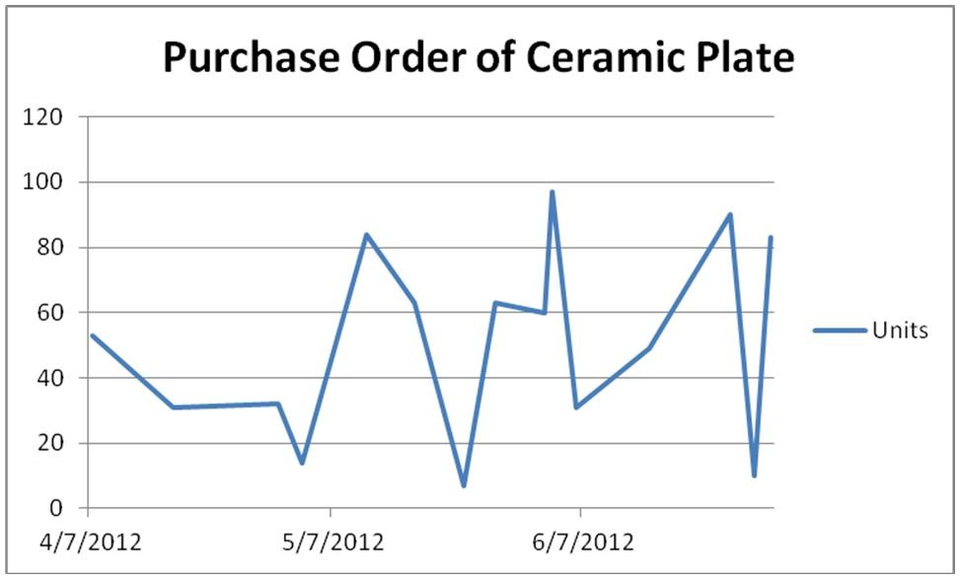

Diff: 3

Blooms: Apply

AACSB: Analytic Skills

Topic: Data Visualization

LO1: Create Microsoft Excel charts.

LO2: Use a modern software tool to perform statistical calculations.

37) Describe how to sort the data by inventory value to compute cumulative percentage of total inventory value to help the restaurateur conduct a Pareto analysis. (Assume that no damages were caused to the inventory purchased over the three months)

Answer:

In order to calculate inventory value of items, only Item, Unit Cost, and Units have to be retained in the table. Inventory value can be calculated by multiplying the unit cost by the number of units. Percentage and the cumulative percentage may be calculated based on the inventory values. Then, sort by Item, calculate subtotals for each Item, calculate percentages, sort the percentage in descending order and then calculate the cumulative percentages.

|  |  |  |  |  |  |
| --- | --- | --- | --- | --- | --- |
| **Item** | **Unit**  **Cost** | **Units** | **Inventory Value** | **Percentage** | **Cumulative percentage** |
| Steel Fork | 5.44 | 98 | 533.12 | 1.776463 | 1.776463261 |
| Ceramic Plate | 23.44 | 53 | 1242.32 | 4.139661 | 5.916123823 |
| Steel Fork | 8.44 | 39 | 329.16 | 1.096827 | 7.012951268 |
| Silver Spoon | 23.44 | 30 | 703.2 | 2.343204 | 9.356155359 |
| Steel Fork | 6.44 | 59 | 379.96 | 1.266103 | 10.62225864 |
| Ceramic Plate | 8.44 | 63 | 531.72 | 1.771798 | 12.39405682 |
| Steel Fork | 5.44 | 78 | 424.32 | 1.41392 | 13.80797656 |
| Steel Fork | 8.44 | 93 | 784.92 | 2.615512 | 16.42348816 |
| Steel Fork | 5.44 | 35 | 190.4 | 0.634451 | 17.05793932 |
| Ceramic Plate | 12.44 | 63 | 783.72 | 2.611513 | 19.66945228 |
| Steel Fork | 8.44 | 93 | 784.92 | 2.615512 | 22.28496387 |
| Ceramic Plate | 5.44 | 32 | 174.08 | 0.58007 | 22.86503351 |
| Ceramic Plate | 23.44 | 84 | 1968.96 | 6.560971 | 29.42600497 |
| Steel Fork | 8.44 | 38 | 320.72 | 1.068704 | 30.49470863 |
| Glass Bottle | 128.45 | 5 | 642.25 | 2.140106 | 32.63481504 |
| Ceramic Bowl | 19.44 | 19 | 369.36 | 1.230782 | 33.86559699 |
| Ceramic Plate | 12.44 | 31 | 385.64 | 1.28503 | 35.15062717 |
| Silver Spoon | 12.44 | 67 | 833.48 | 2.777323 | 37.92795047 |
| Silver Spoon | 23.44 | 18 | 421.92 | 1.405922 | 39.33387293 |
| Ceramic Bowl | 8.44 | 99 | 835.56 | 2.784254 | 42.11812721 |
| Steel Fork | 4.74 | 70 | 331.8 | 1.105624 | 43.22375167 |
| Ceramic Bowl | 19.44 | 77 | 1496.88 | 4.987906 | 48.21165744 |
| Ceramic Plate | 12.44 | 49 | 609.56 | 2.031177 | 50.24283418 |
| Ceramic Plate | 18.45 | 90 | 1660.5 | 5.533121 | 55.77595477 |
| Ceramic Plate | 8.44 | 7 | 59.08 | 0.196866 | 55.97282123 |
| Ceramic Plate | 23.44 | 10 | 234.4 | 0.781068 | 56.75388926 |
| Ceramic Bowl | 8.44 | 53 | 447.32 | 1.49056 | 58.24444964 |
| Steel Fork | 5.44 | 69 | 375.36 | 1.250775 | 59.49522479 |
| Silver Spoon | 8.44 | 99 | 835.56 | 2.784254 | 62.27947907 |
| Steel Fork | 4.74 | 56 | 265.44 | 0.8845 | 63.16397864 |
| Ceramic Plate | 12.44 | 83 | 1032.52 | 3.440565 | 66.60454332 |
| Glass Bottle | 128.45 | 8 | 1027.6 | 3.42417 | 70.02871358 |
| Ceramic Bowl | 8.44 | 65 | 548.6 | 1.828046 | 71.85675932 |
| Ceramic Bowl | 15.94 | 58 | 924.52 | 3.080687 | 74.93744625 |
| Ceramic Bowl | 27.4 | 45 | 1233 | 4.108604 | 79.04605069 |
| Glass Bottle | 278.45 | 6 | 1670.7 | 5.567109 | 84.61315973 |
| Steel Fork | 4.74 | 10 | 47.4 | 0.157946 | 84.77110608 |
| Silver Spoon | 5.44 | 79 | 429.76 | 1.432047 | 86.203153 |
| Ceramic Plate | 23.44 | 60 | 1406.4 | 4.686408 | 90.88956118 |
| Steel Fork | 4.74 | 17 | 80.58 | 0.268509 | 91.15806998 |
| Ceramic Plate | 8.44 | 14 | 118.16 | 0.393733 | 91.5518029 |
| Ceramic Plate | 23.44 | 97 | 2273.68 | 7.57636 | 99.1281628 |
| Ceramic Plate | 8.44 | 31 | 261.64 | 0.871837 | 100 |
| Total |  |  | 30010.19 |  |  |

Diff: 3

Blooms: Apply

AACSB: Analytic Skills

Topic: Data Queries: Using Sorting and Filtering

LO1: Sort a data set in an Excel spreadsheet.

LO2: Use a modern software tool to perform statistical calculations.

38) Construct a relative frequency distribution for items in the purchase order database and show the proportions of the frequencies visually using a pie chart.

Answer: In a new table, list out the items and use the COUNTIF function to calculate the frequencies. The relative frequency may be calculated as:

(frequency of an item) / total number of observations

|  |  |  |
| --- | --- | --- |
| **Items** | **Frequency** | **Relative Frequency** |
| Steel Fork | 13 | 0.30 |
| Ceramic  Plate | 15 | 0.35 |
| Silver Spoon | 5 | 0.12 |
| Glass Bottle | 3 | 0.07 |
| Ceramic Bowl | 7 | 0.16 |
| Total | 43 | 1.00 |

The pie chart can be constructed for the items with their corresponding relative frequencies.

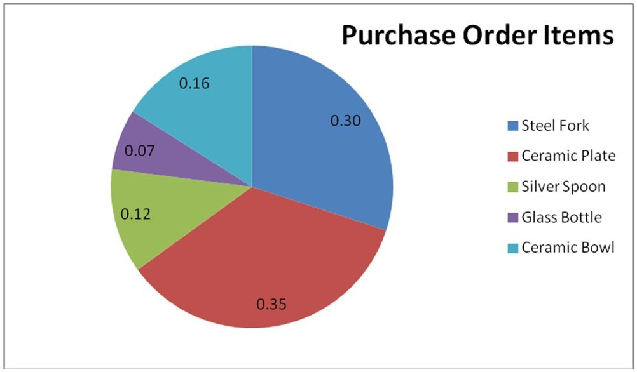

Diff: 3

Blooms: Apply

AACSB: Analytic Skills

Topic: Statistical Methods for Summarizing Data

LO1: Construct a relative frequency distribution and histogram.

LO2: Use a modern software tool to perform statistical calculations.

39) Describe and construct a cross-tabulation showing the region-wise percentage breakdown of purchase of glass bottles and silver spoons and visually represent the data in a 3-D columnchart.

Counts:

|  |  |  |  |
| --- | --- | --- | --- |
| **Region** | **Glass Bottle** | **Silver Spoon** | **Grand Total** |
| Almeco | 6 | 79 | 85 |
| Antasia | 0 | 184 | 184 |
| Puitoria | 13 | 30 | 43 |

Percentages by Region:

|  |  |  |  |
| --- | --- | --- | --- |
| **Region** | **Glass Bottle** | **Silver Spoon** | **Grand Total** |
| Almeco | 7% | 93% | 100% |
| Antasia | 0% | 100% | 100% |
| Puitoria | 30% | 70% | 100% |

Answer: Construct a pivot table with regions as the row labels and filtering the items to include only glass bottle and silver spoon. Compute the percentage purchase within each region and construct a chart on that data.

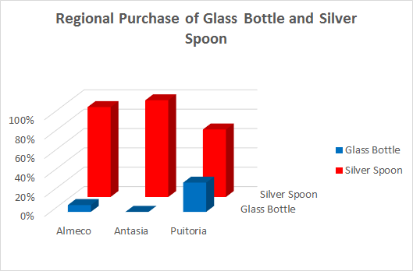

Diff: 3

Blooms: Apply

AACSB: Analytic Skills

Topic: Statistical Methods for Summarizing Data. Exploring Data Using PivotTables

LO1: Use PivotTables to construct a cross-tabulation.

LO2: Use a modern software tool to perform statistical calculations.

40) Construct a PivotChart to visualize the purchase order total units for steel forks and ceramic bowls within each region.

Answer: Choose the whole range of data set and opt for PivotChart in the Insert Tab. Set the regions as row labels and the items as column labels after filtering to include only ceramic bowl and steel fork.

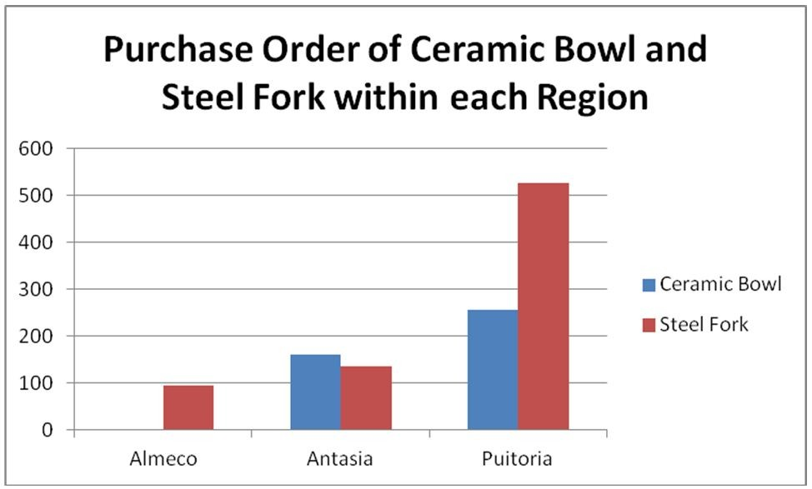

Diff: 3

Blooms: Apply

AACSB: Analytic Skills

Topic: Exploring Data Using PivotTables

LO1: Display the results of PivotTables using PivotCharts.

LO2: Use a modern software tool to perform statistical calculations.

41) Changes to the type of chart, data included in the chart, and chart layout and styles can be made from the Layout tab.

Answer: FALSE

Diff: 1

Blooms: Remember

Topic: Data Visualization

LO1: Create Microsoft Excel charts.

LO2: Compare and contrast tools for presenting and organizing data

42) AutoFilter creates filtering criteria based on the type of data being filtered.

Answer: TRUE

Diff: 1

Blooms: Remember

Topic: Data Queries: Using Sorting and Filtering

LO1: Use the Excel Autofilter to identify records in a database meeting certain characteristics.

LO2: Compare and contrast tools for presenting and organizing data

43) Whenconstructing frequency distributions for numerical data, SUMIF is used to count the frequencies of each discrete value.

Answer: FALSE

Diff: 1

Blooms: Remember

Topic: Statistical Methods for Summarizing Data

LO1: Construct a frequency distribution for both discrete and continuous data.

LO2: Use a modern software tool to perform statistical calculations.

44) Not specifying a Bin Range will not allow Excel to automatically determine bin values for the frequency distribution and histogram.

Answer: FALSE

Diff: 1

Blooms: Remember

Topic: Statistical Methods for Summarizing Data

LO1: Construct a relative frequency distribution and histogram.

LO2: Use a modern software tool to perform statistical calculations.

45) Fewer groups provide a "coarser" histogram.

Answer: TRUE

Diff: 2

Blooms: Remember

Topic: Statistical Methods for Summarizing Data

LO1: Construct a relative frequency distribution and histogram.

LO2: Use a modern software tool to perform statistical calculations.

46) How does Excel distinguish between vertical and horizontal bar charts?

Answer: Excel distinguishes between vertical and horizontal bar charts, calling the former column charts and the latter bar charts. A clustered column chart compares values across categories using vertical rectangles; a stacked column chart displays the contribution of each value to the total by stacking the rectangles; and a 100% stacked column chart compares the percentage that each value contributes to a total.

Diff: 1

Blooms: Remember

Topic: Data Visualization

LO1: Determine the appropriate chart to visualize different types of data.

LO2: Use a modern software tool to perform statistical calculations.

47) Elaborate on the use of geographic data mapping in business analytics.

Answer: Many applications of business analytics involve geographic data. For example, problems such as finding the best location for production and distribution facilities, analyzing regional sales performance, transporting raw materials and finished goods, and routing vehicles such as delivery trucks involve geographic data. In such problems, data mapping can help in a variety of ways. Visualizing geographic data can highlight key data relationships, identify trends, and uncover business opportunities. In addition, it can often help to spot data errors and help end users understand solutions, thus increasing the likelihood of acceptance of decision models. MapPoint is a geographic data-mapping tool that allows you to visualize data imported from Excel and other database sources and integrate them into other Microsoft Office applications.

Diff: 1

Blooms: Remember

Topic: Data Visualization

LO1: Create Microsoft Excel charts.

LO2: Use a modern software tool to perform statistical calculations.

48) Explain with an example the filtering tool provided by Excel for simple criteria.

Answer: Excel provides AutoFilter for simple criteria. AutoFilter creates filtering criteria based on the type of data being filtered. For instance, the Number Filters menu list includes numerical criteria such as "equals," "does not equal," and so on. If one chooses to filter data based on categories such as Order Date or Arrival Date, the AutoFilter tools will display a different Date Filters menu list for filtering that includes "tomorrow," "next week," "year to date," and so on. The AutoFilter can be used sequentially to "drill down" into the data.

Diff: 1

Blooms: Remember

Topic: Data Queries: Using Sorting and Filtering

LO1: Use the Excel Autofilter to identify records in a database meeting certain characteristics.

LO2: Use a modern software tool to perform statistical calculations.

49) Explain statistics as defined by David Hand. What are the two ways in which Microsoft Excel supports statistical analysis?

Answer: Statistics, as defined by David Hand, is both the science of uncertainty and the technology of extracting information from data. Statistics involves collecting, organizing, analyzing, interpreting, and presenting data. A statistic is a summary measure of data. Microsoft Excel supports statistical analysis in two ways:

• with statistical functions that are entered in worksheet cells directly, or embedded in formulas

• with the Excel Analysis Toolpak add-in to perform more complex statistical computations.

Diff: 1

Blooms: Remember

Topic: Statistical Methods for Summarizing Data

LO1: Explain the science of statistics and define the term statistic.

LO2: Use a modern software tool to perform statistical calculations.

50) How is a frequency distribution calculated for categorical and numerical data?

Answer: A frequency distribution is a table that shows the number of observations in each of several non-overlapping groups. Categorical variables naturally define the groups in a frequency distribution. The frequencies may be expressed as a fraction, or proportion, of the total; these are called relative frequencies. A relative frequency distribution is a tabular summary of the relative frequencies of all categories. For numerical data that consist of a small number of discrete values, frequency distributions may be constructed in a similar way as done for categorical data; COUNTIF is used to count the frequencies of each value. A graphical depiction of frequency distributions for numerical data in the form of a column chart is called a histogram.

Diff: 2

Blooms: Remember

Topic: Statistical Methods for Summarizing Data

LO1: Construct a frequency distribution for both discrete and continuous data.

LO2: Use a modern software tool to perform statistical calculations.