**Session 1**

### **Neural Network and Its Applications**

#### **What is a Neural Network?**

A neural network is a computational model inspired by the structure and functioning of biological neural networks in the human brain. Neural networks consist of layers of interconnected nodes (neurons), where each connection has an associated weight and bias. The primary goal of a neural network is to learn patterns and representations from data to make predictions or decisions.

#### **Structure of a Neural Network**

1. **Input Layer**: Receives the input features of the data.
2. **Hidden Layers**: Perform computations and transformations on the input data using weights and activation functions. There can be one or multiple hidden layers.
3. **Output Layer**: Provides the final output (e.g., classification or regression results).
4. **Weights and Biases**: Parameters learned during training to adjust the importance of input features.
5. **Activation Function**: Introduces non-linearity, enabling the network to learn complex patterns. Common functions include:
   * ReLU (Rectified Linear Unit)
   * Sigmoid
   * Tanh
   * Softmax

#### **Learning in Neural Networks**

* **Forward Propagation**: The input data passes through the network layer by layer to generate predictions.
* **Loss Function**: Measures the difference between predictions and actual labels (e.g., Mean Squared Error for regression, Cross-Entropy Loss for classification).
* **Backpropagation**: Adjusts the weights and biases by propagating the error backward through the network using the gradient descent optimization algorithm.

#### **Applications of Neural Networks**

1. **Image Recognition**:
   * Object detection
   * Facial recognition
2. **Natural Language Processing**:
   * Sentiment analysis
   * Text translation
3. **Healthcare**:
   * Disease diagnosis
   * Medical image analysis
4. **Finance**:
   * Fraud detection
   * Stock price prediction
5. **Autonomous Systems**:
   * Self-driving cars
   * Robotics
6. **Gaming**:
   * AI opponents in video games

### **20 MCQs on Neural Networks**

**Easy:**

1. What is the primary purpose of a neural network?

a) To store data  
b) To learn patterns from data  
c) To act as a database  
d) To create hardware  
**Answer**: b) To learn patterns from data

1. Which of the following is the simplest neural network layer?

a) Input layer  
b) Hidden layer  
c) Output layer  
d) Convolutional layer  
**Answer**: a) Input layer

1. What does the activation function introduce in a neural network?  
   a) Linearity  
   b) Complexity  
   c) Non-linearity  
   d) Memory  
   **Answer**: c) Non-linearity
2. The process of adjusting weights in a neural network is called:  
   a) Forward propagation  
   b) Backpropagation  
   c) Initialization  
   d) Training  
   **Answer**: b) Backpropagation
3. Which of these is NOT a type of activation function?  
   a) ReLU  
   b) Sigmoid  
   c) Logarithmic  
   d) Tanh  
   **Answer**: c) Logarithmic

**Medium:**

6. What happens during forward propagation in a neural network?  
a) Weights are updated  
b) Predictions are calculated  
c) Loss is minimized  
d) Gradients are computed  
**Answer**: b) Predictions are calculated

1. Which of the following optimizers is commonly used in neural networks?  
   a) Newton's method  
   b) Gradient Descent  
   c) Monte Carlo Simulation  
   d) Bayesian Optimization  
   **Answer**: b) Gradient Descent
2. Which layer in a neural network provides the final output?  
   a) Hidden layer  
   b) Input layer  
   c) Output layer  
   d) Convolutional layer  
   **Answer**: c) Output layer
3. What type of neural network is commonly used for image processing tasks?  
   a) Recurrent Neural Network (RNN)  
   b) Convolutional Neural Network (CNN)  
   c) Feedforward Neural Network  
   d) Generative Adversarial Network (GAN)  
   **Answer**: b) Convolutional Neural Network (CNN)
4. The process of preventing a neural network from overfitting is known as:  
   a) Regularization  
   b) Optimization  
   c) Initialization  
   d) Normalization  
   **Answer**: a) Regularization

**Hard:**

11. Which loss function is best suited for binary classification tasks?  
a) Cross-Entropy Loss  
b) Mean Squared Error  
c) Hinge Loss  
d) L2 Loss  
**Answer**: a) Cross-Entropy Loss

1. What does a weight in a neural network represent?  
   a) Importance of a feature  
   b) Loss value  
   c) Bias value  
   d) Prediction score  
   **Answer**: a) Importance of a feature
2. In neural networks, a vanishing gradient problem occurs when:  
   a) Gradients are too small to make significant updates  
   b) Gradients explode, making updates unstable  
   c) The learning rate is too high  
   d) The model has too many neurons  
   **Answer**: a) Gradients are too small to make significant updates
3. Dropout in neural networks is used to:  
   a) Increase model complexity  
   b) Reduce overfitting  
   c) Decrease training time  
   d) Improve loss calculation  
   **Answer**: b) Reduce overfitting
4. In which layer of a neural network does feature extraction typically occur?  
   a) Input layer  
   b) Hidden layer  
   c) Output layer  
   d) Loss layer  
   **Answer**: b) Hidden layer
5. Why is softmax activation used in the output layer for multi-class classification?  
   a) To apply linearity  
   b) To normalize class probabilities  
   c) To compute gradients  
   d) To reduce dimensionality  
   **Answer**: b) To normalize class probabilities
6. Which type of neural network is ideal for sequential data?  
   a) Convolutional Neural Network (CNN)  
   b) Feedforward Neural Network  
   c) Recurrent Neural Network (RNN)  
   d) Autoencoder  
   **Answer**: c) Recurrent Neural Network (RNN)
7. Weight initialization is crucial in deep learning because:  
   a) It affects learning rate  
   b) It prevents vanishing gradients  
   c) It reduces training data size  
   d) It skips the forward propagation step  
   **Answer**: b) It prevents vanishing gradients
8. Batch normalization in neural networks helps in:  
   a) Reducing variance in predictions  
   b) Accelerating training  
   c) Improving generalization  
   d) All of the above  
   **Answer**: d) All of the above
9. A neural network with too many parameters is prone to:  
   a) Overfitting  
   b) Underfitting  
   c) Bias  
   d) Regularization  
   **Answer**: a) Overfitting

### **Single-Layer Neural Network**

#### **What is a Single-Layer Neural Network?**

A **single-layer neural network** is the simplest form of artificial neural networks, consisting of:

1. **Input Layer**: Receives input features.
2. **Output Layer**: Produces the final prediction.

This type of network has no hidden layers, meaning the input is directly mapped to the output using a linear or non-linear transformation. The weights and biases in the model determine the strength and direction of the input-output relationship.

#### **How It Works**

1. Each input is multiplied by a weight.
2. The weighted inputs are summed and passed through an activation function to generate an output.
3. The network adjusts the weights during training to minimize the difference between predicted and actual values using a loss function and an optimization algorithm like gradient descent.

#### **Mathematical Representation**

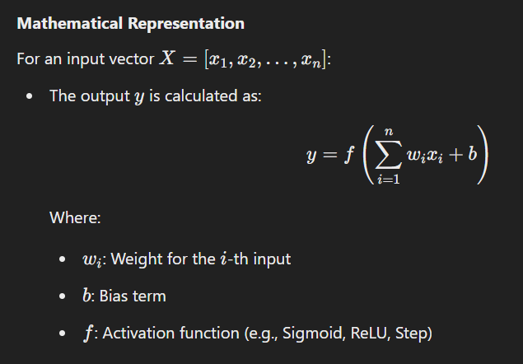

### **Characteristics of Single-Layer Neural Networks**

1. **Linear Decision Boundaries**:
   * A single-layer network can only solve linearly separable problems (e.g., XOR cannot be solved by a single-layer network).
2. **Simple Architecture**:
   * No hidden layers; the model is computationally inexpensive and easy to train.
3. **Limited Learning Power**:
   * It cannot learn complex patterns or relationships in data due to the lack of hidden layers.

### **Applications of Single-Layer Neural Networks**

1. **Linear Regression**: Predicting continuous variables.
2. **Binary Classification**: Classifying data into two categories (e.g., spam or not spam).
3. **Perceptron Model**: A classic example of a single-layer neural network used for linearly separable data.

### **Advantages**

1. **Fast Training**: Due to the absence of hidden layers.
2. **Easy to Implement**: Simple architecture with fewer parameters.
3. **Interpretable**: Output is directly based on weighted inputs.

### **Limitations**

1. **Inability to Learn Non-Linear Patterns**: It struggles with problems requiring non-linear decision boundaries.
2. **No Feature Extraction**: Cannot capture higher-level features from the data.
3. **Overfitting Risks**: May perform poorly on unseen data if not regularized.

### **20 MCQs on Single-Layer Neural Networks**

#### **Easy:**

1. What is the output layer responsible for in a single-layer neural network?  
   a) Learning patterns  
   b) Processing inputs  
   c) Producing the final prediction  
   d) Activating hidden neurons  
   **Answer**: c) Producing the final prediction
2. Which problem type can a single-layer neural network solve?  
   a) XOR  
   b) Linearly separable problems  
   c) Non-linearly separable problems  
   d) Multi-class classification  
   **Answer**: b) Linearly separable problems
3. Which component adjusts weights during training in a neural network?  
   a) Input layer  
   b) Bias term  
   c) Loss function  
   d) Optimization algorithm  
   **Answer**: d) Optimization algorithm
4. What is the simplest form of a neural network?  
   a) Multi-layer Perceptron  
   b) Convolutional Neural Network  
   c) Single-layer Neural Network  
   d) Recurrent Neural Network  
   **Answer**: c) Single-layer Neural Network
5. Which activation function outputs values between 0 and 1?  
   a) ReLU  
   b) Tanh  
   c) Sigmoid  
   d) Linear  
   **Answer**: c) Sigmoid

#### **Medium:**

1. Which neural network cannot solve the XOR problem?  
   a) Multi-layer Neural Network  
   b) Single-layer Neural Network  
   c) Convolutional Neural Network  
   d) Recurrent Neural Network  
   **Answer**: b) Single-layer Neural Network
2. The perceptron algorithm minimizes which type of error?  
   a) Mean Squared Error  
   b) Classification Error  
   c) Absolute Error  
   d) Cross-Entropy Error  
   **Answer**: b) Classification Error
3. What role does the bias term play in a single-layer network?  
   a) Prevents overfitting  
   b) Improves interpretability  
   c) Shifts the activation function  
   d) Regularizes the model  
   **Answer**: c) Shifts the activation function
4. In which scenario is a single-layer neural network most suitable?  
   a) Image recognition  
   b) Speech processing  
   c) Linearly separable data  
   d) Sequential data analysis  
   **Answer**: c) Linearly separable data
5. What type of decision boundary does a single-layer neural network create?  
   a) Circular  
   b) Linear  
   c) Quadratic  
   d) Non-linear  
   **Answer**: b) Linear

#### **Hard:**

1. A single-layer neural network trained with a step function is equivalent to which algorithm?  
   a) k-Nearest Neighbors  
   b) Linear Regression  
   c) Perceptron  
   d) Decision Tree  
   **Answer**: c) Perceptron
2. What happens when a single-layer network is applied to non-linearly separable data?  
   a) It overfits the data  
   b) It underfits the data  
   c) It provides accurate predictions  
   d) It creates a non-linear decision boundary  
   **Answer**: b) It underfits the data
3. Which metric is used to evaluate single-layer neural networks in classification tasks?  
   a) Mean Absolute Error  
   b) Accuracy  
   c) R-squared  
   d) Adjusted R-squared  
   **Answer**: b) Accuracy
4. What causes a single-layer neural network to fail in complex tasks?  
   a) Lack of regularization  
   b) Lack of hidden layers  
   c) Too many weights  
   d) Excessive bias  
   **Answer**: b) Lack of hidden layers
5. Which optimization algorithm is commonly used in training single-layer neural networks?  
   a) Backpropagation  
   b) Stochastic Gradient Descent  
   c) Adam  
   d) Batch Normalization  
   **Answer**: b) Stochastic Gradient Descent
6. Which function is minimized in a single-layer neural network during training?  
   a) Objective Function  
   b) Loss Function  
   c) Regularization Function  
   d) Cost Function  
   **Answer**: d) Cost Function
7. Why does a single-layer network fail to recognize complex patterns?  
   a) Over-parameterization  
   b) Linear decision boundaries  
   c) Non-linear optimization  
   d) Small dataset size  
   **Answer**: b) Linear decision boundaries
8. What is the main drawback of using the perceptron algorithm?  
   a) Slow training  
   b) Inability to converge  
   c) Requires a large dataset  
   d) Only works for linearly separable data  
   **Answer**: d) Only works for linearly separable data
9. What happens to the weights in a perceptron when a misclassification occurs?  
   a) Weights are incremented by 1  
   b) Weights are adjusted to minimize error  
   c) Weights are removed  
   d) Weights remain unchanged  
   **Answer**: b) Weights are adjusted to minimize error
10. Which activation function would NOT be suitable for a single-layer neural network?  
    a) Linear  
    b) ReLU  
    c) Sigmoid  
    d) Softmax  
    **Answer**: d) Softmax

### **What is an Activation Function?**

An **activation function** in a neural network is a mathematical function applied to the output of a neuron to introduce non-linearity into the model. It determines whether a neuron should be activated (or fired) and plays a crucial role in learning complex patterns in data. Without activation functions, a neural network would behave like a linear regression model, regardless of its depth.

### **Purpose of Activation Functions**

1. **Non-linearity:** Allows the model to learn and represent complex relationships.
2. **Output Mapping:** Maps input signals to a specific range (e.g., between 0 and 1 or -1 and 1).
3. **Gradient-Based Optimization:** Ensures that gradients can be backpropagated effectively during training.

### **Types of Activation Functions**

#### **uj1. Linear Activation Function**

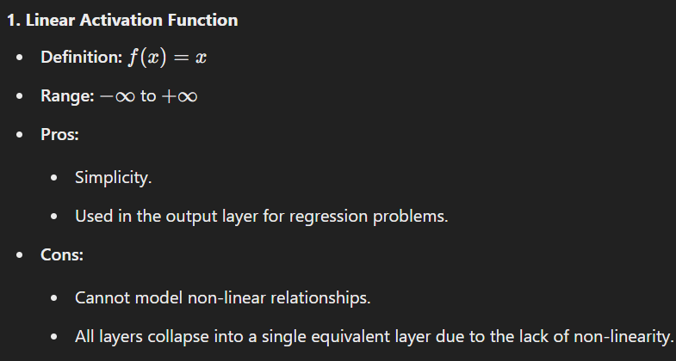

#### **2. Non-linear Activation Functions**

Non-linear functions introduce complexity and enable the network to learn non-linear mappings.

##### **a. Sigmoid Function**

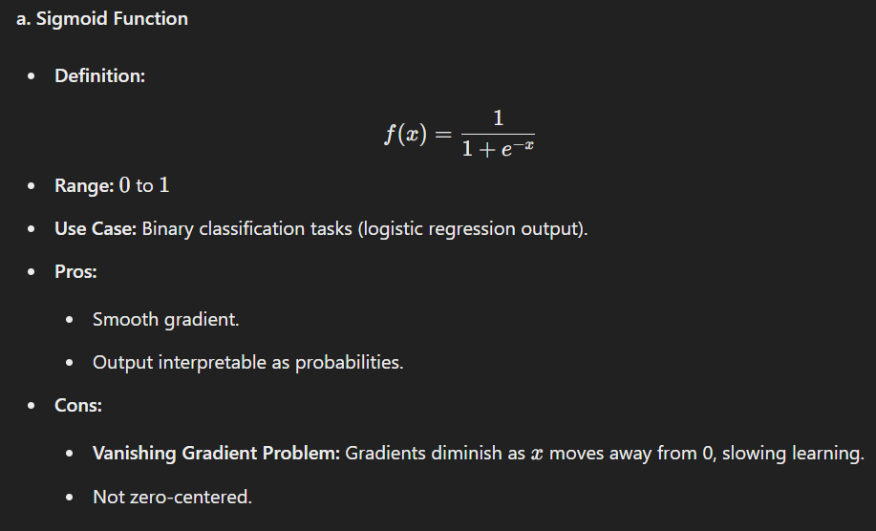

##### 

##### 

##### 

##### **b. Tanh (Hyperbolic Tangent) Function**

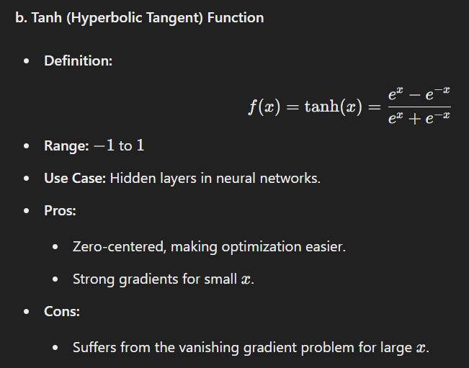

##### **c. ReLU (Rectified Linear Unit)**

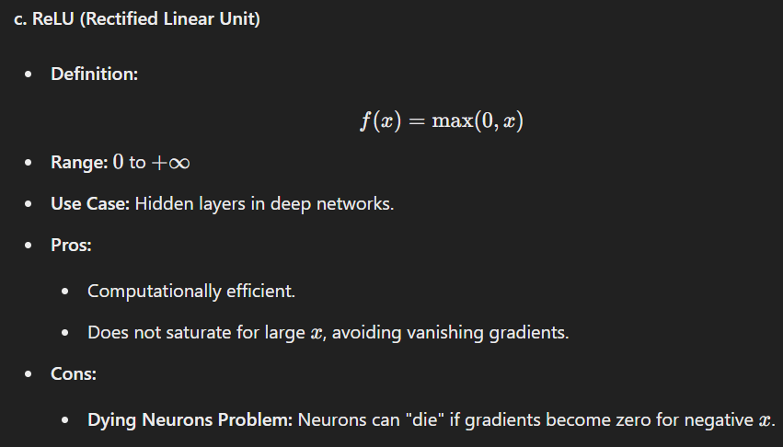

##### **d. Leaky ReLU**

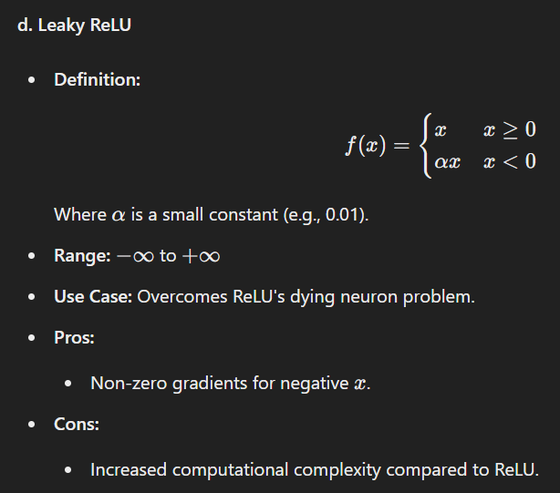

##### 

##### 

##### 

##### 

##### 

##### 

##### 

##### 

##### 

##### 

##### 

##### 

##### 

##### **e. Softmax**

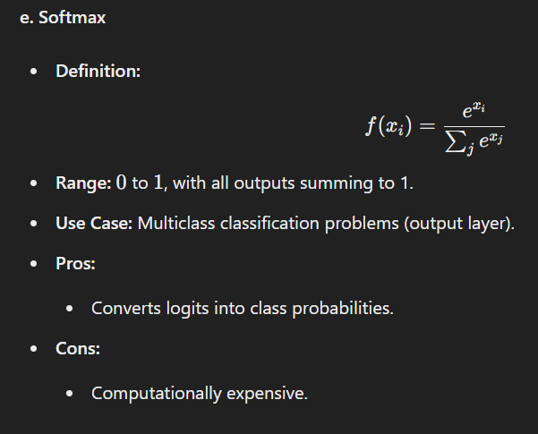

##### **f. Swish**

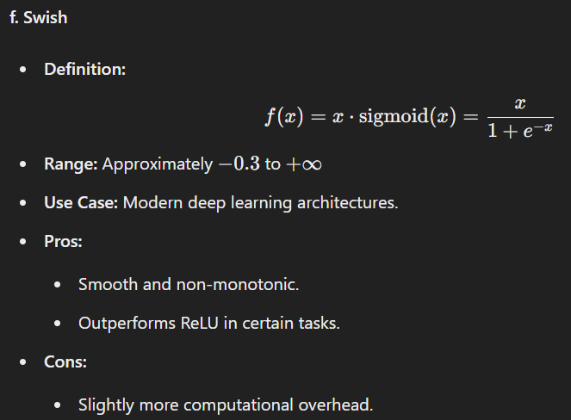

### **Choosing an Activation Function**

* **Output Layer:**
  + Binary Classification: **Sigmoid**
  + Multiclass Classification: **Softmax**
  + Regression: **Linear**
* **Hidden Layers:**
  + Use **ReLU** or its variants (Leaky ReLU, Swish) for efficiency.
  + Use **Tanh** if zero-centered output is preferred.

### **Summary Table**

|  |  |  |  |  |
| --- | --- | --- | --- | --- |
|  |  |  |  |  |
|  |  |  |  |  |
|  |  |  |  |  |
|  |  |  |  |  |
|  |  |  |  |  |
|  |  |  |  |  |
|  |  |  |  |  |

### **Basic Concept Questions**

1. **What is the primary purpose of an activation function in a neural network?**a. To initialize weights  
   b. To introduce non-linearity  
   c. To normalize the data  
   d. To reduce computation time  
   **Answer:** b
2. **What happens if a neural network does not use an activation function?**a. It behaves like a logistic regression model  
   b. It becomes a non-linear system  
   c. It behaves like a linear model  
   d. It performs gradient clipping  
   **Answer:** c
3. **Which activation function is used to output probabilities in a binary classification task?**a. ReLU  
   b. Sigmoid  
   c. Softmax  
   d. Tanh  
   **Answer:** b
4. **Which of the following is not a property of an activation function?**a. Mapping non-linearity  
   b. Providing zero-centered output  
   c. Reducing the number of layers  
   d. Controlling gradient flow  
   **Answer:** c

### **Types of Activation Functions**

1. **Which of the following activation functions maps input values to the range [0,1]?**a. Tanh  
   b. Sigmoid  
   c. ReLU  
   d. Leaky ReLU  
   **Answer:** b
2. **The Tanh activation function outputs values in which range?**a. 0 to 1  
   b. −1 to 1  
   c. −∞ to +∞  
   d. 0 to +∞  
   **Answer:** b
3. **Which activation function is commonly used in the hidden layers of a neural network?**a. ReLU  
   b. Softmax  
   c. Linear  
   d. None of the above  
   **Answer:** a
4. **Which activation function solves the dying neuron problem faced by ReLU?**a. Sigmoid  
   b. Leaky ReLU  
   c. Tanh  
   d. Softmax  
   **Answer:** b
5. **Which activation function outputs probabilities that sum to 1 across all classes?**a. Tanh  
   b. ReLU  
   c. Softmax  
   d. Swish  
   **Answer:** c
6. **Which activation function introduces a non-monotonic property?**a. ReLU  
   b. Swish  
   c. Sigmoid  
   d. Softmax  
   **Answer:** b

### **Behavior and Properties**

1. **What is the key limitation of the Sigmoid activation function?**a. Exploding gradient  
   b. Vanishing gradient  
   c. Non-differentiable  
   d. High computational cost  
   **Answer:** b
2. **Which of the following is true for ReLU?**a. It outputs negative values for negative inputs.  
   b. It has a range of 0 to 1.  
   c. It is computationally efficient.  
   d. It suffers from the exploding gradient problem.  
   **Answer:** c
3. **What is the primary issue with using ReLU activation functions?**a. Computational inefficiency  
   b. Lack of non-linearity  
   c. Dying neurons problem  
   d. Saturated outputs for large inputs  
   **Answer:** c
4. **What is the effect of using a Leaky ReLU activation function?**a. It reduces computational efficiency.  
   b. It assigns a small gradient to negative inputs.  
   c. It maps outputs to a fixed range.  
   d. It introduces vanishing gradients.  
   **Answer:** b
5. **Why is the Softmax function primarily used in the output layer of classification tasks?**a. It is computationally inexpensive.  
   b. It normalizes inputs to probabilities.  
   c. It works with both regression and classification problems.  
   d. It handles vanishing gradients effectively.  
   **Answer:** b

### **Application-Based Questions**

1. **Which activation function is ideal for regression problems?**a. Sigmoid  
   b. Softmax  
   c. Linear  
   d. Tanh  
   **Answer:** c
2. **In which scenario would the Swish activation function outperform ReLU?**a. When computational cost is a concern  
   b. When the network depth is shallow  
   c. In deep networks requiring smooth gradients  
   d. In binary classification tasks  
   **Answer:** c
3. **Which of the following activation functions works well for both positive and negative input ranges?**a. ReLU  
   b. Leaky ReLU  
   c. Tanh  
   d. Softmax  
   **Answer:** c
4. **Why is ReLU often preferred in deep neural networks over Sigmoid?**a. Faster computation and no vanishing gradients  
   b. Outputs values between 000 and 111  
   c. Works with probabilities  
   d. Outputs zero-centered values  
   **Answer:** a
5. **Which activation function can output negative values but with a small slope?**a. Sigmoid  
   b. ReLU  
   c. Leaky ReLU  
   d. Softmax  
   **Answer:** c

### **Overview of Backpropagation of Error**

**Backpropagation** (short for **backward propagation of errors**) is a supervised learning algorithm used for training artificial neural networks. It enables the network to adjust its weights and biases by minimizing the error in the predictions.

### **Key Components of Backpropagation**

1. **Forward Pass**:
   * Input data is passed through the network layer by layer.
   * Each neuron applies weights, biases, and an activation function to compute the output.
   * The final layer produces the prediction.
2. **Loss Calculation**:
   * A loss function (e.g., Mean Squared Error, Cross-Entropy Loss) compares the predicted output with the true output to compute the error.
3. **Backward Pass**:
   * The error is propagated backward through the network, layer by layer, to update the weights.
   * The gradients of the loss function with respect to the weights are calculated using the **chain rule** of calculus.
4. **Weight Update**:
   * The calculated gradients are used to adjust the weights and biases using an optimization algorithm (e.g., **Gradient Descent**):

Wnew=Wold−η∂L/∂Wold​ Where:

* + - w = weights
    - η = learning rate
    - L = loss function

### **Steps in Backpropagation**

#### **1. Initialization:**

* Initialize weights and biases to small random values.

#### **2. Forward Propagation:**

* Compute the outputs of all neurons from the input layer to the output layer.

#### **3. Compute the Loss:**

* Calculate the error using the loss function.

#### **4. Backward Propagation:**

* For the **output layer**:
  + Compute the gradient of the loss with respect to the output.
* For the **hidden layers**:
  + Use the chain rule to calculate the gradients of the loss with respect to the weights and biases.
  + Gradients are passed backward from the output layer to the input layer.

#### **5. Update Weights and Biases:**

* Use the gradients to update weights and biases with an optimization algorithm.

#### **6. Repeat:**

* Perform the forward and backward passes iteratively for multiple epochs until the network converges to a solution.

### **Mathematics Behind Backpropagation**

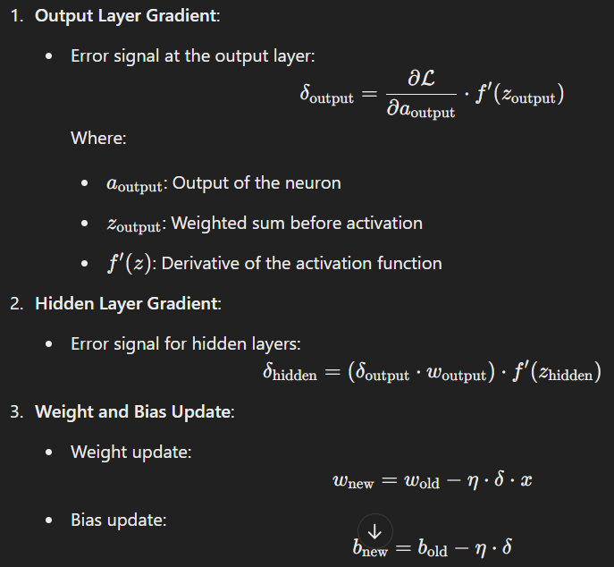

### **Key Advantages of Backpropagation**

1. **Efficiency**: Backpropagation is computationally efficient for training deep networks.
2. **Flexibility**: It can be applied to a variety of network architectures.
3. **Adaptability**: Works well with various optimization algorithms like SGD, Adam, etc.

### **Limitations**

1. **Vanishing Gradient Problem**:
   * In very deep networks, gradients can become very small, making it hard to update weights effectively.
2. **Exploding Gradient Problem**:
   * Opposite of vanishing gradients, where gradients become excessively large.
3. **Sensitive to Initialization**:
   * Poor initialization can lead to slow convergence or suboptimal solutions.
4. **Requires Differentiable Functions**:
   * The activation functions must be differentiable.

### **Applications of Backpropagation**

* Image classification
* Natural language processing
* Speech recognition
* Recommendation systems
* Reinforcement learning

### **20 MCQs on Backpropagation**

#### **Easy:**

1. What is the purpose of backpropagation?  
   a) Forward propagation of data  
   b) Update weights using error gradients  
   c) Generate random weights  
   d) Perform feature selection  
   **Answer**: b) Update weights using error gradients
2. Backpropagation relies on which mathematical concept?  
   a) Statistics  
   b) Chain rule of calculus  
   c) Matrix inversion  
   d) Fourier transform  
   **Answer**: b) Chain rule of calculus
3. Which optimization algorithm is commonly used with backpropagation?  
   a) Gradient Descent  
   b) K-Means  
   c) DBSCAN  
   d) Decision Trees  
   **Answer**: a) Gradient Descent
4. What is the first step in backpropagation?  
   a) Compute gradients  
   b) Forward pass  
   c) Update weights  
   d) Initialize biases  
   **Answer**: b) Forward pass
5. Backpropagation adjusts:  
   a) Input values  
   b) Activation functions  
   c) Weights and biases  
   d) Output labels  
   **Answer**: c) Weights and biases

#### **Medium:**

1. In backpropagation, gradients flow from:  
   a) Input to output  
   b) Output to input  
   c) Hidden layers to input  
   d) Output to biases only  
   **Answer**: b) Output to input
2. Which problem is commonly associated with very deep networks?  
   a) Overfitting  
   b) Vanishing gradients  
   c) High computational cost  
   d) Convergence issues  
   **Answer**: b) Vanishing gradients
3. What is updated in each iteration of backpropagation?  
   a) Loss function  
   b) Gradients  
   c) Weights and biases  
   d) All of the above  
   **Answer**: d) All of the above
4. What does the term "learning rate" refer to?  
   a) Speed of the forward pass  
   b) Magnitude of weight updates  
   c) Number of neurons  
   d) Activation function slope  
   **Answer**: b) Magnitude of weight updates
5. Backpropagation is used for which type of learning?  
   a) Supervised  
   b) Unsupervised  
   c) Reinforcement  
   d) Semi-supervised  
   **Answer**: a) Supervised

#### **Hard:**

1. What is the role of the loss function in backpropagation?  
   a) Generate random gradients  
   b) Measure error between predictions and true values  
   c) Initialize weights  
   d) Increase computation time  
   **Answer**: b) Measure error between predictions and true values
2. What is the derivative of ReLU used for in backpropagation?  
   a) Compute output values  
   b) Compute gradients for weights  
   c) Update biases only  
   d) Perform forward pass  
   **Answer**: b) Compute gradients for weights
3. Which function is used for binary classification in backpropagation?  
   a) Softmax  
   b) Sigmoid  
   c) Tanh  
   d) ReLU  
   **Answer**: b) Sigmoid
4. What happens if the learning rate is too high?  
   a) Faster convergence  
   b) Divergence or oscillations  
   c) Better accuracy  
   d) Reduced training time  
   **Answer**: b) Divergence or oscillations
5. The vanishing gradient problem occurs when gradients:  
   a) Become very small  
   b) Become very large  
   c) Do not update weights  
   d) Do not exist  
   **Answer**: a) Become very small

============================================================================================================================================

**Session 2**

### **Introduction to TensorFlow**

**TensorFlow** is an open-source deep learning framework developed by Google. It is widely used for building and deploying machine learning and deep learning models. TensorFlow provides flexibility, scalability, and powerful tools for both beginners and professionals.

### **Key Features of TensorFlow**

1. **Computation Graphs**: TensorFlow constructs computational graphs for efficient execution.
2. **Eager Execution**: It allows for immediate execution of operations for easier debugging and dynamic behavior.
3. **High Performance**: Optimized for CPU, GPU, and TPU computations.
4. **Scalability**: Supports distributed training across multiple devices and servers.
5. **Rich Ecosystem**:
   * **Keras**: High-level API for rapid model development.
   * **TensorBoard**: Visualization tool for monitoring training.
   * **TF Lite**: Framework for deploying models on mobile and embedded devices.
   * **TF Serving**: For model deployment in production.
6. **Community and Documentation**: Extensive support and resources.

### **Applications of TensorFlow**

* Image and speech recognition
* Time-series forecasting
* Natural language processing
* Reinforcement learning
* Recommendation systems

### **Introduction to PyTorch**

**PyTorch** is an open-source deep learning framework developed by Facebook's AI Research lab (FAIR). Known for its simplicity and flexibility, PyTorch is particularly favored for research and development.

### **Key Features of PyTorch**

1. **Dynamic Computation Graphs**: Unlike TensorFlow (static graphs), PyTorch uses dynamic graphs, making it easier to modify computations on the fly.
2. **Pythonic Syntax**: PyTorch integrates seamlessly with Python, enabling a more intuitive coding experience.
3. **Tensors**: Supports multi-dimensional arrays (tensors) with GPU acceleration.
4. **Autograd**: Built-in automatic differentiation for gradient computations.
5. **TorchScript**: Allows switching between eager execution and graph mode for production.
6. **Community Support**: Strong community backing with abundant resources and tutorials.

### **Applications of PyTorch**

* Research-focused deep learning
* Dynamic model development
* Complex NLP models like transformers
* Computer vision tasks
* Reinforcement learning

### **Comparison: TensorFlow vs. PyTorch**

| **Feature** | **TensorFlow** | **PyTorch** |
| --- | --- | --- |
| **Computation Graph** | Static (with option for eager execution) | Dynamic (easier for debugging) |
| **Ease of Use** | High learning curve for beginners | Intuitive and Pythonic |
| **Performance** | Optimized for scalability and production | Great for research and prototyping |
| **Visualization** | TensorBoard (built-in) | Needs external tools like Matplotlib |
| **Deployment** | TF Serving, TF Lite, TensorFlow.js | TorchScript, ONNX |
| **Community** | Large, extensive documentation | Research-focused, growing community |
| **Flexibility** | Extensive APIs and tools | Flexible and minimalistic |

### **20 MCQs: TensorFlow and PyTorch**

#### **Easy**

1. TensorFlow was developed by:  
   a) Facebook  
   b) Google  
   c) Microsoft  
   d) Amazon  
   **Answer**: b) Google
2. PyTorch was developed by:  
   a) Facebook  
   b) Google  
   c) IBM  
   d) OpenAI  
   **Answer**: a) Facebook
3. Which feature is unique to PyTorch compared to TensorFlow?  
   a) TensorFlow.js  
   b) Static computation graph  
   c) Dynamic computation graph  
   d) Keras integration  
   **Answer**: c) Dynamic computation graph
4. TensorFlow's high-level API is called:  
   a) TorchScript  
   b) NumPy  
   c) Keras  
   d) Matplotlib  
   **Answer**: c) Keras
5. Which TensorFlow tool is used for visualization?  
   a) TensorBoard  
   b) PyBoard  
   c) TorchView  
   d) GraphPlot  
   **Answer**: a) TensorBoard

#### **Medium**

1. PyTorch supports tensors, which are:  
   a) Single-dimensional arrays  
   b) Multi-dimensional arrays  
   c) Matrices only  
   d) Linear regression models  
   **Answer**: b) Multi-dimensional arrays
2. What is the role of TensorFlow Lite?  
   a) Distributed training  
   b) Model deployment on mobile devices  
   c) Real-time debugging  
   d) Creating dynamic graphs  
   **Answer**: b) Model deployment on mobile devices
3. What does PyTorch's Autograd module do?  
   a) Visualizes data  
   b) Automatically computes gradients  
   c) Trains models on TPUs  
   d) Deploys models in production  
   **Answer**: b) Automatically computes gradients
4. Which framework is known for being more research-oriented?  
   a) TensorFlow  
   b) PyTorch  
   c) Keras  
   d) SciKit-Learn  
   **Answer**: b) PyTorch
5. TensorFlow.js allows you to:  
   a) Train models on mobile devices  
   b) Deploy models on the web  
   c) Create dynamic computation graphs  
   d) Visualize gradients  
   **Answer**: b) Deploy models on the web

#### **Hard**

1. Which of these tools is used for deploying PyTorch models?  
   a) TensorBoard  
   b) TorchScript  
   c) TF Lite  
   d) PyBoard  
   **Answer**: b) TorchScript
2. What type of execution does PyTorch primarily use?  
   a) Eager execution  
   b) Static graph execution  
   c) Mixed execution  
   d) Delayed execution  
   **Answer**: a) Eager execution
3. Which optimization library is integrated into TensorFlow?  
   a) Optuna  
   b) TensorBoard  
   c) TF-Optimizer  
   d) TensorFlow Probability  
   **Answer**: d) TensorFlow Probability
4. A TensorFlow Tensor is:  
   a) Immutable  
   b) Mutable  
   c) Only GPU-compatible  
   d) Used only for forward passes  
   **Answer**: a) Immutable
5. Which framework provides better scalability for distributed training?  
   a) TensorFlow  
   b) PyTorch  
   c) Keras  
   d) TorchVision  
   **Answer**: a) TensorFlow

============================================================================================================================================

**Session 3 & 4**

### **Introduction to Deep Learning and Neural Networks**

**Deep Learning** is a subset of Machine Learning focused on neural networks with multiple layers. It allows models to automatically learn representations from data, making it suitable for tasks like image recognition, natural language processing, and speech recognition.

#### **Key Components of Deep Learning**

1. **Neural Networks**: Composed of interconnected nodes (neurons) organized in layers:
   * **Input Layer**: Accepts input data.
   * **Hidden Layers**: Processes inputs using learned weights and biases.
   * **Output Layer**: Produces the final prediction.
2. **Learning Process**:
   * Data is fed into the network.
   * Predictions are compared to actual results using a **cost function**.
   * The model adjusts weights and biases using **backpropagation** and **gradient descent**.
3. **Applications**:
   * Image classification (e.g., facial recognition).
   * Time-series forecasting.
   * Recommendation systems.
   * Autonomous vehicles.

### **Practical Application of Neural Networks**

1. **Classification Tasks**: Spam detection, sentiment analysis.
2. **Regression Tasks**: Predicting house prices, stock trends.
3. **Generative Tasks**: Creating realistic images or text.
4. **Reinforcement Learning**: Training AI for games or robotics.

### **"Hello World" of Neural Network (Logistic Regression)**

Logistic regression can be considered a foundational example of a neural network. It uses a single-layer model to classify data into binary categories (e.g., spam or not spam).

#### **Steps:**

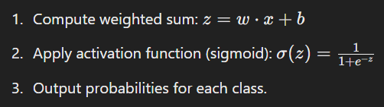

### **Cost Function**

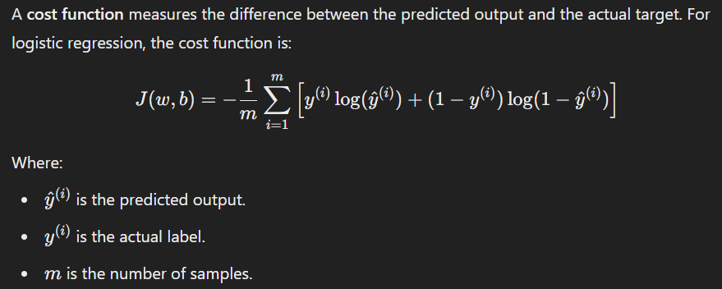

### **Activation Functions**

Activation functions introduce non-linearity to neural networks. Common functions include:

1. **Sigmoid**: Outputs values between 0 and 1.
2. **Tanh**: Outputs values between -1 and 1.
3. **ReLU**: Outputs max⁡(0,x), introducing sparsity and efficiency.

### **Gradient Descent for Logistic Regression**

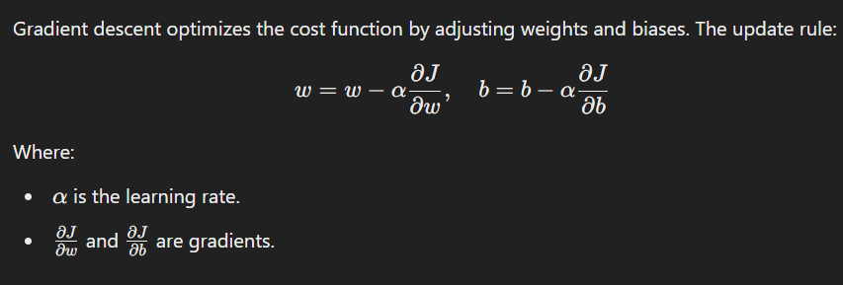

### **Backpropagation**

**Backpropagation** is an algorithm for training neural networks by propagating the error backward from the output layer to the input layer. It involves:

1. **Forward Pass**: Compute predictions.
2. **Compute Loss**: Measure the error using a cost function.
3. **Backward Pass**: Calculate gradients using the chain rule.
4. **Parameter Update**: Use gradient descent to minimize loss.

### **20 MCQs**

#### **Easy**

1. What is the purpose of an activation function?  
   a) Introduce linearity  
   b) Introduce non-linearity  
   c) Calculate gradients  
   d) Minimize the cost function  
   **Answer**: b) Introduce non-linearity
2. Which function is used in logistic regression?  
   a) ReLU  
   b) Sigmoid  
   c) Tanh  
   d) Softmax  
   **Answer**: b) Sigmoid
3. What is the range of the sigmoid function?  
   a) 0 to 1  
   b) -1 to 1  
   c) 0 to infinity  
   d) Negative infinity to infinity  
   **Answer**: a) 0 to 1
4. The cost function for logistic regression is:  
   a) Mean Squared Error  
   b) Binary Cross-Entropy  
   c) Hinge Loss  
   d) KL Divergence  
   **Answer**: b) Binary Cross-Entropy
5. Backpropagation uses:  
   a) Forward pass only  
   b) Chain rule for gradients  
   c) Random weight updates  
   d) Fixed weights  
   **Answer**: b) Chain rule for gradients

#### **Medium**

1. In logistic regression, the decision boundary is:  
   a) Linear  
   b) Non-linear  
   c) Curved  
   d) Random  
   **Answer**: a) Linear
2. Which property makes ReLU popular?  
   a) No vanishing gradient problem  
   b) Always outputs positive values  
   c) Smooth curve  
   d) Computationally expensive  
   **Answer**: a) No vanishing gradient problem
3. Gradient descent works by:  
   a) Increasing the cost function  
   b) Minimizing the cost function  
   c) Eliminating weights  
   d) Avoiding gradients  
   **Answer**: b) Minimizing the cost function
4. What is the key advantage of backpropagation?  
   a) Avoids overfitting  
   b) Efficient computation of gradients  
   c) Faster inference  
   d) Requires no activation functions  
   **Answer**: b) Efficient computation of gradients
5. The output of a logistic regression model is:  
   a) Binary values (0 or 1)  
   b) Probabilities  
   c) Real numbers  
   d) Vectors  
   **Answer**: b) Probabilities

#### **Hard**

1. What does the gradient represent in gradient descent?  
   a) Maximum value of the function  
   b) Direction of steepest ascent  
   c) Direction of steepest descent  
   d) None of the above  
   **Answer**: c) Direction of steepest descent
2. Why does gradient descent use a learning rate?  
   a) To avoid overfitting  
   b) To control the step size  
   c) To speed up training  
   d) To prevent gradient vanishing  
   **Answer**: b) To control the step size
3. The main drawback of sigmoid activation is:  
   a) Non-linearity  
   b) Vanishing gradient  
   c) Exploding gradient  
   d) Negative output  
   **Answer**: b) Vanishing gradient
4. What is the derivative of ReLU for x<0?  
   a) 0  
   b) 1  
   c) Undefined  
   d) -1  
   **Answer**: a) 0
5. Backpropagation relies heavily on:  
   a) Taylor series  
   b) Chain rule of differentiation  
   c) Numerical differentiation  
   d) Forward propagation only  
   **Answer**: b) Chain rule of differentiation

============================================================================================================================================

**Session 5**

### **Sigmoid Model**

The **Sigmoid Model** is widely used for binary classification tasks. It employs the **sigmoid activation function**, which maps any input value to a range between 0 and 1. This makes it ideal for probability estimation.

#### **Sigmoid Function Formula:**

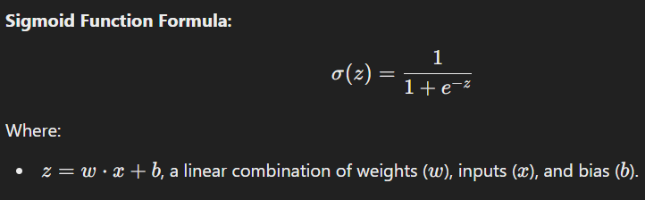

#### **Applications:**

* Logistic regression.
* Binary classification in neural networks.
* Probabilistic predictions.

#### **Characteristics:**

* Output range: (0,1).
* Smooth and differentiable.
* Prone to vanishing gradients for extreme input values.

### **Sigmoid Loss Function**

The **Sigmoid Loss Function**, also known as **Binary Cross-Entropy Loss**, is commonly used with the sigmoid model to measure the discrepancy between predicted probabilities and actual labels.

#### **Loss Function Formula:**

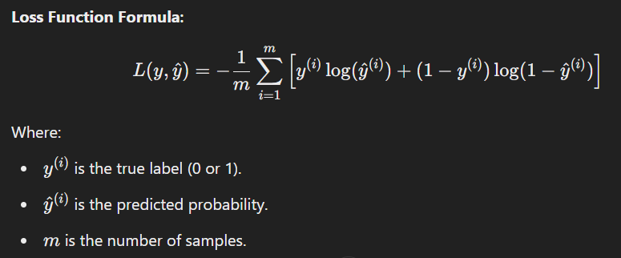

#### **Key Points:**

* Encourages the model to predict values close to actual labels.
* Sensitive to class imbalances (addressed by reweighting or sampling).

### **Introduction to Learning Algorithm**

A **learning algorithm** determines how a model updates its parameters to minimize the loss function. Examples include:

1. **Gradient Descent**: Adjusts parameters iteratively to reduce loss.
2. **Stochastic Gradient Descent (SGD)**: Updates parameters using a single or small batch of samples.
3. **Momentum-Based Methods**: Adds momentum to avoid oscillations in updates.
4. **Adaptive Methods**: Adjust learning rates dynamically (e.g., Adam, RMSProp).

#### **Goal:**

To find the optimal parameters w and b that minimize the loss function.

### **Deriving the Gradient Descent Update Rule**

Gradient descent optimizes parameters by computing the gradient of the loss function with respect to each parameter and updating them iteratively.

#### **Steps:**

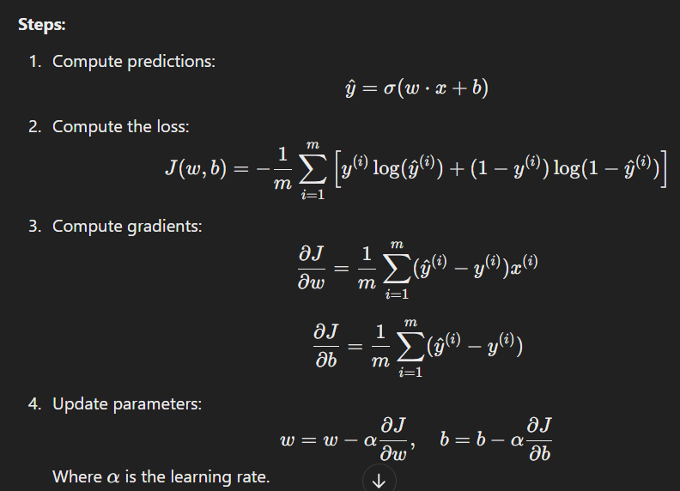

### **Sigmoid Evaluation**

Evaluating a sigmoid model involves assessing its predictive performance. Common metrics include:

1. **Accuracy**: Fraction of correct predictions.
2. **Precision**: True Positives / (True Positives+False Positives).
3. **Recall**: True Positives/(True Positives+False Negatives).
4. **F1 Score**: Harmonic mean of precision and recall.
5. **AUC-ROC**: Measures the ability to distinguish between classes.

### **MCQs**

#### **Easy**

1. The sigmoid function maps any input to a range of:  
   a) 0 to 1  
   b) -1 to 1  
   c) 0 to infinity  
   d) -infinity to infinity  
   **Answer**: a) 0 to 1
2. What does the sigmoid loss function minimize?  
   a) Mean squared error  
   b) Binary cross-entropy  
   c) Hinge loss  
   d) KL divergence  
   **Answer**: b) Binary cross-entropy
3. Gradient descent updates parameters by:  
   a) Adding random noise  
   b) Following the gradient  
   c) Following the negative gradient  
   d) Doubling the learning rate  
   **Answer**: c) Following the negative gradient
4. What is the derivative of the sigmoid function?  
   a) σ(x)⋅(1−σ(x))  
   b) x⋅σ(x)  
   c) σ(x)+1  
   d) None of the above  
   **Answer**: a) σ(x)⋅(1−σ(x))
5. The sigmoid model is primarily used for:  
   a) Multi-class classification  
   b) Binary classification  
   c) Clustering  
   d) Regression  
   **Answer**: b) Binary classification

#### **Medium**

1. Which metric is best for evaluating a sigmoid model in imbalanced datasets?  
   a) Accuracy  
   b) Precision  
   c) Recall  
   d) F1 Score  
   **Answer**: d) F1 Score
2. What happens when the learning rate is too high?  
   a) Faster convergence  
   b) Oscillation around the minimum  
   c) Stuck in local minima  
   d) Zero gradient  
   **Answer**: b) Oscillation around the minimum
3. Binary cross-entropy loss penalizes:  
   a) Small predictions  
   b) Predictions far from the true labels  
   c) Large predictions  
   d) All predictions equally  
   **Answer**: b) Predictions far from the true labels
4. AUC-ROC evaluates:  
   a) Precision and recall  
   b) True positive rate vs. false positive rate  
   c) Sensitivity and specificity  
   d) Cost function value  
   **Answer**: b) True positive rate vs. false positive rate
5. What is the primary hyperparameter in gradient descent?  
   a) Batch size  
   b) Learning rate  
   c) Momentum  
   d) Epochs  
   **Answer**: b) Learning rate

#### **Hard**

1. Which property makes the sigmoid prone to vanishing gradients?  
   a) Smooth curve  
   b) Saturation for large values of z  
   c) Non-linearity  
   d) Differentiability  
   **Answer**: b) Saturation for large values of zzz
2. The gradient of binary cross-entropy with respect to weights is:  
   a) Proportional to the error  
   b) Proportional to 1/x  
   c) Independent of the input  
   d) Always positive  
   **Answer**: a) Proportional to the error
3. A poor choice of learning rate in gradient descent leads to:  
   a) Better generalization  
   b) Overfitting  
   c) Divergence or slow convergence  
   d) Increased accuracy  
   **Answer**: c) Divergence or slow convergence
4. Which metric combines precision and recall?  
   a) F1 Score  
   b) AUC-ROC  
   c) Accuracy  
   d) Specificity  
   **Answer**: a) F1 Score
5. Which activation function can avoid vanishing gradients better than sigmoid?  
   a) ReLU  
   b) Tanh  
   c) Linear  
   d) Softmax  
   **Answer**: a) ReLU

============================================================================================================================================

**Session 6**

### **Shallow Neural Networks**

A **shallow neural network** consists of an input layer, one hidden layer, and an output layer. It is called shallow because it has a single hidden layer, as opposed to deep networks which have multiple hidden layers.

* **Input layer**: Receives the input features.
* **Hidden layer**: Performs computations by applying weights and activation functions.
* **Output layer**: Produces the final result, such as a classification or regression output.

#### **Key Properties:**

* **Limited capacity**: Shallow networks are less capable of learning complex patterns compared to deep networks.
* **Training**: Training shallow networks typically requires fewer computations and may converge faster.

Shallow networks are useful for simpler tasks, but for more complex data like images or speech, deeper models are usually preferred.

### **Hidden Units and Hidden Layers**

* **Hidden Units**: These are the neurons within the hidden layer. Each hidden unit processes the input by applying a weighted sum of inputs and passing it through an activation function to produce an output. The number of hidden units determines the capacity of the network to learn from the data.
* **Hidden Layers**: In deep learning, multiple hidden layers are stacked on top of each other. Each layer extracts increasingly abstract features from the data. The more hidden layers, the more complex the patterns that can be learned.

#### **Key Points:**

* The first hidden layer learns basic patterns.
* Deeper hidden layers learn more abstract and complex features.
* The number of hidden layers and units should be chosen carefully to avoid overfitting or underfitting.

### **Activation Functions: Tanh and ReLU**

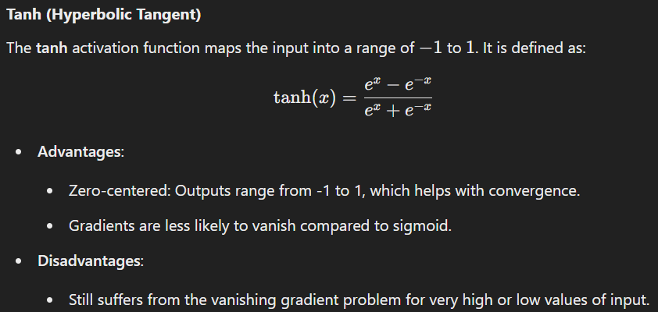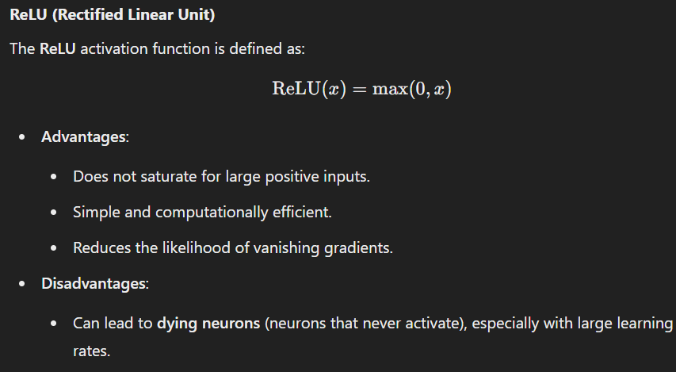

### **Forward and Backward Propagation with a Hidden Layer**

#### **Forward Propagation:**

* The process of passing input data through the network to generate an output.

1. Multiply the input values by weights.
2. Add biases to the weighted sum.
3. Apply the activation function to produce an output.
4. Repeat this process for each hidden layer and the output layer.

#### **Backward Propagation:**

* Used to adjust the weights based on the error between the predicted output and the actual target.

1. Compute the loss (e.g., MSE, cross-entropy).
2. Calculate the gradient of the loss with respect to each weight using the chain rule.
3. Update the weights by applying gradient descent (or another optimization method).
4. Repeat this process iteratively until the error is minimized.

The backward propagation ensures that the weights in the network are optimized to reduce prediction errors.

### **Deep Learning Notations and Neural Network Representations**

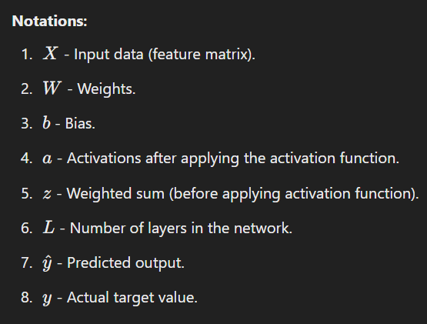

#### **Neural Network Representations:**

* **Graphical Representation**: A neural network can be represented as a graph where each node (neuron) is connected to other neurons by edges (weights). The connections represent the flow of information, with each edge indicating the weight between two neurons.
* **Layer Representation**: Each layer is represented as a group of neurons that processes data from the previous layer.
* **Activation Representation**: Activation functions are applied after calculating the weighted sum in each layer to introduce non-linearity.

### **MCQs**

#### **Easy**

1. A shallow neural network consists of:  
   a) One input layer, one hidden layer, and one output layer  
   b) Only one input layer  
   c) One input and multiple hidden layers  
   d) No output layer  
   **Answer**: a) One input layer, one hidden layer, and one output layer
2. Which of the following is an advantage of the ReLU activation function?  
   a) Saturates for positive values  
   b) Output values between -1 and 1  
   c) Computationally efficient  
   d) Gradients always vanish  
   **Answer**: c) Computationally efficient
3. In the forward propagation process, the weights are:  
   a) Initialized randomly and never updated  
   b) Applied after activation function  
   c) Used to calculate the output from the input  
   d) Always set to zero  
   **Answer**: c) Used to calculate the output from the input
4. Tanh function maps its output to the range:  
   a) 0 to 1  
   b) -1 to 1  
   c) -infinity to infinity  
   d) 0 to infinity  
   **Answer**: b) -1 to 1
5. Which of the following is a disadvantage of ReLU?  
   a) Computationally expensive  
   b) May lead to dying neurons  
   c) Saturates for large inputs  
   d) Outputs are between -1 and 1  
   **Answer**: b) May lead to dying neurons

#### **Medium**

1. The primary goal of backward propagation is to:  
   a) Compute the output for the given inputs  
   b) Adjust weights and biases to minimize the error  
   c) Apply activation functions  
   d) Compute the loss for the given dataset  
   **Answer**: b) Adjust weights and biases to minimize the error
2. In which activation function are the output values always positive?  
   a) Sigmoid  
   b) ReLU  
   c) Tanh  
   d) Softmax  
   **Answer**: b) ReLU
3. Which of the following is NOT part of forward propagation?  
   a) Calculating the weighted sum  
   b) Applying the activation function  
   c) Updating the weights  
   d) Generating the output  
   **Answer**: c) Updating the weights
4. The weights in a neural network are initialized:  
   a) Based on the output values  
   b) Randomly  
   c) Equal to the input values  
   d) Manually set to 1  
   **Answer**: b) Randomly
5. Backpropagation uses which method to update weights?  
   a) Gradient descent  
   b) Random selection  
   c) Batch processing  
   d) Mean squared error  
   **Answer**: a) Gradient descent

#### **Hard**

1. The primary advantage of using multiple hidden layers in deep neural networks is:  
   a) Better capacity to learn complex patterns  
   b) Faster convergence  
   c) Reduced risk of overfitting  
   d) Simpler computation  
   **Answer**: a) Better capacity to learn complex patterns
2. What is the main disadvantage of the Tanh activation function?  
   a) It can cause the vanishing gradient problem  
   b) It does not allow negative values  
   c) It is computationally expensive  
   d) It does not have any advantages  
   **Answer**: a) It can cause the vanishing gradient problem
3. In a deep learning model, which part of the network is responsible for introducing non-linearity?  
   a) Weights  
   b) Bias  
   c) Activation functions  
   d) Output layer  
   **Answer**: c) Activation functions
4. In gradient descent, the update rule for weights is determined by:  
   a) The sigmoid of the weighted sum  
   b) The gradient of the loss function with respect to weights  
   c) The output of the activation function  
   d) The target value  
   **Answer**: b) The gradient of the loss function with respect to weights
5. Which of the following is NOT a type of gradient descent optimization?  
   a) Stochastic gradient descent  
   b) Batch gradient descent  
   c) Momentum-based gradient descent  
   d) Hinge loss gradient descent  
   **Answer**: d) Hinge loss gradient descent

============================================================================================================================================

**Session 7 & 8**

### **Parameters vs Hyperparameters**

In machine learning, understanding the difference between **parameters** and **hyperparameters** is crucial for tuning and training models effectively.

#### **Parameters:**

* **Definition**: Parameters are the internal variables that the model learns from the training data. These values are optimized during the training process by the learning algorithm (e.g., gradient descent).
* **Examples**: In linear regression, parameters are the **weights** and **biases**. In neural networks, parameters are the **weights** between neurons and **biases** for each neuron.
* **Control**: Parameters are **learned** automatically by the model.

#### **Hyperparameters:**

* **Definition**: Hyperparameters are external configurations that are set before the learning process begins. They control the model's structure and the learning process itself, but they are not learned from the data.
* **Examples**: The **learning rate**, **batch size**, **number of layers** in a neural network, **regularization strength** (e.g., λ\lambdaλ in Ridge or Lasso), and **number of trees** in a random forest.
* **Control**: Hyperparameters are manually set or optimized through techniques like grid search, random search, or Bayesian optimization.

### **Regularization**

Regularization is a technique used to prevent **overfitting** in machine learning models. It introduces additional information (penalties) into the model training process to discourage overly complex models.

#### **Types of Regularization:**

1. **L1 Regularization (Lasso)**:
   * Adds the absolute values of the weights to the cost function.
   * Encourages sparsity, meaning it drives some feature weights to zero, effectively performing feature selection.
   * Penalty term: λ∑∣wi∣, where λ is the regularization parameter.
2. **L2 Regularization (Ridge)**:
   * Adds the squared values of the weights to the cost function.
   * Encourages smaller weight values but does not necessarily drive them to zero.
   * Penalty term: λ∑wi^2​.
3. **Elastic Net Regularization**:
   * Combines both L1 and L2 regularization. It is useful when there are many correlated features.

#### **Why Regularization Works:**

Regularization prevents the model from fitting noise in the training data, helping it generalize better on unseen data.

### **L1-L2 Normalization**

L1 and L2 normalization are techniques used to scale the input data or regularize the model weights in machine learning.

1. **L1 Normalization**:
   * This method scales the data by dividing each feature by the sum of the absolute values of all features.
   * It encourages sparsity and helps with feature selection, as it can drive weights of less important features to zero.
   * 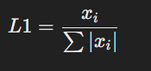
2. **L2 Normalization**:
   * This method scales the data by dividing each feature by the Euclidean norm (square root of sum of squares of all features).
   * It keeps all features but penalizes large weights by making them smaller.
3. 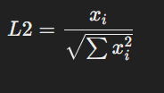

### **Frobenius Norm**

The **Frobenius norm** is a matrix norm that can be used to regularize weight matrices in machine learning, especially in the context of neural networks or matrix factorization problems.

#### **Definition:**

The Frobenius norm of a matrix A (where A is a matrix with elements aij) is the square root of the sum of the absolute squares of its elements. It is defined as:

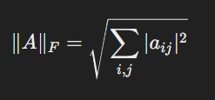

* **Usage in Machine Learning**: The Frobenius norm is often used in **matrix factorization** problems or as a regularizer to prevent large weight matrices in deep learning models.
* **Key Idea**: It encourages small values for the weight parameters by penalizing large weights.

#### **Properties:**

* The Frobenius norm is the natural extension of the L2 norm to matrices.
* It is **computationally expensive** to compute for large matrices, especially in deep learning models.

### **MCQs**

#### **Easy**

1. **Which of the following are parameters that are learned by the model?**a) Learning rate  
   b) Weights and biases  
   c) Number of hidden layers  
   d) Batch size  
   **Answer**: b) Weights and biases
2. **Which of the following is true for hyperparameters?**a) They are learned from the data  
   b) They are manually set before training  
   c) They are always the same for all models  
   d) They are computed during training  
   **Answer**: b) They are manually set before training
3. **What does regularization in machine learning help to prevent?**a) Overfitting  
   b) Underfitting  
   c) Convergence  
   d) Data imbalance  
   **Answer**: a) Overfitting
4. **L2 regularization is also known as:**a) Lasso  
   b) Ridge  
   c) Elastic Net  
   d) Dropout  
   **Answer**: b) Ridge
5. **Which of the following is a key advantage of L1 regularization?**a) It shrinks the coefficients to zero, effectively performing feature selection.  
   b) It never results in zero coefficients.  
   c) It improves the convergence speed.  
   d) It increases the model complexity.  
   **Answer**: a) It shrinks the coefficients to zero, effectively performing feature selection.

#### **Medium**

1. **What does L2 regularization add to the cost function?**a) The sum of the absolute values of the weights  
   b) The squared values of the weights  
   c) The sum of the exponential values of the weights  
   d) The logarithmic values of the weights  
   **Answer**: b) The squared values of the weights
2. **Which regularization technique is a combination of L1 and L2 regularization?**a) Lasso  
   b) Ridge  
   c) Elastic Net  
   d) Dropout  
   **Answer**: c) Elastic Net
3. **Which of the following is NOT a characteristic of the Frobenius norm?**a) It is the square root of the sum of squares of matrix elements.  
   b) It is often used in matrix factorization problems.  
   c) It penalizes large values of matrix elements.  
   d) It is used to prevent overfitting in decision trees.  
   **Answer**: d) It is used to prevent overfitting in decision trees.
4. **Which of the following is the main purpose of the regularization parameter λ in L1/L2 regularization?**a) To adjust the learning rate  
   b) To control the penalty applied to the model's weights  
   c) To define the number of hidden units in the network  
   d) To control the number of epochs  
   **Answer**: b) To control the penalty applied to the model's weights
5. **Which of the following is a potential downside of using L1 regularization?**a) It does not help in preventing overfitting.  
   b) It may lead to underfitting.  
   c) It encourages sparsity and may eliminate useful features.  
   d) It has no effect on model complexity.  
   **Answer**: c) It encourages sparsity and may eliminate useful features.

#### **Hard**

1. **Which of the following optimization methods would you use to minimize a regularized loss function?**a) Gradient descent  
   b) Genetic algorithms  
   c) K-means clustering  
   d) Expectation-Maximization  
   **Answer**: a) Gradient descent
2. **What is the Frobenius norm used for in machine learning models?**a) To regularize matrices and prevent large weight values  
   b) To calculate the accuracy of a classification model  
   c) To handle missing data  
   d) To calculate the variance of the model's predictions  
   **Answer**: a) To regularize matrices and prevent large weight values
3. **Which regularization technique is best suited for feature selection?**a) L1 regularization (Lasso)  
   b) L2 regularization (Ridge)  
   c) Elastic Net  
   d) Dropout  
   **Answer**: a) L1 regularization (Lasso)
4. **In the context of neural networks, what is the effect of using the Frobenius norm as a regularizer on weight matrices?**a) It reduces the complexity of the model by encouraging smaller weight values.  
   b) It has no impact on the model's training process.  
   c) It increases the model's capacity to overfit the data.  
   d) It drives all weights to zero, eliminating the need for learning.  
   **Answer**: a) It reduces the complexity of the model by encouraging smaller weight values.
5. **How does L2 regularization (Ridge) affect the model's weights?**a) It forces all weights to be exactly zero.  
   b) It encourages weights to be small but does not force them to zero.  
   c) It makes the model more complex.  
   d) It has no effect on the weights.  
   **Answer**: b) It encourages weights to be small but does not force them to zero.

============================================================================================================================================

**Session 9**

### **Dropouts and Early Stopping**

#### **Dropout:**

* **Definition**: Dropout is a regularization technique used to prevent overfitting in neural networks, especially in deep learning models. During training, **dropout** randomly "drops out" (sets to zero) a percentage of neurons in the network, forcing the model to become less dependent on any specific neuron and thus improving its generalization ability.
* **How it works**:
  + At each training step, randomly selected neurons are "dropped out" (i.e., their output is set to zero).
  + The dropout rate, which is the percentage of neurons to drop, is typically between 20% and 50%.
  + During testing, no neurons are dropped out, and the weights of the neurons are scaled down by the dropout rate to maintain consistency between training and testing.
* **Why it helps**:
  + Dropout prevents overfitting by ensuring that the model does not become too reliant on any one neuron.
  + This randomness forces the network to learn redundant representations, making the model more robust and generalizable.

#### **Early Stopping:**

* **Definition**: Early stopping is a technique used during the training process to prevent overfitting. It involves stopping the training when the performance on a validation dataset starts to degrade, even if the performance on the training set is still improving.
* **How it works**:
  + During training, after each epoch, the model's performance is evaluated on a validation set.
  + If the validation performance has not improved for a specified number of epochs (patience), training is halted.
  + This helps avoid overfitting, which occurs when the model starts to fit the noise in the training data.
* **Why it helps**:
  + By stopping training early, you avoid excessive fitting to the training data, especially if the model starts memorizing rather than generalizing.
  + It reduces the computational cost of training by saving resources after the optimal performance is reached.

### **Data Augmentation**

**Data Augmentation** refers to the process of artificially increasing the size of a dataset by creating modified versions of data points in the dataset. This is particularly useful for training machine learning models, especially deep learning models, where large amounts of data are required to avoid overfitting.

#### **Techniques of Data Augmentation:**

1. **For Images**:
   * **Rotation**: Rotating images at random angles.
   * **Flipping**: Horizontally or vertically flipping images.
   * **Zooming**: Randomly zooming in or out of an image.
   * **Translation**: Shifting the image along x or y axis.
   * **Color modification**: Adjusting the brightness, contrast, or saturation.
   * **Cropping**: Randomly cropping the image and resizing it back.
2. **For Text**:
   * **Synonym Replacement**: Replacing words with their synonyms.
   * **Random Insertion**: Inserting random words into the text.
   * **Random Deletion**: Deleting random words from the text.
   * **Text Rotation**: Rearranging the order of words in sentences.
3. **For Audio**:
   * **Time Stretching**: Changing the speed of the audio.
   * **Pitch Shifting**: Altering the pitch of the audio.
   * **Noise Injection**: Adding noise to the audio.
   * **Volume Perturbation**: Adjusting the audio volume.

#### **Why Data Augmentation is Important:**

* **Reduces Overfitting**: By artificially increasing the size of the dataset, models are less likely to memorize the training data, and they generalize better.
* **Improves Model Performance**: When data is augmented, the model is exposed to more variety, which improves its ability to handle real-world data that may vary from the training set.
* **Makes the Model Robust**: It can improve robustness against variations, such as noise in images, distortions in speech, or paraphrasing in text.

### **MCQs**

#### **Easy**

1. **What does the dropout technique do in neural networks?**a) Increases the number of neurons  
   b) Prevents overfitting by randomly deactivating neurons  
   c) Increases the accuracy of training data  
   d) Makes the network deeper  
   **Answer**: b) Prevents overfitting by randomly deactivating neurons
2. **What is the main purpose of early stopping in machine learning?**a) To speed up training  
   b) To prevent the model from overfitting by stopping when the performance starts to degrade on the validation set  
   c) To increase the model complexity  
   d) To reduce the number of training epochs  
   **Answer**: b) To prevent the model from overfitting by stopping when the performance starts to degrade on the validation set
3. **Data augmentation is typically used for which purpose in machine learning?**a) To reduce the size of the dataset  
   b) To increase the size of the dataset by creating variations of the data  
   c) To reduce noise in the data  
   d) To select important features  
   **Answer**: b) To increase the size of the dataset by creating variations of the data
4. **Which of the following is NOT a common data augmentation technique for images?**a) Rotation  
   b) Translation  
   c) Noise removal  
   d) Flipping  
   **Answer**: c) Noise removal
5. **What happens when early stopping is used during training?**a) Training stops when validation loss starts increasing  
   b) Training stops when training accuracy reaches 100%  
   c) Training stops when the learning rate is reduced  
   d) Training stops after a fixed number of epochs  
   **Answer**: a) Training stops when validation loss starts increasing

#### **Medium**

1. **How does dropout regularization improve the generalization of a model?**a) By decreasing the training time  
   b) By forcing the model to rely on fewer neurons and preventing co-adaptation  
   c) By increasing the number of hidden layers  
   d) By using the full capacity of all neurons during training  
   **Answer**: b) By forcing the model to rely on fewer neurons and preventing co-adaptation
2. **What is the main advantage of using data augmentation in deep learning?**a) It reduces the need for a large computational budget  
   b) It helps the model generalize better by exposing it to a variety of data points  
   c) It ensures that the model learns from the training set only  
   d) It speeds up the training process  
   **Answer**: b) It helps the model generalize better by exposing it to a variety of data points
3. **Which of the following is NOT a typical transformation applied during data augmentation for text data?**a) Synonym replacement  
   b) Random deletion of words  
   c) Changing the text to uppercase  
   d) Random insertion of words  
   **Answer**: c) Changing the text to uppercase
4. **Which is the best description of the role of early stopping in training a neural network?**a) To reduce the model's complexity  
   b) To prevent the model from overfitting by halting when performance on the validation set deteriorates  
   c) To adjust the learning rate dynamically during training  
   d) To train the model until a fixed number of epochs is reached  
   **Answer**: b) To prevent the model from overfitting by halting when performance on the validation set deteriorates
5. **In data augmentation, what effect does randomly rotating an image have on the model?**a) It helps the model become invariant to rotations, making it more robust to changes in orientation  
   b) It only changes the size of the image  
   c) It introduces noise into the dataset  
   d) It increases the data variance without improving robustness  
   **Answer**: a) It helps the model become invariant to rotations, making it more robust to changes in orientation

#### **Hard**

1. **Which of the following would be a potential risk if data augmentation is not used properly?**a) Model underfitting  
   b) Model overfitting due to too many augmented samples  
   c) Increase in the model's training time  
   d) Inconsistent model convergence  
   **Answer**: b) Model overfitting due to too many augmented samples
2. **How does dropout regularization affect the neural network during training?**a) It trains only a few randomly selected neurons during each iteration.  
   b) It trains all the neurons at full capacity and reduces learning rate.  
   c) It accelerates convergence of the network.  
   d) It increases the depth of the neural network by adding layers.  
   **Answer**: a) It trains only a few randomly selected neurons during each iteration.
3. **What is the effect of early stopping when the validation error starts increasing?**a) It prevents the model from further training, thus avoiding overfitting.  
   b) It triggers a new training cycle with updated hyperparameters.  
   c) It increases the learning rate to escape local minima.  
   d) It reduces the number of epochs.  
   **Answer**: a) It prevents the model from further training, thus avoiding overfitting.
4. **Which of the following is an example of a data augmentation technique for audio data?**a) Random rotation of the waveform  
   b) Adding noise or altering pitch  
   c) Changing the hue of the spectrogram  
   d) Increasing brightness in the waveform  
   **Answer**: b) Adding noise or altering pitch
5. **What happens during the dropout process in neural networks during training?**a) It ensures that the weights are updated for all neurons  
   b) It randomly drops neurons, setting their output to zero for each iteration  
   c) It decreases the learning rate  
   d) It improves the convergence speed of the network  
   **Answer**: b) It randomly drops neurons, setting their output to zero for each iteration

#### **Advanced**

1. **Which method is commonly used for tuning the dropout rate?**a) Cross-validation on the validation set  
   b) Direct backpropagation updates  
   c) Adding more layers  
   d) Gradient descent optimization  
   **Answer**: a) Cross-validation on the validation set
2. **What could happen if the dropout rate is set too high?**a) The model may struggle to learn any meaningful patterns  
   b) The model will overfit the data  
   c) The training time will be significantly reduced  
   d) The model will become too complex  
   **Answer**: a) The model may struggle to learn any meaningful patterns
3. **In data augmentation, what is a common strategy to prevent overfitting when performing transformations?**a) Keep the transformations minimal and only slightly alter the original data  
   b) Only augment the data if the model is overfitting  
   c) Perform a very high level of transformation for each image  
   d) Use augmented data only for testing  
   **Answer**: a) Keep the transformations minimal and only slightly alter the original data
4. **In early stopping, what is the term "patience" referring to?**a) The number of iterations allowed before the model starts learning  
   b) The number of epochs without improvement before stopping  
   c) The time interval between each epoch  
   d) The minimum error required to stop training  
   **Answer**: b) The number of epochs without improvement before stopping
5. **How does early stopping prevent overfitting?**a) By reducing the learning rate dynamically  
   b) By training the model for a fixed number of epochs  
   c) By halting training when validation error stops improving, avoiding unnecessary overfitting  
   d) By adding regularization terms during training  
   **Answer**: c) By halting training when validation error stops improving, avoiding unnecessary overfitting

============================================================================================================================================

**Session 10**

### **Vanishing Gradient and Exploding Gradient Problems**

#### **Vanishing Gradient Problem:**

* **Definition**: The vanishing gradient problem occurs when the gradients (or the partial derivatives) of the loss function become extremely small as they are propagated backward through the network. This typically happens during the training of deep neural networks using gradient-based optimization techniques, such as gradient descent.
* **Why it happens**:
  + In deep neural networks, when backpropagation is used to update the weights, gradients are passed from the output layer back to the input layer. As the gradients are passed through multiple layers, they are multiplied by the weights, and due to activation functions like **sigmoid** or **tanh**, the gradients can diminish significantly.
  + For example, when using the **sigmoid** or **tanh** activation functions, their derivatives approach zero for extreme input values (i.e., the gradient becomes vanishingly small), causing the weight updates to become negligible for deeper layers.
* **Effects**:
  + The network struggles to learn properly, especially in the deeper layers, as the weights in these layers are not updated effectively. This leads to slow convergence or the model failing to converge at all.
  + The model will learn slowly, and in some cases, it may completely fail to learn patterns from the data, especially for very deep networks.

#### **Exploding Gradient Problem:**

* **Definition**: The exploding gradient problem is the opposite of the vanishing gradient problem, where the gradients become extremely large during backpropagation. This leads to excessively large updates to the model's weights, resulting in unstable training.
* **Why it happens**:
  + In some cases, when weights are initialized improperly or when activation functions have very large gradients, the gradients can grow exponentially as they are propagated back through the network.
  + For example, using activation functions like **ReLU** with large weights can cause the gradients to increase exponentially as they are passed backward through the layers.
* **Effects**:
  + When the gradients explode, the weight updates become too large, and the learning process becomes unstable. This can cause the model to diverge (i.e., the model's error starts increasing drastically instead of decreasing).
  + Training may fail to converge, and the model may become unable to generalize on new data.

#### **Solutions:**

1. **For Vanishing Gradients**:
   * **Weight Initialization**: Using techniques like **Xavier initialization** (for tanh) or **He initialization** (for ReLU) to properly initialize weights can help mitigate the vanishing gradient problem.
   * **ReLU and Variants**: Using activation functions like **ReLU** or its variants (**Leaky ReLU**, **ELU**) instead of sigmoid or tanh can help as they do not saturate and maintain stronger gradients.
   * **Batch Normalization**: This technique normalizes the inputs to each layer, preventing the gradients from vanishing.
2. **For Exploding Gradients**:
   * **Gradient Clipping**: Gradient clipping involves setting a threshold value for the gradients. If the gradients exceed this threshold, they are scaled down to the limit to avoid explosion.
   * **Weight Regularization**: L2 regularization or using smaller weight values during initialization can help prevent the gradients from exploding.
   * **Proper Weight Initialization**: Using methods like **Xavier** and **He initialization** also helps prevent gradients from exploding.

### **Gradient Checking:**

* **Definition**: Gradient checking is a technique used to verify the correctness of gradients computed by backpropagation. It is primarily used for debugging purposes, especially in the early stages of building and training neural networks.
* **How it works**:
  + In gradient checking, the gradients calculated by backpropagation are compared to numerically approximated gradients.
  + The numerical gradient is computed using the finite difference method, which approximates the gradient of a function at a point by measuring the change in the function value with respect to a small change in input.
* **Mathematical Formula for Numerical Gradient**:

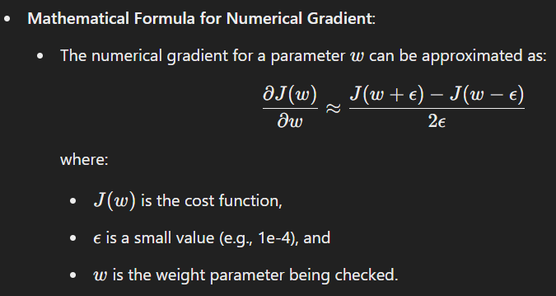

* **Why it is important**:
  + By comparing the gradients computed by backpropagation with the numerical gradients, you can check if the backpropagation is implemented correctly.
  + If the two gradients match, it indicates that the backpropagation implementation is correct. If they do not match, it indicates an issue with the backpropagation code (e.g., an error in the chain rule implementation).
* **Challenges**:
  + **Numerical gradients** are computationally expensive and require recalculating the cost function for each weight, so they are not used during the actual training process but only for verification.
  + The approximation of gradients using finite differences may not be accurate enough for very large networks, especially with many parameters.

### **MCQs**

#### **Easy**

1. **What is the vanishing gradient problem in neural networks?**a) Gradients become excessively large, causing unstable training  
   b) Gradients become too small to update the weights effectively  
   c) The network stops learning  
   d) The model converges too quickly  
   **Answer**: b) Gradients become too small to update the weights effectively
2. **What is the primary cause of exploding gradients?**a) Too small weight values  
   b) Incorrect gradient computation  
   c) Large gradients that cause unstable training  
   d) Too many layers in the network  
   **Answer**: c) Large gradients that cause unstable training
3. **Which activation function is less likely to cause the vanishing gradient problem?**a) Sigmoid  
   b) Tanh  
   c) ReLU  
   d) Softmax  
   **Answer**: c) ReLU
4. **What is gradient checking used for?**a) To optimize weights  
   b) To verify the correctness of backpropagation gradients  
   c) To reduce overfitting  
   d) To calculate the learning rate  
   **Answer**: b) To verify the correctness of backpropagation gradients
5. **What is the main effect of exploding gradients?**a) The model learns very slowly  
   b) The weights update too slowly  
   c) The model's loss increases drastically, making training unstable  
   d) The model converges to a suboptimal solution  
   **Answer**: c) The model's loss increases drastically, making training unstable

#### **Medium**

1. **Which method can be used to handle the exploding gradient problem?**a) Dropout  
   b) Gradient clipping  
   c) Early stopping  
   d) Batch normalization  
   **Answer**: b) Gradient clipping
2. **What is the purpose of the finite difference method in gradient checking?**a) To compute the exact gradient for backpropagation  
   b) To approximate the gradient numerically for comparison  
   c) To improve the speed of the gradient descent algorithm  
   d) To prevent overfitting in the model  
   **Answer**: b) To approximate the gradient numerically for comparison
3. **What happens when the vanishing gradient problem occurs in a deep network?**a) The model becomes unable to fit data properly due to extremely small gradients  
   b) The model diverges during training  
   c) The model converges too quickly  
   d) The training becomes more stable  
   **Answer**: a) The model becomes unable to fit data properly due to extremely small gradients
4. **Which of the following is a solution to the vanishing gradient problem?**a) Increasing the learning rate  
   b) Using larger batch sizes  
   c) Using ReLU or Leaky ReLU activations  
   d) Decreasing the number of training epochs  
   **Answer**: c) Using ReLU or Leaky ReLU activations
5. **Which gradient checking method uses a small perturbation to approximate the gradient?**a) Stochastic gradient descent  
   b) Finite difference method  
   c) Backpropagation  
   d) Momentum-based gradient descent  
   **Answer**: b) Finite difference method

#### **Hard**

1. **What is the effect of using very small learning rates when dealing with exploding gradients?**a) It can cause the gradients to vanish  
   b) It can cause slow convergence and ineffective learning  
   c) It stabilizes training by reducing gradient fluctuations  
   d) It amplifies the exploding gradient problem  
   **Answer**: b) It can cause slow convergence and ineffective learning
2. **Which of the following is a potential downside of gradient checking?**a) It significantly reduces the number of training iterations  
   b) It is computationally expensive and cannot be used during training  
   c) It always improves the accuracy of backpropagation  
   d) It increases the likelihood of overfitting  
   **Answer**: b) It is computationally expensive and cannot be used during training
3. **What is a good way to initialize weights to avoid the vanishing gradient problem?**a) Initialize weights randomly with values close to zero  
   b) Initialize weights with large random values  
   c) Use Xavier or He initialization depending on the activation function  
   d) Use small constant values for weights  
   **Answer**: c) Use Xavier or He initialization depending on the activation function
4. **Which of the following is NOT a common technique for mitigating the vanishing gradient problem?**a) Using ReLU activations  
   b) Xavier initialization  
   c) Using tanh activations  
   d) Batch normalization  
   **Answer**: c) Using tanh activations
5. **During gradient checking, how do you calculate the numerical gradient for a parameter www?**a) By averaging the gradients from all layers  
   b) By using the finite difference formula  
   c) By directly using the backpropagated gradients  
   d) By integrating over all input values  
   **Answer**: b) By using the finite difference formula

============================================================================================================================================

**Session 11**

### **Batch Normalization and Other Methods for Data Normalization**

### **Batch Normalization (BN)**

#### **Overview:**

* **Batch Normalization** is a technique introduced by Sergey Ioffe and Christian Szegedy in 2015 to improve the training of deep neural networks. It normalizes the output of each layer so that the network can train faster and become more stable.
* In deep neural networks, the inputs to each layer can have highly varying distributions during training, a phenomenon called **internal covariate shift**. This makes training slower because the optimizer has to adapt to these changing distributions of layer inputs. Batch normalization addresses this issue by standardizing the inputs to each layer.

#### **How Batch Normalization Works:**

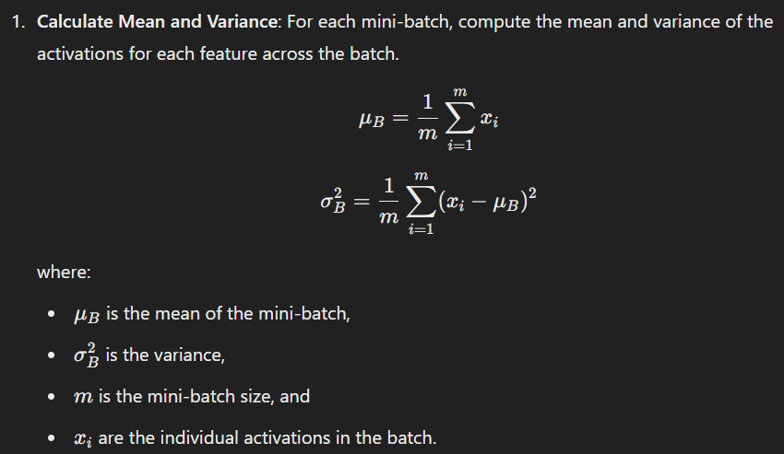

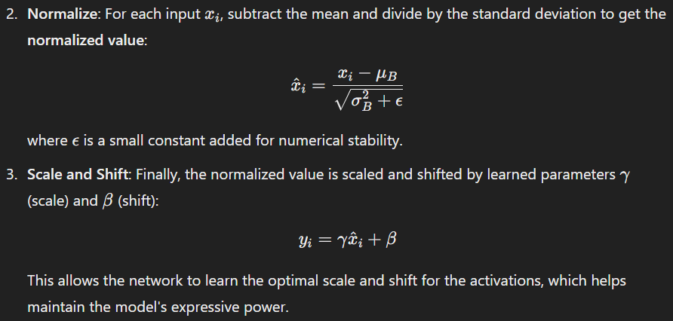

#### **Why Batch Normalization Helps:**

1. **Reduces Internal Covariate Shift**: By normalizing the inputs, BN helps reduce the variance in the activation distributions, making the training process more stable.
2. **Improves Convergence**: With more stable activations, the optimizer can take larger steps, speeding up convergence.
3. **Acts as a Regularizer**: The noise introduced by the mini-batch statistics has a regularizing effect, often eliminating the need for other regularization techniques like **Dropout**.
4. **Reduces Sensitivity to Initialization**: BN helps mitigate the dependency on careful initialization, allowing the use of higher learning rates.

#### **Limitations:**

* **Computational Overhead**: For very large networks or large batch sizes, the computation of mean and variance can add overhead, especially for distributed systems.
* **Dependency on Batch Size**: Small batch sizes may lead to noisy estimates of the mean and variance, affecting the effectiveness of the normalization.

### **Other Methods for Data Normalization**

#### **1. Standardization (Z-score Normalization):**

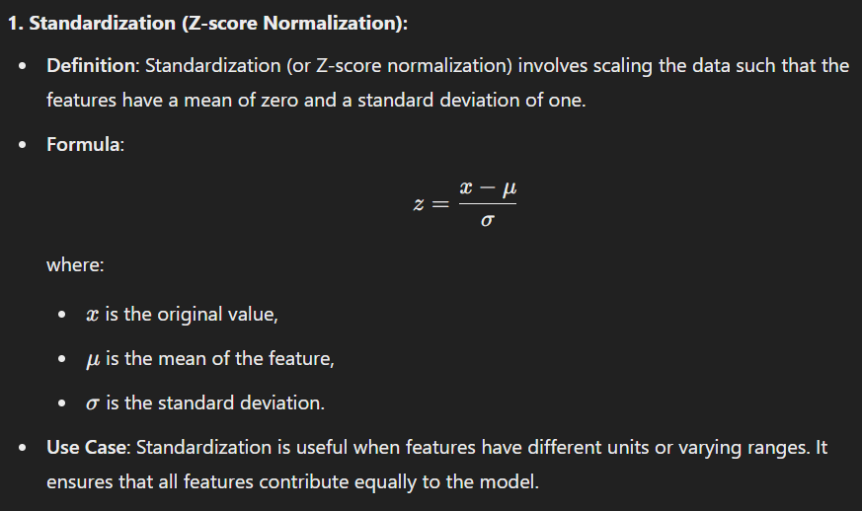

#### **2. Min-Max Scaling (Normalization):**

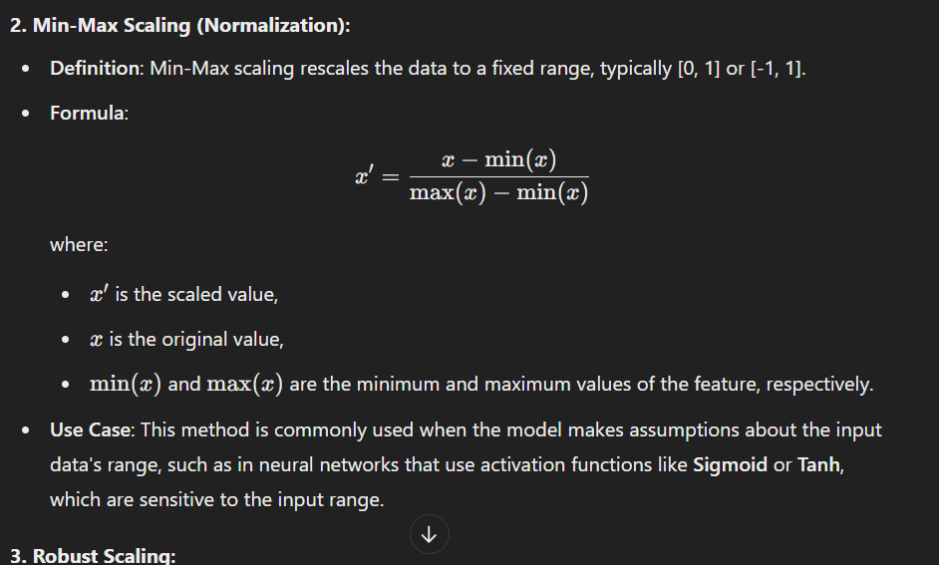

#### **3. Robust Scaling:**

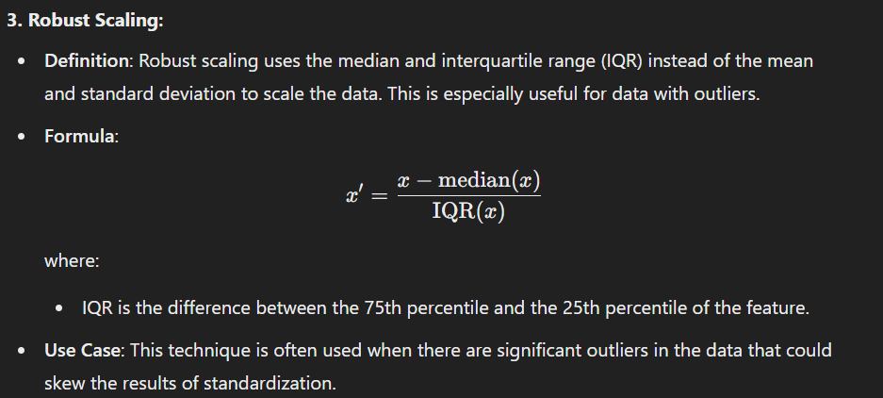

#### **4. Log Transformation:**

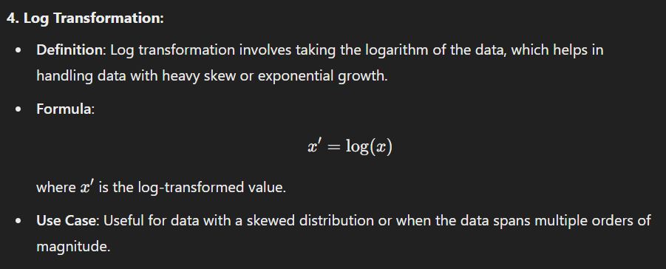

#### **5. Max Abs Scaling:**

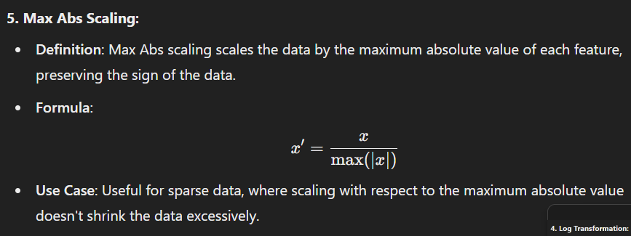

### **MCQs on Batch Normalization and Data Normalization**

#### **Easy**

1. **What is the main purpose of batch normalization in deep neural networks?**a) To increase the model's complexity  
   b) To reduce internal covariate shift  
   c) To prevent overfitting  
   d) To increase the batch size  
   **Answer**: b) To reduce internal covariate shift
2. **In batch normalization, which parameter controls the scale of the normalized output?**a) Mean  
   b) Beta  
   c) Gamma  
   d) Epsilon  
   **Answer**: c) Gamma
3. **What is the typical range of values obtained after applying Min-Max scaling?**a) [-1, 1]  
   b) [0, 1]  
   c) [0, ∞]  
   d) [-∞, ∞]  
   **Answer**: b) [0, 1]
4. **Which normalization method is sensitive to outliers?**a) Standardization  
   b) Min-Max Scaling  
   c) Robust Scaling  
   d) Batch Normalization  
   **Answer**: b) Min-Max Scaling
5. **Which method is used for normalizing the data when there are extreme outliers present?**a) Min-Max scaling  
   b) Z-score normalization  
   c) Robust Scaling  
   d) Log transformation  
   **Answer**: c) Robust Scaling

#### **Medium**

1. **What is the main advantage of using Batch Normalization during training?**a) It speeds up convergence by reducing internal covariate shift  
   b) It increases the number of parameters  
   c) It prevents the model from overfitting  
   d) It simplifies the network architecture  
   **Answer**: a) It speeds up convergence by reducing internal covariate shift
2. **Which method normalizes data by subtracting the median and dividing by the interquartile range?**a) Min-Max scaling  
   b) Z-score normalization  
   c) Robust Scaling  
   d) Log transformation  
   **Answer**: c) Robust Scaling
3. **In Batch Normalization, which value is typically calculated per mini-batch?**a) Mean and variance  
   b) Mean and standard deviation  
   c) Median and IQR  
   d) Maximum and minimum  
   **Answer**: a) Mean and variance
4. **Which of the following methods is useful when features have different units or scales?**a) Min-Max scaling  
   b) Robust Scaling  
   c) Z-score normalization  
   d) All of the above  
   **Answer**: d) All of the above
5. **What is the main disadvantage of using Min-Max scaling when working with unseen data?**a) The transformed data may not be in the range [0, 1]  
   b) It can lead to overfitting  
   c) It requires large computational resources  
   d) It is sensitive to outliers  
   **Answer**: d) It is sensitive to outliers

#### **Hard**

1. **Which normalization technique would be best suited for data with significant outliers?**a) Z-score normalization  
   b) Min-Max scaling  
   c) Robust Scaling  
   d) Log transformation  
   **Answer**: c) Robust Scaling
2. **Batch Normalization helps to stabilize training by reducing which of the following?**a) Learning rate  
   b) Internal covariate shift  
   c) Activation functions  
   d) Model complexity  
   **Answer**: b) Internal covariate shift
3. **What does the parameter β\betaβ in Batch Normalization control?**a) The mean of the activations  
   b) The standard deviation of the activations  
   c) The shift or offset applied to the normalized activations  
   d) The scaling of the normalized activations  
   **Answer**: c) The shift or offset applied to the normalized activations
4. **Which of the following is NOT a feature of Batch Normalization?**a) It normalizes each mini-batch independently  
   b) It helps mitigate vanishing/exploding gradients  
   c) It eliminates the need for regularization  
   d) It uses the global mean and variance  
   **Answer**: d) It uses the global mean and variance
5. **What is the typical behavior of batch normalization when using very small batch sizes?**a) It becomes more effective  
   b) It may lead to unstable training  
   c) It no longer normalizes the data  
   d) It reduces computation time  
   **Answer**: b) It may lead to unstable training

===============================================================================================================================

**Session 12:**

### **Optimization Algorithms in Deep Learning: ADAM & Mini-Batch Gradient Descent**

### **Optimization Algorithms in Deep Learning**

In deep learning, optimization refers to the process of minimizing (or maximizing) a cost (or loss) function by adjusting the weights of the model. Optimization algorithms are key to the training process of machine learning models, helping find the optimal parameters to minimize errors.

### **1. Gradient Descent (GD)**

Gradient descent is the most fundamental optimization algorithm. The goal of gradient descent is to minimize the loss function by updating the parameters (weights) in the direction of the negative gradient of the loss function.

#### **Gradient Descent Formula:**

θ=θ−η⋅∇θJ(θ)

Where:

* θ is the model parameter (weight),
* η is the learning rate,
* ∇θJ(θ) is the gradient of the loss function J(θ) with respect to the model parameter.

### **2. Mini-Batch Gradient Descent**

#### **Overview:**

* **Mini-batch gradient descent** is a compromise between **Stochastic Gradient Descent (SGD)** and **Batch Gradient Descent**.
* **Stochastic Gradient Descent** updates the parameters using only one data point, which can make the learning noisy and less stable.
* **Batch Gradient Descent** calculates the gradient using the entire training dataset, but it can be computationally expensive for large datasets.

#### **Mini-Batch Gradient Descent:**

* Mini-batch GD splits the training dataset into small batches and computes the gradient for each mini-batch. The parameters are then updated after processing each mini-batch.
* It strikes a balance between the stability of batch GD and the speed of SGD.

#### **Advantages:**

* More efficient for large datasets than full-batch gradient descent.
* Reduces the variance in the parameter updates, making the optimization process more stable than stochastic gradient descent.
* Can take advantage of modern hardware (such as GPUs), which are optimized for parallel processing.

#### **Update Rule:**

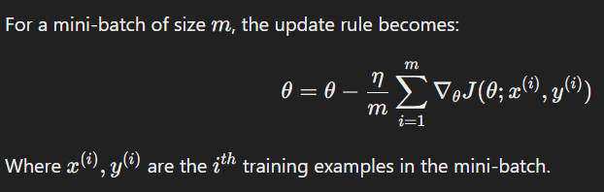

### **4. ADAM Optimizer**

#### **Overview:**

* **ADAM (Adaptive Moment Estimation)** is an advanced optimization algorithm designed to combine the advantages of two other extensions of gradient descent: **AdaGrad** and **RMSProp**.
* ADAM adapts the learning rate based on estimates of first-order moments (mean) and second-order moments (uncentered variance) of the gradients.

#### **Key Features:**

* **Adaptive Learning Rates**: Each parameter has its own learning rate that adapts during training.
* **Momentum**: ADAM uses momentum to accumulate gradients over time to smooth out updates, accelerating convergence.
* **Bias Correction**: ADAM corrects the bias in moment estimates during the early stages of training.

#### **ADAM Algorithm Steps:**

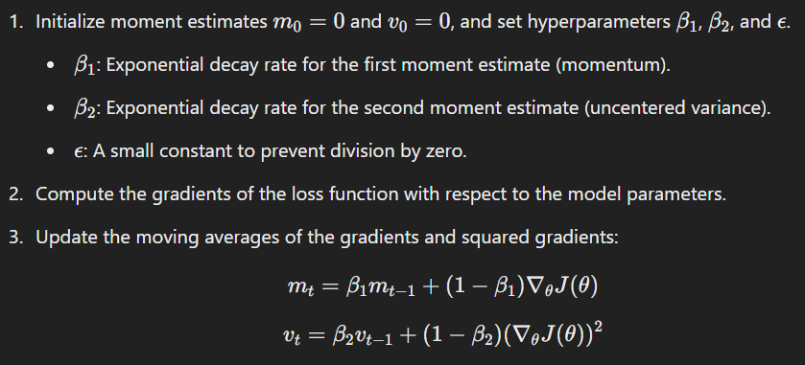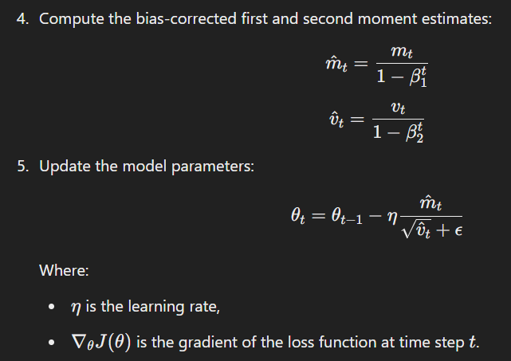

#### **Advantages of ADAM:**

* It works well with sparse data.
* Less memory intensive compared to full-batch gradient descent.
* Adaptive learning rates ensure faster convergence.

### **Comparison of Optimization Algorithms**

| **Optimizer** | **Advantages** | **Disadvantages** |
| --- | --- | --- |
| **Gradient Descent** | Simple, guaranteed convergence if the learning rate is small. | Slow, can get stuck in local minima. |
| **Mini-Batch GD** | Faster than batch GD, good for large datasets. | Can be noisy, requires fine-tuning of batch size. |
| **Stochastic GD (SGD)** | Very fast, good for online learning. | Noisy, slow convergence. |
| **ADAM** | Fast, handles sparse gradients, adaptive learning rate, reduces bias. | More hyperparameters, memory-intensive, can be prone to overfitting. |

### **MCQs on Optimization Algorithms (ADAM & Mini-Batch Gradient Descent)**

#### **Easy**

1. **Which of the following optimizers is an extension of stochastic gradient descent?**

a) ADAM  
b) Batch Gradient Descent  
c) Momentum  
d) None of the above  
**Answer**: a) ADAM

1. **In mini-batch gradient descent, the parameter update occurs after processing which part of the data?**

a) The entire dataset  
b) A single data point  
c) A small batch of data  
d) None of the above  
**Answer**: c) A small batch of data

1. **Which of the following is NOT a key feature of ADAM optimizer?**

a) Adaptive learning rate  
b) Momentum  
c) Regularization  
d) Bias correction  
**Answer**: c) Regularization

1. **Which of the following is used to compute the bias-corrected estimates in ADAM?**

a) Mini-batch gradients  
b) Exponential decay rates  
c) Learning rate  
d) Mean squared errors  
**Answer**: b) Exponential decay rates

1. **In mini-batch gradient descent, what is the typical range of batch sizes?**

a) 1 to 1000  
b) 50 to 500  
c) 100 to 10000  
d) 1 to 100  
**Answer**: a) 1 to 1000

#### **Medium**

1. **What is the key difference between stochastic gradient descent and mini-batch gradient descent?**

a) Stochastic GD uses the entire dataset, while mini-batch GD uses only one data point.  
b) Stochastic GD updates parameters after each data point, while mini-batch GD updates after a subset of data.  
c) Mini-batch GD is slower than stochastic GD.  
d) None of the above  
**Answer**: b) Stochastic GD updates parameters after each data point, while mini-batch GD updates after a subset of data.

1. **Which of the following optimizers is best for handling sparse gradients in deep learning models?**

a) Stochastic Gradient Descent  
b) Batch Gradient Descent  
c) ADAM  
d) Mini-batch Gradient Descent  
**Answer**: c) ADAM

1. **Which of the following is true about the ADAM optimizer?**

a) It uses only the first moment (mean) of the gradient.  
b) It uses both the first and second moments (mean and variance).  
c) It does not adapt the learning rate.  
d) It always requires large batch sizes.  
**Answer**: b) It uses both the first and second moments (mean and variance).

1. **What does the hyperparameter β1 in ADAM represent?**

a) The exponential decay rate for the second moment estimate.  
b) The learning rate.  
c) The exponential decay rate for the first moment estimate (momentum).  
d) The regularization term.  
**Answer**: c) The exponential decay rate for the first moment estimate (momentum).

1. **What does the parameter ϵ\epsilonϵ in ADAM optimizer do?**

a) Prevents overfitting.  
b) Prevents division by zero.  
c) Scales the gradients.  
d) Accelerates convergence.  
**Answer**: b) Prevents division by zero.

#### **Hard**

1. **What is the impact of using very small mini-batch sizes in mini-batch gradient descent?**

a) Faster convergence  
b) More noisy updates, making the training unstable  
c) Improved generalization  
d) None of the above  
**Answer**: b) More noisy updates, making the training unstable

1. **In the context of ADAM optimizer, what does the parameter β2\beta_2β2​ control?**

a) The learning rate  
b) The exponential decay rate for the second moment estimate  
c) The size of the mini-batch  
d) The bias correction term  
**Answer**: b) The exponential decay rate for the second moment estimate

1. **Which of the following is NOT a potential drawback of the ADAM optimizer?** a) Memory-intensive  
   b) It can lead to overfitting on small datasets  
   c) It is computationally inefficient for sparse data  
   d) It may not generalize well on new data  
   **Answer**: c) It is computationally inefficient for sparse data
2. **Which optimization algorithm is best for online learning or learning from a stream of data?** a) Mini-batch Gradient Descent  
   b) Batch Gradient Descent  
   c) Stochastic Gradient Descent  
   d) ADAM  
   **Answer**: c) Stochastic Gradient Descent
3. **Which of the following is an advantage of mini-batch gradient descent over full-batch gradient descent?** a) More efficient for large datasets  
   b) Always produces the best results  
   c) Can only be used with very small datasets  
   d) It does not require a learning rate  
   **Answer**: a) More efficient for large datasets

============================================================================================================================================

**Session 13:**

### **RMSProp, Momentum, and Other Gradient Descent Algorithms**

### **1. RMSProp (Root Mean Square Propagation)**

RMSProp is an adaptive learning rate optimization algorithm that divides the learning rate by an exponentially decaying average of squared gradients. It is designed to resolve the problem of diminishing learning rates in traditional gradient descent methods.

#### **Working of RMSProp:**

* It adjusts the learning rate based on the magnitude of recent gradients. Large gradients will result in a smaller update, and small gradients will result in a larger update.
* The main advantage is that it adapts the learning rate for each parameter, making it particularly effective for online or non-stationary problems.

#### **Mathematical Formula:**

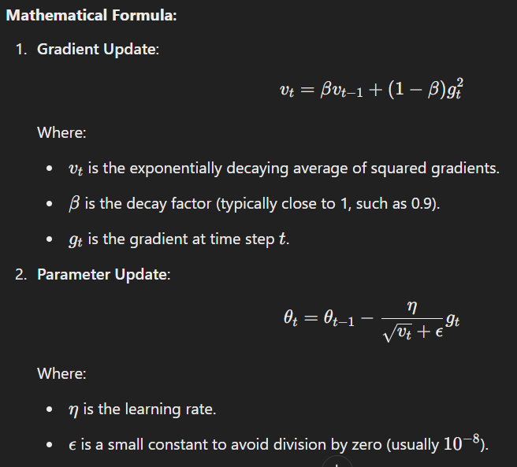

#### **Advantages of RMSProp:**

* **Adapts the learning rate**: Different learning rates for different parameters allow the algorithm to make faster progress in some directions while avoiding overshooting in others.
* **Works well for non-stationary objectives**: Such as those encountered in deep learning tasks.
* **Prevents issues with diminishing learning rates**: Ensures that learning continues efficiently.

### **2. Momentum**

Momentum is a gradient descent optimization technique that helps accelerate gradient descent in the relevant direction and dampens oscillations. Momentum updates the parameter by combining the current gradient with the previous gradient, allowing the optimizer to overcome small, non-important gradients.

#### **Working of Momentum:**

Momentum helps the optimizer to keep moving in the same direction (if the gradient is consistent) and avoid getting stuck in local minima or flat regions.

#### **Momentum Update Rule:**

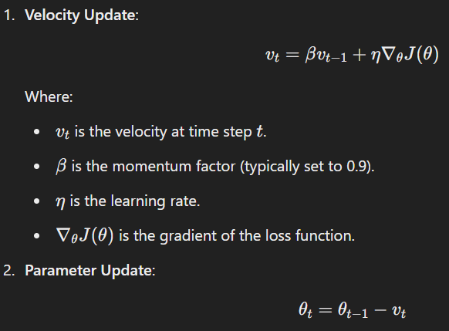

#### **Advantages of Momentum:**

* **Speeds up convergence**: Momentum accelerates gradient descent, especially in regions where the gradient is consistent.
* **Reduces oscillations**: It helps prevent the optimizer from oscillating back and forth across the minima.

#### **Comparison with Basic Gradient Descent:**

* In regular gradient descent, the updates depend solely on the current gradient, which can lead to oscillations.
* Momentum accumulates gradients from past steps, resulting in a smoother and faster convergence.

### **3. Nesterov Accelerated Gradient (NAG)**

Nesterov Accelerated Gradient is a variant of momentum. It computes the gradient not at the current position but at the approximated position after applying the momentum update. It allows for faster convergence compared to standard momentum.

#### **Formula:**

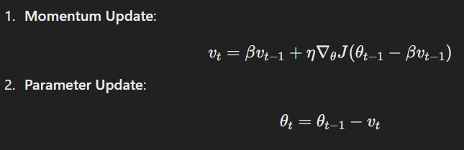

#### **Advantages of NAG:**

* It leads to faster convergence because it uses a lookahead strategy by calculating gradients after a momentum step.
* It is less likely to oscillate and can escape local minima.

### **4. Adagrad**

Adagrad is an adaptive learning rate algorithm that adjusts the learning rate based on the historical sum of squared gradients. It gives a large learning rate for parameters with sparse gradients and a smaller one for parameters with dense gradients.

#### **Adagrad Update Rule:**

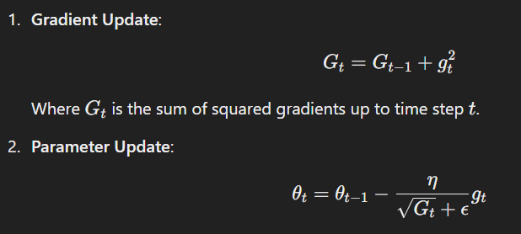

#### **Advantages of Adagrad:**

* **Good for sparse data**: Suitable for natural language processing and computer vision tasks where features are sparse.
* **Adapts to the data**: Learning rates decrease automatically when gradients become small.

### **5. AdaDelta**

AdaDelta is a modification of Adagrad that seeks to address its problem of the learning rate shrinking too much. AdaDelta uses a moving window of gradients and scales the learning rate based on the recent gradient updates.

#### **AdaDelta Update Rule:**

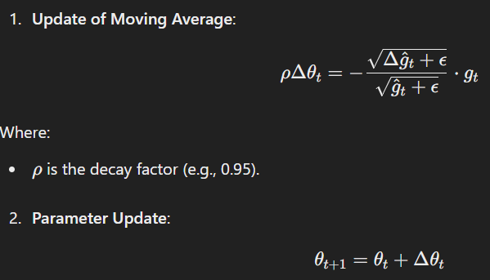

#### **Advantages:**

* Solves the issue of vanishing learning rates in Adagrad.
* Does not require tuning the learning rate.

### **MCQs on RMSProp, Momentum, and Gradient Descent Algorithms**

#### **Easy**

1. **Which optimizer is known for handling non-stationary objectives?**

a) SGD  
b) RMSProp  
c) Momentum  
d) Adagrad  
**Answer**: b) RMSProp

1. **In the momentum update rule, the parameter β is responsible for:**

a) Learning rate  
b) Momentum factor  
c) Gradient  
d) Loss function  
**Answer**: b) Momentum factor

1. **What is the main advantage of the Momentum algorithm?**

a) Faster convergence and reduced oscillations  
b) Adaptive learning rate  
c) Requires no tuning  
d) Reduces bias  
**Answer**: a) Faster convergence and reduced oscillations

1. **Which of the following is a disadvantage of RMSProp?**

a) It adapts the learning rate  
b) It can become sensitive to hyperparameter tuning  
c) It is computationally efficient  
d) It always converges to the global minimum  
**Answer**: b) It can become sensitive to hyperparameter tuning

1. **What is the main purpose of Nesterov Accelerated Gradient (NAG)?**

a) To avoid the vanishing gradient problem  
b) To provide a faster convergence by looking ahead  
c) To reduce the computation time  
d) To prevent overfitting  
**Answer**: b) To provide a faster convergence by looking ahead

#### **Medium**

1. **Which of the following is true for AdaGrad?**

a) It performs well on sparse data  
b) It increases the learning rate as training progresses  
c) It does not adjust the learning rate  
d) It works best for dense data  
**Answer**: a) It performs well on sparse data

1. **What is the update rule for the RMSProp optimizer?**

a) vt=βvt−1+gtv_t = \beta v_{t-1} + g_tvt​=βvt−1​+gt​  
b) vt=βvt−1+(1−β)gt2v_t = \beta v_{t-1} + (1 - \beta) g_t^2vt​=βvt−1​+(1−β)gt2​  
c) vt=βvt−1+∇θJ(θ)v_t = \beta v_{t-1} + \nabla_\theta J(\theta)vt​=βvt−1​+∇θ​J(θ)  
d) vt=gtv_t = g_tvt​=gt​  
**Answer**: b) vt=βvt−1+(1−β)gt2v_t = \beta v_{t-1} + (1 - \beta) g_t^2vt​=βvt−1​+(1−β)gt2​

1. **Which of the following optimizers can help prevent the issue of shrinking learning rates in Adagrad?**

a) SGD  
b) Adadelta  
c) Adam  
d) RMSProp  
**Answer**: b) Adadelta

1. **In the Momentum optimizer, which of the following is true?**

a) The update rule depends only on the current gradient  
b) It speeds up gradient descent by including previous gradients  
c) It uses only the current gradient without considering past gradients  
d) It is slower than regular gradient descent  
**Answer**: b) It speeds up gradient descent by including previous gradients

1. **Which of the following algorithms is best suited for large and sparse datasets like text classification?**

a) RMSProp  
b) Adam  
c) AdaGrad  
d) Stochastic Gradient Descent  
**Answer**: c) AdaGrad

#### **Hard**

1. **What is the main advantage of using the Nesterov Accelerated Gradient (NAG) over regular momentum?**

a) It speeds up convergence by using lookahead gradients  
b) It reduces the amount of memory required  
c) It is less sensitive to hyperparameter tuning  
d) It works best for sparse data  
**Answer**: a) It speeds up convergence by using lookahead gradients

1. **Which optimization method calculates the moving average of squared gradients for each parameter?**

a) AdaGrad  
b) RMSProp  
c) Stochastic Gradient Descent  
d) Adam  
**Answer**: b) RMSProp

1. **What does the term "exploding gradient" refer to in gradient descent?**

a) The learning rate becomes too small  
b) The gradient value becomes too large  
c) The optimizer converges too quickly  
d) The learning rate remains constant  
**Answer**: b) The gradient value becomes too large

1. **Which optimizer uses an exponentially decaying average of past gradients to improve optimization?** a) Adam  
   b) AdaGrad  
   c) Nesterov Accelerated Gradient  
   d) Momentum  
   **Answer**: a) Adam
2. **How does RMSProp prevent learning rates from shrinking too quickly?** a) By maintaining a fixed learning rate  
   b) By dividing by the square root of the sum of squared gradients  
   c) By using the exponential moving average of gradients  
   d) By decaying the learning rate exponentially  
   **Answer**: b) By dividing by the square root of the sum of squared gradients

============================================================================================================================================

**Session 14 & 15:**

### **TensorFlow Data Structures and Library**

**TensorFlow** is an open-source framework developed by Google for numerical computation and machine learning, particularly deep learning. It provides a comprehensive ecosystem for developing machine learning models, but at the core, it operates on **Tensors**, which are the primary data structure in TensorFlow. Below is an overview of TensorFlow's key data structures and the associated library functions.

### **1. TensorFlow Data Structures**

#### **a) Tensor**

* A **tensor** is the fundamental data structure in TensorFlow. It is a generalization of matrices to higher dimensions.
* Tensors can be considered as a multi-dimensional array (also known as a **rank-n tensor**), where each element of the array represents a number. Tensors can hold data of various types such as integers, floats, or complex numbers.

**Types of Tensors:**

* **Scalar**: A tensor with zero dimensions (rank-0 tensor), for example, a single number (e.g., 5).
* **Vector**: A tensor with one dimension (rank-1 tensor), for example, an array of numbers (e.g., [1, 2, 3]).
* **Matrix**: A tensor with two dimensions (rank-2 tensor), for example, a 2D array (e.g., [[1, 2], [3, 4]]).
* **Higher-dimensional tensor**: Tensors with three or more dimensions.

#### **b) Tensor Shapes**

* **Shape** refers to the dimensions of a tensor. For example, a tensor with shape [3, 3] would represent a matrix of 3 rows and 3 columns.
* TensorFlow uses shapes to define how tensors are processed in operations. The shape is specified by a list or tuple of integers.

#### **c) TensorFlow Dtypes**

* **Dtypes (Data Types)** represent the data type of the tensor values. Examples of dtypes include:
  + tf.float32: 32-bit floating point
  + tf.int32: 32-bit integer
  + tf.bool: Boolean values
  + tf.string: String values
  + tf.complex64: Complex numbers

#### **d) Rank of Tensor**

* The **rank** of a tensor refers to the number of dimensions it has. For example, a scalar has a rank of 0, a vector has a rank of 1, a matrix has a rank of 2, etc.

### **2. TensorFlow Library and Core Components**

TensorFlow is not just about tensors; it also includes a variety of tools and libraries that make machine learning and deep learning tasks easier. Some of these tools are:

#### **a) TensorFlow Core Library**

The core library provides all the necessary functionality for creating, training, and deploying machine learning models. The core API includes:

* **Tensors and Variables**: The basic building blocks for data representation and storage.
* **Operations**: Mathematical operations (e.g., addition, multiplication) that can be applied to tensors.
* **Graph**: In TensorFlow, the computation is expressed as a dataflow graph. Each node in the graph represents a mathematical operation, and the edges represent the flow of tensors between operations.
* **Sessions**: TensorFlow computations are run within a session. The session is responsible for evaluating and executing the operations in the graph.

#### **b) tf.keras (High-Level API)**

tf.keras is TensorFlow's high-level API for building neural networks. It provides simple methods to create models and train them with minimal code.

Key Features:

* **Sequential model**: Defines a linear stack of layers.
* **Functional API**: For more complex models that need non-linear connections between layers.
* **Pre-built layers**: Layers such as Dense, Conv2D, LSTM, Dropout, etc.
* **Optimizers**: Like SGD, Adam, RMSprop, etc.
* **Loss functions**: Cross-entropy loss, mean squared error, etc.
* **Metrics**: Accuracy, precision, recall, etc.

#### **c) tf.data API**

The tf.data API allows for efficient input pipeline creation, particularly when dealing with large datasets. It supports:

* **Loading data**: From files, directories, or datasets.
* **Data augmentation**: For tasks such as image transformations.
* **Batching**: For creating mini-batches during training.
* **Shuffling**: Random shuffling of data.
* **Prefetching**: Ensures data is loaded asynchronously to avoid bottlenecks during model training.

#### **d) TensorFlow Estimators**

Estimators are a high-level API that simplifies the training and evaluation process for machine learning models. Estimators manage the training loop, so users can focus on the architecture and evaluation of the model.

* Common Estimators include tf.estimator.DNNClassifier, tf.estimator.DNNRegressor, and tf.estimator.LinearClassifier.

#### **e) TensorFlow Hub**

TensorFlow Hub is a library for reusable machine learning modules. It provides pre-trained models that can be reused in different contexts, helping developers save time.

### **3. TensorFlow Operations**

TensorFlow provides a wide range of operations (also known as "ops") that can be performed on tensors. Some key operations include:

* **Mathematical Operations**:
  + tf.add(), tf.multiply(), tf.matmul() for addition, multiplication, and matrix multiplication.
* **Element-wise Operations**:
  + tf.sqrt(), tf.exp(), tf.log() for element-wise square root, exponentiation, and logarithm.
* **Reduction Operations**:
  + tf.reduce_sum(), tf.reduce_mean(), tf.reduce_max() for summing, averaging, and finding the max value along specified dimensions.
* **Matrix Operations**:
  + tf.transpose() for transposing matrices, tf.linalg.inv() for computing the matrix inverse.

#### **Special Tensor Operations:**

* **Slicing**: Extracting parts of tensors using the tf.slice() operation.
* **Reshaping**: Changing the shape of a tensor using tf.reshape().
* **Concatenation**: Joining multiple tensors using tf.concat().

### **4. TensorFlow with GPU Acceleration**

TensorFlow offers GPU acceleration for faster training of models, particularly deep neural networks. TensorFlow utilizes **CUDA** (a parallel computing platform and API model developed by NVIDIA) to run on GPUs for faster processing of large datasets.

* **Automatic Device Placement**: TensorFlow automatically places operations on available hardware devices (CPU or GPU). You can also manually place operations on specific devices.
* **TensorFlow with CUDA**: To use GPUs, TensorFlow requires the installation of the CUDA toolkit and cuDNN (a GPU-accelerated library for deep neural networks).

### **5. TensorFlow Serving**

TensorFlow Serving is a tool for serving machine learning models in production environments. It allows you to:

* Serve models as REST APIs.
* Handle model versioning and deployment.
* Monitor and log predictions.

### **Summary of TensorFlow Library and Data Structures**

* **Core Data Structure**: Tensor (rank-0 to rank-n)
* **High-Level API**: tf.keras for model building
* **Data Pipelines**: tf.data API for managing datasets
* **Pre-trained Models**: TensorFlow Hub for reusable machine learning modules
* **Optimization**: Built-in optimizers like SGD, Adam, and RMSProp
* **Serving**: TensorFlow Serving for model deployment in production

### **MCQs on TensorFlow Data Structures and Library**

#### **Easy**

1. **What is the basic data structure used in TensorFlow?**

a) Matrix  
b) List  
c) Tensor  
d) Array  
**Answer**: c) Tensor

1. **Which TensorFlow module is used for building neural network models?**

a) tf.keras  
b) tf.data  
c) tf.estimator  
d) tf.function  
**Answer**: a) tf.keras

1. **Which of the following is used to represent the dimensions of a tensor in TensorFlow?**

a) Shape  
b) Rank  
c) Size  
d) Dtype  
**Answer**: a) Shape

1. **Which TensorFlow function is used to reshape a tensor?**

a) tf.reshape()  
b) tf.slice()  
c) tf.transpose()  
d) tf.concat()  
**Answer**: a) tf.reshape()

1. **Which type of TensorFlow operation is used to compute the sum of elements across dimensions?**

a) tf.reduce_sum()  
b) tf.add()  
c) tf.matmul()  
d) tf.sqrt()  
**Answer**: a) tf.reduce_sum()

#### **Medium**

1. **What does the tf.data API primarily deal with in TensorFlow?**

a) Optimizers  
b) Model evaluation  
c) Data loading and preprocessing  
d) Neural network architecture  
**Answer**: c) Data loading and preprocessing

1. **What is the main advantage of using TensorFlow Hub?**

a) Reduces the need for training models from scratch  
b) Increases memory consumption  
c) Reduces the use of GPUs  
d) Allows manual gradient calculation  
**Answer**: a) Reduces the need for training models from scratch

1. **In TensorFlow, what does the term 'Rank' refer to?**

a) The value of the tensor  
b) The data type of the tensor  
c) The number of dimensions of the tensor  
d) The size of the tensor  
**Answer**: c) The number of dimensions of the tensor

1. **What is the default data type for tensors in TensorFlow?**

a) tf.int32  
b) tf.float32  
c) tf.bool  
d) tf.string  
**Answer**: b) tf.float32

1. **Which operation would you use to compute the transpose of a matrix in TensorFlow?**

a) tf.transpose()  
b) tf.reshape()  
c) tf.slice()  
d) tf.matmul()  
**Answer**: a) tf.transpose()

#### **Hard**

1. **Which TensorFlow function is used to serve machine learning models in production?**

a) tf.keras  
b) tf.estimator  
c) tf.serving  
d) TensorFlow Serving  
**Answer**: d) TensorFlow Serving

1. **Which function is used to perform a matrix multiplication in TensorFlow?**

a) tf.matmul()  
b) tf.multiply()  
c) tf.reduce_sum()  
d) tf.add()  
**Answer**: a) tf.matmul()

1. **In TensorFlow, how can we automatically place operations on the available hardware (CPU or GPU)?**

a) tf.device()  
b) tf.function()  
c) TensorFlow will automatically handle device placement  
d) tf.Session()  
**Answer**: c) TensorFlow will automatically handle device placement

1. **Which of the following is used for building input pipelines in TensorFlow for large datasets?**

a) tf.keras  
b) tf.estimator  
c) tf.data  
d) tf.variable  
**Answer**: c) tf.data

1. **What is the purpose of a session in TensorFlow?**

a) To calculate gradients  
b) To execute the computation graph  
c) To define operations  
d) To store tensors  
**Answer**: b) To execute the computation graph

================================================================================================================================

**Session 16:**

### **Sequential Modeling**

**Sequential modeling** is a process of building machine learning models where data points are dependent on each other in a sequence. This type of modeling is particularly useful in tasks where the order of the data points matters, such as time series forecasting, speech recognition, and natural language processing (NLP). Unlike traditional machine learning models where each data point is independent, sequential models account for the temporal dependencies between observations.

#### **Key Features of Sequential Modeling:**

* **Temporal Dependencies**: The model learns to predict future values or classifications based on past information in the sequence.
* **Stateful vs. Stateless**: In stateful models, the model retains information from previous time steps, while in stateless models, the model doesn’t store information across time steps.

#### **Common Applications:**

* **Time Series Forecasting**: Predicting future values based on past data (e.g., stock prices, weather).
* **Speech Recognition**: Converting audio signals into text.
* **Text Generation**: Creating new text based on the patterns observed in existing text (e.g., generating new sentences or paragraphs).
* **Machine Translation**: Translating text from one language to another by learning from sequential patterns.

#### **Types of Sequential Models:**

1. **Recurrent Neural Networks (RNNs)**: These networks are specifically designed for sequential data, where output at each step depends on previous time steps.
2. **Long Short-Term Memory (LSTM)**: An advanced version of RNNs, LSTMs are designed to avoid the vanishing gradient problem and capture long-term dependencies in data.
3. **Gated Recurrent Units (GRUs)**: A simpler and more efficient alternative to LSTM that performs well in many sequential tasks.

### **Introduction to Basic Building Blocks of RNNs**

A **Recurrent Neural Network (RNN)** is a class of neural networks designed for sequential data. RNNs are built to recognize patterns in sequences of data, such as text, time series, or speech. Unlike traditional feedforward neural networks, RNNs have connections that form cycles, allowing information to persist. This allows the model to retain information about previous inputs, which is crucial for tasks involving sequential data.

#### **Key Building Blocks of RNNs:**

1. **Input Layer**: The input layer of an RNN takes the sequential data (such as time series or sentences) and passes it through the network.
2. **Hidden Layer**: The hidden layer of an RNN contains the recurrent connections that allow the network to "remember" previous states. These states are updated as the sequence progresses.
3. **Output Layer**: The output layer generates the prediction or output at each time step, such as a classification or regression value.
4. **Recurrent Connections**: RNNs have feedback loops where the output of the previous time step is fed as an input to the next time step, allowing the model to learn temporal dependencies.

#### **Challenges with Basic RNNs:**

* **Vanishing Gradient Problem**: RNNs often struggle to capture long-term dependencies because gradients (used for training) can diminish over time, making it difficult to learn long-range dependencies.
* **Exploding Gradient Problem**: Conversely, the gradients can sometimes explode, causing large updates and instability during training.

### **Introduction to RNNs**

**Recurrent Neural Networks (RNNs)** are a type of neural network designed to work with sequential data. They process input data in a sequence, maintaining an internal state that captures information from previous inputs. This makes RNNs particularly effective for tasks like speech recognition, time series forecasting, and natural language processing (NLP).

#### **How RNNs Work:**

1. **Step-by-Step Processing**: RNNs process input data one time step at a time, passing information from one step to the next through the recurrent connections. Each output depends on both the current input and the previous hidden state.
2. **Hidden State**: The hidden state serves as a memory, holding relevant information from previous steps. At each time step, the hidden state is updated based on the current input and the previous hidden state.
3. **Activation Function**: An activation function, such as **sigmoid**, **tanh**, or **ReLU**, is used in the hidden layers to introduce non-linearity and help the network learn complex patterns.

#### **Challenges with RNNs:**

* **Vanishing Gradient Problem**: When training RNNs, gradients can become too small during backpropagation, making it hard to update weights in earlier layers, which hinders learning.
* **Exploding Gradient Problem**: Conversely, gradients can become very large, causing instability during training.

### **Key Applications of RNNs**

1. **Natural Language Processing (NLP)**: RNNs can model sequential relationships in text, making them useful for tasks like language translation, sentiment analysis, and text generation.
2. **Speech Recognition**: RNNs can process audio data sequentially, recognizing patterns in sound and converting them into text.
3. **Time Series Forecasting**: RNNs can capture patterns in sequential data, making them suitable for tasks like stock market prediction, weather forecasting, etc.
4. **Video Processing**: RNNs can be used for action recognition in videos, processing the temporal sequence of frames to understand the action being performed.

### **MCQs for Sequential Modeling and RNNs**

#### **Easy**

1. **What is the main characteristic of sequential modeling?**

a) Data points are independent  
b) Data points are dependent on each other  
c) No need for training  
d) Only works for tabular data  
**Answer**: b) Data points are dependent on each other

1. **Which of the following is commonly used for time series forecasting?**

a) Linear regression  
b) Decision trees  
c) Recurrent Neural Networks (RNNs)  
d) K-Nearest Neighbors  
**Answer**: c) Recurrent Neural Networks (RNNs)

1. **What does RNN stand for?**

a) Recurrent Neural Network  
b) Real Neural Network  
c) Repeated Neural Network  
d) Residual Neural Network  
**Answer**: a) Recurrent Neural Network

1. **Which activation function is commonly used in the hidden layers of an RNN?**

a) ReLU  
b) Sigmoid  
c) Tanh  
d) Softmax  
**Answer**: c) Tanh

1. **In RNNs, what is the term used to refer to the model's memory?**

a) Input layer  
b) Output layer  
c) Hidden state  
d) Activation layer  
**Answer**: c) Hidden state

#### **Medium**

1. **Which of the following is a major challenge faced by basic RNNs during training?**

a) Vanishing gradients  
b) Overfitting  
c) Underfitting  
d) Data imbalance  
**Answer**: a) Vanishing gradients

1. **Which of the following is an advantage of RNNs over traditional feedforward networks?**

a) RNNs cannot capture sequential dependencies  
b) RNNs are faster in processing independent data  
c) RNNs can model temporal dependencies in sequential data  
d) RNNs require less data for training  
**Answer**: c) RNNs can model temporal dependencies in sequential data

1. **What does the "hidden state" of an RNN represent?**

a) The output of the last neuron  
b) The temporal memory of the network  
c) The weight matrix of the network  
d) The number of layers in the model  
**Answer**: b) The temporal memory of the network

1. **Which of the following problems can RNNs address effectively?**

a) Image classification  
b) Text generation  
c) Anomaly detection in tabular data  
d) Feature selection  
**Answer**: b) Text generation

1. **Which variant of RNN is designed to mitigate the vanishing gradient problem?** a) Deep Neural Networks  
   b) LSTM  
   c) Convolutional Neural Networks  
   d) Naïve Bayes  
   **Answer**: b) LSTM

#### **Hard**

1. **Which part of an RNN retains information from previous time steps?**

a) Input layer  
b) Hidden state  
c) Output layer  
d) Bias term  
**Answer**: b) Hidden state

1. **Which technique is used to prevent the vanishing gradient problem in RNNs?** a) Regularization  
   b) L1 and L2 normalization  
   c) Long Short-Term Memory (LSTM) units  
   d) Dropout  
   **Answer**: c) Long Short-Term Memory (LSTM) units
2. **What is the key difference between an RNN and a standard feedforward neural network?** a) RNNs are better for image data  
   b) RNNs have recurrent connections that allow memory of previous time steps  
   c) RNNs do not require an activation function  
   d) RNNs do not use backpropagation for training  
   **Answer**: b) RNNs have recurrent connections that allow memory of previous time steps
3. **Which of the following is not an application of RNNs?**

a) Language translation  
b) Stock market prediction  
c) Facial recognition  
d) Speech recognition  
**Answer**: c) Facial recognition

1. **In a typical RNN, the output at each time step is influenced by:**

a) The current input only  
b) The previous hidden state and current input  
c) The previous output only  
d) The current input and output  
**Answer**: b) The previous hidden state and current input

============================================================================================================================================

**Session 17 & 18:**

### **Convolutional Neural Networks (CNNs)**

Convolutional Neural Networks (CNNs) are a class of deep learning algorithms primarily used for analyzing visual data such as images and videos. CNNs are highly effective for image recognition, object detection, and classification tasks due to their ability to automatically learn spatial hierarchies of features from the raw input data.

#### **Basic Building Blocks of CNN:**

1. **Convolutional Layer:**
   * The core component of CNNs, which applies convolution operations on the input data.
   * Convolution helps detect patterns, such as edges, textures, or shapes, by applying a filter (kernel) that slides over the input image, performing element-wise multiplication and summing the result.
2. **Activation Function (ReLU):**
   * After applying the convolution operation, an activation function (usually **ReLU**) is used to introduce non-linearity, allowing the network to learn more complex patterns.
3. **Pooling Layer:**
   * Pooling layers reduce the spatial dimensions of the feature maps (height and width), retaining the most essential features while reducing computational complexity.
   * Common types of pooling are **Max Pooling** and **Average Pooling**.
4. **Fully Connected (FC) Layer:**
   * These are traditional neural network layers that connect every neuron to every neuron in the previous and next layers.
   * In CNNs, FC layers are used toward the end of the network to make final predictions or classifications.
5. **Flattening Layer:**
   * Before feeding the output into the fully connected layers, the feature map is flattened into a 1D array.

#### **Convolutional Concept:**

In CNNs, **convolution** refers to applying filters (also called kernels) to the input image or feature maps to extract local features. These filters slide across the input data to detect various patterns, such as edges, corners, and textures.

* **Filter/Kernels**: Small matrixes (e.g., 3x3 or 5x5) that are applied to the image in a sliding window fashion.
* **Stride**: The step size with which the filter moves across the input image. A stride of 1 means the filter moves one pixel at a time, while a stride of 2 means it moves two pixels at a time.
* **Padding**: To ensure the output size is appropriate or to avoid losing edge information, padding is added to the input image. Common padding types are **'valid'** (no padding) and **'same'** (zero padding to keep output dimensions same as input).

#### **Inception Network:**

The **Inception Network** (also known as **GoogLeNet**) is a deep CNN architecture that uses **Inception modules** to improve the efficiency and effectiveness of the network. These modules apply multiple convolution operations with different filter sizes simultaneously and then concatenate the results, allowing the model to capture more diverse features.

* **Advantages of Inception**:
  + Helps the network to learn features at multiple scales.
  + Reduces the computational cost by reducing the number of parameters through **1x1 convolutions**.
  + Introduced **global average pooling** to reduce overfitting.

#### **Transfer Learning:**

**Transfer Learning** refers to the technique of leveraging a pre-trained model on a large dataset (such as ImageNet) and fine-tuning it on a new, often smaller, dataset for a related task. This helps save computational resources and time, especially when there is limited labeled data available.

* **Steps in Transfer Learning**:
  + **Pretrain a model** on a large dataset.
  + **Fine-tune the model** on a smaller, task-specific dataset.
  + **Use pre-trained weights** for feature extraction and then retrain the last few layers for the new task.
* **Advantages**:
  + Speeds up training.
  + Reduces the amount of labeled data required for training.
  + Achieves higher accuracy with fewer data points.

#### **Data Augmentation:**

**Data Augmentation** refers to the technique of artificially increasing the size of the training dataset by applying transformations such as rotations, translations, flipping, and scaling to the original images. This helps improve the model’s robustness and generalization capability by simulating variations in real-world scenarios.

* **Common Augmentation Techniques**:
  + **Rotation**: Rotating images by a certain angle.
  + **Flipping**: Horizontally or vertically flipping the image.
  + **Zooming**: Randomly zooming in or out.
  + **Shearing**: Applying affine transformations to skew the image.
  + **Cropping**: Randomly cropping regions of the image.

#### **Padding and Strides:**

* **Padding**: Padding is used to prevent the reduction of spatial dimensions after the convolution operation. It helps preserve edge information and avoid shrinking of the feature map. The most common padding strategies are:
  + **Valid Padding**: No padding, output size is smaller than input.
  + **Same Padding**: Padding added to ensure the output size is the same as the input.
* **Stride**: The stride controls how much the filter moves across the input image. Larger strides reduce the size of the output feature map, which can help in reducing the computational load.

#### **Pooling Layers:**

**Pooling** layers are used to downsample the feature maps and reduce the spatial dimensions. Pooling helps reduce the computational cost, memory usage, and prevents overfitting.

* **Max Pooling**: Selects the maximum value in each patch of the feature map.
* **Average Pooling**: Computes the average of each patch of the feature map.
* **Global Average Pooling**: Computes the average across the entire feature map.

#### **Fully Connected Layers:**

After the convolutional and pooling layers, the feature maps are flattened into a one-dimensional vector and passed into fully connected layers for final classification. These layers are traditional neural network layers where each neuron is connected to every neuron from the previous layer.

#### **Applications and Use Cases of CNNs:**

1. **Image Classification**: Classifying images into predefined categories (e.g., dogs vs. cats).
2. **Object Detection**: Identifying and classifying objects within an image (e.g., detecting faces, vehicles).
3. **Image Segmentation**: Dividing an image into segments or regions for detailed analysis (e.g., medical image segmentation).
4. **Video Processing**: Action recognition, activity detection, or object tracking in videos.
5. **Speech Recognition**: Converting audio signals into text.
6. **Self-driving Cars**: Recognizing traffic signs, pedestrians, and other vehicles.

### **MCQs for CNN and Its Applications**

#### **Easy**

1. **What is the main purpose of convolution in CNNs?**

a) To introduce non-linearity  
b) To reduce the spatial dimensions  
c) To detect patterns or features in the image  
d) To classify the image  
**Answer**: c) To detect patterns or features in the image

1. **Which of the following is a common activation function used in CNNs?**

a) ReLU  
b) Sigmoid  
c) Tanh  
d) Softmax  
**Answer**: a) ReLU

1. **Which layer in CNNs reduces the spatial size of the feature maps?**

a) Convolutional layer  
b) Pooling layer  
c) Fully connected layer  
d) Flattening layer  
**Answer**: b) Pooling layer

1. **What does padding in a CNN do?**

a) Reduces the size of the image  
b) Increases the computational cost  
c) Preserves edge information  
d) Increases the number of parameters  
**Answer**: c) Preserves edge information

1. **What is the key advantage of using Transfer Learning in CNNs?**

a) Reduces training time  
b) Requires no labeled data  
c) Increases the number of parameters  
d) Works only with small datasets  
**Answer**: a) Reduces training time

#### **Medium**

1. **Which of the following is an application of CNNs?**

a) Text classification  
b) Image recognition  
c) Time series forecasting  
d) Natural language processing  
**Answer**: b) Image recognition

1. **Which of the following methods is used to increase the training dataset size in CNNs?**

a) Data augmentation  
b) Pooling  
c) Dropout  
d) Batch normalization  
**Answer**: a) Data augmentation

1. **What does a filter in a convolution layer detect?**

a) Data normalization  
b) Features or patterns in the image  
c) The class of the image  
d) The size of the image  
**Answer**: b) Features or patterns in the image

1. **Which of the following is a primary benefit of pooling in CNNs?**

a) Increase the size of the feature map  
b) Reduce the complexity and computational cost  
c) Prevent overfitting  
d) Add non-linearity to the network  
**Answer**: b) Reduce the complexity and computational cost

1. **What is the function of the Fully Connected layer in CNNs?**

a) Detect features in the image  
b) Reduce the size of the feature map  
c) Make final predictions or classifications  
d) Introduce non-linearity  
**Answer**: c) Make final predictions or classifications

#### **Hard**

1. **Which of the following techniques does Inception Network use to improve computational efficiency?**

a) Batch normalization  
b) 1x1 convolutions  
c) Max pooling  
d) Data augmentation  
**Answer**: b) 1x1 convolutions

1. **Which of the following problems does the vanishing gradient issue primarily affect in CNNs?

a) Pooling  
b) Weight updates during training  
c) Image resizing  
d) Feature extraction  
**Answer**: b) Weight updates during training

1. **In a CNN, what is the stride of a convolution layer?**

a) The number of layers in the network  
b) The size of the filter  
c) The step size of the filter movement across the input  
d) The output dimensions of the feature map  
**Answer**: c) The step size of the filter movement across the input

1. **Which type of pooling preserves more spatial information?**

a) Max pooling  
b) Average pooling  
c) Global average pooling  
d) Fractional pooling  
**Answer**: b) Average pooling

1. **What is the purpose of flattening in CNNs?**

a) Reduces the size of the feature map  
b) Converts the 2D feature map into a 1D array for input to FC layers  
c) Adds non-linearity to the network  
d) Prevents overfitting  
**Answer**: b) Converts the 2D feature map into a 1D array for input to FC layers

============================================================================================================================================

**Session 19**

### **Generative Adversarial Networks (GANs)**

Generative Adversarial Networks (GANs) are a class of machine learning frameworks designed by Ian Goodfellow and his colleagues in 2014. They consist of two neural networks, a **Generator** and a **Discriminator**, that compete against each other in a game-theoretic setting. GANs are widely used for generating new data that resembles a given dataset, such as realistic images, videos, and even music.

### **Basic Building Blocks of GANs**

1. **Generator:**
   * The generator creates synthetic data (e.g., images) from random noise. Its goal is to generate data that is indistinguishable from the real data.
   * It takes a random vector (often from a Gaussian or uniform distribution) as input and outputs data in the same format as the real dataset.
2. **Discriminator:**
   * The discriminator is a binary classifier that distinguishes between real and fake data.
   * It receives data from both the real dataset and the generator and outputs the probability that the input data is real.
3. **Objective:**
   * The generator tries to **fool** the discriminator by generating data that appears real.
   * The discriminator tries to correctly identify whether the input data is real or fake.
   * This adversarial process pushes both networks to improve their performance iteratively.

### **How GANs Work:**

1. **Step 1: Initialization**
   * Both networks are initialized with random weights.
   * A random noise vector is fed into the generator to produce synthetic data.
2. **Step 2: Training the Discriminator**
   * The discriminator is trained on two datasets:
     + Real data (labeled as 1).
     + Fake data generated by the generator (labeled as 0).
   * The discriminator learns to maximize its ability to distinguish real data from fake data.
3. **Step 3: Training the Generator**
   * The generator is trained to minimize the discriminator's ability to distinguish real data from fake data.
   * The generator updates its weights to produce data that better fools the discriminator.
4. **Step 4: Iteration**
   * The process alternates between training the discriminator and the generator.
   * This adversarial training continues until the generator produces data that is nearly indistinguishable from real data.

### **Mathematical Formulation:**

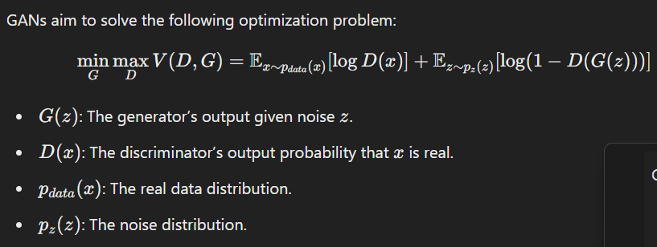

### **Challenges with GANs:**

1. **Mode Collapse:**
   * The generator produces a limited variety of outputs, focusing on fooling the discriminator rather than generating diverse samples.
2. **Vanishing Gradient:**
   * If the discriminator becomes too strong, the generator may struggle to learn due to vanishing gradients.
3. **Training Instability:**
   * The adversarial nature of GANs can lead to oscillations or failure to converge.
4. **Evaluation Metrics:**
   * Measuring the quality of generated samples can be challenging.

### **Applications of GANs:**

1. **Image Generation:**
   * Generating realistic images from random noise.
   * Applications include deepfake generation and artistic style transfer.
2. **Data Augmentation:**
   * Creating synthetic data to augment small datasets.
3. **Image-to-Image Translation:**
   * Transforming an input image into a different style (e.g., converting sketches into colored images).
4. **Video and Animation:**
   * Generating synthetic videos or animations from textual descriptions.
5. **Healthcare:**
   * Generating synthetic medical images for training diagnostic models.
6. **Text-to-Image Generation:**
   * Generating images from textual descriptions.

### **Implementing GANs**

A basic GAN implementation involves the following steps:

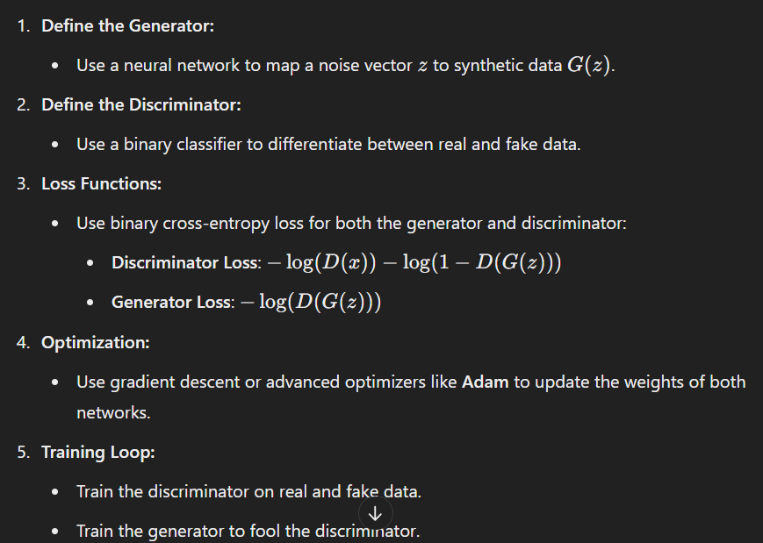

### **MCQs for GANs**

#### **Easy**

1. **What does GAN stand for?**a) Generative Artificial Network  
   b) Generative Adversarial Network  
   c) Generalized Adversarial Network  
   d) General Augmentation Network  
   **Answer**: b) Generative Adversarial Network
2. **What is the primary role of the generator in a GAN?**a) To classify data  
   b) To create realistic data  
   c) To detect real data  
   d) To optimize the discriminator  
   **Answer**: b) To create realistic data
3. **Which type of data does the generator take as input?**a) Real data  
   b) Noise vector  
   c) Labels  
   d) Feature maps  
   **Answer**: b) Noise vector
4. **What type of network is used for the discriminator in GANs?**a) Regression network  
   b) Classification network  
   c) Generative network  
   d) Clustering network  
   **Answer**: b) Classification network
5. **What is the objective of the discriminator in GANs?**a) To generate data  
   b) To classify data as real or fake  
   c) To minimize loss  
   d) To perform backpropagation  
   **Answer**: b) To classify data as real or fake

#### **Medium**

1. **Which optimizer is commonly used for training GANs?**a) SGD  
   b) Adam  
   c) RMSProp  
   d) Momentum  
   **Answer**: b) Adam
2. **What is mode collapse in GANs?**a) Generator produces diverse outputs  
   b) Generator outputs are identical or lack diversity  
   c) Discriminator fails to classify correctly  
   d) Training stops prematurely  
   **Answer**: b) Generator outputs are identical or lack diversity
3. **What does the loss function of the generator aim to minimize?**a) Discriminator accuracy  
   b) Discriminator's ability to classify fake data as fake  
   c) Generator's ability to classify real data  
   d) Generator accuracy  
   **Answer**: b) Discriminator's ability to classify fake data as fake
4. **Which problem is commonly associated with GAN training?**a) Overfitting  
   b) Gradient explosion  
   c) Convergence issues  
   d) Lack of regularization  
   **Answer**: c) Convergence issues
5. **Which GAN application focuses on transforming images from one style to another?**a) Data augmentation  
   b) Style transfer  
   c) Text-to-image generation  
   d) Deepfakes  
   **Answer**: b) Style transfer

#### **Hard**

1. **What is the primary purpose of 1D convolution in GANs?**a) Process textual data  
   b) Generate random noise  
   c) Improve gradient flow  
   d) Enhance discriminator loss  
   **Answer**: a) Process textual data
2. **Which metric is difficult to measure in GANs?**a) Model accuracy  
   b) Loss reduction  
   c) Quality of generated data  
   d) Computational cost  
   **Answer**: c) Quality of generated data
3. **What is the output of the discriminator in GANs?**a) A noise vector  
   b) A binary probability (real or fake)  
   c) A feature map  
   d) Loss value  
   **Answer**: b) A binary probability (real or fake)
4. **What is one way to overcome mode collapse in GANs?**a) Use larger datasets  
   b) Modify the generator loss function  
   c) Use dropout layers  
   d) Train only the discriminator  
   **Answer**: b) Modify the generator loss function
5. **In GANs, what type of data is used to train the discriminator?**a) Only real data  
   b) Only fake data  
   c) Both real and fake data  
   d) Random noise  
   **Answer**: c) Both real and fake data

============================================================================================================================================**Session 20**

### **Tuning Deep Learning Models**

#### **Deciding the Number of Layers**

* **Shallow Networks:**
  + Good for simple problems with linear separability or fewer features.
  + Risk: May underfit complex data.
* **Deep Networks:**
  + Better for handling complex data and extracting hierarchical features.
  + Risk: Overfitting and increased training time if too deep.

**Strategies:**

1. Start with a few layers and incrementally add more based on performance.
2. Use pre-trained models for transfer learning when dealing with image or language data.

#### **Deciding the Number of Neurons**

* Too few neurons: Model may underfit.
* Too many neurons: Increased risk of overfitting and computational cost.

**Approach:**

1. Use a heuristic like starting with twice the number of input features.
2. Monitor performance metrics like accuracy and loss.

#### **CNN Tuning for Better Performance**

1. **Filter Size and Number:**
   * Larger filters capture broad features; smaller filters focus on fine details.
2. **Pooling Layers:**
   * Use max pooling for sharp feature extraction or average pooling for smoothing.
3. **Regularization:**
   * Apply dropout layers to prevent overfitting.
4. **Learning Rate Tuning:**
   * Use learning rate schedulers or adaptive optimizers like Adam.

#### **RNN/LSTM for Time Series Prediction**

1. RNNs capture sequential dependencies but suffer from vanishing gradients.
2. LSTMs (Long Short-Term Memory networks) solve vanishing gradients with gates:
   * Forget Gate: Removes irrelevant data.
   * Input Gate: Adds important new data.
   * Output Gate: Decides the output.
3. Useful for:
   * Stock price prediction.
   * Weather forecasting.

### **Trends in Deep Learning**

#### **Echo State Networks / Reservoir Computing**

* Used for temporal data and time-series analysis.
* Consists of:
  + A fixed recurrent neural network (reservoir).
  + A trainable linear layer (output).
* Benefits:
  + Requires less training than conventional RNNs.
  + Efficient for hardware implementation.

#### **Autoencoders**

1. **Standard Autoencoders:**
   * Unsupervised learning for dimensionality reduction or denoising.
   * Architecture:
     + Encoder: Compresses input to a latent representation.
     + Decoder: Reconstructs the input from latent representation.
2. **Convolutional Autoencoder:**
   * Combines convolutional layers with autoencoders for image data.
   * Useful for:
     + Image denoising.
     + Feature extraction.

#### **Extreme Learning**

* A single-layer feedforward neural network with randomly initialized weights.
* Benefits:
  + Fast training with high accuracy.
  + Suitable for simple classification and regression tasks.

### **Deep Learning Case Studies**

#### **Whale Identification (5k Classes)**

* Challenge: Large number of classes with imbalanced data.
* Approach:
  + Use CNNs with transfer learning (e.g., ResNet).
  + Employ data augmentation and weighted loss functions.

#### **Iris Detection**

* Focus: Detecting species of iris flowers.
* Approach:
  + Use shallow networks or traditional machine learning.
  + Fine-tune models with a softmax classifier.

#### **Devanagari Digit Detection**

* Challenge: Handwritten character recognition.
* Approach:
  + CNNs with feature extraction and classification layers.
  + Use a dataset like MNIST but specific to Devanagari digits.

#### **Flood Prediction in Dams**

* Use Case: Predict floods using meteorological and hydrological data.
* Approach:
  + Combine RNN/LSTMs for temporal data and dense layers for feature interaction.
  + Evaluate with RMSE and MAE.

#### **Heart Disease Prediction**

* Approach:
  + Use feedforward networks with patient data.
  + Features like age, blood pressure, and cholesterol are crucial.

### **MCQs**

#### **Easy**

1. **What is the primary role of tuning deep learning models?**a) To avoid training the model  
   b) To improve the model's architecture and performance  
   c) To generate data  
   d) To replace optimization algorithms  
   **Answer**: b) To improve the model's architecture and performance
2. **What is the risk of using too many neurons in a layer?**a) Underfitting  
   b) Overfitting  
   c) Reduced complexity  
   d) Faster training  
   **Answer**: b) Overfitting
3. **Which layer is used to down-sample the input in CNNs?**a) Fully connected  
   b) Pooling layer  
   c) Convolutional layer  
   d) Dropout layer  
   **Answer**: b) Pooling layer
4. **What problem do LSTMs solve compared to RNNs?**a) Underfitting  
   b) Vanishing gradients  
   c) Feature extraction  
   d) Noise reduction  
   **Answer**: b) Vanishing gradients

#### **Medium**

1. **What does the forget gate in LSTM do?**a) Decides which part of the input to add to the output.  
   b) Removes irrelevant data from memory.  
   c) Decides what output to predict.  
   d) Combines input and memory cell.  
   **Answer**: b) Removes irrelevant data from memory.
2. **What type of tasks are autoencoders primarily used for?**a) Classification  
   b) Regression  
   c) Dimensionality reduction and denoising  
   d) Reinforcement learning  
   **Answer**: c) Dimensionality reduction and denoising
3. **Which layer in CNN helps reduce overfitting?**a) Fully connected layer  
   b) Pooling layer  
   c) Dropout layer  
   d) Convolutional layer  
   **Answer**: c) Dropout layer
4. **Which optimization algorithm is suitable for sparse gradients?**a) SGD  
   b) Adam  
   c) RMSProp  
   d) Adagrad  
   **Answer**: d) Adagrad

#### **Hard**

1. **What is the main advantage of Reservoir Computing over standard RNNs?**a) Requires less computational power  
   b) Fully trainable architecture  
   c) Handles image data efficiently  
   d) Works only for non-temporal data  
   **Answer**: a) Requires less computational power
2. **What is the key difference between a convolutional and standard autoencoder?**a) Encoder is removed in convolutional autoencoders.  
   b) Decoder uses pooling in convolutional autoencoders.  
   c) Uses convolutional layers instead of dense layers for spatial data.  
   d) Convolutional autoencoders are only for text data.  
   **Answer**: c) Uses convolutional layers instead of dense layers for spatial data
3. **What metric is suitable for evaluating flood prediction models?**a) F1 score  
   b) ROC-AUC  
   c) RMSE or MAE  
   d) Precision  
   **Answer**: c) RMSE or MAE

#### **Easy**

1. **What is a key benefit of transfer learning in CNNs?**a) Reduces overfitting.  
   b) Requires less training data.  
   c) Speeds up model training.  
   d) All of the above.  
   **Answer**: d) All of the above.
2. **What is the role of padding in CNNs?**a) To increase the training time.  
   b) To reduce the model size.  
   c) To preserve spatial dimensions after convolution.  
   d) To improve pooling operations.  
   **Answer**: c) To preserve spatial dimensions after convolution.
3. **Which activation function is most likely to cause vanishing gradients?**a) ReLU  
   b) Sigmoid  
   c) Tanh  
   d) Softmax  
   **Answer**: b) Sigmoid
4. **What kind of data is LSTM most suitable for?**a) Image data  
   b) Sequential data  
   c) Tabular data  
   d) Categorical data  
   **Answer**: b) Sequential data

#### **Medium**

1. **What happens when you increase the stride in a convolutional layer?**a) Spatial dimensions increase.  
   b) Spatial dimensions decrease.  
   c) Convolutional operation slows down.  
   d) More features are extracted.  
   **Answer**: b) Spatial dimensions decrease.
2. **Which type of pooling helps preserve sharper features in CNNs?**a) Max pooling  
   b) Average pooling  
   c) Global pooling  
   d) None of the above  
   **Answer**: a) Max pooling
3. **What is the primary advantage of using Dropout in a neural network?**a) Increases training speed.  
   b) Prevents overfitting by randomly dropping units.  
   c) Reduces the need for normalization.  
   d) Helps initialize weights effectively.  
   **Answer**: b) Prevents overfitting by randomly dropping units.
4. **Which method is used in GANs to generate new samples?**a) Gradient descent  
   b) Adversarial training  
   c) Autoencoder reconstruction  
   d) Transfer learning  
   **Answer**: b) Adversarial training
5. **Which layer in a CNN reduces the number of parameters?**a) Convolutional  
   b) Fully connected  
   c) Pooling  
   d) Dropout  
   **Answer**: c) Pooling
6. **Which optimizer combines Momentum and RMSProp techniques?**a) Adam  
   b) SGD  
   c) Adagrad  
   d) Nadam  
   **Answer**: a) Adam

#### **Hard**

1. **Why does Batch Normalization improve training?**a) Reduces internal covariate shift.  
   b) Increases vanishing gradients.  
   c) Prevents dropout layers from functioning.  
   d) Reduces the depth of the network.  
   **Answer**: a) Reduces internal covariate shift.
2. **What is the primary goal of Gradient Checking?**a) To speed up training.  
   b) To verify the correctness of backpropagation.  
   c) To improve the vanishing gradient problem.  
   d) To initialize weights more effectively.  
   **Answer**: b) To verify the correctness of backpropagation.
3. **What is the difference between RNN and Echo State Networks?**a) ESNs do not update reservoir weights during training.  
   b) ESNs use dropout for regularization.  
   c) RNNs are faster than ESNs.  
   d) ESNs are specific to image recognition.  
   **Answer**: a) ESNs do not update reservoir weights during training.
4. **What is the key difference between vanilla autoencoders and convolutional autoencoders?**a) Vanilla autoencoders do not use pooling.  
   b) Convolutional autoencoders handle spatial hierarchies.  
   c) Vanilla autoencoders are used for image data.  
   d) Both are the same.  
   **Answer**: b) Convolutional autoencoders handle spatial hierarchies.
5. **How does L2 regularization help prevent overfitting?**a) By adding noise to the model weights.  
   b) By adding a penalty proportional to the square of weights.  
   c) By randomly dropping connections.  
   d) By normalizing the input data.  
   **Answer**: b) By adding a penalty proportional to the square of weights.
6. **Which evaluation metric is best suited for imbalanced datasets?**a) Accuracy  
   b) Precision  
   c) F1 Score  
   d) Recall  
   **Answer**: c) F1 Score
7. **Which technique helps in generating artificial images for training?**a) Data Augmentation  
   b) Dropout  
   c) LSTM  
   d) Batch Normalization  
   **Answer**: a) Data Augmentation
8. **What is a key characteristic of Reservoir Computing models?**a) Trainable recurrent connections.  
   b) Fixed weights in the recurrent layer.  
   c) High computational cost.  
   d) Inability to process sequential data.  
   **Answer**: b) Fixed weights in the recurrent layer.
9. **What does an "inception module" in CNN allow?**a) Multiple convolutional operations at varying filter sizes in parallel.  
   b) Reduction in pooling operations.  
   c) Avoidance of overfitting by increasing model depth.  
   d) Training RNNs within CNNs.  
   **Answer**: a) Multiple convolutional operations at varying filter sizes in parallel.
10. **Why are GANs difficult to train?**a) The generator and discriminator do not share weights.  
    b) They require a fixed learning rate.  
    c) Training depends on maintaining a balance between generator and discriminator.  
    d) They cannot process sequential data.  
    **Answer**: c) Training depends on maintaining a balance between generator and discriminator.