### **Machine Learning in a Nutshell**

**Machine Learning (ML)** is a subset of artificial intelligence that enables computers to learn from data and improve their performance without being explicitly programmed. It uses algorithms to identify patterns, make predictions, and automate decision-making processes.

#### **Key Concepts:**

1. **Learning from Data**:
   * ML models are trained on datasets to identify patterns.
   * These models generalize knowledge from training data to unseen data.
2. **Types of Learning**:
   * **Supervised Learning**: Learning with labeled data.
   * **Unsupervised Learning**: Learning with unlabeled data.
   * **Reinforcement Learning**: Learning by interacting with an environment.
3. **Process**:
   * Data Collection → Preprocessing → Training → Evaluation → Deployment.
4. **Examples**:
   * Email spam filters, image recognition, recommendation systems.

### **Supervised and Unsupervised Learning**

#### **Supervised Learning:**

* **Definition**: The model learns a function that maps input data (features) to output labels.
* **Goal**: Minimize the difference between predicted and actual labels.
* **Examples**:
  + Regression (predict continuous values, e.g., house prices).
  + Classification (categorize data, e.g., spam vs. non-spam emails).

#### **Unsupervised Learning:**

* **Definition**: The model identifies patterns and structures in data without predefined labels.
* **Goal**: Group or reduce data to meaningful insights.
* **Examples**:
  + Clustering (grouping customers by behavior).
  + Dimensionality Reduction (e.g., PCA for simplifying datasets).

### **Machine Learning Applications**

1. **Healthcare**:
   * Disease diagnosis, personalized treatment.
2. **Finance**:
   * Fraud detection, stock price prediction.
3. **Retail**:
   * Recommendation systems, customer segmentation.
4. **Transportation**:
   * Autonomous vehicles, traffic predictions.
5. **Manufacturing**:
   * Predictive maintenance, quality control.
6. **Natural Language Processing**:
   * Chatbots, sentiment analysis.

### **Evaluating ML Techniques**

1. **Metrics**:
   * **Accuracy**: Percentage of correct predictions.
   * **Precision**: Ratio of true positives to all predicted positives.
   * **Recall**: Ratio of true positives to all actual positives.
   * **F1 Score**: Harmonic mean of precision and recall.
2. **Evaluation Methods**:
   * **Holdout Validation**: Splitting data into training and test sets.
   * **Cross-Validation**: Dividing data into multiple folds to validate performance.
3. **Overfitting and Underfitting**:
   * **Overfitting**: Model performs well on training data but poorly on test data.
   * **Underfitting**: Model fails to capture patterns in training data.

### **MCQs**

#### **Easy**

1. What is the primary goal of supervised learning?

a) Identify hidden patterns in unlabeled data  
b) Map input data to output labels  
c) Reduce data dimensionality  
d) Interact with an environment  
**Answer**: b) Map input data to output labels

1. In which scenario would clustering be most appropriate?  
   a) Predicting house prices  
   b) Categorizing emails as spam  
   c) Grouping customers based on purchasing behavior  
   d) Diagnosing diseases  
   **Answer**: c) Grouping customers based on purchasing behavior
2. What is the main cause of overfitting?  
   a) Too little data  
   b) A complex model  
   c) A simple model  
   d) Noisy data  
   **Answer**: b) A complex model

#### **Medium**

1. Which metric is suitable for imbalanced datasets?  
   a) Accuracy  
   b) Precision  
   c) Recall  
   d) F1 Score  
   **Answer**: d) F1 Score
2. Cross-validation helps to:  
   a) Optimize hyperparameters  
   b) Test the model on unseen data  
   c) Reduce overfitting  
   d) All of the above  
   **Answer**: d) All of the above
3. What does PCA stand for in dimensionality reduction?  
   a) Principal Component Analysis  
   b) Pattern Clustering Algorithm  
   c) Probabilistic Calculation Approach  
   d) Predictive Component Algorithm  
   **Answer**: a) Principal Component Analysis

#### **Hard**

1. Which technique minimizes overfitting in decision trees?  
   a) Bagging  
   b) Boosting  
   c) Pruning  
   d) Gradient Descent  
   **Answer**: c) Pruning
2. What is the key difference between precision and recall?  
   a) Precision measures all positives, while recall measures accuracy.  
   b) Precision measures relevant positives, while recall measures retrieved positives.  
   c) Precision focuses on negatives, while recall focuses on positives.  
   d) Precision and recall are interchangeable.  
   **Answer**: b) Precision measures relevant positives, while recall measures retrieved positives.
3. Which algorithm is unsupervised?  
   a) K-Nearest Neighbors  
   b) Decision Trees  
   c) K-Means Clustering  
   d) Random Forest  
   **Answer**: c) K-Means Clustering
4. What is the drawback of using accuracy as a metric?  
   a) It is computationally expensive.  
   b) It ignores class imbalance.  
   c) It cannot be used for classification.  
   d) It requires feature scaling.  
   **Answer**: b) It ignores class imbalance.

=================================================================

### **Feature Engineering and Data Pre-Processing**

Feature engineering and data pre-processing are crucial steps in Machine Learning to improve model performance by preparing and transforming raw data into meaningful features.

### **Data Preparation**

* **Definition**: The process of collecting, cleaning, and organizing raw data for analysis.
* **Key Steps**:
  1. **Data Collection**: Gathering raw data from various sources.
  2. **Data Understanding**: Analyzing the structure, types, and relationships within the data.

### **Feature Creation**

* **Definition**: Generating new features or modifying existing ones to make data more predictive.
* **Examples**:
  + **Date Feature Extraction**: From a timestamp, derive day, month, or year.
  + **Aggregations**: Summarizing data, such as total sales or average temperature.

### **Data Cleaning & Transformation**

* **Data Cleaning**:
  + Removing duplicates, handling missing values, and correcting inconsistent entries.
  + Techniques:
    - Imputation (mean/median/mode replacement).
    - Dropping irrelevant columns.
* **Data Transformation**:
  + Scaling (Standardization/Normalization): Ensures numerical features have uniform scales.
  + Encoding categorical variables: Converts categories into numerical values using one-hot encoding or label encoding.

### **Data Validation and Modelling**

* **Data Validation**:
  + Ensures data integrity and correctness before modeling.
  + Techniques:
    - Cross-validation to split data into training and testing sets.
* **Modeling**:
  + Applying machine learning algorithms to make predictions based on processed data.

### **Feature Selection**

Feature selection is the process of identifying and selecting the most relevant features (variables, columns, or attributes) in a dataset that contribute most to the predictive output of a model. Its goal is to reduce the dimensionality of the data without losing significant information.

#### **Importance of Feature Selection**

1. **Improves Model Performance**: Reduces overfitting by eliminating irrelevant or redundant features.
2. **Enhances Model Interpretability**: Makes the model easier to understand and explain.
3. **Reduces Computational Cost**: Fewer features mean faster training and prediction times.
4. **Prevents the Curse of Dimensionality**: High-dimensional data can lead to poor model performance due to sparse data distribution.

#### **Types of Feature Selection Methods**

1. **Filter Methods**:
   * Select features based on their statistical properties.
   * Common techniques:
     + **Correlation Analysis**: Removes features that are highly correlated with each other.
     + **Chi-Square Test**: Evaluates the dependency between categorical variables.
     + **ANOVA (Analysis of Variance)**: Tests the significance of features concerning the target variable.
     + **Variance Threshold**: Removes features with low variance.
   * Example:
     + For a dataset with features A, B, and C:
       - A and B have a correlation of 0.95 → Remove one to avoid redundancy.
2. **Wrapper Methods**:
   * Use machine learning models to evaluate feature subsets.
   * Techniques:
     + **Forward Selection**: Starts with no features and adds them one by one based on performance improvement.
     + **Backward Elimination**: Starts with all features and removes them iteratively based on their contribution.
     + **Recursive Feature Elimination (RFE)**: Uses a model (e.g., Decision Trees) to rank features and eliminate the least significant ones.
3. **Embedded Methods**:
   * Perform feature selection as part of the model training process.
   * Common examples:
     + **Lasso Regression (L1 Regularization)**: Shrinks less important feature coefficients to zero.
     + **Decision Trees**: Automatically ranks feature importance during model training.

#### **Applications of Feature Selection**

* In financial modeling, selecting only key indicators like interest rates or stock prices.
* In healthcare, using only significant biomarkers for disease prediction.

### **Dimensionality Reduction**

Dimensionality reduction reduces the number of input variables in a dataset while retaining as much information as possible. Unlike feature selection, dimensionality reduction creates new features that are a combination of the original features.

#### **Importance of Dimensionality Reduction**

1. **Simplifies Models**: Reduces the number of variables, making the model less complex.
2. **Improves Visualization**: Allows high-dimensional data to be visualized in 2D or 3D.
3. **Eliminates Noise**: Filters out less relevant or redundant data.
4. **Enhances Generalization**: Reduces overfitting in high-dimensional data.

#### **Techniques for Dimensionality Reduction**

1. **Principal Component Analysis (PCA)**:
   * Converts correlated features into a set of uncorrelated components called Principal Components.
   * Each component captures a certain percentage of the total variance in the data.
   * Example:
     + A dataset with 10 features is reduced to 2 principal components that explain 95% of the variance.
2. **Linear Discriminant Analysis (LDA)**:
   * Projects data onto a lower-dimensional space while maximizing class separability.
   * Commonly used for classification problems.
3. **t-Distributed Stochastic Neighbor Embedding (t-SNE)**:
   * A non-linear technique for visualizing high-dimensional data in 2D or 3D.
   * Suitable for clustering or exploratory data analysis.
4. **Autoencoders**:
   * Neural networks that compress data into a latent space (lower dimension) and then reconstruct it.

#### **Differences Between Feature Selection and Dimensionality Reduction**

| **Aspect** | **Feature Selection** | **Dimensionality Reduction** |
| --- | --- | --- |
| **Output** | Subset of original features | New transformed features |
| **Approach** | Removes irrelevant/redundant features | Combines features into new dimensions |
| **Preservation of Features** | Retains original features | Creates new features |
| **Example Techniques** | Filter, Wrapper, Embedded methods | PCA, t-SNE, Autoencoders |

#### **Example for Clarification**

1. **Feature Selection**:
   * Dataset: [Height, Weight, Age, Income].
   * After selection: [Height, Income] (most relevant features).
2. **Dimensionality Reduction**:
   * Dataset: [Height, Weight, Age, Income].
   * After PCA: [PC1, PC2] (two principal components).

### **MCQs**

#### **Easy**

1. What is the primary purpose of feature engineering?  
   a) To collect raw data  
   b) To make data more predictive for models  
   c) To visualize data in charts  
   d) To perform statistical tests  
   **Answer**: b) To make data more predictive for models
2. Which of the following is a data cleaning technique?  
   a) PCA  
   b) Scaling  
   c) Imputation  
   d) Feature Extraction  
   **Answer**: c) Imputation
3. What does one-hot encoding do?  
   a) Scales numerical features to a standard range  
   b) Encodes categorical variables as binary vectors  
   c) Reduces dimensionality of data  
   d) Removes outliers from data  
   **Answer**: b) Encodes categorical variables as binary vectors
4. Which dimensionality reduction technique uses eigenvalues and eigenvectors?  
   a) t-SNE  
   b) PCA  
   c) Autoencoders  
   d) Scaling  
   **Answer**: b) PCA
5. What is the key goal of data validation?  
   a) Reducing the size of datasets  
   b) Ensuring data quality before analysis  
   c) Encoding categorical variables  
   d) Creating new features  
   **Answer**: b) Ensuring data quality before analysis

#### **Medium**

1. Which feature selection method evaluates subsets of features by using a machine learning model?  
   a) Filter Methods  
   b) Wrapper Methods  
   c) Embedded Methods  
   d) Statistical Tests  
   **Answer**: b) Wrapper Methods
2. Which of the following scales data to have a mean of 0 and a standard deviation of 1?  
   a) Normalization  
   b) Standardization  
   c) Log Transformation  
   d) Min-Max Scaling  
   **Answer**: b) Standardization
3. Why is dimensionality reduction important in machine learning?  
   a) To increase the number of features for the model  
   b) To reduce overfitting and improve interpretability  
   c) To eliminate all categorical variables  
   d) To validate data  
   **Answer**: b) To reduce overfitting and improve interpretability
4. What is the output of PCA?  
   a) Reduced dimensional categorical data  
   b) Principal Components as new uncorrelated features  
   c) Compressed textual data  
   d) Scaled numerical features  
   **Answer**: b) Principal Components as new uncorrelated features
5. Which method is best suited for high-dimensional data visualization?  
   a) RFE  
   b) t-SNE  
   c) Lasso Regression  
   d) Autoencoders  
   **Answer**: b) t-SNE

#### **Hard**

1. In which scenario is Recursive Feature Elimination (RFE) most useful?  
   a) Reducing class imbalance  
   b) Selecting relevant features iteratively  
   c) Encoding categorical variables  
   d) Dimensionality reduction  
   **Answer**: b) Selecting relevant features iteratively
2. Which algorithm helps reduce dimensionality while maintaining interpretability of the dataset?  
   a) PCA  
   b) Linear Regression  
   c) Lasso Regression  
   d) Decision Trees  
   **Answer**: a) PCA
3. How does Min-Max scaling transform data?  
   a) It centers data around zero.  
   b) It transforms data to a fixed range, typically [0, 1].  
   c) It reduces the number of features.  
   d) It converts categorical features into binary.  
   **Answer**: b) It transforms data to a fixed range, typically [0, 1].
4. What does a high-dimensional dataset often lead to in machine learning?  
   a) Overfitting  
   b) Underfitting  
   c) Improved model accuracy  
   d) Reduced computation time  
   **Answer**: a) Overfitting
5. Which technique is used in feature selection during training in models like Lasso Regression?  
   a) Filter Methods  
   b) Embedded Methods  
   c) Wrapper Methods  
   d) Principal Component Analysis  
   **Answer**: b) Embedded Methods
6. What is a disadvantage of one-hot encoding?  
   a) It introduces redundancy in the dataset.  
   b) It cannot handle numerical data.  
   c) It removes important information from categorical data.  
   d) It requires specialized algorithms to work.  
   **Answer**: a) It introduces redundancy in the dataset.
7. Which method compresses data using neural networks?  
   a) PCA  
   b) t-SNE  
   c) Autoencoders  
   d) Standardization  
   **Answer**: c) Autoencoders
8. What is the primary goal of cross-validation in data validation?  
   a) To standardize data  
   b) To avoid overfitting and assess generalization  
   c) To visualize clusters  
   d) To create new features  
   **Answer**: b) To avoid overfitting and assess generalization
9. What does "curse of dimensionality" refer to?  
   a) Increased model accuracy with high-dimensional data  
   b) Difficulty in training with too many features  
   c) Overfitting due to large datasets  
   d) Reduced interpretability of low-dimensional data  
   **Answer**: b) Difficulty in training with too many features
10. Which of the following is an iterative process to refine the dataset?  
    a) Data Cleaning  
    b) Feature Selection  
    c) Dimensionality Reduction  
    d) All of the above  
    **Answer**: d) All of the above

======================================================================

**Session : 4 & 5**

### **Principal Component Analysis (PCA)**

PCA is a dimensionality reduction technique that transforms a dataset with correlated features into a smaller set of uncorrelated features called **principal components**. Each principal component captures a portion of the total variance in the data.

#### **Key Concepts**

1. **Variance Maximization**: PCA identifies directions (principal components) in which the variance of the data is maximized.
2. **Orthogonal Components**: Principal components are perpendicular to each other, ensuring no redundancy.
3. **Eigenvectors and Eigenvalues**:
   * Eigenvectors define the direction of principal components.
   * Eigenvalues quantify the amount of variance explained by each component.

#### **Steps in PCA**

1. **Standardize the Data**: Ensure all features have the same scale (e.g., z-score normalization).
2. **Compute the Covariance Matrix**: Captures relationships between features.
3. **Calculate Eigenvalues and Eigenvectors**: Determine principal components.
4. **Sort and Select Principal Components**: Choose components that explain the majority of variance (e.g., 95%).
5. **Transform Data**: Project original data onto the principal components.

#### **Applications**

* Image compression and recognition.
* Reducing dimensions for visualization in datasets with many features.
* Feature extraction for machine learning.

### **t-SNE (t-Distributed Stochastic Neighbor Embedding)**

t-SNE is a **dimensionality reduction technique** primarily used to visualize high-dimensional data in a lower-dimensional space, such as 2D or 3D. It is particularly effective for visualizing complex structures like clusters, making it popular in machine learning and data analysis.

### **Key Characteristics**

1. **Nonlinear Dimensionality Reduction**:
   * Unlike methods like PCA, t-SNE captures nonlinear relationships and complex patterns in data.
2. **Preserves Local Structure**:
   * Focuses on maintaining the relative distances of nearby data points while de-emphasizing far-apart points.
3. **Visualization-Oriented**:
   * Primarily used for plotting and understanding the structure of data, not for predictive modeling.

### **How t-SNE Works**

1. **Input**:
   * A high-dimensional dataset with n data points.
2. **Step 1: Convert High-Dimensional Distances into Probabilities**:
   * Compute pairwise similarities between points in high-dimensional space.
   * Use a Gaussian distribution to assign probabilities that represent how similar two points are.
3. **Step 2: Map to Low-Dimensional Space**:
   * Initialize random coordinates for all points in the lower-dimensional space.
   * Assign a similar probability distribution qij
4. **Step 3: Minimize Divergence**:
   * Minimize the Kullback-Leibler (KL) divergence between pij and qij.
   * Optimization ensures that the low-dimensional representation preserves the local structure.
5. **Output**:
   * A 2D or 3D representation of the dataset, where clusters and patterns in high-dimensional space are visually apparent.

### **Example of t-SNE**

#### **Dataset:**

* Assume a dataset of 1,000 images, each represented as a 1,024-dimensional vector (e.g., pixel intensities).

#### **Steps:**

1. Apply t-SNE to reduce dimensions to 2D.
2. Plot the 2D points. Points that are close in the high-dimensional space appear as clusters in the 2D plot.
3. Use the clusters to identify patterns, such as grouping similar images (e.g., all images of cats are close together).

### **Key Parameters in t-SNE**

1. **Perplexity**:
   * Determines the number of nearest neighbors considered for similarity.
   * Affects cluster sizes. Typical values: 5–50.
2. **Learning Rate**:
   * Controls the step size during optimization.
   * A small value may lead to poor convergence; a large value may overshoot.
3. **Number of Iterations**:
   * The algorithm typically converges after 1,000–2,000 iterations.

### **Strengths of t-SNE**

1. **High-Quality Visualization**:
   * Excels at visualizing clusters and complex relationships in data.
2. **Captures Nonlinear Structures**:
   * Unlike PCA, it can reveal intricate patterns in data.

### **Limitations of t-SNE**

1. **Not for Large Datasets**:
   * Computationally expensive and slow for datasets with more than ~10,000 points.
2. **Non-Deterministic**:
   * May produce different results on different runs due to random initialization.
3. **Interpretation Challenges**:
   * The distances in the 2D plot do not correspond directly to distances in the original space.
4. **Parameter Sensitivity**:
   * Results depend heavily on hyperparameters like perplexity.

### **Applications of t-SNE**

1. **Visualizing High-Dimensional Data**:
   * Gene expression data in bioinformatics.
   * Word embeddings in NLP (e.g., Word2Vec, GloVe).
2. **Cluster Analysis**:
   * Identifying patterns in customer segmentation or image datasets.
3. **Exploratory Data Analysis**:
   * Analyzing relationships in datasets before applying machine learning models.

### **Example Use Case**

#### **Problem:**

A company has a customer dataset with 500 features and wants to understand customer groupings.

#### **Solution:**

1. Use t-SNE to reduce dimensions to 2D.
2. Visualize the data in a scatterplot.
3. Identify clusters, representing groups of similar customers.
4. Leverage these insights to create targeted marketing strategies.

### **K-Means Clustering**

K-Means clustering is an **unsupervised learning algorithm** used for grouping data points into distinct clusters. It minimizes intra-cluster distances while maximizing inter-cluster distances, aiming to achieve compact and well-separated clusters.

### **Key Characteristics**

1. **Unsupervised Learning**: No labeled data is required; it identifies patterns based solely on the data itself.
2. **Centroids**: Each cluster is represented by its centroid (the mean of data points in that cluster).
3. **Partitioning**: Divides data into k clusters, where k is a user-specified parameter.

### **Steps in K-Means Algorithm**

1. **Initialization**:
   * Choose k, the number of clusters.
   * Randomly select k initial centroids from the data.
2. **Assign Clusters**:
   * For each data point, calculate its distance from each centroid.
   * Assign the point to the cluster with the nearest centroid. Common distance measures:
     + **Euclidean Distance**: Straight-line distance.
     + **Manhattan Distance**: Sum of absolute differences.
3. **Update Centroids**:
   * Recompute the centroid for each cluster by taking the mean of all points assigned to that cluster.
4. **Repeat**:
   * Iterate between assignment and updating until centroids stabilize (i.e., no significant change in cluster assignments).
5. **Convergence**:
   * The algorithm converges when centroids stop changing or a maximum number of iterations is reached.

### **Strengths of K-Means**

* Simple and easy to implement.
* Efficient for large datasets.
* Works well when clusters are spherical and equally sized.

### **Limitations of K-Means**

1. **Sensitivity to k:**
   * Requires the user to specify the number of clusters (k).
   * Improper selection of k can lead to poor clustering.
2. **Sensitive to Outliers**:
   * Outliers can skew centroids, leading to incorrect cluster assignments.
3. **Assumes Spherical Clusters**:
   * Performs poorly when clusters are non-spherical or of varying densities.
4. **Initialization Dependency**:
   * Results depend on initial centroid positions (may converge to a local optimum).

### **Applications of K-Means**

1. **Market Segmentation**: Group customers based on purchasing behaviors.
2. **Image Compression**: Reduce colors in an image by grouping similar colors.
3. **Document Clustering**: Organize text documents based on similarity.

### **Key Metrics in K-Means**

1. **Inertia (Within-Cluster Sum of Squares - WCSS)**:
   * Measures compactness of clusters.
   * Lower inertia indicates better clustering.
2. **Elbow Method**:
   * Plot WCSS against different k values.
   * The "elbow point" indicates the optimal number of clusters.

### **Example Use Case**

#### **Problem:**

A retail company wants to group customers based on annual spending on two categories: groceries and electronics.

#### **Solution:**

1. Apply K-means clustering with k=3.
2. After clustering, the company identifies three groups:
   * **Cluster 1**: Low spending in both categories.
   * **Cluster 2**: High spending on groceries, low on electronics.
   * **Cluster 3**: High spending in both categories.

This insight allows the company to tailor marketing strategies for each group.

### **Distance Measure and Data Preparation – Scaling & Weighting**

#### **Distance Measures**

1. **Euclidean Distance**: Straight-line distance between two points.
   * Formula: d(p,q) = (∑i=1 to n (pi − qi) ^2​)^1/2
2. **Manhattan Distance**: Sum of absolute differences.
   * Formula: d(p,q) = ∑i=1 to n ∣pi−qi∣
3. **Cosine Similarity**: Measures the cosine of the angle between two vectors.
   * Formula: cos⁡(θ) = vec{A} dot vec{B} / ||vec{A}|| ||vec{B}||​

#### **Data Scaling**

* Normalization ensures that features are on the same scale.
* Common techniques:
  + **Min-Max Scaling**: Rescales data to a range of [0, 1].
  + **Z-Score Scaling**: Centers data around the mean with a standard deviation of 1.

#### **Data Weighting**

* Assigns higher importance to certain features during analysis.
* Often used in clustering algorithms to emphasize significant features.

### **MCQs on PCA, t-SNE, K-Means, and Distance Measures**

#### **Easy**

1. **What is the primary purpose of PCA?**a) Increase data dimensions  
   b) Minimize variance in data  
   c) Reduce data dimensions while retaining variance  
   d) Eliminate noise completely  
   **Answer**: c) Reduce data dimensions while retaining variance
2. **In t-SNE, which type of distribution is used in low-dimensional space?**a) Gaussian  
   b) Student's t-distribution  
   c) Binomial  
   d) Poisson  
   **Answer**: b) Student's t-distribution
3. **What does K in K-means represent?**a) Number of features  
   b) Number of centroids  
   c) Number of clusters  
   d) None of the above  
   **Answer**: c) Number of clusters
4. **Which of the following is a linear dimensionality reduction technique?**a) PCA  
   b) t-SNE  
   c) K-Means  
   d) Decision Trees  
   **Answer**: a) PCA
5. **What type of distance does Euclidean distance measure?**a) Straight-line distance  
   b) Curved distance  
   c) Weighted distance  
   d) Logarithmic distance  
   **Answer**: a) Straight-line distance

#### **Medium**

1. **Which step is necessary before applying PCA?**a) One-hot encoding  
   b) Feature scaling  
   c) Data splitting  
   d) Label encoding  
   **Answer**: b) Feature scaling
2. **What is the main drawback of t-SNE?**a) High memory consumption  
   b) Ineffective for classification  
   c) Computationally expensive for large datasets  
   d) Lack of interpretability  
   **Answer**: c) Computationally expensive for large datasets
3. **K-means aims to minimize which of the following?**a) Inter-cluster similarity  
   b) Intra-cluster similarity  
   c) Within-cluster sum of squares  
   d) Mean distance between clusters  
   **Answer**: c) Within-cluster sum of squares
4. **What does a high cosine similarity value indicate?**a) Data points are similar  
   b) Data points are dissimilar  
   c) Data points are orthogonal  
   d) None of the above  
   **Answer**: a) Data points are similar
5. **In PCA, what do eigenvalues represent?**a) The total number of dimensions  
   b) The amount of variance captured by a principal component  
   c) The distance between data points  
   d) The scaling factor of data  
   **Answer**: b) The amount of variance captured by a principal component

#### **Hard**

1. **What happens when all features have the same variance in PCA?**a) PCA becomes ineffective  
   b) PCA selects features randomly  
   c) All principal components have equal variance  
   d) PCA fails to reduce dimensions  
   **Answer**: c) All principal components have equal variance
2. **Which technique can handle non-linear relationships between features?**a) PCA  
   b) t-SNE  
   c) Linear Discriminant Analysis  
   d) K-Means  
   **Answer**: b) t-SNE
3. **How do you determine the optimal number of clusters in K-means?**a) Cross-validation  
   b) Elbow method  
   c) Variance thresholding  
   d) Decision trees  
   **Answer**: b) Elbow method
4. **Which distance measure is most appropriate for high-dimensional data?**a) Euclidean distance  
   b) Manhattan distance  
   c) Cosine similarity  
   d) Hamming distance  
   **Answer**: c) Cosine similarity
5. **If the first principal component explains 90% of variance, what does it mean?**a) Data is mostly aligned along one direction  
   b) Remaining components are redundant  
   c) Data has been perfectly reduced  
   d) There is no need for further components  
   **Answer**: a) Data is mostly aligned along one direction
6. **Why is t-SNE unsuitable for clustering?**a) Cannot handle categorical data  
   b) It does not preserve global relationships  
   c) Requires extensive preprocessing  
   d) Too many hyperparameters  
   **Answer**: b) It does not preserve global relationships
7. **What problem does scaling solve in distance-based algorithms?**a) Reduces overfitting  
   b) Prevents bias from features with larger magnitudes  
   c) Improves feature interpretability  
   d) Ensures categorical features are prioritized  
   **Answer**: b) Prevents bias from features with larger magnitudes
8. **When is PCA most effective?**a) When features are highly correlated  
   b) When features are independent  
   c) When data is categorical  
   d) When variance across features is uniform  
   **Answer**: a) When features are highly correlated
9. **What is a drawback of K-means clustering?**a) Works only with labeled data  
   b) Sensitive to outliers  
   c) Cannot handle large datasets  
   d) Ineffective for data visualization  
   **Answer**: b) Sensitive to outliers
10. **Why is feature weighting important in clustering?**a) To ensure all features contribute equally  
    b) To prioritize features based on relevance  
    c) To improve computational efficiency  
    d) To eliminate irrelevant features  
    **Answer**: b) To prioritize features based on relevance

======================================================================

**Session : 6**

### **Evaluation and Profiling of Clusters**

Clustering evaluation and profiling are critical steps in ensuring that the clusters identified by algorithms are meaningful and useful for analysis.

#### **Evaluation of Clusters**

1. **Internal Evaluation Metrics**:
   * These metrics evaluate clusters without reference to external data.
   * Common metrics include:
     + **Silhouette Score**: Measures how similar an object is to its own cluster compared to others. Ranges from -1 (poor) to 1 (good).
     + **Dunn Index**: The ratio of the minimum inter-cluster distance to the maximum intra-cluster distance. Higher values indicate better clusters.
     + **Inertia (Within-Cluster Sum of Squares)**: Measures compactness. Lower inertia indicates tighter clusters.
2. **External Evaluation Metrics**:
   * Used when the true labels of the data are known.
   * Common metrics include:
     + **Rand Index**: Measures the agreement between predicted and actual cluster assignments.
     + **Adjusted Rand Index (ARI)**: Corrects the Rand Index for chance.
     + **F1 Score**: Considers precision and recall for evaluating cluster overlap.
3. **Visual Inspection**:
   * For 2D or 3D datasets, cluster quality can be visualized using scatterplots or t-SNE for higher-dimensional data.

#### **Profiling of Clusters**

Profiling involves analyzing the characteristics of each cluster to understand its significance. Steps include:

1. **Identify Key Attributes**:
   * For each cluster, calculate summary statistics (mean, median, mode) of features to describe its properties.
2. **Label Clusters**:
   * Based on the dominant characteristics, assign meaningful labels to clusters.
3. **Visualize Clusters**:
   * Use box plots, histograms, or parallel coordinates to illustrate differences between clusters.
4. **Assess Business Relevance**:
   * Evaluate how the clusters align with business objectives (e.g., customer segmentation).

### **Hierarchical Clustering**

Hierarchical clustering is a method of clustering that builds a hierarchy of clusters. It can be visualized using a **dendrogram**, a tree-like diagram that illustrates the merging or splitting of clusters.

#### **Types of Hierarchical Clustering**

1. **Agglomerative Clustering (Bottom-Up)**:
   * Starts with each data point as a single cluster.
   * Iteratively merges the closest clusters until all data points are in a single cluster.
2. **Divisive Clustering (Top-Down)**:
   * Starts with a single cluster containing all data points.
   * Splits the cluster iteratively until each data point forms its own cluster.

#### **Distance Metrics**

The choice of distance metric affects cluster formation:

1. **Euclidean Distance**: Measures straight-line distance between points.
2. **Manhattan Distance**: Measures distance along axes at right angles.
3. **Cosine Similarity**: Measures the cosine of the angle between vectors.

#### **Linkage Methods**

Defines how the distance between clusters is calculated:

1. **Single Linkage**: Distance between the closest points of two clusters.
2. **Complete Linkage**: Distance between the farthest points of two clusters.
3. **Average Linkage**: Average distance between all points of two clusters.
4. **Ward’s Method**: Minimizes the variance within clusters.

#### **Advantages**

* Does not require the number of clusters to be pre-specified.
* Produces a dendrogram that provides insights into the cluster hierarchy.

#### **Disadvantages**

* Computationally expensive for large datasets.
* Sensitive to noise and outliers.

### **Clustering Case Study**

#### **Objective:**

A retail company wants to segment its customers based on purchasing behavior.

#### **Steps:**

1. **Data Collection**:
   * Transactional data including purchase frequency, total spending, and product categories.
2. **Data Preparation**:
   * Handle missing values and normalize data.
3. **Clustering Algorithm**:
   * Apply k-means or hierarchical clustering to group customers.
4. **Evaluation**:
   * Use silhouette score and inertia to determine the optimal number of clusters.
5. **Profiling**:
   * Analyze each cluster to identify key characteristics, e.g., high spenders, frequent buyers.
6. **Business Strategy**:
   * Design targeted marketing campaigns based on cluster profiles.

### **20 MCQs**

#### **Easy**

1. What does the silhouette score measure?
   * a) Distance within clusters
   * b) Separation of clusters
   * c) Compactness of clusters
   * d) Both b and c  
     **Answer**: d) Both b and c
2. What is a dendrogram used for?
   * a) Feature selection
   * b) Visualizing hierarchical clustering
   * c) Dimensionality reduction
   * d) Evaluating clusters  
     **Answer**: b) Visualizing hierarchical clustering
3. Which linkage method uses the farthest points between clusters?
   * a) Single
   * b) Complete
   * c) Average
   * d) Ward’s  
     **Answer**: b) Complete
4. In agglomerative clustering, clusters are:
   * a) Split from a single cluster
   * b) Merged iteratively
   * c) Randomly assigned
   * d) Split using a centroid  
     **Answer**: b) Merged iteratively
5. Which metric is not used in cluster evaluation?
   * a) Silhouette score
   * b) Dunn Index
   * c) Cross-validation score
   * d) Inertia  
     **Answer**: c) Cross-validation score

#### **Medium**

1. Which hierarchical clustering type starts with one large cluster?
   * a) Agglomerative
   * b) Divisive
   * c) Partitioning
   * d) K-means  
     **Answer**: b) Divisive
2. What is the primary disadvantage of hierarchical clustering?
   * a) Difficulty interpreting dendrograms
   * b) Computational cost for large datasets
   * c) Limited to small data
   * d) Fixed number of clusters  
     **Answer**: b) Computational cost for large datasets
3. What is the role of profiling in clustering?
   * a) To determine cluster count
   * b) To label and understand clusters
   * c) To normalize data
   * d) To optimize hyperparameters  
     **Answer**: b) To label and understand clusters
4. Which of the following affects clustering results the most?
   * a) Distance metric
   * b) Evaluation metric
   * c) Visualization tool
   * d) Sampling technique  
     **Answer**: a) Distance metric
5. Ward's method minimizes:
   * a) Inter-cluster variance
   * b) Intra-cluster variance
   * c) Total variance
   * d) Compactness  
     **Answer**: b) Intra-cluster variance

#### **Hard**

1. What does the Adjusted Rand Index account for?
   * a) Data dimensionality
   * b) Number of clusters
   * c) Random chance
   * d) Cluster hierarchy  
     **Answer**: c) Random chance
2. What does a negative silhouette score indicate?
   * a) Tight clusters
   * b) Poor cluster assignment
   * c) Optimal clustering
   * d) Dendrogram inconsistency  
     **Answer**: b) Poor cluster assignment
3. Which clustering technique works better for non-convex shapes?
   * a) K-means
   * b) Hierarchical clustering
   * c) DBSCAN
   * d) Ward’s method  
     **Answer**: c) DBSCAN
4. In a retail case study, what feature might define a cluster of frequent buyers?
   * a) High spending
   * b) High purchase frequency
   * c) Low spending
   * d) Rare purchases  
     **Answer**: b) High purchase frequency
5. Which of these is a limitation of cluster evaluation using the Rand Index?
   * a) Sensitivity to noise
   * b) Complexity for large datasets
   * c) Dependency on true labels
   * d) Ignoring compactness  
     **Answer**: c) Dependency on true labels
6. How does normalization affect clustering?
   * a) Changes the number of clusters
   * b) Reduces feature bias
   * c) Simplifies distance calculations
   * d) Increases inertia  
     **Answer**: b) Reduces feature bias
7. In profiling, which visualization is best for categorical variables?
   * a) Scatterplot
   * b) Bar chart
   * c) Box plot
   * d) Heatmap  
     **Answer**: b) Bar chart
8. Why is cluster profiling important in business?
   * a) It determines customer demographics
   * b) It provides actionable insights
   * c) It predicts future trends
   * d) It generates random labels  
     **Answer**: b) It provides actionable insights
9. Which linkage method produces elongated clusters?
   * a) Single
   * b) Complete
   * c) Average
   * d) Ward’s  
     **Answer**: a) Single
10. Clustering algorithms are primarily:
    * a) Supervised
    * b) Unsupervised
    * c) Semi-supervised
    * d) Deterministic  
      **Answer**: b) Unsupervised

=====================================================================

**Session: 7**

### **DBSCAN Clustering (Density-Based Spatial Clustering of Applications with Noise)**

DBSCAN is a density-based clustering algorithm that groups data points closely packed together while marking outliers that lie in low-density regions.

#### **Key Concepts**

1. **Density-Based Approach**:
   * DBSCAN relies on the idea that clusters are dense regions in the data space separated by regions of lower density.
2. **Core Points, Border Points, and Noise**:
   * **Core Point**: A point with at least minPts neighbors within a radius ε.
   * **Border Point**: A point that is not a core point but lies within the ε neighborhood of a core point.
   * **Noise**: A point that is neither a core point nor a border point.
3. **Parameters**:
   * **ε (Epsilon)**: The maximum distance between two points to be considered as neighbors.
   * **minPts (Minimum Points)**: The minimum number of points required to form a dense region.

#### **DBSCAN Algorithm**

1. Start with an arbitrary point in the dataset.
2. If the point is a core point, a new cluster is formed.
3. Expand the cluster by including all points that are density-reachable (i.e., connected through core points within the ε neighborhood).
4. Mark points that are not part of any cluster as noise.
5. Repeat until all points are processed.

#### **Advantages**

* Automatically detects the number of clusters.
* Handles clusters of arbitrary shapes and sizes.
* Robust to noise and outliers.

#### **Disadvantages**

* Sensitive to the choice of ε and minPts.
* Struggles with varying densities in the data.

#### **Applications**

* Spatial data analysis (e.g., geographic data clustering).
* Identifying anomalous behavior in financial transactions.
* Image segmentation in computer vision.

#### **Example**

**Dataset**: Locations of trees in a forest.  
**Objective**: Cluster trees based on their proximity.

1. Define ε = 5 meters and minPts = 3.
2. A tree is a core point if it has at least 3 other trees within 5 meters.
3. Trees forming dense clusters are grouped, while isolated trees are marked as noise.

### **20 MCQs**

#### **Easy**

1. What does DBSCAN stand for?
   * a) Distance-Based Scanning
   * b) Density-Based Spatial Clustering of Applications with Noise
   * c) Data-Based Scanning Algorithm
   * d) Density-Based Smoothing Algorithm  
     **Answer**: b) Density-Based Spatial Clustering of Applications with Noise
2. What is the role of ε in DBSCAN?
   * a) To define the number of clusters
   * b) To determine the neighborhood radius
   * c) To calculate distances
   * d) To remove noise  
     **Answer**: b) To determine the neighborhood radius
3. A point in DBSCAN with fewer than minPts neighbors is called:
   * a) Core point
   * b) Border point
   * c) Noise point
   * d) Centroid  
     **Answer**: c) Noise point
4. What type of clustering does DBSCAN perform?
   * a) Hierarchical
   * b) Partition-based
   * c) Density-based
   * d) Centroid-based  
     **Answer**: c) Density-based
5. What happens to points not belonging to any cluster in DBSCAN?
   * a) They are assigned to the nearest cluster.
   * b) They are removed from the dataset.
   * c) They are marked as noise.
   * d) They are ignored during evaluation.  
     **Answer**: c) They are marked as noise.

#### **Medium**

1. What is the minimum requirement for a core point in DBSCAN?
   * a) It must have at least minPts neighbors.
   * b) It must be noise-free.
   * c) It must lie in the cluster center.
   * d) It must form a dense region.  
     **Answer**: a) It must have at least minPts neighbors.
2. Which of the following data characteristics is DBSCAN best suited for?
   * a) Data with varying densities
   * b) Convex-shaped clusters
   * c) Clusters with arbitrary shapes
   * d) Overlapping clusters  
     **Answer**: c) Clusters with arbitrary shapes
3. What determines whether two points belong to the same cluster in DBSCAN?
   * a) Their distance is below ε.
   * b) Their density-reachability through core points.
   * c) They have the same label.
   * d) They are both border points.  
     **Answer**: b) Their density-reachability through core points.
4. Which parameter influences DBSCAN's sensitivity to noise?
   * a) minPts
   * b) ε
   * c) Both a and b
   * d) Neither a nor b  
     **Answer**: c) Both a and b
5. DBSCAN is less effective when:
   * a) Clusters have uniform densities.
   * b) Clusters overlap.
   * c) Data has varying densities.
   * d) Data has a high number of noise points.  
     **Answer**: c) Data has varying densities.

#### **Hard**

1. In DBSCAN, if a border point connects two clusters, what happens?
   * a) It forms a new cluster.
   * b) It is ignored.
   * c) It is assigned to one of the clusters.
   * d) It becomes noise.  
     **Answer**: c) It is assigned to one of the clusters.
2. How does DBSCAN handle high-dimensional data?
   * a) It scales well due to low computational cost.
   * b) It requires dimensionality reduction before clustering.
   * c) It depends solely on the minPts parameter.
   * d) It clusters based on predefined labels.  
     **Answer**: b) It requires dimensionality reduction before clustering.
3. What type of dataset is DBSCAN ineffective on?
   * a) Sparse datasets
   * b) Uniformly distributed datasets
   * c) Noisy datasets
   * d) Datasets with dense regions  
     **Answer**: b) Uniformly distributed datasets
4. What does a high value of minPts typically result in?
   * a) Fewer clusters with denser cores.
   * b) More noise points.
   * c) Increased number of small clusters.
   * d) Decreased sensitivity to ε.  
     **Answer**: a) Fewer clusters with denser cores.
5. What is an alternative clustering method to DBSCAN for varying densities?
   * a) K-means
   * b) OPTICS
   * c) Hierarchical clustering
   * d) Gaussian Mixture Models  
     **Answer**: b) OPTICS
6. Which of the following is a major advantage of DBSCAN over k-means?
   * a) Requires less computation
   * b) Handles non-convex shapes
   * c) Supports multi-dimensional data directly
   * d) Produces hierarchical clusters  
     **Answer**: b) Handles non-convex shapes
7. If ε is too small in DBSCAN, what is likely to happen?
   * a) Too many clusters form.
   * b) Noise points increase.
   * c) Clusters overlap.
   * d) Both a and b.  
     **Answer**: d) Both a and b.
8. Which condition makes DBSCAN computationally expensive?
   * a) High dimensionality
   * b) Uniform cluster densities
   * c) Low minPts values
   * d) Sparse datasets  
     **Answer**: a) High dimensionality
9. How does DBSCAN define cluster boundaries?
   * a) By assigning centroids
   * b) Through decision trees
   * c) By density-connected regions
   * d) By merging overlapping regions  
     **Answer**: c) By density-connected regions
10. Which industry commonly uses DBSCAN for anomaly detection?
    * a) Healthcare
    * b) Finance
    * c) Retail
    * d) Manufacturing  
      **Answer**: b) Finance

======================================================================

**Session : 8 & 9**

### **Linear Regression**

Linear Regression is one of the simplest and most commonly used techniques in machine learning and statistics. It aims to model the relationship between a dependent variable (Y) and one or more independent variables (X) by fitting a linear equation to the observed data. The primary goal is to predict the value of Y based on the values of X.

### **Key Concepts**

1. **Linear Relationship**:
   * Linear regression assumes that the relationship between X and Y is linear. The predicted value of Y can be represented by a straight line in 2D space or a plane/hyperplane in higher dimensions.
2. **Equation**:
   * The general equation for linear regression is:

Y=β0+β1X+ϵ

* + - Y: Dependent variable (target)
    - X: Independent variable (input features)
    - β0: Intercept (the value of Y when X=0)
    - β1​: Coefficient (slope, representing the change in Y for a unit change in X)
    - ϵ: Error term (difference between actual and predicted Y)

1. **Multiple Linear Regression**:
   * When there are multiple independent variables: Y=β0+β1X1+β2X2+⋯+βnXn+ϵ
2. **Cost Function**:
   * Linear regression minimizes the **Residual Sum of Squares (RSS)**, which is calculated as: RSS=∑i=1 to n(yi−y^i)^2
     + yi: Actual value
     + y^i: Predicted value
3. **Optimization**:
   * Linear regression uses **Ordinary Least Squares (OLS)** to find the values of β0 and β1​ that minimize RSS.

### **Assumptions of Linear Regression**

1. **Linearity**: The relationship between independent and dependent variables is linear.
2. **Independence**: The residuals (errors) are independent.
3. **Homoscedasticity**: Constant variance of residuals across all levels of X.
4. **Normality**: The residuals are normally distributed.
5. **No Multicollinearity**: Independent variables are not highly correlated.

### **Evaluation Metrics**

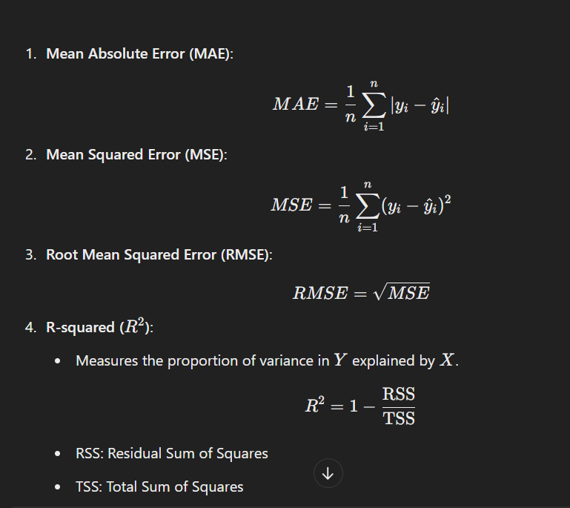

### **Applications**

1. **Predictive Modeling**:
   * Predict housing prices based on features like area, number of bedrooms, etc.
2. **Trend Analysis**:
   * Forecast sales trends over time.
3. **Risk Assessment**:
   * Estimate the risk in financial portfolios.
4. **Marketing**:
   * Determine how advertising budgets affect sales.

### **Advantages**

* Simple to implement and interpret.
* Computationally efficient for small to medium datasets.
* Provides interpretable coefficients.

### **Limitations**

* Sensitive to outliers.
* Assumes a linear relationship, which may not hold true in complex datasets.
* Performance can degrade with multicollinearity or high-dimensional data.

### **MCQs**

#### **Easy**

1. What does linear regression predict?  
   a) Categorical variables  
   b) Continuous variables  
   c) Probabilities  
   d) Labels  
   **Answer**: b) Continuous variables
2. The formula Y=β0+β1X represents:  
   a) Logistic Regression  
   b) Linear Regression  
   c) Polynomial Regression  
   d) Ridge Regression  
   **Answer**: b) Linear Regression
3. Which of the following is minimized in linear regression?  
   a) Mean Absolute Error  
   b) Residual Sum of Squares  
   c) Variance  
   d) Log-Loss  
   **Answer**: b) Residual Sum of Squares
4. Which method is used to estimate coefficients in linear regression?  
   a) Gradient Descent  
   b) Ordinary Least Squares  
   c) Cross Entropy  
   d) Maximum Likelihood Estimation  
   **Answer**: b) Ordinary Least Squares
5. What does R2 measure?  
   a) Error in predictions  
   b) Variance explained by the model  
   c) Correlation between variables  
   d) Linearity of data  
   **Answer**: b) Variance explained by the model

#### **Medium**

1. Linear regression assumes:  
   a) Non-linear relationship  
   b) Normal distribution of residuals  
   c) No multicollinearity  
   d) Both b and c  
   **Answer**: d) Both b and c
2. When multicollinearity exists, linear regression may produce:  
   a) Biased coefficients  
   b) Unbiased coefficients  
   c) Large confidence intervals  
   d) Invalid predictions  
   **Answer**: c) Large confidence intervals
3. What is the primary purpose of the intercept in linear regression?  
   a) Represent the slope of the line  
   b) Adjust for bias  
   c) Predict Y when X=0  
   d) Penalize large coefficients  
   **Answer**: c) Predict Y when X=0
4. Linear regression is not ideal for datasets with:  
   a) Non-linear relationships  
   b) Outliers  
   c) High dimensionality  
   d) All of the above  
   **Answer**: d) All of the above
5. What happens when overfitting occurs in linear regression?  
   a) Low training error, high test error  
   b) High training error, low test error  
   c) Both training and test error are high  
   d) Both training and test error are low  
   **Answer**: a) Low training error, high test error

#### **Hard**

1. What is the impact of high variance in data on linear regression?  
   a) Underfitting  
   b) Overfitting  
   c) Improved accuracy  
   d) Reduced bias  
   **Answer**: b) Overfitting
2. Which of the following is not an assumption of linear regression?  
   a) Linearity  
   b) Independence of residuals  
   c) Categorical target variable  
   d) Normality of residuals  
   **Answer**: c) Categorical target variable
3. If R2=0.95, what does it signify?  
   a) Model explains 95% of the variance in data  
   b) 95% of predictions are correct  
   c) 95% of residuals are positive  
   d) None of the above  
   **Answer**: a) Model explains 95% of the variance in data
4. Regularization techniques in linear regression are used to:  
   a) Increase RSS  
   b) Reduce overfitting  
   c) Eliminate residuals  
   d) Increase dimensionality  
   **Answer**: b) Reduce overfitting
5. Which of the following metrics is used to evaluate linear regression models?  
   a) Accuracy  
   b) F1-score  
   c) Mean Squared Error  
   d) Precision  
   **Answer**: c) Mean Squared Error
6. What happens to predictions if residuals show a pattern?  
   a) Predictions improve  
   b) Model assumptions are violated  
   c) Predictions become constant  
   d) Variance increases  
   **Answer**: b) Model assumptions are violated
7. Adding an irrelevant variable to the model may lead to:  
   a) Reduced accuracy  
   b) Increased R-squared  
   c) Decreased variance  
   d) Reduced residual error  
   **Answer**: b) Increased R-squared
8. What is multicollinearity?  
   a) Correlation between X and Y  
   b) Correlation between independent variables  
   c) Correlation between residuals  
   d) Correlation between error terms  
   **Answer**: b) Correlation between independent variables
9. The slope of a linear regression line represents:  
   a) Change in Y for a unit change in X  
   b) Change in X for a unit change in Y  
   c) Residual error  
   d) Bias of the model  
   **Answer**: a) Change in Y for a unit change in X
10. Ridge regression is an extension of linear regression used for:  
    a) Handling multicollinearity  
    b) Increasing the model's complexity  
    c) Predicting categorical variables  
    d) Removing residuals  
    **Answer**: a) Handling multicollinearity

### **Logistic Regression**

Logistic regression is a statistical method used for binary classification problems, where the target variable (Y) is categorical and takes on values such as 0 or1 (e.g., success/failure, true/false, spam/non-spam). Unlike linear regression, which predicts continuous values, logistic regression predicts probabilities that map to specific categories.

### **Key Concepts**

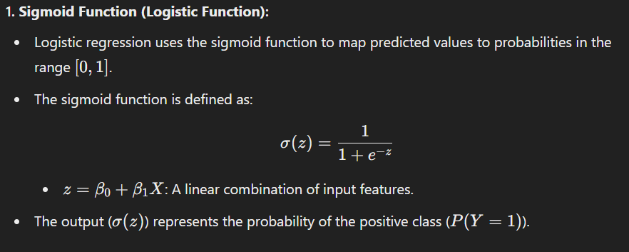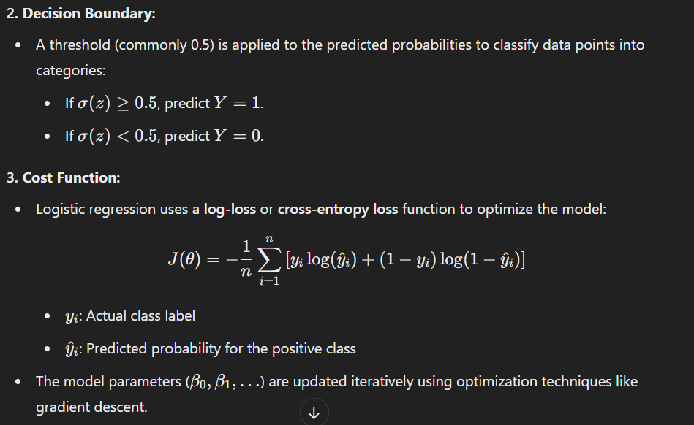

#### 

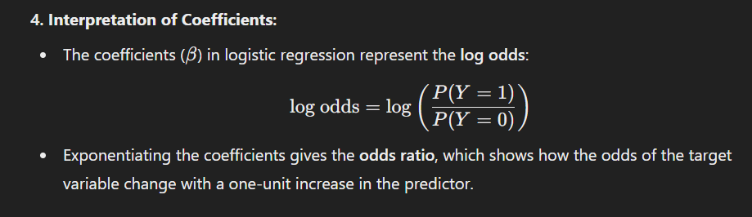

### **Types of Logistic Regression**

1. **Binary Logistic Regression**:
   * Used for problems with two classes (e.g., yes/no, spam/non-spam).
2. **Multinomial Logistic Regression**:
   * Used when the target variable has more than two unordered categories (e.g., red/green/blue).
3. **Ordinal Logistic Regression**:
   * Used when the target variable has ordered categories (e.g., low/medium/high).

### **Assumptions of Logistic Regression**

1. **Binary or Multinomial Target**: The dependent variable should be categorical.
2. **Independence of Observations**: Data points should not influence each other.
3. **Linear Relationship in Log-Odds**: The predictors have a linear relationship with the log-odds of the outcome.
4. **No Multicollinearity**: Predictors should not be highly correlated.
5. **Sufficient Sample Size**: A larger sample size improves the reliability of results.

### **Advantages**

1. Simple and interpretable.
2. Works well for binary classification problems.
3. Does not require scaling for most cases.
4. Outputs probabilities, which are useful for decision-making.

### **Limitations**

1. Assumes linearity in the log-odds space.
2. Sensitive to outliers.
3. Not suitable for non-linear relationships without transformations.
4. Can be less effective with high-dimensional or sparse data.

### **Applications**

1. **Healthcare**: Predict the likelihood of a disease based on symptoms.
2. **Finance**: Assess the risk of loan default.
3. **Marketing**: Determine the probability of a customer clicking an ad.
4. **Customer Retention**: Predict whether a customer will churn.

### **MCQs**

#### **Easy**

1. Logistic regression is used for:

a) Regression analysis  
b) Binary classification problems  
c) Non-linear regression problems  
d) Time series forecasting  
**Answer**: b) Binary classification problems

1. The logistic function maps values to the range:  
   a) [0,∞)  
   b) [−1,1]  
   c) [0,1]  
   d) (−∞,∞)  
   **Answer**: c) [0,1]
2. Which of the following is the cost function for logistic regression?  
   a) Mean Squared Error  
   b) Log-Loss  
   c) Hinge Loss  
   d) Accuracy  
   **Answer**: b) Log-Loss
3. Logistic regression predicts:  
   a) Probabilities  
   b) Continuous values  
   c) Clusters  
   d) Categories only  
   **Answer**: a) Probabilities
4. What is the sigmoid function’s output when z=0?  
   a) 0  
   b) 0.5  
   c) 1  
   d) Undefined  
   **Answer**: b) 0.5

#### **Medium**

1. Logistic regression assumes a linear relationship between:  
   a) X and Y  
   b) X and probabilities  
   c) X and log-odds  
   d) Y and residuals  
   **Answer**: c) X and log-odds
2. What happens if multicollinearity exists in logistic regression?  
   a) Coefficients become unreliable  
   b) The model overfits  
   c) Log-loss increases  
   d) The sigmoid function fails  
   **Answer**: a) Coefficients become unreliable
3. What is the primary advantage of logistic regression over linear regression for binary classification?  
   a) Predicts continuous values  
   b) Maps outputs to probabilities  
   c) Is less sensitive to outliers  
   d) Does not require optimization  
   **Answer**: b) Maps outputs to probabilities
4. What is the threshold commonly used for classification in logistic regression?  
   a) 0.2  
   b) 0.5  
   c) 0.7  
   d) 1.0  
   **Answer**: b) 0.5
5. Increasing the regularization parameter in logistic regression results in:  
   a) Larger coefficients  
   b) Smaller coefficients  
   c) Higher variance  
   d) Higher bias  
   **Answer**: b) Smaller coefficients

#### **Hard**

1. Which technique improves logistic regression performance on imbalanced datasets?  
   a) Feature scaling  
   b) Oversampling the minority class  
   c) Increasing the threshold  
   d) Removing outliers  
   **Answer**: b) Oversampling the minority class
2. The log-odds are equal to zero when the probability is:  
   a) 0  
   b) 0.5  
   c) 1  
   d) Undefined  
   **Answer**: b) 0.5
3. Which of the following evaluation metrics is best for logistic regression?  
   a) MSE  
   b) Accuracy  
   c) AUC-ROC  
   d) Mean Absolute Error  
   **Answer**: c) AUC-ROC
4. Logistic regression is a type of:  
   a) Linear model  
   b) Non-linear model  
   c) Clustering model  
   d) Tree-based model  
   **Answer**: a) Linear model
5. L1 regularization in logistic regression leads to:  
   a) Larger coefficients  
   b) Sparse solutions  
   c) Reduced residuals  
   d) Increased variance  
   **Answer**: b) Sparse solutions

### **Polynomial Regression**

Polynomial regression is an extension of linear regression that models the relationship between the independent variable (X) and the dependent variable (Y) as an n-th degree polynomial. It is a form of regression analysis used when the data does not follow a linear trend but shows a curvilinear relationship.

### 

### 

### 

### 

### 

### **Key Concepts**

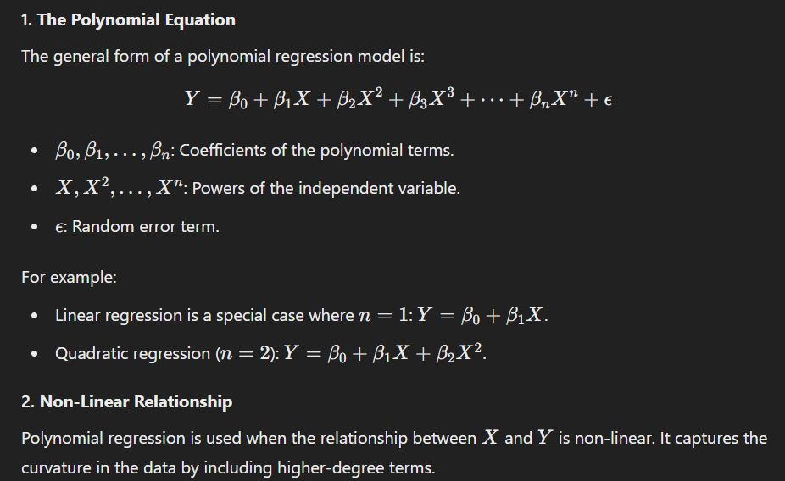

### **Steps in Polynomial Regression**

1. **Data Preparation**:
   * Organize your data into input (X) and output (Y) variables.
   * Check for a non-linear relationship using scatter plots.
2. **Feature Transformation**:
   * Transform the independent variable (X) into polynomial features (X, X^2, X^3,..... ).
3. **Fitting the Model**:
   * Use ordinary least squares (OLS) or another fitting technique to estimate the coefficients (β\betaβ).
4. **Model Evaluation**:
   * Evaluate the model using metrics such as:
     + R2: Goodness of fit.
     + Root Mean Square Error (RMSE).
     + Cross-validation for generalization.
5. **Prediction**:
   * Use the model equation to predict Y values for given X.

### **Advantages**

1. Captures non-linear relationships that linear regression cannot model.
2. Easy to implement and interpret for low-degree polynomials.
3. Flexible for different curvatures in data.

### **Limitations**

1. **Overfitting**:
   * Higher-degree polynomials may overfit the training data, capturing noise rather than the true trend.
2. **Extrapolation Issues**:
   * Predictions outside the observed range of X may become highly unreliable.
3. **Multicollinearity**:
   * Adding polynomial terms increases the risk of multicollinearity (correlation among predictors).
4. **Computational Complexity**:
   * High-degree polynomials can increase computational cost and make interpretation challenging.

#### 

### **Applications**

1. **Finance**: Predicting stock prices with complex trends.
2. **Healthcare**: Modeling growth rates, e.g., tumor growth over time.
3. **Economics**: Analyzing non-linear relationships in economic indicators.
4. **Marketing**: Understanding the impact of advertising spend on sales.

### **MCQs**

#### **Easy**

1. Polynomial regression is an extension of:  
   a) Logistic regression  
   b) Decision trees  
   c) Linear regression  
   d) Support vector machines  
   **Answer**: c) Linear regression
2. What is the degree of a polynomial in the equation Y=β0+β1X+β2X2?  
   a) 1  
   b) 2  
   c) 3  
   d) 4  
   **Answer**: b) 2
3. The output of polynomial regression is:  
   a) A probability  
   b) A curve  
   c) A binary classification  
   d) A cluster label  
   **Answer**: b) A curve
4. Polynomial regression is used for:  
   a) Non-linear relationships  
   b) Binary classification  
   c) Time series analysis  
   d) Dimensionality reduction  
   **Answer**: a) Non-linear relationships
5. Adding higher-degree polynomial terms can lead to:  
   a) Underfitting  
   b) Overfitting  
   c) Reduced variance  
   d) Increased bias  
   **Answer**: b) Overfitting

#### **Medium**

1. The term β2X2 in a polynomial regression equation represents:  
   a) The slope of the curve  
   b) The quadratic effect of X  
   c) The intercept  
   d) The error term  
   **Answer**: b) The quadratic effect of X
2. Which metric is commonly used to evaluate polynomial regression?  
   a) Log-loss  
   b) AUC-ROC  
   c) R2  
   d) Accuracy  
   **Answer**: c) R2
3. What is the primary challenge of high-degree polynomials in regression?  
   a) Simplified interpretation  
   b) Reduced flexibility  
   c) Overfitting  
   d) Improved generalization  
   **Answer**: c) Overfitting
4. Polynomial regression can be reduced to linear regression by:  
   a) Removing the intercept  
   b) Reducing the degree to 1  
   c) Adding higher-degree terms  
   d) Using logistic loss  
   **Answer**: b) Reducing the degree to 1
5. Multicollinearity in polynomial regression occurs because:  
   a) Predictor variables are unrelated  
   b) Higher-degree terms are highly correlated with lower-degree terms  
   c) The model has insufficient data  
   d) The predictors are categorical  
   **Answer**: b) Higher-degree terms are highly correlated with lower-degree terms

#### **Hard**

1. In polynomial regression, what happens to R2 as the degree of the polynomial increases?  
   a) It decreases  
   b) It remains constant  
   c) It increases  
   d) It oscillates  
   **Answer**: c) It increases
2. Which technique can mitigate overfitting in polynomial regression?  
   a) Increasing the degree of the polynomial  
   b) Using regularization (e.g., Lasso, Ridge)  
   c) Removing the intercept term  
   d) Ignoring the error term  
   **Answer**: b) Using regularization (e.g., Lasso, Ridge)
3. What is the main purpose of cross-validation in polynomial regression?  
   a) To increase training error  
   b) To prevent multicollinearity  
   c) To evaluate the model's performance on unseen data  
   d) To minimize computational cost  
   **Answer**: c) To evaluate the model's performance on unseen data
4. Polynomial regression can approximate non-linear functions using:  
   a) Higher-order polynomial terms  
   b) Logarithmic transformations  
   c) Piecewise linear models  
   d) Linear terms only  
   **Answer**: a) Higher-order polynomial terms
5. Which of the following is a sign of underfitting in polynomial regression?  
   a) High training error and low test error  
   b) Low training error and high test error  
   c) High training error and high test error  
   d) Low training error and low test error  
   **Answer**: c) High training error and high test error

### **Ridge Regression**

Ridge regression, also known as **Tikhonov regularization**, is a type of linear regression that incorporates a regularization term to reduce overfitting and handle multicollinearity in the data. It is particularly useful when the independent variables are highly correlated (multicollinearity) or when the dataset has more features than observations.

### **Key Concepts**

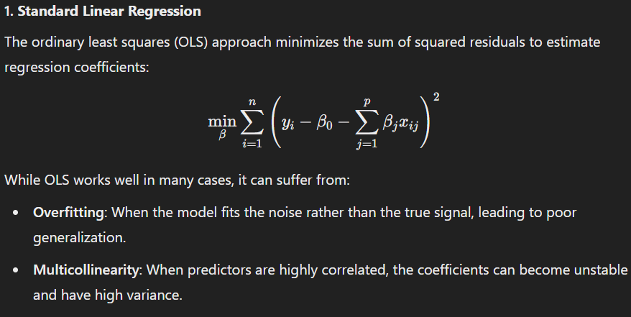

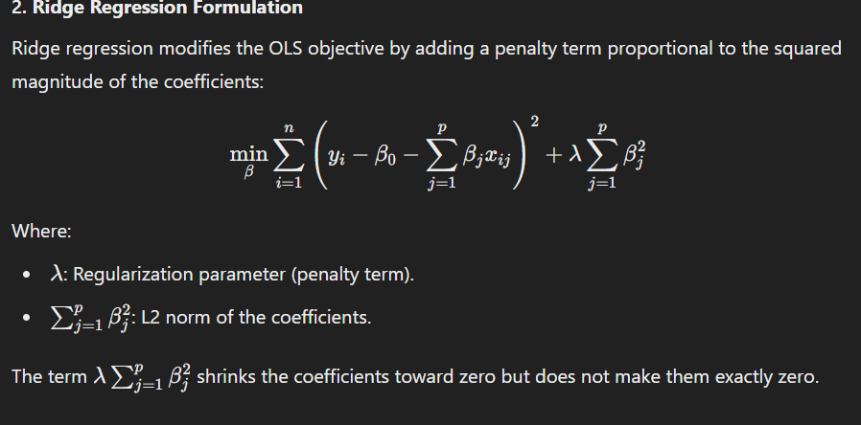

### **Impact of the Regularization Parameter (λ)**

1. **When λ=0**:
   * Ridge regression reduces to ordinary least squares (no regularization).
   * The model is more likely to overfit.
2. **When λ>0**:
   * Coefficients are shrunk, reducing their variance and improving generalization.
   * Larger values increase the penalty, resulting in smaller coefficients.
3. **When λ→∞**:
   * Coefficients shrink toward zero, making the model overly simplistic and leading to underfitting.

### **Advantages of Ridge Regression**

1. **Handles Multicollinearity**:
   * By adding a penalty term, ridge regression stabilizes the solution, making it less sensitive to multicollinearity.
2. **Prevents Overfitting**:
   * The penalty term controls model complexity, reducing overfitting on training data.
3. **Works Well with Many Features**:
   * Useful when the number of predictors exceeds the number of observations.

### **Limitations**

1. **Bias Introduction**:
   * Ridge regression introduces bias into the estimates. However, it often reduces variance significantly, improving overall prediction accuracy.
2. **Feature Selection**:
   * Unlike Lasso regression, Ridge does not shrink coefficients to zero, so it cannot perform feature selection.
3. **Choice of λ**:
   * The regularization parameter must be carefully chosen, often through cross-validation.

### **Ridge Regression vs. Other Techniques**

| **Aspect** | **Ridge Regression** | **Lasso Regression** |
| --- | --- | --- |
| Penalty | L2 (sum of squared coefficients) | L1 (sum of absolute coefficients) |
| Effect on Coefficients | Shrinks coefficients but does not make them zero | Shrinks some coefficients to exactly zero (feature selection) |
| Best Use Case | Multicollinearity | Feature selection and sparsity |

### **Interpretation**

* Ridge reduces overfitting and improves predictions on unseen data.

### **MCQs**

#### **Easy**

1. Ridge regression minimizes the:  
   a) L1 norm  
   b) L2 norm  
   c) Manhattan distance  
   d) Euclidean distance  
   **Answer**: b) L2 norm
2. Ridge regression is also known as:  
   a) Lasso regression  
   b) Ordinary least squares  
   c) Tikhonov regularization  
   d) Logistic regression  
   **Answer**: c) Tikhonov regularization
3. The regularization parameter in Ridge regression is denoted by:  
   a) β\betaβ  
   b) α\alphaα  
   c) λ\lambdaλ  
   d) γ\gammaγ  
   **Answer**: c) λ\lambdaλ
4. What happens as λ→0 in Ridge regression?  
   a) Coefficients shrink to zero  
   b) Ridge regression reduces to ordinary least squares  
   c) Overfitting decreases  
   d) Variance increases  
   **Answer**: b) Ridge regression reduces to ordinary least squares
5. Ridge regression is best suited for datasets with:  
   a) Low multicollinearity  
   b) High multicollinearity  
   c) Sparse features  
   d) Binary classification labels  
   **Answer**: b) High multicollinearity

#### **Medium**

1. Which of the following is not an advantage of Ridge regression?  
   a) Handles multicollinearity  
   b) Performs feature selection  
   c) Reduces overfitting  
   d) Stabilizes coefficients  
   **Answer**: b) Performs feature selection
2. Ridge regression can handle:  
   a) Non-linear relationships  
   b) Multicollinearity in linear relationships  
   c) Binary classification problems  
   d) Time series data without transformation  
   **Answer**: b) Multicollinearity in linear relationships
3. What is the penalty term in Ridge regression?  
   a) ∑j=1p∣βj∣\sum_{j=1}^{p} |\beta_j|∑j=1p​∣βj​∣  
   b) ∑j=1pβj2\sum_{j=1}^{p} \beta_j^2∑j=1p​βj2​  
   c) ∑j=1pβj\sum_{j=1}^{p} \beta_j∑j=1p​βj​  
   d) ∑j=1pβj\sum_{j=1}^{p} \sqrt{\beta_j}∑j=1p​βj​​  
   **Answer**: b) ∑j=1pβj2\sum_{j=1}^{p} \beta_j^2∑j=1p​βj2​
4. A high λ\lambdaλ in Ridge regression leads to:  
   a) Overfitting  
   b) Underfitting  
   c) Sparse coefficients  
   d) Reduced bias  
   **Answer**: b) Underfitting
5. Ridge regression can be solved using:  
   a) Gradient descent  
   b) Logistic regression  
   c) Support vector machines  
   d) K-means clustering  
   **Answer**: a) Gradient descent

#### **Hard**

1. Ridge regression minimizes the objective function by adding a penalty to the:  
   a) Intercept term  
   b) Slope coefficient  
   c) Sum of squared errors  
   d) Mean of residuals  
   **Answer**: c) Sum of squared errors
2. Ridge regression is unsuitable for:  
   a) Datasets with many predictors  
   b) Categorical variables without encoding  
   c) Handling multicollinearity  
   d) Continuous predictors  
   **Answer**: b) Categorical variables without encoding
3. Which metric is most sensitive to the regularization parameter in Ridge regression?  
   a) Accuracy  
   b) Root mean squared error  
   c) R2  
   d) Precision  
   **Answer**: b) Root mean squared error
4. What happens to the bias-variance tradeoff in Ridge regression?  
   a) Bias decreases, variance increases  
   b) Both bias and variance increase  
   c) Bias increases, variance decreases  
   d) Both bias and variance decrease  
   **Answer**: c) Bias increases, variance decreases
5. Ridge regression is preferred over OLS when:  
   a) Multicollinearity is low  
   b) Dataset is small  
   c) Predictors are highly correlated  
   d) Overfitting is irrelevant  
   **Answer**: c) Predictors are highly correlated

### **Lasso Regression**

Lasso regression, short for **Least Absolute Shrinkage and Selection Operator**, is a type of linear regression that adds regularization to the model by incorporating a penalty term based on the absolute values of the coefficients. It is widely used for regression problems, especially when feature selection is essential, as it can shrink some coefficients to exactly zero, effectively removing those features from the model.

### 

### 

### 

### 

### 

### 

### 

### **Key Concepts**

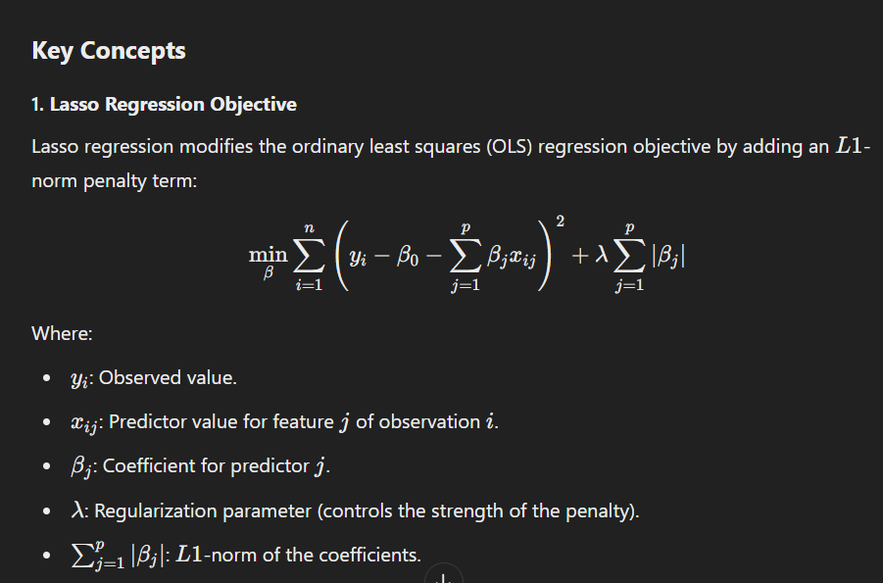

### **Key Properties of Lasso Regression**

1. **Feature Selection**:
   * Unlike Ridge regression, Lasso can shrink some coefficients to exactly zero, effectively excluding those features from the model.
   * This makes Lasso useful for creating sparse models.
2. **Regularization Effect**:

parameter controls the extent of regularization:

* + - λ=0: Lasso regression reduces to ordinary least squares.
    - λ>0: Coefficients are penalized, leading to shrinkage and potential elimination of features.
    - λ→∞: All coefficients shrink to zero, resulting in an intercept-only model.

1. **Bias-Variance Tradeoff**:
   * Lasso increases bias in the model but significantly reduces variance, improving generalization and reducing overfitting.

### **Geometric Intuition**

Lasso regression uses the L1-norm, which constrains the sum of the absolute values of the coefficients within a diamond-shaped region. The sharp corners of the diamond often result in some coefficients being exactly zero, unlike Ridge regression's L2-norm, which has a circular constraint.

### **Advantages**

1. **Feature Selection**:
   * By shrinking coefficients to zero, Lasso automatically selects a subset of features, making the model simpler and interpretable.
2. **Prevents Overfitting**:
   * The penalty term reduces the risk of overfitting on training data.
3. **Works Well with High-Dimensional Data**:
   * Particularly useful when the number of predictors exceeds the number of observations.
4. **Improves Model Interpretability**:
   * Sparse solutions make it easier to identify the most important predictors.

### **Disadvantages**

1. **Multicollinearity**:
   * Lasso struggles when predictors are highly correlated. It tends to select one variable and ignore others.
2. **Choice of λ**:
   * The regularization parameter must be carefully tuned, usually via cross-validation.
3. **Bias Introduction**:
   * The shrinkage of coefficients introduces bias, which may affect predictions.
4. **Exclusion of Features**:
   * Important features with small effects may be excluded if λ is too large.

### **Lasso Regression vs. Ridge Regression**

| **Aspect** | **Lasso Regression** | **Ridge Regression** |
| --- | --- | --- |
| Penalty | L1 (absolute values of coefficients) | L2 (squared values of coefficients) |
| Feature Selection | Shrinks some coefficients to zero | Shrinks coefficients but never zero |
| Best Use Case | Sparse models | Multicollinearity |

### **Applications**

1. **High-Dimensional Data**:
   * Genomics, where the number of features is much larger than the observations.
2. **Sparse Models**:
   * Useful in situations where interpretability is crucial, like finance and healthcare.
3. **Feature Selection**:
   * Lasso is often used as a preprocessing step to identify the most relevant features.

### **MCQs**

#### **Easy**

1. The penalty term in Lasso regression is based on:  
   a) L1-norm  
   b) L2-norm  
   c) Manhattan distance  
   d) Euclidean distance  
   **Answer**: a) L1L1L1-norm
2. Lasso regression can be used for:  
   a) Feature selection  
   b) Binary classification  
   c) Time series forecasting  
   d) Data imputation  
   **Answer**: a) Feature selection
3. When λ=0, Lasso regression is equivalent to:  
   a) Ridge regression  
   b) Logistic regression  
   c) Ordinary least squares regression  
   d) Polynomial regression  
   **Answer**: c) Ordinary least squares regression
4. In Lasso regression, λ→∞ results in:  
   a) A sparse model with zero coefficients  
   b) Overfitting  
   c) All coefficients becoming equal  
   d) Perfect predictions  
   **Answer**: a) A sparse model with zero coefficients
5. Lasso regression is preferred when:  
   a) Multicollinearity is high  
   b) Feature selection is required  
   c) The dataset has no outliers  
   d) Non-linear relationships exist  
   **Answer**: b) Feature selection

#### **Medium**

1. The key difference between Lasso and Ridge regression is:  
   a) The type of penalty term  
   b) The use of cross-validation  
   c) Handling of categorical variables  
   d) Applicability to non-linear data  
   **Answer**: a) The type of penalty term
2. Which of the following is not true about Lasso regression?  
   a) It uses L1-norm regularization  
   b) It can shrink coefficients to zero  
   c) It handles multicollinearity well  
   d) It introduces bias into predictions  
   **Answer**: c) It handles multicollinearity well
3. The effect of a high λ value in Lasso regression is:  
   a) Overfitting  
   b) Underfitting  
   c) Increased coefficient magnitudes  
   d) Improved accuracy  
   **Answer**: b) Underfitting
4. Which metric is most affected by Lasso regression's penalty?  
   a) Mean absolute error  
   b) Root mean squared error  
   c) Coefficient magnitude  
   d) Intercept  
   **Answer**: c) Coefficient magnitude
5. Lasso regression is an example of:  
   a) Regularized regression  
   b) Classification  
   c) Unsupervised learning  
   d) Non-linear regression  
   **Answer**: a) Regularized regression

#### **Hard**

1. Lasso regression struggles when:  
   a) Predictors are highly correlated  
   b) Feature selection is required  
   c) The dataset is sparse  
   d) Regularization is unnecessary  
   **Answer**: a) Predictors are highly correlated
2. Which of the following regression models performs automatic feature selection?  
   a) Ridge regression  
   b) Lasso regression  
   c) Polynomial regression  
   d) Logistic regression  
   **Answer**: b) Lasso regression
3. Lasso regression may not perform well when:  
   a) λ is too small  
   b) λ is too large  
   c) Multicollinearity is present  
   d) All of the above  
   **Answer**: d) All of the above
4. Which regularization technique penalizes the absolute value of coefficients?  
   a) Lasso  
   b) Ridge  
   c) Elastic Net  
   d) None of the above  
   **Answer**: a) Lasso
5. In a high-dimensional dataset, Lasso regression is typically preferred because:  
   a) It avoids overfitting entirely  
   b) It shrinks unimportant coefficients to zero  
   c) It increases interpretability  
   d) Both b and c  
   **Answer**: d) Both b and c

### **Elastic Net Regression: A Detailed Explanation**

**Elastic Net Regression** is a regularization technique that combines the properties of **Ridge Regression** and **Lasso Regression**. It is particularly useful in handling datasets with multicollinearity or when there are a large number of correlated features.

### **Key Concepts**

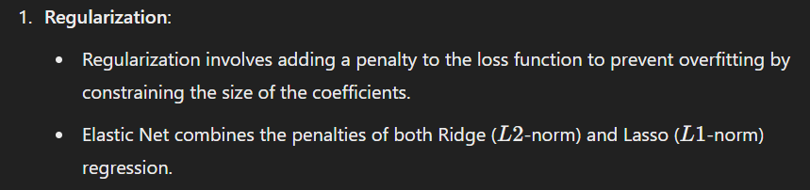

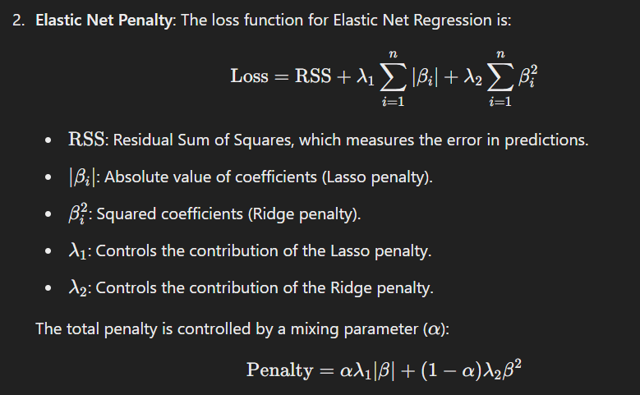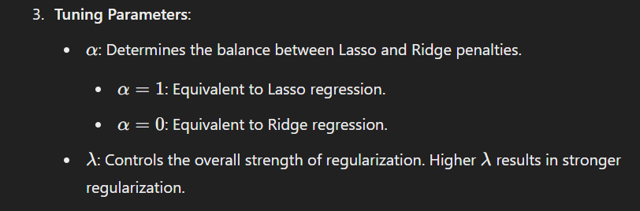

### **Why Use Elastic Net Regression?**

1. **Handles Multicollinearity**:
   * Elastic Net is effective when features are highly correlated. Lasso tends to pick one feature and ignore others, while Ridge assigns similar weights to correlated features. Elastic Net provides a balanced approach by combining both penalties.
2. **Feature Selection**:
   * Like Lasso, Elastic Net can shrink some coefficients to exactly zero, effectively selecting a subset of features.
   * However, Elastic Net avoids the limitations of Lasso when dealing with correlated predictors by not arbitrarily dropping one of them.
3. **Flexibility**:
   * By tuning α, Elastic Net can mimic Ridge or Lasso behavior or provide a compromise between the two.

### **Steps in Elastic Net Regression**

1. **Standardize the Data**:
   * Elastic Net performs better when predictors are on the same scale, as the penalties depend on the magnitude of coefficients.
2. **Choose α and λ**:
   * Use cross-validation to find the optimal values of α and λ that minimize the prediction error.
3. **Fit the Model**:
   * Solve the loss function with the chosen regularization parameters.
4. **Evaluate the Model**:
   * Use metrics such as RMSE, R2, or AUC (for classification problems) to assess the performance.

### **Example**

#### **Scenario:**

Suppose you are predicting house prices based on features like area, number of bedrooms, location, and age of the house. Some features (e.g., area and number of bedrooms) may be highly correlated.

#### **Solution:**

* Use Elastic Net regression to handle multicollinearity.
* Tune α and λ to balance Ridge and Lasso penalties.

### **Advantages**

1. **Balances Ridge and Lasso**:
   * Retains the strengths of both methods while addressing their weaknesses.
2. **Handles Correlated Features**:
   * Distributes weights among correlated predictors instead of dropping them.
3. **Feature Selection**:
   * Performs automatic feature selection by shrinking some coefficients to zero.
4. **Prevents Overfitting**:
   * Regularization reduces overfitting, especially in high-dimensional data.

### **Disadvantages**

1. **Parameter Tuning**:
   * Requires careful selection of αand λ, which can be computationally expensive.
2. **Interpretability**:
   * Regularization shrinks coefficients, which may make interpretation less straightforward.
3. **Not Suitable for All Data**:
   * If the features are not correlated or the dataset is small, simpler models like ordinary least squares may suffice.

### **MCQs on Elastic Net Regression**

1. **What does Elastic Net regression combine?**a) Lasso and Linear Regression  
   b) Ridge and Logistic Regression  
   c) Ridge and Lasso Regression  
   d) Decision Tree and Ridge Regression  
   **Answer**: c) Ridge and Lasso Regression
2. **What is the role of α\alphaα in Elastic Net?**a) To control the regularization strength  
   b) To balance L1 and L2 penalties  
   c) To shrink coefficients to zero  
   d) To handle multicollinearity  
   **Answer**: b) To balance L1 and L2 penalties
3. **Which type of dataset is Elastic Net best suited for?**a) Low-dimensional data with uncorrelated features  
   b) High-dimensional data with correlated features  
   c) High-dimensional data with uncorrelated features  
   d) Low-dimensional data with correlated features  
   **Answer**: b) High-dimensional data with correlated features
4. **If α=0, what does Elastic Net become equivalent to?**a) Lasso Regression  
   b) Ridge Regression  
   c) Linear Regression  
   d) Logistic Regression  
   **Answer**: b) Ridge Regression
5. **What happens when λ increases in Elastic Net regression?**a) Overfitting increases  
   b) Coefficients shrink further  
   c) Coefficients remain unchanged  
   d) Multicollinearity increases  
   **Answer**: b) Coefficients shrink further
6. **Elastic Net is particularly useful when:**a) All predictors are uncorrelated  
   b) Predictors are highly correlated  
   c) There are no categorical predictors  
   d) The dataset is small  
   **Answer**: b) Predictors are highly correlated
7. **Which of the following is minimized in Elastic Net Regression?**a) Mean Squared Error only  
   b) Residual Sum of Squares only  
   c) Residual Sum of Squares with L1 and L2 penalties  
   d) Residual Sum of Squares with no penalties  
   **Answer**: c) Residual Sum of Squares with L1 and L2 penalties
8. **The Elastic Net penalty is defined as a combination of:**a) Linear and Logistic Regression penalties  
   b) Ridge (L2) and Lasso (L1) penalties  
   c) Decision Tree and Ridge penalties  
   d) Random Forest and Lasso penalties  
   **Answer**: b) Ridge (L2L2L2) and Lasso (L1L1L1) penalties
9. **Which parameter controls the overall strength of regularization in Elastic Net?**a) α  
   b) λ  
   c) R2  
   d) β  
   **Answer**: b) λ
10. **What happens when α is set to 1 in Elastic Net Regression?**a) Elastic Net behaves like Lasso Regression  
    b) Elastic Net behaves like Ridge Regression  
    c) Regularization is turned off  
    d) Coefficients become independent of penalties  
    **Answer**: a) Elastic Net behaves like Lasso Regression
11. **Which Elastic Net parameter decides the mixing ratio between Lasso and Ridge?**a) β\betaβ  
    b) α\alphaα  
    c) λ\lambdaλ  
    d) R2R^2R2  
    **Answer**: b) α\alphaα
12. **Elastic Net is likely to be preferred over Ridge or Lasso when:**a) Features are sparse  
    b) There are uncorrelated predictors  
    c) Features are highly correlated  
    d) The dataset has no missing values  
    **Answer**: c) Features are highly correlated
13. **Elastic Net regression is used for:**a) Feature extraction  
    b) Feature selection  
    c) Both feature selection and prediction  
    d) Data preprocessing only  
    **Answer**: c) Both feature selection and prediction
14. **Which is NOT a property of Elastic Net Regression?**a) Handles multicollinearity  
    b) Performs feature selection  
    c) Provides unbiased coefficient estimates  
    d) Combines L1 and L2 penalties  
    **Answer**: c) Provides unbiased coefficient estimates
15. **In Elastic Net, the sum of L1 and L2 penalties is called:**a) Coefficient penalty  
    b) Regularization term  
    c) Mixed norm  
    d) Bias-variance tradeoff  
    **Answer**: b) Regularization term
16. **Which statement is true about Elastic Net?**a) It uses only the L2L2L2-norm penalty  
    b) It uses only the L1L1L1-norm penalty  
    c) It blends L1L1L1 and L2L2L2 penalties through a mixing parameter  
    d) It doesn't require cross-validation  
    **Answer**: c) It blends L1L1L1 and L2L2L2 penalties through a mixing parameter
17. **When compared to Ridge and Lasso, Elastic Net:**a) Ignores multicollinearity  
    b) Can perform better with highly correlated features  
    c) Assigns equal weights to all predictors  
    d) Requires no tuning of parameters  
    **Answer**: b) Can perform better with highly correlated features
18. **Elastic Net can select variables by:**a) Shrinking some coefficients to zero  
    b) Equalizing all coefficients  
    c) Ignoring regularization completely  
    d) Using unregularized optimization  
    **Answer**: a) Shrinking some coefficients to zero
19. **What is the primary advantage of Elastic Net over Lasso regression?**a) Reduces multicollinearity issues  
    b) More interpretable models  
    c) Eliminates the need for hyperparameter tuning  
    d) Ensures all coefficients remain non-zero  
    **Answer**: a) Reduces multicollinearity issues
20. **Elastic Net is a suitable choice when:**a) The dataset contains few features  
    b) Features are uncorrelated and sparse  
    c) There are many features with multicollinearity  
    d) Regularization is unnecessary  
    **Answer**: c) There are many features with multicollinearity

============================================================================================================================================

**Session 10 & 11**

### **Support Vector Machine (SVM): Detailed Explanation**

Support Vector Machines (SVM) are supervised machine learning algorithms commonly used for classification, regression, and outlier detection. They are particularly effective for high-dimensional spaces and when the number of dimensions is greater than the number of samples.

#### **Key Concepts of SVM**

1. **Hyperplane**:
   * A hyperplane is a decision boundary that separates the classes in the feature space.
   * For a dataset with two classes, the SVM algorithm finds the optimal hyperplane that maximizes the margin between the two classes.
2. **Margin**:
   * The margin is the distance between the hyperplane and the nearest data points from either class.
   * SVM aims to maximize this margin to improve generalization and robustness.
3. **Support Vectors**:
   * Support vectors are the data points closest to the hyperplane.
   * These points are critical as they define the position and orientation of the hyperplane.
4. **Linear and Non-Linear SVM**:
   * **Linear SVM**: Used when data is linearly separable, meaning a straight line (or plane in higher dimensions) can separate the classes.
   * **Non-Linear SVM**: Used when data is not linearly separable. It uses the "kernel trick" to map data into higher dimensions where a linear hyperplane can separate the classes.
5. **Kernel Trick**:
   * Kernels are mathematical functions that transform the input data into a higher-dimensional feature space.
   * Common kernel functions include:
     + **Linear Kernel**: For linearly separable data.
     + **Polynomial Kernel**: Maps data into a polynomial feature space.
     + **Radial Basis Function (RBF) Kernel**: Handles complex relationships and is effective for non-linear separable data.
     + **Sigmoid Kernel**: Often used in neural networks.
6. **Soft Margin vs. Hard Margin**:
   * **Hard Margin SVM**: Requires all data points to be classified correctly with a strict margin. Suitable for noise-free datasets.
   * **Soft Margin SVM**: Allows some misclassification by introducing a slack variable to handle noisy data and overlapping classes.

#### **Mathematics of SVM**

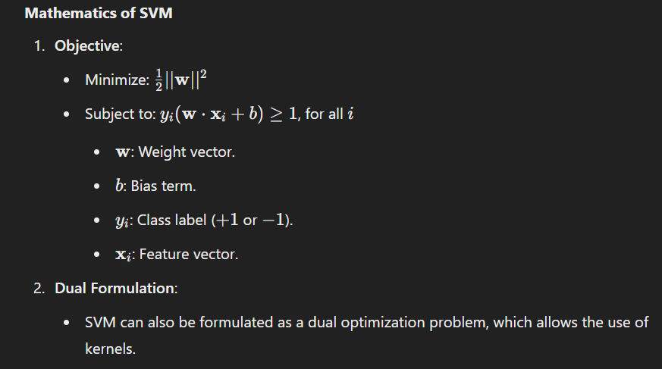

#### **Advantages of SVM**

* Works well with high-dimensional data.
* Effective in cases where the number of dimensions is greater than the number of samples.
* Robust to overfitting, especially with the right choice of regularization and kernel.
* Versatile, as different kernels can handle a variety of data distributions.

#### **Disadvantages of SVM**

* Computationally expensive for large datasets, as training complexity is O(n^3).
* Requires careful parameter tuning (e.g., choice of kernel, regularization parameter C).
* Less effective when the classes are heavily overlapped or not well-separated.
* Not ideal for noisy datasets.

#### **Applications of SVM**

1. **Text Classification**:
   * Spam email detection.
   * Sentiment analysis.
2. **Image Recognition**:
   * Handwritten digit recognition.
   * Object detection.
3. **Bioinformatics**:
   * Protein classification.
   * Cancer classification.
4. **Finance**:
   * Fraud detection.
   * Credit risk analysis.

#### **Example**

Consider a binary classification problem to separate two classes of points in a 2D space. A linear SVM would find the optimal line (hyperplane) that separates the classes with the maximum margin. If the points are not linearly separable, an RBF kernel can transform the data into a higher-dimensional space, making it linearly separable.

### **20 MCQs on Support Vector Machines**

1. SVM is primarily used for:  
   a) Clustering  
   b) Classification  
   c) Dimensionality reduction  
   d) Data cleaning  
   **Answer**: b) Classification
2. The hyperplane in SVM is:  
   a) A line that minimizes the margin  
   b) A decision boundary separating classes  
   c) Always non-linear  
   d) A kernel function  
   **Answer**: b) A decision boundary separating classes
3. Support vectors in SVM are:  
   a) All data points  
   b) Points closest to the hyperplane  
   c) Points farthest from the hyperplane  
   d) Misclassified points  
   **Answer**: b) Points closest to the hyperplane
4. What is the goal of SVM?  
   a) Minimize classification error only  
   b) Maximize the margin between classes  
   c) Minimize the margin between classes  
   d) Eliminate support vectors  
   **Answer**: b) Maximize the margin between classes
5. The kernel trick is used to:  
   a) Transform linear data into non-linear data  
   b) Perform dimensionality reduction  
   c) Solve optimization problems  
   d) Transform non-linear data into a higher-dimensional space  
   **Answer**: d) Transform non-linear data into a higher-dimensional space
6. Which kernel is suitable for linearly separable data?  
   a) Linear kernel  
   b) RBF kernel  
   c) Polynomial kernel  
   d) Sigmoid kernel  
   **Answer**: a) Linear kernel
7. Hard margin SVM is effective for:  
   a) Noisy data  
   b) Noise-free data  
   c) Small datasets  
   d) Non-linear data  
   **Answer**: b) Noise-free data
8. The soft margin parameter C controls:  
   a) Kernel type  
   b) Bias term  
   c) Trade-off between maximizing margin and classification error  
   d) Number of support vectors  
   **Answer**: c) Trade-off between maximizing margin and classification error
9. RBF kernel is also known as:  
   a) Linear kernel  
   b) Gaussian kernel  
   c) Polynomial kernel  
   d) Laplace kernel  
   **Answer**: b) Gaussian kernel
10. In a high-dimensional space, SVM is:  
    a) Inefficient  
    b) Very effective  
    c) Only usable with polynomial kernel  
    d) Dependent on decision trees  
    **Answer**: b) Very effect
11. Which of the following is NOT true about support vectors?  
    a) They determine the hyperplane.  
    b) Removing a support vector affects the model.  
    c) All data points are treated as support vectors.  
    d) Support vectors lie closest to the margin.  
    **Answer**: c) All data points are treated as support vectors
12. A high value of the regularization parameter CCC results in:  
    a) Larger margin with higher misclassification  
    b) Smaller margin with less misclassification  
    c) Less regularization  
    d) Ignoring kernel functions  
    **Answer**: b) Smaller margin with less misclassification
13. Which kernel would be the best choice for data with circular boundaries?  
    a) Linear  
    b) Polynomial  
    c) RBF (Radial Basis Function)  
    d) Sigmoid  
    **Answer**: c) RBF (Radial Basis Function)
14. What is the primary purpose of the slack variable in SVM?  
    a) Increase the number of support vectors  
    b) Allow some misclassification in the data  
    c) Enforce stricter classification  
    d) Reduce dimensionality  
    **Answer**: b) Allow some misclassification in the data
15. In the context of SVM, overfitting is more likely to occur when:  
    a) CCC is set to a very low value  
    b) The margin is maximized  
    c) CCC is set to a very high value  
    d) The kernel function is non-linear  
    **Answer**: c) C is set to a very high value
16. Which metric is most appropriate for evaluating an SVM classifier?  
    a) AUC-ROC  
    b) Mean Squared Error (MSE)  
    c) Adjusted R-Squared  
    d) Mean Absolute Error (MAE)  
    **Answer**: a) AUC-ROC
17. For multi-class classification, SVM typically uses:  
    a) One-vs-All or One-vs-One approach  
    b) Decision trees  
    c) Only linear kernels  
    d) Unsupervised learning methods  
    **Answer**: a) One-vs-All or One-vs-One approach
18. Which of the following statements is true about SVM with an RBF kernel?  
    a) It cannot handle non-linear relationships.  
    b) It uses a fixed margin for all data points.  
    c) It transforms data into higher-dimensional space for separation.  
    d) It requires the dataset to be linearly separable.  
    **Answer**: c) It transforms data into higher-dimensional space for separation
19. SVM can handle:  
    a) Only binary classification problems  
    b) Only regression problems  
    c) Both classification and regression problems  
    d) Only clustering problems  
    **Answer**: c) Both classification and regression problems
20. If two classes in an SVM model are completely overlapped, which approach should be taken?  
    a) Reduce the number of features  
    b) Increase the regularization parameter CCC  
    c) Use a non-linear kernel like RBF  
    d) Increase the number of samples  
    **Answer**: c) Use a non-linear kernel like RBF

### **Basic Classification Principle of Support Vector Machines (SVM)**

Support Vector Machines (SVM) are supervised machine learning algorithms primarily used for classification tasks (and regression). The core idea behind SVM is to find a hyperplane (decision boundary) that best separates the data points of different classes in a high-dimensional space.

### **Key Principles of SVM**

1. **Separation with a Hyperplane**:
   * A hyperplane is a flat affine subspace of one dimension less than its ambient space. For example, in 2D, the hyperplane is a line, while in 3D, it’s a plane.
   * The primary goal of SVM is to find the optimal hyperplane that separates data points of different classes.
2. **Maximum Margin Classifier**:
   * SVM seeks to maximize the margin, which is the distance between the hyperplane and the nearest data points of any class.
   * A large margin ensures better generalization, meaning the model is less likely to overfit the data.
3. **Support Vectors**:
   * Support vectors are the data points that lie closest to the hyperplane and influence its position and orientation.
   * These points are critical because moving or removing them would alter the hyperplane.
4. **Soft Margin and Slack Variables**:
   * In real-world data, perfect linear separability is rare due to noise and overlap between classes.
   * SVM introduces a "soft margin" using slack variables to allow some misclassification while still maximizing the margin.
   * A regularization parameter C controls the trade-off between maximizing the margin and minimizing classification errors.
5. **Non-Linear Classification with Kernels**:
   * When data cannot be separated linearly, SVM uses kernel functions to transform the data into a higher-dimensional space where it becomes linearly separable.
   * Popular kernel functions include:
     + **Linear Kernel**: K(x,x′)=x^T x'K
     + **Polynomial Kernel**: K(x,x′)=(x^T x' + c)^d
     + **Radial Basis Function (RBF)**: K(x,x′)=e^{-\gamma ||x - x'||^2}
     + **Sigmoid Kernel**: K(x,x′)=tanh(x^T x' + c)
6. **Binary and Multi-Class Classification**:
   * SVMs are naturally binary classifiers. For multi-class problems, strategies like One-vs-One (OvO) or One-vs-All (OvA) are used.

### **Mathematics Behind SVM**

#### **Finding the Hyperplane:**

The equation of a hyperplane in nnn-dimensional space is:

w⋅x+b=0w \cdot x + b = 0w⋅x+b=0

Where:

* www is the normal vector to the hyperplane.
* xxx is the data point.
* bbb is the bias term.

#### **Maximizing the Margin:**

The margin is defined as 2∣∣w∣∣\frac{2}{||w||}∣∣w∣∣2​, where ∣∣w∣∣||w||∣∣w∣∣ is the norm of www. To maximize the margin, we minimize ∣∣w∣∣||w||∣∣w∣∣ under the constraint:

yi(w⋅xi+b)≥1,∀iy_i (w \cdot x_i + b) \geq 1, \quad \forall iyi​(w⋅xi​+b)≥1,∀i

Here, yiy_iyi​ is the class label (+1+1+1 or −1-1−1).

#### **Objective Function:**

The optimization problem can be written as:

min⁡w,b12∣∣w∣∣2\min_{w,b} \frac{1}{2} ||w||^2w,bmin​21​∣∣w∣∣2

Subject to:

yi(w⋅xi+b)≥1,∀iy_i (w \cdot x_i + b) \geq 1, \quad \forall iyi​(w⋅xi​+b)≥1,∀i

When a soft margin is used, the objective becomes:

min⁡w,b12∣∣w∣∣2+C∑iξi\min_{w,b} \frac{1}{2} ||w||^2 + C \sum_{i} \xi_iw,bmin​21​∣∣w∣∣2+Ci∑​ξi​

Where ξi\xi_iξi​ are the slack variables, and CCC is the penalty for misclassification.

### **Advantages of SVM**

1. **Effective in high-dimensional spaces**.
2. **Robust against overfitting**, especially in cases of a large feature space and small sample size.
3. **Works well for both linearly separable and non-linear data** (using kernels).

### **Disadvantages of SVM**

1. **Computationally expensive for large datasets**, especially with non-linear kernels.
2. **Choosing the correct kernel and hyperparameters** (e.g., CCC, γ\gammaγ) requires careful tuning.
3. **Hard to interpret** for non-linear kernels.

### **Example of SVM in Action**

#### **Dataset:**

* Class A: (1,2),(2,3),(3,3)
* Class B: (6,5),(7,8),(8,6)

#### **Visualization:**

* These points can be separated by a line.
* The margin would be maximized to ensure better classification of new points.

### **Practical Use Case**

**Spam Detection**:

* Features like word frequency, punctuation marks, etc., can be used as input to an SVM.
* The SVM would classify emails as spam or not spam by creating a hyperplane in a high-dimensional space.

### **Comparing Linear and Non-Linear Classification**

| **Feature** | **Linear Classification** | **Non-Linear Classification** |
| --- | --- | --- |
| **Hyperplane** | Straight line/flat plane | Curved/complex decision boundary |
| **Kernel Used** | Linear kernel | Polynomial, RBF, or Sigmoid |
| **Complexity** | Low | High |
| **Data Requirement** | Linearly separable data | Non-linearly separable data |
| **Performance** | Faster | More flexible but slower |

============================================================================================================================================

**Session 12**

### **Discriminant Analysis (Linear and Quadratic)**

Discriminant Analysis is a statistical technique used for classification and dimensionality reduction. The goal is to determine which features discriminate between classes. It assumes that different classes generate data based on different statistical distributions, and the goal is to find the decision boundaries that best separate these classes.

Discriminant Analysis comes in two main forms:

1. **Linear Discriminant Analysis (LDA)**
2. **Quadratic Discriminant Analysis (QDA)**

Let's dive deeper into each of these methods:

### **1. Linear Discriminant Analysis (LDA)**

#### **Overview**

Linear Discriminant Analysis is a technique used when the classes are assumed to have the same covariance structure. In other words, LDA assumes that each class follows a Gaussian distribution with a class-specific mean, but all classes share the same variance-covariance matrix.

#### **Key Concepts of LDA:**

* **Goal**: Maximize the separability of the classes by finding a linear combination of features.
* **Linearly Separable Data**: LDA projects the data onto a lower-dimensional space, typically one-dimensional, such that the separation between the classes is maximized.
* **Assumptions**:
  + The classes have the same covariance matrix (homoscedasticity).
  + The features are normally distributed within each class.
  + The prior probabilities of classes are equal or known.

#### **Mathematical Formulation:**

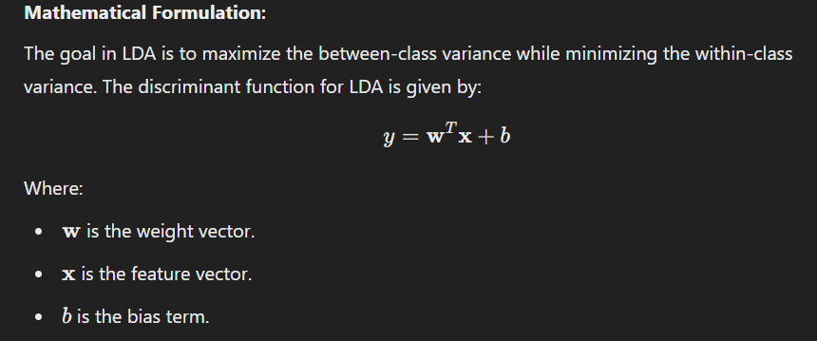

#### **Steps in LDA:**

1. **Compute the mean vectors** for each class.
2. **Compute the covariance matrix** of each class.
3. **Compute the within-class scatter matrix** and the between-class scatter matrix.
4. **Compute the eigenvalues and eigenvectors** of the scatter matrices to find the projection directions.
5. **Project the data** onto the new space to classify.

#### **Example:**

Imagine a dataset where we want to classify animals into categories such as "Mammals" and "Reptiles" based on features like "Weight" and "Height". LDA will find a linear combination of these features that best separates the two categories.

### **2. Quadratic Discriminant Analysis (QDA)**

#### **Overview**

Quadratic Discriminant Analysis is similar to LDA but differs in that it assumes each class has its own covariance matrix. In QDA, the decision boundary is quadratic (non-linear), rather than linear, because each class is modeled with its own covariance matrix.

#### **Key Concepts of QDA:**

* **Goal**: Similar to LDA but with the assumption that each class has a different covariance structure.
* **Quadratic Boundaries**: The decision boundaries in QDA are quadratic, meaning that the separation between classes is modeled as a curve or a parabola, rather than a straight line.
* **Assumptions**:
  + The features within each class are normally distributed.
  + The classes have different covariance matrices (heteroscedasticity).

#### **Mathematical Formulation:**

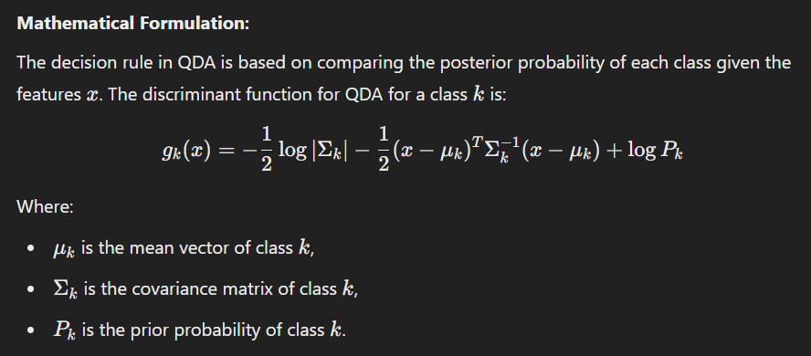

#### **Steps in QDA:**

1. **Compute the mean vector** for each class.
2. **Compute the covariance matrix** for each class.
3. **Estimate the class priors**.
4. **Use the quadratic decision function** to assign class labels based on the computed discriminant function.

#### **Example:**

If we extend the previous example, where "Mammals" and "Reptiles" are classified based on "Weight" and "Height", QDA would allow for different variances in the "Weight" feature for each class. The decision boundary would likely be curved instead of a straight line.

### **Key Differences Between LDA and QDA**

| **Feature** | **Linear Discriminant Analysis (LDA)** | **Quadratic Discriminant Analysis (QDA)** |
| --- | --- | --- |
| **Assumption on Covariance** | Same covariance matrix for all classes | Different covariance matrix for each class |
| **Decision Boundary** | Linear | Quadratic |
| **Complexity** | Less complex (fewer parameters to estimate) | More complex (needs to estimate covariance for each class) |
| **When to Use** | When classes share the same covariance structure | When classes have different covariance structures |
| **Bias-Variance Trade-off** | Less variance, more bias | More variance, less bias |

### **Applications of Discriminant Analysis**

* **Medical Diagnosis**: Identifying the disease category based on symptoms.
* **Image Classification**: Classifying images into categories (e.g., identifying different objects).
* **Text Classification**: Identifying spam versus non-spam emails.
* **Financial Predictions**: Classifying a company’s financial health as "good" or "bad".

### **MCQs for Discriminant Analysis (Linear and Quadratic)**

#### **Easy MCQs:**

1. **What is the primary goal of Linear Discriminant Analysis (LDA)?**

a) Minimize the classification error  
b) Maximize the separation between classes  
c) Minimize the variance within classes  
d) Maximize the variance within classes  
**Answer**: b) Maximize the separation between classes

1. **Which of the following assumptions does LDA make about the classes?**

a) Different covariance matrices for each class  
b) Different priors for each class  
c) Same covariance matrix for all classes  
d) Same mean for all classes  
**Answer**: c) Same covariance matrix for all classes

1. **What type of decision boundary does LDA create?**

a) Quadratic  
b) Exponential  
c) Linear  
d) Logarithmic  
**Answer**: c) Linear

1. **In QDA, the decision boundary between classes is:**

a) Linear  
b) Quadratic  
c) Exponential  
d) Logarithmic  
**Answer**: b) Quadratic

1. **Which of the following is assumed in QDA but not in LDA?**

a) The classes have different priors  
b) The classes have the same covariance matrix  
c) The classes have different covariance matrices  
d) The classes are normally distributed  
**Answer**: c) The classes have different covariance matrices

#### **Medium MCQs:**

1. **What is the role of the covariance matrix in LDA?**

a) It helps compute the class means  
b) It is used to find the decision boundary  
c) It defines the variance of the data  
d) It is used to compute the priors  
**Answer**: b) It is used to find the decision boundary

1. **Which of the following is NOT a step in the process of Linear Discriminant Analysis (LDA)?**

a) Compute the within-class scatter matrix  
b) Compute the between-class scatter matrix  
c) Estimate the covariance matrix for each class  
d) Project the data onto a lower-dimensional space  
**Answer**: c) Estimate the covariance matrix for each class

1. **Which kernel function is typically used in QDA for non-linear boundaries?**

a) RBF kernel  
b) Polynomial kernel  
c) Sigmoid kernel  
d) No kernel is used in QDA  
**Answer**: d) No kernel is used in QDA

1. **What kind of decision boundary does QDA generate?**

a) A straight line  
b) A curved boundary  
c) A constant value  
d) A threshold  
**Answer**: b) A curved boundary

1. **LDA is best used when the covariance matrices of each class are:**

a) Different  
b) Identical  
c) Unknown  
d) Very large  
**Answer**: b) Identical

#### **Hard MCQs:**

1. **Which of the following metrics does LDA primarily use to perform the dimensionality reduction?**

a) Principal Component Analysis (PCA)  
b) Minimizing the loss function  
c) Maximizing the ratio of between-class variance to within-class variance  
d) Gaussian Mixture Model (GMM)  
**Answer**: c) Maximizing the ratio of between-class variance to within-class variance

1. **Which method can lead to a better performance when classes have different variances?**

a) LDA  
b) QDA  
c) Logistic Regression  
d) K-Nearest Neighbors (KNN)  
**Answer**: b) QDA

1. **Which of the following is a limitation of LDA?**

a) LDA assumes classes have identical covariance matrices, which may not always hold true.  
b) LDA is computationally expensive.  
c) LDA works best with non-Gaussian data.  
d) LDA requires a large amount of training data.  
**Answer**: a) LDA assumes classes have identical covariance matrices, which may not always hold true.

1. **In QDA, the covariance matrix for each class is estimated independently. What effect does this have?**

a) It allows QDA to create linear decision boundaries.  
b) It results in computational complexity.  
c) It makes QDA less sensitive to noise.  
d) It reduces the model complexity.  
**Answer**: b) It results in computational complexity.

1. **What is one disadvantage of QDA compared to LDA?** a) QDA is faster to compute.  
   b) QDA works well for very large datasets.  
   c) QDA is more computationally intensive due to estimating separate covariance matrices.  
   d) QDA assumes linear decision boundaries.  
   **Answer**: c) QDA is more computationally intensive due to estimating separate covariance matrices.

### **K-Nearest Neighbors (K-NN) Algorithm in Detail**

The **K-Nearest Neighbors (K-NN)** algorithm is one of the simplest and most widely used machine learning algorithms for classification and regression tasks. It is a non-parametric, instance-based learning algorithm. K-NN works by making predictions based on the proximity of the data points in a feature space.

### **Key Concepts of K-Nearest Neighbors (K-NN)**

1. **Non-parametric**: K-NN doesn't assume any prior distribution or underlying model for the data. It stores all the training data and makes predictions based on this stored data, making it non-parametric.
2. **Instance-based learning**: In K-NN, the model does not learn a global model (like a linear regression line or decision tree). Instead, it memorizes the training data and makes predictions by comparing the test data to the stored training data.
3. **Lazy Learning**: Unlike other algorithms such as decision trees or neural networks, K-NN doesn't perform explicit training. The model "learns" by simply storing the training data and making predictions when needed.
4. **Distance-based algorithm**: K-NN relies on the concept of distance (typically Euclidean distance) to determine which data points are nearest to the query point.

### **How K-NN Works?**

#### **Steps Involved in K-NN Algorithm:**

1. **Choose the number of neighbors (K)**:
   * The first step is to select the value of **K**, which is the number of nearest neighbors the algorithm should consider when making predictions.
   * Common values for K are 3, 5, or 7. It is typically chosen based on the dataset size and experimentation.
2. **Calculate the distance between data points**:
   * The next step is to calculate the distance between the test point (query point) and each data point in the training set. The most common distance metric is **Euclidean distance**, but other metrics like **Manhattan distance**, **Cosine similarity**, or **Minkowski distance** can also be used.
3. The **Euclidean distance** between two points x=(x1,x2,...,xn) and y=(y1,y2,...,yn) in an n-dimensional space is given by:  
   d(x,y)=∑i=1ton(xi−yi)2d(x, y) = \sqrt{\sum_{i=1}^{n} (x_i - y_i)^2}
4. **Sort the distances**:
   * Once the distances between the test point and all points in the training dataset are computed, the next step is to **sort** the distances in ascending order.
5. **Select the K nearest neighbors**:
   * After sorting, the K smallest distances are selected, and the corresponding data points are chosen as the K nearest neighbors.
6. **Classify the test point** (for classification tasks):
   * For classification, K-NN predicts the class label based on a **majority voting mechanism**. The class label that appears most frequently among the K nearest neighbors is assigned to the test point.
7. **Predict the target value** (for regression tasks):
   * For regression, the K-NN algorithm predicts the value of the target by computing the **average** (or sometimes the median) of the target values of the K nearest neighbors.

### **Example of K-NN in Classification**

Let’s assume we have a dataset of fruits with two features, weight and color intensity, and we want to classify a new fruit based on these features.

| **Fruit** | **Weight (g)** | **Color Intensity** | **Class** |
| --- | --- | --- | --- |
| Apple | 150 | 7 | A |
| Orange | 180 | 6 | O |
| Banana | 120 | 4 | B |
| Apple | 140 | 8 | A |
| Orange | 160 | 7 | O |
| Banana | 130 | 5 | B |

Now, we have a new fruit with:

* Weight: 145g
* Color Intensity: 6

We need to classify this fruit using K-NN with K=3.

1. **Calculate the Euclidean distance** between the new fruit and all the fruits in the dataset.
2. **Sort the distances** and pick the K=3 nearest neighbors.
3. **Majority voting**: If the nearest neighbors are two Apples and one Banana, the new fruit will be classified as an Apple because Apple is the majority class.

### **Advantages of K-NN Algorithm**

1. **Simple and Intuitive**: K-NN is easy to understand and implement. It doesn’t require any explicit training phase, making it quick to set up.
2. **No Assumptions about Data Distribution**: K-NN is a non-parametric model, meaning it makes no assumptions about the underlying data distribution (e.g., normality). This makes it flexible and suitable for many types of data.
3. **Effective for Non-linear Data**: K-NN can perform well even with data that isn’t linearly separable, as the decision boundary is determined by the distances between points.
4. **Versatility**: It can be used for both classification and regression tasks.

### **Disadvantages of K-NN Algorithm**

1. **Computationally Expensive**: Since K-NN stores the entire dataset and makes a prediction by comparing the test point to all training points, it can become slow and computationally expensive, especially for large datasets.
2. **Sensitive to the Choice of K**: The performance of K-NN heavily depends on the value of K. A small value of K might lead to overfitting, while a large value of K might cause underfitting.
3. **Sensitive to Feature Scaling**: K-NN uses distance metrics, so it is sensitive to the scale of the features. Features with larger scales (e.g., height in cm, weight in kg) can dominate the distance computation unless the data is scaled properly.
4. **Memory Intensive**: Since K-NN is instance-based, it requires storing the entire training dataset, which can be a problem for large datasets.

### **Choosing the Right Value of K**

* A **small value of K** (e.g., K=1) can lead to **overfitting**, where the model becomes too sensitive to noise and outliers in the data.
* A **larger value of K** can lead to **underfitting**, where the model becomes too simple and cannot capture the complexities of the data.

**Best practices** for choosing K:

* Use **cross-validation** to find the optimal K.
* Generally, start with small values like K=3 or K=5, and increase K if needed.

### **Distance Metrics in K-NN**

K-NN typically uses **Euclidean distance**, but there are other distance measures, such as:

1. **Manhattan Distance**: Sum of the absolute differences of the coordinates. d(x,y)=∑i=1n∣xi−yi∣d(x, y) = \sum_{i=1}^{n} |x_i - y_i|d(x,y)=i=1∑n​∣xi​−yi​∣
2. **Minkowski Distance**: Generalized form of Euclidean and Manhattan distance.
3. **Cosine Similarity**: Measures the cosine of the angle between two vectors, often used in text analysis.

### **Applications of K-NN**

1. **Image Recognition**: K-NN can classify images based on pixel features.
2. **Medical Diagnosis**: K-NN can classify medical conditions based on diagnostic features.
3. **Recommendation Systems**: K-NN can suggest products based on the similarity to other products users have liked.
4. **Handwriting Recognition**: K-NN can classify handwritten characters based on stroke patterns.

### **MCQs on K-Nearest Neighbors (K-NN)**

#### **Easy MCQs:**

1. **What is the primary concept behind K-NN?** a) Minimizing loss function  
   b) Memory-based learning  
   c) Maximizing accuracy  
   d) Linear separation of classes  
   **Answer**: b) Memory-based learning
2. **What does K-NN algorithm use to classify data points?** a) Random Forest  
   b) Support Vector Machines  
   c) Distance metrics  
   d) Bayesian Inference  
   **Answer**: c) Distance metrics
3. **Which distance metric is most commonly used in K-NN?** a) Euclidean Distance  
   b) Manhattan Distance  
   c) Cosine Similarity  
   d) Jaccard Index  
   **Answer**: a) Euclidean Distance
4. **What is the effect of choosing a very small value of K in K-NN?** a) Underfitting  
   b) Overfitting  
   c) Low computational cost  
   d) High computational cost  
   **Answer**: b) Overfitting
5. **What is the decision boundary of K-NN?** a) Linear  
   b) Quadratic  
   c) Varies with K  
   d) Non-existent  
   **Answer**: c) Varies with K

#### **Medium MCQs:**

1. **Which of the following is a limitation of K-NN?** a) It requires a training phase  
   b) It’s computationally expensive  
   c) It’s not suitable for high-dimensional data  
   d) It cannot be used for regression  
   **Answer**: b) It’s computationally expensive
2. **Which of the following is true about K-NN algorithm?** a) It’s a supervised learning algorithm  
   b) It builds a model using training data  
   c) It assumes a linear relationship between features  
   d) It works best for high-dimensional sparse data  
   **Answer**: a) It’s a supervised learning algorithm
3. **What is the primary issue when K is too large in K-NN?** a) Overfitting  
   b) Computational inefficiency  
   c) Underfitting  
   d) Class imbalance  
   **Answer**: c) Underfitting

#### **Hard MCQs:**

1. **How does K-NN deal with categorical data?** a) It uses a one-hot encoding strategy  
   b) It ignores categorical data  
   c) It calculates the mode of the nearest neighbors  
   d) It uses Euclidean distance for categorical variables  
   **Answer**: c) It calculates the mode of the nearest neighbors
2. **What happens when you scale the features before using K-NN?** a) It increases the computation time  
   b) It reduces the effect of features with large variance  
   c) It reduces the need for cross-validation  
   d) It increases the bias  
   **Answer**: b) It reduces the effect of features with large variance

============================================================================================================================================

**Session 13**

### **Decision Tree Algorithm in Detail**

A **Decision Tree (DT)** is a popular machine learning algorithm used for both classification and regression tasks. It works by recursively splitting the data into subsets based on the most significant feature at each node, which helps to classify or predict the target variable.

A decision tree is one of the most intuitive and interpretable models, as it mimics human decision-making through a tree-like structure of decisions and their possible consequences.

### **Key Concepts of Decision Trees**

1. **Tree Structure**:
   * A decision tree is composed of **nodes** and **edges**.
   * **Root node**: The topmost node representing the entire dataset.
   * **Leaf node**: The terminal nodes of the tree that contain the output or classification.
   * **Branches**: These are the decision rules that lead to the next node.
2. **Splitting**:
   * At each node, the data is split into subsets based on a feature that maximizes the information gain (or reduces impurity).
   * Splitting is done recursively until some stopping criteria are met, such as a node having enough data, or the maximum depth of the tree being reached.
3. **Decision Rules**:
   * At each internal node, a decision rule is applied, and data is divided into subsets.
   * Each split is made based on a feature (e.g., feature x < value), and the process continues until each subset can be classified or predicted.

### **How Decision Trees Work**

1. **Choosing the Best Split**:
   * The goal of a decision tree is to choose the feature and split point that best separates the data into pure subsets (i.e., subsets where all the target variables are the same).
   * **Criteria for best split**:
     + **Gini Impurity** (commonly used in classification): Measures how often a randomly chosen element would be incorrectly classified.
     + **Entropy and Information Gain** (used in ID3 and C4.5 algorithms): Entropy measures the disorder, and information gain is based on how much uncertainty is reduced when a dataset is split.
     + **Variance Reduction** (used in regression trees): Measures how much variance is reduced by the split.
2. **Building the Tree**:
   * Start with the root node, where all the data points are present.
   * At each step, calculate the best feature and split point.
   * Recursively apply this process to the subsets created until the tree reaches a stopping criterion.
3. **Stopping Criteria**:
   * When a node has reached a predefined depth.
   * When all the data points in a node belong to the same class.
   * When a node contains fewer data points than a threshold.
4. **Classification or Regression**:
   * **Classification**: For classification tasks, each leaf node contains the class label that is most frequent in the data points that reach that leaf.
   * **Regression**: For regression tasks, the leaf node contains the average of the target values of the data points that reach that leaf.

### **Advantages of Decision Trees**

1. **Interpretability**: Decision trees are easy to visualize and interpret. You can easily explain the reasoning behind each prediction made by the model.
2. **No Need for Feature Scaling**: Decision trees do not require feature scaling, unlike models like k-NN or SVM.
3. **Handling Non-linear Data**: Decision trees can handle non-linear relationships between features without the need for transformations or kernel tricks.
4. **Can Handle Both Categorical and Numerical Data**: Decision trees can handle both types of data without needing preprocessing like one-hot encoding.

### **Disadvantages of Decision Trees**

1. **Overfitting**: Decision trees can easily overfit to the training data, especially if they are allowed to grow too deep. Overfitting happens when the tree becomes too specific to the training data and performs poorly on unseen data.
2. **Instability**: Small changes in the data can lead to a very different tree structure. This instability can be mitigated using ensemble methods like **Random Forest** or **Gradient Boosting Trees**.
3. **Greedy Algorithm**: The algorithm makes locally optimal decisions at each node without considering the global structure of the tree, which can lead to suboptimal splits.
4. **Bias towards Features with More Categories**: Decision trees can be biased towards features with more categories. For example, if one feature has many different values, it may appear to be a better splitter even though it is not necessarily the most important.

### **Types of Decision Trees**

1. **Classification Trees**: These are used for classification tasks. The leaf nodes contain class labels, and the splits are made to maximize class purity.
2. **Regression Trees**: These are used for regression tasks. The leaf nodes contain the mean value of the target variable for the data points that fall into that leaf.

### **Pruning the Decision Tree**

Pruning is the process of removing unnecessary parts of the tree that do not improve its performance. There are two types of pruning:

1. **Pre-pruning (Early Stopping)**: Prevents the tree from growing too deep by setting limits on its growth (e.g., maximum depth, minimum number of samples in a node).
2. **Post-pruning**: After the tree is fully grown, some branches are removed if they do not provide significant improvement to the model's performance. Techniques like **Cost Complexity Pruning (CCP)** or **Reduced Error Pruning** are commonly used.

### **Example: Decision Tree for Classification**

Suppose you have a dataset of animals with features like weight, height, and leg count, and you want to classify them as either mammals, reptiles, or birds.

| **Animal** | **Weight** | **Height** | **Leg Count** | **Class** |
| --- | --- | --- | --- | --- |
| Elephant | 5000 | 10 | 4 | Mammal |
| Snake | 15 | 1 | 0 | Reptile |
| Ostrich | 100 | 6 | 2 | Bird |
| Tiger | 200 | 4 | 4 | Mammal |
| Crocodile | 300 | 5 | 4 | Reptile |

1. Start at the root node with all animals.
2. Choose the feature (e.g., leg count) to split the data. If leg count = 4, the animal is either a mammal or reptile.
3. For the subset where leg count = 0, classify as reptile.
4. For the subset where leg count = 2, classify as bird.
5. Continue until all data points are classified.

### **Easy MCQs:**

1. **What is the main advantage of using decision trees?** a) They are fast and easy to train  
   b) They work well with missing data  
   c) They provide a clear visualization of the decision-making process  
   d) They require a large amount of data  
   **Answer**: c) They provide a clear visualization of the decision-making process
2. **In decision trees, which of the following metrics is typically used to measure the best split for a classification problem?** a) Gini Impurity  
   b) Variance Reduction  
   c) Cross-Validation Score  
   d) Mean Squared Error  
   **Answer**: a) Gini Impurity
3. **What type of decision tree is used for classification tasks?** a) Regression tree  
   b) Classification tree  
   c) Both a and b  
   d) None  
   **Answer**: b) Classification tree
4. **Which of the following is a disadvantage of decision trees?** a) They cannot be used for regression problems  
   b) They are less interpretable than other models  
   c) They are prone to overfitting  
   d) They cannot handle categorical data  
   **Answer**: c) They are prone to overfitting
5. **Which of the following is NOT a key component of a decision tree?** a) Root node  
   b) Leaf node  
   c) Hyperplane  
   d) Branch  
   **Answer**: c) Hyperplane
6. **In decision trees, what does each internal node represent?** a) A decision rule based on a feature  
   b) A target value  
   c) A predicted label  
   d) A split of the data based on a target value  
   **Answer**: a) A decision rule based on a feature
7. **Which of the following stopping criteria is commonly used to prevent overfitting in decision trees?** a) Limiting tree depth  
   b) Adding more features  
   c) Increasing the sample size  
   d) Randomizing the order of data  
   **Answer**: a) Limiting tree depth

### **Medium MCQs:**

1. **Which of the following methods can be used to avoid overfitting in decision trees?** a) Regularization  
   b) Cross-validation  
   c) Pruning  
   d) Gradient boosting  
   **Answer**: c) Pruning
2. **What is the Gini Index used for in decision trees?** a) To measure the variance within a node  
   b) To calculate the purity of a node  
   c) To find the feature importance  
   d) To perform feature selection  
   **Answer**: b) To calculate the purity of a node
3. **Which type of tree would you use when predicting a continuous target variable?** a) Regression tree  
   b) Classification tree  
   c) Both a and b  
   d) None of the above  
   **Answer**: a) Regression tree
4. **When does a decision tree overfit the training data?** a) When it is too shallow  
   b) When it has too few branches  
   c) When it is too deep and captures noise in the data  
   d) When it uses too few features  
   **Answer**: c) When it is too deep and captures noise in the data
5. **Which technique is used to split the data at each node in decision trees?** a) Cross-validation  
   b) Random search  
   c) Best feature selection based on impurity measure  
   d) Unsupervised learning  
   **Answer**: c) Best feature selection based on impurity measure
6. **What is the purpose of leaf nodes in a decision tree?** a) To split the data into smaller subsets  
   b) To predict the target variable  
   c) To determine the splitting criteria  
   d) To increase the tree depth  
   **Answer**: b) To predict the target variable

### **Hard MCQs:**

1. **Which of the following is a method of pruning used in decision trees?** a) Reduced Error Pruning  
   b) Variance Pruning  
   c) K-fold Pruning  
   d) Random Pruning  
   **Answer**: a) Reduced Error Pruning
2. **What is a common evaluation metric for decision tree models in classification problems?** a) AUC-ROC  
   b) Root Mean Squared Error (RMSE)  
   c) Gini Impurity  
   d) Precision and Recall  
   **Answer**: d) Precision and Recall
3. **In decision trees, which of the following is typically used to handle missing data?** a) Assigning a default value  
   b) Dropping the rows with missing data  
   c) Imputing missing values based on the mean or median  
   d) Ignoring the missing data  
   **Answer**: c) Imputing missing values based on the mean or median
4. **What is the role of the entropy function in decision trees?** a) It measures the amount of randomness or uncertainty in the data  
   b) It calculates the splitting criteria based on impurity  
   c) It computes the variance reduction at each node  
   d) It increases the depth of the tree  
   **Answer**: a) It measures the amount of randomness or uncertainty in the data
5. **Which of the following is a drawback of a very deep decision tree?** a) Increased interpretability  
   b) Less chance of overfitting  
   c) Increased computational complexity  
   d) Improved model accuracy on new data  
   **Answer**: c) Increased computational complexity
6. **Which method would you use to measure the importance of different features in a decision tree?** a) Mean Squared Error (MSE)  
   b) Gini Index  
   c) Feature Impurity  
   d) Information Gain  
   **Answer**: d) Information Gain
7. **Which of the following is the main purpose of using a decision tree in machine learning?** a) To reduce the variance of the data  
   b) To create a flowchart-like model for decision making  
   c) To perform dimensionality reduction  
   d) To map data directly to predictions without any rules  
   **Answer**: b) To create a flowchart-like model for decision making

============================================================================================================================================

**Session 14**

### **Bayesian Analysis and Naïve Bayes Classifier**

Bayesian analysis is a statistical method that applies Bayes' theorem to update the probability for a hypothesis as more evidence or information becomes available. In the context of machine learning, it provides a powerful framework for probabilistic inference, helping to make predictions, even when some data is uncertain.

The **Naïve Bayes classifier** is one of the simplest and most effective machine learning algorithms that applies the principles of Bayesian analysis for classification problems. It is particularly popular in text classification, such as spam detection and sentiment analysis.

### **1. Bayesian Analysis: Overview**

**Bayesian analysis** is based on **Bayes' Theorem**, which describes the probability of a hypothesis (event) given some observed data.

#### **Bayes' Theorem:**

P(H∣E) = {P(E|H)P(H)} / {P(E)}

Where:

* P(H|E) is the **posterior probability**, the probability of the hypothesis H given the evidence E.
* P(E∣H) is the **likelihood**, the probability of observing the evidence E given that the hypothesis H is true.
* P(H) is the **prior probability**, the initial probability of the hypothesis before observing any evidence.
* P(E) is the **marginal likelihood**, the total probability of the evidence, which serves as a normalizing constant.

#### **Purpose of Bayesian Analysis:**

Bayesian analysis provides a way to incorporate prior knowledge into the analysis and update predictions as new data is observed. This is especially useful when dealing with uncertainty or incomplete data.

### **2. Naïve Bayes Classifier**

The **Naïve Bayes classifier** is a probabilistic model based on Bayes' Theorem. It assumes that the features used to make a prediction are **independent**, which is a simplifying assumption and why it's called "naïve".

#### **Steps Involved in Naïve Bayes:**

1. **Training Phase:**
   * **Estimate Prior Probabilities**: Calculate the prior probability of each class.
   * **Estimate Likelihood**: For each feature in the dataset, estimate the conditional probability of the feature given the class (i.e., P(feature∣class)).
2. **Prediction Phase:**
   * **Apply Bayes’ Theorem**: For a given instance, calculate the posterior probability for each class using Bayes' Theorem. Choose the class with the highest posterior probability.

#### **Mathematical Formulation:**

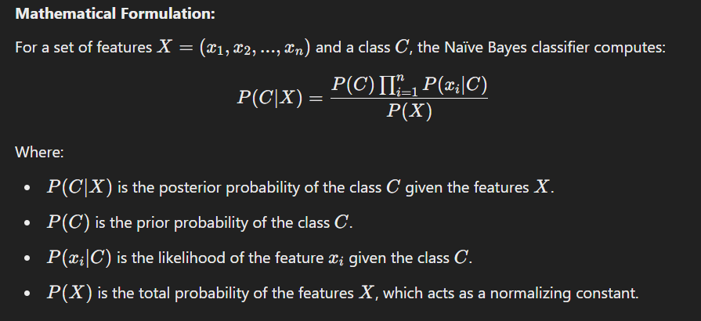

#### **Types of Naïve Bayes Classifiers:**

* **Gaussian Naïve Bayes**: Assumes that the features follow a Gaussian (normal) distribution. It is commonly used when the features are continuous.
* **Multinomial Naïve Bayes**: Used for discrete features, typically for text classification tasks where features are word frequencies.
* **Bernoulli Naïve Bayes**: Assumes that each feature is binary (e.g., whether a word appears or not). Used for text classification with binary features.

### **3. Advantages of Naïve Bayes:**

* **Simple and Fast**: Naïve Bayes classifiers are computationally efficient and can handle large datasets quickly.
* **Works Well with High-Dimensional Data**: It performs well with high-dimensional feature spaces, such as in text classification tasks (e.g., spam filtering).
* **Handles Missing Data Well**: Naïve Bayes classifiers can handle missing data by ignoring the missing features during classification.
* **Easy to Interpret**: The model is simple and easy to understand, with interpretable probabilities for predictions.

### **4. Disadvantages of Naïve Bayes:**

* **Strong Independence Assumption**: The main disadvantage is the assumption that features are independent, which may not hold in real-world data. This "naïve" assumption often doesn't capture the true relationships between features.
* **Poor Performance with Highly Correlated Features**: If features are highly correlated, Naïve Bayes may perform poorly compared to other algorithms.
* **Zero Probability Problem**: If any feature has a zero probability for a class (i.e., the feature never appears in the training set for that class), the Naïve Bayes classifier assigns a zero probability to that class. This can be handled using **Laplace smoothing**.

### **5. Applications of Naïve Bayes**

* **Spam Email Classification**: Naïve Bayes is widely used for classifying emails as spam or not spam.
* **Text Classification and Sentiment Analysis**: It is used in natural language processing tasks such as categorizing news articles, sentiment analysis, or customer reviews.
* **Medical Diagnosis**: It can be used to predict the likelihood of a disease based on symptoms and patient data.

### **6. Example of Naïve Bayes Classifier**

Consider a dataset where we want to classify whether a customer will buy a product based on two features:

* Age (Continuous variable)
* Income (Continuous variable)

#### **Training Data:**

| **Age** | **Income** | **Buy Product (Yes/No)** |
| --- | --- | --- |
| 25 | 50,000 | No |
| 30 | 60,000 | Yes |
| 35 | 80,000 | Yes |
| 40 | 90,000 | No |

In this case, the Naïve Bayes classifier would:

1. Calculate the prior probabilities P(Yes)P(Yes)P(Yes) and P(No)P(No)P(No).
2. Estimate the likelihood of "Age" and "Income" for both classes (Yes and No).
3. Use Bayes' Theorem to calculate the posterior probability for each class and predict the class with the higher posterior probability for new data.

### **15 - 20 MCQs on Bayesian Analysis and Naïve Bayes Classifier**

1. **What does Bayes' theorem help in updating?** a) Probability of hypothesis  
   b) Mean of data  
   c) Variance of data  
   d) None of the above  
   **Answer**: a) Probability of hypothesis
2. **Which of the following is true about Naïve Bayes classifiers?** a) They assume that features are dependent  
   b) They are suitable for classification tasks  
   c) They are computationally expensive  
   d) They do not require a large dataset  
   **Answer**: b) They are suitable for classification tasks
3. **In Naïve Bayes, what does the likelihood P(xi∣C) represent?** a) The prior probability of class C  
   b) The probability of feature xi​ given class C  
   c) The posterior probability of class C  
   d) The total probability of feature xi  
   **Answer**: b) The probability of feature xi​ given class C
4. **Which distribution does Gaussian Naïve Bayes assume for features?** a) Exponential distribution  
   b) Uniform distribution  
   c) Poisson distribution  
   d) Normal distribution  
   **Answer**: d) Normal distribution
5. **What is the main advantage of Naïve Bayes?** a) High computational complexity  
   b) Can handle high-dimensional data  
   c) Requires large datasets  
   d) Doesn’t need preprocessing  
   **Answer**: b) Can handle high-dimensional data
6. **Which of the following is a disadvantage of Naïve Bayes?** a) It works with both continuous and categorical data  
   b) It assumes independence between features  
   c) It is easy to interpret  
   d) It can be used for regression problems  
   **Answer**: b) It assumes independence between features
7. **What is Laplace smoothing used for in Naïve Bayes?** a) To handle missing data  
   b) To avoid zero probability problem  
   c) To speed up the computation  
   d) To increase model complexity  
   **Answer**: b) To avoid zero probability problem
8. **What is the purpose of the prior probability P(C) in Naïve Bayes?** a) To normalize the posterior probability  
   b) To predict the class of the data  
   c) To calculate the likelihood  
   d) To measure uncertainty of the hypothesis  
   **Answer**: a) To normalize the posterior probability
9. **In the Naïve Bayes classification, the features are assumed to be:** a) Dependent  
   b) Uncorrelated  
   c) Correlated  
   d) Mixed  
   **Answer**: b) Uncorrelated
10. **Which of the following is true for multinomial Naïve Bayes?** a) It is used for continuous features  
    b) It is suitable for text classification  
    c) It assumes a normal distribution of features  
    d) It does not handle categorical data  
    **Answer**: b) It is suitable for text classification
11. **What is the primary use of the Naïve Bayes classifier?** a) Regression problems  
    b) Text classification  
    c) Dimensionality reduction  
    d) Clustering  
    **Answer**: b) Text classification
12. **In a classification problem, which type of Naïve Bayes would you use if the features are binary?** a) Gaussian Naïve Bayes  
    b) Bernoulli Naïve Bayes  
    c) Multinomial Naïve Bayes  
    d) Poisson Naïve Bayes  
    **Answer**: b) Bernoulli Naïve Bayes
13. **Which of the following is an advantage of Bayesian analysis?** a) It is computationally intensive  
    b) It does not handle uncertain data  
    c) It can incorporate prior knowledge  
    d) It does not allow evidence updates  
    **Answer**: c) It can incorporate prior knowledge
14. **The posterior probability P(H∣E)P(H|E)P(H∣E) represents:** a) Prior belief  
    b) Probability of data  
    c) The updated probability after observing evidence  
    d) The likelihood of the evidence  
    **Answer**: c) The updated probability after observing evidence

============================================================================================================================================

**Session 15 & 16**

### **Model Ensembling: Concept and Explanation**

Model ensembling is a machine learning technique that combines the predictions of multiple models to produce a single output. The primary goal of ensembling is to improve the predictive performance and robustness of the model by leveraging the strengths of individual models and reducing the weaknesses. It is commonly used in both classification and regression problems.

### **1. Why Model Ensembling?**

1. **Improved Accuracy**: By combining multiple models, the final prediction is often more accurate than individual models.
2. **Reduction in Variance and Bias**: Ensembling helps mitigate overfitting (variance) and underfitting (bias) by balancing the predictions.
3. **Robustness**: If one model performs poorly, the ensemble can still perform well due to the collective decision-making.

### **2. Types of Model Ensembling**

Model ensembling can be broadly categorized into **Bagging**, **Boosting**, and other advanced techniques like Stacking and Voting.

#### **a) Bagging (Bootstrap Aggregating):**

* Bagging reduces variance by creating multiple subsets of the data through bootstrapping (random sampling with replacement) and training models independently on these subsets.
* The final output is typically the **average** for regression problems or the **majority vote** for classification problems.

**Example Algorithms:**

* Random Forest: An ensemble of decision trees built using bagging.

#### **b) Boosting:**

* Boosting reduces bias by sequentially building models where each new model focuses on correcting the errors of the previous one.
* The models are trained in a weighted manner, where incorrectly predicted samples get more weight in subsequent models.

**Example Algorithms:**

* AdaBoost (Adaptive Boosting)
* Gradient Boosting Machines (GBM)
* XGBoost
* LightGBM
* CatBoost

#### **c) Stacking:**

* Stacking combines predictions from multiple base models using a meta-model (e.g., logistic regression or another machine learning algorithm).
* It uses the predictions of base models as features for the meta-model.

#### **d) Voting:**

* Voting combines predictions by taking a majority vote for classification or averaging the predictions for regression.
* Can be **hard voting** (choosing the class with the most votes) or **soft voting** (choosing the class with the highest probability).

### **3. Advantages of Ensembling**

* **Better Generalization**: Reduces the chance of overfitting and improves generalization on unseen data.
* **Flexibility**: Works well with a variety of models, including weak and strong learners.
* **Robustness**: Handles noisy and imbalanced datasets better.

### **4. Disadvantages of Ensembling**

* **Complexity**: Ensembling models can increase computational complexity and training time.
* **Interpretability**: Combined models are harder to interpret than single models.
* **Overhead**: Requires careful tuning of hyperparameters and selection of models.

### **5. Applications of Ensembling**

1. Kaggle Competitions: Ensembling techniques are widely used in predictive modeling competitions.
2. Fraud Detection: Combines multiple algorithms to improve detection accuracy.
3. Finance: Risk modeling and stock price prediction.
4. Healthcare: Disease prediction and medical imaging.
5. NLP: Sentiment analysis and document classification.

### **6. Example of Model Ensembling**

Suppose you are working on a dataset to predict whether a loan application will be approved. Using ensembling, you:

1. Train three models: Logistic Regression, Decision Tree, and Support Vector Machine (SVM).
2. Combine their predictions using voting or stacking:
   * If Voting: Choose the majority class from the predictions of the three models.
   * If Stacking: Use their predictions as features for a meta-model (e.g., another Logistic Regression model) to produce the final prediction.

### **20 MCQs on Model Ensembling**

1. **What is the primary goal of model ensembling?**

a) Reduce overfitting  
b) Improve interpretability  
c) Combine predictions to improve accuracy  
d) Increase training time  
**Answer**: c) Combine predictions to improve accuracy

1. **Which of the following is a bagging-based ensemble method?**

a) Random Forest  
b) Gradient Boosting  
c) AdaBoost  
d) XGBoost  
**Answer**: a) Random Forest

1. **In boosting, how are models trained?** a) Independently  
   b) Sequentially  
   c) Randomly  
   d) In parallel  
   **Answer**: b) Sequentially
2. **What is the main drawback of ensembling?** a) Poor accuracy  
   b) Complexity and training overhead  
   c) Reduces generalization  
   d) Only works with decision trees  
   **Answer**: b) Complexity and training overhead
3. **What does the "meta-model" do in stacking?**

a) Combines predictions of base models  
b) Performs bagging  
c) Increases bias of the base models  
d) Reduces variance in the base models  
**Answer**: a) Combines predictions of base models

1. **Which ensembling method reduces variance in predictions?**

a) Boosting  
b) Bagging  
c) Stacking  
d) Gradient Descent  
**Answer**: b) Bagging

1. **What is a characteristic of boosting?**

a) Focuses on correcting errors of previous models  
b) Combines predictions using hard voting  
c) Trains models on disjoint data subsets  
d) Always uses a neural network as the base model  
**Answer**: a) Focuses on correcting errors of previous models

1. **Which ensemble technique uses random sampling with replacement?**

a) Bagging  
b) Boosting  
c) Stacking  
d) Voting  
**Answer**: a) Bagging

1. **What does "soft voting" in ensembling involve?**

a) Averaging class probabilities for classification  
b) Selecting the majority class directly  
c) Averaging predictions for regression  
d) Ignoring probabilities and focusing on predictions  
**Answer**: a) Averaging class probabilities for classification

1. **Which algorithm is an example of boosting?**

a) Random Forest  
b) AdaBoost  
c) K-Means  
d) Naïve Bayes  
**Answer**: b) AdaBoost

1. **What is the main goal of stacking in model ensembling?**

a) Use weaker models for better results  
b) Combine predictions of multiple models using a meta-model  
c) Apply hard voting to predictions  
d) Reduce computational time  
**Answer**: b) Combine predictions of multiple models using a meta-model

1. **How does Random Forest reduce overfitting?**

a) By pruning trees  
b) By averaging predictions across many decision trees  
c) By weighting samples with higher errors  
d) By increasing model complexity  
**Answer**: b) By averaging predictions across many decision trees

1. **In which scenario is ensembling most beneficial?**

a) When using simple datasets  
b) When a single model is performing well  
c) When models show varying strengths and weaknesses  
d) When computational resources are limited  
**Answer**: c) When models show varying strengths and weaknesses

1. **What kind of voting method averages probabilities of classes?**

a) Hard Voting  
b) Soft Voting  
c) Random Voting  
d) Weighted Voting  
**Answer**: b) Soft Voting

1. **Which of the following is NOT an advantage of ensembling?**

a) Reduces overfitting  
b) Improves model interpretability  
c) Handles noisy datasets better  
d) Increases prediction accuracy  
**Answer**: b) Improves model interpretability

1. **What is a weakness of boosting algorithms?**

a) Low bias  
b) Sensitive to noisy data  
c) Low variance  
d) Works poorly with weak learners  
**Answer**: b) Sensitive to noisy data

1. **What is bootstrapping in bagging?**

a) Using all data for training  
b) Random sampling with replacement  
c) Sequentially training models  
d) Combining predictions using weights  
**Answer**: b) Random sampling with replacement

1. **Which ensembling method is best for imbalanced datasets?**

a) Bagging  
b) Boosting  
c) Voting  
d) K-Means  
**Answer**: b) Boosting

1. **What is the role of base models in stacking?**

a) To provide predictions as input to the meta-model  
b) To combine predictions using averaging  
c) To reduce computational complexity  
d) To independently classify data  
**Answer**: a) To provide predictions as input to the meta-model

1. **Which algorithm combines decision trees using bagging?**

a) Random Forest  
b) XGBoost  
c) AdaBoost  
d) CatBoost  
**Answer**: a) Random Forest

### **Random Forest, Gradient Boosting Machines, and Model Stacking**

Below are detailed explanations of the topics along with at least 20 MCQs for each.

### **1. Random Forest**

**Overview:**Random Forest is an ensemble learning method primarily used for classification and regression tasks. It builds multiple decision trees during training and combines their predictions for better accuracy and robustness. The key concept behind Random Forest is **Bagging (Bootstrap Aggregating)**.

#### **Key Features:**

* **Bagging Technique**: Random Forest creates subsets of data by random sampling with replacement.
* **Random Feature Selection**: At each split in the tree, only a random subset of features is considered, reducing overfitting.
* **Majority Voting or Averaging**: For classification, it uses majority voting, and for regression, it averages the predictions.
* **Parallel Processing**: Trees are built independently, making Random Forest efficient to train.

#### **Advantages:**

1. Handles missing data and outliers effectively.
2. Reduces overfitting compared to individual decision trees.
3. Works well with high-dimensional datasets.

#### **Disadvantages:**

1. Requires more computational power and resources.
2. May become less interpretable with a large number of trees.

#### **Applications:**

* Fraud detection
* Disease prediction
* Stock market analysis

### **2. Gradient Boosting Machines (GBM)**

**Overview:**Gradient Boosting Machines (GBM) is an ensemble method that builds models sequentially. Each subsequent model attempts to correct the errors made by its predecessor. It uses **Boosting** to improve accuracy.

#### **Key Features:**

* **Sequential Training**: Models are trained one after another, focusing on correcting the previous model's errors.
* **Weighted Instances**: Instances with higher errors are given more weight in subsequent models.
* **Gradient Descent**: The algorithm minimizes the loss function using gradient descent optimization.

#### **Popular Variants:**

* **XGBoost**: An optimized version of GBM with parallel processing and regularization.
* **LightGBM**: Designed for large datasets with faster training.
* **CatBoost**: Handles categorical data efficiently.

#### **Advantages:**

1. Highly accurate and robust.
2. Handles complex datasets effectively.
3. Supports various loss functions (e.g., log-loss, mean squared error).

#### **Disadvantages:**

1. Sensitive to hyperparameters.
2. Can overfit if not regularized properly.
3. Training can be slow compared to simpler models.

#### **Applications:**

* Predictive analytics
* Risk modeling
* Recommender systems

### **3. Model Stacking**

**Overview:**Model Stacking is a more complex ensemble method where multiple base models are combined using a **meta-model**. The predictions of the base models are used as input features for the meta-model, which learns to optimize the final predictions.

#### **Key Features:**

* **Heterogeneous Models**: Combines models of different types (e.g., Decision Trees, SVMs, Logistic Regression).
* **Meta-Learner**: A secondary model (e.g., Logistic Regression) combines the predictions of base models.
* **Blending**: A simplified version of stacking where the meta-model is trained on a separate validation set.

#### **Advantages:**

1. Reduces bias and variance.
2. Leverages the strengths of diverse models.
3. Improves overall accuracy.

#### **Disadvantages:**

1. Computationally intensive.
2. Complex to implement and tune.
3. May suffer from overfitting if not carefully designed.

#### **Applications:**

* Kaggle competitions
* Complex predictive modeling tasks
* Ensemble learning pipelines

### **MCQs**

#### **Random Forest MCQs**

1. **Random Forest is based on which ensemble method?**a) Boosting  
   b) Bagging  
   c) Stacking  
   d) Blending  
   **Answer**: b) Bagging
2. **What is the main reason for using random feature selection in Random Forest?**a) To increase training speed  
   b) To prevent overfitting  
   c) To improve interpretability  
   d) To reduce computation  
   **Answer**: b) To prevent overfitting
3. **Random Forest handles missing values by:**a) Dropping rows with missing values  
   b) Imputing mean or median  
   c) Using surrogate splits  
   d) Ignoring missing data  
   **Answer**: c) Using surrogate splits
4. **What is the primary metric for measuring feature importance in Random Forest?**a) Gini impurity  
   b) Variance  
   c) Information gain  
   d) Mean decrease in accuracy  
   **Answer**: d) Mean decrease in accuracy
5. **What type of output does Random Forest provide for classification problems?**a) Weighted average  
   b) Majority voting  
   c) Median prediction  
   d) None of the above  
   **Answer**: b) Majority voting

#### **Gradient Boosting Machines MCQs**

1. **Gradient Boosting focuses on reducing which of the following?**a) Bias  
   b) Variance  
   c) Overfitting  
   d) Data imbalance  
   **Answer**: a) Bias
2. **What type of training process is used in Gradient Boosting?**a) Parallel  
   b) Sequential  
   c) Randomized  
   d) Layered  
   **Answer**: b) Sequential
3. **Which algorithm is NOT a variant of Gradient Boosting?**a) Random Forest  
   b) XGBoost  
   c) LightGBM  
   d) CatBoost  
   **Answer**: a) Random Forest
4. **What is the primary difference between GBM and XGBoost?**a) XGBoost uses regularization  
   b) GBM is faster  
   c) GBM uses boosting while XGBoost uses bagging  
   d) XGBoost is only for classification problems  
   **Answer**: a) XGBoost uses regularization
5. **Gradient Boosting Machines can handle: (Choose all that apply)**a) Regression tasks  
   b) Classification tasks  
   c) Clustering tasks  
   d) Dimensionality reduction  
   **Answer**: a) Regression tasks, b) Classification tasks

#### **Model Stacking MCQs**

1. **Model Stacking combines predictions using:**a) Weighted average  
   b) Majority voting  
   c) A meta-model  
   d) Random sampling  
   **Answer**: c) A meta-model
2. **The base models in stacking are:**a) Independent  
   b) Sequentially dependent  
   c) Randomly selected  
   d) Interchangeable with meta-model  
   **Answer**: a) Independent
3. **What is a drawback of stacking?**a) It overfits the data  
   b) It reduces model diversity  
   c) It is computationally intensive  
   d) It only works with linear models  
   **Answer**: c) It is computationally intensive
4. **What is the role of the meta-model in stacking?**a) Optimize hyperparameters of base models  
   b) Combine predictions of base models  
   c) Handle data preprocessing  
   d) Perform feature selection  
   **Answer**: b) Combine predictions of base models
5. **What is a simplified version of stacking?**a) Bagging  
   b) Blending  
   c) Boosting  
   d) Random sampling  
   **Answer**: b) Blending

============================================================================================================================================

**Session 17 & 18**

### **Association Rule Mining**

**Overview:**Association Rule Mining is a key technique in data mining that discovers interesting relationships, correlations, or patterns among items in large datasets. It is commonly used in market basket analysis to identify which items are frequently bought together. The rules generated by this process can help businesses improve decision-making, optimize inventory, and enhance marketing strategies.

### **Key Concepts in Association Rule Mining**

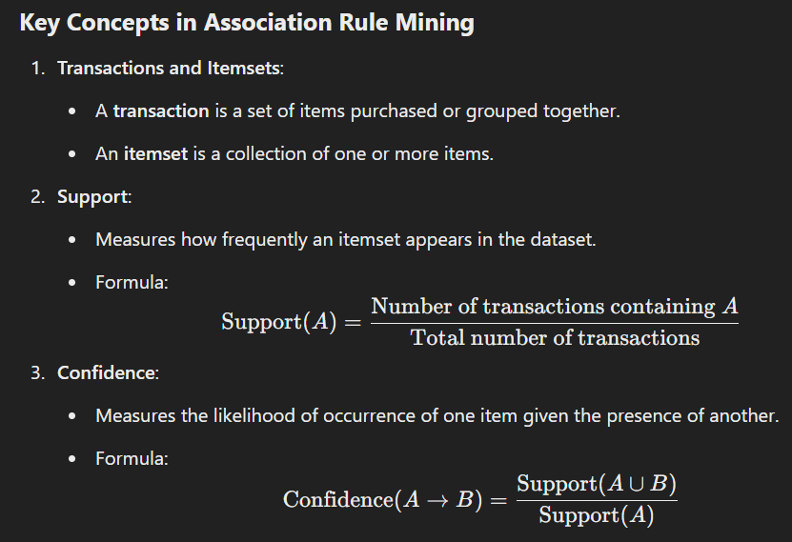

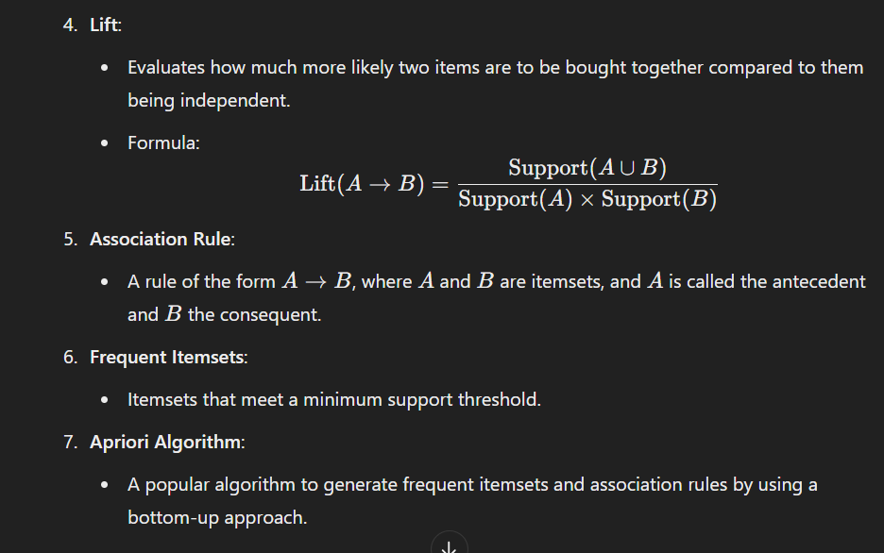

### **Steps in Association Rule Mining**

1. **Generate Frequent Itemsets**:
   * Identify all itemsets that meet the minimum support threshold.
2. **Generate Association Rules**:
   * For each frequent itemset, generate rules that meet the minimum confidence threshold.
3. **Evaluate Rules**:
   * Use metrics like confidence, lift, and support to filter and rank the rules.

### **Applications of Association Rule Mining**

1. **Market Basket Analysis**:
   * Identifying products that are frequently bought together.
2. **Recommendation Systems**:
   * Suggesting complementary products based on customer behavior.
3. **Fraud Detection**:
   * Detecting unusual patterns in financial transactions.
4. **Healthcare**:
   * Finding correlations between symptoms, diagnoses, and treatments.

### **Advantages of Association Rule Mining**

* Discovers hidden patterns and relationships.
* Helps businesses make data-driven decisions.
* Supports various domains like retail, healthcare, and finance.

### **Limitations**

* Computationally expensive for large datasets.
* Generates a large number of rules, making interpretation challenging.
* Requires setting appropriate thresholds for support and confidence.

### **MCQs on Association Rule Mining**

#### **Easy**

1. **Which of the following is NOT a metric used in association rule mining?**a) Support  
   b) Confidence  
   c) Lift  
   d) Gradient  
   **Answer**: d) Gradient
2. **What is the output of association rule mining?**a) Frequent itemsets  
   b) Decision trees  
   c) Clusters  
   d) Neural networks  
   **Answer**: a) Frequent itemsets
3. **What does the support metric measure?**a) The likelihood of one item given another  
   b) The co-occurrence frequency of an itemset  
   c) The independence of items  
   d) None of the above  
   **Answer**: b) The co-occurrence frequency of an itemset
4. **What is the primary purpose of lift in association rules?**a) Measure the confidence of rules  
   b) Measure the strength of an association  
   c) Determine the frequency of an itemset  
   d) Reduce computational complexity  
   **Answer**: b) Measure the strength of an association
5. **The Apriori algorithm is used for:**a) Clustering  
   b) Frequent itemset mining  
   c) Predictive modeling  
   d) Classification  
   **Answer**: b) Frequent itemset mining

#### **Medium**

1. **What is the confidence of a rule A→B?**a) The fraction of transactions containing A that also contain B.  
   b) The fraction of transactions containing B that also contain A.  
   c) The support of A divided by the support of B.  
   d) None of the above.  
   **Answer**: a) The fraction of transactions containing A that also contain B.
2. **If the lift of a rule is greater than 1, it means:**a) A and B are independent.  
   b) A and B are positively correlated.  
   c) A and B are negatively correlated.  
   d) None of the above.  
   **Answer**: b) AAA and BBB are positively correlated.
3. **Which of the following is TRUE for the Apriori algorithm?**a) It generates all possible itemsets.  
   b) It uses a top-down approach.  
   c) It prunes itemsets that do not meet the minimum support threshold.  
   d) It only works with binary data.  
   **Answer**: c) It prunes itemsets that do not meet the minimum support threshold.
4. **The confidence of a rule A→B is 0.8. What does this mean?**a) 80% of transactions contain both A and B.  
   b) 80% of transactions containing A also contain B.  
   c) BBB is dependent on A.  
   d) None of the above.  
   **Answer**: b) 80% of transactions containing A also contain B.
5. **What is the main challenge in association rule mining?**a) Finding frequent itemsets  
   b) Setting minimum thresholds  
   c) Handling large datasets  
   d) All of the above  
   **Answer**: d) All of the above

#### **Hard**

1. **Which of the following methods can speed up the Apriori algorithm?**a) Reduce support threshold  
   b) Use hashing to filter itemsets  
   c) Generate all combinations of items  
   d) Increase dataset size  
   **Answer**: b) Use hashing to filter itemsets
2. **What does a lift value less than 1 indicate?**a) Positive correlation between A and B.  
   b) Independence of A and B.  
   c) Negative correlation between A and B.  
   d) None of the above.  
   **Answer**: c) Negative correlation between AAA and BBB.
3. **Why is Apriori not suitable for very large datasets?**a) It cannot handle continuous data.  
   b) It generates too many itemsets to evaluate.  
   c) It only works with small transaction sets.  
   d) None of the above.  
   **Answer**: b) It generates too many itemsets to evaluate.
4. **What is the main goal of the ECLAT algorithm?**a) Optimize lift calculations.  
   b) Mine frequent itemsets using transaction IDs.  
   c) Reduce overfitting in rules.  
   d) Enhance rule visualization.  
   **Answer**: b) Mine frequent itemsets using transaction IDs.
5. **Which of the following is NOT a step in association rule mining?**a) Data preprocessing  
   b) Frequent itemset generation  
   c) Decision tree creation  
   d) Rule evaluation  
   **Answer**: c) Decision tree creation

### **Apriori Algorithm: Overview**

The Apriori algorithm is a fundamental algorithm in association rule mining and frequent itemset generation. It identifies itemsets that frequently occur together in a dataset and generates association rules that describe relationships between these itemsets. This algorithm is based on the **"Apriori Property"**, which states:  
*"All non-empty subsets of a frequent itemset must also be frequent."*

### **Key Concepts**

1. **Frequent Itemset**:
   * A group of items that appear together in a transaction database with a frequency higher than a predefined support threshold.
2. **Support**:
   * Measures the proportion of transactions in the dataset that contain a specific itemset.
   * Formula: Support(X)=Number of transactions containing X / Total transactions​
3. **Confidence**:
   * Measures the likelihood that a transaction containing the antecedent A also contains the consequent B.
   * Formula: Confidence(A→B)=Support(A∪B) / Support(A)
4. **Lift**:
   * Evaluates the strength of the association rule A→B compared to the independent occurrence of A and B.
   * Formula: Lift(A→B)=Support(A∪B) / Support(A)×Support(B)
5. **Apriori Property**:
   * If an itemset is infrequent, all its supersets will also be infrequent. This property is used to prune the search space.

### **Steps in Apriori Algorithm**

1. **Generate Candidate Itemsets**:
   * Create a list of itemsets of length 1 from the dataset.
2. **Calculate Support**:
   * Compute the support for each candidate itemset and filter out those that do not meet the minimum support threshold.
3. **Generate Larger Itemsets**:
   * Combine frequent itemsets of size k to create candidate itemsets of size k+1.
4. **Repeat Until No More Candidates**:
   * Repeat the process of generating candidate itemsets and filtering by support until no more frequent itemsets can be generated.
5. **Generate Association Rules**:
   * Create rules from the frequent itemsets that meet the minimum confidence threshold.

### **Advantages of Apriori Algorithm**

* Simple and easy to implement.
* Works well with smaller datasets.
* Widely used for market basket analysis.

### **Limitations**

* Computationally expensive for large datasets.
* Requires multiple database scans, which can be slow.
* Generates a large number of candidate itemsets.

### **Applications**

1. **Market Basket Analysis**:
   * Understanding which products are bought together.
2. **Recommendation Systems**:
   * Suggesting items based on previous purchases.
3. **Healthcare**:
   * Identifying patterns in patient diagnoses and treatments.

### **MCQs on Apriori Algorithm**

#### **Easy**

1. **What is the primary purpose of the Apriori algorithm?**a) Clustering  
   b) Frequent itemset mining  
   c) Classification  
   d) Dimensionality reduction  
   **Answer**: b) Frequent itemset mining
2. **What is the Apriori property?**a) If an itemset is frequent, its subsets are infrequent.  
   b) If an itemset is infrequent, its supersets are infrequent.  
   c) All subsets of an itemset must be infrequent.  
   d) All supersets of an itemset must be frequent.  
   **Answer**: b) If an itemset is infrequent, its supersets are infrequent.
3. **Which metric is NOT used in association rule mining?**a) Support  
   b) Confidence  
   c) Lift  
   d) Mean Absolute Error  
   **Answer**: d) Mean Absolute Error
4. **What does the support metric measure?**a) The frequency of an itemset in a transaction database.  
   b) The independence of items in a dataset.  
   c) The strength of a rule.  
   d) The likelihood of one item given another.  
   **Answer**: a) The frequency of an itemset in a transaction database.
5. **What is the output of the Apriori algorithm?**a) Clusters  
   b) Decision Trees  
   c) Frequent Itemsets  
   d) Neural Networks  
   **Answer**: c) Frequent Itemsets

#### **Medium**

1. **Which step in the Apriori algorithm is used to prune the search space?**a) Rule generation  
   b) Candidate generation  
   c) Frequent itemset generation  
   d) Support calculation  
   **Answer**: c) Frequent itemset generation
2. **What is the main challenge of the Apriori algorithm?**a) Handling categorical data  
   b) Generating too many candidate itemsets  
   c) Working with small datasets  
   d) Visualizing results  
   **Answer**: b) Generating too many candidate itemsets
3. **If the confidence of a rule A→B is 0.9, it means:**a) 90% of transactions contain AAA and BBB.  
   b) 90% of transactions containing A also contain B.  
   c) 90% of transactions contain BBB but not AAA.  
   d) None of the above.  
   **Answer**: b) 90% of transactions containing AAA also contain BBB.
4. **The lift of a rule A→B is 1.2. What does this indicate?**a) A and B are independent.  
   b) A and B are positively correlated.  
   c) A and B are negatively correlated.  
   d) A and B do not co-occur.  
   **Answer**: b) A and B are positively correlated.
5. **What type of data is typically used in Apriori algorithm?**a) Continuous data  
   b) Categorical data  
   c) Text data  
   d) Numerical data  
   **Answer**: b) Categorical data

#### **Hard**

1. **What is a key optimization in the Apriori algorithm to reduce computational complexity?**a) Generate all possible combinations of items.  
   b) Skip infrequent subsets during candidate generation.  
   c) Use continuous variables instead of categorical ones.  
   d) Increase the dataset size.  
   **Answer**: b) Skip infrequent subsets during candidate generation.
2. **What is the computational cost of the Apriori algorithm primarily dependent on?**a) The number of transactions in the dataset.  
   b) The number of distinct items in the dataset.  
   c) The minimum support threshold.  
   d) All of the above.  
   **Answer**: d) All of the above.
3. **Which of the following is TRUE for association rule A→B?**a) High lift indicates independence of AAA and BBB.  
   b) High confidence guarantees strong association.  
   c) High support and high confidence are needed for rule selection.  
   d) Low support rules are always valuable.  
   **Answer**: c) High support and high confidence are needed for rule selection.
4. **What is the main limitation of using a very low support threshold in Apriori?**a) Reduced computational complexity.  
   b) Increased computational cost and generation of irrelevant rules.  
   c) Improved interpretability of rules.  
   d) Reduction in dataset size.  
   **Answer**: b) Increased computational cost and generation of irrelevant rules.
5. **Which of the following best describes "confidence" in association rule mining?**a) Probability of AAA and BBB occurring together.  
   b) Probability of BBB occurring given AAA.  
   c) Probability of AAA occurring given BBB.  
   d) None of the above.  
   **Answer**: b) Probability of BBB occurring given AAA.

============================================================================================================================================

**Session 19 & 20**

### **Moving Average**

#### **Overview**

The moving average is a simple statistical method used to smooth out short-term fluctuations in data and highlight long-term trends. It is widely applied in time series analysis, particularly for forecasting.

#### **Key Concepts**

1. **Purpose**: To reduce noise in time series data by averaging a specified number of data points.
2. **Types**:
   * **Simple Moving Average (SMA)**: Averages data over a fixed number of time periods.
   * **Weighted Moving Average (WMA)**: Assigns different weights to data points, typically giving more importance to recent points.
3. **Formula**:

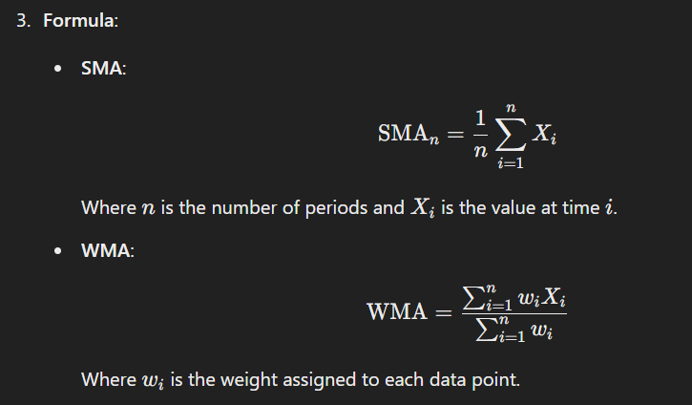

#### **Applications**

* Forecasting stock prices, sales, or demand.
* Analyzing trends in economic data.
* Identifying seasonal patterns in data.

#### **Advantages**

* Simple and easy to compute.
* Useful for trend analysis.

#### **Limitations**

* Lags behind the actual data, particularly for SMA.
* Ignores data outside the moving window.

### **Exponential Smoothing**

#### **Overview**

Exponential smoothing is an advanced forecasting technique that assigns exponentially decreasing weights to older observations. It is suitable for data with a clear trend or seasonality.

#### **Key Concepts**

1. **Purpose**: To give more importance to recent data points while still considering past data.
2. **Types**:
   * **Single Exponential Smoothing (SES)**: Used for data without a trend or seasonality.
   * **Double Exponential Smoothing (DES)**: Incorporates trend into the forecast.
   * **Triple Exponential Smoothing (TES/Holt-Winters)**: Accounts for trend and seasonality.
3. **Formula**:

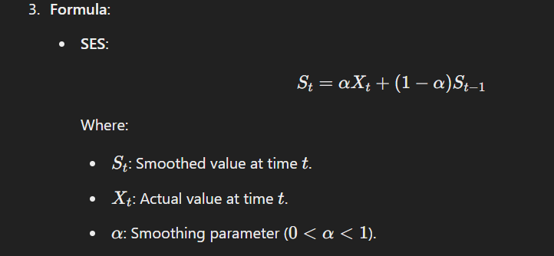

1. **Components**:
   * **Trend**: Captures the direction of the data (upward or downward).
   * **Seasonality**: Repeating patterns over a fixed period.

#### **Applications**

* Forecasting sales or inventory.
* Predicting demand for perishable goods.
* Analyzing financial time series.

#### **Advantages**

* Adapts to changes in the data.
* Can handle trends and seasonality with appropriate models.

#### **Limitations**

* Requires careful tuning of parameters.
* Less effective for highly erratic data.

### **MCQs on Moving Average and Exponential Smoothing**

#### **Easy**

1. **What is the purpose of the moving average?**a) To predict random events  
   b) To smooth data and identify trends  
   c) To increase data complexity  
   d) To compute seasonality  
   **Answer**: b) To smooth data and identify trends
2. **In a simple moving average, each data point is assigned:**a) Equal weight  
   b) Exponentially decreasing weight  
   c) Random weight  
   d) Increasing weight  
   **Answer**: a) Equal weight
3. **Which parameter controls the weighting in exponential smoothing?**a) α\alphaα  
   b) β\betaβ  
   c) Window size  
   d) Frequency  
   **Answer**: a) α\alphaα
4. **Exponential smoothing assigns higher weights to:**a) Older data points  
   b) Random data points  
   c) Recent data points  
   d) Seasonal data points  
   **Answer**: c) Recent data points
5. **Which type of exponential smoothing accounts for trend and seasonality?**a) Single  
   b) Double  
   c) Triple  
   d) Weighted  
   **Answer**: c) Triple

#### **Medium**

1. **What is the main drawback of a simple moving average?**a) High computational cost  
   b) It lags behind the data  
   c) Requires seasonality adjustments  
   d) Ignores recent data  
   **Answer**: b) It lags behind the data
2. **In weighted moving average, higher weights are typically given to:**a) Older data points  
   b) Seasonal data points  
   c) Recent data points  
   d) Random data points  
   **Answer**: c) Recent data points
3. **What does α\alphaα represent in exponential smoothing?**a) Trend strength  
   b) Weighting for recent data  
   c) Forecast error  
   d) Seasonal index  
   **Answer**: b) Weighting for recent data
4. **Double exponential smoothing is most suitable for:**a) Random data  
   b) Data with no trend or seasonality  
   c) Data with a trend but no seasonality  
   d) Data with both trend and seasonality  
   **Answer**: c) Data with a trend but no seasonality
5. **What happens when α=1 in exponential smoothing?**a) All data is smoothed equally  
   b) Only the most recent observation is used  
   c) The smoothing parameter is ignored  
   d) Past observations are given higher weight  
   **Answer**: b) Only the most recent observation is used

#### **Hard**

1. **Which type of moving average is most sensitive to recent changes in data?**a) Simple  
   b) Weighted  
   c) Exponential  
   d) Triple  
   **Answer**: c) Exponential
2. **What is the key limitation of triple exponential smoothing?**a) Cannot model trends  
   b) Requires large datasets  
   c) Complex parameter tuning  
   d) Only works for stationary data  
   **Answer**: c) Complex parameter tuning
3. **In time series forecasting, moving average is least effective for:**a) Data with random noise  
   b) Data with clear trends  
   c) Stationary data  
   d) Data with seasonality  
   **Answer**: d) Data with seasonality
4. **Which method adjusts for both trend and seasonal effects in time series data?**a) Weighted moving average  
   b) Double exponential smoothing  
   c) Triple exponential smoothing  
   d) Simple moving average  
   **Answer**: c) Triple exponential smoothing
5. **If a simple moving average uses 3 periods, what is the window size?**a) 1  
   b) 3  
   c) 6  
   d) Variable  
   **Answer**: b) 3
6. **Exponential smoothing is preferred over moving average because:**a) It is computationally simpler  
   b) It emphasizes older data points  
   c) It adjusts for recent changes in data  
   d) It works only for random data  
   **Answer**: c) It adjusts for recent changes in data
7. **What happens if α\alphaα in exponential smoothing is too small?**a) Forecast reacts too quickly to changes  
   b) Forecast ignores all changes  
   c) Forecast becomes overly smooth  
   d) Forecast becomes erratic  
   **Answer**: c) Forecast becomes overly smooth
8. **In weighted moving average, the weights must:**a) Sum to 1  
   b) Be equal for all data points  
   c) Be higher for seasonal data  
   d) Be random  
   **Answer**: a) Sum to 1
9. **Which is NOT an advantage of exponential smoothing?**a) Adapts to changes in data  
   b) Handles trends and seasonality  
   c) Reduces lag in forecasts  
   d) Requires no parameter tuning  
   **Answer**: d) Requires no parameter tuning
10. **Which forecasting method is best for short-term demand forecasting?**a) Simple moving average  
    b) Exponential smoothing  
    c) Weighted moving average  
    d) Regression analysis  
    **Answer**: b) Exponential smoothing

### **Holt’s Trend Method (Double Exponential Smoothing)**

#### **Overview**

Holt's Trend Method, also known as Holt’s linear trend method, is an extension of simple exponential smoothing designed to handle data with a trend component. It introduces two additional components: one for the level and another for the trend.

### **Key Components**

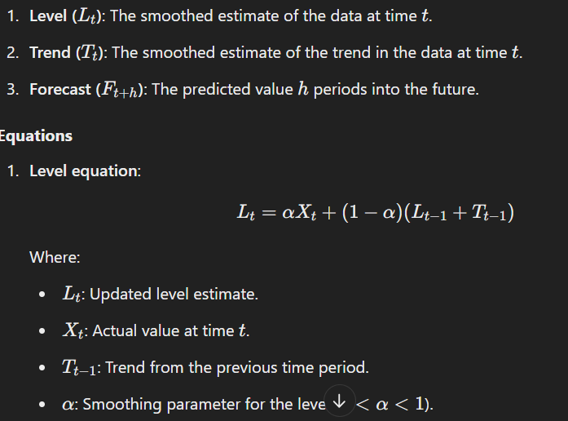

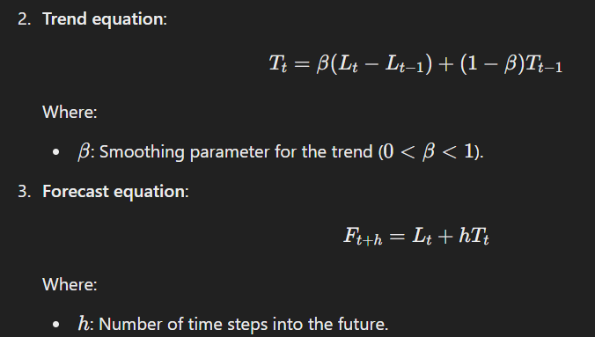

### **Working**

1. **Initialize**: Determine initial values for the level and trend components (L0​ and T0).
2. **Smooth**: Use the observed data and smoothing parameters (α and β) to update the level and trend estimates iteratively.
3. **Forecast**: Use the level and trend estimates to predict future values.

### **Applications**

* Forecasting sales data with a linear trend.
* Predicting economic indicators with time-varying trends.
* Analyzing temperature or demand trends over time.

### **Advantages**

* Captures both level and trend components of the data.
* Provides a more accurate forecast for data with trends compared to simple exponential smoothing.

### **Limitations**

* Ineffective for seasonal data (addressed by Holt-Winters method).
* Requires careful tuning of α\alphaα and β\betaβ.
* Sensitive to sudden changes in trends.

### **Example**

Consider monthly sales data with a clear upward trend. Using Holt's method:

1. **Initial Level (L0​)**: Average of the first few data points.
2. **Initial Trend (T0​)**: Difference between successive data points (average slope).
3. Forecast sales for the next 12 months using the formula Ft+h=Lt+hTt​.

### **MCQs on Holt’s Trend Method**

#### **Easy**

1. **Holt’s trend method is an extension of which smoothing technique?**a) Weighted moving average  
   b) Simple exponential smoothing  
   c) Triple exponential smoothing  
   d) Time series decomposition  
   **Answer**: b) Simple exponential smoothing
2. **What additional component does Holt’s method account for?**a) Seasonality  
   b) Random variation  
   c) Trend  
   d) Cyclic patterns  
   **Answer**: c) Trend
3. **In Holt’s method, the trend is updated using:**a) Smoothing parameter α\alphaα  
   b) Smoothing parameter β\betaβ  
   c) Moving average  
   d) Lagged difference  
   **Answer**: b) Smoothing parameter β\betaβ
4. **The formula for Holt's forecast includes:**a) Level and seasonality  
   b) Level and trend  
   c) Trend and random noise  
   d) Seasonality and cyclic patterns  
   **Answer**: b) Level and trend
5. **Which parameter in Holt’s method controls the sensitivity of the trend?**a) α\alphaα  
   b) β\betaβ  
   c) γ\gammaγ  
   d) δ\deltaδ  
   **Answer**: b) β\betaβ

#### **Medium**

1. **The trend component in Holt’s method is calculated as the:**a) Difference between current and previous levels  
   b) Average of all observations  
   c) Weighted average of past trends  
   d) Product of level and forecast  
   **Answer**: a) Difference between current and previous levels
2. **What is a key limitation of Holt’s trend method?**a) Does not account for random noise  
   b) Ineffective for seasonal data  
   c) Requires large datasets  
   d) Overestimates trends  
   **Answer**: b) Ineffective for seasonal data
3. **In Holt’s method, if α=0.5, what does it mean?**a) Recent observations are given more weight.  
   b) All observations are weighted equally.  
   c) Past data is ignored.  
   d) Trends are ignored.  
   **Answer**: a) Recent observations are given more weight.
4. **What happens when β\betaβ is too high in Holt’s method?**a) Trend estimates lag behind actual trends.  
   b) Trend estimates become overly reactive.  
   c) Smoothing becomes too aggressive.  
   d) Seasonality is ignored.  
   **Answer**: b) Trend estimates become overly reactive.
5. **Holt’s method can be extended to handle seasonal data by:**a) Adding a third smoothing parameter.  
   b) Increasing the window size.  
   c) Applying weighted moving averages.  
   d) Using random forests.  
   **Answer**: a) Adding a third smoothing parameter.

#### **Hard**

1. **If the trend component Tt​ is negative, the forecast will:**a) Remain constant.  
   b) Show a declining trend.  
   c) Show an increasing trend.  
   d) Be invalid.  
   **Answer**: b) Show a declining trend.
2. **Holt’s trend method is most suitable for:**a) Data with no trend or seasonality.  
   b) Data with a linear trend and no seasonality.  
   c) Data with cyclic patterns.  
   d) Data with random noise.  
   **Answer**: b) Data with a linear trend and no seasonality.
3. **What is the role of the level component (LtL_tLt​) in Holt’s method?**a) Predicts future seasonality.  
   b) Represents the base value of the series at time ttt.  
   c) Measures variability in the series.  
   d) Ignores the trend.  
   **Answer**: b) Represents the base value of the series at time ttt.
4. **What would happen if β=0\beta = 0β=0 in Holt’s method?**a) The trend would not be updated.  
   b) The forecast would become exponential.  
   c) The level would become constant.  
   d) Random noise would dominate.  
   **Answer**: a) The trend would not be updated.
5. **When should Holt’s trend method NOT be used?**a) When data has a linear trend.  
   b) When data exhibits strong seasonality.  
   c) When data is stationary.  
   d) When data has random noise.  
   **Answer**: b) When data exhibits strong seasonality.
6. **If α=1\alpha = 1α=1 in Holt’s method, the forecast is equivalent to:**a) Moving average.  
   b) Naive forecast.  
   c) Weighted moving average.  
   d) Triple exponential smoothing.  
   **Answer**: b) Naive forecast.
7. **Which component distinguishes Holt’s method from simple exponential smoothing?**a) Random error  
   b) Trend  
   c) Seasonality  
   d) Cyclic variation  
   **Answer**: b) Trend
8. **Holt’s trend method forecasts are computed as a function of:**a) The level and seasonality components.  
   b) The trend and cyclic components.  
   c) The level and trend components.  
   d) Random error and smoothing constants.  
   **Answer**: c) The level and trend components.
9. **If a series is both trending and seasonal, Holt’s method will:**a) Overfit the data.  
   b) Provide inaccurate forecasts.  
   c) Accurately model the data.  
   d) Ignore the seasonality.  
   **Answer**: d) Ignore the seasonality.
10. **Holt's method assumes the trend is:**a) Cyclic  
    b) Linear  
    c) Exponential  
    d) Random  
    **Answer:** b) Linear

### **Holt-Winters’ Methods for Seasonality**

The **Holt-Winters’ method**, also known as **Triple Exponential Smoothing**, extends the Holt’s method by incorporating a seasonal component into the forecasting model. This makes it suitable for data with both a trend and a repeating seasonal pattern.

### **Components of Holt-Winters' Method**

1. **Level (Lt)**: The smoothed estimate of the data at time ttt.
2. **Trend (Tt​)**: The smoothed estimate of the trend at time ttt.
3. **Seasonality (St​)**: The smoothed estimate of the seasonal component at time ttt.
4. **Forecast (Ft+h​)**: The predicted value hhh periods into the future.

### **Two Variants**

1. **Additive Seasonality**: Suitable when the magnitude of seasonal variations remains constant over time.
   * Seasonal effect is added to the trend and level.
   * Use for cases like temperature changes.
2. **Multiplicative Seasonality**: Suitable when the magnitude of seasonal variations increases or decreases proportionally to the level.
   * Seasonal effect is multiplied with the trend and level.
   * Use for cases like sales with growing seasonal spikes.

### **Equations**

#### 

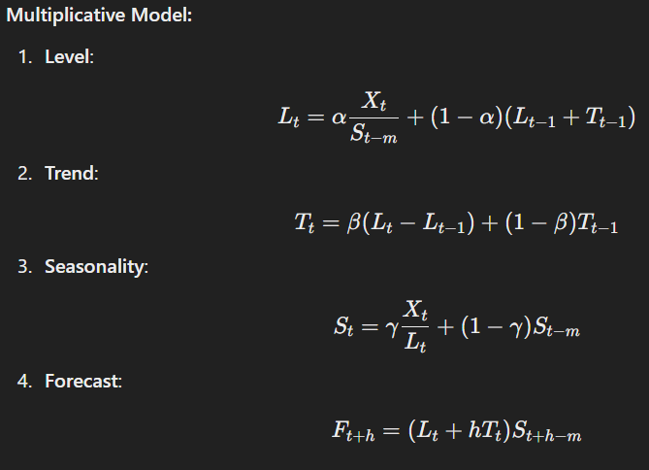

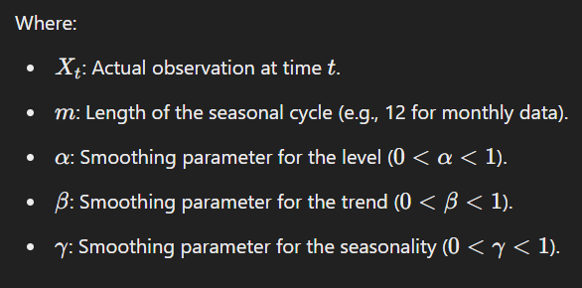

### **Steps for Holt-Winters’ Method**

1. **Initialize the components**:
   * Level (L0​): Average of the first seasonal cycle.
   * Trend (T0​): Difference between average of two consecutive seasonal cycles.
   * Seasonality (S0​): Average deviation of each cycle from the overall mean.
2. **Smooth the data**: Use observed values and smoothing parameters to iteratively update Lt, Ttt​, and St​.
3. **Forecast**: Combine smoothed components to make future predictions.

### **Applications**

* Demand forecasting for seasonal products.
* Predicting website traffic trends.
* Seasonal temperature or rainfall prediction.
* Financial market analysis for cyclic trends.

### **Advantages**

* Handles both trend and seasonality effectively.
* Adaptable to both additive and multiplicative seasonality.
* Provides accurate forecasts for data with regular seasonal patterns.

### **Limitations**

* Sensitive to the choice of smoothing parameters.
* Assumes a fixed seasonality period (m).
* Ineffective for irregular or non-stationary seasonality.

### **Example**

Consider monthly sales data for a retail store over three years, showing an upward trend and recurring seasonal spikes.

* m=12 (seasonal cycle length).
* Use Holt-Winters’ method to smooth and forecast next year’s sales.

### **MCQs on Holt-Winters' Method**

#### **Easy**

1. **Holt-Winters’ method is also known as:**a) Double exponential smoothing  
   b) Triple exponential smoothing  
   c) Linear regression  
   d) Weighted moving average  
   **Answer**: b) Triple exponential smoothing
2. **Which component is unique to the Holt-Winters’ method?**a) Level  
   b) Trend  
   c) Seasonality  
   d) Random noise  
   **Answer**: c) Seasonality
3. **Holt-Winters' method is suitable for:**a) Data with seasonality and trend  
   b) Data with no trend or seasonality  
   c) Random noise  
   d) Non-linear relationships  
   **Answer**: a) Data with seasonality and trend
4. **In Holt-Winters’ additive model, seasonality is:**a) Multiplied by the level  
   b) Added to the level  
   c) Ignored  
   d) Subtracted from the trend  
   **Answer**: b) Added to the level
5. **The parameter γ\gammaγ in Holt-Winters' method controls:**a) Trend smoothing  
   b) Level smoothing  
   c) Seasonal smoothing  
   d) Forecast horizon  
   **Answer**: c) Seasonal smoothing

#### **Medium**

1. **The multiplicative Holt-Winters’ model is appropriate when:**a) Seasonal variations are constant.  
   b) Seasonal variations change with the level.  
   c) Data has no trend.  
   d) The trend is exponential.  
   **Answer**: b) Seasonal variations change with the level.
2. **What does the term St−mS_{t-m}St−m​ represent in the Holt-Winters' method?**a) Trend component at time ttt.  
   b) Seasonal component from the last cycle.  
   c) Random noise.  
   d) Forecast error.  
   **Answer**: b) Seasonal component from the last cycle.
3. **If α=0\alpha = 0α=0, the level component:**a) Remains constant.  
   b) Becomes a naive forecast.  
   c) Ignores seasonal variations.  
   d) Ignores trend variations.  
   **Answer**: a) Remains constant.
4. **The seasonality length (mmm) is determined by:**a) Smoothing parameters.  
   b) Data frequency.  
   c) Data amplitude.  
   d) Random fluctuations.  
   **Answer**: b) Data frequency.
5. **Holt-Winters’ method assumes the seasonal pattern is:**a) Fixed and repeating.  
   b) Irregular.  
   c) Randomly distributed.  
   d) Non-linear.  
   **Answer**: a) Fixed and repeating.

#### **Hard**

1. **In the forecast equation of the multiplicative model, seasonality is:**a) Added to the trend.  
   b) Multiplied by the trend.  
   c) Subtracted from the level.  
   d) Divided by the trend.  
   **Answer**: b) Multiplied by the trend.
2. **Which component can make Holt-Winters’ forecasts less accurate?**a) Random noise in the data  
   b) Constant trend  
   c) Regular seasonal patterns  
   d) Stationary time series  
   **Answer**: a) Random noise in the data
3. **Holt-Winters’ method cannot model:**a) Multiplicative seasonality.  
   b) Additive seasonality.  
   c) Cyclic variations.  
   d) Linear trends.  
   **Answer**: c) Cyclic variations.
4. **Which of the following indicates seasonality in a dataset?**a) Upward trend over time.  
   b) Regular, repeating patterns.  
   c) Irregular spikes in data.  
   d) High random noise.  
   **Answer**: b) Regular, repeating patterns.
5. **If seasonal patterns are underestimated in Holt-Winters' forecasts, it is likely due to:**a) High α\alphaα.  
   b) Low β\betaβ.  
   c) Low γ\gammaγ.  
   d) High smoothing parameters overall.  
   **Answer**: c) Low γ\gammaγ.
6. **In the additive model, the forecast is calculated as:**a) \

Ft+h = L_t + hT_t + S_{t+h-m}​

Where:

* F_{t+h}: Forecast for hhh periods ahead.
* Lt: Level at time ttt.
* Tt​: Trend at time ttt.
* S_{t+h-m}​: Seasonal component from the last cycle.

**Answer**: Ft+h = L_t + hT_t + S_{t+h-m}​

#### **Hard MCQs (Continued)**

1. **What happens when β=0\beta = 0β=0 in Holt-Winters' method?**a) The trend component is ignored.  
   b) The seasonal component is fixed.  
   c) The level component remains constant.  
   d) The forecast depends only on the random noise.  
   **Answer**: a) The trend component is ignored.
2. **A multiplicative seasonal model is preferred when:**a) Seasonal patterns amplify with an increasing level.  
   b) Seasonal patterns are constant over time.  
   c) Trend is non-linear.  
   d) Random fluctuations dominate the data.  
   **Answer**: a) Seasonal patterns amplify with an increasing level.
3. **The key difference between Holt-Winters' additive and multiplicative models is:**a) Treatment of random noise.  
   b) How the seasonal component is applied.  
   c) Calculation of trend.  
   d) Data preparation requirements.  
   **Answer**: b) How the seasonal component is applied.
4. **To evaluate the accuracy of Holt-Winters’ forecasts, you would typically use:**a) Mean Absolute Error (MAE).  
   b) Root Mean Squared Error (RMSE).  
   c) Mean Absolute Percentage Error (MAPE).  
   d) All of the above.  
   **Answer**: d) All of the above.

============================================================================================================================================

**Session 21 & 22**

### **Auto-correlation (ACF) & Partial Auto-correlation (PACF)**

Auto-correlation and Partial Auto-correlation are essential tools in time series analysis, used to understand the dependencies between observations in a dataset over time.

### **Auto-correlation (ACF)**

#### **Definition**

Auto-correlation measures the correlation between a time series and its lagged version. It tells us how current values in the time series relate to past values.

#### **Mathematical Formula**

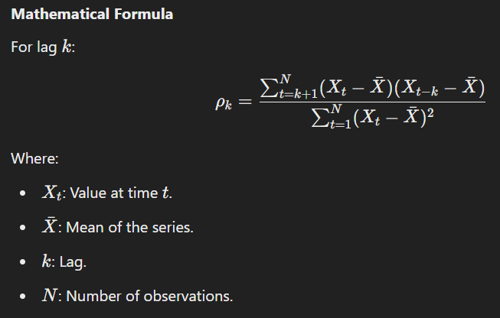

#### **Interpretation of ACF Plot**

* ACF values range from -1 to 1.
  + **1**: Perfect positive correlation.
  + **-1**: Perfect negative correlation.
  + **0**: No correlation.
* An **ACF plot** shows correlation values for various lags.
* Significant spikes indicate strong correlations, while values within the confidence band (usually ±2 standard errors) are considered statistically insignificant.

#### **Use of ACF**

* Identifies seasonality in the data.
* Helps select lag values for AR or MA models in ARIMA.
* Diagnoses residuals to check for randomness.

### **Partial Auto-correlation (PACF)**

#### **Definition**

PACF measures the correlation between a time series and its lagged values while controlling for the effects of intermediate lags. It isolates the direct relationship between a value and its lag.

#### **Mathematical Formula**

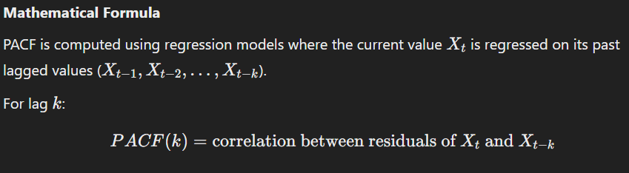

#### **Interpretation of PACF Plot**

* Shows how much a lag contributes to the time series after removing the influence of other lags.
* Spikes in the PACF plot indicate significant direct relationships at those lags.

#### **Use of PACF**

* Identifies the appropriate lag p for AR models in ARIMA.
* Helps distinguish between AR, MA, and ARMA processes.

### **Difference Between ACF and PACF**

| **Feature** | **ACF** | **PACF** |
| --- | --- | --- |
| **Definition** | Measures correlation between observations at different lags. | Measures direct correlation between observations at a specific lag. |
| **Includes Intermediate Lags** | Yes. | No. |
| **Key Use** | Identifies q (MA order) in ARIMA. | Identifies p (AR order) in ARIMA. |
| **Plot Behavior** | Decays gradually for stationary data. | Cuts off after a specific lag for AR models. |

### **Example**

Consider a time series of monthly sales data.

1. **ACF Plot**:
   * Significant spikes at lag 12 indicate yearly seasonality.
   * Gradual decay suggests an AR process.
2. **PACF Plot**:
   * Significant spike at lag 1 indicates strong direct dependency on the previous month.

### **Applications**

* Used in ARIMA modeling to identify p and q.
* Detects seasonality in data.
* Validates stationarity by analyzing residuals.

### **MCQs on ACF and PACF**

#### **Basic**

1. **What does ACF measure?**a) Dependency of data on residuals  
   b) Correlation between data at different lags  
   c) Direct relationship between observations  
   d) Randomness in residuals  
   **Answer**: b) Correlation between data at different lags
2. **Which plot is used to identify the order p in AR models?**a) ACF  
   b) PACF  
   c) Histogram  
   d) QQ Plot  
   **Answer**: b) PACF
3. **What does a significant spike in the PACF at lag 1 indicate?**a) Strong seasonality  
   b) Direct correlation with the previous observation  
   c) Random fluctuations  
   d) No correlation  
   **Answer**: b) Direct correlation with the previous observation
4. **The range of ACF values is:**a) 0 to 1  
   b) -1 to 1  
   c) 0 to infinity  
   d) -2 to 2  
   **Answer**: b) -1 to 1
5. **ACF is commonly used in which type of analysis?**a) Linear regression  
   b) Time series analysis  
   c) Classification  
   d) Clustering  
   **Answer**: b) Time series analysis

#### **Intermediate**

1. **Which method calculates PACF values?**a) Smoothing  
   b) Regression  
   c) Differencing  
   d) Summation  
   **Answer**: b) Regression
2. **A gradual decay in the ACF plot suggests:**a) MA process  
   b) AR process  
   c) Random noise  
   d) Stationary process  
   **Answer**: b) AR process
3. **Which plot helps identify seasonality?**a) PACF  
   b) ACF  
   c) Scatter plot  
   d) Residual plot  
   **Answer**: b) ACF
4. **A sudden drop after a few lags in the PACF plot indicates:**a) AR process  
   b) MA process  
   c) Random noise  
   d) Stationary data  
   **Answer**: a) AR process
5. **Which statistic is critical for analyzing ACF and PACF plots?**a) Standard deviation  
   b) Confidence interval  
   c) Mean absolute error  
   d) Mode  
   **Answer**: b) Confidence interval

#### **Advanced**

1. **What does a spike at lag k in the ACF plot indicate?**a) Direct correlation at lag k.  
   b) Combined correlation at lag k.  
   c) Lack of seasonality.  
   d) High noise.  
   **Answer**: b) Combined correlation at lag kkk.
2. **If ACF shows periodic spikes, it suggests:**a) Randomness  
   b) Seasonality  
   c) Stationarity  
   d) AR process  
   **Answer**: b) Seasonality
3. **ACF decays exponentially while PACF cuts off abruptly; this indicates:**a) Random noise  
   b) MA process  
   c) AR process  
   d) Non-stationarity  
   **Answer**: c) AR process
4. **The role of ACF in ARIMA modeling is to:**a) Identify trend.  
   b) Determine qqq (MA order).  
   c) Predict seasonal patterns.  
   d) Test residuals for randomness.  
   **Answer**: b) Determine qqq (MA order).
5. **Which plot is directly influenced by intermediate lags?**a) ACF  
   b) PACF  
   c) Histogram  
   d) Scatter plot  
   **Answer**: a) ACF

### **Auto-regression (AR)**

Auto-regression (AR) is a statistical modeling technique used in time series analysis, where the value of a variable at a given time is regressed on its own past values (lags). AR models are used to capture the linear dependency of a variable on its own previous observations.

### **Definition**

An AR model expresses the current value of the time series (XtX_tXt​) as a linear combination of its p past values and a random error term (ete_tet​).

#### **Mathematical Representation**

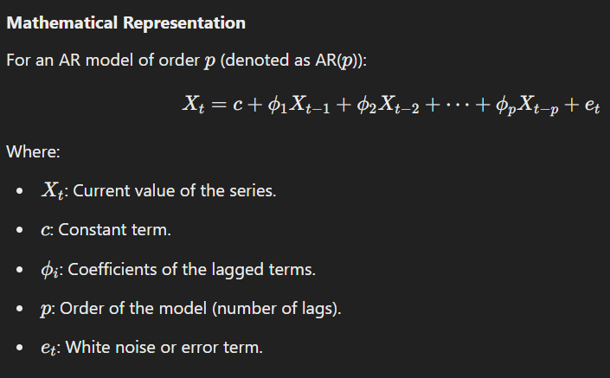

### **Key Features**

1. **Stationarity**:
   * AR models assume that the time series is stationary, meaning the statistical properties (mean, variance, autocorrelation) do not change over time.
   * Stationarity can be achieved by differencing or detrending non-stationary data.
2. **Order of AR Model**:
   * The order p determines how many past observations are used to predict the current value.
   * The order can be identified using Partial Auto-correlation Function (PACF).
3. **Lagged Relationships**:
   * The model captures how strongly the past observations influence the current observation.

### **Applications**

* Financial markets (stock prices, interest rates).
* Weather forecasting.
* Electricity demand prediction.
* Economics (GDP growth, inflation rates).

### **Example**

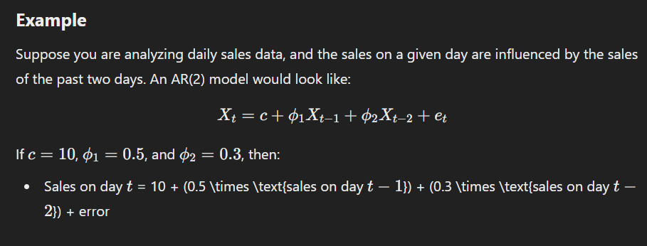

### **Strengths of AR Models**

* Simple to understand and implement.
* Effective for stationary time series.
* Can capture linear dependencies in time series data.

### **Limitations of AR Models**

* Assumes linear relationships between lags.
* Requires stationarity; non-stationary data must be transformed.
* Performance may degrade if the time series has long-term trends or seasonality.
* Cannot handle non-linear dependencies.

### **MCQs on Auto-regression**

#### **Basic Questions**

1. **What does an AR(1) model represent?**a) First-order moving average  
   b) First-order auto-regression  
   c) Multi-variable regression  
   d) Stationary random process  
   **Answer**: b) First-order auto-regression
2. **Which assumption is necessary for an AR model?**a) The data is normally distributed.  
   b) The data is stationary.  
   c) The data has no outliers.  
   d) The data is seasonal.  
   **Answer**: b) The data is stationary.
3. **In an AR model, the current value is dependent on:**a) Future values  
   b) Past values  
   c) Mean of the series  
   d) Residuals only  
   **Answer**: b) Past values
4. **What does the order ppp of an AR model signify?**a) Number of future values used  
   b) Number of past values used  
   c) Number of variables in the model  
   d) Number of residual terms  
   **Answer**: b) Number of past values used
5. **Which plot is used to determine the order of an AR model?**a) ACF plot  
   b) PACF plot  
   c) Histogram  
   d) Residual plot  
   **Answer**: b) PACF plot

#### **Intermediate Questions**

1. **What happens when a time series is non-stationary?**a) AR models work better.  
   b) The series must be transformed.  
   c) The order p increases.  
   d) AR models fail completely.  
   **Answer**: b) The series must be transformed.
2. **In an AR(2) model, how many lagged terms are used?**a) 1  
   b) 2  
   c) 3  
   d) Infinite  
   **Answer**: b) 2
3. **Which of the following methods can be used to make a series stationary?**a) Differencing  
   b) Scaling  
   c) Exponential smoothing  
   d) Seasonal adjustment  
   **Answer**: a) Differencing
4. **What is the error term in an AR model assumed to be?**a) Random noise  
   b) Linearly dependent on past values  
   c) Non-stationary  
   d) Correlated  
   **Answer**: a) Random noise
5. **In an AR(3) model, which lags are included?**a) Only t−1  
   b) t−1,t−2  
   c) t−1,t−2,t−3  
   d) t−3 only  
   **Answer**: c) t−1,t−2,t−3

#### **Advanced Questions**

1. **The coefficient ϕ\phiϕ in an AR(1) model represents:**a) The strength of lagged relationship  
   b) The residual variance  
   c) The mean of the series  
   d) The model’s intercept  
   **Answer**: a) The strength of lagged relationship
2. **When the PACF plot cuts off abruptly after lag 2, it suggests:**a) AR(2) process  
   b) MA(2) process  
   c) Random walk  
   d) Non-stationary data  
   **Answer**: a) AR(2) process
3. **The main drawback of AR models is:**a) Handling non-linear data  
   b) Overfitting the data  
   c) Interpreting coefficients  
   d) Stationarity assumption  
   **Answer**: d) Stationarity assumption
4. **Which of the following is true for AR models?**a) They rely on external predictors.  
   b) They use past observations as predictors.  
   c) They ignore residuals completely.  
   d) They are independent of stationarity.  
   **Answer**: b) They use past observations as predictors.
5. **An AR(1) process with ϕ=0.9\phi = 0.9ϕ=0.9 indicates:**a) Rapid decay of correlations  
   b) Strong persistence over time  
   c) Non-stationary series  
   d) White noise  
   **Answer**: b) Strong persistence over time

### **Auto-regressive (AR) Models**

#### **Overview**

Auto-regressive (AR) models are a type of statistical model used in time series analysis. They express the current value of a time series as a linear combination of its previous values and a random error term. The basic idea is that past values can help predict future values.

#### **Mathematical Representation**

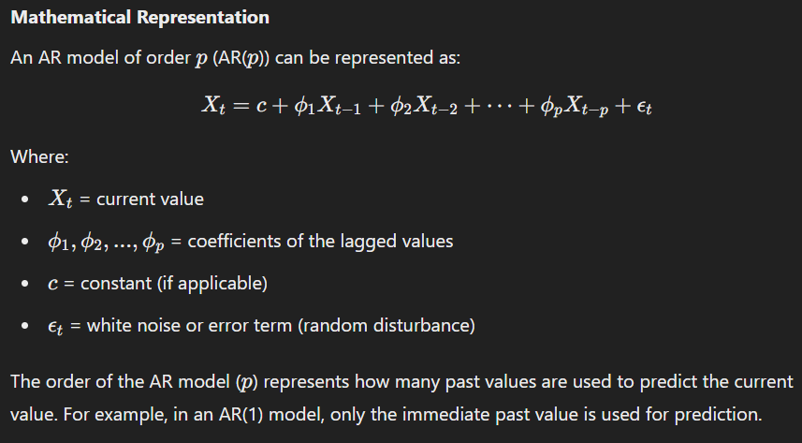

The order of the AR model (ppp) represents how many past values are used to predict the current value. For example, in an AR(1) model, only the immediate past value is used for prediction.

#### **Key Features**

* **Stationarity**: AR models assume that the time series is stationary, meaning that the mean, variance, and autocorrelation structure do not change over time.
* **Lagged Dependence**: AR models capture linear dependencies on past observations.
* **PACF Plot**: The Partial Auto-correlation Function (PACF) helps determine the appropriate lag order for the model.

### **Moving Average (MA) Models**

#### **Overview**

A Moving Average (MA) model describes a time series as a linear combination of the past white noise (error terms). Instead of using previous values of the time series, it uses the error terms from previous periods to predict the current value.

#### **Mathematical Representation**

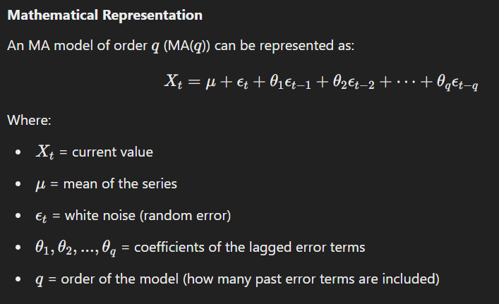

#### **Key Features**

* **Error Terms**: Unlike AR models that rely on past values, MA models are driven by the error terms from previous time periods.
* **Stationarity**: MA models also assume stationarity for the time series.
* **ACF Plot**: The Auto-correlation Function (ACF) helps determine the appropriate order for the model.

### **ARMA and ARIMA Models**

#### **ARMA (Auto-Regressive Moving Average) Model**

ARMA is a combination of AR and MA models. It is used for modeling stationary time series data, combining both autoregressive and moving average components.

#### **Mathematical Representation of ARMA(p,q)**

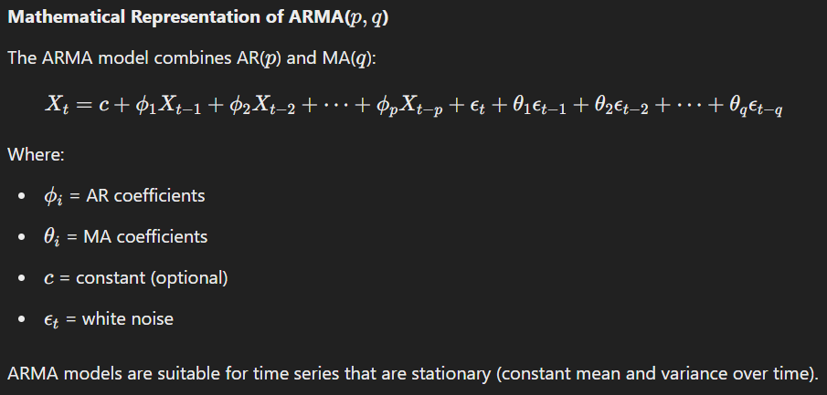

#### **ARIMA (Auto-Regressive Integrated Moving Average) Model**

ARIMA models are an extension of ARMA models that can handle non-stationary time series by including differencing. The "I" in ARIMA stands for "Integrated," which means that the model includes a differencing component to make the time series stationary.

#### **Mathematical Representation of ARIMA(p,d,q)**

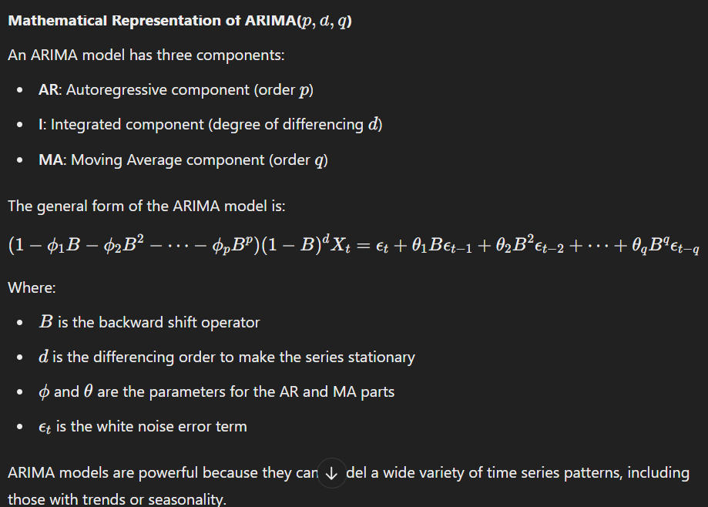

### **Key Differences**

1. **Stationarity**:
   * AR and MA models are for stationary series.
   * ARIMA can handle non-stationary series by applying differencing.
2. **Components**:
   * AR is based on the past values of the time series.
   * MA is based on past error terms.
   * ARMA combines both AR and MA.
   * ARIMA adds a differencing component to ARMA to deal with non-stationary series.

### **Example Applications**

* **AR**: Predicting stock prices based on past stock prices.
* **MA**: Predicting the impact of past errors (shocks) on future demand in a product.
* **ARMA**: Modeling temperature variations with both past values and error corrections.
* **ARIMA**: Forecasting GDP growth, where the data might have a trend or seasonality.

### **MCQs on Auto-regressive Models, Moving Average Models, ARMA & ARIMA**

#### **Basic Questions**

1. **In an AR model, the current value is dependent on:**a) Past values of the time series  
   b) Future values  
   c) Past error terms  
   d) Residuals only  
   **Answer**: a) Past values of the time series
2. **The order of the AR model (p) indicates:**a) The number of lagged values to use  
   b) The number of differenced observations  
   c) The number of moving average terms  
   d) The number of residual terms  
   **Answer**: a) The number of lagged values to use
3. **Which model includes both autoregressive and moving average components?**a) AR  
   b) MA  
   c) ARMA  
   d) ARIMA  
   **Answer**: c) ARMA
4. **Which model is used for non-stationary time series data?**a) AR  
   b) ARMA  
   c) ARIMA  
   d) MA  
   **Answer**: c) ARIMA
5. **The differencing component in ARIMA is denoted by:**a) ppp  
   b) ddd  
   c) qqq  
   d) ccc  
   **Answer**: b) ddd

#### **Intermediate Questions**

1. **In an MA model, the current value depends on:**a) Past values of the time series  
   b) Past error terms  
   c) Current residuals  
   d) Past and current values  
   **Answer**: b) Past error terms
2. **Which plot is helpful in determining the order of an MA model?**a) ACF plot  
   b) PACF plot  
   c) Histogram  
   d) Box plot  
   **Answer**: a) ACF plot
3. **In ARIMA, what does the order q represent?**a) Number of lagged terms  
   b) Number of differenced terms  
   c) Number of moving average terms  
   d) Constant term  
   **Answer**: c) Number of moving average terms
4. **What happens to a time series when d>0 in ARIMA?**a) It is transformed into a stationary series by differencing.  
   b) It introduces seasonal components.  
   c) It adds noise to the series.  
   d) It models long-term trends.  
   **Answer**: a) It is transformed into a stationary series by differencing.
5. **Which of the following is true for an ARIMA model?**a) It only works for non-stationary data.  
   b) It includes both differencing and error terms.  
   c) It ignores the seasonal components.  
   d) It requires a high number of parameters.  
   **Answer**: b) It includes both differencing and error terms.

#### **Advanced Questions**

1. **If the ACF plot cuts off after lag 3 and the PACF decays slowly, it suggests a:**a) AR(3) model  
   b) MA(3) model  
   c) ARMA(3, 3) model  
   d) ARIMA(3, 1, 3) model  
   **Answer**: a) AR(3) model
2. **In ARIMA modeling, what does the term "integration" refer to?**a) The combination of AR and MA models  
   b) The application of differencing to make the series stationary  
   c) The inclusion of external predictors  
   d) The smoothing of residuals  
   **Answer**: b) The application of differencing to make the series stationary
3. **Which of the following is required for ARIMA modeling?**a) Data should be non-stationary  
   b) The series should have no seasonality  
   c) The series should be stationary or made stationary  
   d) Data must be normalized  
   **Answer**: c) The series should be stationary or made stationary
4. **Which of the following best describes an ARMA(1, 1) model?**a) A model with 1 autoregressive term and 1 moving average term  
   b) A model with 1 differencing term  
   c) A model with 1 seasonal term  
   d) A non-linear regression model  
   **Answer**: a) A model with 1 autoregressive term and 1 moving average term
5. **In ARMA models, the residuals should ideally be:**a) Non-random  
   b) Correlated  
   c) Normally distributed and uncorrelated  
   d) Uncorrelated but not normally distributed  
   **Answer**: c) Normally distributed and uncorrelated

============================================================================================================================================**Session 23**

### **Machine Learning in Real-Time**

#### **Overview**

Machine learning in real-time refers to the application of machine learning models to continuously incoming data to make immediate predictions or decisions. Real-time machine learning is used in systems that require rapid decision-making and adaptation, such as recommendation systems, fraud detection, autonomous vehicles, and dynamic pricing systems.

In real-time machine learning:

* **Data Streams**: Models need to process streaming data in real-time.
* **Low Latency**: The goal is to achieve low-latency predictions, meaning the system should react quickly to incoming data.
* **Continuous Learning**: Many systems require the model to update in real-time based on new data. This is often referred to as online learning or incremental learning.

#### **Applications of Real-Time ML:**

* **Recommendation Systems**: Platforms like Netflix and Amazon use real-time data to recommend products based on users' immediate browsing or viewing behavior.
* **Autonomous Vehicles**: Self-driving cars use real-time machine learning to analyze sensor data, make decisions, and control the vehicle.
* **Fraud Detection**: Credit card companies use real-time machine learning to detect suspicious transactions as they happen.
* **Social Media Monitoring**: Real-time sentiment analysis on social media platforms to detect trends or events.

#### **Challenges in Real-Time ML:**

* **Scalability**: Real-time systems often deal with huge volumes of data, requiring scalable solutions.
* **Model Updates**: Real-time systems often need models to adapt quickly to changing data distributions (concept drift).
* **Low Latency**: Ensuring the system is responsive within the required time frame is a critical challenge.

### **Algorithm Performance Metrics**

Performance metrics are crucial for assessing the effectiveness of machine learning models. These metrics help evaluate the model's predictive ability and its appropriateness for a given task. Common performance metrics include:

* **Accuracy**
* **Precision**
* **Recall**
* **F1-Score**
* **ROC-AUC**
* **MSE/MAE** (for regression models)

Each metric offers insight into different aspects of the model's performance.

### **ROC and AUC (Receiver Operating Characteristic and Area Under Curve)**

#### **ROC Curve**

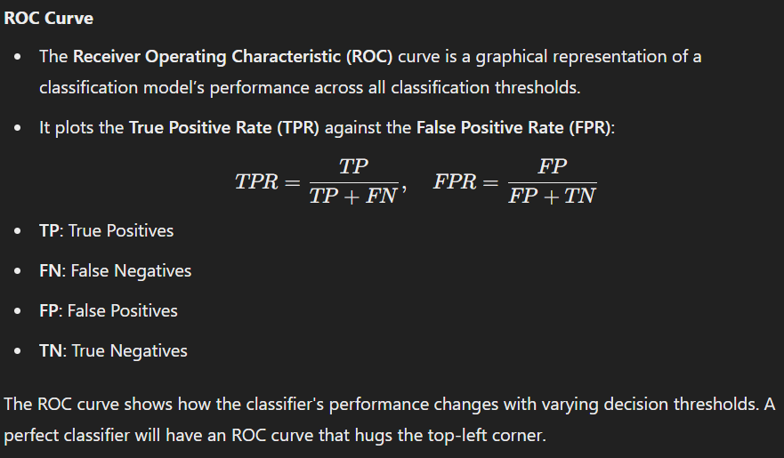

#### **AUC (Area Under Curve)**

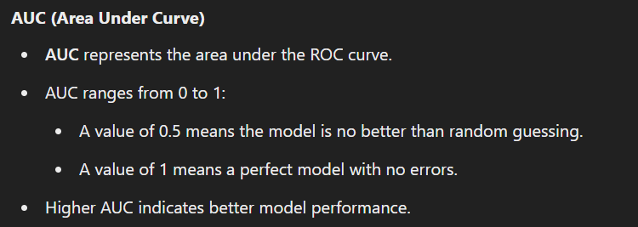

### **Confusion Matrix**

#### 

### **F1-Score**

#### 

### **MSE (Mean Squared Error) and MAE (Mean Absolute Error)**

#### **MSE (Mean Squared Error)**

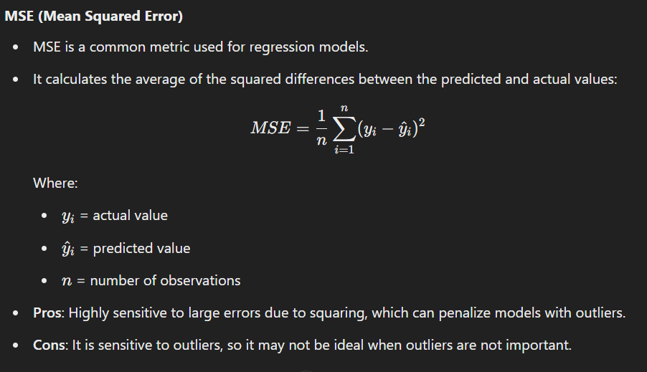

#### **MAE (Mean Absolute Error)**

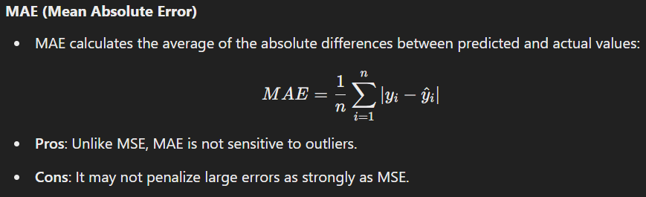

### **MCQs on the Topics**

#### **Basic Questions**

1. **Which of the following is a real-time machine learning application?**a) Image recognition  
   b) Fraud detection  
   c) Movie recommendation  
   d) All of the above  
   **Answer**: d) All of the above
2. **What does the AUC of an ROC curve represent?**a) Average Error Rate  
   b) Area under the curve  
   c) True Positive Rate  
   d) Classification error  
   **Answer**: b) Area under the curve
3. **The confusion matrix helps in calculating which of the following?**a) Precision  
   b) Recall  
   c) F1-Score  
   d) All of the above  
   **Answer**: d) All of the above
4. **Which of the following metrics is used to evaluate a regression model?**a) Accuracy  
   b) F1-Score  
   c) MSE  
   d) AUC  
   **Answer**: c) MSE
5. **In an imbalanced classification problem, which metric is most useful?**a) Accuracy  
   b) F1-Score  
   c) MAE  
   d) ROC-AUC  
   **Answer**: b) F1-Score

#### **Intermediate Questions**

1. **The F1-score is the harmonic mean of which two metrics?**a) Precision and Accuracy  
   b) Recall and Accuracy  
   c) Precision and Recall  
   d) Precision and MSE  
   **Answer**: c) Precision and Recall
2. **Which of the following does the ROC curve plot?**a) Precision vs Recall  
   b) True Positive Rate vs False Positive Rate  
   c) AUC vs Threshold  
   d) MSE vs Time  
   **Answer**: b) True Positive Rate vs False Positive Rate
3. **Which metric is commonly used to assess the performance of a binary classifier?**a) MAE  
   b) Precision  
   c) F1-Score  
   d) All of the above  
   **Answer**: d) All of the above
4. **The MAE metric gives more weight to large errors than MSE. True or False?**a) True  
   b) False  
   **Answer**: b) False
5. **Which of the following is true about MSE?**a) It is more sensitive to outliers compared to MAE.  
   b) It is less sensitive to outliers than MAE.  
   c) It is suitable for imbalanced data.  
   d) It penalizes small errors more than large errors.  
   **Answer**: a) It is more sensitive to outliers compared to MAE.

#### **Advanced Questions**

1. **Which of the following is true for a perfect classifier in terms of ROC curve?**a) The ROC curve will touch the bottom-right corner.  
   b) The ROC curve will hug the top-left corner.  
   c) The ROC curve will be a straight diagonal line.  
   d) The ROC curve will have no slope.  
   **Answer**: b) The ROC curve will hug the top-left corner.
2. **Which of the following metrics would be most useful for evaluating a model in an imbalanced dataset?**a) F1-Score  
   b) MSE  
   c) Accuracy  
   d) MAE  
   **Answer**: a) F1-Score
3. **The confusion matrix is primarily used in which type of models?**a) Classification models  
   b) Regression models  
   c) Clustering models  
   d) Both classification and regression models  
   **Answer**: a) Classification models
4. **AUC-ROC curve with a value closer to 1 indicates:**a) Perfect model performance  
   b) Random guessing  
   c) Poor performance  
   d) Overfitting  
   **Answer**: a) Perfect model performance
5. **In the context of regression models, MSE is used to measure:**a) The variance of the residuals  
   b) The bias of the model  
   c) The difference between the predicted and actual values  
   d) The strength of the correlation between the predictor and outcome  
   **Answer**: c) The difference between the predicted and actual values

============================================================================================================================================

**Session 24 & 25**

### **Recommendation Systems Overview**

A **Recommendation System** is a type of information filtering system that aims to suggest items (products, services, content, etc.) to users based on their preferences, past behavior, or the behavior of similar users. Recommendation systems are widely used in e-commerce, streaming services, social media platforms, and other online services to help users discover items they might be interested in.

There are three primary types of recommendation systems:

1. **Collaborative Filtering**Collaborative filtering is based on the idea that users who have agreed in the past will agree in the future about item preferences. There are two types:
   * **User-based Collaborative Filtering**: This approach recommends items by finding similar users. If user A likes items 1, 2, and 3, and user B likes items 2, 3, and 4, we assume that user A will like item 4, and user B will like item 1.
   * **Item-based Collaborative Filtering**: Instead of finding similar users, this method finds similar items based on user interactions. If a user likes item 1, and item 1 is similar to item 2, then item 2 is recommended to the user.
2. **Content-Based Filtering**Content-based filtering recommends items based on their characteristics and the user's past behavior. For example, if a user likes movies of a certain genre, such as action movies, the system will recommend other action movies based on the movie's features (genre, actors, director, etc.).
3. **Hybrid Recommendation Systems**Hybrid systems combine both collaborative and content-based filtering to improve recommendation accuracy. These systems aim to leverage the strengths of both methods while mitigating their weaknesses. Common techniques for hybrid systems include:
   * Weighted hybrid (combining recommendations from both systems based on assigned weights).
   * Switching hybrid (using collaborative filtering when sufficient data is available and content-based filtering otherwise).
   * Mixed hybrid (simultaneously using collaborative and content-based filtering to make independent recommendations and then combining the results).

### **Key Concepts in Recommendation Systems**

1. **Similarity Measures**Similarity is essential in both collaborative filtering and content-based filtering. Some of the most common similarity measures are:
   * **Cosine Similarity**: Measures the cosine of the angle between two vectors. It's widely used in collaborative filtering.
   * **Pearson Correlation**: Measures the linear correlation between two variables.
   * **Euclidean Distance**: Measures the straight-line distance between two points in a multi-dimensional space.
2. **Matrix Factorization**Matrix factorization techniques such as **Singular Value Decomposition (SVD)** are often used to decompose large user-item interaction matrices into smaller, lower-dimensional matrices that are easier to work with. This method helps uncover latent features that explain the interactions between users and items.
3. **Evaluation Metrics**
   * **Precision**: The fraction of recommended items that are relevant.
   * **Recall**: The fraction of relevant items that are recommended.
   * **F1-Score**: The harmonic mean of precision and recall.
   * **Mean Average Precision (MAP)**: The mean of the average precision at each level of recall.
   * **Root Mean Squared Error (RMSE)**: Measures the difference between predicted ratings and actual ratings.
4. **Cold Start Problem**The cold start problem occurs when there is insufficient data to make accurate recommendations. This is a challenge in recommendation systems, especially for new users or new items. Solutions to this problem may include hybrid systems, content-based methods, or even leveraging metadata for items.

### **Applications of Recommendation Systems**

1. **E-commerce**Platforms like Amazon and eBay use recommendation systems to suggest products based on a user's past purchases, browsing history, and preferences.
2. **Streaming Services**Netflix and Spotify use recommendation systems to suggest movies, shows, and music based on users' previous behavior and preferences.
3. **Social Media**Social media platforms like Facebook and Instagram recommend friends, posts, pages, and ads based on user interaction and engagement patterns.
4. **News Websites**News aggregators such as Google News or Flipboard recommend articles based on your reading history and preferences.
5. **Online Learning Platforms**Platforms like Coursera and Khan Academy recommend courses based on your learning history and progress.

### **Challenges in Recommendation Systems**

1. **Scalability**As the number of users and items increases, recommendation systems need to efficiently handle large-scale data. Collaborative filtering, for instance, can face challenges with performance as the user-item matrix grows.
2. **Sparsity**In many recommendation systems, user-item interaction matrices are sparse, meaning most users do not interact with most items. This sparsity makes it difficult to compute accurate recommendations.
3. **Cold Start Problem**When new users or items are introduced to the system, there is insufficient data for making accurate recommendations.
4. **Diversity**Recommendation systems may recommend the same type of content repeatedly, reducing diversity in suggestions. Balancing relevance with diversity is crucial.
5. **Bias**The system may develop biases based on past user interactions. For example, popular items may receive more recommendations, even though they may not be the best choice for each individual user.

### **MCQs on Recommendation Systems**

#### **Basic Questions**

1. **Which of the following is a type of recommendation system?**a) Collaborative Filtering  
   b) Content-Based Filtering  
   c) Hybrid Filtering  
   d) All of the above  
   **Answer**: d) All of the above
2. **Which similarity measure is commonly used in collaborative filtering?**a) Pearson Correlation  
   b) Cosine Similarity  
   c) Euclidean Distance  
   d) All of the above  
   **Answer**: d) All of the above
3. **In which of the following scenarios is content-based filtering most effective?**a) When user behavior data is sparse  
   b) When there is a large number of users  
   c) When there is a large user-item interaction matrix  
   d) When the system is new and lacks user data  
   **Answer**: a) When user behavior data is sparse
4. **Which of the following is a major challenge in recommendation systems?**a) Cold start problem  
   b) Overfitting  
   c) Underfitting  
   d) None of the above  
   **Answer**: a) Cold start problem
5. **Which of the following is NOT a typical evaluation metric for recommendation systems?**a) Precision  
   b) Recall  
   c) RMSE  
   d) R-squared  
   **Answer**: d) R-squared

#### **Intermediate Questions**

1. **What does the cold start problem refer to?**a) Difficulty in recommending items to new users or items due to lack of data  
   b) Slow processing speed of recommendation algorithms  
   c) Overfitting the model with too much data  
   d) Errors in data collection  
   **Answer**: a) Difficulty in recommending items to new users or items due to lack of data
2. **Which of the following is a method used to mitigate the cold start problem?**a) Collaborative Filtering  
   b) Content-Based Filtering  
   c) Hybrid Recommendation Systems  
   d) K-Means Clustering  
   **Answer**: c) Hybrid Recommendation Systems
3. **Which is an example of a real-time recommendation system?**a) Movie recommendation based on previous views  
   b) Product recommendation based on browsing history  
   c) Music playlist based on recent listens  
   d) All of the above  
   **Answer**: d) All of the above
4. **What is matrix factorization used for in recommendation systems?**a) To decompose a large user-item interaction matrix into smaller matrices  
   b) To reduce the dimensionality of the feature space  
   c) To measure the similarity between users  
   d) To calculate the popularity of items  
   **Answer**: a) To decompose a large user-item interaction matrix into smaller matrices
5. **Which of the following techniques can be used for similarity calculation in collaborative filtering?**a) Cosine Similarity  
   b) Pearson Correlation  
   c) Euclidean Distance  
   d) All of the above  
   **Answer**: d) All of the above

#### **Advanced Questions**

1. **In hybrid recommendation systems, which method combines collaborative and content-based approaches?**a) Switching hybrid  
   b) Weighted hybrid  
   c) Mixed hybrid  
   d) All of the above  
   **Answer**: d) All of the above
2. **Which evaluation metric is most commonly used to assess the accuracy of a recommendation system?**a) F1-Score  
   b) Precision  
   c) Recall  
   d) RMSE  
   **Answer**: d) RMSE
3. **Which of the following best describes item-based collaborative filtering?**a) Recommending items by finding users who are similar to the current user  
   b) Recommending items that are similar to items the user has liked  
   c) Recommending items based on content features  
   d) None of the above  
   **Answer**: b) Recommending items that are similar to items the user has liked
4. **What is the purpose of content-based filtering in recommendation systems?**a) To recommend items based on the user's past behavior and preferences  
   b) To recommend items based on similarity to other users  
   c) To recommend items based on popularity  
   d) To recommend items using hybrid methods  
   **Answer**: a) To recommend items based on the user's past behavior and preferences
5. **Which of the following methods is most commonly used to address sparsity in user-item interaction matrices?**a) Matrix Factorization  
   b) Neural Networks  
   c) K-Nearest Neighbors  
   d) Random Forest  
   **Answer**: a) Matrix Factorization
6. **Which algorithm is commonly used to perform feature extraction in content-based filtering?**a) SVD  
   b) K-Means Clustering  
   c) PCA  
   d) Decision Trees  
   **Answer**: c) PCA
7. **Which of the following is a major benefit of hybrid recommendation systems?**a) They are more computationally efficient  
   b) They can alleviate both cold start and sparsity issues  
   c) They only rely on user-item interaction data  
   d) They always outperform content-based and collaborative filtering individually  
   **Answer**: b) They can alleviate both cold start and sparsity issues
8. **Which of the following is NOT a type of recommendation system?**a) Content-based filtering  
   b) Collaborative filtering  
   c) Hybrid filtering  
   d) Decision tree filtering  
   **Answer**: d) Decision tree filtering
9. **Which of the following metrics would you primarily use to evaluate the performance of a recommendation system?**a) Mean squared error (MSE)  
   b) Accuracy  
   c) Precision and recall  
   d) R-squared  
   **Answer**: c) Precision and recall
10. **Which of the following is an example of a content-based recommendation?**a) Recommending products based on other users’ preferences  
    b) Recommending books based on the genre you have read before  
    c) Recommending items based on geographical location  
    d) Recommending a new song based on your listening history  
    **Answer**: b) Recommending books based on the genre you have read before

============================================================================================================================================**Session 26**

### **Anomaly Detection Overview**

Anomaly detection, also known as **outlier detection**, refers to the identification of patterns or data points that deviate significantly from the expected behavior or norm. These deviations, or **anomalies**, can indicate critical incidents, such as fraud, network intrusions, equipment malfunctions, or rare but important events that may require further investigation.

Anomaly detection is used in various fields, including finance, healthcare, cybersecurity, and manufacturing. It helps in identifying patterns that do not conform to expected behavior, which can often point to errors, fraud, or even potential system failures.

### **Types of Anomalies**

1. **Point Anomalies**A **point anomaly** occurs when a single data point is significantly different from the rest of the dataset. For instance, in a dataset of daily temperatures, a temperature value that is far higher or lower than the rest could be an anomaly.
2. **Contextual Anomalies**Contextual anomalies depend on the context in which the data point appears. For example, a sudden spike in web traffic may be normal during a holiday season but could be anomalous if it occurs on a random weekday.
3. **Collective Anomalies**A **collective anomaly** is when a collection of data points is anomalous, even though individual data points might not be. This could occur when a series of measurements, taken over time, deviates significantly from expected trends.

### **Methods of Anomaly Detection**

1. **Statistical Methods**Statistical anomaly detection involves using statistical tests to detect outliers. This method assumes that data follows a known distribution (such as a Gaussian distribution) and that outliers are far from the mean (or expected value).  
   Examples of statistical methods include:
   * **Z-Score**: Measures how many standard deviations a data point is from the mean.
   * **Boxplots**: Visualizes data spread and identifies points outside the interquartile range.
2. **Distance-based Methods**Distance-based methods rely on measuring the distance between data points. If a point is far away from others, it may be considered an anomaly. These methods are effective when data is in a continuous space.
   * **k-Nearest Neighbors (k-NN)**: If a point has fewer than 'k' neighbors within a specified distance, it may be considered an anomaly.
3. **Clustering-based Methods**Clustering algorithms such as **k-means** can be used for anomaly detection. Points that do not fit into any cluster (or are far from their closest cluster centroid) are considered anomalies.
   * **DBSCAN (Density-Based Spatial Clustering of Applications with Noise)**: Identifies clusters of varying shapes and density and marks low-density points as anomalies.
4. **Machine Learning-based Methods**Some machine learning algorithms are specifically designed for anomaly detection. These methods involve training a model to recognize normal patterns in data and flagging deviations from those patterns.
   * **Isolation Forest**: This algorithm isolates observations by randomly selecting a feature and then randomly selecting a split value between the maximum and minimum values of that feature.
   * **One-Class SVM**: A variation of the support vector machine (SVM) that is trained on only normal data points to identify anomalies in unseen data.
5. **Deep Learning-based Methods**Deep learning techniques can also be used for anomaly detection, especially in high-dimensional data such as images or sequences.
   * **Autoencoders**: A neural network that learns to compress and reconstruct input data. The reconstruction error is used to detect anomalies; if the error is high, the point is flagged as anomalous.

### **Applications of Anomaly Detection**

1. **Fraud Detection**Financial institutions use anomaly detection to identify fraudulent transactions by analyzing spending patterns and flagging unusual transactions.
2. **Network Security**In cybersecurity, anomaly detection is used to identify unusual network traffic that could indicate an intrusion or attack. Techniques like the **intrusion detection system (IDS)** rely heavily on anomaly detection.
3. **Manufacturing and Predictive Maintenance**In manufacturing, anomaly detection is used to identify faulty sensors or equipment failure by spotting unusual readings or deviations from expected behaviors.
4. **Healthcare**In healthcare, anomaly detection can be used to detect abnormal patient data, such as unusual vital signs that might indicate health issues or errors in data collection.
5. **Credit Scoring**In credit scoring, anomaly detection is used to spot unusual patterns in an applicant’s financial history that may signal higher risk or potential fraud.

### **Challenges in Anomaly Detection**

1. **High Dimensionality**In high-dimensional data, the distance between points increases, making it more challenging to detect anomalies. Dimensionality reduction techniques like **PCA** (Principal Component Analysis) can be useful in such cases.
2. **Imbalanced Datasets**Anomaly detection tasks often involve imbalanced datasets, where normal observations far outnumber anomalies. This imbalance can make it difficult for the model to correctly identify rare anomalies.
3. **Dynamic Nature**In some domains, the definition of what constitutes an anomaly can change over time (e.g., in financial markets), making it difficult to apply static models.

### **Evaluation Metrics for Anomaly Detection**

1. **Precision**The percentage of detected anomalies that are actual anomalies.
2. **Recall**The percentage of actual anomalies that were correctly identified.
3. **F1 Score**The harmonic mean of precision and recall, providing a balanced evaluation.
4. **ROC Curve**Plots the trade-off between true positive rate (recall) and false positive rate for different thresholds.
5. **AUC-ROC**The area under the ROC curve. A higher value indicates better performance in distinguishing anomalies from normal data.

### **MCQs on Anomaly Detection**

#### **Basic Questions**

1. **What is anomaly detection used for?**a) Identifying patterns in data  
   b) Identifying rare data points that deviate from the norm  
   c) Predicting future trends  
   d) Classifying data  
   **Answer**: b) Identifying rare data points that deviate from the norm
2. **Which of the following methods is commonly used in anomaly detection?**a) k-Nearest Neighbors  
   b) Linear Regression  
   c) Decision Trees  
   d) Random Forest  
   **Answer**: a) k-Nearest Neighbors
3. **Which of the following is a type of anomaly detection?**a) Outlier detection  
   b) Clustering  
   c) Classification  
   d) None of the above  
   **Answer**: a) Outlier detection
4. **Which type of anomaly is typically detected when a single data point is far from the rest?**a) Contextual anomaly  
   b) Collective anomaly  
   c) Point anomaly  
   d) None of the above  
   **Answer**: c) Point anomaly
5. **What is the cold start problem in anomaly detection?**a) Difficulty in detecting anomalies when no prior data is available  
   b) Difficulty in detecting anomalies due to noise  
   c) Difficulty in clustering the data  
   d) Difficulty in predicting trends  
   **Answer**: a) Difficulty in detecting anomalies when no prior data is available

#### **Intermediate Questions**

1. **Which algorithm is based on finding data points that are isolated from others?**a) DBSCAN  
   b) Isolation Forest  
   c) k-Nearest Neighbors  
   d) Decision Tree  
   **Answer**: b) Isolation Forest
2. **Which of the following is NOT a commonly used method in anomaly detection?**a) Clustering  
   b) Distance-based methods  
   c) Neural Networks  
   d) Linear Regression  
   **Answer**: d) Linear Regression
3. **Which metric is used to evaluate the performance of anomaly detection models?**a) Mean Squared Error (MSE)  
   b) Precision  
   c) R-squared  
   d) Recall  
   **Answer**: b) Precision
4. **What type of anomaly detection method is used when data points are clustered together, and deviations from these clusters are identified as anomalies?**a) Clustering-based anomaly detection  
   b) Statistical anomaly detection  
   c) Distance-based anomaly detection  
   d) Content-based anomaly detection  
   **Answer**: a) Clustering-based anomaly detection
5. **Which of the following methods would you typically use for detecting anomalies in high-dimensional data?**a) k-Nearest Neighbors  
   b) DBSCAN  
   c) PCA  
   d) Naïve Bayes  
   **Answer**: c) PCA

#### **Advanced Questions**

1. **In which domain is anomaly detection commonly used for identifying fraudulent transactions?**a) Healthcare  
   b) Finance  
   c) Manufacturing  
   d) Retail  
   **Answer**: b) Finance
2. **Which of the following methods is most effective when anomalies appear as dense clusters rather than isolated points?**a) k-Nearest Neighbors  
   b) DBSCAN  
   c) Isolation Forest  
   d) PCA  
   **Answer**: b) DBSCAN
3. **What is the main advantage of using the Isolation Forest algorithm for anomaly detection?**a) It is based on k-means clustering  
   b) It is easy to implement  
   c) It isolates anomalies rather than profiling normal data  
   d) It requires labeled data  
   **Answer**: c) It isolates anomalies rather than profiling normal data
4. **Which evaluation metric for anomaly detection combines precision and recall?**a) ROC Curve  
   b) F1 Score  
   c) AUC-ROC  
   d) Root Mean Squared Error  
   **Answer**: b) F1 Score
5. **Which anomaly detection technique is best suited for streaming data?**a) k-Nearest Neighbors  
   b) Isolation Forest  
   c) DBSCAN  
   d) Autoencoders  
   **Answer**: b) Isolation Forest