Student Name: Aditya Verma UID: 24BAI70937
Branch: AIT-CSE (AIML) Section/Group: 24AIT_KRG-G2
Semester: 4
Subject Name: Database Management System Subject Code: 24CSH-298

Experiment 9 – Creating and Implementing Packages in PL/SQL
Experiment 9: PL/SQL Package Development: Procedures and Shared Cursors for Enterprise
Aim
To create and implement PL/SQL packages by developing a package specification and package body containing procedures and shared cursors, in order to achieve modular, reusable, and efficient database programming.
Objective
- To understand the concept and structure of PL/SQL packages.
- To differentiate between package specification and package body.
- To implement procedures inside packages.
- To use shared cursors for retrieving data.
- To develop modular and reusable PL/SQL code.
Software Requirements
Database Management System:
- Oracle Database Express Edition (Oracle XE)
- PostgreSQL Database
Database Administration Tool / Client Tool:
- Oracle SQL Developer
- pgAdmin

Problem Statement
In enterprise applications, database operations are grouped into packages for better maintainability, security, and reuse. A structured package should be designed to fetch and display employee details using shared cursors.
Practical / Experiment Steps
- Create an employee table.
- Insert sample data.
- Create a package specification.
- Create a package body.
- Define procedures inside the package.
- Use a shared cursor to fetch employee records.
- Execute package procedures.
- Display output.
Procedure
• Open Oracle SQL Developer.
• Create employee table.
• Insert sample data.
• Create package specification.
• Create package body.
• Declare shared cursor.
• Write procedure to fetch employee details.
• Compile package.
• Execute procedure.
• Display output.

Input / Output Details
Input
- Table: employee (id, name, salary)
Step-wise Output
Step 1 – Create Employee Table
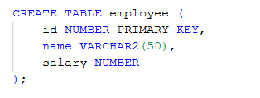
Step 2 – Insert Sample Data
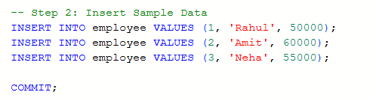
Step 3 – Create Package Specification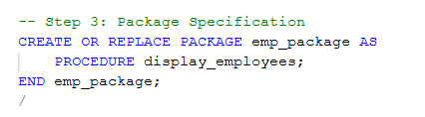
Step 4 – Create Package Body
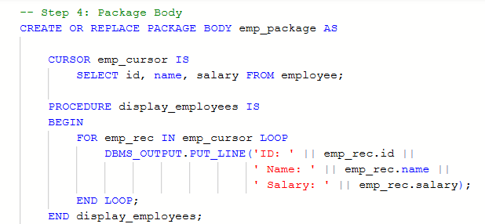
Step 5 – Execute Package Procedure
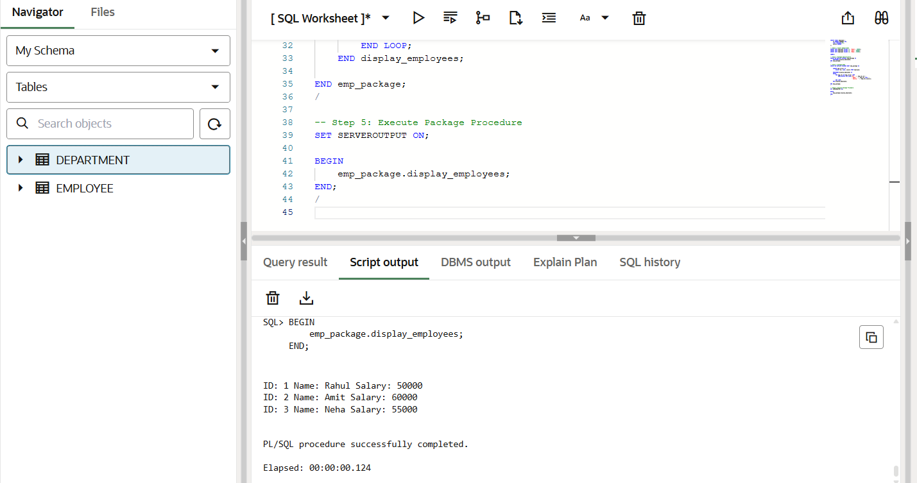

Learning Outcome
After completing this experiment, the learner will be able to:
- Understand PL/SQL package structure.
- Implement package specification and body.
- Use shared cursors effectively.
- Develop modular and reusable code.
- Apply enterprise-level database programming practices used in companies like Rippling, Oracle, SAP, and PayPal.

