# **Session 1 - Basics**

## First steps in finance

It’s all about finance , whether its HR , public relations , marketing etc..

Building blocks

1) Structure of business

Always forward looking ( what we do in future , planning for future , not what we have done in the past)

2) cashflows

What are cashflows and why are they important??

How are earnings related with cashflows.

3) measurement of risk

4) time value of money

-- dollar today is worth more than a dollar in future.

5) Valuation

-- value of an asset is the present value of its cash flow

6) Trading fundamentals

-- markets not specifically required for business, these are just lubricants, but the important thing is how do we perform trading / business transactions

Arbitrage 🡪 why its important in finance

## 1.Concept of Business

Understanding the business structure

Assets and Liabilities

Difference between financial and Accounting BS

Financial balance sheet 🡪 not what you have already put in the assets but what these assets will give you in return in future based on what you have invested in them today. Always about future .

**2 ways to fund a business**

1) Equity 🡪 the money which we own ourselves.

2) Debt 🡪 if equity is not sufficient , we borrow money

## 2.Importance of Cashflows

Important to understand why cashflows is different to earning.

Why few business that looks good in accouting BS may not really be productive

1) contractually set in the beginning

Like a bond or loan when the business takes in the beginning

2) residual cashflows

Profits made in the business

3) contingent cashflows

If some event occurs , you have some savings kept which will be used for business

## 3.Measurement of risk

3 things to note here :

Good risk and bad risk 🡪 we need to e careful here

Risk though whose eyes, perspective of risk from govt point of view , company , shareholders , stakeholders etc..

Quantifying the risk 🡪 convert the risk into something measurable ( like a risk measure which can be adjusted)

Also understand the history of risk , how company has performed in the past helps us to assess its risk for future.

## 4.Time value of moneyd

Dollar today is more than dollar worth tomorrow 🡪 but why??

What decides the value of asset for tomorrow ,,if there is some cashflow right now , what would be its value in future

Or if there is some cashflow in future , can we find the value for that in present to make a financial decision.

## 5.Valuation

It depends upon the type of cashflow

Ex: for contractual cashflow , like bond or loan , you discount them using the fixed amount( promised cash) when the bond was made

For equity ( residual cashflow) 🡪 discount expected cashflow what the investors expect in the cash flow

Contingent cashflow 🡪 value the asset using an option pricing model

## 6.Trading

Financial markets where buying / selling is happening

Investors would like to get 100% profits ( but that’s impossible , you need to take risk most of the times)

At the same time , there are 2 kinds of frictions that every investor need to go through:

1) trading costs

2) taxes ( govt imposed taxes)

# **Session 2 – Structure of a business**

## Financial Balance Sheet

Assets and Liabilities

2 types of assets

1. **Assets in place** 🡪 value of investments you have already made as a company in the history. 🡪 current wealth / value of a company

2 . **Growth Assets** 🡪 future value of investments done today

Debt 🡪 borrow money 🡪 whatever profits are earned, these will get distributed to the Lenders first and then only company

Equity 🡪 value get after meeting the debt obligations (own money, no debt involved)

1. Assets in place 🡪 ex: for an automobile company these are the plants which are already setup. Company is reaping the benefits for such assets.

Ex : Microsoft 🡪 Assets in place 🡪 Windows and Microsoft

For ex: if the asset is performing good, then its ROI will be greater than the capital money spent initially (this is forward looking) and vice versa (backward looking).

**2. Growth Assets**

Again, its ROI that matters, not the money spent in acquiring these assets.

Value of GA will be :

1) higher 🡪 if ROI is high

2) lower -> low ROI (profit is low, not much cashflow, assets not getting much returns)

3) Negative 🡪 value invested (capital money is more) and ROI is less than money invested.

Asset value is declining but we still continue to invest. Loss of money.

Debt

3 ways to find out the cashflow is debt or not

1) contractual agreement:

Fixed set of money to be given. This is signed in the agreement before hand between both parties. Floating rate debt also its possible but the cashflow is still fixed. Now cashflow can change with time but its fixed.

2) Failure meet this cashflow 🡪 out of business, how?? 🡪 if you have lent some money, and unable to pay to your lender, then he will take over your business. Bankrupt.

3) payments made are tax deductible, meaning no additional tax need to be paid to govt when you are returning money to lender.

Equity

Cashflow left over after everybody needs have been met.

Lender needs

**Residual claim**

If we are the owner , then we have the right to take everything left after paying away all dues.

**Dividend claim**

If we are stock holder of a public company , then managers decide how much money we are going to get.

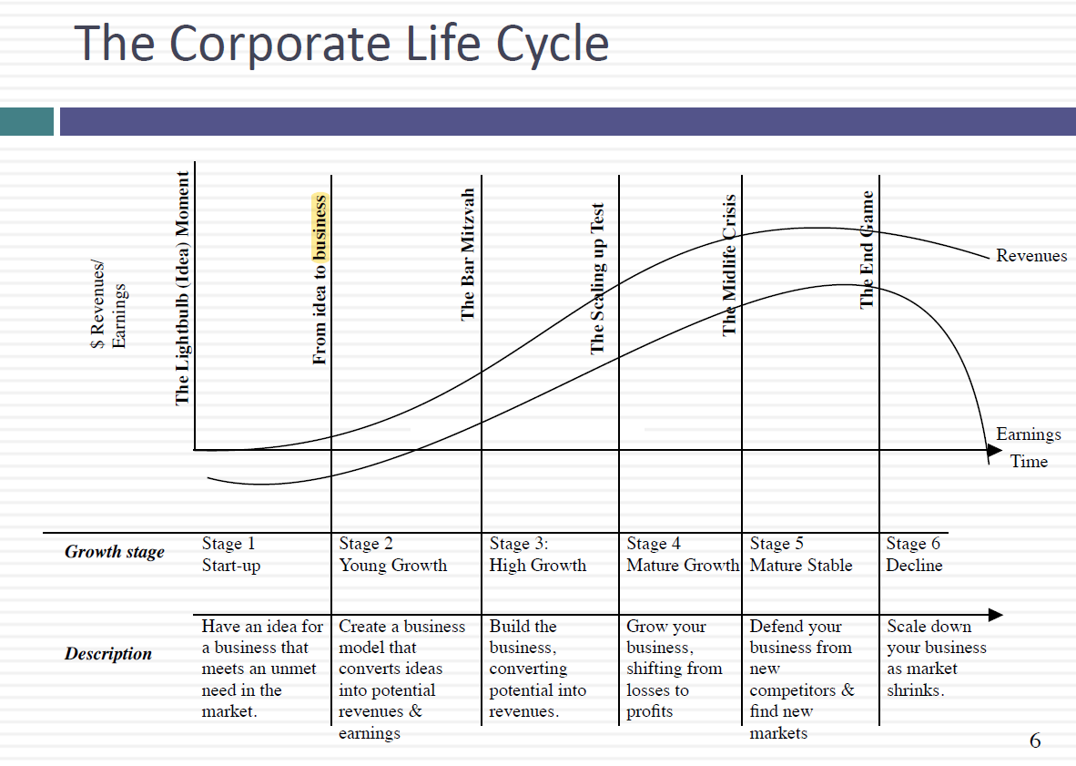 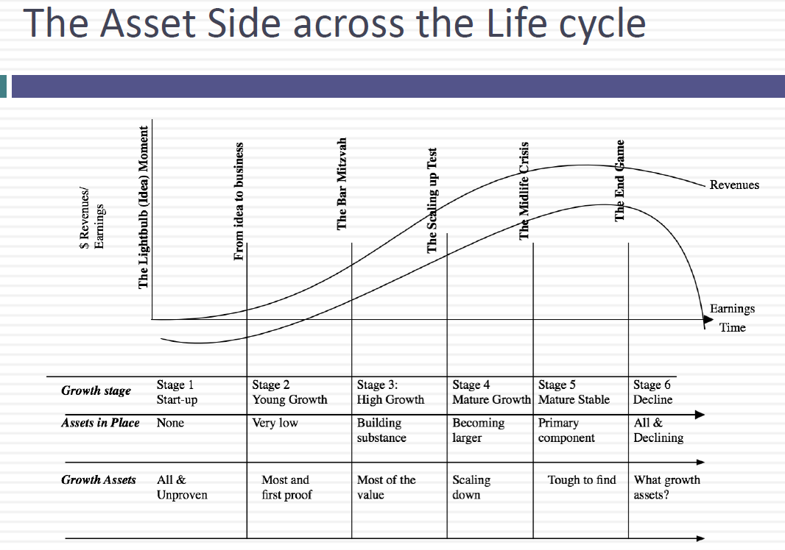

Initially company starts and its only growth assets ( no asset in place) 🡪 freshers joined and profits are coming in as everybody is motivated.

With the above motivation , the growth assets will grow 🡪 assets in place will also increase slowly but still growth assets are more dominate than assets in place.

Mature stage 🡪 Assets in place will overtake growth assets, this is the time when you are at peak.

Midlife crises 🡪 growth assets starts declining and assets in place are consumed much faster..company profits reduces. At this point of time we cant do much , even if we start building assets inplace , we are just going to destroy them even faster.

End game 🡪 decline is faster 🡪 assets in place almost 0. Growth is 0

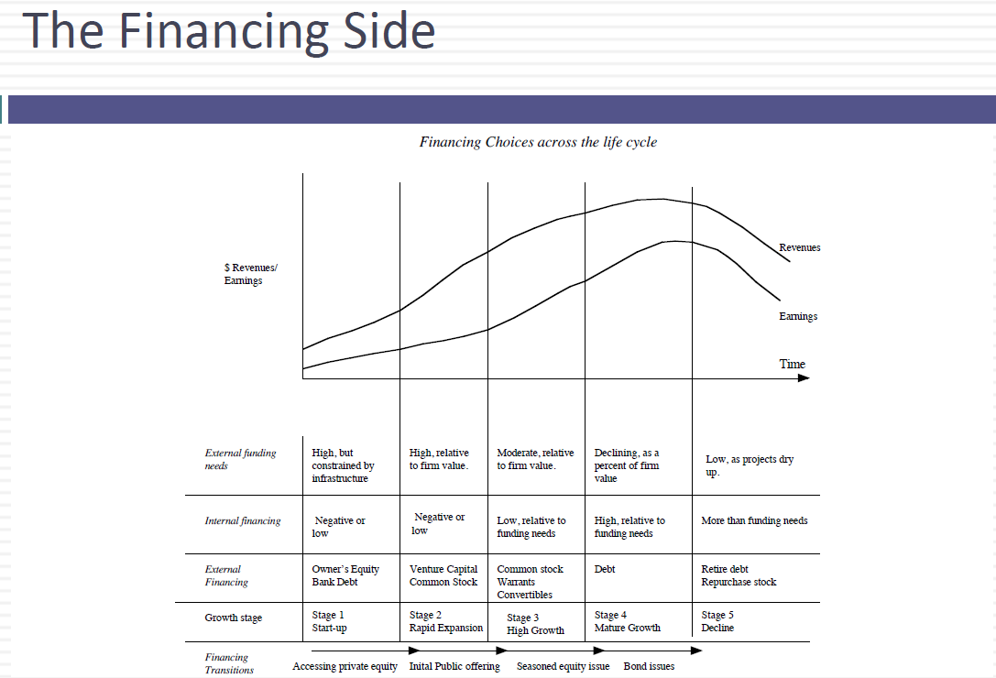 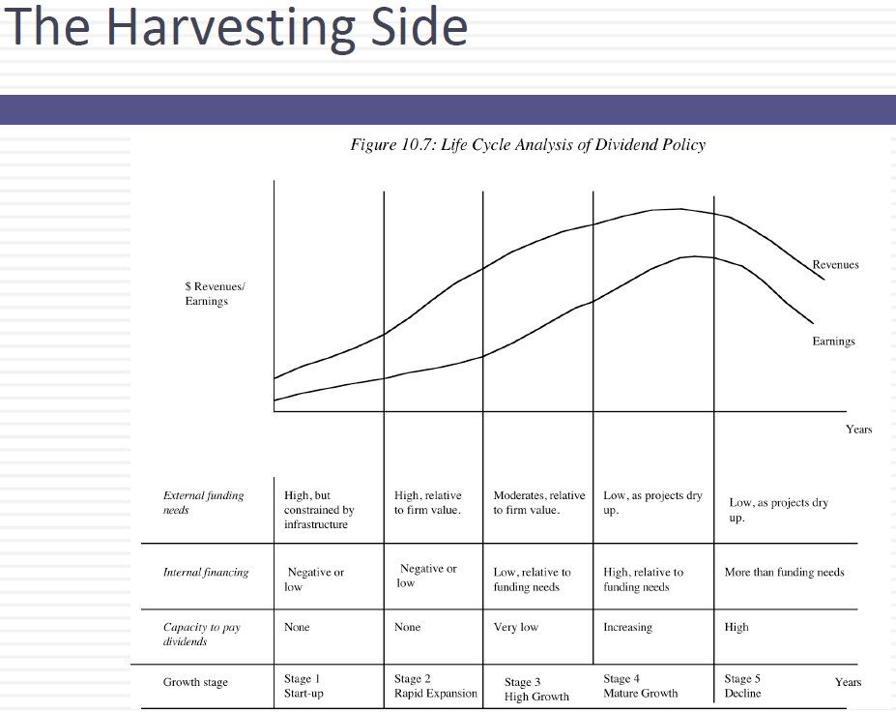

# **Session 3 – Cashflow claims**

Cash flow vs earnings

Why they are different?

1) Accrual accounting requires you to report transactions as they happen, not as you get paid or pay your suppliers

For ex: you perform a transaction in your business, and then you need to instantly show your revenue (even when the revenue hasn’t happened yet)

2) Accounting classifies expense into 3 groups

a. operating 🡪 labour , raw material, rent ( income statement) ( only in current year)

b. capital 🡪 exp created by the use of debt ..( don’t show up in the year they are done , they spread out over time as depreciation and amortization )

d. financial expenses 🡪 exp that create benefits over many years. Like land , building , etc ( below operating expense)

earnings to Cashflow

if you have to convert earnings to cashflow for a business , there are only 3 things we need to do:

1) add back any accounting exp that are non-cash ( like depreciation , amortization)

-- why do we need to include them , cos they lower the cashflows

2) subtract out capital expenses in that period

3) subtract out change in non-cash working capital

Types of cashflows

1) contractual cashflows 🡪 linked with some agreement , bond 🡪 timely money transacted between 2 parties mutually agreed upon

2) residual cashflows 🡪 equity cashflow 🡪 money left over after contractual obligations are met

3)contingent cashflows 🡪 cashflow that will happen in case of any disaster

Contractual cashflow claims

Constant 🡪 fixed cashflow 🡪 bank loan or corporate bond

Variable 🡪 timely cashflow but the amount is variable and depends upon below:

Floating rate loan 🡪 depends upon the interest rate ( LIBOR , bond rate)

Commodity loan 🡪 for ex: interest payments may be linked with the price of a commodity like gold.

Residual cashflow this one can be negative if contractual obligations exceed the cash generated from operations ( for ex: new company)

# **Session 4- What is risk**

In general word, risk is always considered to be negative (exposing to danger)

In business and investment, risk cannot be viewed just as negative (cos if risk is only negative, then its best to just avoid it. but if we check the history, companies who have actually grown overtime have taken risk over and over based on their research and confidence)

Good and bad outcomes

Bernoulli experiment and st. Petersburg Paradox

Exp run by Nicholas Bernoulli in 1700 ..

Coin flip 🡪 if tail you get 50 cents and it heads then game over. How much money you are willing to play the game.

What Nich found out that on average ppl willing to pay 2$.

2 other observations:

1) value attached to this gamble would vary across individuals

2) utility from gaining an additional dollar would decrease with wealth

3) Ass ppl get richer they are willing to take risk

Findings and observations how people are risk averse

1) Male vs Female 🡪 on smaller bets female are more risk averse but as the bet increases then both are same

2) Naïve vs experienced 🡪 naïve more exp less ( exp understand the business more hence willing to take risk)

3) young vs old 🡪 old are more risk averse

4) racial and cultural diff 🡪 almost same across all races

**Some unique observations of how and why ppl are risk averse**

1) framing 🡪 would you save 200/600 ppl or accept 30% chance of all ppl to be saved

Here most of them replied with 200 .. since this is confirmed.

2) Loss aversion 🡪 out of 1000$ , will you take 750$ confirmed or 75 % chance of getting entire 1000$ dollars.. again here 750$

3) Myopic loss aversion 🡪 getting continuous feed back to ppl about how their investments are performing .

4) house money effect 🡪 more risk taking on money which they have obtained easily ( like other ppl money rather than their own money) ..for ex: you obtained some money from your father as inheritance or some gift from relative 🡪 easy to invest on more risk taking stocks..

The one which you are earning 🡪 less risk taking

5) breakeven effect 🡪 like when you have lost money in a gamble you will come back and eager to put more money to win back more money ( even though the same risk is applicable now as well)

# **Session 5 – Measurement of Risk**

In general Ppl tend to pay less for more riskier investment as compared to safer investment (even when ROI is much higher than riskier investment)

## Mean variance framework

Expected return = as per theory and your estimate how much ROI you will get after investing money

Actual return = the money which you get in reality

If your actual ROI = expected ROI 🡪 then its risk-free return

In mean variance world, we assume that investors would only pick investments only for 2 below conditions:

1) expected ROI in positive

2) risk is negative

And the above can hold only if:

1) returns are normally distributed

2) utility functions (risk calculations) are 100% accurate

## Diversification of Risk

What all factors contribute to risk and how we can categories them.

Ex: it can be as small as related with a single project level to whole country wide economic risk

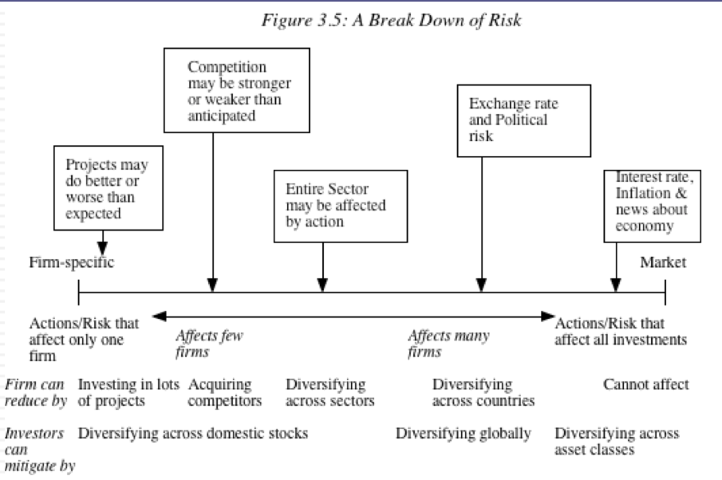

## Effects of diversification

By being diversified, reduces the firm specific risk (~law of large numbers)

Also for every bad investment that happens, there would be a good investment, in that way it will cancel out bad investments ..

Plus, even if one asset where you invested performs bad, the other assets have better chances of performing good since they belong to diff types.

## Statistical proof of correlation

We put 50% of money ( w1 = 0.5) into stock1 and same as in stock2. Standard deviation is 9.81 that is less then standard deviation of both the stocks.

Quick observations:

The more diversified the assets are, higher benefit would be.

As you keep adding stocks (from 2 –> 3 🡪 4 ……🡪 100), marginal benefits of adding a stock, will decrease as you increase the numbers of assets in your portfolio.

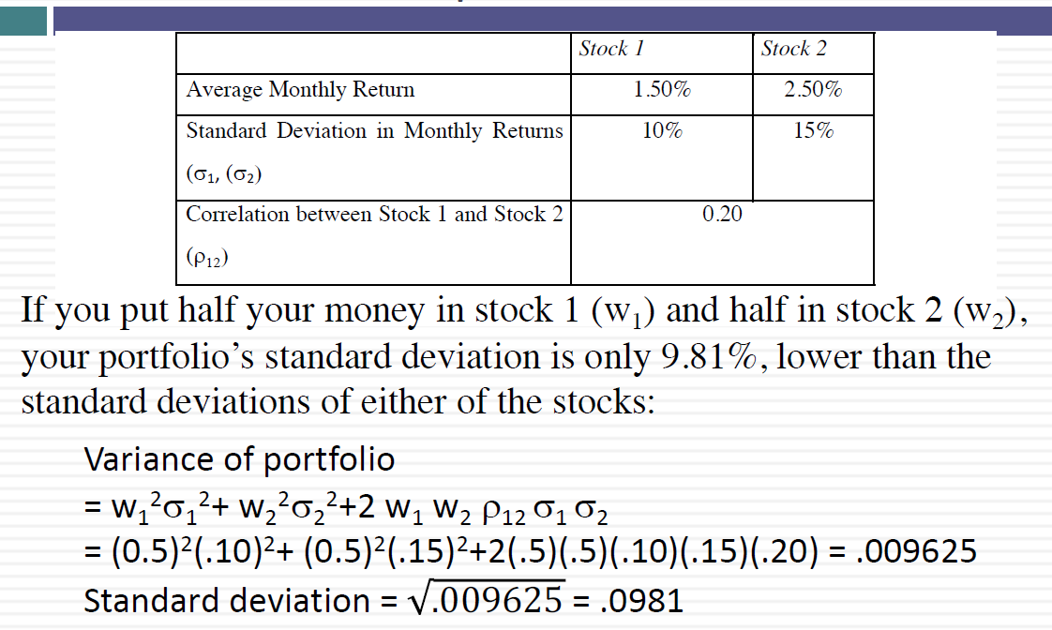

## Marginal investor (institutional investors 🡪 diversified investor)

He is the investor who is most likely to be the buyer or seller on the next trade and to influence the stock price. 2 points to describe marginal investor:

1) one who own a lot of stock and also trades lot of stock

2) ( so this may not be the owner , since owner may own lot of stock but may not trade them )..

## Market portfolio

List of assets which the investors owns and make them diversified to reduce overall risk. This collection of them is called as Market Portfolio.

For individual investors , they will reduce their risk , by keeping some of their money in riskless assets and part of that in market portfolio. Ex below:

|  |  |
| --- | --- |
| Risk Level | Allocation decision |
| No risk | 100% in riskless asset ( T bill) |
| Some risk | 50% in T bill and 50% in market portfolio |
| High risk | 100 % in Marlet portfolio |
| Risk hogg (Peak risk) | Borrow money and put all in MP |

What is risk of an individual Asset?

Measure of risk that it adds to the market portfolio. This risk can be measured by measuring how much this asset will move in relation with the market

Beta is this measure = covariance of asset // covariance of Market

Beta also measured by = ROI of an asset // ROI in general from Market

**Expected return = Risk Free Rate + Beta * (Expected Return on the market Portfolio – Risk Free Rate)**