**Duration Prediction using ML**

**Mohanaditya Karampudi (**U69444699**)**

The code is executed in jupyter notebook (amazing python language’s interface). As, this notebook is created in 5 hours and I do not have the domain knowledge and business understanding of the sensor data. The output of graphs were not making much sense to me. I am even ready to create .py file in needed.

I have implemented Random forest and gradient boosting to find out the duration column, as I am not so clear about the Objective from the pdf which is

**Objective: The objective of this exercise is to develop an algorithm to identify date‐time and duration when the participant is taking a shower.**

If it is just about getting the data when the participant is having shower then a simple rule of sub-setting data based on sensor ID and counting the seconds between start time and end time will do.

But, because of the word “algorithm” in Objective. I discarded the above approach and started digging into each and every column to understand how the data is and what features can we extract in order to create a regression model.

There are two files Training_phase.ipynb and testing_phase.ipynb.

Training_phse.ipynb contains the code used to understand the data, visualize it and create models and save them.

Testing_phase.ipynb is used only for testing the models with sample_test.csv. (please change the file name that you want to test as sample_test.csv).

So lets start about the code in training_phase.ipynb

* Importing necessary libraries
* Checking the mean, std, quantiles through describe() code
* From describe we can conclude that the independent variable (duration) has same value till 75% quantile. Hence, we can clearly say that the values above 75% quantile are outliers.
* The column id has unique values and this will not help us in any way hence dropping it off
* The NA values in whole dataset are zero
* Changing the type of columns to clean them.
* Created new columns like
  + date which holds date in YYYY-MM-DD format,
  + hour in 24 hour format
  + weekday the day of the week
  + sensor the name of sensor based on sensor id
* Next was to understand the data by visualizing.

This is the value of Duration by each sensor averaged out by date.

From here we find that the duration remained very low from 5 to 8 june

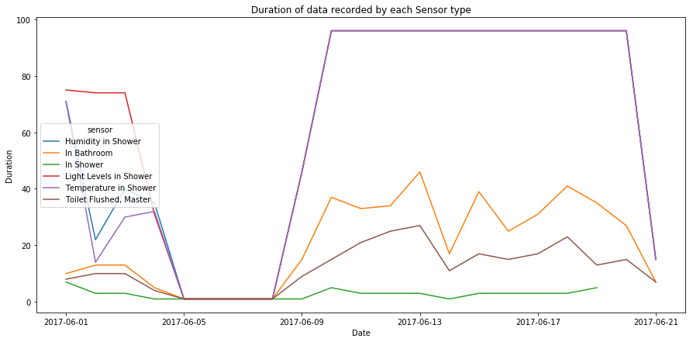

The Box plot were clearly saying that the duration data is scattered vividly. Such small box plot in figure one states the variation of outliers. The outliers have huge values.

We can keep looking at these plots and infer much more details

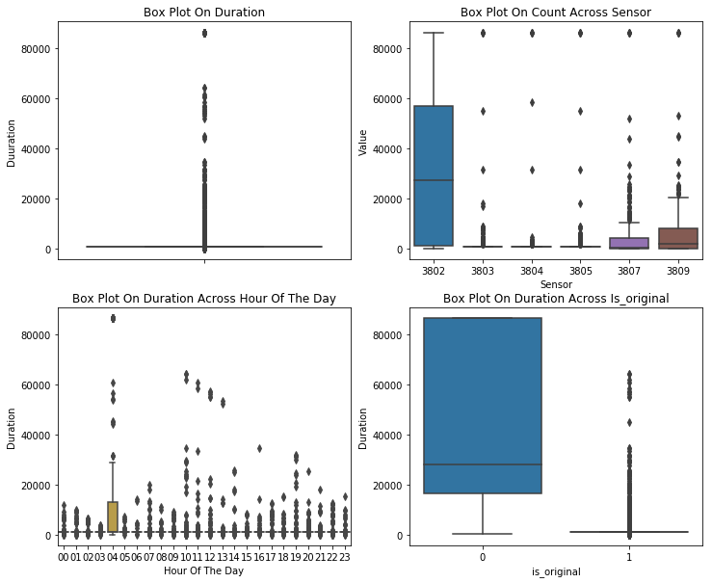

The duration based on sensors and days.

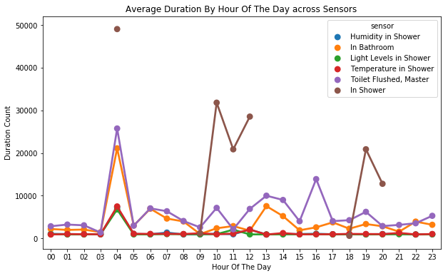

The Q-Q plot clearly depicts that the distribution is greatly skewed. So we have to remove outliers.

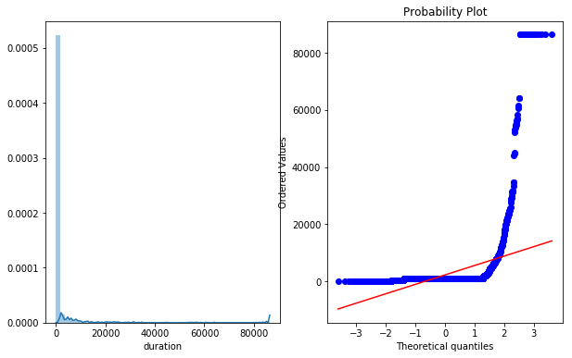

This plot shows the average duration of the shower sensor on everyday.

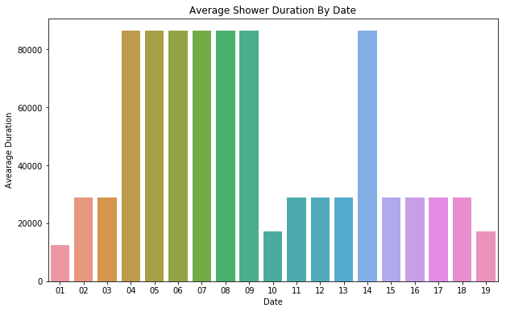

Keeping the Duration aside. I have focused on understanding the columns based on the instructions in metadata.

Visualizing the temperature sensor values. We can find that the temparture setting do not change drastically they flicker between 75 and 78.

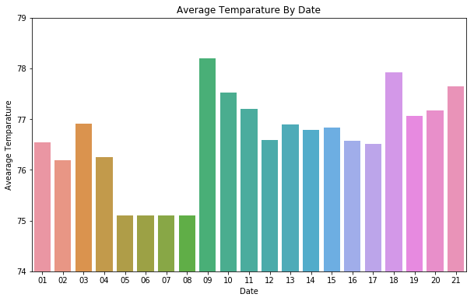

The data from light sensor is interesting as the luminous values are changed sporadically. With the value ranging from 18 to 136

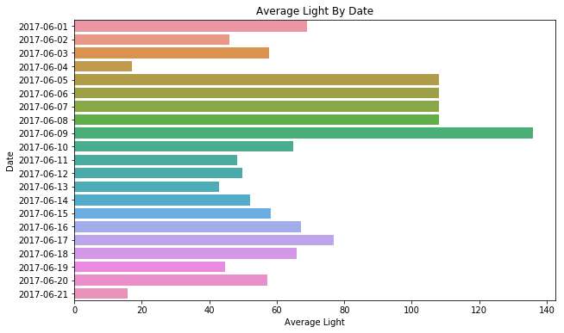

Plotting the humidity used each day we can conclude the humidity stays between 45 and 55

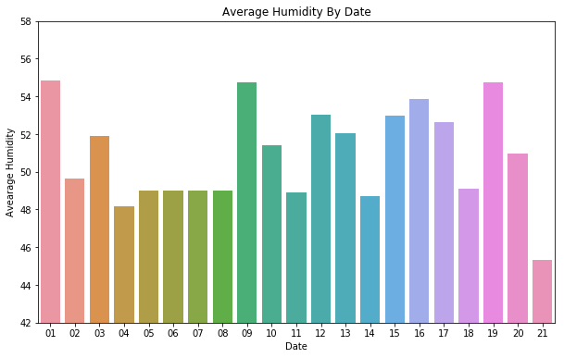

This small plot says that there are more number of times that bathroom has been used and the need of flush was not the priority. This means bath and other activities are more dominating than commod usage.

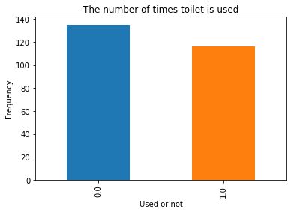

Later on I have further cleaned the data removed unnecessary columns etc etc and split the data into train and test

Tried random forest and GBM with RMSLE error and also tried GBM with RMSE error.

From the results, I can safely say that the model is overfitting. For now, I have to stop here because of time constraints and hence did not focus on parameter tuning.

If you get an intuition that my findings are interesting, then please get in touch with me for any further process over this data or to help understand the other aspects in the code.

Happy data surfing.

Signing off ☺