**Recommendation Engine**

**What is the Objective?**

The objective is to build a Recommendation Engine which takes Content and Collaborative approaches into consideration for recommending job to a user. It is used to analyze available data to make suggestions for something that a website user might be interested in our cases it is recommending jobs.

An [engine](http://whatis.techtarget.com/definition/engine), in a software context, is a special-purpose program that performs a task through a variable algorithm, often as a feature of some larger program. A [search engine](http://searchsoa.techtarget.com/definition/search-engine) is one type of recommendation engine, responding to search queries with pages of results that are (at least theoretically) the search engine's best suggestions for websites that satisfy the user's query, based on the search term plus other data, such as location and trending topics.

**Who uses?**

Basically any list of inventories big enough to make the customers confused in a pool of choices can benefit from a recommender system. The inventory subject to the recommendation can be digitally available contents such as music, movies, TV programs, or news. They can also be physical (or so-called brick and mortar) products such as grocery or other consumer products, or even job positions or dating profiles.

* **Spotify uses Collaborative filtering for radio featuring, related artists and recommending trendy songs.**
* **Microsoft has implemented recommendation systems in a variety of products, from providing recommendations to customer when he/she watch’s an Xbox movie, to recommending a workout based on his/her previous activity with Microsoft band.**
* **Netflix for movie recommendations**
* **Quora for quest recommendations**
* **eBay, Amazon for product,**
* **LinkedIn for job recommendations**
* **Google News Personalization System**
* **Facebook for “you may know”, “you might like” etc.**
* **Recommendation systems is widely being used in almost all online services.**

**Data**

The data is of Quickhire company which has collected two years of data from 2014 to 2015. It used to recommend jobs based on distance between the applicant’s location and job location and industry to make recommendations to the applicants. However, their engine might not be working efficiently because it is seen that almost 70% of the data contains NA in their Industry and this boils down to the point that the recommendations are mostly from the distance of applicant from the job which is ok but in order to get more personalized recommendations it won’t work as the engine might be suggesting jobs which doesn’t match applicants domain and hence that would not make a good recommendations.

**The dataset consists of twelve csv files.**

* **Combined_Jobs_final** : The dataset consists of different columns which are
* Job.ID : Unique number given to every job and there are 84,067 job openings
* Provider : there are two providers so the provider of that job. This is not needed for analysis
* Status: Is the job currently active? And all the jobs are active and we can drop this attribute
* Slug: it is combination of title, position, company and city this can be dropped
* Title: It is the combination of position and company and this is of no use
* Position: It is the name of the position this info can be used for content recommendation has few NA
* Company: It is the name of the company in which job is posted and is needed for analysis
* City: This is the city where the job posting is done and is needed
* State.Name: the state in which the city is located and is not needed as we already taken city
* State.Code: this is of no use
* Address: no need of address as city is taken into consideration
* Latitude: This is already taken into account by present company recommendation
* Longitude: This is already taken into account by present company recommendation
* Industry: although this is needed but there are 70% NA hence ignoring the industry
* Job.Description: This can be ignored but we can draw content from it so it is taken into consideration
* Requirements: this is of no use
* Salary: This is mostly NA hence dropping
* Employement.Type: This is about part time and full time employment and is considered
* Education.Required: This is also considered

Now even though few attributes are important it has been ignored cause they might not be present in user data hence while searching this wont help in any way. So while creating corpus users data should also be taken into consideration and this will refine search. In real time the data keeps on changing and updating hence a refresh rate would help in tackling this.

Although there are important attributes in job corpus because of NA values in almost all the attributes it is necessary to take a look at them and understand how they happened and find optimum solution. There are about 10 companies whose city is NA and have almost 500 records now the NA have been replaced with the headquarters of the company. Next there are NA values of company Uber in Employment.Type and this has been replaced with Part-time/Full-time and this are the assumptions that have been made for NA values.

The attributes used for creating job corpus are Position, Company, City, Employment type and job description. Before creating corpus the characters in the attribute are not only alphabets but also other ascii characters. So pre-processing is done which includes converting all the characters to lower case, removing all the characters except alphabets, stemming the data and also removing the stop words. Now the data is ready for creating job corpus. Tf-IDF matrix is used to create matrix and dense function is used to shrink the matrix.

For User there are many files which are pretty important to filter and gear up for better recommendation. The files are:

**Credentials**: This file consists of applicants skills and tools they used and have hands on. As there is no information from the job corpus it is irrelevant to consider.

**Education**: This is featured in job corpus so this would help in content recommendation. Looking at the data there are few columns in this file they are:

Graduate.Year: which year did the applicant finished final semester. The only record that matter is the latest study of the applicant.

School.Name: which school did the applicant pursue. This attribute will not help in recommending as job providers will not specifically require applicants from particular school.

City: which city did he/she study. This city is covered in applicants info hence this is not included.

Degree: what type of education did the applicant had. This is the education applicant had and this is need as it might match the Education requirement of the job.ID

With these two attributes from Education There are NA in both the attributes so the best way to deal is to remove all the records that contains NA in latest graduate year and then sort it by latest graduate year and choose the latest one for each applicant and the Degree contains text and is cleaned.

**Experience:** This criteria is important to recommend jobs accordingly but the problem is each company has different role name for the same work and due to this the recommendation can go off the relevance and hence ignoring. The criteria can be brought in if the job seeker specifies the experience requirement but as it is not present it is not considered.

**Interest:** The Interest file mainly deals with the hobbies and the usage of time by applicants when they are free. This doesn’t make recommendation any better. Hence, not considering

**Job_Views:**  There is another file named main_jobviews which has even more information like time spent on job, applied or not. This is not considered.

**Languages**: The main language used in USA for communication is English and there are very few companies which specifically ask for skills in other languages and as this is not present in job corpus it is ignored.

**Main_Info:** This consists of Applicants City, Zipcode, State.Name, State.Code, Latitude, Longitude, Estimated.age, Status, No.of Applied jobs. In these the only relevant attribute I felt needed is City.

**MainJobViews:** This file contains Event.ID, Applicant.ID, Job.URL, Position.Name, Company.Name, Spent.Time, Job.Applied. In these features the job.applied has much to tell as it is the main focus of the applicant. Hence I have extracted Job.ID which have been applied.

**Positions_Of_Interest:** The file contains the list of positions that an applicant is interested in and this would be of interest as the position name in job corpus might match with the position of interest.

**Visualizations:**

The map of United States revealing details about the number of jobs in each area. This is derived using Folium package on latitude and longitude information present in job dataset.

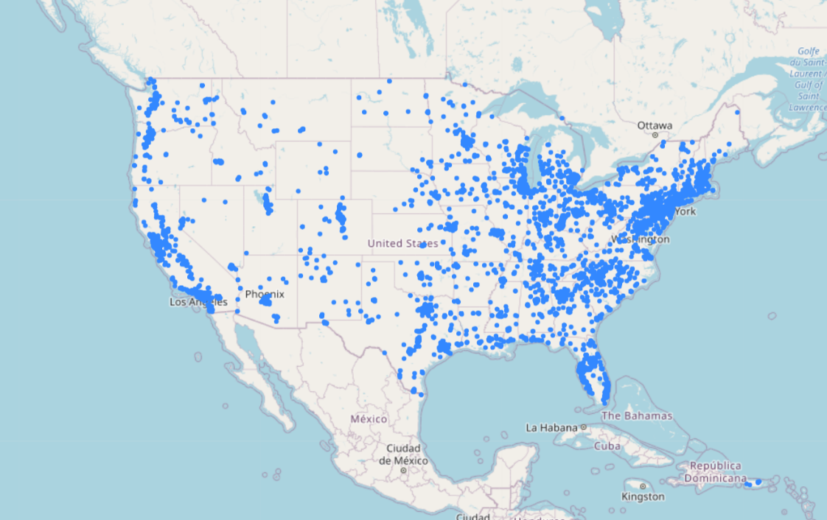

**Position Names**

The following wordcloud shows the different words used in position attribute

**Job Cities:** Most Jobs are present in Chicago, Houston, SFO, Indianapolis and so on.

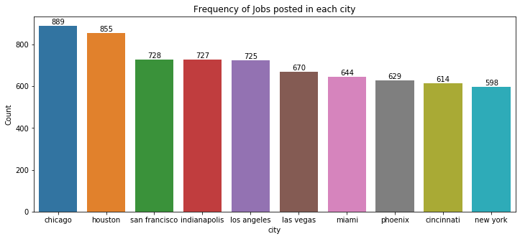

**Collaborative Filtering Models**

Collaborative ﬁltering models use the collaborative power of the ratings provided by multiple users to make recommendations. The main challenge in designing collaborative ﬁltering methods is that the underlying ratings matrices are sparse. Consider an example of a movie application in which users specify ratings indicating their like or dislike of speciﬁc movies. Most users would have viewed only a small fraction of the large universe of available movies. As a result, most of the ratings are unspeciﬁed. The speciﬁed ratings are also referred to as observed ratings. The basic idea of collaborative ﬁltering methods is that these unspeciﬁed ratings can be imputed because the observed ratings are often highly correlated across various users and items. For example, consider two users named Alice and Bob, who have very similar tastes. If the ratings, which both have speciﬁed, are very similar, then their similarity can be identiﬁed by the underlying algorithm. In such cases, it is very likely that the ratings in which only one of them has speciﬁed a value, are also likely to be similar. This similarity can be used to make inferences about incompletely speciﬁed values.

The dataset consists of 7812 five level rating of different applicants on different jobs. Going down further it is seen that the matrix is only filled with 0.04% of ratings and the remaining are zeros. For the sake of reducing the dimensions I have considered only those applicants or records who gave ratings to more than one job. It is also found that no applicant rated more than 45 jobs. Applied SVD and took the U matrix which is user*user matrix. Now for a user to find out the most similar users the svd of the user is compared with matrix by cosine similarity distance and took the most similar user index. In order to recommend jobs we need to find to which jobs did the similar user rate and then recommend those jobs to the user.

The file train_data consists of all the ratings given by applicants to jobids. On creating a matrix with rows as applicants and columns as jobid and ratings as the value. It is found that the matrix is 4% filled this says that it is extremely sparse matrix. Inorder to reduce its dimensions I have taken only the users who gave rating to more than one job.ID and thus the records reduced from 3027 to 1533 and reducing tis sparsity. Above this I have applied SVD and have considered U matrix which is user*user matrix. Inorder to recommend a user with jobs we need to find out the similar kind of user and then recommend jobs that the applicant has rated. So the SVD gave the relation of a user with all other users and with cosine similarity I found the 25 users who are more similar to a user and have recommended the jobs that they have applied to.

**1.3.2 Content-Based Recommender Systems**

In content-based recommender systems, the descriptive attributes of items are used to make recommendations. The term “content” refers to these descriptions. In content-based methods, the ratings and buying behavior of users are combined with the content information available in the items. For example, consider a situation where John has rated the movie Terminator highly, but we do not have access to the ratings of other users. Therefore, collaborative ﬁltering methods are ruled out. However, the item description of Terminator contains similar genre keywords as other science ﬁction movies, such as Alien and Predator. In such cases, these movies can be recommended to John. In content-based methods, the item descriptions, which are labeled with ratings, are used as training data to create a user-speciﬁc classiﬁcation or regression modeling problem. For each user, the training documents correspond to the descriptions of the items she has bought or rated. The class (or dependent) variable corresponds to the speciﬁed ratings or buying behavior. These training documents are used to create a classiﬁcation or regression model, which is speciﬁc to the user at hand (or active user). This user-speciﬁc model is used to predict whether the corresponding individual will like an item for which her rating or buying behavior is unknown.

Content-based methods have some advantages in making recommendations for new items, when suﬃcient rating data are not available for that item. This is because other items with similar attributes might have been rated by the active user. Therefore, the supervised model will be able to leverage these ratings in conjunction with the item attributes to make recommendations even when there is no history of ratings for that item. Content-based methods do have several disadvantages as well:

1. In many cases, content-based methods provide obvious recommendations because of the use of keywords or content. For example, if a user has never consumed an item with a particular set of keywords, such an item has no chance of being recommended. This is because the constructed model is speciﬁc to the user at hand, and the community knowledge from similar users is not leveraged. This phenomenon tends to reduce the diversity of the recommended items, which is undesirable.

2. Even though content-based methods are eﬀective at providing recommendations for new items, they are not eﬀective at providing recommendations for new users. This is because the training model for the target user needs to use the history of her ratings. In fact, it is usually important to have a large number of ratings available for the target user in order to make robust predictions without overﬁtting.

Therefore, content-based methods have diﬀerent trade-oﬀs from collaborative ﬁltering systems. For example, users can specify relevant keywords in their own proﬁles. These proﬁles can be matched with item descriptions in order to make recommendations. Such an approach does not use ratings in the recommendation process, and it is therefore useful in cold-start scenarios. In this way the cold start problem can be solved and more personalized recommendations can be generated.

To apply content based recommendation a job corpus is created with position name, company name, city name, education required and description for each job and then a user query is done with his interests, applied job, education and city. The TF-IDF matrix is applied to job corpus and also to user query and then cosine similarity is chosen for user and corpus which has yielded the most similar jobs for the user and then the job ids are recommended to the user.

Now with all these files I have created a user dataframe which contains education, city, job views, position of interest and created a TF-IDF vector with the training set and this is compared to the job corpus with cosine similarity. Taking the top 25 job.ids which have highest cosine similarity to the query and printing out has given the following result.

This shows the sample user query and the result

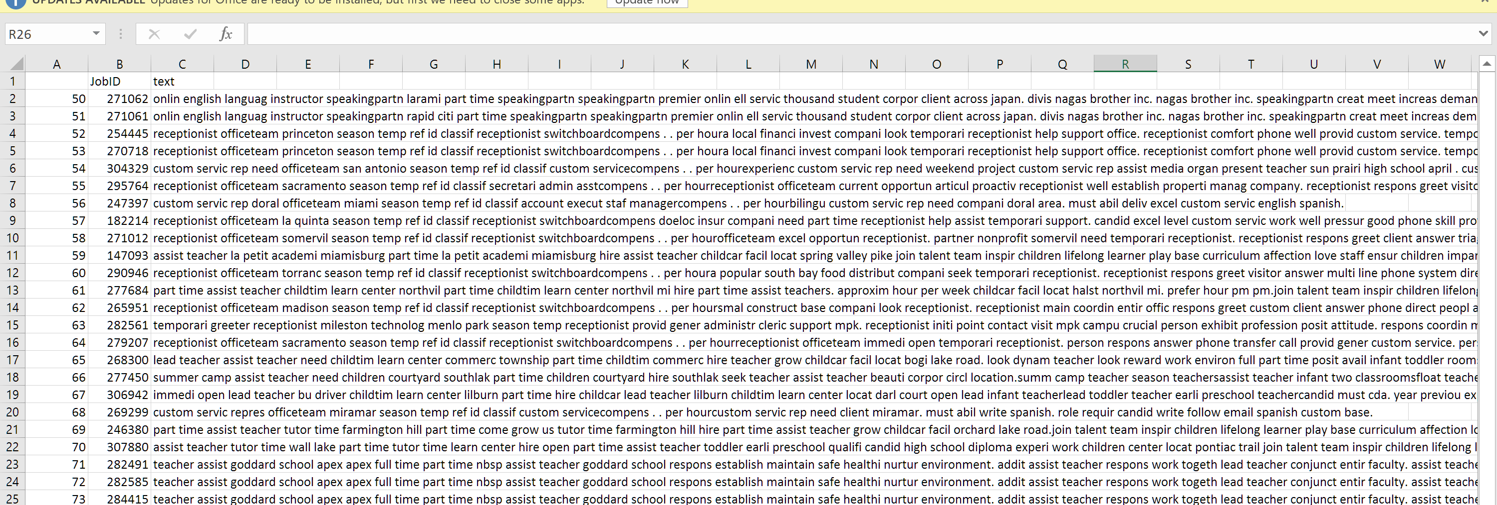

This is content-based recommendation…

**Clustering Analysis:** This is the fun part. Recommending on ratings and content is pretty decent job and to add icing on the cake we have considered clustering. The concept is that when we cluster, similar users are going to come in same group and now finding the nearest users to a user and recommending jobs that the nearest users have applied.

The process consists of clubbing the data of applicants from different files i.e the applicants position of interest, their education background, state and jobviews. As these all are categorical in nature inorder to create clusters we have to convert them into numeric. The columns are converted to dummies and elbow method is applied to find the optimum number of cluster where the distance of each point of cluster is going to be minimal from the centroid of that cluster. Applied k-means with 10 clusters and did visualization with PCA. Now for an applicant Euclidean distance is calculated with the members of the cluster and have picked 25 applicants which have least distance. Now the jobs that are viewed, applied by the other 25 applicants are recommended.

The curve with elbow method.

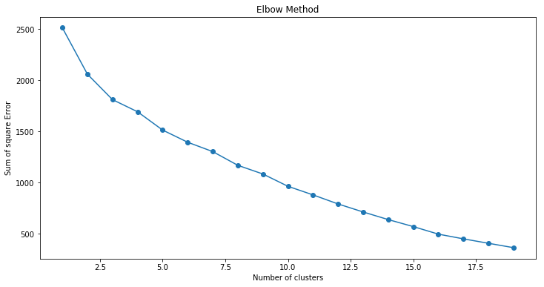

Visualization of clusters with centroids

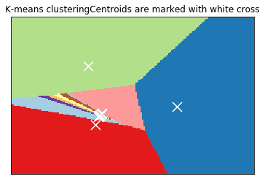

With this the recommendation system can be improved by adding all the recommendations done by three algorithms and making it a hybrid recommendation system.

The Engine can be further developed by clustering Job data and can be used to recommend nearest jobs to a job.

**Recommender Systems has few major hurdles**

**A. Sparsity Problem**

Sparsity problem is one of the major problems encountered by recommender system and data sparsity has great influence on the quality of recommendation. Generally, data of system like MovieLens is represented in form of user-item matrix populated by ratings given to movies and as no. of users and items increases the matrix dimensions and sparsity evolves. The main reason behind data sparsity is that most users do not rate most of the items and the available ratings are usually sparse. Collaborative filtering suffers from this problem because it is dependent over the rating matrix in most cases.

**B. Cold Start problem**

Cold start problem refers to the situation when a new user or item just enters the system. Three kinds of cold start problems are: new user problem, new item problem and new system problem. In such cases, it is really very difficult to provide recommendation as in case of new user, there is very less information about user that is available and also for a new item, no ratings are usually available and thus collaborative filtering cannot make useful recommendations in case of new item as well as new user. However, content based methods can provide recommendation in case of new item as they do not depends on any previous rating information of other users to recommend the item.

**C. Scalability**

Scalability is the property of system indicates its ability to handle growing amount of information in a graceful manner. With enormous growth in information over internet, it is obvious that the recommender systems are having an explosion of data and thus it is a great challenge to handle with continuously growing demand. Some of the recommender system algorithms deal with the computations which increase with growing number of users and items. In CF computations grow exponentially and get expensive, sometimes leading to inaccurate results. Methods proposed for handling this scalability problem and speeding up recommendation formulation are based on approximation mechanisms. Even if they improve performance, most of the time they result in accuracy reduction.

**D. Serendipity**

Serendipity denotes the property of making fortunate discoveries while looking for something unrelated, or the occurrence of such a discovery during such a search.

The experience of browsing items in a physical space or online catalogue can differ substantially. For example when you’re browsing records in a store you often come across items you weren’t actively looking for but which you instantly recognize as desirable. Online stores offer some mechanisms for discovery but they’re highly limited in scope when compared to physical environments. They may offer a much higher number of items on sale than a physical store, but because screen space is scarce catalogues have to resort to categorization trees, so users are only exposed to a small subset of the full range of possibilities. Online, users have less peripheral vision and a limited awareness.

To overcome the issues of cold-start , Sparsity problem I have chosen Collaborative filtering and Content Filtering and combined to make hybrid filtering and when it comes to serendipity it is often difficult to accomplish. So the recommendation system I worked mainly deals with cold start and sparsity problem.

The basic models for recommender systems work with two kinds of data, which are (i) the user-item interactions, such as ratings or buying behavior, and (ii) the attribute information about the users and items such as textual proﬁles or relevant keywords. Methods that use the former are referred to as collaborative ﬁltering methods, whereas methods that use the latter are referred to as content-based recommender methods. I have combined these diﬀerent aspects to create hybrid systems. Hybrid systems can combine the strengths of various types of recommender systems to create techniques that can perform more robustly in a wide variety of settings. In the following, I will discuss these basic models brieﬂy.