**Introduction**

Being anonymous over the internet can sometimes make people say nasty things that they normally would not in real life. Let's filter out the hate from our platforms one comment at a time.

**Objective:**

To create an EDA/ feature-engineering starter notebook for toxic comment classification.

**Data Overview:**

The dataset here is from wiki corpus dataset which was rated by human raters for toxicity. The corpus contains 63M comments from discussions relating to user pages and articles dating from 2004-2015.

Different platforms/sites can have different standards for their toxic screening process. Hence the comments are tagged in the following five categories

* toxic
* severe\_toxic
* obscene
* threat
* insult
* identity\_hate

The tagging was done via **crowdsourcing** which means that the dataset was rated by different people and the tagging might not be 100% accurate too. The same concern is being discussed [here](https://www.kaggle.com/c/jigsaw-toxic-comment-classification-challenge/discussion/46131).

The [source paper](https://arxiv.org/pdf/1610.08914.pdf) also contains more interesting details about the dataset creation.

## Note:

A [New test dataset](https://www.kaggle.com/c/jigsaw-toxic-comment-classification-challenge/discussion/46177) is being created by the organizers as the test set labels are present [here](https://figshare.com/articles/Wikipedia_Talk_Labels_Toxicity/4563973).

The kernal has been updated for the new data.

**Analysis:**

There are a greater number of clean messages than abusive so it must be class imbalance.

Total comments = 159571

Total clean comments = 143346

Total tags = 35098

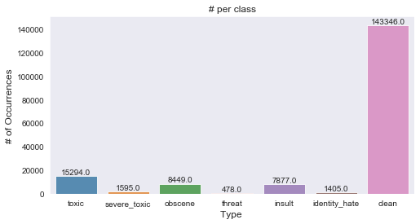

* The toxicity is not evenly spread out across classes. Hence we might face class imbalance problems
* There are ~95k comments in the training dataset and there are ~21 k tags and ~86k clean comments!?
  + This is only possible when multiple tags are associated with each comment (eg) a comment can be classified as both toxic and obscene.

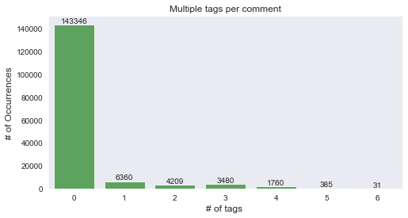

The above plot shows the number of multiple tags present for each row. It can be concluded that there are even rows which have been tagged into 6 categories.

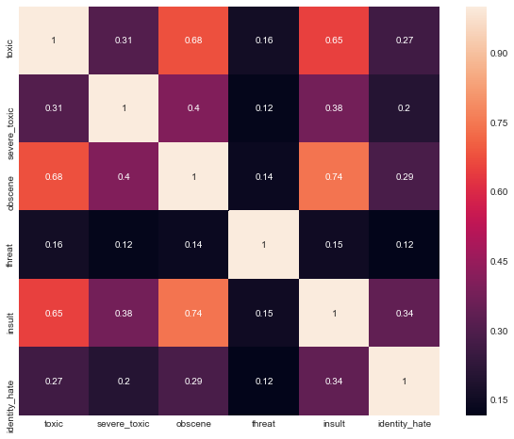

Only ~10% of the total comments have some sort of toxicity in them. There are certain comments(31) that are marked as all of the above!

## Which tags go together?

Now let's have a look at how often the tags occur together. A good indicator of that would be a correlation plot.

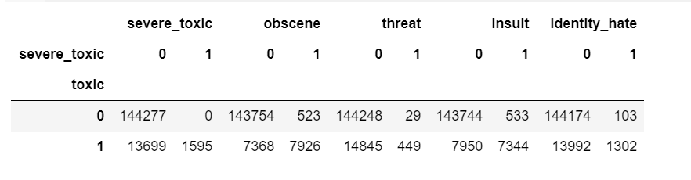

The above table represents the Crosstab/ confusion matrix of Toxic comments with the other classes.

Some interesting observations:

* A Severe toxic comment is always toxic
* Other classes seem to be a subset of toxic barring a few exceptions

More about cramers test can be studied at <https://en.wikipedia.org/wiki/Cram%C3%A9r%27s_V>

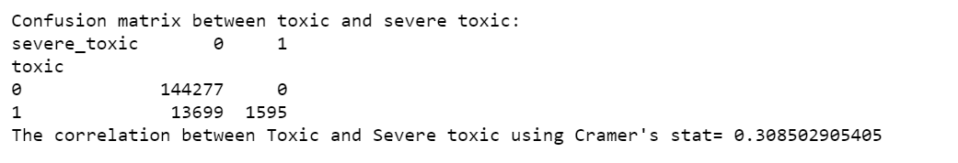

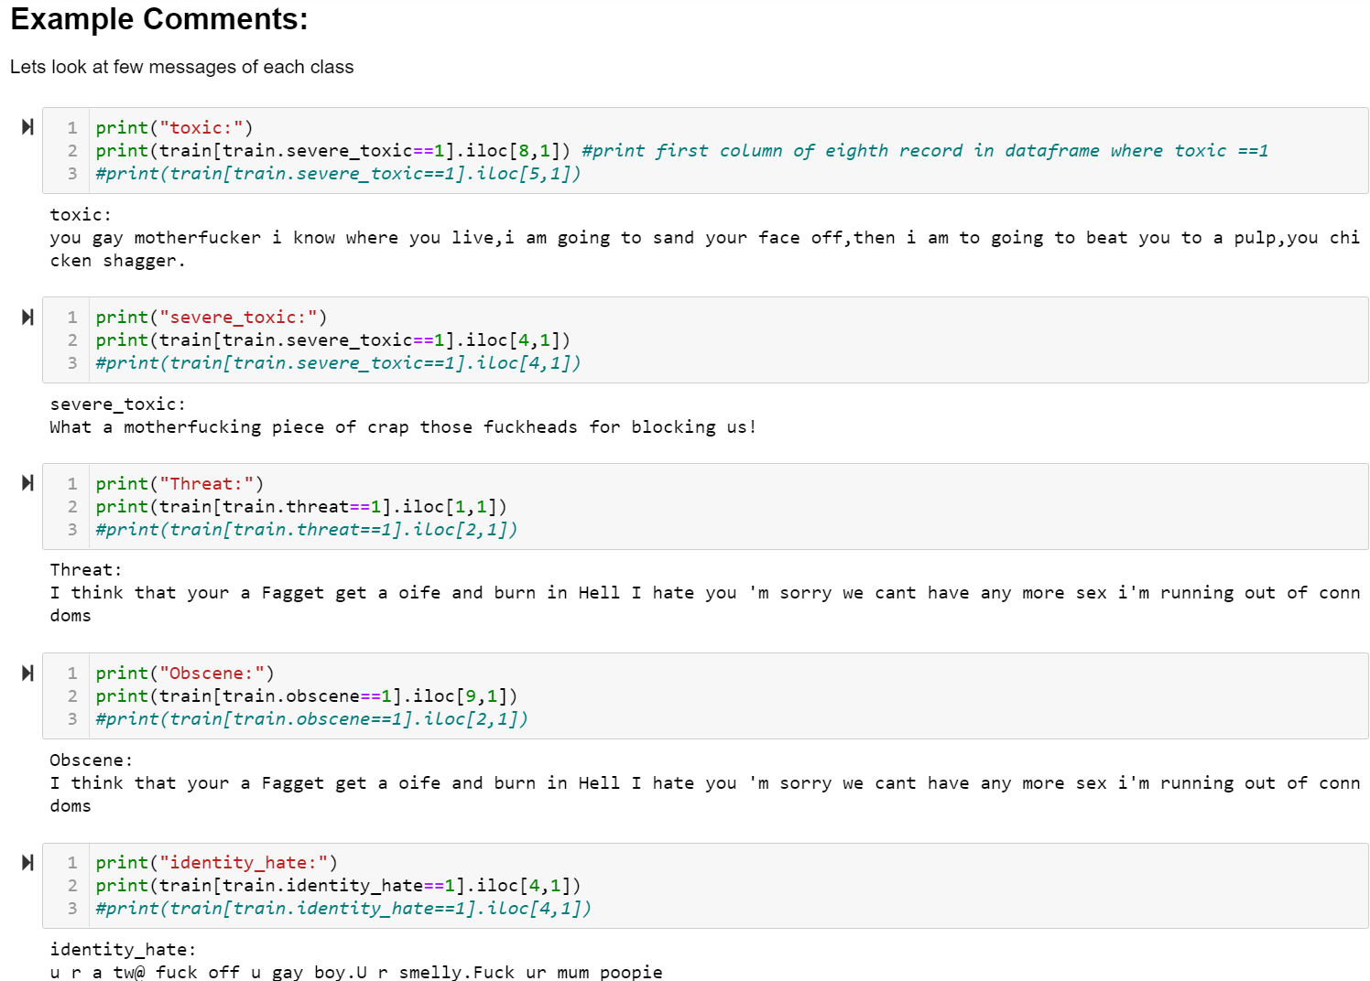

That was a whole lot of toxicity. Some weird observations:

* Some of the comments are extremely and mere copy paste of the same thing
* Comments can still contain IP addresses(eg:62.158.73.165), usernames(eg:ARKJEDI10) and some mystery numbers(i assume is article-IDs)

# Wordclouds - Frequent words:

Now, let's take a look at words that are associated with these classes.

Chart Desc: The visuals here are word clouds (ie) more frequent words appear bigger. A cool way to create word clouds with funky pics is given [in\_this\_link](https://www.kaggle.com/arthurtok/spooky-nlp-and-topic-modelling-tutorial" \t "_blank). It involves the following steps.

* Search for an image and its base 64 encoding
* Paste encoding in a cell and convert it using codecs package to image
* Create word cloud with the new image as a mask

A simpler way would be to create a new kaggle dataset and import images from there.

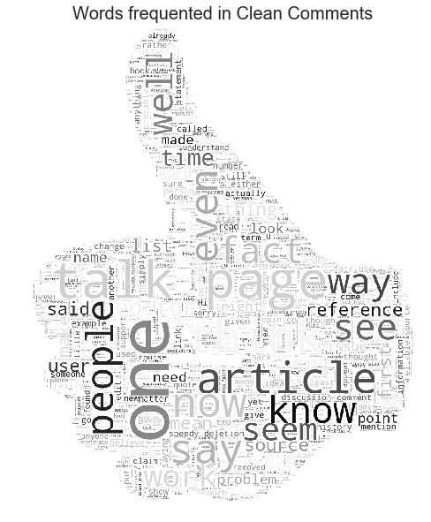

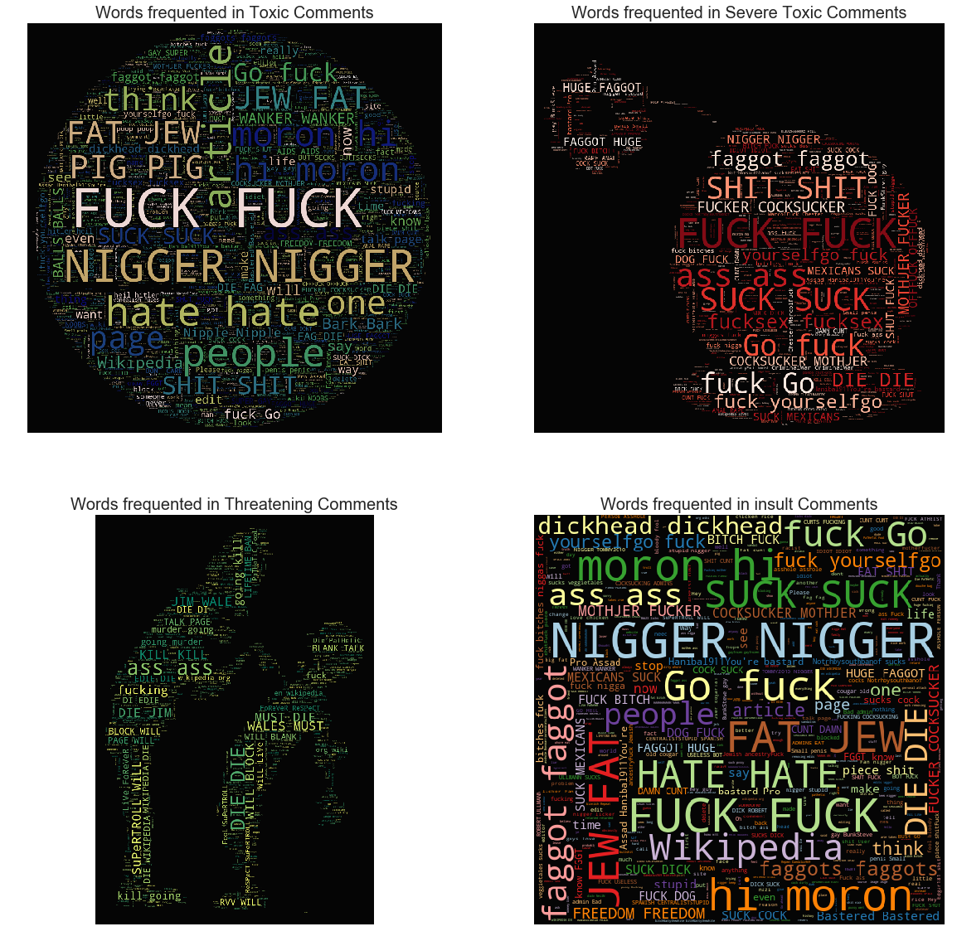

# Feature engineering:

I've broadly classified my feature engineering ideas into the following three groups

## Direct features:

Features which are a directly due to words/content.We would be exploring the following techniques

* Word frequency features
  + Count features
  + Bigrams
  + Trigrams
* Vector distance mapping of words (Eg: Word2Vec)
* Sentiment scores

## Indirect features:

Some more experimental features.

* count of sentences
* count of words
* count of unique words
* count of letters
* count of punctuations
* count of uppercase words/letters
* count of stop words
* Avg length of each word

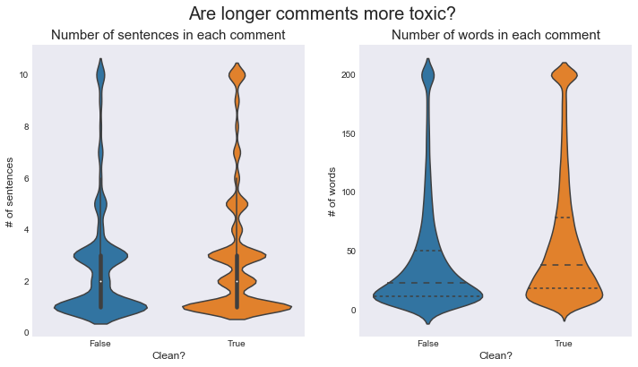

Long sentences or more words do not seem to be a significant indicator of toxicity.

Chart desc: Violin plot is an alternative to the traditional box plot. The inner markings show the percentiles while the width of the "violin" shows the volume of comments at that level/instance.

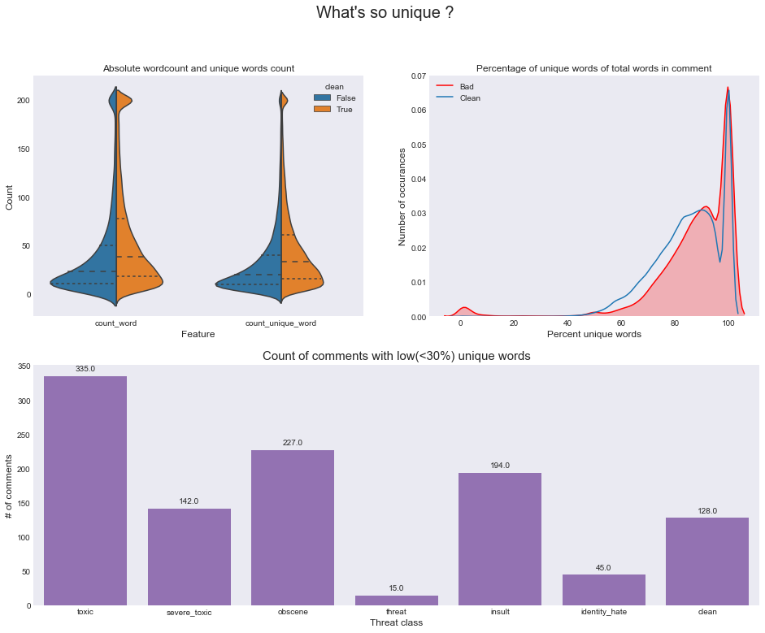

### **Word count VS unique word count:**

There are noticeable shifts in the mean of both word count and unique word count across clean and toxic comments.

* Chart desc: The first chart is a split violin chart. It is a variation of the traditional box chart/violin chart which allows us to split the violin in the middle based on a categorical variable.

### Unique word count percent:

There is a bulge near the 0-10% mark which indicates a large number of toxic comments which contain very little variety of words.

* Chart desc: The second chart is an overlay of two kernel density estimation plots of percentage of unique words out of all the words in the comment, done for both clean and toxic comments

Even though the number of clean comments dominates the dataset(~90%), there are only 75 clean comments that are spam, which makes it a powerful indicator of a toxic comment.

# Spammers are more toxic!

# Direct features:

## 1)Count based features(for unigrams):

Lets create some features based on frequency distribution of the words. Initially lets consider taking words one at a time (ie) Unigrams

Python's SKlearn provides 3 ways of creating count features.All three of them first create a vocabulary(dictionary) of words and then create a [sparse matrix](http://localhost:8889/notebooks/Toxic_Text_Classification/Toxic_text_classification.ipynb#https://en.wikipedia.org/wiki/Sparse_matrix) of word counts for the words in the sentence that are present in the dictionary. A brief description of them:

* CountVectorizer
  + Creates a matrix with frequency counts of each word in the text corpus
* TF-IDF Vectorizer
  + TF - Term Frequency -- Count of the words(Terms) in the text corpus (same of Count Vect)
  + IDF - Inverse Document Frequency -- Penalizes words that are too frequent. We can think of this as regularization
* HashingVectorizer
  + Creates a hashmap(word to number mapping based on hashing technique) instead of a dictionary for vocabulary
  + This enables it to be more scalable and faster for larger text coprus
  + Can be parallelized across multiple threads

Using TF-IDF here. Note: Using the concatenated dataframe "merge" which contains both text from train and test dataset to ensure that the vocabulary that we create does not missout on the words that are unique to testset

# 

# 