# Front-end tasks

## Task 1

Implement the following screen and interaction using ReactJS.

User can type in a word in the given input field and press enter or click on the ‘Add’ Button. Following which, a tag element is added below the input field. A maximum of 10 tags are allowed. User can click on the ‘x’ button present on the tag to delete it.

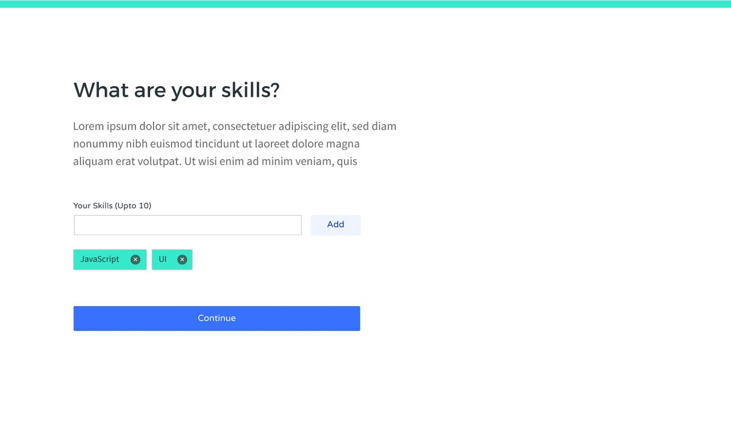

User should also be able to reorder the tags like shown in the GIF below.



On pressing ‘Continue’, log the tags to the console in form of an array.

e.g. [‘JavaScript’, ‘UI’, ‘Design’, ‘CSS’, ‘ReactJS’]

## Task 2:

Create the following layout using only CSS.

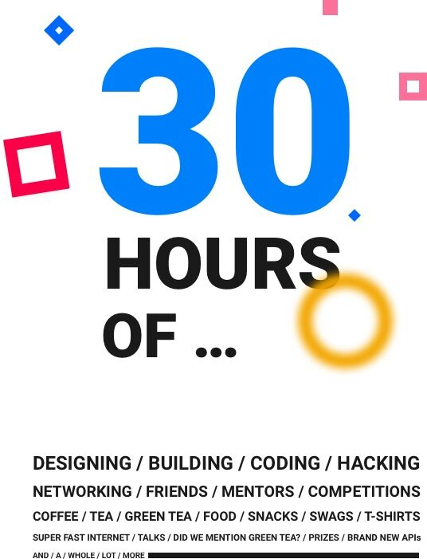

**It would be great if the projects are done on** [**http://codepen.io**](http://codepen.io) **and you can mail us back the link. Otherwise link to a GitHub repo will also do. Best of luck!**