Basics of Docker

# Why Learn Docker?

Long Setup

* First environment had to be setup using requirement.txt
* Manual activity to run the code.
* Need to follow above step in very stage of model e.g. development, staging, production.

Solution

* Put all required file in one directory.
* Write down configuration.
* Run the application anywhere without any efforts.

# What is Docker?

Docker is a software platform that employs OS virtualization and enabled organizations to swiftly generate, deploy and execute application within docker containers.

This container encapsulates all the necessary dependencies including frameworks, libraries and make them lightweight and self-sufficient.

Benefits

* Facilitates effortless migration of application across environments e.g. development to staging to production.

# Difference between docker and virtual machine

|  |  |
| --- | --- |
| Docker | Virtual Os |
| Operates with docker engine layer | Operates with hypervisor |
| Low memory usage | High memory usage |
| High performance | Inferior performance |

# How Does Docker Works?

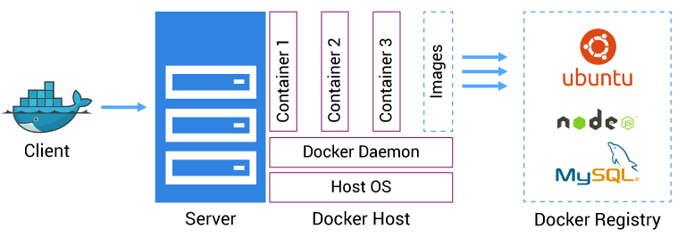

Docker Client and Server

* Docker engine has docker server(docker Deamon), docker client (CLI) and REST PAI to communicate between them.
* Docker deamon further communicates with docker registry , images and containers.
* E.g. User entered ‘Docker pull’, in CMD (CLI), CLI communicates with docker Deamon using REST API then , Deamon further communicated with docker registry to pull particular container.

Docker Image

* A YAML file which contains instructions for creating docker container. Rubibg an docker file will create a docker image.
* It consists of multiple layers to build a application upon it
* Install OS
* Make structure and rules
* Copy the codes.
* Run the code

Docker Registry

* Platform to host and distributes various docker images.e.g. docker hub

Process

1. Write application in modular code.
2. Write docker file and execute it to create docker image.
3. Host Docker Image in Docker Registery.
4. Use Docker CLI to pull docker registry.
   1. Docker CLI requests DOCker deamon to fetch respective image.
   2. Docker deamon fetch the image from registry.
5. Use CLI to run docker image.
   1. CLI request docker deamon to run image.
   2. Deamon creates the docker container over docker engine and runs the application independently.