Aditya Pankaj Mathpal

230905232
CSE C2 37

PPL Week 2

1. Write an MPI program using synchronous send. The sender process sends a word to the receiver. The second process receives the word, toggles each letter of the word and sends it back to the first process. Both processes use synchronous send operations.

Code:
#include"mpi.h"
#include<stdio.h>
#include<ctype.h>

int main(int argc, char *argv[]) {
int rank, size;
char x[100];
MPI_Init(&argc, &argv);
MPI_Comm_rank(MPI_COMM_WORLD, &rank);
MPI_Comm_size(MPI_COMM_WORLD, &size);
MPI_Status status;
if(rank == 0) {
fprintf(stdout, "Enter word: ");
fflush(stdout);
scanf("%s", x);
MPI_Ssend(&x, 100, MPI_CHAR, 1, 1, MPI_COMM_WORLD);
fprintf(stdout, "String \"%s\" sent from process 0\n", x);
fflush(stdout);
MPI_Recv(&x, 100, MPI_CHAR, 1, 2, MPI_COMM_WORLD, &status);
fprintf(stdout, "String \"%s\" received from process 1\n", x);
fflush(stdout);
} else {
MPI_Recv(&x, 100, MPI_CHAR, 0, 1, MPI_COMM_WORLD, &status);
fprintf(stdout, "String \"%s\" received from process 0\n", x);
for(int i = 0; x[i]!=0; i++) {
if(islower(x[i])) x[i] = toupper(x[i]);
else x[i] = tolower(x[i]);
}
MPI_Ssend(&x, 100, MPI_CHAR, 0, 2, MPI_COMM_WORLD);
fprintf(stdout, "String \"%s\" sent from process 1\n", x);
fflush(stdout);
}
MPI_Finalize();
return 0;
}

Output:
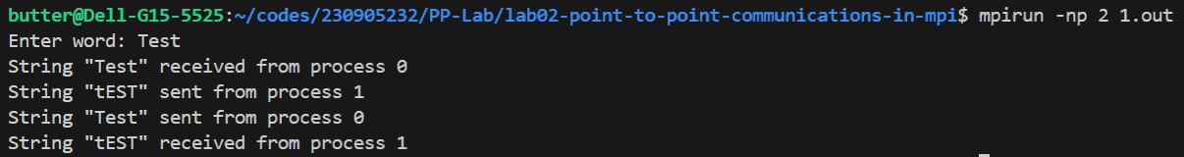
2. Write an MPI program where the master process (process 0) sends a number to each of the slave and the slave processes receive the number and prints it. Use standard send.

Code:
#include"mpi.h"
#include<stdio.h>

int main(int argc, char *argv[]) {
int rank, size, x;
MPI_Init(&argc, &argv);
MPI_Comm_rank(MPI_COMM_WORLD, &rank);
MPI_Comm_size(MPI_COMM_WORLD, &size);
MPI_Status status;
if(rank == 0) {
fprintf(stdout, "Enter number: ");
fflush(stdout);
scanf("%d", &x);
for(int i = 1; i < size; i++) {
fprintf(stdout, "%d sent to process %d\n", x, i);
fflush(stdout);
MPI_Send(&x, 1, MPI_INT, i, i, MPI_COMM_WORLD);
}
}
else {
MPI_Recv(&x, 1, MPI_INT, 0, rank, MPI_COMM_WORLD, &status);
fprintf(stdout, "%d received by process %d\n", x, rank);
fflush(stdout);
}
MPI_Finalize();
return 0;
}
Output:
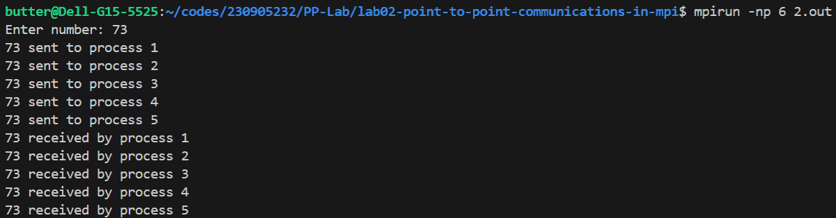
3. Write an MPI program to read N elements of the array in the root process (process 0) where N is equal to the total number of processes. The root process sends one value to each of the slaves. Let even ranked procss find square of the received element and odd ranked process find cube of received element. Use buffered send.

Code:
#include"mpi.h"
#include<stdio.h>
#include<stdlib.h>

int main(int argc, char *argv[]) {
int rank, size, x;
int bufsize = 100*(MPI_BSEND_OVERHEAD + sizeof(MPI_INT));
void *buf = malloc(bufsize);
MPI_Init(&argc, &argv);
MPI_Comm_rank(MPI_COMM_WORLD, &rank);
MPI_Comm_size(MPI_COMM_WORLD, &size);
MPI_Status status;
MPI_Buffer_attach(buf, bufsize);
if(rank == 0) {
int arr[100];
fprintf(stdout, "Enter %d numbers: ", size-1);
fflush(stdout);
for(int i = 1; i < size; i++) scanf("%d", &arr[i-1]);
for(int i = 1; i < size; i++) {
fprintf(stdout, "%d sent to process %d\n", arr[i-1], i);
fflush(stdout);
MPI_Bsend(&arr[i-1], 1, MPI_INT, i, i, MPI_COMM_WORLD);
}
} else {
MPI_Recv(&x, 1, MPI_INT, 0, rank, MPI_COMM_WORLD, &status);
fprintf(stdout, "%d received by process %d\n", x, rank);
fflush(stdout);
if(rank%2) {
fprintf(stdout, "Cube of %d is %d\n", x, x*x*x);
fflush(stdout);
}
else {
fprintf(stdout, "Square of %d is %d\n", x, x*x);
fflush(stdout);
}
}
MPI_Buffer_detach(buf, &bufsize);
MPI_Finalize();
return 0;
}
Output:
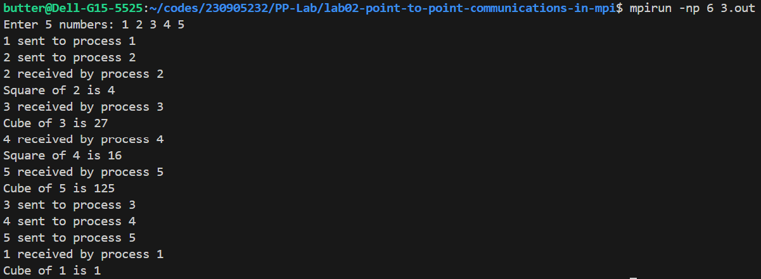
4. Write an MPI program to read an integer value in the root process. Root process sends this value to Process1, Process1 sends this value to Process2 and so on. Last process sends the value back to root process. When sending the value each process will first increment the received value by one. Write the program using point to point communication routines.
Code:
#include"mpi.h"
#include<stdio.h>

int main(int argc, char *argv[]) {
int rank, size, x;
MPI_Init(&argc, &argv);
MPI_Comm_rank(MPI_COMM_WORLD, &rank);
MPI_Comm_size(MPI_COMM_WORLD, &size);
MPI_Status status;
if(rank == 0) {
fprintf(stdout, "Enter number: ");
fflush(stdout);
scanf("%d", &x);
fprintf(stdout, "%d sent to process 1\n", x);
fflush(stdout);
MPI_Send(&x, 1, MPI_INT, 1, 1, MPI_COMM_WORLD);
MPI_Recv(&x, 1, MPI_INT, size-1, 0, MPI_COMM_WORLD, &status);
fprintf(stdout, "%d received by process 0\n", x);
fflush(stdout);
} else {
MPI_Recv(&x, 1, MPI_INT, rank-1, rank, MPI_COMM_WORLD, &status);
fprintf(stdout, "%d received by process %d\n", x, rank);
fflush(stdout);
fprintf(stdout, "%d sent to process %d\n", x, (rank+1)%size);
fflush(stdout);
MPI_Send(&x, 1, MPI_INT, (rank+1)%size, (rank+1)%size, MPI_COMM_WORLD);
}
MPI_Finalize();
return 0;
}
Output:
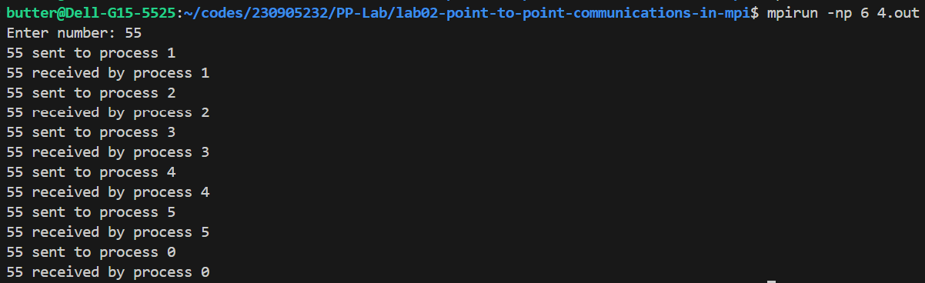
Additional
1. Write an MPI program to read N elements of an array in the master process. Let N processes including master process check whether the array values are prime or not.
Code:
#include"mpi.h"
#include<stdio.h>
#include<stdlib.h>

int isPrime(int x) {
if(x==1) return 0;
for(int i = 2; i*i <= x; i++) if(x%i==0) return 0;
return 1;
}

void checkPrime(int x) {
if(isPrime(x)) fprintf(stdout, "%d is prime\n", x);
else fprintf(stdout, "%d is not prime\n", x);
fflush(stdout);
}

int main(int argc, char *argv[]) {
int rank, size, x;
MPI_Init(&argc, &argv);
MPI_Comm_rank(MPI_COMM_WORLD, &rank);
MPI_Comm_size(MPI_COMM_WORLD, &size);
MPI_Status status;
if(rank == 0) {
int* arr = (int*)malloc(sizeof(int)*size);
fprintf(stdout, "Enter %d numbers: ", size);
fflush(stdout);
for(int i = 0; i < size; i++) scanf("%d", &arr[i]);
for(int i = 1; i < size; i++) {
fprintf(stdout, "%d sent to process %d\n", arr[i], i);
fflush(stdout);
MPI_Send(&arr[i], 1, MPI_INT, i, i, MPI_COMM_WORLD);
}
checkPrime(arr[0]);
} else {
MPI_Recv(&x, 1, MPI_INT, 0, rank, MPI_COMM_WORLD, &status);
checkPrime(x);
}
MPI_Finalize();
return 0;
}

Output:
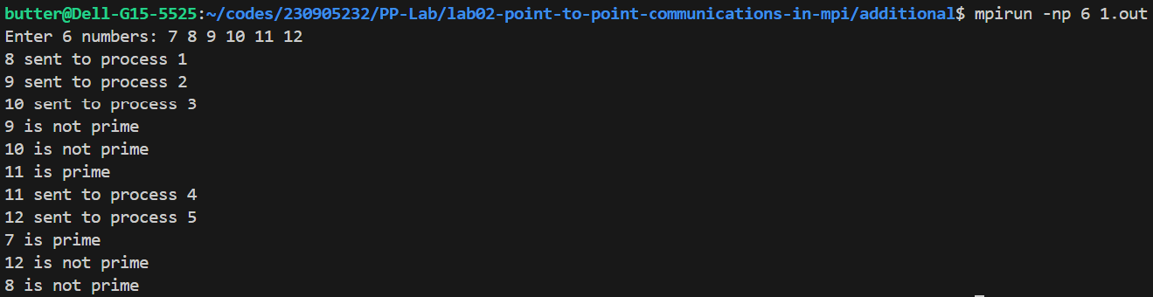
2. Write an MPI program to read value of N in the root process. Using N processes, including root, find out 1! + (1+2) + 3! + (1+2+3+4) + 5! + (1+2+3+4+5+6) + ... and print the result in the root process.
Code:
#include"mpi.h"
#include<stdio.h>

int main(int argc, char *argv[]) {
int rank, size, x, y, n;
MPI_Init(&argc, &argv);
MPI_Comm_rank(MPI_COMM_WORLD, &rank);
MPI_Comm_size(MPI_COMM_WORLD, &size);
MPI_Status status;
if(rank == 0) {
fprintf(stdout, "Enter N: ");
fflush(stdout);
scanf("%d", &n);
y = 1;
for(int i = 1; i < n; i++) {
MPI_Recv(&x, 1, MPI_INT, i, i, MPI_COMM_WORLD, &status);
y += x;
}
fprintf(stdout, "result: %d\n", y);
fflush(stdout);
} else {
if(rank%2) x = (int)(((rank+2)/2.0)*(rank+1));
else {
x = 1;
for(int i = 2; i <= rank+1; i++) x *= i;
}
MPI_Ssend(&x, 1, MPI_INT, 0, rank, MPI_COMM_WORLD);
}
MPI_Finalize();
return 0;
}
Output:
3. Implement at least 2 programs to identify deadlock conditions in synchronous send and standard send with multiple point to point communications beteween two processes

3a:
code:
#include"mpi.h"
#include<stdio.h>
#include<stdlib.h>

#define n 9999999

int main(int argc, char *argv[]) {
int rank, size;
// sending large data to avoid usage of buffer
int *x = (int*)malloc(sizeof(int) * n), *y = (int*)malloc(sizeof(int) * n);
MPI_Init(&argc, &argv);
MPI_Comm_rank(MPI_COMM_WORLD, &rank);
MPI_Comm_size(MPI_COMM_WORLD, &size);
MPI_Status status;
if(rank==0) {
MPI_Send(&x, n, MPI_INT, 1, 1, MPI_COMM_WORLD);
MPI_Recv(&y, n, MPI_INT, 1, 2, MPI_COMM_WORLD, &status);
fprintf(stdout, "process %d received data\n", 0);
fflush(stdout);
} else {
MPI_Send(&y, n, MPI_INT, 0, 2, MPI_COMM_WORLD);
MPI_Recv(&x, n, MPI_INT, 0, 1, MPI_COMM_WORLD, &status);
fprintf(stdout, "process %d received data\n", 1);
fflush(stdout);
}
MPI_Finalize();
return 0;
}
output:
(deadlock)
3b:
code:
#include"mpi.h"
#include<stdio.h>
#include<stdlib.h>

#define n 9999999

int main(int argc, char *argv[]) {
int rank, size, x, y;
MPI_Init(&argc, &argv);
MPI_Comm_rank(MPI_COMM_WORLD, &rank);
MPI_Comm_size(MPI_COMM_WORLD, &size);
MPI_Status status;
if(rank==0) {
MPI_Ssend(&x, n, MPI_INT, 1, 1, MPI_COMM_WORLD);
MPI_Recv(&y, n, MPI_INT, 1, 2, MPI_COMM_WORLD, &status);
fprintf(stdout, "process %d received data\n", 0);
fflush(stdout);
} else {
MPI_Ssend(&y, n, MPI_INT, 0, 2, MPI_COMM_WORLD);
MPI_Recv(&x, n, MPI_INT, 0, 1, MPI_COMM_WORLD, &status);
fprintf(stdout, "process %d received data\n", 1);
fflush(stdout);
}
MPI_Finalize();
return 0;
}
output:
(deadlock)

