Aditya Pankaj Mathpal

230905232

CSE C2 Roll No. 37

PP Lab 1

1
code:
#include"mpi.h"
#include<stdio.h>

int power(int x, int rank) {
int res = 1;
while(rank) {
res *= x;
rank -= 1;
}
return res;
}

int main(int argc, char *argv[]) {
int rank, size;
MPI_Init(&argc, &argv);
MPI_Comm_rank(MPI_COMM_WORLD, &rank);
MPI_Comm_size(MPI_COMM_WORLD, &size);
printf("%d^%d = %d ",3, rank, power(3, rank));
if(rank%2 == 0) printf("Hello\n");
else printf("World\n");

MPI_Finalize();
return 0;
}

output:
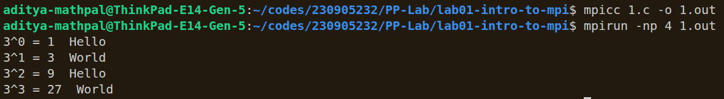
2
code:
#include"mpi.h"
#include<stdio.h>

void op(int rank) {
int a = 15, b = 3;
if(rank%4 == 0) printf("a + b = %d\n", a+b);
else if(rank%4 == 1) printf("a - b = %d\n", a-b);
else if(rank%4 == 2) printf("a * b = %d\n", a*b);
else printf("a / b = %.2f\n", (float)a/b);
}

int main(int argc, char *argv[]) {
int rank, size;
MPI_Init(&argc, &argv);
MPI_Comm_rank(MPI_COMM_WORLD, &rank);
MPI_Comm_size(MPI_COMM_WORLD, &size);
op(rank);
MPI_Finalize();
return 0;
}
output:
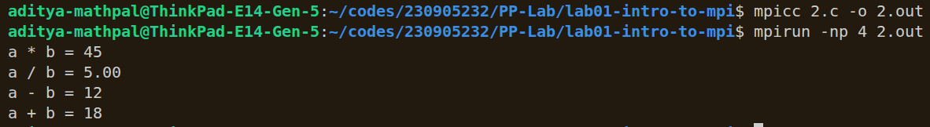
3
code:
#include"mpi.h"
#include<stdio.h>

int main(int argc, char *argv[]) {
int rank, size;
MPI_Init(&argc, &argv);
MPI_Comm_rank(MPI_COMM_WORLD, &rank);
MPI_Comm_size(MPI_COMM_WORLD, &size);
char str[] = "HELLO";
str[rank%5] += 32;
printf("%d: %s\n", rank, str);
MPI_Finalize();
return 0;
}

output:
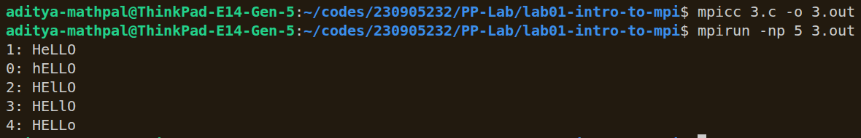
4
code:
#include"mpi.h"
#include<stdio.h>

void FactOrFib(int x) {
int r = x;
if(x%2 == 0) {
int res = 1;
while(x>0) {
res *= x;
x -= 1;
}
printf("Factorial of %d is %d\n", r, res);
}
else {
if(x == 1) {
printf("Index 1 in Fibonacci series is 1\n");
return;
}
int a = 0, b = 1, c;
x -= 1;
while(x--) {
c = a+b;
a = b;
b = c;
}
printf("Index %d in Fibonacci series is %d\n", r, c);
}
}

int main(int argc, char *argv[]) {
int rank, size;
MPI_Init(&argc, &argv);
MPI_Comm_rank(MPI_COMM_WORLD, &rank);
MPI_Comm_size(MPI_COMM_WORLD, &size);
FactOrFib(rank);
MPI_Finalize();
return 0;
}

output:
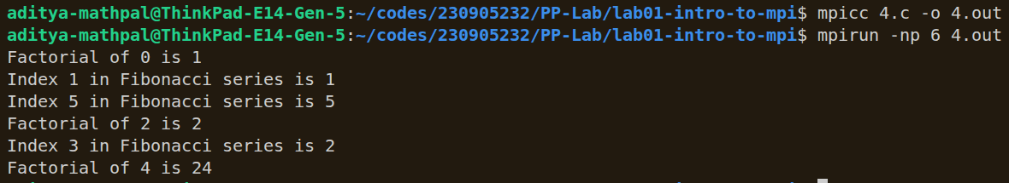

Additionals
1
code:
#include"mpi.h"
#include<stdio.h>

int reverse(int x) {
int res = 0;
while(x) {
res = res*10 + x%10;
x /= 10;
}
return res;
}

int main(int argc, char *argv[]) {
int rank, size;
MPI_Init(&argc, &argv);
MPI_Comm_rank(MPI_COMM_WORLD, &rank);
MPI_Comm_size(MPI_COMM_WORLD, &size);
int arr[] = {18, 523, 301, 1234, 2, 14, 108, 150, 1928};
arr[rank%9] = reverse(arr[rank%9]);
printf("%d reversed: %d ", arr[rank], reverse(arr[rank]));
printf("\n");
MPI_Finalize();
return 0;
}

output:
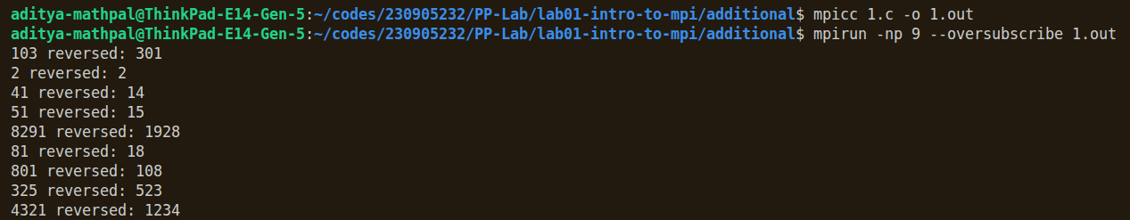
2
code:
#include"mpi.h"
#include<stdio.h>

int isPrime(int x) {
if(x == 1) return 0;
for(int i = 2; i*i <= x; i++)
if(x%i == 0) return 0;
return 1;
}

int main(int argc, char *argv[]) {
int rank, size;
MPI_Init(&argc, &argv);
MPI_Comm_rank(MPI_COMM_WORLD, &rank);
MPI_Comm_size(MPI_COMM_WORLD, &size);
for(int i = 1; i <= 50; i++) {
int test = 50*rank+i;
if(isPrime(test)) printf("%d is prime\n", test);
else printf("%d is not prime\n",test);
}
MPI_Finalize();
return 0;
}

output:
