230905232

Aditya Pankaj Mathpal

CSE C2 37

Lab 7: Form Processing using Django – Part I

Lab Assignments

urls.py (common):
"""
URL configuration for myproject project.

The `urlpatterns` list routes URLs to views. For more information please see:
https://docs.djangoproject.com/en/5.2/topics/http/urls/
Examples:
Function views
1. Add an import: from my_app import views
2. Add a URL to urlpatterns: path('', views.home, name='home')
Class-based views
1. Add an import: from other_app.views import Home
2. Add a URL to urlpatterns: path('', Home.as_view(), name='home')
Including another URLconf
1. Import the include() function: from django.urls import include, path
2. Add a URL to urlpatterns: path('blog/', include('blog.urls'))
"""
from django.contrib import admin
from django.urls import path, include

urlpatterns = [
path('studentform/', include('studentform.urls')),
path('carform/', include('carform.urls')),
path('formex/', include('formex.urls')),
path('admin/', admin.site.urls),
path('webapp/', include('webapp.urls')),
path('formapp/',include('formapp.urls')),
path('ex1app/', include('ex1app.urls')),
path('ex2app/', include('ex2app.urls')),
path('homeex1app/', include('homeex1app.urls')),
path('basic_calc/', include('basic_calc.urls')),
path('magazine/', include('magazine.urls')),
path('book/', include('book.urls')),
path('label/', include('label.urls')),
]

1) Develop a web application using Django framework to demonstrate the transfer of
multiple parameters between web pages. User should be presented with a dropdown
list containing car manufacturers, a text box which takes model name of the
manufacturer and a submit button. On submitting the web page, the user is forwarded
to a new page. This new page should display the selected car manufacturer name and
the model name.

forms.py:
from django import forms

class CarForm(forms.Form):
CAR_CHOICES = [
('Toyota', 'Toyota'),
('Honda', 'Honda'),
('Ford', 'Ford'),
('BMW', 'BMW'),
('Hyundai', 'Hyundai'),
]

manufacturer = forms.ChoiceField(
choices=CAR_CHOICES,
label="Select Car Manufacturer"
)

model_name = forms.CharField(
max_length=100,
label="Enter Model Name"
)

views.py:
from django.shortcuts import render
from .forms import CarForm

def home_view(request):
if request.method == "POST":
form = CarForm(request.POST)
if form.is_valid():
manufacturer = form.cleaned_data['manufacturer']
model_name = form.cleaned_data['model_name']

return render(request, "result.html", {
'manufacturer': manufacturer,
'model_name': model_name
})
else:
form = CarForm()

return render(request, "home.html", {'form': form})

urls.py:
from django.urls import path
from . import views

urlpatterns = [
path('', views.home_view, name='home_view')
]

home.html:
<!DOCTYPE html>
<html>
<head>
<title>Car Selection</title>
</head>
<body>
<h2>Select Car Details</h2>

<form method="POST">
{% csrf_token %}
{{ form.as_p }}
<input type="submit" value="Submit">
</form>

</body>
</html>

result.html:
<!DOCTYPE html>
<html>
<head>
<title>Selected Car</title>
</head>
<body>
<h2>Car Details Submitted</h2>

<p><strong>Manufacturer:</strong> {{ manufacturer }}</p>
<p><strong>Model Name:</strong> {{ model_name }}</p>

</body>
</html>

output:
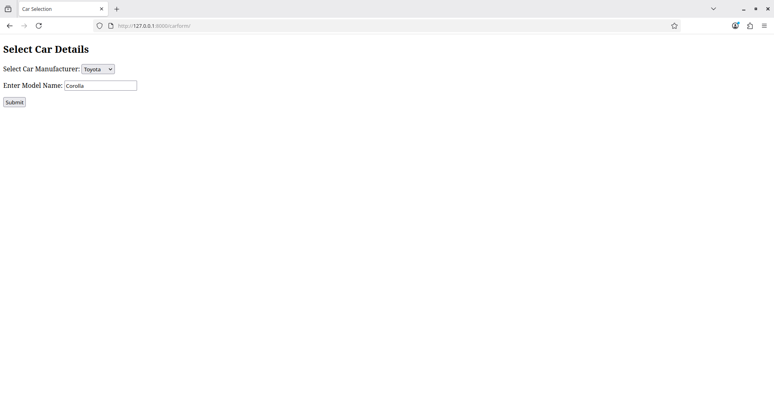
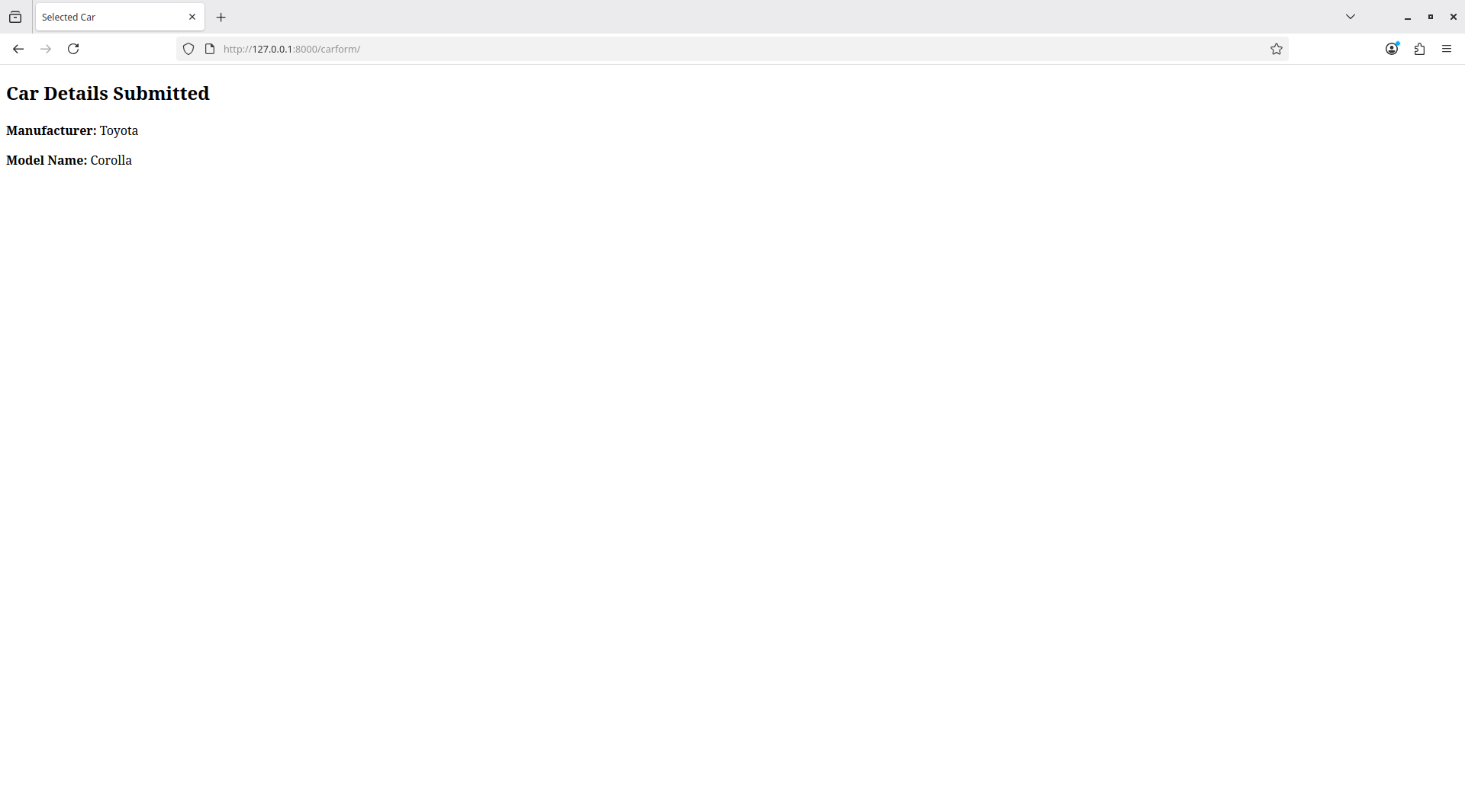
2) Create a page firstPage.html with two TextBoxes [Name, Roll], DropDownList
[Subjects], and a button. Create another page secondPage.html with a label and a
button. When the user clicks the button in first Page, he should be sent to the second
page and display the contents passed from first page in the label. The button in second
page should navigate the user back to firstPage. Use Django sessions to transfer
information.

forms.py:
from django import forms

class StudentForm(forms.Form):
SUBJECT_CHOICES = [
('Maths', 'Maths'),
('Physics', 'Physics'),
('Chemistry', 'Chemistry'),
('Computer Science', 'Computer Science'),
]

name = forms.CharField(max_length=100, label="Name")
roll = forms.CharField(max_length=20, label="Roll")
subject = forms.ChoiceField(choices=SUBJECT_CHOICES, label="Subject")

views.py:
from django.shortcuts import render, redirect

# Create your views here.

from .forms import StudentForm

def first_page(request):
if request.method == "POST":
form = StudentForm(request.POST)
if form.is_valid():
# Store data in session
request.session['name'] = form.cleaned_data['name']
request.session['roll'] = form.cleaned_data['roll']
request.session['subject'] = form.cleaned_data['subject']

return redirect('second')
else:
form = StudentForm()

return render(request, "firstPage.html", {'form': form})

def second_page(request):
name = request.session.get('name')
roll = request.session.get('roll')
subject = request.session.get('subject')

context = {
'name': name,
'roll': roll,
'subject': subject
}

return render(request, "secondPage.html", context)

urls.py:
from django.urls import path
from . import views

urlpatterns = [
path('', views.first_page, name='first'),
path('second/', views.second_page, name='second'),
]

firstPage.html:
<!DOCTYPE html>
<html>
<head>
<title>First Page</title>
</head>
<body>

<h2>Enter Student Details</h2>

<form method="POST">
{% csrf_token %}
{{ form.as_p }}
<input type="submit" value="Submit">
</form>

</body>
</html>

secondPage.html:
<!DOCTYPE html>
<html>
<head>
<title>Second Page</title>
</head>
<body>

<h2>Details Submitted</h2>

<p>
Name: {{ name }} <br>
Roll: {{ roll }} <br>
Subject: {{ subject }}
</p>

<form action="{% url 'first' %}">
<input type="submit" value="Go Back">
</form>

</body>
</html>

output:
