230905232

Aditya Pankaj Mathpal

CSE C2 37

Lab 7: Form Processing using Django – Part I

Home Assignments

urls.py (common):
"""
URL configuration for myproject project.

The `urlpatterns` list routes URLs to views. For more information please see:
https://docs.djangoproject.com/en/5.2/topics/http/urls/
Examples:
Function views
1. Add an import: from my_app import views
2. Add a URL to urlpatterns: path('', views.home, name='home')
Class-based views
1. Add an import: from other_app.views import Home
2. Add a URL to urlpatterns: path('', Home.as_view(), name='home')
Including another URLconf
1. Import the include() function: from django.urls import include, path
2. Add a URL to urlpatterns: path('blog/', include('blog.urls'))
"""
from django.contrib import admin
from django.urls import path, include

urlpatterns = [
path('groceryform/', include('groceryform.urls')),
path('studentform/', include('studentform.urls')),
path('carform/', include('carform.urls')),
path('formex/', include('formex.urls')),
path('admin/', admin.site.urls),
path('webapp/', include('webapp.urls')),
path('formapp/',include('formapp.urls')),
path('ex1app/', include('ex1app.urls')),
path('ex2app/', include('ex2app.urls')),
path('homeex1app/', include('homeex1app.urls')),
path('basic_calc/', include('basic_calc.urls')),
path('magazine/', include('magazine.urls')),
path('book/', include('book.urls')),
path('label/', include('label.urls')),
]

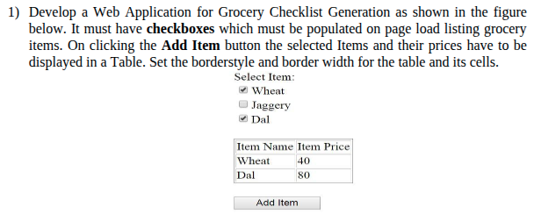

forms.py:
from django import forms

class GroceryForm(forms.Form):
ITEM_CHOICES = [
('Wheat', 'Wheat'),
('Jaggery', 'Jaggery'),
('Dal', 'Dal'),
]

items = forms.MultipleChoiceField(
choices=ITEM_CHOICES,
widget=forms.CheckboxSelectMultiple,
label="Select Item:"
)

views.py:
from django.shortcuts import render

# Create your views here.

from .forms import GroceryForm

def grocery_view(request):
prices = {
'Wheat': 40,
'Jaggery': 60,
'Dal': 80,
}
selected_items = []
if request.method == "POST":
form = GroceryForm(request.POST)
if form.is_valid():
items = form.cleaned_data['items']
for item in items:
selected_items.append({
'name': item,
'price': prices[item]
})
else:
form = GroceryForm()

return render(request, "grocery.html", {
'form': form,
'selected_items': selected_items
})

urls.py:
from django.urls import path
from . import views

urlpatterns = [
path('', views.grocery_view, name='grocery'),
]

grocery.html:
<!DOCTYPE html>
<html>
<head>
<title>Grocery Checklist</title>
</head>
<body>

<form method="POST">
{% csrf_token %}

{{ form.as_p }}

{% if selected_items %}
<table border="1" cellspacing="3">
<tr>
<th>Item Name</th>
<th>Item Price</th>
</tr>

{% for item in selected_items %}
<tr>
<td>{{ item.name }}</td>
<td>{{ item.price }}</td>
</tr>
{% endfor %}
</table>
{% endif %}
<br>
<input type="submit" value="Add Item">
</form>

</body>
</html>

output:
