230905232

Aditya Pankaj Mathpal

CSE C Roll No. 37

WPL Week 5

Lab Assignments

myproject/urls.py:
from django.contrib import admin
from django.urls import path, include

urlpatterns = [
path('admin/', admin.site.urls),
path('webapp/', include('webapp.urls')),
path('formapp/',include('formapp.urls')),
path('ex1app/', include('ex1app.urls')),
path('ex2app/', include('ex2app.urls')),
]

1) Create a web form which allows the teacher to enter the student details like name, date of birth, address, contact number, email id and marks of English, Physics and Chemistry. After filling all the information and on clicking submit button, details should be added to a textarea displayed on the same page. Display the total percentage of marks obtained in a label.

Code:

ex1app/urls.py:
from django.urls import path
from . import views

urlpatterns = [
path('', views.index, name='index')
]

ex1app/views.py:
from django.shortcuts import render

# Create your views here.

def index(request):
return render(request, "ex1app/basic.html")

ex1app/templates/ex1app/basic.html:
<!DOCTYPE html>
<html lang="en">
<head>
<meta charset="UTF-8">
<meta name="viewport" content="width=device-width, initial-scale=1.0">
<title>Student Details Form</title>
<script>
function submitDetails() {
let name = document.getElementById("name").value;
let dob = document.getElementById("dob").value;
let address = document.getElementById("address").value;
let contact = document.getElementById("contact").value;
let email = document.getElementById("email").value;

let eng = parseInt(document.getElementById("english").value);
let phy = parseInt(document.getElementById("physics").value);
let chem = parseInt(document.getElementById("chemistry").value);

let total = eng + phy + chem;
let percentage = (total / 300) * 100;

document.getElementById("percentage").innerText =
"Percentage: " + percentage.toFixed(2) + "%";

let output =
"Name: " + name + "\n" +
"Date of Birth: " + dob + "\n" +
"Address: " + address + "\n" +
"Contact Number: " + contact + "\n" +
"Email ID: " + email + "\n" +
"English: " + eng + "\n" +
"Physics: " + phy + "\n" +
"Chemistry: " + chem + "\n" +
"-----------------------------\n";

document.getElementById("details").value += output;

return false;
}
</script>
</head>
<body>
<h2>Student Details Form</h2>

<form onsubmit="return submitDetails();">
Name: <input type="text" id="name" required><br><br>
Date of Birth: <input type="date" id="dob" required><br><br>
Address: <textarea id="address" required></textarea><br><br>
Contact Number: <input type="text" id="contact" required><br><br>
Email ID: <input type="email" id="email" required><br><br>

English Marks: <input type="number" id="english" required><br><br>
Physics Marks: <input type="number" id="physics" required><br><br>
Chemistry Marks: <input type="number" id="chemistry" required><br><br>

<input type="submit" value="Submit">
</form>

<br>

<label id="percentage">Percentage: </label>

<br><br>

<textarea id="details" rows="12" cols="50" readonly></textarea>

</body>
</html>

output:
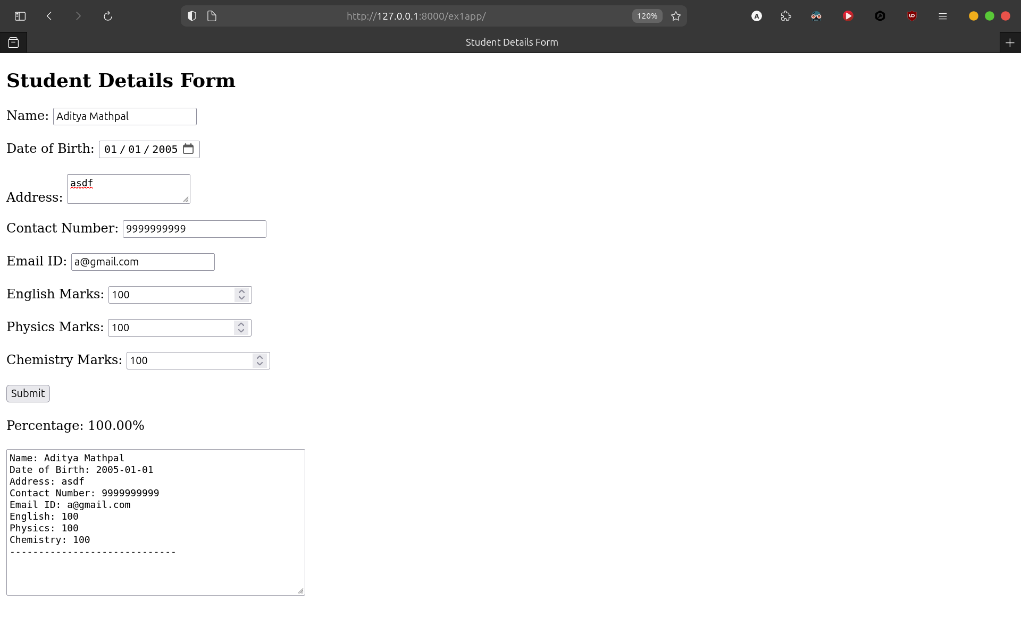

2) Create a web form with employee ids in dropdown list. Use a textbox for accepting date of joining. Add a button named “Am I Eligible for Promotion”. On clicking the button, if he has more than 5 years of experience, then display “YES” else “NO” in the label control.

Code:

ex2app/urls.py:
from django.urls import path
from . import views

urlpatterns = [
path('', views.index, name='index')
]

ex2app/views.py:
from django.shortcuts import render

# Create your views here.

def index(request):
return render(request, "ex2app.html")

ex2app/templates/ex2app.html:
<!DOCTYPE html>
<html lang="en">
<head>
<meta charset="UTF-8">
<meta name="viewport" content="width=device-width, initial-scale=1.0">
<title>Employee Form</title>
<script>
function checkEligibility() {
let doj = document.getElementById("doj").value;
if (doj === "") {
document.getElementById("result").innerText = "";
return;
}

let parts = doj.split("-");
let joinYear = parseInt(parts[0]);
let joinMonth = parseInt(parts[1]);
let joinDay = parseInt(parts[2]);

let today = new Date();
let years = today.getFullYear() - joinYear;

if (
today.getMonth() + 1 < joinMonth ||
(today.getMonth() + 1 === joinMonth &&
today.getDate() < joinDay)
) {
years--;
}

document.getElementById("result").innerText =
years >= 5 ? "YES" : "NO";
}
</script>
</head>
<body>
<h2>Promotion Eligibility Form</h2>

<form onsubmit="return false;">
Employee ID:
<select>
<option>EMP001</option>
<option>EMP002</option>
<option>EMP003</option>
<option>EMP004</option>
</select>
<br><br>

Date of Joining:
<input type="date" id="doj">
<br><br>

<button type="button" onclick="checkEligibility()">
Am I Eligible for Promotion
</button>
</form>

<br>

<label>Eligible for Promotion: </label>
<label id="result"></label>
</body>
</html>

output:
