230905232
Aditya Pankaj Mathpal
CSE C2 Roll No. 37

WPL Week 4

Home Assignments

1. Write a python program to select smallest element from a list in an expected
linear time.

Code:
arr = list(map(int, input("Enter elements of the list: ").split()))
smallest = float('inf')
for i in arr:
if smallest > i: smallest = i
print("smallest element is", smallest)

output:

2. Write a python program to implement bubble sort.

Code:
def bubble_sort(arr):
n = len(arr)
swapped = False
for i in range(n-1):
swapped = False
for j in range(n-i-1):
if arr[j] > arr[j+1]:
arr[j], arr[j+1] = arr[j+1], arr[j]
swapped = True
if not swapped: return

arr = list(map(int, input("Enter elements of the list: ").split()))
bubble_sort(arr)
print("sorted list:", arr)

output:

3. Write a python program to multiply two matrices

code:
import numpy as np

def mat_product(matA, matB):
m, n = len(matA), len(matB)
res = [[0]*m for i in range(m)]
for i in range(m):
for j in range(m):
for k in range(n):
res[i][j] += matA[i][k] * matB[k][j]
return res

def read_mat_input(mat):
m, n = len(mat), len(mat[0])
for i in range(m):
mat[i] = list(map(int, input().split()))

m, n = list(map(int, input("Enter dimensions of matrix A: ").split()))
o, p = list(map(int, input("Enter dimensions of matrix B: ").split()))
if m != p or n != o:
print("Enter valid dimensions")
raise SystemExit(1)

matA = [[0]*n for i in range(m)]
matB = [[0]*m for i in range(n)]

print("Enter elements of matrix A:")
read_mat_input(matA)
print("Enter elements of matrix B:")
read_mat_input(matB)

print("matA x matB =\n",np.array(mat_product(matA, matB)))

output:
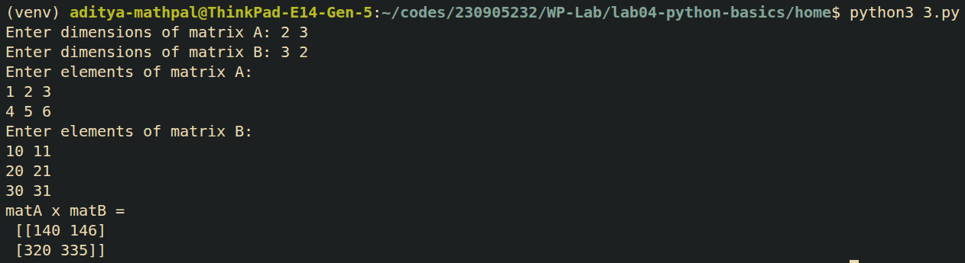

4. Write a Python class to find validity of a string of parentheses, '(', ')', '{', '}', '['
and ']. These brackets must be close in the correct order, for example "()" and
"()[]{}" are valid but "[)", "({[)]" and "{{{" are invalid.

Code:
def verify_string(s):
stack = []
dict = {')':'(', '}':'{', ']':'['}
for i in s:
if i in '({[':
stack.append(i)
elif dict[i] == stack[-1]:
stack.pop()
else:
return 0
return not stack

s = input("Enter string: ")
if verify_string(s):
print("Valid string")
else:
print("Invalid string")

output:
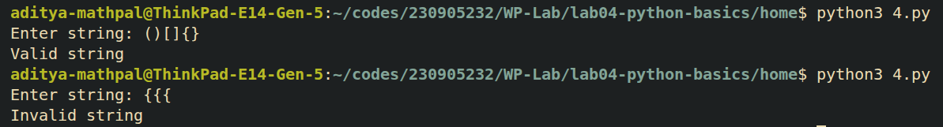
5. Write a Python class to reverse a string word by word.

Code:
class Reverse:
def __init__(self, s):
self.s = s

def rev(self):
words = self.s.split()
res = ' '.join(words[::-1])
return res

words = input("Enter string: ")
obj = Reverse(words)
output = obj.rev()
print("Words reversed:", output)

output:
6. Write a Python class named Circle constructed by a radius and two methods
which will compute the area and the perimeter of a circle.

Code:
import math

class Circle:
def __init__(self, radius):
self.radius = radius

def area(self):
return math.pi*self.radius**2

def perimeter(self):
return 2*math.pi*self.radius

r = float(input("Enter radius of circle: "))
obj = Circle(r)
print(f"Area of circle is {round(obj.area(), 4)}, perimeter is {round(obj.perimeter(), 4)}")

output:

