230905232

Aditya Pankaj Mathpal

CSE C2 Roll No. 37

WPL Week 6

Home Assignments

urls.py (common file):
from django.contrib import admin
from django.urls import path, include

urlpatterns = [
path('admin/', admin.site.urls),
path('webapp/', include('webapp.urls')),
path('formapp/',include('formapp.urls')),
path('ex1app/', include('ex1app.urls')),
path('ex2app/', include('ex2app.urls')),
path('homeex1app/', include('homeex1app.urls')),
path('basic_calc/', include('basic_calc.urls')),
path('magazine/', include('magazine.urls')),
path('book/', include('book.urls')),
path('label/', include('label.urls')),
]

1. Design a simple web application to provide information about a book. The home page of the application should display the cover page of the book along with three hyperlinks: Metadata, Reviews, Publisher info. Give provision to revert to home page from any other page.

book/urls.py:
from django.urls import path
from . import views

urlpatterns = [
path('', views.index, name='index')
]

book/views.py:
from django.shortcuts import render

# Create your views here.

def index(request):
return render(request, "book.html")

book/template/book.html:
{% load static %}
<!DOCTYPE html>
<html lang="en">
<head>
<meta charset="UTF-8">
<meta name="viewport" content="width=device-width, initial-scale=1.0">
<title>Book</title>
<style>
body {
font-family: Arial, sans-serif;
text-align: center;
}
.page {
display: none;
}
img {
width: 300px;
}
a {
display: block;
margin: 10px;
cursor: pointer;
color: blue;
}
</style>
</head>
<body>
<div id="home" class="page">
<h1>The Science of Interstellar</h1>
<img src="{% static 'image.jpg' %}">

<a onclick="showPage('meta')">Metadata</a>
<a onclick="showPage('reviews')">Reviews</a>
<a onclick="showPage('publisher')">Publisher Info</a>
</div>

<div id="meta" class="page">
<h2>Metadata</h2>
<p>Author: Kip Thorne</p>
<p>Genre: Non-fiction</p>
<p>Year: 2014</p>
<a onclick="showPage('home')">Home</a>
</div>

<div id="reviews" class="page">
<h2>Reviews</h2>
<p>"Explains complex concepts in a simple manner."</p>
<p>"Must read for fans of Interstellar."</p>
<a onclick="showPage('home')">Home</a>
</div>

<div id="publisher" class="page">
<h2>Publisher Info</h2>
<p>Publisher: W. W. Norton & Company</p>
<p>Location: New York</p>
<a onclick="showPage('home')">Home</a>
</div>

<script>
function showPage(pageId) {
var pages = document.getElementsByClassName("page");
for (var i = 0; i < pages.length; i++) {
pages[i].style.display = "none";
}
document.getElementById(pageId).style.display = "block";
}
showPage("home");
</script>
</body>
</html>

output:
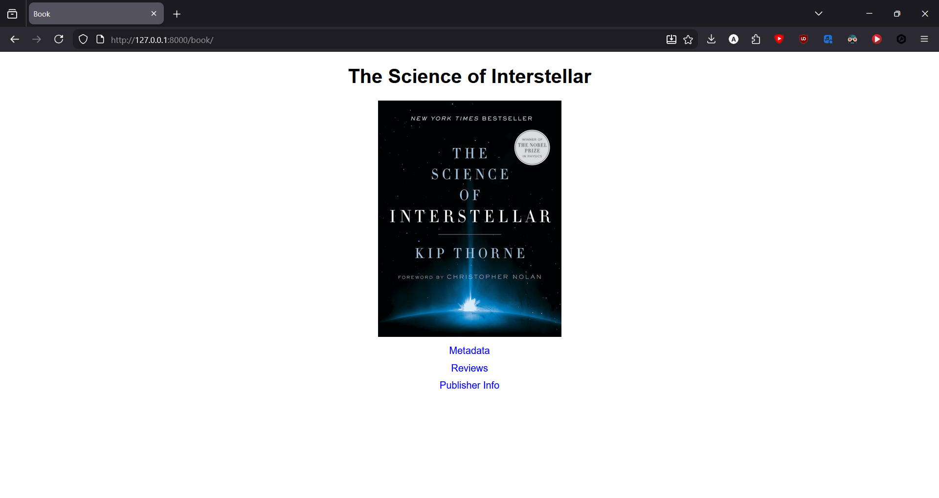
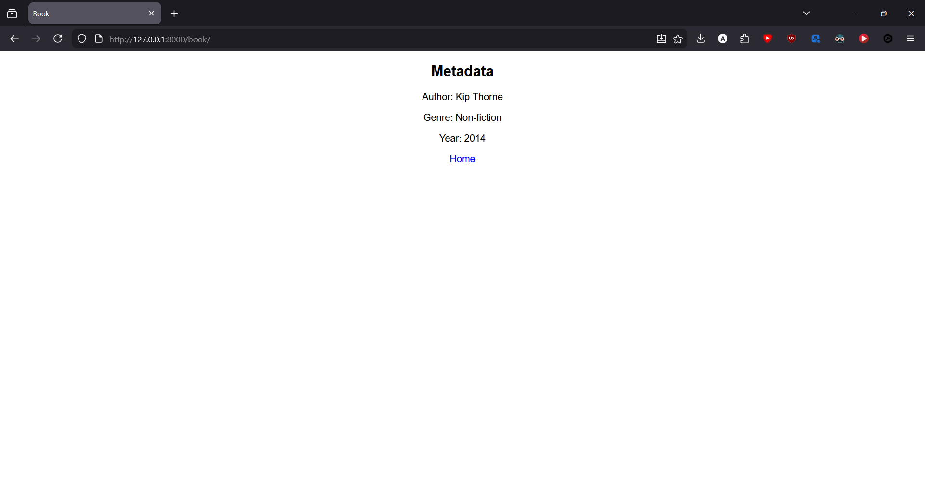

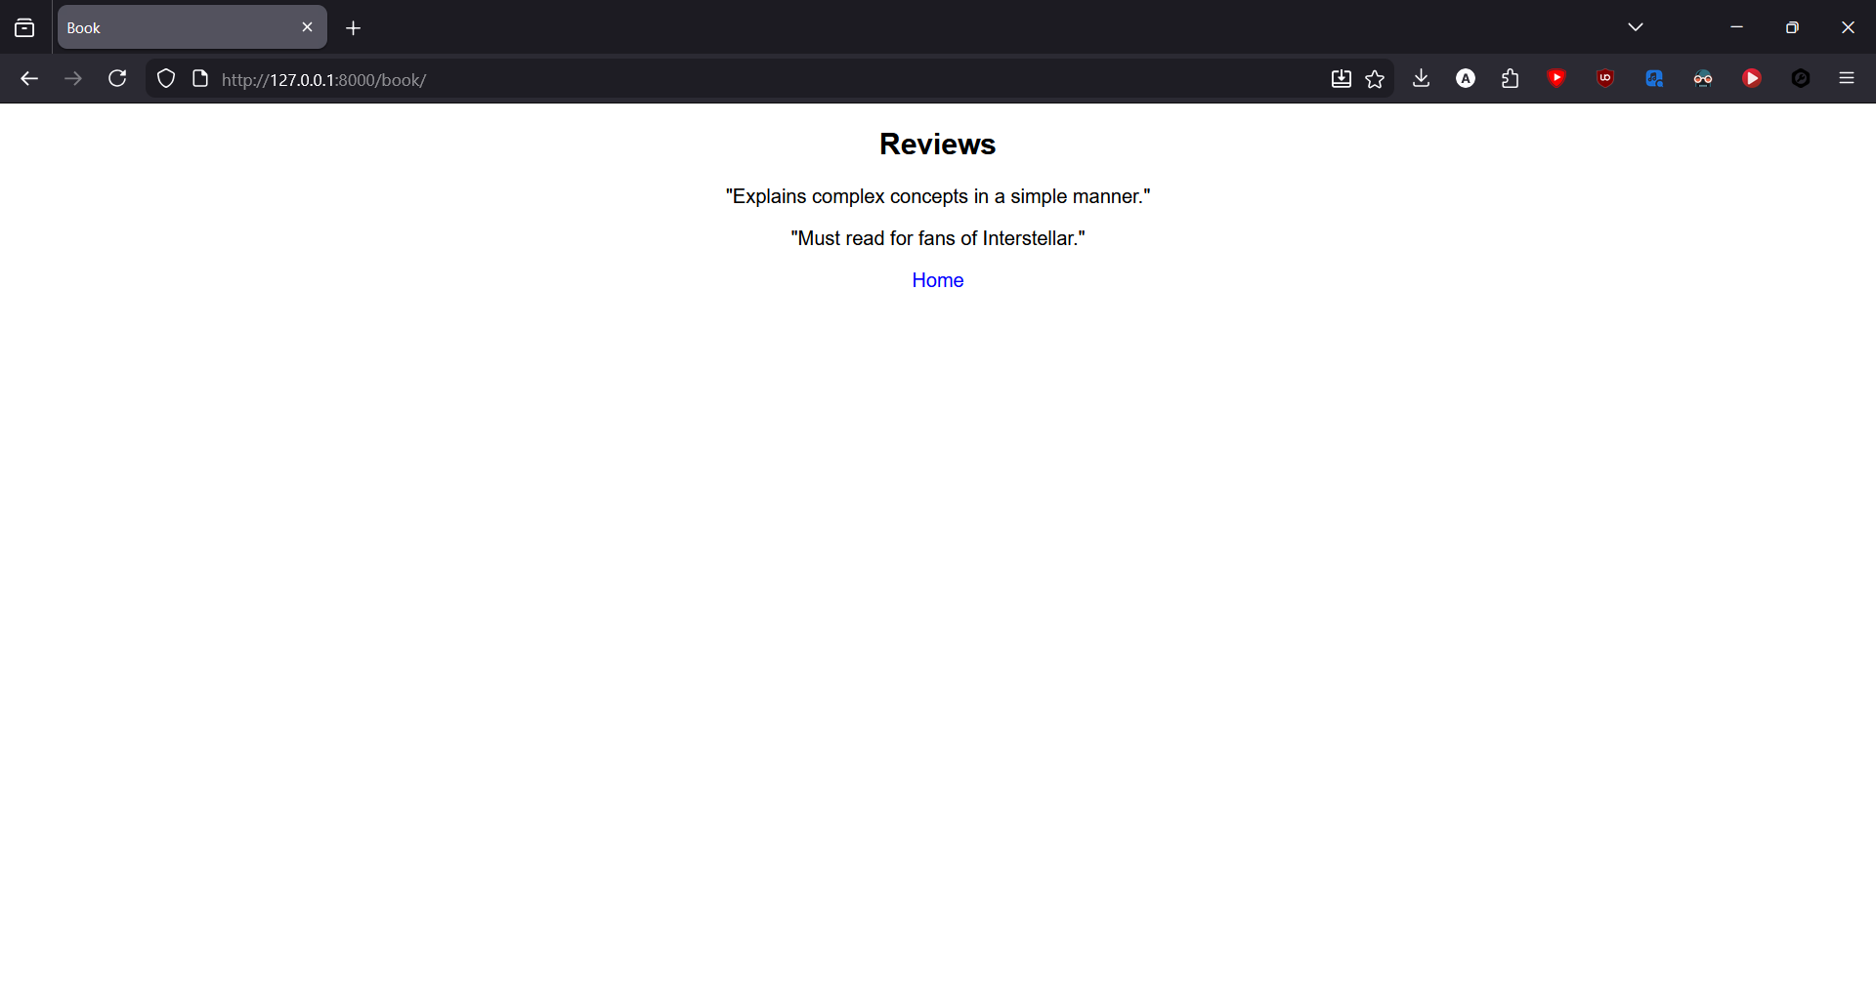
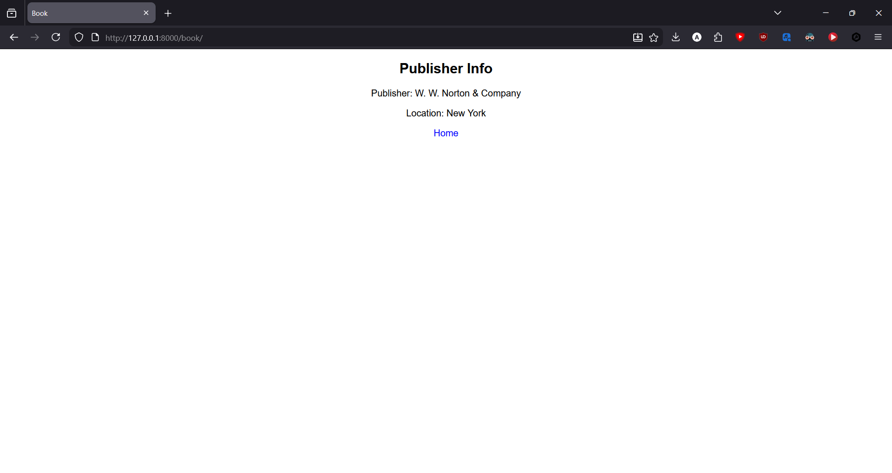

2. Design a simple web application which will ask the user to input his name and a message, display the two items concatenated in a label, and change the format of the label using radio buttons and check boxes for selection, the user can make the label text bold, underlined or italic and change its color. include buttons to display the message in the label, clear the text boxes and label and exit

label/urls.py:
from django.urls import path
from . import views

urlpatterns = [
path('', views.index, name='index')
]

label/views.py:
from django.shortcuts import render

# Create your views here.

def index(request):
return render(request, "label.html")

label/templates/label.html:
<!DOCTYPE html>
<html lang="en">
<head>
<meta charset="UTF-8">
<meta name="viewport" content="width=device-width, initial-scale=1.0">
<title>Customize Label</title>
<style>
body {
font-family: Arial, sans-serif;
text-align: center;
}
#output {
margin-top: 20px;
font-size: 20px;
}
</style>
</head>
<body>
<h2>Enter Details</h2>

<input type="text" id="name" placeholder="Enter Name"><br><br>
<input type="text" id="message" placeholder="Enter Message"><br><br>

<input type="checkbox" id="bold" onchange="formatText()"> Bold
<input type="checkbox" id="italic" onchange="formatText()"> Italic
<input type="checkbox" id="underline" onchange="formatText()"> Underline
<br><br>

<input type="radio" name="color" value="red" onchange="formatText()"> Red
<input type="radio" name="color" value="blue" onchange="formatText()"> Blue
<input type="radio" name="color" value="green" onchange="formatText()"> Green
<br><br>

<button onclick="displayMessage()">Display</button>
<button onclick="clearAll()">Clear</button>
<button onclick="exitApp()">Exit</button>

<div id="output"></div>

<script>
function displayMessage() {
var name = document.getElementById("name").value;
var message = document.getElementById("message").value;
document.getElementById("output").innerHTML = name + ": " + message;
formatText();
}

function formatText() {
var output = document.getElementById("output");

output.style.fontWeight = document.getElementById("bold").checked ? "bold" : "normal";
output.style.fontStyle = document.getElementById("italic").checked ? "italic" : "normal";
output.style.textDecoration = document.getElementById("underline").checked ? "underline" : "none";

var colors = document.getElementsByName("color");
for (var i = 0; i < colors.length; i++) {
if (colors[i].checked) {
output.style.color = colors[i].value;
}
}
}

function clearAll() {
document.getElementById("name").value = "";
document.getElementById("message").value = "";
document.getElementById("output").innerHTML = "";
document.getElementById("output").style = "";
}

function exitApp() {
window.close();
}
</script>
</body>
</html>

output:
